
The One Thing Needed

  - Luke 10:38-42; Psalms 46:10; Proverbs 3:5-6
  - Online Sermon: http://www.mckeesfamily.com/?page_id=3567


What’s the number one thing you’re chasing after in life right now? Maybe, in your deep longing for connection, you're seeking to be known—really known—understood, and loved... and to love others in return. Maybe it's recognition, status, or a legacy that drives you—so your calendar is packed with goals, ambitions, and the pursuit of success. Maybe, in this chaotic world, you're searching for peace, joy, and contentment by diving into hobbies, strengthening family bonds, improving your health or finances. Or perhaps there's just this deep, unshakable desire to become a better version of yourself… but you're unsure how to get there.
Whatever it is you're striving for—here’s the real question: Are you getting there? And if not… what’s holding you back? Experts tell us it takes 21 days to form a simple habit, 66 days for a more complex one, and about 10,000 hours of focused effort to master a skill like music, chess, or sports. But who has that kind of time when life pulls us in a thousand directions at once? Sure, studies show that nearly two-thirds of Canadians are satisfied with their leisure time —but that doesn’t mean we’re spending it wisely. We live in a culture that celebrates being busy. 'Time poverty' has become a strange badge of honor. So maybe the problem isn’t a lack of time—but how we spend it. Maybe it's the nearly five hours a day we devote to our smartphones and social media. Maybe it's our relentless drive to work harder, earn more, and chase after what the world says matters most. In the process, we lose sight of the fact that we do have a choice—a choice to slow down and live with intentionality.
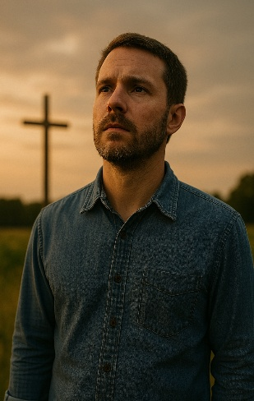
And that’s exactly what today’s message is about. God is not just concerned with what you do, but who you’re becoming—and whether He’s truly at the center of it all. It’s an invitation: Take time… to be holy. In a world overflowing with options, Apostle Paul reminds us that not all things are beneficial. Being constantly busy—always chasing, always doing—can mean being under Satan’s yoke, robbed of the very time we need to spend with the Lord. The one thing most worth striving for is a deeper relationship with Christ—the One who paid the ultimate price to redeem you. Yes, daily tasks and responsibilities matter. God calls us to be diligent and work faithfully. But He never meant for us to be enslaved by our ambitions, anxieties, or addictions to success and approval. To be holy as God is holy means learning to let go. It means refusing to let what is temporary control your life. It means anchoring yourself to the Rock of your salvation—and making Him your priority.
So, before we turn to Scripture, take a moment. Reflect. What is truly consuming your time? What are you pouring your energy into—and is it eternal or fleeting?
What would it look like if you fully surrendered …
your time, your desires, your future…
to Christ?
Let us see what Luke has to say about the dangers of multitasking (Luke 10:38-42), the Psalmist about our need to be still and know God (46:10), and king Solomon about trusting in God so that we might make Him the number One priority in our lives (Proverbs 3:5-6)!

Martha’s Mistake of Multitasking

To better understand what it looks like to put God first, let’s turn to a familiar story in Luke’s Gospel—one that paints a vivid picture of the tension between busyness and being present with God. In Luke 10:38–40, we meet two sisters—Martha and Mary—who make very different choices in response to Jesus' visit:
As Jesus and his disciples were on their way, he came to a village where a woman named Martha opened her home to him. She had a sister called Mary, who sat at the Lord’s feet listening to what he said. But Martha was distracted by all the preparations that had to be made. She came to him and asked, “Lord, don’t you care that my sister has left me to do the work by myself? Tell her to help me!”
Luke 10:38-40
This moment may seem simple at first—but it’s deeply revealing.
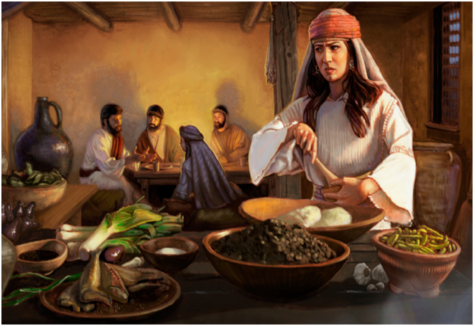
In Jesus’ day, women were often treated as little more than property, and their voices rarely counted in religious spaces. So, for a Jewish rabbi to enter the home of two women—and allow one to sit at His feet in the posture of a disciple—was radical. Martha, aware of the cultural weight of the moment, did what many of us might do. She sprang into action—opened her home, rolled up her sleeves, and got to work making sure everything was just right. You’ve probably met a Martha or two in your life—those who carry the load for everyone else. And if you’re honest, you may even be her. She’s the one who serves faithfully but feels constantly behind. The one who seems outwardly grateful to help but inwardly carries a burden of guilt, anxiety, and the fear that it’s never quite enough. As she scrambled to prepare the perfect meal for her honored Guest, her focus shifted—from serving out of love to striving for perfection. And as Mary sat in stillness, soaking in every word from Jesus, Martha’s heart grew heavy… and frustrated.
Can you relate? Maybe you’re the one who always makes sure everything gets done "the right way"—but you feel unsupported, unnoticed, or unappreciated. Maybe, like Martha, you’ve convinced yourself that busyness is the same as faithfulness. After all, Jesus came to serve—shouldn’t we do the same? Yes… but not at the cost of intimacy with Him. Not when our doing replaces our being with the One who matters most.

Mary’s One Thing (Luke 10:41-42)

In this moment, Jesus lovingly reorients Martha’s priorities—not to condemn her service, but to exalt what matters most: intimacy with Him.
“Martha, Martha,” the Lord answered, “you are worried and upset about many things, ⁴² but few things are needed—or indeed only one. Mary has chosen what is better, and it will not be taken away from her.”
Luke 10:41-42
Yes, it’s important that we use the spiritual gifts God has given us to build up the body of Christ. But we must not do so at the expense of our personal relationship with the Lord. Mary was praised by Jesus because she did the one thing that mattered most—she sat at His feet and listened. Her posture was one of surrender and devotion: “casting down the weapons of self-sufficiency and humbly acknowledging the Redeemer as Lord and King of her soul.” Just a few verses earlier in Luke’s Gospel, we see another lesson unfold, the parable of the Good Samaritan—a story that teaches us that “God is better honored through acts of mercy than through empty religious ritual.” But now, in Mary, we see that even our deeds of mercy must flow from a heart deeply connected to Christ.
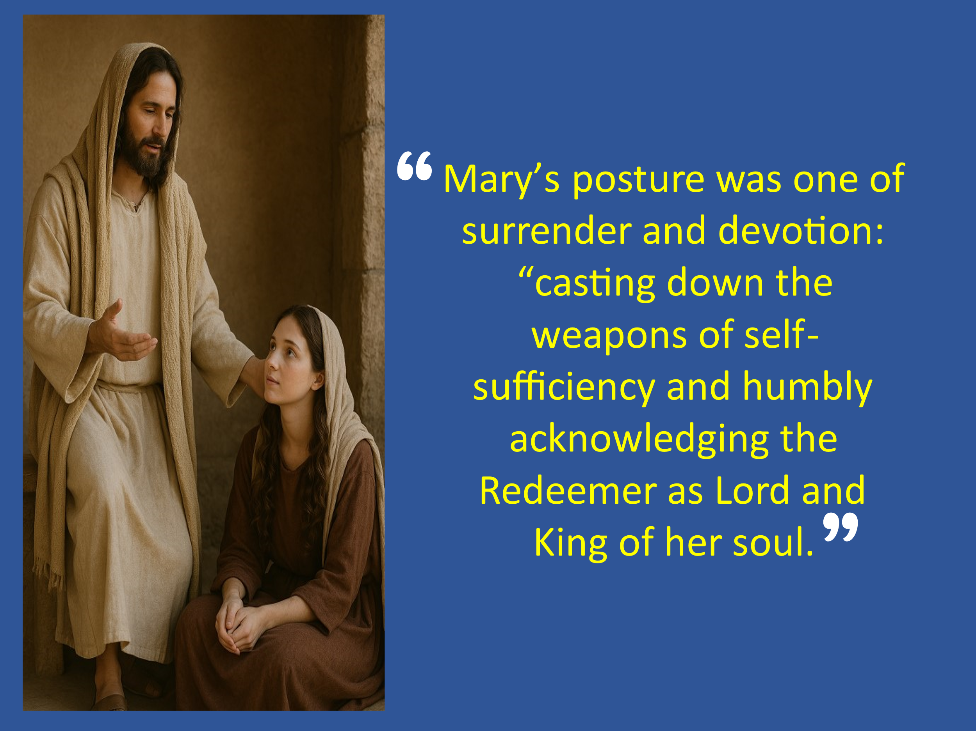
So, in the busyness of life, remember: God didn’t save you so that you could exhaust yourself chasing the pleasures of this world. He didn’t redeem you so that your calendar would be full of activity, but your soul left empty.
God saved you out of love, grace, and mercy so that you might walk in joyful relationship with Him. He invites you to meditate on His Word, day and night… to humbly fall at His feet and be fed, shaped, and sustained by the Master of the vineyard. The one thing we need most is to remain connected to the Vine—for apart from Christ, we can do nothing (John 15:5). In a world addicted to noise, performance, and self-promotion, what we need most is a posture of discipline and obedience to the One who leads us on the right path—for His name’s sake. Let’s remember the words of King David:
“The Lord is my shepherd; I lack nothing. He makes me lie down in green pastures, He leads me beside quiet waters, He refreshes my soul.”
Psalm 23:1–2
So, what about you? Are you living like Martha—busy, distracted, and burdened—or are you choosing the better thing, like Mary, to sit at the feet of Jesus? Christ is inviting you today—not to do more, but to come close. To stop striving… and start abiding.

Pausing to be Fed (Psalms 46:10)

Choosing the better thing, as Mary did, means resisting the urge to rush, perform, or fix everything. It means slowing down—and learning to be still. The psalmist offers us the same invitation:
He says, “Be still, and know that I am God;
I will be exalted among the nations,
I will be exalted in the earth.”

Psalms 46:10
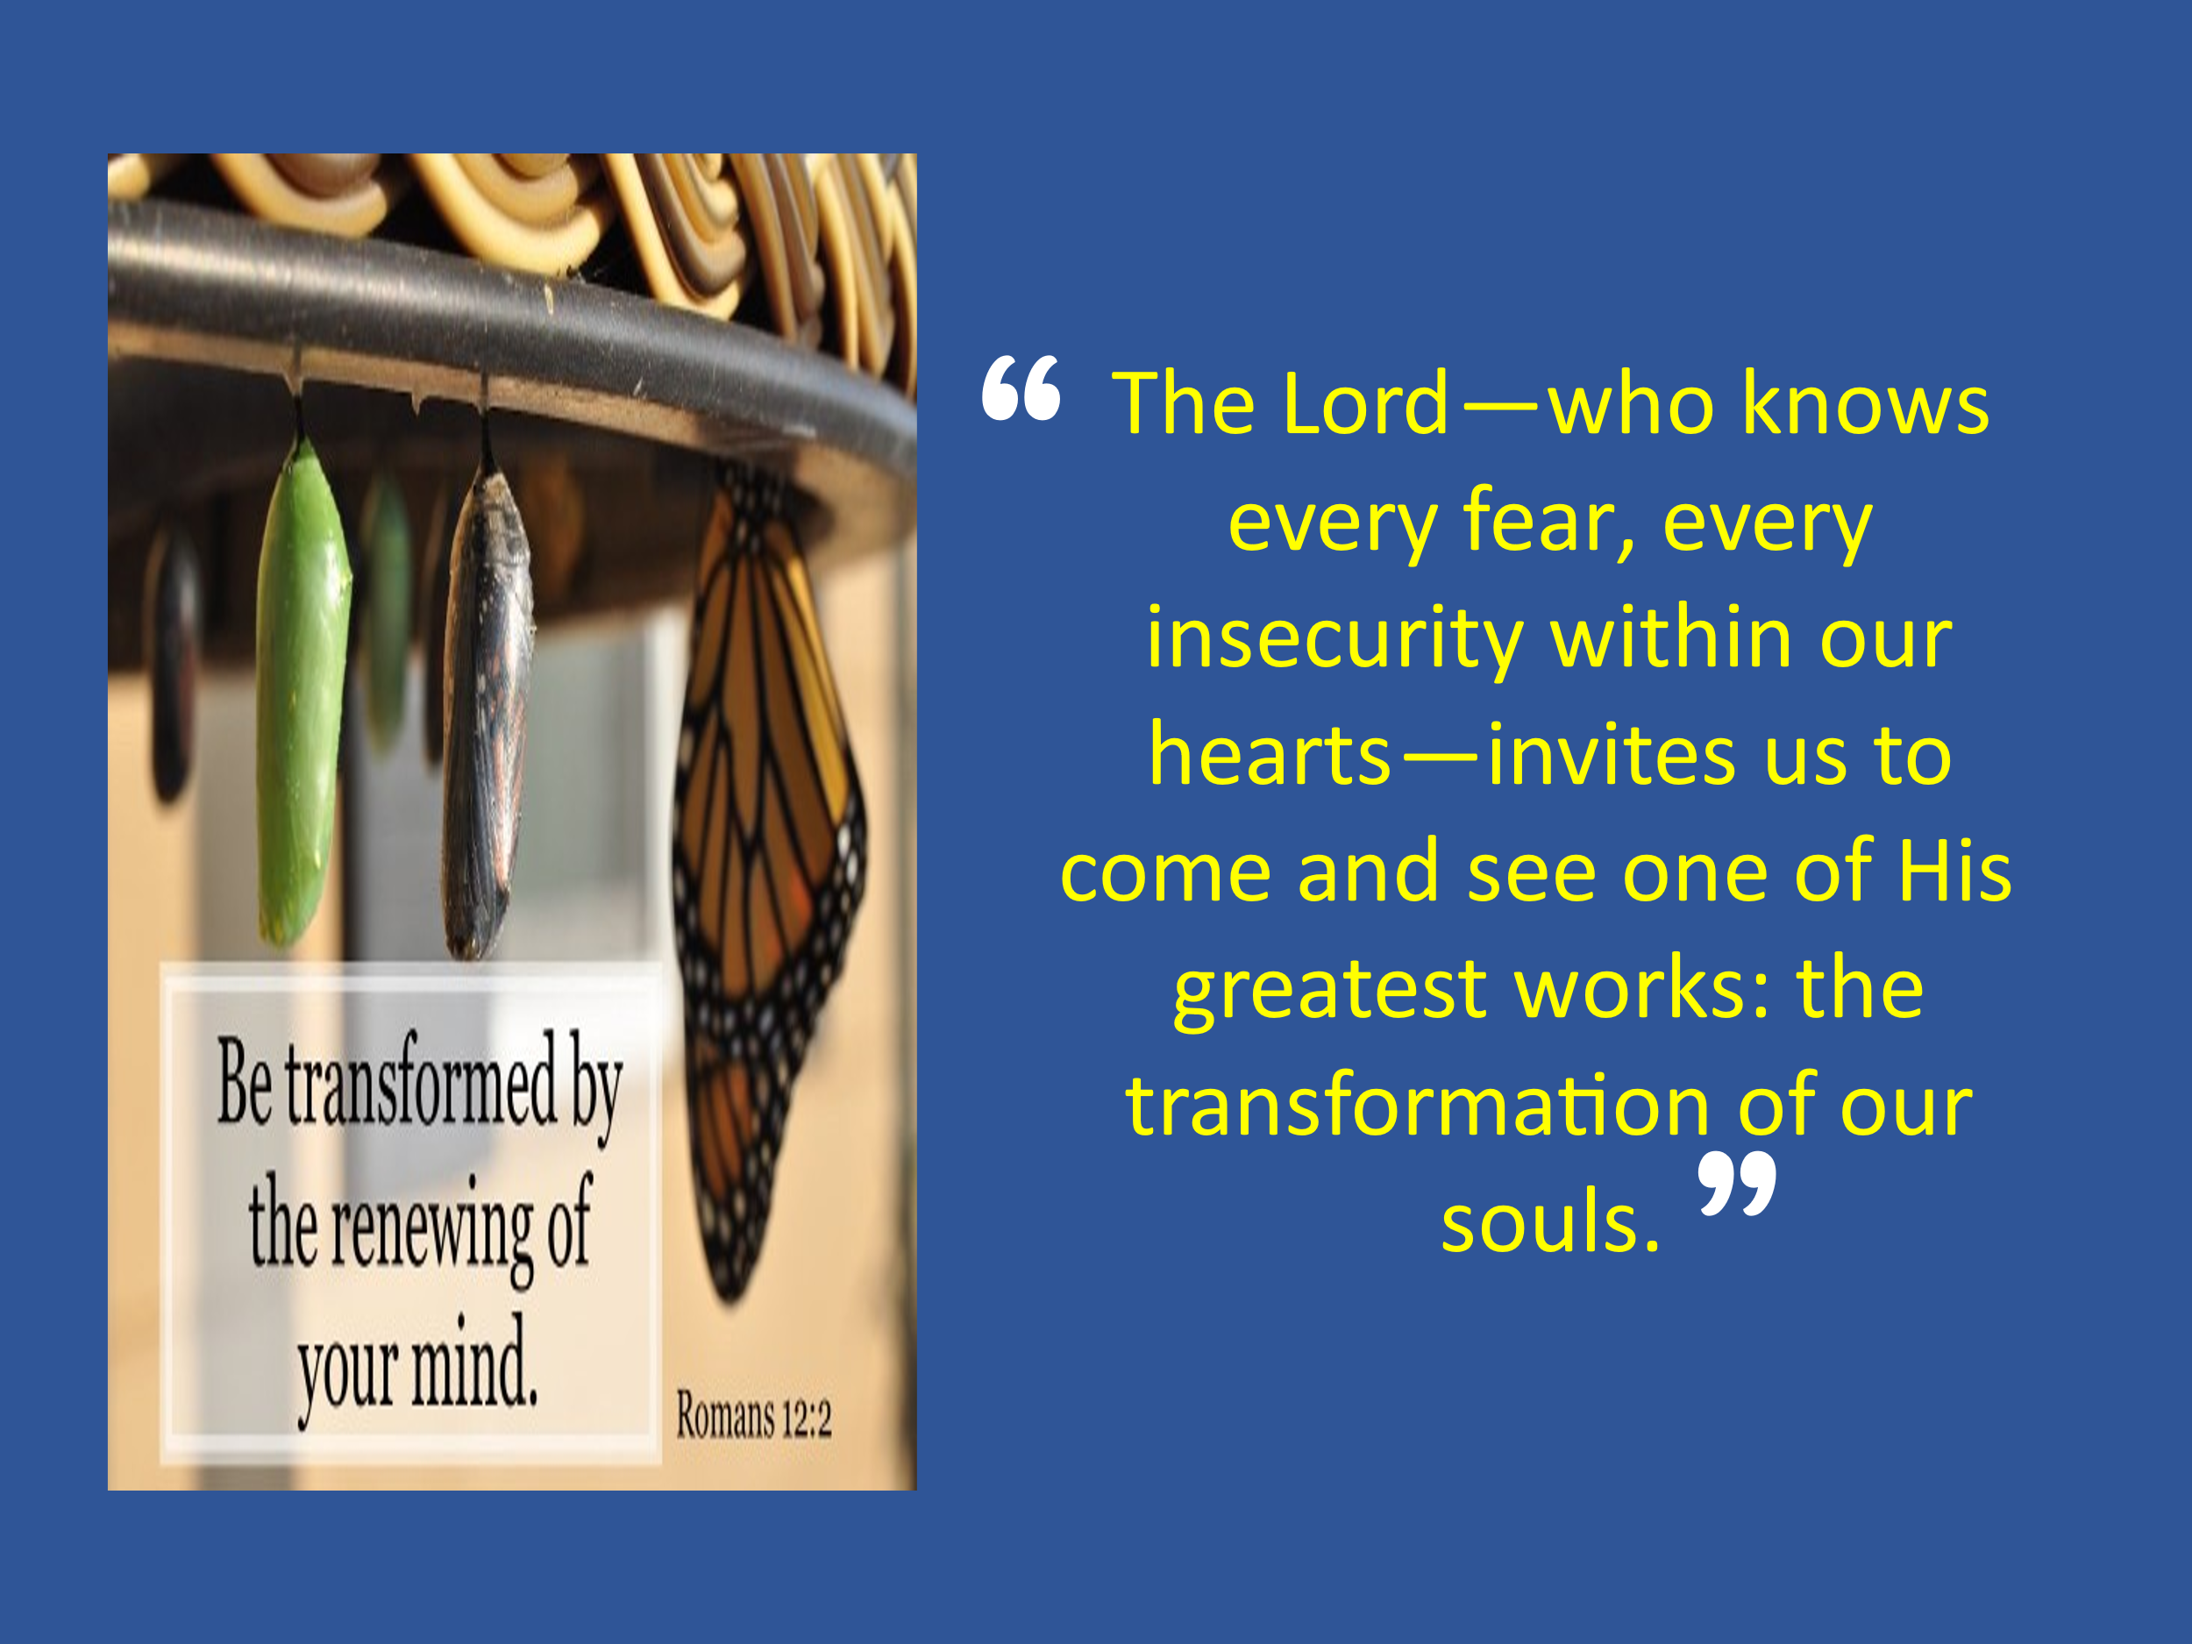
Isn’t that what God is calling us to even now? To put down our phones. To stop striving to impress others or chasing after fleeting pleasures. The Lord—who knows every fear, every insecurity within our hearts—invites us to come and see one of His greatest works: the transformation of our souls. At the feet of Jesus, we don’t need to worry about what we will eat, drink, or wear—or whether we’ll find happiness in this world. When we feast on the Bread of Life and drink from His Living Water, we find something far greater than silver or gold: we find unspeakable joy, held in His everlasting arms of peace, forgiveness, grace, and mercy.
And yes, being still before God opens us up to pruning. It may bring moments of discomfort—even persecution for His name’s sake. But we will not fear. For the God who calls us to stillness is also our refuge, our fortress, our stronghold —the unshakable source of strength and joy without end.

Pathway to Trust in Jesus (Proverbs 3:5-6)

But learning to be still at the Master’s feet doesn’t come naturally. It requires something deeper—a heart that fully trusts Him. If we’re going to surrender control and let Him lead, we must first be willing to let go of our own understanding and submit to His wisdom.
Trust in the LORD with all your heart
and lean not on your own understanding;
in all your ways submit to him,
and he will make your paths straight.
Proverbs 3:5-6

It’s not our relentless striving, problem-solving, or pursuit of worldly success that calms the chaos of life—it’s faith in a risen Savior. The storms we face—whether internal or external—aren’t stilled by our efforts to control everything, but by surrendering to the One who speaks peace into the winds and waves. Each of us has a choice: to stay caught in the current of busyness and self-reliance, or to slow down, step back, and live intentionally at the feet of Jesus. But this isn’t easy. It takes courage—real courage—to stop striving and trust that God's ways are higher than our own (Isaiah 55:8–9), and that His plans for us are far greater than anything we could ever ask for or even imagine.
That kind of trust grows when we begin to truly believe that He is not just after our obedience—but our transformation. As the prophets foretold, God has written His law upon our hearts (Jeremiah 31:33), and He has given us His Spirit to move us to walk in His ways (Ezekiel 36:26–27). But this internal renewal only takes root when we pause long enough to meditate on His Word and respond with humble obedience. So rather than leaning on our own understanding or being wise in our own eyes, let us bow low before the Lord—the One who instructs, empowers, and walks with us through the darkest valleys, all the way into eternal glory.
As Saint Augustine once wrote,
“You have made us for Yourself, O Lord, and our hearts are restless until they rest in You.”

Conclusion

What is the one thing you’re choosing today? Will you continue chasing what the world says matters most—productivity, performance, perfection? Or will you choose the better thing... to slow down, to trust, and to be still at the feet of Jesus? Martha was worried and distracted by many things. Mary chose one. And Jesus said it would not be taken away from her. That offer still stands. Jesus is calling you—not to do more, but to come close. Not to strive harder, but to rest deeper. Not to prove your worth, but to abide in His love. And when you do—when you choose that “one thing”—you’ll find peace that surpasses understanding, joy that outlasts circumstances, and purpose that no storm can shake.
So today, if your heart has been restless...
If your soul has been weary...
If your calendar has been full, but your spirit feels empty...
Then come to Him.
Be still.
Trust deeply.
And choose the one thing that truly matters.

Prayer:
Lord Jesus, in a world that constantly pulls at our attention, teach us to choose the better thing—to sit at Your feet. Quiet our hearts. Still our minds. Redirect our priorities. And help us, day by day, to walk in step with You. Amen.

Thabiti Anyabwile, Exalting Jesus in Luke, Christ-Centered Exposition Commentary (Nashville, TN: Holman Reference, 2018), 184.
Thabiti Anyabwile, Exalting Jesus in Luke, Christ-Centered Exposition Commentary (Nashville, TN: Holman Reference, 2018), 185.
C. H. Spurgeon, “The One Thing Needful,” in The Metropolitan Tabernacle Pulpit Sermons, vol. 17 (London: Passmore & Alabaster, 1871), 565.
Craig A. Evans, Luke, Understanding the Bible Commentary Series (Grand Rapids, MI: Baker Books, 1990), 177.
Thabiti Anyabwile, Exalting Jesus in Luke, Christ-Centered Exposition Commentary (Nashville, TN: Holman Reference, 2018), 186.
Walter L. Liefeld, “Luke,” in The Expositor’s Bible Commentary: Matthew, Mark, Luke, ed. Frank E. Gaebelein, vol. 8 (Grand Rapids, MI: Zondervan Publishing House, 1984), 945.
J. Josh Smith and Daniel L. Akin, Exalting Jesus in Psalms 1–50, ed. David Platt, Daniel L. Akin, and Tony Merida, Christ-Centered Exposition Commentary (Nashville, TN: Holman Reference, 2022), 324.
James Montgomery Boice, Psalms 42–106: An Expositional Commentary (Grand Rapids, MI: Baker Books, 2005), 389.
Jonathan Akin, Exalting Jesus in Proverbs, ed. David Platt, Daniel L. Akin, and Tony Merida, Christ-Centered Exposition Commentary (Nashville, TN: Holman Reference, 2017), 42.
Augustine, Confessions, Book 1, Chapter 1.

