My Sorrow Turned into Joy

  - John 16:16-24
  - Online Sermon: http://www.mckeesfamily.com/?page_id=3567

Imagine being one of Jesus’ disciples and hearing Him say that He would only be with you a little while longer.
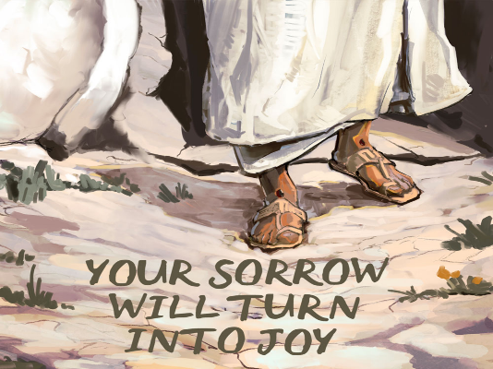
You can still recall the first time you met Him—the moment He searched your heart and knew you completely. Like Nathanael, you marveled at how He saw you before you even knew Him (John 1:48-51). He spoke with an authority unlike any other, revealing truths about God’s kingdom that had remained hidden for generations. And though you were fearfully and wonderfully made (Psalm 139:13-14), you also knew you were deeply flawed by sin.
Yet when Jesus called, “Follow Me, and I will make you fishers of men,” you didn’t hesitate (Mark 1:17). You left everything behind—your family, your trade, your security—to walk in His footsteps. You listened intently as He taught in parables, witnessed miracles beyond imagination, and even took part in His ministry, healing the sick and casting out demons in His name (Matthew 10:1).
But now, He speaks of leaving. Mary had been told that Jesus would be called the Son of the Most High, and that His kingdom would have no end (Luke 1:32-33). Now, Jesus speaks of something unthinkable—His death. At first, His words seemed mysterious:
“Destroy this temple, and in three days I will raise it up” (John 2:19).
“As Moses lifted up the serpent in the wilderness, so must the Son of Man be lifted up” (John 3:14-15).

But as time went on, His meaning became painfully clear.
“I am the Good Shepherd. The Good Shepherd lays down His life for the sheep.”
“No one takes it from Me, but I lay it down of My own accord” (John 10:11-18).
And then, the most troubling words of all: “I am going to the Father… where I am going, you cannot come” (John 13:33, 14:2).

Can you imagine the weight of those words? You had given up everything to follow Him, and now He was saying He would be taken away, crucified, and leaving you behind. Had everything been for nothing? Without its King, how could God’s kingdom ever spread?
It must have felt like the end of everything.
But what if this wasn’t the end at all?
What if His departure wasn’t the end of joy—but the beginning of something far greater than you ever imagined?

Preparing them for Sorrow

As the Gospel story unfolds and the shadow of Christ’s arrest and crucifixion looms closer, one can’t help but wonder—how would our Good Shepherd prepare His disciples for the crushing sorrow that was about to consume them?
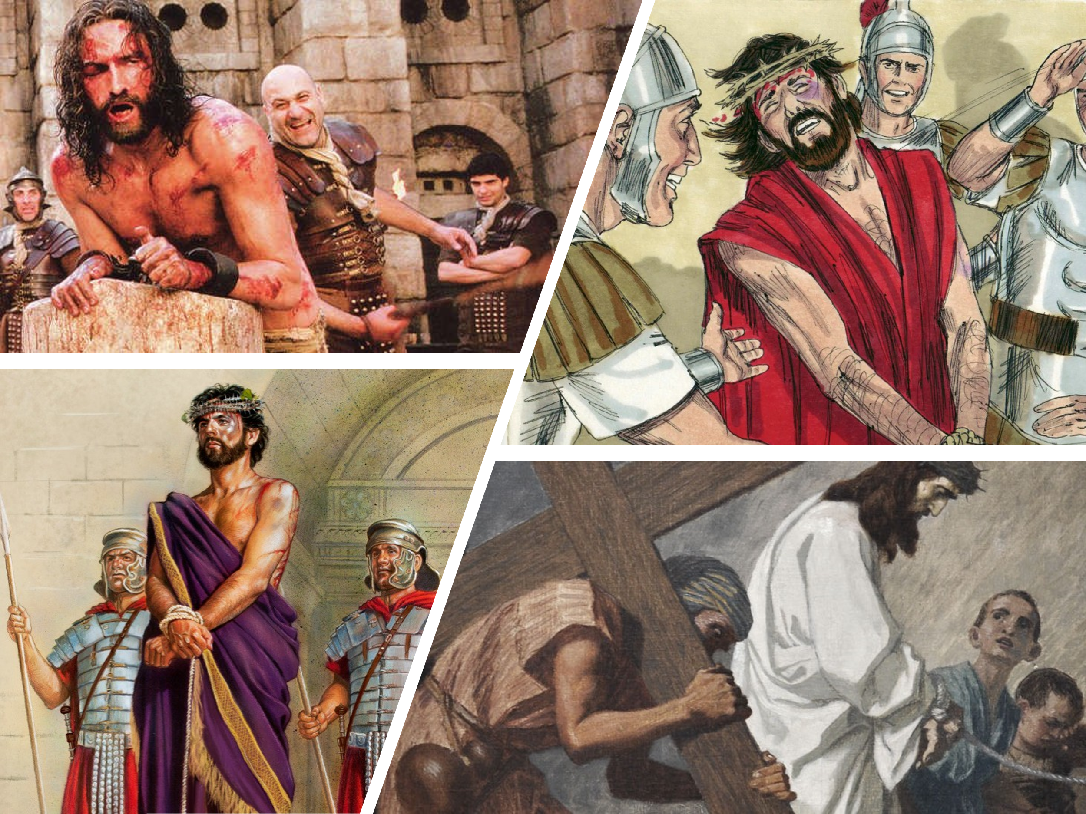
How would they endure the news that their beloved Master had been brutalized by His captors—beaten and mocked by the men guarding Him (Luke 22:63-65), spat upon and struck in the face by His accusers (Matthew 26:67-68)? Imagine their anguish upon hearing that Pilate had ordered Jesus to be flogged (John 19:1-3) and that the governor’s soldiers had stripped Him, draped Him in a scarlet robe, pressed a crown of thorns into His head, and mercilessly mocked Him as a false king (Matthew 27:27-31). And how would Jesus prepare John, the disciple He loved, for the heartbreak of watching His Master collapse under the weight of the cross, forcing Simon of Cyrene to carry it in His place (Matthew 27:32)? How would John bear the agony of standing at the foot of the cross, witnessing Jesus’ final moments as He cried out in a loud voice and breathed His last (Mark 15:37)?
When His bruised and lifeless body was taken down, wrapped in burial cloths, and placed in a sealed tomb under Roman guard, it must have seemed as if all hope was lost. Their world had shattered. And if their grief weren’t heavy enough, while the disciples wept and mourned the loss of their Lord, the world rejoiced in His death. The religious leaders, the soldiers, and even the crowds celebrated their perceived victory over the one who had claimed to be the Son of God. At this point in the story, one question lingers: how could anyone survive such unbearable sorrow? How could Jesus' followers possibly be prepared for the depths of despair that awaited them?

The Necessity of the Cross

Though the disciples would experience overwhelming sorrow, there was simply no other way for humanity to be saved from sin. Satan had tempted Jesus with the kingdoms of the world and their splendor, but they were never his to give, for there is only one true Lord and God (Matthew 4:8-10). The only path to redemption was through the agony of the cross.
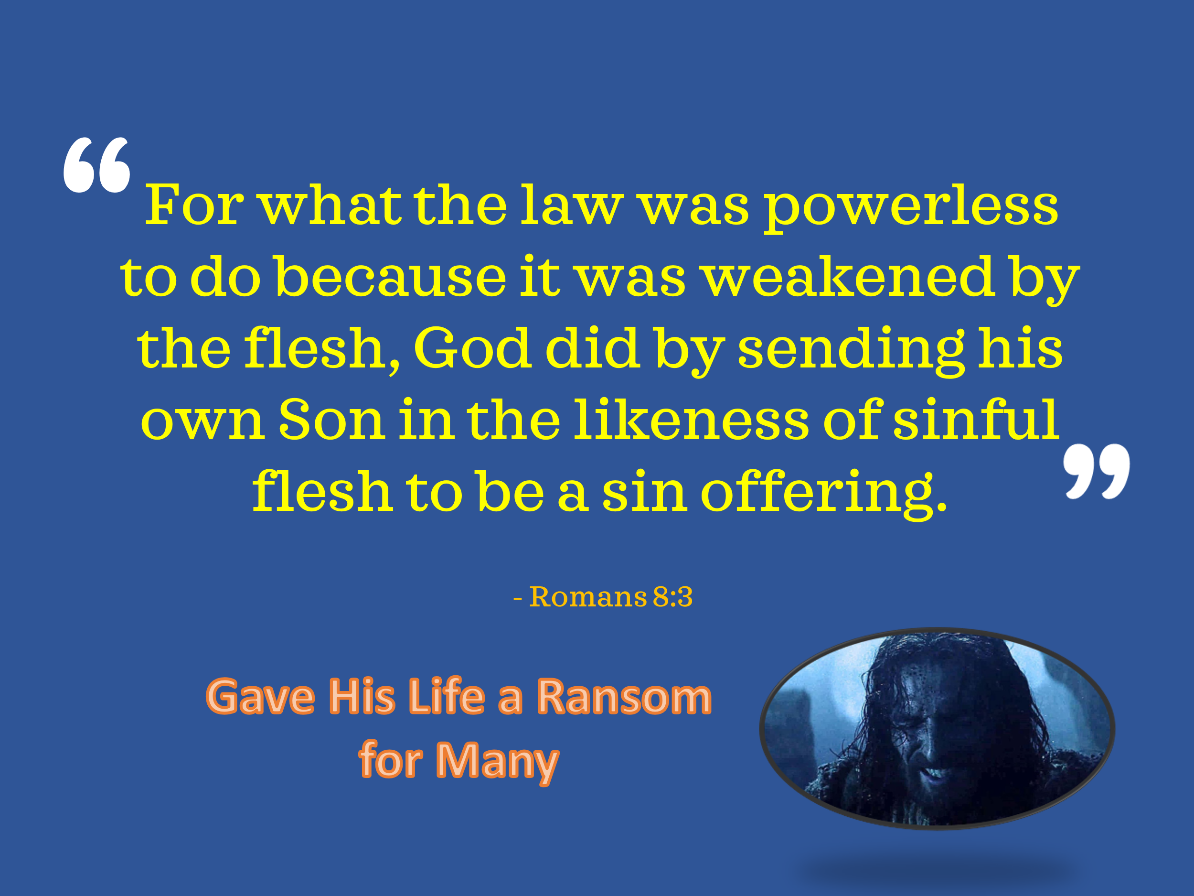
In the Garden of Gethsemane, Jesus fell to the ground, His face pressed into the earth (Matthew 26:39), His body trembling under the weight of what was to come. In anguish so deep that His sweat was like drops of blood (Luke 22:44), He cried out to the Father, knowing that there was no other way—only His sacrificial death could atone for the sins of the world. What the law was powerless to accomplish because of human sinfulness, Christ fulfilled by offering Himself as the sinless Lamb of God, a ransom for many (Mark 10:45).

Peter, out of genuine love and passion, tried to stop Jesus from going to the cross, but even the gates of Hell could not prevent God's plan of redemption (Matthew 16:21-23). Not even Satan, the so-called prince of this world, could prevent the Lamb who was slain before the foundation of the world from fulfilling His mission (Revelation 13:8). Jesus’ sacrifice was an unstoppable expression of divine love—not just for His disciples, friends, and family, but especially for His enemies (Romans 5:10).
Without the cross, there would be no resurrection joy, no eternal victory, and no sealing of the redeemed by the Holy Spirit (2 Corinthians 1:21-22). But because of the cross, sorrow would be turned into joy, despair into hope, and sinners into saints, forever secured in Christ.

It would be easy for us to judge the apostles from this side of the cross and wonder how they could have doubted. Had they not heard the prophecies? Had Jesus Himself not told them He would rise again? Yet, if we are truly honest with ourselves, we must humbly admit that we, too, struggle with faith amid trials. Despite the countless blessings God has promised us, when pain and suffering come, we often cannot see beyond the walls of our anguish. We cry out in desperation, feeling as though God has somehow forsaken us—just as the disciples must have felt in their darkest hour.

But here’s what we learn from them: even in the bleakest moments, the Good Shepherd is at work. His plan is never to harm us, but to shape us, refine us, and allow us to flourish. Can we not look to the cloud of witnesses in Scripture and to our own testimonies of deliverance? Do we not have countless reminders of God’s faithfulness that assure us He will never leave us nor forsake us? It is precisely because we have walked through the crucible of affliction—carried on the shoulders of our Lord—that we learn to rejoice. We rejoice not only because He delivers us from suffering, but because He strengthens our faith through it.
So, I pray, Lord, teach us to find joy amid mourning. Until we learn to do so, we will never be fully grateful or satisfied, for the crumbs of our afflictions will blind us to the feast of spiritual blessings You have prepared for us. Without the cross, there would be no resurrection joy, no eternal victory, and no sealing of the redeemed by the Holy Spirit. But through the cross, death itself would be defeated, and a new dawn of redemption would rise (2 Corinthians 1:21-22). Lord, teach us to find joy amid mourning.

Joy that Cannot be Taken Away

But just as sorrow filled the hearts of the disciples at the cross, Jesus had already promised that their grief would not last forever. To help them grasp the emotional turmoil they were about to endure, He compared it to childbirth—a process filled with pain, struggle, and anticipation, yet ending in overwhelming joy.
Pregnancy is no easy task. What mother could forget the morning sickness, exhaustion, swollen ankles, aching back, constant trips to the bathroom, and digestive struggles that seem endless? If that weren’t enough, the emotional toll of mood swings, fear of the unknown, and restless nights only add to the burden. And in ancient times, labor itself was even more grueling—most women delivered squatting or kneeling, without modern medicine, relying only on herbs, warm water, and massage for relief. Truly, as Genesis 3:16 declares, "I will make your pains in childbearing very severe"—a promise every mother can attest to!
And yet, something miraculous happens. The moment a mother holds her child, the pain that once seemed unbearable fades in the overwhelming joy of new life in her arms. Jesus assured His disciples that their sorrow, too, would not be the final chapter. Just as labor pains give way to unspeakable joy, their grief would be swallowed up in a joy that no one could ever take away (John 16:20-22).
What else in life carries such a guarantee? Wealth can vanish in an instant—stolen by thieves or lost in a stock market crash. Good health can be taken by disease. Reputations can be tarnished by gossip, cruelty, and slander. But there is one thing that no power on earth or in hell can ever take away—the love that Christ demonstrated on the cross! As Paul declares:
“For I am convinced that neither death nor life, neither angels nor demons, neither the present nor the future, nor any powers, neither height nor depth, nor anything else in all creation, will be able to separate us from the love of God that is in Christ Jesus our Lord” (Romans 8:38-39).
Even death itself has no sting for those who are in Christ! Why? Because “The sting of death is sin, and the power of sin is the law. But thanks be to God! He gives us the victory through our Lord Jesus Christ” (1 Corinthians 15:56-57).

Yet so often, we place our joy in things that can be taken from us—relationships, careers, financial security, health, fame, and power. But doing so is like storing all your life’s savings in a piggy bank and leaving it in a high-crime neighborhood, expecting it to remain untouched. Jesus warned His disciples:
You will feel the excruciating pain of watching Me crucified. You will be deeply troubled, lost in grief for three days, wondering if all your hopes in the kingdom of God have been in vain. But on that glorious resurrection morning, when the tomb stands empty and the Holy Spirit fills your hearts, you will know that death has lost, and joy has won!
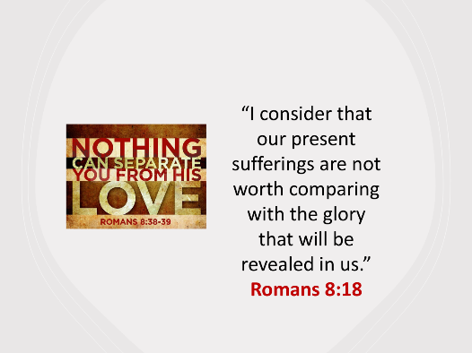
Like the disciples, we are called not just to endure hardship, but to endure it with hope—knowing that joy is coming. While we cannot avoid the pain of trials and tribulations, we can see them for what they truly are—momentary afflictions that cannot compare to the eternal joy awaiting us. As Paul reminds us:
“I consider that our present sufferings are not worth comparing with the glory that will be revealed in us” (Romans 8:18).
Just as a mother forgets her labor pains in the presence of her newborn, so too will all suffering pale in comparison to the resurrection joy we will experience when we stand before the pioneer and perfecter of our faith, Jesus Christ (Hebrews 12:1-2). Earthly joy is fleeting, but the joy found in Christ is eternal. While everything else fades, His love, His promises, and our inheritance in Him remain forever!

Let our Joy be Refreshed in Prayer

But even as we cling to the unshakable joy found in Christ, we must remember that joy is not a fleeting emotion nor a one-time experience—it is a wellspring that must be nurtured, renewed, and refreshed daily. Just as a weary traveler finds relief in a cool stream, we must continually return to the presence of God to sustain our joy. Through prayer, we are anchored in His promises, strengthened by His Spirit, and refilled with the peace that surpasses all understanding.
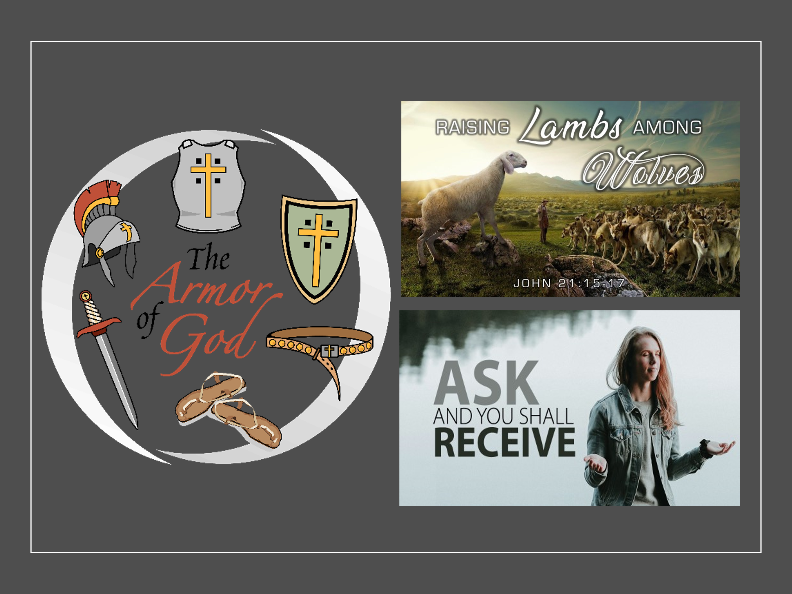
Like the disciples, we do not fear, for though we are sent out like sheep among wolves, we go not with mere words of wisdom or persuasion, but in the demonstration of the Spirit’s power (1 Corinthians 2:4-5). Jesus assures us that whatever we ask in His name, He will do—not as a genie who grants wishes, but as our sovereign Lord who aligns our hearts with His perfect and pleasing will (Romans 12:1-2). It is through prayer that we discern His will, receive His strength, and are empowered to live lives worthy of the Gospel (Philippians 1:27). We are called to holiness, generosity, boldness, gratitude, repentance, and selflessness—but we cannot do this on our own. It is only as we humble ourselves before God, pleading for His work in us, that we are transformed.
A prayerless life is a powerless life. And a powerless life is one that lacks true, lasting joy. May we never neglect the privilege and power of prayer—for in His presence, our joy is renewed, our faith is strengthened, and our purpose is made clear.

Conclusion

As we stand at the end of this journey—from the sorrow of the cross to the unshakable joy of the resurrection—we are reminded of a truth that transforms everything: our pain is temporary, but our joy in Christ is eternal. Just as the disciples faced crushing sorrow, only to be overwhelmed with resurrection joy, so too must we remember that our trials are not the end of the story. We do not grieve as those without hope. We do not endure suffering without purpose. We do not walk through life without the presence of our risen Savior. Our joy is not in circumstances, not in temporary pleasures, not in the fleeting things of this world. Our joy is in Christ alone—the One who conquered death, the One who defeated sin, the One who has sealed us with His Spirit and secured for us an eternal inheritance that can never fade!
So, no matter what trials we face, no matter what burdens we carry, we cling to the truth that nothing—absolutely nothing—can separate us from the love of God that is in Christ Jesus our Lord (Romans 8:38-39).
And how do we keep this joy alive?
Through prayer.
Through abiding in His presence.
Through fixing our eyes on Jesus, the pioneer and perfecter of our faith (Hebrews 12:2).

Let us, then, walk in the power of His Spirit, live lives worthy of the Gospel, and hold fast to the unshakable joy that no trial, no hardship, and no force of darkness can take away.

For the tomb is still empty.
The victory is still won.
And the joy of the Lord is still our strength—forever!

Matt Carter and Josh Wredberg, Exalting Jesus in John (Nashville, TN: Holman Reference, 2017), 329.
Matt Carter and Josh Wredberg, Exalting Jesus in John (Nashville, TN: Holman Reference, 2017), 330.

