Loving God by Loving one Another

  - 1 John 4:7-11
  - Online Sermon: http://www.mckeesfamily.com/?page_id=3567

What happens when the people who are supposed to love each other the most turn against one another?

Have you ever walked into a church and sensed the tension in the air? Maybe it wasn’t spoken outright, but you knew—there were sides. Factions had formed. Trust was broken. And the warmth that once made that congregation feel like family had been replaced with whispers, resentment, and division. Sadly, this isn’t just a modern issue. Church splits, theological disputes, and relational breakdowns have plagued God’s people since the beginning. Even John, the disciple whom Jesus loved, faced a church tearing itself apart—one side clinging to the truth while the other distorted it in the name of progress. It’s easy to blame others for division, but James reminds us that conflict starts within: “What causes fights and quarrels among you? Don’t they come from your desires that battle within you?” (James 4:1). If even John—a direct disciple of Jesus—couldn’t prevent division, what hope do we have? The answer isn’t more theological debates, better leadership strategies, or even stricter church governance. The answer is found in something far more radical: agape love. Have you ever found yourself caught in church tension, feeling the weight of division?

Today, we will explore how John confronted division, not with politics or power, but with the very thing that defines true followers of Christ: a love that is voluntary, unconditional, and sacrificial. Scripture challenges us to confront the presence of deceit, false teachings, and the divisive influences that threaten our unity (see 2 John 7; 1 John 2:4, 22; 1 John 4:1; 1 John 2:18, 22). In John’s time, as today, there were those who clung to old traditions while embracing new ideas that undermined the core tenets of our faith. John could not remain silent when some claimed sinlessness yet refused to love one another, obey God, or acknowledge Jesus as the Christ (1 John 1:8–10; 1 John 1:6; 1 John 2:9, 11; 3:10–18; 1 John 2:22).
We are called to emulate the love Christ demonstrated on the cross—voluntary, unconditional, and sacrificial. As we prepare to hear John’s admonitions and guidance, let us open our hearts to forgive, to seek understanding, and to extend love even toward those we might have too quickly dismissed. In doing so, we not only uphold the unity of our church but also reflect the very nature of Christ’s love in our daily lives.

What Causes Quarrels and Fights?


Even within the sanctity of our church communities, human frailty often gives way to discord. Quarrels and conflicts emerge as stark reminders of our ongoing need for forgiveness and reconciliation. Apostle Paul reminds us that every believer wrestles with deep-seated strongholds in their thinking (1 Corinthians 10:3–5). While we long to echo his declaration, “I have died so that Christ might live in me” (Galatians 2:20), the truth is that we often struggle to overcome the pride of life—the tendency to believe we are the best interpreters of God’s Word, the sole arbiters of His will, and the ultimate exemplars of holiness. As our finite faith attempts to comprehend what Tozer once called the “Unknowable,” those with motes of sin in their eyes (Matthew 7:3–5) and limited understanding frequently clash over what it truly means to live a life worthy of the Gospel. Rather than celebrating our differences and striving for unity in the body of Christ (1 Corinthians 12:12–31), some among us resort to backbiting, politicizing, and slandering others in a misguided effort to assert superiority. If we are to allow “iron to sharpen iron” (Proverbs 27:17), should we not embrace our diverse opinions through prayer and fasting, seeking a deeper understanding of God’s truth? Even when others have clearly erred, are we not called to extend grace and mercy as we collectively pursue peace (Ephesians 4:3)?

Even as God’s children, we are not immune to the trap of intellectual and spiritual superiority. With an estimated 47,000 Christian denominations worldwide, the schisms we witness—even within John’s own church—reveal not so much a failure of leadership as an epidemic afflicting our congregations today. So, what is the remedy? Is it enhanced conflict management training for pastors or more rigorous theological insights handed down from a centralized denomination? For John, neither option addresses the real issue at hand. What truly causes quarrels and conflicts to escalate into indifference or hatred is a lack of genuine love—for God and for one another. Let us now turn to John’s passage and discover how agape love can serve as the antidote to pride and intolerance.


A pastor once joked about a church that split over the color of the carpet. One half wanted blue for a calming effect, while the other insisted red brought holy energy. He quipped, 'In the end, they didn't just choose a color; they painted the town divided! But as they learned, it’s not about the carpet we walk on but the love that we stand upon.' What if the biggest problem in church division isn’t ‘them’ but ‘us’?

Agape Love

If division stems from pride and spiritual superiority, then the only true solution must be a radical shift from self-centeredness to Christ-centered love. John’s solution to church conflict and division is summed up in his bold declaration:
"Dear friends, let us love one another, for love comes from God. Everyone who loves has been born of God and knows God." (1 John 4:7)
It should come as no surprise that the thread holding the church together—the key to maintaining unity and peace—is found in the greatest commandment (Matthew 22:36-40). The evidence of our relationship with God is not found in theological eloquence, religious traditions, or moral superiority, but in how we love one another. What kind of love would willingly suffer rejection, betrayal, and death for those who caused the pain?
However, John is not speaking of worldly love, which is rooted in self-interest, fleeting emotions, and conditional affections. Instead, he calls us to agape love—a love that originates from God Himself. It is a love defined by sacrifice, service, and unwavering commitment, most clearly displayed on the cross. There, Jesus, the very Son of God, chose to lay down His life, becoming "a curse for us upon a tree" (Galatians 3:13), so that the lost might be saved (Luke 19:10). For John, the antidote to church division is not found in human strategies, debates, or leadership structures but in seeking the One who can always be found (Isaiah 55:6). It is found in sitting at the Master’s feet and learning true humility—to do nothing out of selfish ambition but to value others above ourselves (Philippians 2:3-4).


Agape love is a love that willingly gives all (Mark 10:21), keeps no record of wrongs (1 Corinthians 13:5), and chooses to do good even to its enemies (Luke 6:27). It refuses to be indifferent or to harbor resentment, for "whoever does not love their brother or sister, whom they have seen, cannot love God, whom they have not seen" (1 John 4:20). Agape love is patient and kind; it is not proud, self-seeking, or delighting in evil, but rejoices in the truth (1 Corinthians 13:4-6). But above all, agape love is willing to sacrifice. It is so captivated by Christ’s sacrifice that it refuses to take Satan’s bait of conflict. Rather than separating from one another, true love compels us to lay down our lives for our brothers and sisters (1 John 3:16).
Yet, we must acknowledge that this kind of love is impossible through human effort alone. Our fallen nature makes us incapable of producing it on our own. But here is our great hope:
"God’s love has been poured out into our hearts through the Holy Spirit, who has been given to us." (Romans 5:5)
This is the love that unites the church. This is the love that conquers division. This is the love that reflects Christ to the world.

Living Through God’s Love

Divisions in the church do not happen because of music styles, leadership struggles, or even theological debates alone—they happen because love has been forgotten. And if love is the problem, only love can be the solution. But not just any love—agape love. For John, the solution to church schisms is not found in a proud, self-centered love that—even when well-intentioned—remains tainted by human sinfulness. Instead, it is found in agape love, a love that must first be received from God before it can truly be expressed to others.

"This is love: not that we loved God, but that He loved us and sent His Son as an atoning sacrifice for our sins." (1 John 4:10)

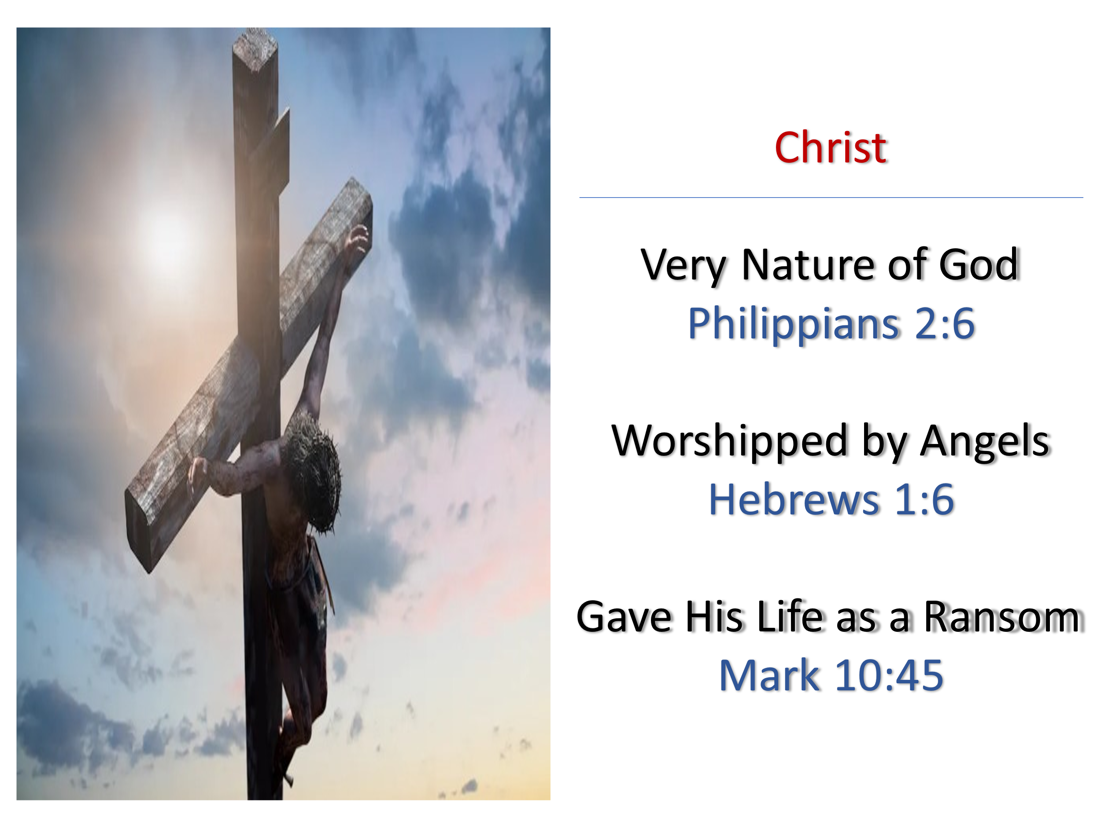
John’s words remind us of a humbling reality—we did not, and could not, love God first. The evidence is clear throughout Scripture: Ever since the Fall, humanity has been incapable of walking in perfect fellowship with God, even when placed in a paradise like Eden (Genesis 3:8). Our sinful nature separates us, leaving us spiritually broken and rebellious. As Paul declares:

"For all have sinned and fall short of the glory of God." (Romans 3:23)
"There is no one righteous, not even one." (Romans 3:10)

John urges the divided church to recognize a crucial truth: agape love is not defined by our flawed, conditional love, but by God's perfect, redemptive love for us. It is only at the cross—where the ultimate act of sacrificial love and reconciliation took place—that we can find true forgiveness, restoration, and the power to love as God loves. At the Master’s feet, we learn what true love looks like—and it is only from there that we can reflect that love to one another. Who in this church have you avoided because of past conflict? Who have you spoken about behind their back instead of praying for them? If love is what sets us apart as Christ’s followers, then what will people see in us?
If the church is to maintain unity within the bounds of peace, then nothing less than emulating Christ’s sacrificial love on the cross will suffice. Though Christ was in very nature God (Philippians 2:6) and worshiped by the angels (Hebrews 1:6), He voluntarily chose to live among us, taking on the form of a servant to give His life as a ransom for many (Mark 10:45). Though He could have rightfully called upon twelve legions of angels (Matthew 26:53) to execute divine justice, He instead chose to bear the punishment we deserved (Romans 6:23). In obedience to the Father’s will, Christ atoned for our sins not with power, but with suffering—allowing Himself to be born in a manger, rejected by His own, spat upon, beaten, and ultimately nailed to a cross by those He came to save. Even while we were enemies of God (Romans 5:10), He endured the cross so that those who believe in Him might be forgiven, reconciled to the Father, and receive eternal life (John 3:16).
It is at the foot of the cross that we learn what true agape love is. Church quarrels and conflicts arise when its members stop reflecting the love of the One who purchased them with His very life. Agape love within the church is not merely a well-intentioned desire to get along, but a love that, like Christ’s, puts aside self-interest for the sake of others (Philippians 2:3). If we have truly been crucified with Christ (Galatians 2:20), then our daily commitment must be to sacrifice what is most dear to us for the good of others. Since agape love originates in God alone, John reminds us that the only true evidence of our discipleship is living out the same sacrificial love Christ demonstrated on the cross (1 John 4:7-8). Doctrinal disputes, leadership power struggles, conflicts over worship styles, and the poison of gossip and bitterness—all of these can only be overcome when we value others above ourselves (Philippians 2:3). It is precisely in God’s presence, before His throne of grace, that we learn to extend to others the same unconditional love that we ourselves have received.
Agape love is not just something we talk about—it’s something we live. It means choosing forgiveness when we’ve been wronged, speaking truth with grace instead of gossip, serving without expecting recognition, and valuing people over personal preferences. It means praying for those who have hurt us, listening before judging, and working toward unity even when disagreements arise. This kind of love is radical, countercultural, and impossible without Christ—but it is the very love that makes us His disciples. So how will you live it out this week? Who in this church do you need to love differently starting today?

Conclusion

The unity of the church is not preserved by theological debates, leadership strategies, or personal preferences—it is preserved by love. Not just any love, but agape love—the love that Christ demonstrated on the cross. It is a love that chooses sacrifice over self-interest, forgiveness over bitterness, and humility over pride. It is a love that refuses to let division win. It is the love that proves to the world that we truly belong to Jesus.
So, let me ask you—where is love missing in your life? Who have you been avoiding because of past conflict? Who do you need to forgive? Who have you spoken about instead of praying for? Who have you placed below yourself instead of above yourself? If love is what sets us apart as Christ’s disciples, then what will people see in us?
We must decide today—will we continue allowing division to grow among us, or will we choose the radical love of Christ? Will we be known as people who seek to win arguments, or as people who seek to win hearts through grace? Will we let Satan use conflict to divide us, or will we follow Christ’s example and lay down our lives for one another?
The good news is that we are not called to do this alone. Romans 5:5 reminds us that ‘God’s love has been poured into our hearts through the Holy Spirit.’ The love we need has already been given to us! If we surrender to the Spirit, if we humble ourselves at the foot of the cross, then this love—God’s love—will flow through us. And when we love like Christ, division has no power over us.
Today, let us make a commitment—not just in our words, but in our actions. Let us be a church that does not just talk about love but lives it. Let us be a church where humility is greater than pride, where unity is stronger than division, and where Christ is glorified in the way we love one another. Because this is the love that unites the church. This is the love that conquers division. This is the love that reflects Christ to the world.

Mark Allen Powell, Introducing the New Testament: A Historical, Literary, and Theological Survey, pages 495-498.
Taken from Knowledge of the Holy by A. W. Tozer.
Taken from the following website: how many christian denominations in the world 2024 - Google Search
Got Questions Ministries, Got Questions? Bible Questions Answered (Bellingham, WA: Logos Bible Software, 2002–2013).
Got Questions Ministries, Got Questions? Bible Questions Answered (Bellingham, WA: Logos Bible Software, 2002–2013).
Thomas F. Johnson, 1, 2, and 3 John, Understanding the Bible Commentary Series (Grand Rapids, MI: Baker Books, 2011), 104.
Glenn W. Barker, “1 John,” in The Expositor’s Bible Commentary: Hebrews through Revelation, ed. Frank E. Gaebelein, vol. 12 (Grand Rapids, MI: Zondervan Publishing House, 1981), 343.
Thomas F. Johnson, 1, 2, and 3 John, Understanding the Bible Commentary Series (Grand Rapids, MI: Baker Books, 2011), 101.

