# **Love Must be Sincere**

**Romans 12:9-21**

Online Sermon: <http://www.mckeesfamily.com/?page_id=3567>

Is your love for God truly sincere? Do you genuinely love the Lord your God with all your heart, all your soul, and all your mind (Matthew 22:37)? That’s more than a question of religious practice—it’s a question of the heart. A question that cuts beneath surface behavior and into the core of our devotion. I'm not talking about a love that wears a mask—a shallow, performance-based kind of love that tries to earn God's favor in exchange for status, wealth, influence, or even health. Too often, we live out our faith like actors on a stage—switching masks depending on who’s watching. In ancient Greek theater, an actor would change roles simply by changing a mask.[1] Don’t we sometimes do the same? We put on the mask of joy. The mask of peace. The mask of kindness. Not because those fruits of the Spirit (Galatians 5:22–23) are truly growing from within, but because we know how they’re supposed to look. And in doing so, we can fool others—and sometimes even ourselves.

But God is not impressed by a performance. I'm not referring to the kind of love that only shows up when it's easy to serve God. Or the kind of love used to manipulate others, guilting them into submission or using spiritual authority as a tool to control. Jesus warned against that kind of leadership in Matthew 20:25–28:

“Not so with you.” In His Kingdom, love doesn’t lord over—it serves.

If our love for God is to be sincere, it must go deeper than transaction or emotion. True agape love is free from hypocrisy. It flows from a heart transformed by the majesty and mercy of God. It is rooted in pure motives.[2] It reflects the character of Christ. It's a love others can trust.

But here’s the truth: We can’t manufacture this kind of love on our own. It requires surrender—dying to self so that Christ may live through us (Galatians 2:20). As James reminds us in James 1:6, we must “believe and not doubt”—trusting that God’s way of living and loving is better than anything the world or our own hearts could ever design. In the end, it’s not others who will judge the sincerity of our love. It is Jesus Christ—the Judge of the living and the dead (2 Timothy 4:1), the One who knit us together in our mother’s womb (Psalm 139:13–14). He sees through every mask. And He knows every motive.

Before we can love sincerely, we must be willing to look inward—honestly, humbly—and ask the hard questions. So today, as we open God’s Word and explore Romans 12:9–21, let’s come with humble and vulnerable hearts. Like David, let us pray:

“Search me, O God, and know my heart; test me and know my anxious thoughts. See if there is any offensive way in me, and lead me in the way everlasting” (Psalm 139:23–24).

May we be honest before God. May we lay down our masks. And may we cry out for the Spirit to teach us how to love—for real.

# **Sincere Love is Hating Evil and Clinging to what is Good**

Romans 12:9 tells us that genuine love not only hates what is evil but actively clings to what is good. Love that is sincere is not passive—it takes a stand. We cannot truly love God while tolerating what He hates. But for our love to be truly authentic and honoring to the One we worship, it cannot be shaped by the shifting morals of the world. Instead, it must be defined by God Himself. True love is not dictated by our emotions, feelings, or human intellect—which, apart from God, is mere foolishness in His sight (1 Corinthians 1:25). If we long to one day hear the words "Well done, good and faithful servant" (Matthew 25:21) from the One who purchased us at the price of His own life (1 Corinthians 6:19-20), then we must submit to His definition of righteousness.

Instead of embracing the world’s values—which ultimately make us enemies of God—we are called to have a deep, holy hatred of all evil.[3] God doesn’t leave us guessing about what is evil in His sight. Proverbs 6:16-19 gives us seven things the Lord hates:

Haughty eyes (prideful arrogance),

A lying tongue,

Hands that shed innocent blood,

A heart that devises wicked schemes,

Feet that rush into evil,

A false witness who pours out lies,

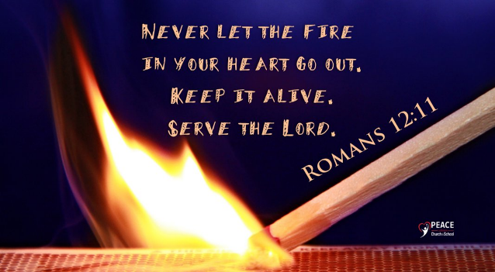A person who stirs up dissension among brothers.

Yet, the Christian life is not only about rejecting evil—it is about clinging to what is good. We are called to put on the character of Christ (Colossians 3:12-14), cultivating compassion, kindness, humility, gentleness, and patience. This transformation happens as we meditate on His Word (Psalm 1:2) and allow the Potter to shape us—fragile jars of clay (2 Corinthians 4:7)—into vessels of His light. Rather than being shaped by the world, we are called to be beacons of hope—illuminating the darkness and pointing others to the Father, our eternal portion (Matthew 5:14-16). This is the evidence of a love that is not just claimed, but truly sincere.

# **Sincere Love is Preserving with Patience**

If Christians are to abhor evil and cling to what is good, then, as Paul instructs, we must never be lacking in zeal but keep our spiritual fervor, serving the Lord (Romans 12:11). Though we have been sent out like sheep among wolves in a world that is decaying and hostile, where trials pour down like a relentless storm, we must stand firm upon the Rock of our salvation—rooted in hope, patience, and prayer. Yes, outwardly we may be wasting away (2 Corinthians 4:16-18), and we will surely face trials of many kinds (James 1:2-4). But we do not endure alone. We are surrounded by a great cloud of witnesses who have gone before us (Hebrews 12:1), and we can look back on our own stories of deliverance—proof that our Good Shepherd never leaves nor forsakes His own (Hebrews 13:5). He is always at work, orchestrating all things for the good of those who love Him (Romans 8:28).

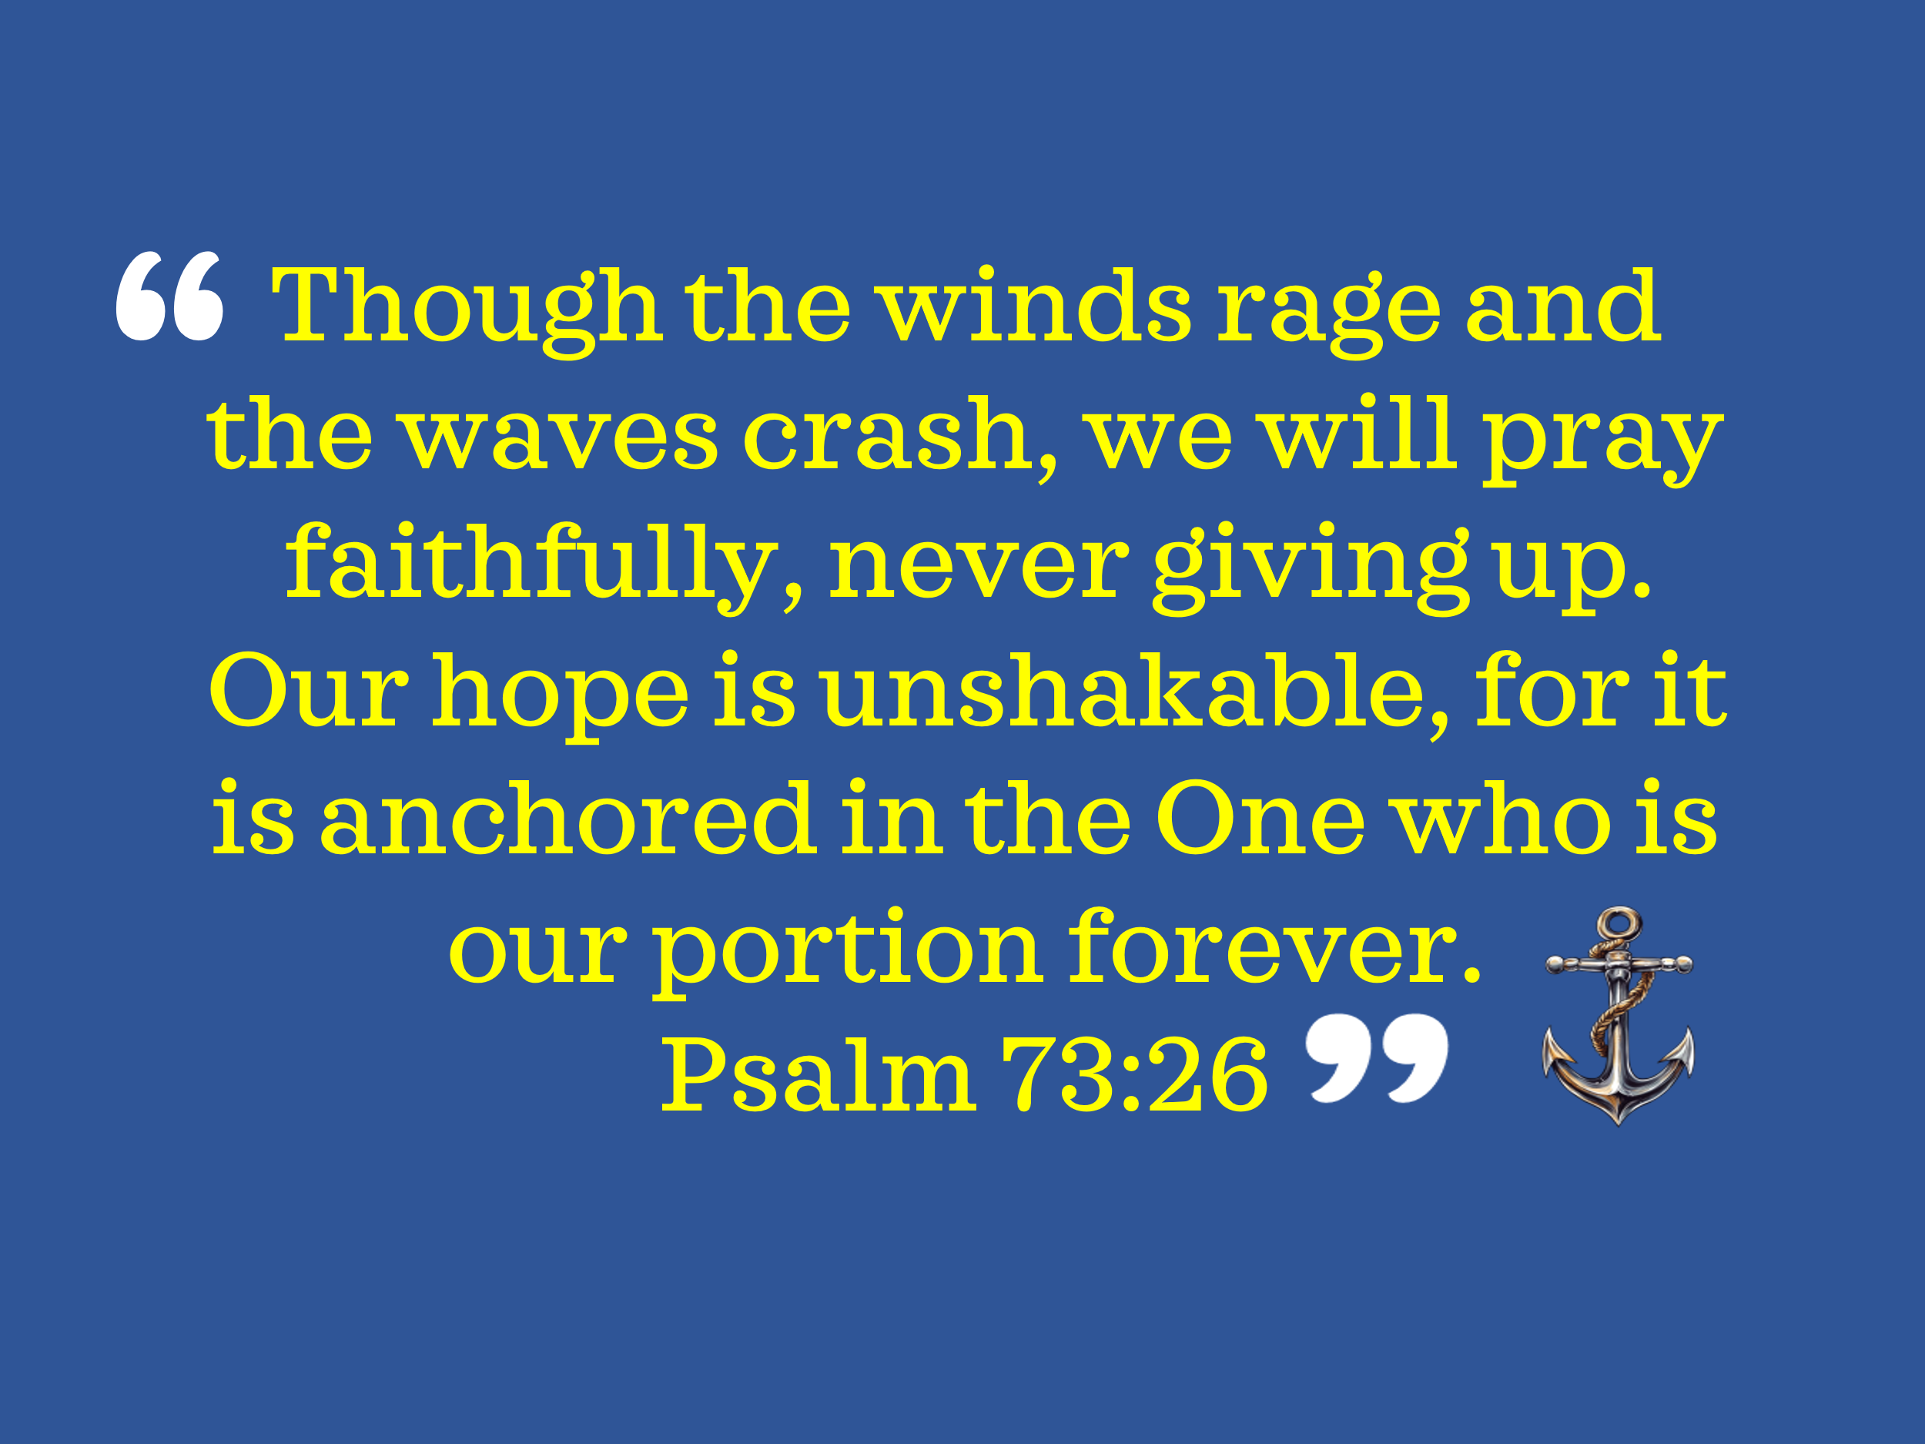If our love for God is genuine, we will be patient in affliction, pressing forward with eyes fixed on Jesus, the pioneer and perfecter of our faith. We will endure with the confidence that perseverance in faith leads to a deeper intimacy with Christ and spiritual maturity. So, though the winds rage and the waves crash, we will pray faithfully, never giving up. Our hope is unshakable, for it is anchored in the One who is our portion forever (Psalm 73:26). And in Him, we find a wellspring of unspeakable joy—a joy that is eternal, overflowing, and far beyond what we could ever ask or imagine.

# **Sincere Love is Other People Focused**

Perseverance is not just about enduring for ourselves—it is about staying strong for others. Sincere love doesn’t just hold on through trials; it reaches out to lift others up. But sincere love does not stop at perseverance—it moves outward. True love is not self-focused; it prioritizes others. Romans 12:10, 12, and 13 call us to be devoted to one another, share in each other’s burdens, and extend generosity to those in need. Yet, we live in a world where self-gratification has become a god—where people chase personal gain while coveting the sinful desires of their hearts (James 4:1-3). But wisdom teaches a different path:

“When we are foolish, we want to conquer the world; when we are wise, we want to conquer self.”[4]

If Christ is to reign sovereignly over our hearts, then self must die. As Galatians 2:20 reminds us:

“I have been crucified with Christ and I no longer live, but Christ lives in me.”

This means valuing and placing the interests of others above our own (Philippians 2:3-4).

There are many in this world who have little to rejoice about—those who face poverty, oppression, and daily injustices. As recipients of God’s unconditional love, we are called to share out of our abundance so that:

"The one who gathered much did not have too much, and the one who gathered little did not have too little" (2 Corinthians 8:13-15).

And when we give, we are to do so as if we were giving to Christ Himself:

“For I was hungry and you gave me something to eat, I was thirsty and you gave me something to drink, I was a stranger and you invited me in” (Matthew 25:35-36).

This is sincere love in action—a love that does not seek self, but seeks Christ, by pouring itself out for the sake of others. No greater love exists than this: that Christ laid down His life for His friends (John 15:13). His love was sincere, sacrificial, and pure. Now He calls us to follow in His steps—not only in loving those who love us, but even in loving our enemies. If we long to love sincerely, we must begin at the cross—where Jesus demonstrated perfect love by laying down His life for us. Have you surrendered to that love? Have you given Him your heart without pretense? Today is the day to take off the mask and follow Him fully. No greater love exists than this: that Christ laid down His life for His friends (John 15:13). His love was sincere, sacrificial, and pure. Now He calls us to follow in His steps.

# **Sincere Love is Participating in Other People’s Lives**

Loving sincerely goes beyond giving—it means truly being present. Romans 12:15-16 calls us to walk alongside others, sharing in both their celebrations and their burdens, uniting in humility and love. As James Edwards rightly states:

“This world is not utopia, whether of a classless society or limitless prosperity. Like everyone else, Christians live in a world twisted by disparities between ideals and double standards, success and failure, friend and foe, life and death.”[5]

The evidence of this brokenness is everywhere—in suffering, injustice, and spiritual decay. But just because pain and sin are abundant does not mean we are excused from compassion. A hardened heart is not a righteous heart. Even as we experience mountaintops of spiritual blessing in Christ, we must never look down on those who remain lost in sin or struggle under the weight of this fallen world.

“Self-conceit is evidence of weakness of mind and of ignorance”[6] —for true wisdom understands that we were called out of darkness only by the grace of God. As 1 Peter 2:9 reminds us:

“He called you out of darkness into His wonderful light.”

Therefore, let us not be envious of the success of others, but rejoice with them, recognizing that God, in His sovereignty, causes the rain to fall on both the righteous and the unrighteous (Matthew 5:45). And as we seek to renew our minds daily, may we ask the Lord to open our eyes—to see His image in both the fallen and the successful, in the downtrodden and the celebrated, in those who have come to faith and in those who are still lost. This is what it means to love sincerely—to see people as God sees them and to walk with them in grace, humility, and love. For in loving others well, we reflect the heart of Christ, who first loved us.

# **Sincere Love Promotes Peace**

Yet, sincere love is not only seen in acts of generosity—it is also revealed in how we respond to injustice. When we are persecuted for righteousness’ sake (Matthew 5:10), we do not seek revenge or harbor bitterness. Instead, we entrust justice to God, leaving room for His perfect righteousness (Romans 12:19-21) and extending mercy, compassion, and grace even to those who wrong us. For Jesus calls us to something greater:

“Love your enemies and pray for those who persecute you, that you may be children of your Father in heaven.” — Matthew 5:43-48

As James Edwards rightly states:

“God is not complacent in the face of evil, but His just wrath is of a wholly different character from human vengeance, which often and easily is fueled by self-interest, excess, and vindictiveness.”[7]

God's justice is holy, pure, and untainted by sinful motives, whereas human anger often leads to unrighteousness. This is why James 1:20 warns us:

“Human anger does not produce the righteousness that God desires.”

Instead of responding with hostility, Christians are called to live at peace with everyone whenever possible (Romans 12:18). But we are not merely peacekeepers—we are called to be peacemakers,[8] actively working to reflect God’s love even in the face of wrongdoing. We overcome evil not by retaliating, but by responding with kindness. As Paul instructs, when our enemy is hungry, we must feed them; when they are thirsty, we must give them something to drink. In doing so, we heap burning coals on their heads—not as an act of vengeance, but as a conviction of shame that may lead them to repentance and a desire to understand why we have responded with good instead of evil (Romans 12:20-21). The world expects hatred to be met with hatred—but the love of Christ confounds expectations. May we, as His followers, reflect that love—turning the other cheek, forgiving as we have been forgiven, and choosing the path of grace over retaliation.

# **Conclusion**

We have explored what it means to love sincerely—to hate what is evil and cling to what is good, to persevere with patience, to place others above ourselves, to participate in the lives of others, and to respond to injustice with Christlike grace. But in the end, sincere love is not something we manufacture—it is something we receive and reflect. It starts at the cross. Jesus Christ demonstrated the ultimate act of sincere love when He laid down His life for us.

“Greater love has no one than this: to lay down one’s life for one’s friends.” - John 15:13

This love was not self-serving. It was not given for recognition, reward, or convenience. It was a love that bore our sins, endured the weight of our shame, and was poured out in blood and agony—so that we might be saved.

And now, He calls us to love as He loved.

* To take off the mask and love with sincerity.
* To hate sin, pursue righteousness, and cling to God’s truth.
* To be patient in affliction, persistent in prayer, and unshakable in hope.
* To serve others, rejoice with the joyful, and weep with the broken.
* To forgive, bless, and even love our enemies.

This is the love that marks us as followers of Jesus. This is the love that reveals Him to a watching world.

So, the question remains:

👉 Is your love for God truly sincere?

👉 Do you love Him with all your heart, soul, and mind?

👉 Do you love others as Christ loved you—sacrificially, sincerely, and without condition?

Has your love been shallow—more about appearances than authenticity, more about comfort than sacrifice? If so, today is the day to surrender. Take off the mask. Lay down your pride. Run to the cross and let God transform your heart—so that you may love as Christ first loved you. Because in the end, it won’t be our words, our appearance, or even our works that matter most—but whether we truly loved as Christ has loved us.

1. James R. Edwards, [*Romans*](https://ref.ly/logosres/nibcnt66ro?ref=Bible.Ro12.9&off=676&ctx=isy%E2%80%9D+or+%E2%80%9Cunstaged.%E2%80%9D+~In+Greek+drama+a+sin), Understanding the Bible Commentary Series (Grand Rapids, MI: Baker Books, 2011), 291–292.
2. Tremper Longman III, Peter Enns, and Mark Strauss, eds., [*The Baker Illustrated Bible Dictionary*](https://ref.ly/logosres/bakerillbbldctnry?ref=Page.p+1549&off=176&ctx=SINCERITY+~The+quality+of+being+free+from) (Grand Rapids, MI: Baker Books, 2013), 1549.
3. Leon Morris, [*The Epistle to the Romans*](https://ref.ly/logosres/pntcrom?ref=Bible.Ro12.9&off=2121&ctx=ression+is+general.+~He+is+saying+that+th), The Pillar New Testament Commentary (Grand Rapids, MI; Leicester, England: W.B. Eerdmans; Inter-Varsity Press, 1988), 444.
4. Galaxie Software, [*10,000 Sermon Illustrations*](https://ref.ly/logosres/gs-illus?art=div3473&off=658&ctx=exander+MacLaren%0a%E2%80%A2++~When+we+are+foolish%2c) (Biblical Studies Press, 2002).
5. James R. Edwards, [*Romans*](https://ref.ly/logosres/nibcnt66ro?ref=Bible.Ro12.14-16&off=11&ctx=ent+day.%0a12%3a14%E2%80%9316+%2f+~This+world+is+not+ut), Understanding the Bible Commentary Series (Grand Rapids, MI: Baker Books, 2011), 296.
6. Leon Morris, [*The Epistle to the Romans*](https://ref.ly/logosres/pntcrom?ref=Bible.Ro12.16&off=1607&ctx=njoins+the+readers%2c+~Do+not+be+conceited%2c), The Pillar New Testament Commentary (Grand Rapids, MI; Leicester, England: W.B. Eerdmans; Inter-Varsity Press, 1988), 451.
7. James R. Edwards, [*Romans*](https://ref.ly/logosres/nibcnt66ro?ref=Bible.Ro12.17-21&off=1688&ctx=gible+caution+here.%0a~God+is+not+complacen), Understanding the Bible Commentary Series (Grand Rapids, MI: Baker Books, 2011), 298.
8. James R. Edwards, [*Romans*](https://ref.ly/logosres/nibcnt66ro?ref=Bible.Ro12.17-21&off=963&ctx=bout+peace+(v.+18).+~Christians+are+comma), Understanding the Bible Commentary Series (Grand Rapids, MI: Baker Books, 2011), 298.