Finding Joy in Every Season

  - Philippians 4:10-13; Job 1:20-21; Psalms 103:2-5
  - Online Sermon: http://www.mckeesfamily.com/?page_id=3567

Is it truly possible for God’s people to experience unspeakable joy at all times? Even though we have been “called out of darkness into His wonderful light” (1 Peter 2:9), can we, as sheep sent among wolves (Matthew 10:16), truly find peace and joy in a world that exalts the god of “self,” where people often prioritize their own desires above all else?

Are not the quarrels and conflicts of this world caused by the evil desires that rage within, as people covet, fight, and strive to take what is not theirs (James 4:1-3)? Does the Good Shepherd truly expect us to endure the world’s injustice with a heart of thanksgiving and unwavering joy? How can a victim of human trafficking feel joy in the midst of unspeakable suffering? How can those in extreme poverty rejoice when a mere 1% of the population controls more wealth than they could ever spend? Is it truly possible to have peace and joy while facing persecution simply for worshiping the one true God? And for those who have been displaced by war—forced to flee from homes they did not ask to leave—how could they feel anything but anger and resentment instead of joy?
While our struggles may look different, don’t we all face trials that weigh just as heavily on our hearts? The Apostle Paul teaches that we are to be content in all situations, but how can one truly feel joy while being battered by the whirlwinds of suffering in this decaying world (Romans 8:20-21)?
Can joy be found in a marriage filled with conflict?
Can joy exist when you are overlooked, mistreated, or discriminated against in your workplace simply because you refuse to conform to the world’s ways?

Can joy remain when the stock market crashes, taking with it a significant portion of your retirement savings, leaving you anxious and uncertain?
Is it possible to experience joy even when diagnosed with a debilitating, life-threatening disease like cancer?
The world would say, "No! Joy is circumstantial!" But today’s sermon will explore why God’s Word says otherwise.
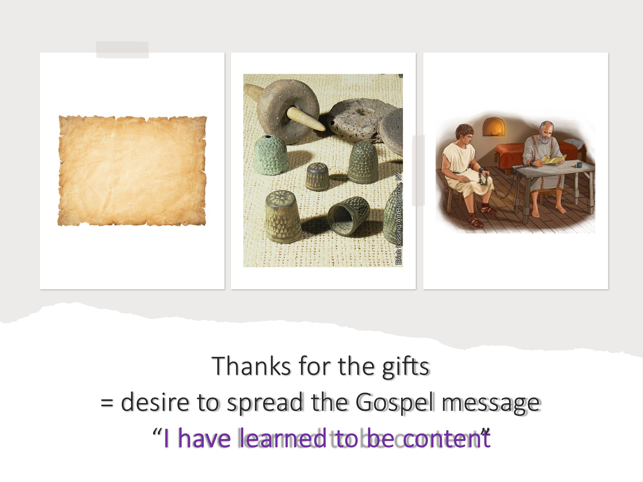
Through the testimonies of the Apostle Paul—who was flogged, shipwrecked, and constantly in danger—and Job—who lost everything, yet still worshiped God—we will uncover how joy is not dependent on circumstances, but rather anchored in something far greater: our eternal blessings in Christ.
As we journey through Scripture today, I invite you to open your heart and allow God to shift your perspective. Joy is not found in our circumstances but in our unshakable hope in Christ. Let Him teach you how to fix your eyes on His eternal promises, so that no storm—no matter how fierce—can steal your joy!

Contentment Through Christ

If anyone had reason to let suffering steal his joy, it was Apostle Paul—imprisoned, beaten, and constantly in danger. Yet, rather than succumbing to despair, he writes with a heart overflowing with gratitude and contentment. Nowhere is this more evident than in his letter to the Philippians, where, despite his chains, he thanks them for their generous gift and testifies to a joy that transcends circumstances. Paul, who likely possessed nothing more than the clothes on his back, a few tools of his trade, and the papyrus and parchment scrolls he mentions in 2 Timothy 4:13, did not rejoice because he sought further provisions. Rather, his joy sprang from seeing their gift as evidence of their eagerness to partner with him in spreading the gospel, bearing fruit, and bringing glory to God. He assured them, “I have learned to be content whatever the circumstances” (Philippians 4:11). But what was Paul’s secret? How could he rejoice despite imprisonment, stoning, lashings, and constant threats from bandits, Jews, and Gentiles alike? What allowed him to remain steadfast in the face of such suffering?
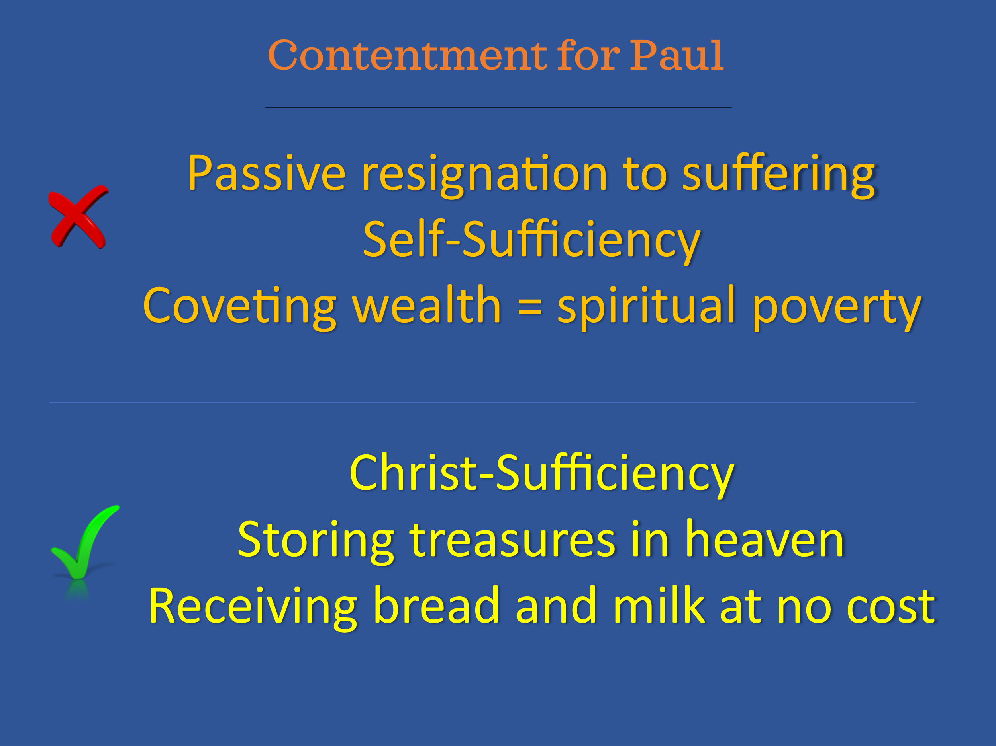

Paul’s struggles may seem distant from ours, but his message remains timeless. Whether we are burdened by financial instability, sickness, or injustice, the question we must answer is the same: Is our joy dependent on changing circumstances, or on the unchanging Christ? Paul gives us the answer: true contentment is found only in Christ, who gives us strength (Philippians 4:13). Charles Spurgeon rightly observed, “Contentment in all states is not a natural propensity of man. Ill weeds grow apace; covetousness, discontent, and murmuring, are as natural to man as thorns are to the soil.” Contentment, for Paul, was not passive resignation to suffering but an active trust in God’s provision, freeing him from the burden of coveting material things—a burden that reveals spiritual poverty rather than prosperity. Paul’s contentment was not about self-sufficiency but Christ-sufficiency. He acknowledged that it took time to reject the pull of worldly desires, learning instead to set his heart on treasures that could not be lost or stolen. Paul found no satisfaction in possessions. Instead, he came before the Lord, thirsty, and received the spiritual food freely given (Isaiah 55:1-2). Though he knew that his body would eventually fail (Psalm 73:26), he fixed his gaze heavenward (Colossians 3:1-2), finding not just contentment but unspeakable joy, for Christ was his portion forever.
Paul’s strength was not from sheer grit or human resilience. No one could endure five lashings, three beatings with rods, and multiple shipwrecks on their own. His strength came from something greater—Christ alone. Contentment flourishes not in the barren soil of self-reliance but in the rich, fertile ground of faith in the One who created and sustains all things (Colossians 1:16). It was this unwavering faith that allowed Paul to experience peace in the fiercest storms, knowing that “when I am weak, then I am strong” (2 Corinthians 12:10). His contentment was not built on the shifting sands of culture or the empty promises of deceitful men, but on his relationship with the Lord, who promised to be his rock and refuge in times of trouble (Psalm 18:2). Even as he walked through the valley of the shadow of death, Paul, like the Psalmist, feared no evil—for his greatest treasure, his deepest joy, and his heart’s desire could never be taken from him. Will you choose contentment in Christ, knowing He is your portion forever? Or will you continue searching for joy in what will inevitably fail you? The choice is ours—but only one path leads to true peace.

Worship in Woes

If we are to keep our tribulations from shaking our trust in Christ—the One who gives us strength and unspeakable joy—then, like Job, we must embrace this truth: God owes us nothing, yet in His grace, He gives us everything!
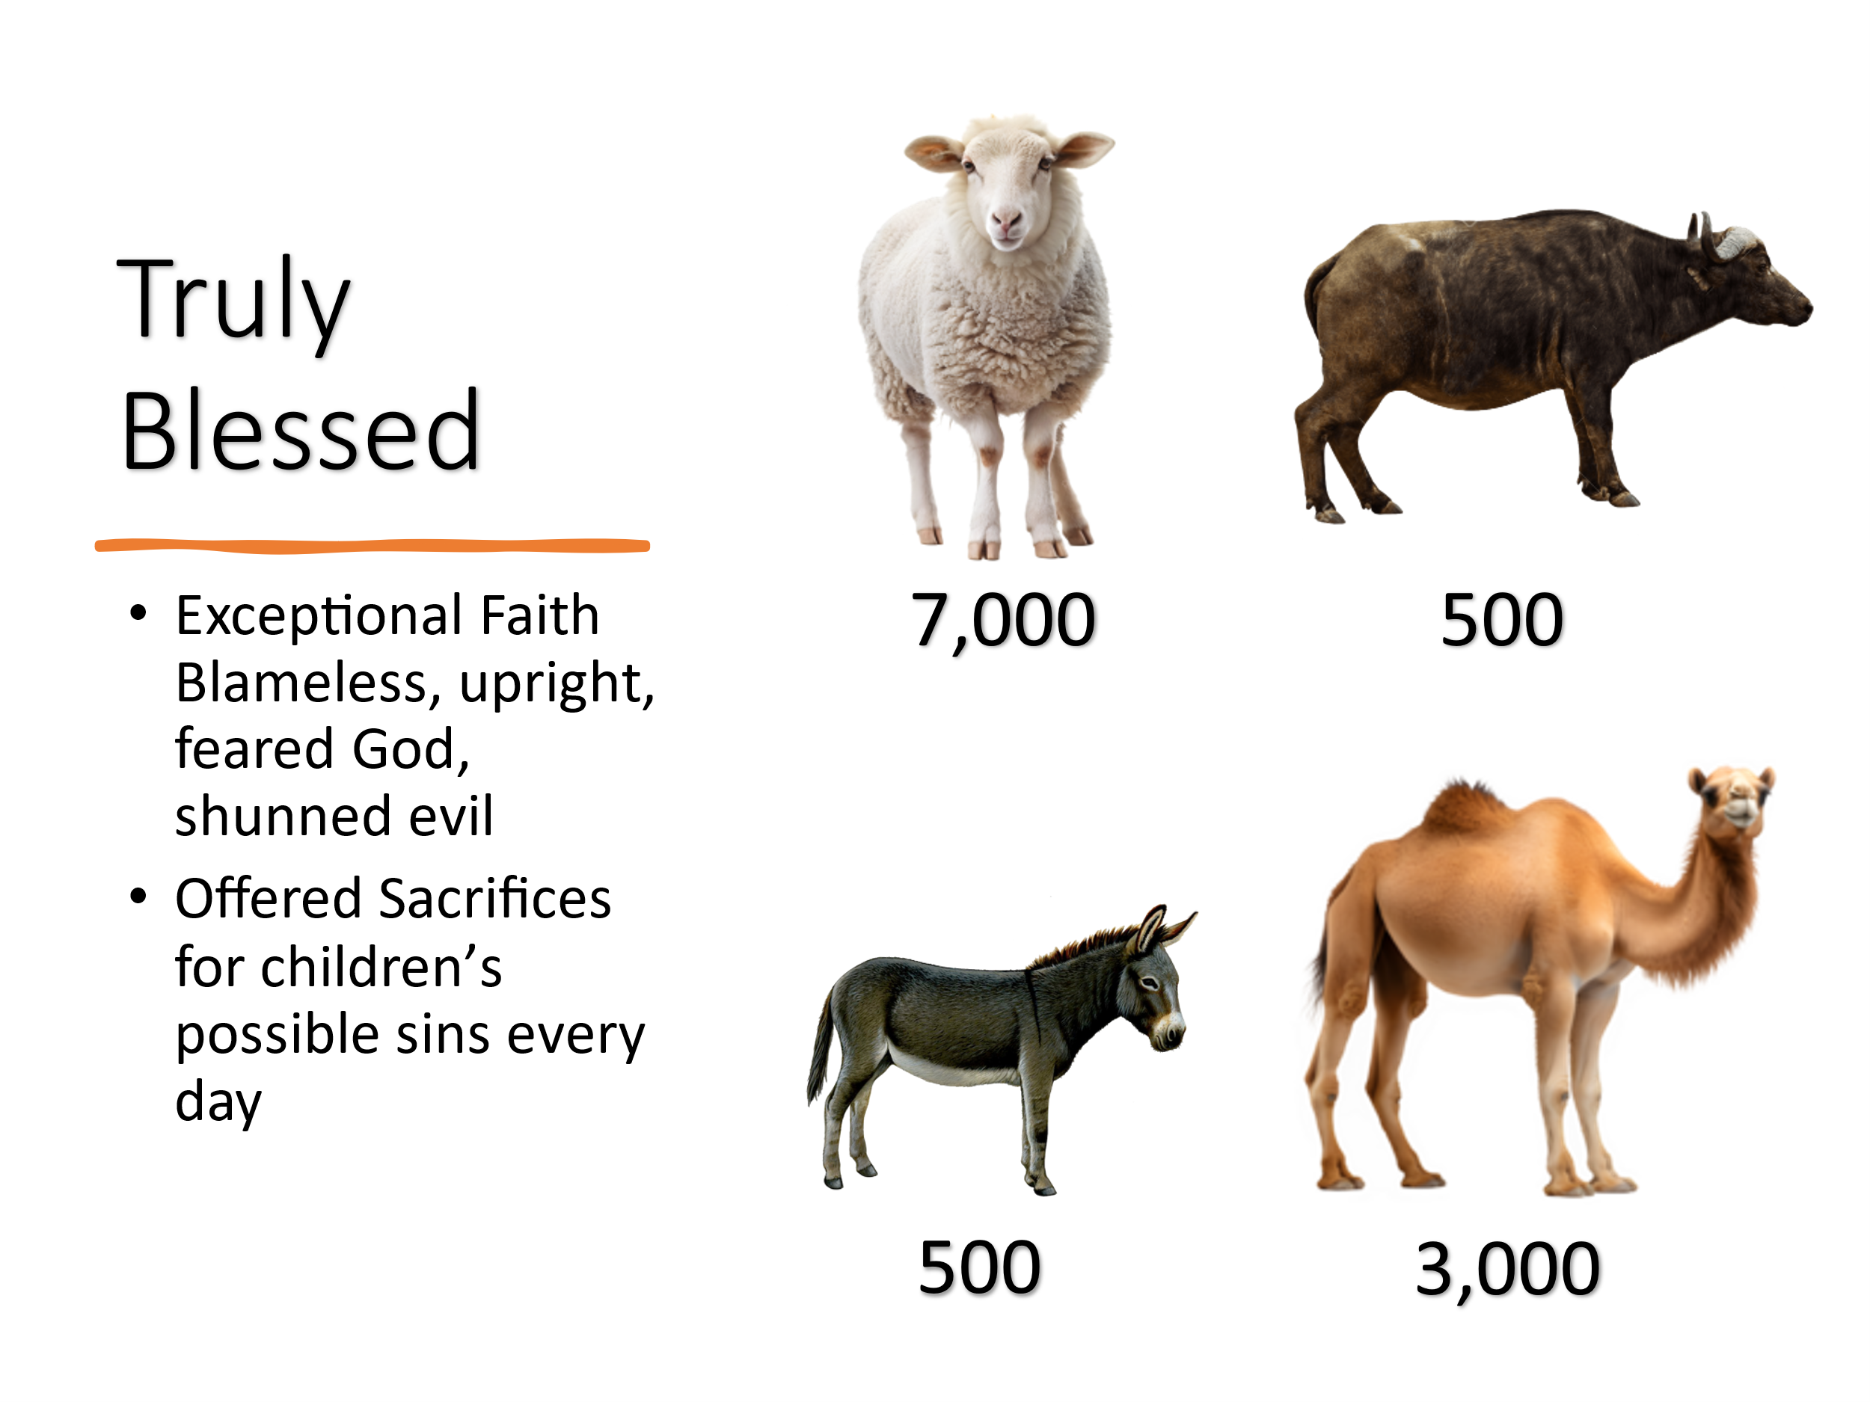
Paul was not the first to experience such trust in God. Long before him, another righteous man was tested beyond imagination—Job. His story teaches us the same lesson: contentment is not found in what we possess but in who we trust. To understand this, let’s summarize Job’s calamities. He is introduced as a man of exceptional faith—blameless, upright, one who feared God and shunned evil (Job 1:1). He was richly blessed, possessing seven sons, three daughters, and vast wealth—7,000 sheep, 3,000 camels, 500 yoke of oxen, 500 donkeys, and a great number of servants (Job 1:2-3). More than his material blessings, he was a man of deep spiritual conviction. Each morning, Job would offer burnt sacrifices for each of his children, fearing that they may have sinned in their hearts (Job 1:5).
Then came the test. One day, as the angels stood before the Lord, Satan appeared among them (Job 1:6). The Lord pointed out Job’s righteousness, but Satan dismissed it, claiming that Job only served God because of His divine protection and blessings (Job 1:9-10). To prove Job’s sincerity, God allowed Satan to strip Job of everything—except his life. The assaults came swiftly.

The Sabeans raided his property and stole his donkeys and oxen (Job 1:15).
Fire fell from heaven, consuming his sheep and servants (Job 1:16).
The Chaldeans formed raiding parties and took his camels (Job 1:17).
And in the ultimate blow, a mighty wind collapsed the house where his children were feasting, killing all ten of them in an instant (Job 1:19).
Yet, instead of cursing God or blaming his enemies, Job fell to the ground in worship and declared:
“Naked I came from my mother’s womb, and naked I shall depart. The Lord gave, and the Lord has taken away; blessed be the name of the Lord.” (Job 1:21)
Here, Job demonstrates the very secret Paul spoke of—contentment is not found in what we possess, but in who we trust. The heart of contentment is our attitude toward God’s sovereignty. Is God in control, or are we?


Satan had misjudged Job’s faith, assuming that his devotion was tied to his wealth and comfort. But Job’s love for God was never transactional. He did not serve God because he expected prosperity—he served God because he trusted His character. Job distinguished between what was eternal and what was temporary. Unlike those who worship the god of self—treating faith as a means to wealth and comfort—Job saw his relationship with God as far more valuable than any material blessing. In his deepest sorrow, Job did not claim rights or privileges. He understood a fundamental truth: God owes us nothing but, in His mercy, gives us everything.
“The earth is the Lord’s, and everything in it, the world, and all who live in it" (Psalm 24:1).
Everything we have belongs to God—our possessions, our health, our very lives. We are merely stewards of what He has entrusted to us. Whatever we possess came from Him and He alone has the right to give or take away.
This was the foundation of Job’s contentment. Even in unimaginable loss, he looked heavenward and recognized that God’s grace and mercy were still at work. His portion was not in his wealth, not in his children, not even in his own health—but in God alone. No Sabean raider, no Chaldean thief, no natural disaster, and not even Satan himself could take away the eternal riches Job had stored in heaven. When trials come, will we, like Job, trust in the sovereignty of God, or will we let suffering shake our faith?

Gratitude in Grace

From both Paul and Job, we learn that the secret to true contentment and unspeakable joy in all circumstances lies in knowing and being thankful for the eternal blessings we have received. Every gift from our Father in heaven is unmerited, yet it is priceless and everlasting!
Is there any earthly treasure that compares to the forgiveness of our sins, the healing of our souls, the redemption from destruction, or the crown of love and compassion placed upon us by God Himself? (Psalm 103:3-4). Both Paul and Job fixed their eyes heavenward because they understood that their greatest treasure was not found in material possessions but in their relationship with God. They rejoiced—not because of what they had or what they lost, but because the Almighty had sought them, even when they were once enemies of God, enslaved to the ways of this world. Even in the darkest storms, their hearts leapt for joy, knowing that their Creator had predestined them for salvation, calling them to be His own, adopting them as children of the Most-High (Ephesians 1:4-5).
Like the Psalmist, we must train our souls to remember: “Praise the Lord, my soul; all my inmost being, praise His holy name” (Psalm 103:1). Let us daily ask the Lord to renew our strength like the eagle’s (Psalm 103:5), reminding ourselves of the eternal riches we have in Christ. May we never cease to praise God continually, for our greatest blessing is not in what He gives—but in who He is. Our relationship with Him is built not on our own merit, but on His unfailing grace, love, and mercy. Let us worship our Lord, Savior, and King with hearts overflowing with gratitude!
If Paul could rejoice in chains and Job could worship in ashes, how will you respond when trials come? Will you focus on what has been taken from you, or will you fix your eyes on the eternal riches that can never be lost? True joy is not the absence of trials, but the presence of Christ. It is not found in a comfortable life, but in knowing the God who holds all things in His hands. Let us lift our voices in praise, not because life is easy, but because our Redeemer lives and our eternity is secure in Him.

Conclusion

We have seen through Paul and Job that joy is not found in comfort, security, or circumstances—but in Christ alone. Paul rejoiced in chains, and Job worshiped in ashes. Their contentment was not in what they possessed but in who possessed them—the Lord Almighty.
This same God who strengthened Paul and sustained Job is the same God who walks with us today. He is the rock that cannot be shaken, the portion that never fails, and the joy that no storm can steal. So, when trials come—and they will—how will you respond? Will you cling to the fleeting treasures of this world, or will you trust in the eternal riches of Christ? Will you let suffering define you, or will you let your faith refine you? Will you focus on what has been taken from you, or will you fix your eyes on the God who gave everything for you?
True joy is not the absence of trials, but the presence of Christ. It is not found in a pain-free life, but in knowing the One who holds all things in His hands. No matter what you are facing today—whether heartbreak, loss, or uncertainty—your joy does not have to waver. Because your joy is anchored in the unshakable love of Christ, your Savior, Redeemer, and King! So today, let us make the choice to rejoice—not because life is easy, but because our Redeemer lives!

F. F. Bruce, Philippians, Understanding the Bible Commentary Series (Peabody, MA: Baker Books, 2011), 149.
F. F. Bruce, Philippians, Understanding the Bible Commentary Series (Peabody, MA: Baker Books, 2011), 148.
Tony Merida and Francis Chan, Exalting Jesus in Philippians, ed. David Platt, Daniel L. Akin, and Tony Merida, Christ-Centered Exposition Commentary (Nashville, TN: Holman Reference, 2016), 186–187.
C. H. Spurgeon and Terence Peter Crosby, 365 Days with Spurgeon (Volume 1) (Leominster, UK: Day One Publications, 1998), 197.
J. C. Connell, “Contentment,” in New Bible Dictionary, ed. D. R. W. Wood et al. (Leicester, England; Downers Grove, IL: InterVarsity Press, 1996), 222.
Alan Carr, “Discovering Spiritual Contentment (Psalm 32:1–11),” in The Sermon Notebook: Old Testament (Lenoir, NC: Alan Carr, 2015), 1528.
Tony Merida and Francis Chan, Exalting Jesus in Philippians, ed. David Platt, Daniel L. Akin, and Tony Merida, Christ-Centered Exposition Commentary (Nashville, TN: Holman Reference, 2016), 187.
David L. Allen, Exalting Jesus in Job, ed. David Platt, Daniel L. Akin, and Tony Merida, Christ-Centered Exposition Commentary (Nashville, TN: Holman Reference, 2022), 39.
David L. Allen, Exalting Jesus in Job, ed. David Platt, Daniel L. Akin, and Tony Merida, Christ-Centered Exposition Commentary (Nashville, TN: Holman Reference, 2022), 39.

