Putting on Christ’s Clothes

  - Colossians 3:12-17
  - Online Sermon: http://www.mckeesfamily.com/?page_id=3567


Can you remember the moment your life changed forever? The moment Christ stepped into your heart and everything was made new? That life-changing moment when God’s grace swept over you, bringing a transformation so profound that words could hardly capture it? How does one describe the experience of receiving a brand-new heart and spirit, as promised in Ezekiel 36:26-27? In that instant, the self—the god we once worshiped—was crucified with Christ. Like Apostle Paul, we can now declare with joy, "It is no longer I who live, but Christ who lives in me" (Galatians 2:20). With deep humility and gratitude, we recognize that salvation was not something we earned through our own righteousness, which is like filthy rags before God (Isaiah 64:6). Instead, we were saved "by His mercy, through the washing of regeneration and renewal by the Holy Spirit" (Titus 3:5). In that moment, we were not just forgiven—we were adopted into God’s family as His children and heirs (John 1:12-13). Who could ever forget such a day?
But salvation didn’t just change our identity—it changed our relationship with sin. Sin lost its mastery over us! Do you remember your baptism? Paul writes in Romans 6:4-6:

"We were therefore buried with Him through baptism into death in order that, just as Christ was raised from the dead by the glory of the Father, we too may live a new life."
Baptism itself does not save us, but it is a powerful symbol of the transformation brought by the Holy Spirit. Once, sin entangled and enslaved us. But in that moment, Christ broke its dominion over us. What the law was powerless to do because of our sinful nature (Romans 8:3), Christ accomplished on our behalf. In baptism, we are united with Christ in His death—so that we die to sin—and in His resurrection, so that we walk in newness of life, filled with His holiness and righteousness. This doesn’t mean that we become incapable of sin after salvation, but it does mean that we are no longer bound by it. Through the Holy Spirit, we now have the power to say NO to sin and YES to holy living.
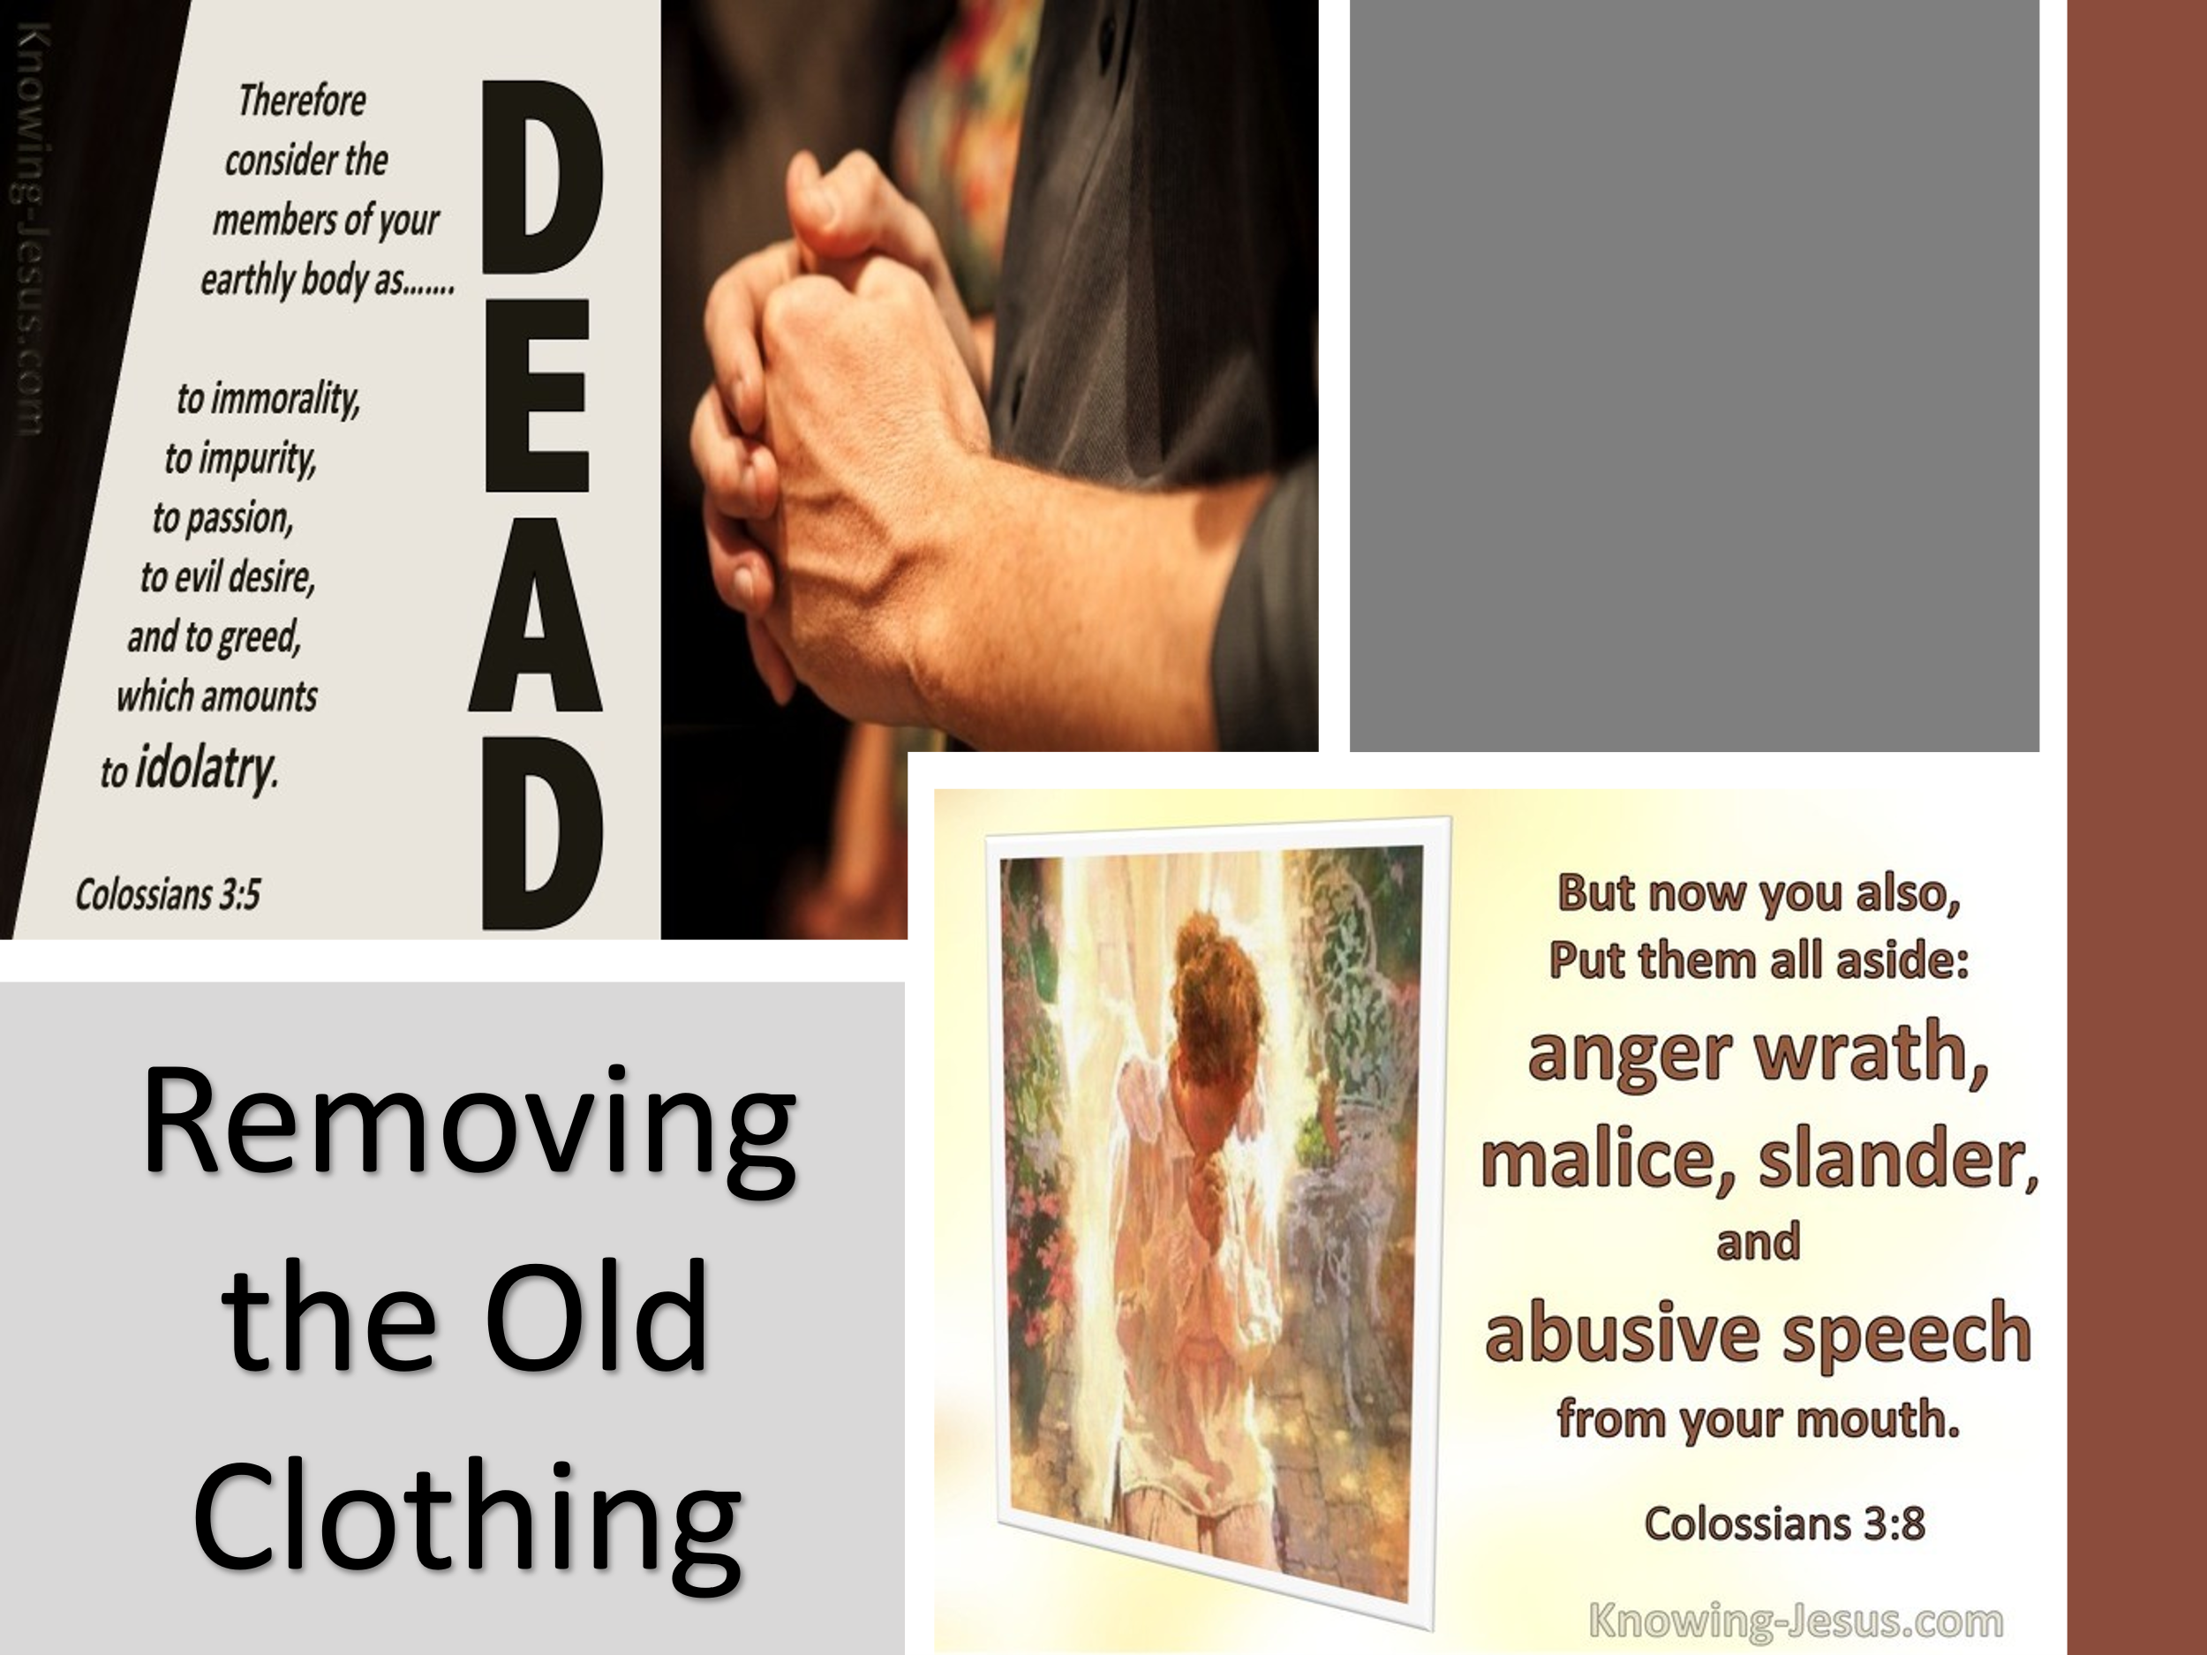
As God’s chosen people, called "out of darkness into His wonderful light" (1 Peter 2:9), we are urged to fix our hearts "on things above, where Christ is, seated at the right hand of God" (Colossians 3:1). This means we must put to death the remnants of our earthly nature—“sexual immorality, impurity, lust, evil desires, and greed, which is idolatry” (Colossians 3:5). We once walked in these ways—anger, rage, malice, slander, and filthy language (Colossians 3:8)—but now, as God’s redeemed masterpieces, salvation is not just a one-time transformation. It is an ongoing, glorious invitation to sit at the feet of the Master, allowing the Potter to continually shape us into His righteousness and holiness. But how do we live this new life daily? How do we practically walk in holiness?

Today's Focus: Clothing Ourselves with Christ
In today’s message, we will dive into how to clothe ourselves with the characteristics of Christ—compassion, kindness, humility, gentleness, and patience. These virtues are not just personal attributes but essential for protecting unity within the body of Christ and living as those who have been made alive in Him. Let us press forward, not merely as those who have been saved, but as those who daily surrender to the Master’s refining work—so that Christ may be seen in us, and through us, for His glory.

Committing to Christ-like Character

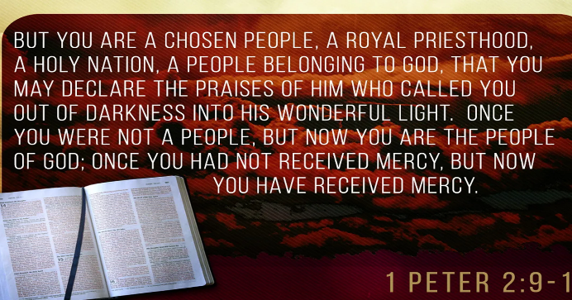
Now that we have been born again of water and the Spirit, we are no longer who we once were—we are new creations, shaped, sustained, and sanctified by Christ Himself. This transformation is not merely personal; it marks our entrance into something far greater—a holy community, the people of God. As His chosen, holy, and dearly loved (Colossians 3:12), we are set apart, not because of anything we have done, but by His sovereign grace. Just as God chose Israel, so He has chosen us: “Out of all the peoples on the face of the earth, to be His treasured possession” (Deuteronomy 7:6-7; 1 Peter 2:9-10).
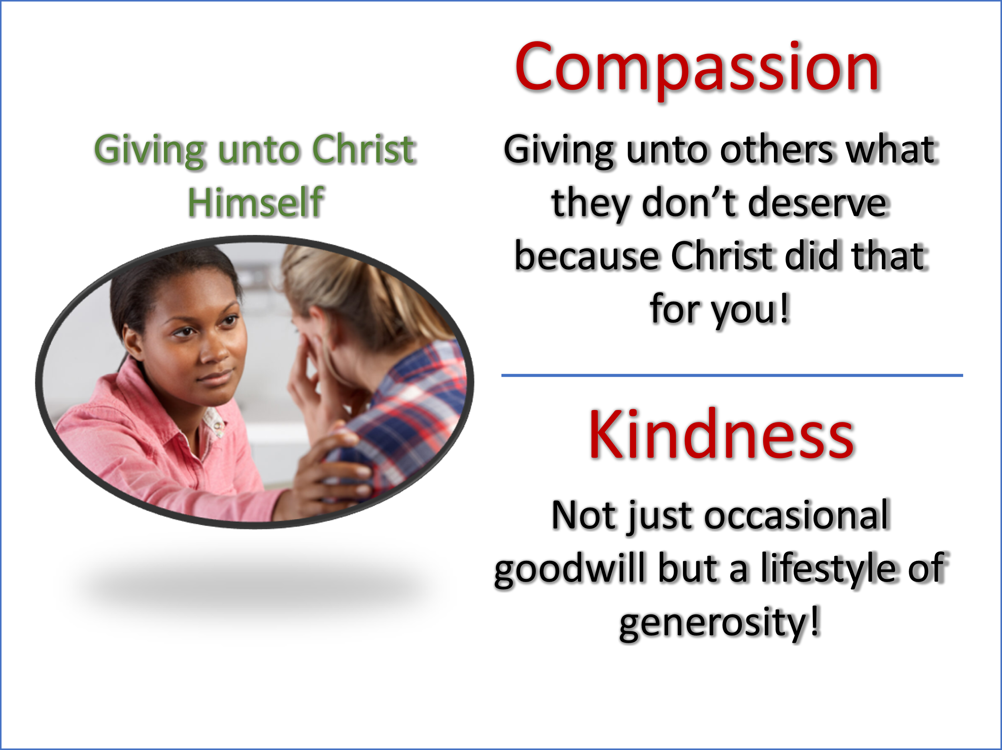
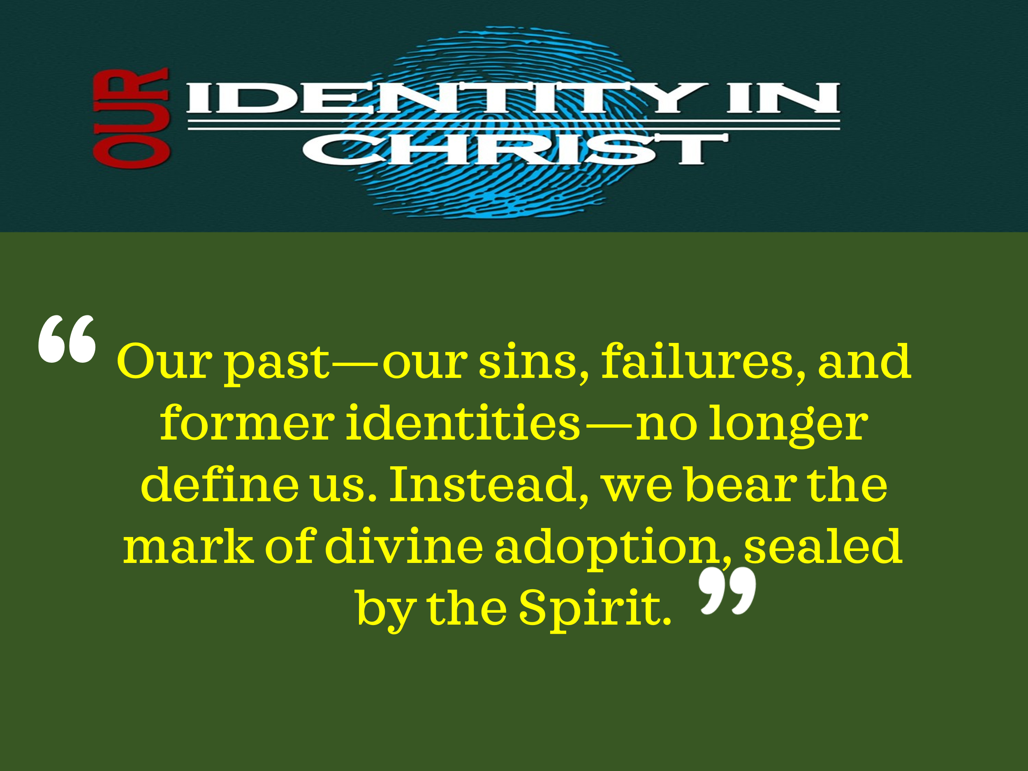
Since no one earns their place in God’s kingdom, there is no room for boasting—only humble, joyful gratitude for His grace. As Paul reminds us, “He has called not only from among the Jews but also from the Gentiles” (Romans 9:24-25), making us partakers in His glorious inheritance (Ephesians 1:11-12). We now belong to a kingdom that is unshakable, a family that is eternal. Our past—our sins, failures, and former identities—no longer define us. Instead, we bear the mark of divine adoption, sealed by the Spirit.
This new identity transcends religious background, ethnicity, and social status; we are one body in Christ, bound together by His love (Galatians 3:28). And as God’s beloved, our calling is clear: to reflect His character, to live out His righteousness, and to walk in the light of His holiness. But what does this look like in our daily lives? How do we embody the identity Christ has bestowed upon us?
Just as Israel was called to be a light to the nations, we too are called to shine in the darkness by clothing ourselves with Christ’s character, so that others may “see your good deeds and glorify your Father in heaven” (Matthew 5:16). Paul, in a passage reminiscent of the fruit of the Spirit (Galatians 5:22-23), outlines six key virtues that we, as followers of Christ, must wear daily. To offer our bodies as living sacrifices (Romans 12:1), we must first remove the tattered garments of our old sinful nature—the pride, selfish ambition, and hardened hearts that once defined us. The world chases status and recognition, but Christ calls us to a life of humility, service, and love. Rather than seeking personal gain, we must clothe ourselves with compassion—a mercy that flows not from obligation, but from a heart transformed by Christ (Colossians 3:12). As God’s chosen people, we are also called to kindness, not just as an occasional gesture of goodwill but as a lifestyle of generosity. To give our time, our resources, and our love to those in need is to give to Christ Himself (Matthew 25:40). True kindness goes beyond politeness—it is a reflection of Christ’s love, seeking the good of others before ourselves.
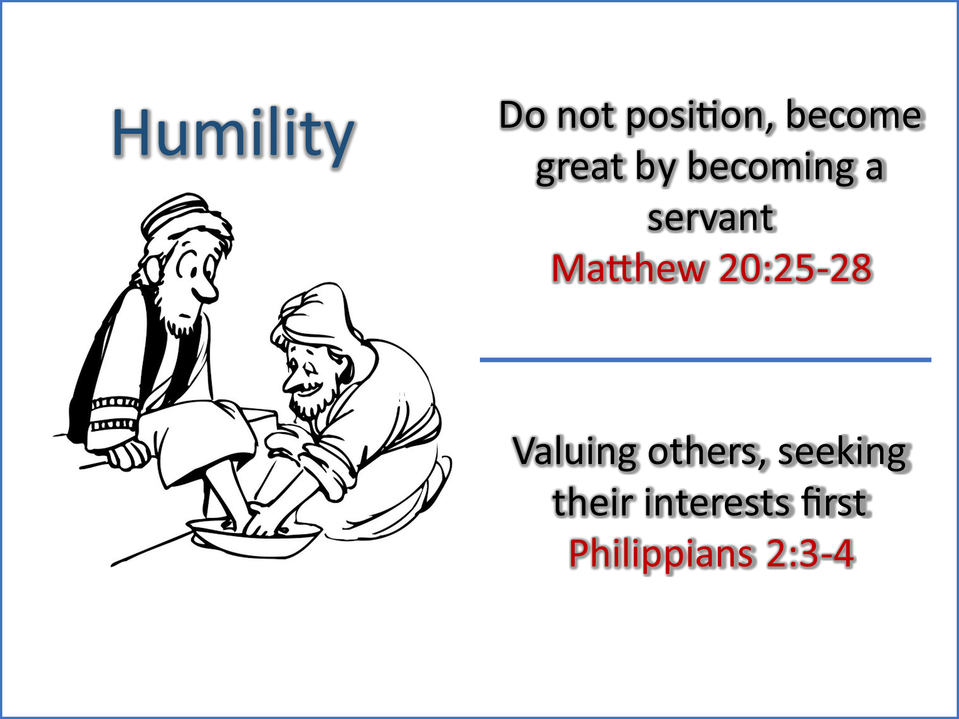
In reflecting the One who gave His life as a ransom for many (Mark 10:45), we must throw off the world’s pursuit of honor—the outward displays of egotism and arrogance that crave recognition—and instead, put on the garment of humility. True humility is not weakness—it is strength under God’s control. It does not strip us of our worth but aligns us with Christ, who, though He was fully God, humbled Himself to serve others (Philippians 2:3-4). Walking in humility means putting others before ourselves, seeking their well-being first, and trusting that in due time, God will lift us up (James 4:10). Instead of prideful self-assertiveness, we bear with one another in love (Colossians 3:13), considering the rights and feelings of others, exercising patience in disagreements, and choosing words that build up rather than tear down. Even when correction is necessary, it should be given not in condemnation but in grace, with the goal of restoring rather than wounding. Above all, as God’s own, we are clothed with patience and forgiveness, extending mercy even to our enemies. Jesus commanded, “Love your enemies, do good to those who hate you, bless those who curse you, pray for those who mistreat you” (Luke 6:27-28). This is not a passive endurance but an active, Christ-like love that refuses to be overcome by evil and instead overcomes evil with good (Romans 12:21). When we wear these virtues, we do not merely reflect Christ—we reveal Him to a world in desperate need of His light.

Cultivating the Bonds of Love

Paul reminds us that simply putting on Christ’s virtues—compassion, kindness, humility, gentleness, patience, and forgiveness—is not enough unless they are bound together by love, which holds them in perfect unity (Colossians 3:14). Without love, even the most righteous actions are incomplete. This truth naturally leads us to reflect on the infamous “love chapter” in Scripture:
“If I speak in the tongues of men or of angels, but do not have love, I am only a resounding gong or a clanging cymbal. If I have the gift of prophecy and can fathom all mysteries and all knowledge, and if I have faith that can move mountains, but do not have love, I am nothing” (1 Corinthians 13:1-2).
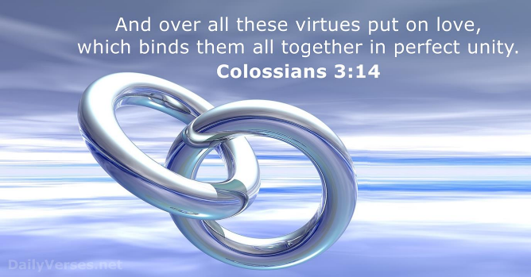
Paul describes love as patient and kind—never envious, boastful, or proud. It does not dishonor others, nor is it self-seeking or easily angered. Above all, love keeps no record of wrongs (1 Corinthians 13:4-5). Love rejoices in the truth, always trusts, always hopes, and always perseveres (1 Corinthians 13:7). Without love, our faith lacks its most essential quality, for as Apostle John declares:
“Everyone who loves has been born of God and knows God. Whoever does not love does not know God, because God is love” (1 John 4:7-8).
Our light cannot truly reflect the glory of the Father until His love is alive in us. So, the question remains: Do you love those whom God has placed in your life? Do you see His image in them, or do you struggle to love as He has loved you?

Cherishing Christ’s Peace

Those who have clothed themselves with Christ’s virtues will, in every circumstance, strive to preserve the bonds of peace (Colossians 3:15). However, being born again does not mean we will never experience adversity, inner turmoil, or moments of remorse over sin. There will be times when our peace is ruffled by trials, overcast by sin, or shaken by a troubled conscience. Yet, for peace to rule in our hearts, we must see the image of God in others—even in those with whom we differ.

As members of one body, we come from varied backgrounds—economically, demographically, and culturally. These differences, however, are not meant to divide us but to be celebrated in unity as we follow Christ, the Head of the body. True peace is not just an individual sense of calm; it is a communal bond that governs our relationships, fostering reconciliation, harmony, and unity in the face of conflict. John MacArthur wisely observes, “Too many churches today have forgotten that their main purpose is one. As the church of the living God, they are to be the pillar of support and truth.” When believers allow Christ’s peace to rule their hearts, even tense and uncomfortable moments become opportunities to demonstrate our allegiance to Christ—the Vine to whom we are grafted at the cost of His very life. It is only when we are at peace with God—in prayer, submission, and trust in His sovereign rule over our lives—that we can truly love as Christ first loved us (1 John 4:10).

Celebrating the Word of Christ

With Christ’s virtues and peace firmly rooted in our lives, Paul urges us to celebrate the words of Christ—both through teaching and singing. John Calvin wisely reminds us, “Unless God’s Word illumine the way, the whole life of men is wrapped in darkness and mist, so that they cannot but miserably stray.” The Christ-centered life is not shallow or superficial, but one deeply anchored in the transformative power of the Gospel. This calls us to not only affirm and encourage one another but also to admonish in wisdom, reflecting Christ’s teaching and example in all we do. God’s Word is our guide:
“Your word is a lamp for my feet, a light on my path” (Psalm 119:105).
“All Scripture is God-breathed and is useful for teaching, rebuking, correcting and training in righteousness, so that the servant of God may be thoroughly equipped for every good work” (2 Timothy 3:16-17).
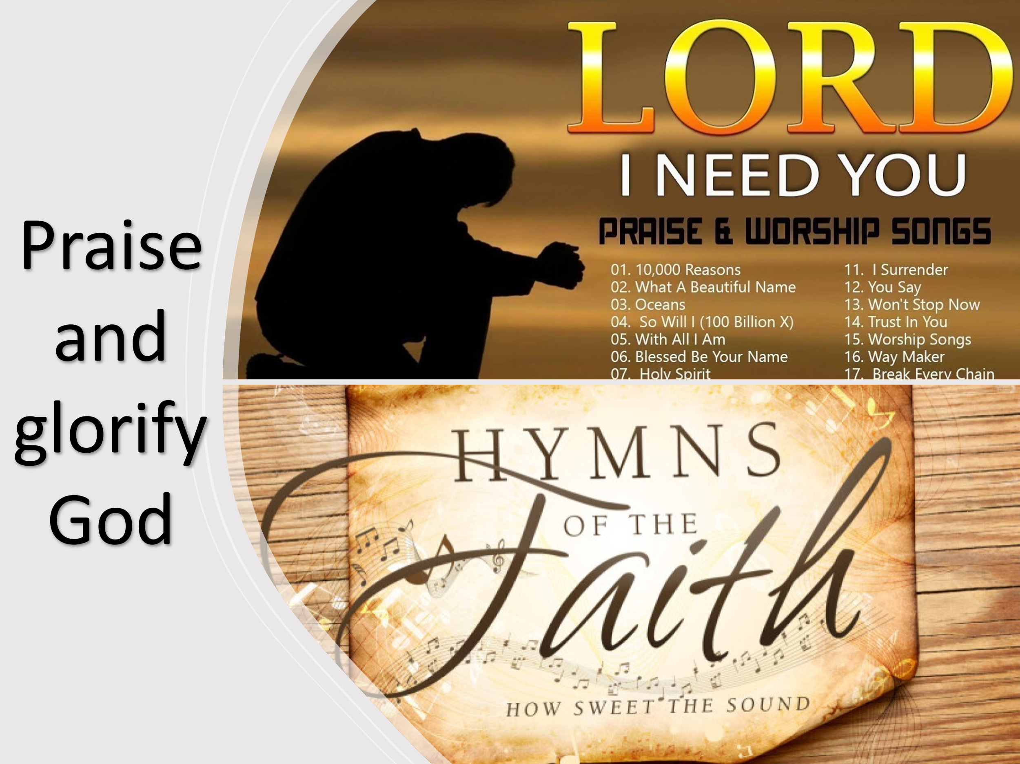
But our response to God’s Word should not be mere intellectual acceptance—it should overflow into praise. Paul encourages us to worship the Lord “through psalms, hymns, and songs from the Spirit” (Colossians 3:16). While preferences in music may vary, Paul reminds us that style is not what matters most. Rather, what pleases God is a heart that sings from a wellspring of gratitude. Thus, Paul concludes with this powerful charge:
“Whatever you do, whether in word or deed, do it all in the name of the Lord Jesus, giving thanks to God the Father through Him” (Colossians 3:17).
May we live, teach, and sing in a way that reflects the glory of Christ, exalting His name in all that we do!

Conclusion

As we come to the end of this message, we are reminded that salvation is not just a moment—it is a transformation that continues daily. The day Christ entered our hearts was the day everything changed. We were washed, renewed, and adopted into God’s family. But this was only the beginning. Our new identity in Christ calls us to live differently—to put off the old self, to clothe ourselves in His righteousness, and to reflect His character in all we do.
Paul challenges us to fix our hearts on things above, to live in the reality of our heavenly calling, and to walk in holiness, love, peace, and gratitude. This transformation is not just for our personal growth—it is a testimony to the world. When we love as Christ loved, when we forgive as He forgave, and when we worship with sincere hearts, we do not just reflect Christ—we reveal Him to a world desperate for hope.
So, as we go forward:
Let us be people of love, bearing with one another in patience and kindness.
Let us be peacemakers, striving for unity in the body of Christ.
Let us be doers of the Word, not merely hearers, allowing Scripture to shape our every decision.
Let us worship with hearts overflowing in gratitude, not caught up in style or preference, but in genuine praise to our Savior.
And above all, let us live every moment for the glory of Christ, for as Paul reminds us:
“Whatever you do, whether in word or deed, do it all in the name of the Lord Jesus, giving thanks to God the Father through Him” (Colossians 3:17).
May we leave here today not just inspired but transformed—fully surrendered to Christ, fully clothed in His righteousness, and fully committed to living, loving, and serving in His name, for His glory, until the day He returns.

Everett F. Harrison, “Romans,” in The Expositor’s Bible Commentary: Romans through Galatians, ed. Frank E. Gaebelein, vol. 10 (Grand Rapids, MI: Zondervan Publishing House, 1976), 68.
Douglas J. Moo, Romans, The NIV Application Commentary (Grand Rapids, MI: Zondervan Publishing House, 2000), 197.
Douglas J. Moo, The Letters to the Colossians and to Philemon, The Pillar New Testament Commentary (Grand Rapids, MI: William B. Eerdmans Pub. Co., 2008), 275.
David E. Garland, Colossians and Philemon, The NIV Application Commentary (Grand Rapids, MI: Zondervan Publishing House, 1998), 210–211.
Curtis Vaughan, “Colossians,” in The Expositor’s Bible Commentary: Ephesians through Philemon, ed. Frank E. Gaebelein, vol. 11 (Grand Rapids, MI: Zondervan Publishing House, 1981), 215.
John Calvin, The Complete Gathered Gold: A Treasury of Quotation of Christians.

