Wind the Clock

  - Online Sermon: http://www.mckeesfamily.com/sermons/


Time is a gift that each of us experiences differently. The historian David McCullough once observed, “The digital watch is a perfect symbol of an imbalance in outlook in our day.” His words capture the tension we often feel some treat time as abundant and grow complacent, while others, fearing its brevity, rush through life in a constant flurry of activity. Neither path leads to true fulfillment.
Life is not measured by hours or achievements but by meaningful moments. Scripture calls us to redeem the time, but how do we do that? Some advocate for constant reinvention—always chasing the next challenge. Others insist that simply mastering what already exists is enough. Yet both perspectives fall short of God's wisdom, for as C.S. Lewis reminds us, "Nothing is inferior for being old, and nothing is valuable for being modern."
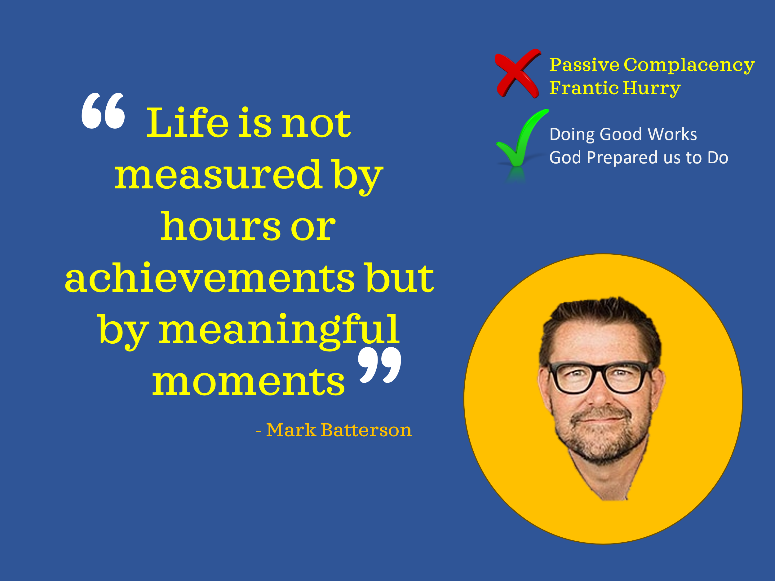
To live lives worthy of the Gospel, we must see time through God's eternal perspective. As 2 Peter 3:8 tells us, "With the Lord, a day is like a thousand years, and a thousand years are like a day." God does not call us to frantic striving for success, nor does He invite us to passive complacency. Instead, He calls us to faithful obedience, walking in the good works He has prepared for us (Ephesians 2:10).
Today, we will explore how to "wind the clock" of our lives—by tuning our hearts to God's voice and aligning our time with His purpose. He lovingly and strategically guides us on the path of faithfulness, shaping us into His image. Let us open our hearts to His Word and reflect on how we can live each moment for His glory.
Prayer:
Lord, You alone are the desire of our hearts. As we listen to Your words of wisdom today, we humbly ask that You transform us. Help us redeem the time You have given us by embracing change where needed and walking faithfully in Your purpose. May everything, we do be for Your glory and honor. In Jesus’ name, Amen.

Mind over Matter

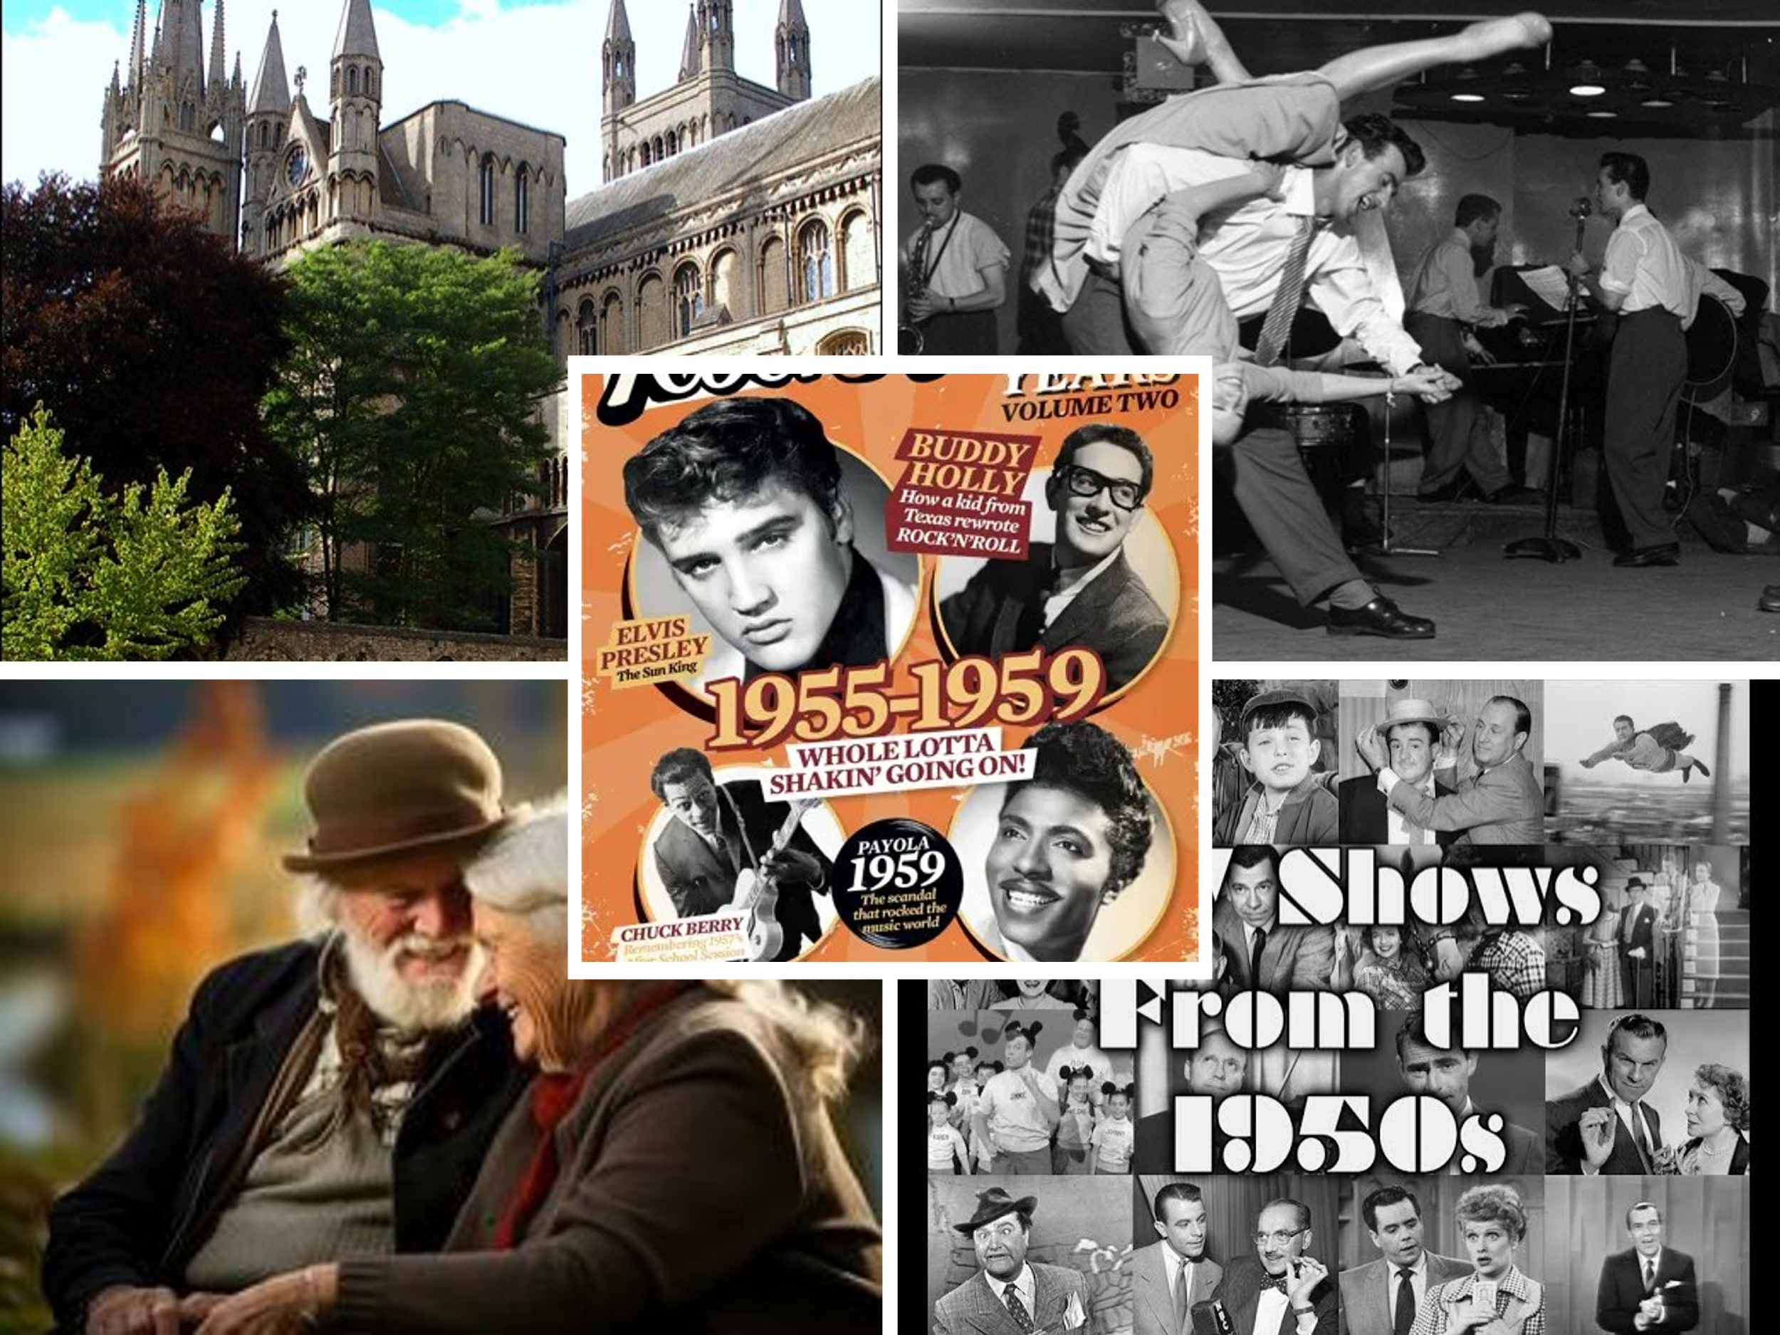
To better understand how we can 'wind the clock' by aligning with God's purpose, we turn to a fascinating concept that highlights the power of mindset—neoteny, which demonstrates how the right attitude can profoundly affect our well-being. In 1979, Harvard professor Ellen Langer conducted the groundbreaking "counterclockwise study," which explored this connection. She and her colleagues transformed an old monastery in Peterborough, New Hampshire, into a perfect recreation of 1959. Participants were instructed to live as if it were twenty years earlier—surrounded by period-specific music, television shows, books, and magazines. Mirrors were removed, and no discussion of events beyond 1959 was allowed. Remarkably, after just one week, these men showed measurable improvements in physical strength, dexterity, hearing, vision, and cognitive performance. By the end of the experiment, men who had struggled to move freely were playing football with surprising vitality. Langer concluded that if these dramatic changes were possible for a group of elderly adults, we too can experience renewal by changing how we perceive time. However, while human mindset can lead to powerful transformation, true renewal comes when we trust in God's eternal plan and walk in faithfulness. This is the essence of 'winding the clock'—tuning our hearts and minds to God's purpose with faith and expectancy. Much like tuning a clock ensures it keeps the correct time, aligning our hearts with God’s voice keeps us walking faithfully in the moments He has prepared for us. What attitudes or beliefs about time might be holding you back from experiencing God's renewal in your life?
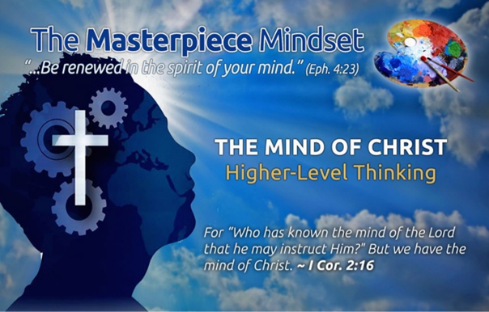
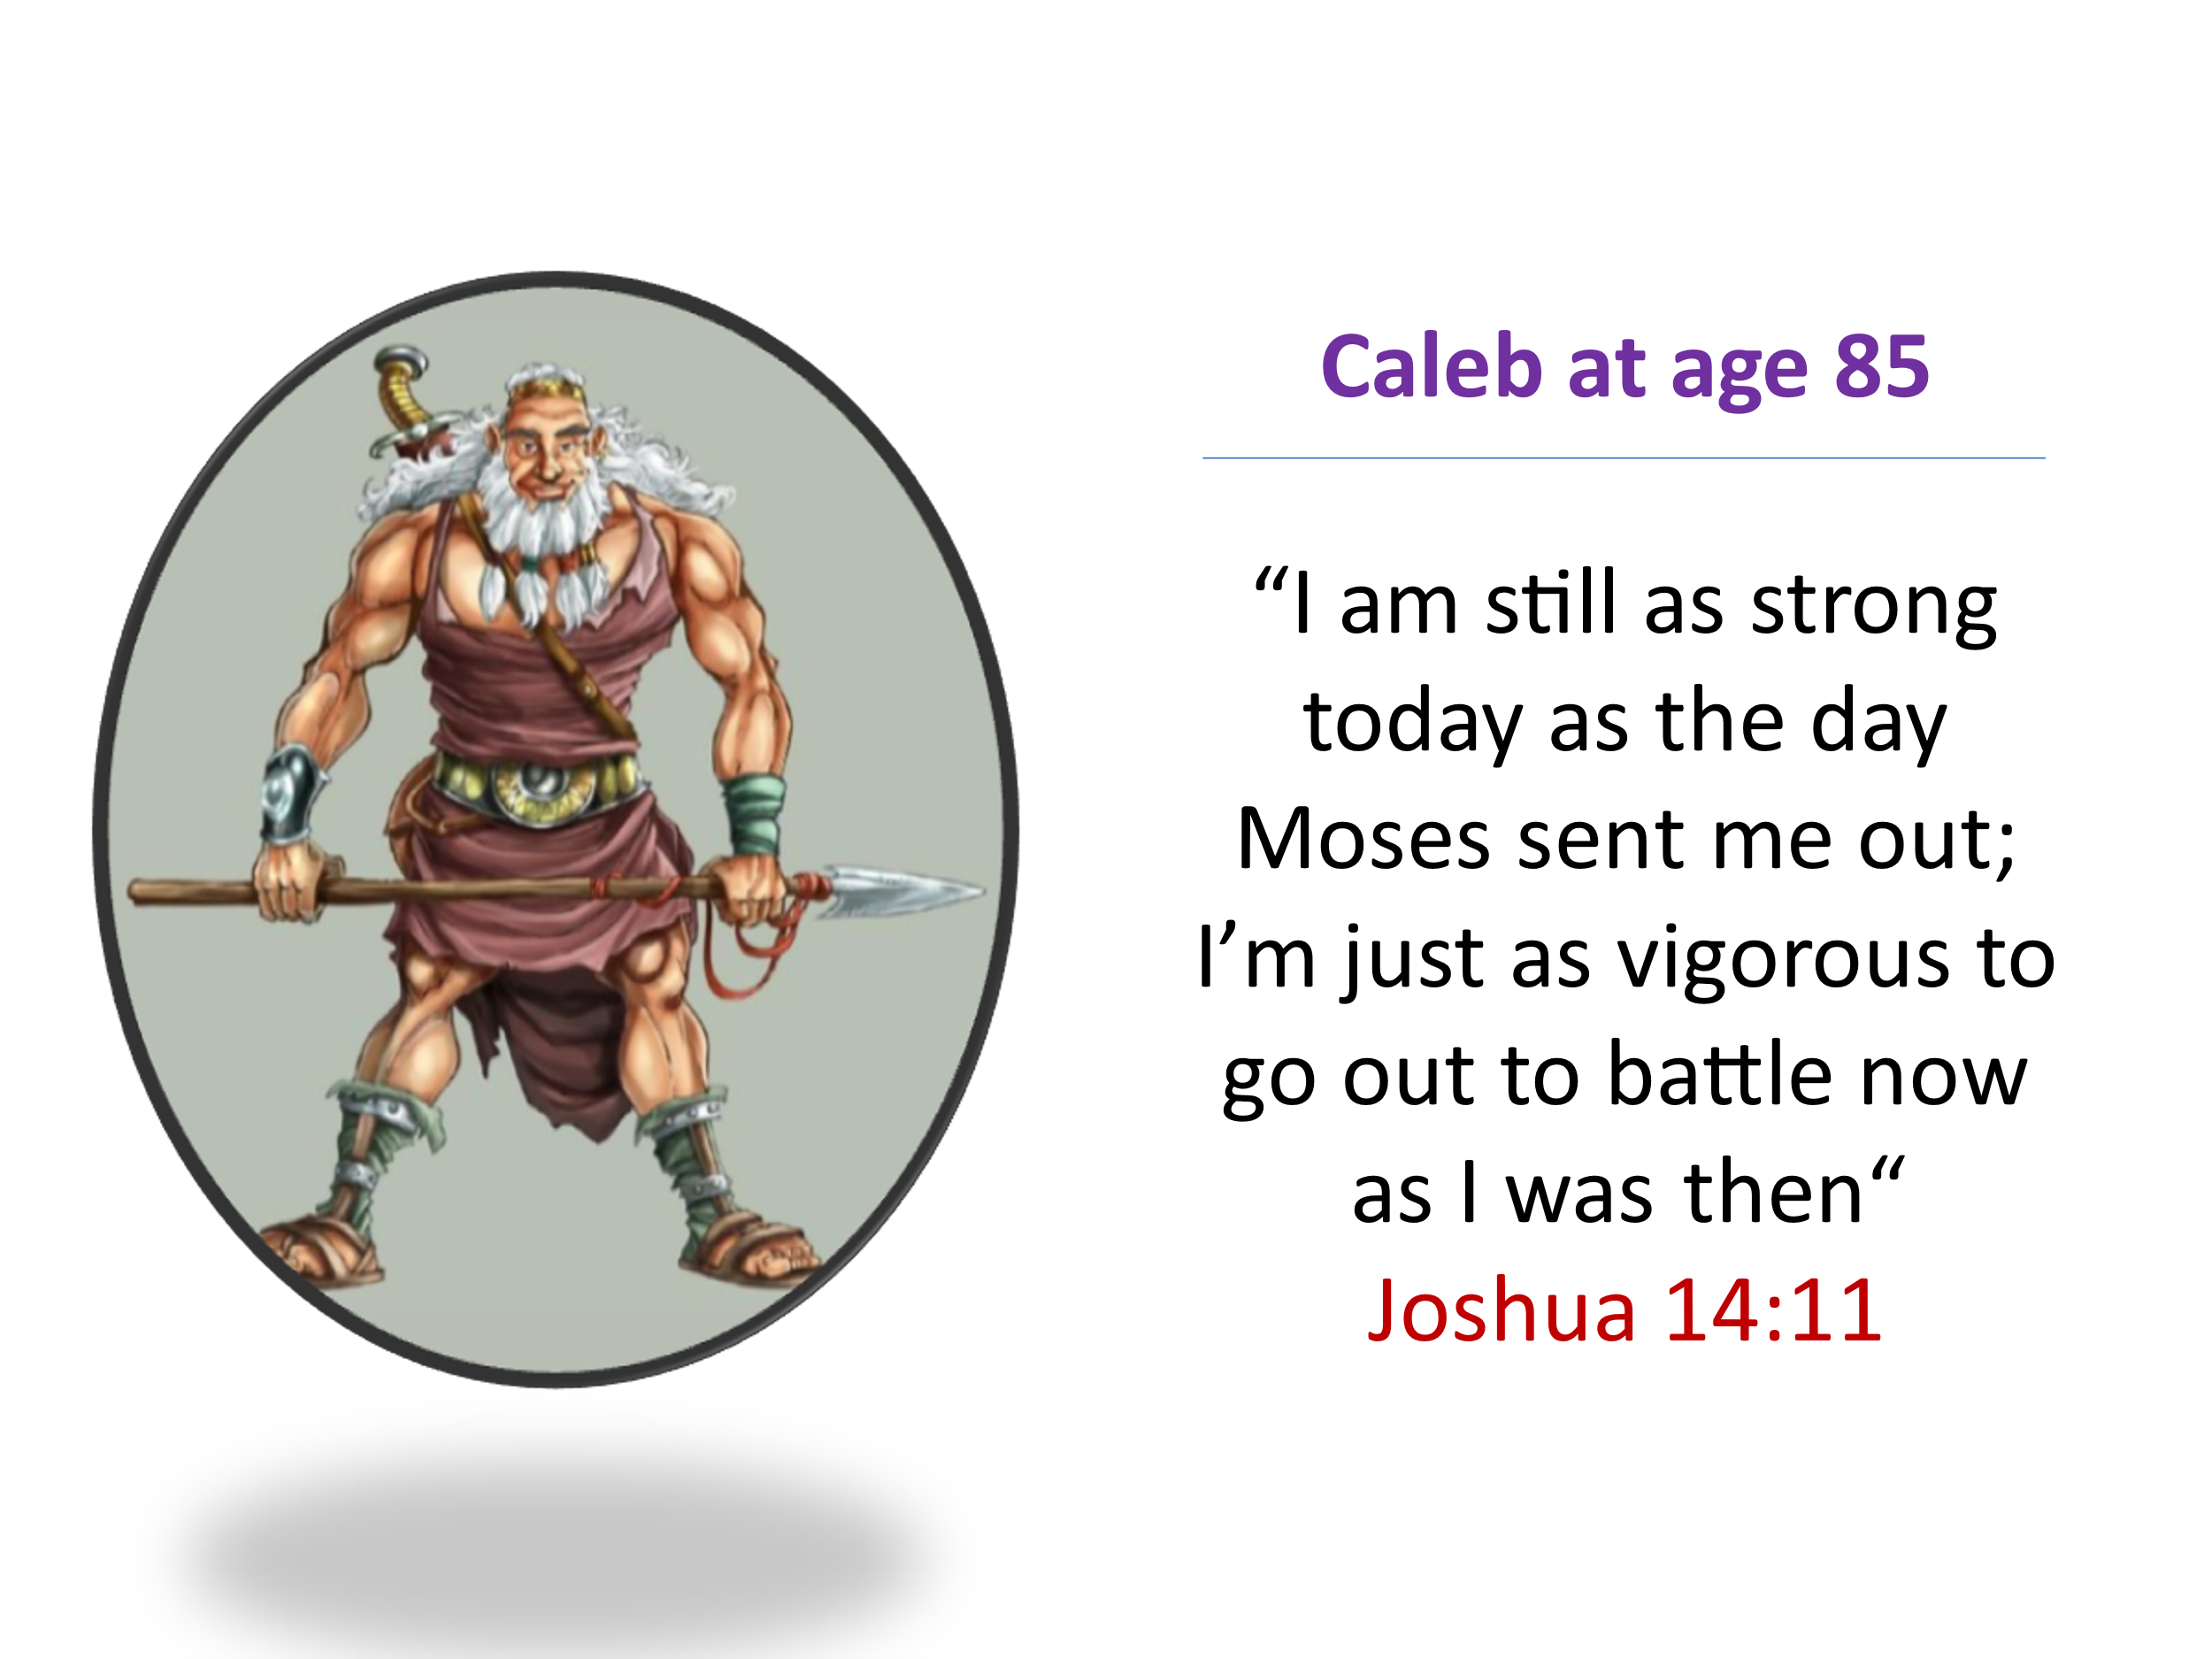
Thankfully, we are not left to rely on our own strength. Scripture assures us in 1 Corinthians 2:16, "But we have the mind of Christ." With this gift, we are empowered to view time and circumstances through God's eternal lens, discerning His will and walking in faithful obedience to the good works He has prepared for us. Faithful obedience may mean seeking God's guidance in your daily tasks, making time for prayer and Scripture, or serving others in His name. To truly redeem each moment, we must keep one eye on eternity and the other on the opportunities God places before us. Yet, this is no easy task. The lure of the world—its fleeting pleasures, the desires of the flesh, the eyes, and the pride of life (1 John 2:15-17)—constantly pulls us toward self-gratification. But Jesus reminds us that life is more than food, clothing, riches, or power (Matthew 6:25). We are Christ’s ambassadors and royal priests (2 Corinthians 5:20; 1 Peter 2:9). Our highest calling is to seek first God’s kingdom and His righteousness (Matthew 6:33). After all, nothing on earth is more desirable than our Lord (Psalm 73:25-26). The true battle is in the mind, where with divine aid we must push out sin and worldly distractions that entangle us. While mindset can lead to temporary change, true and lasting renewal comes when we allow Christ to transform our hearts and minds through His Spirit. Have you been intentionally seeking Christ's transformation of your mind so that you may fulfill His "good, pleasing, and perfect will" (Romans 12:2)? Today, I encourage you to ask Christ to transform your mind, to guide you in redeeming each moment for His glory, and to give you the strength to walk in His good and perfect will.

Own your Age

Redeeming every moment isn't just for the young; it's a calling for all of us, especially those who feel the weight of physical aging. God's purpose for our lives continues in every season, and He invites us to live with renewed strength and intention, no matter our age. When I think of someone who embraced this truth, I think of Caleb. Only he and Joshua believed that, with God’s help, they could take the Promised Land (Numbers 14:6-9). After 40 years of wandering in the wilderness because of Israel's disobedience, Caleb—now 85 years old—was ready to claim what God had promised. He boldly declared, "I am still as strong today as the day Moses sent me out; I’m just as vigorous to go out to battle now as I was then" (Joshua 14:11). Was this an exaggeration? Hardly! Whether God miraculously preserved his physical strength or Caleb’s unshakable trust in God’s sovereignty kept his spirit youthful, one thing is clear: he never let age diminish his faith or purpose. As Mark Batterson puts it, "As long as you’re going after a God-sized dream with God-sized passion, you’re never past your prime!" Are there areas of your life where you've allowed your age to hold you back from serving? Remember, God "who is able to do immeasurably more than all we ask or imagine" (Ephesians 3:20-21) has already secured your victory through Christ.
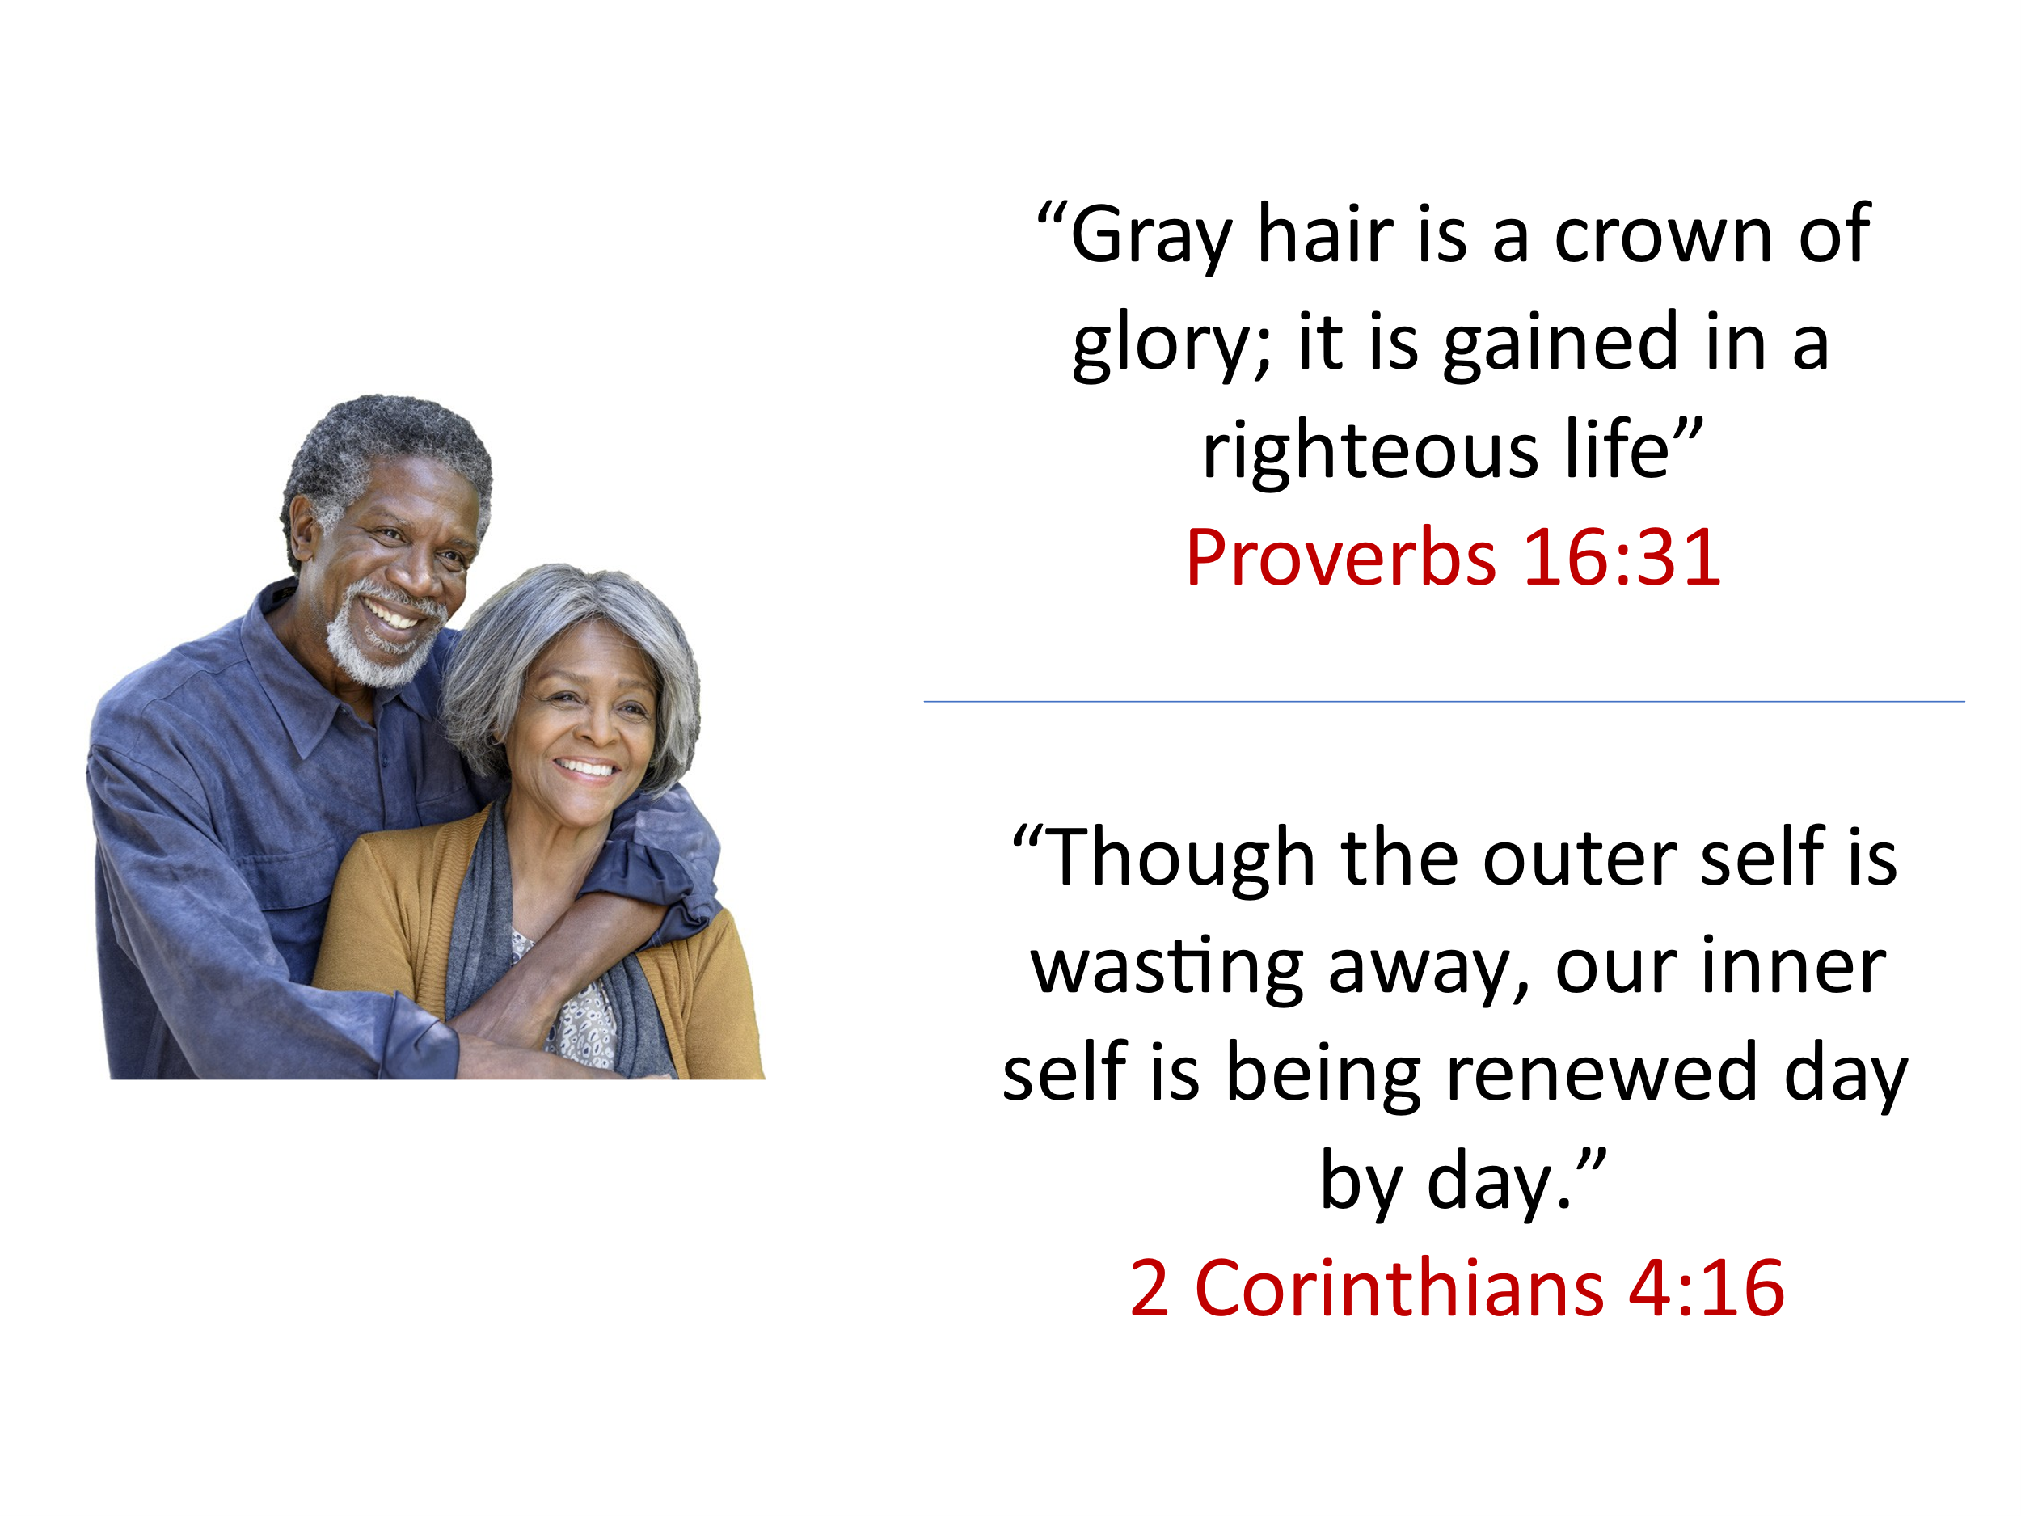
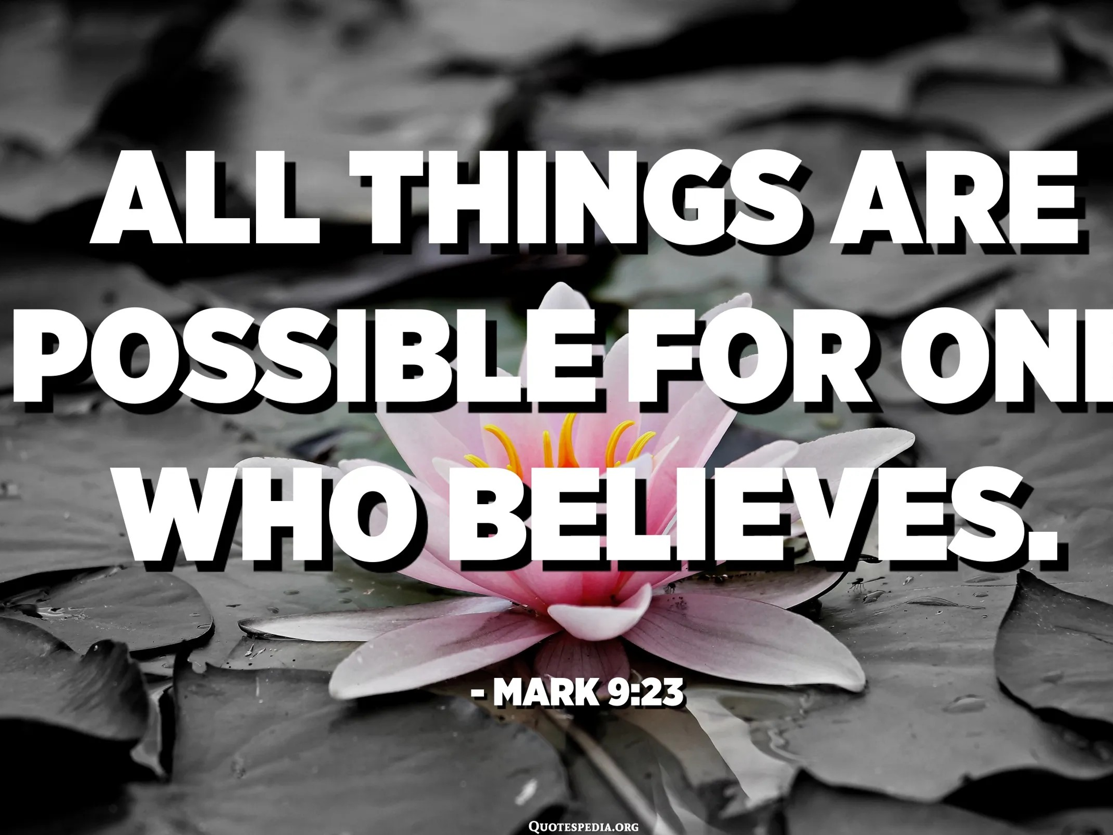
Ashley Montagu, the British American anthropologist, once said, “I want to die young at a ripe old age.” It's easy to feel discouraged by the challenges of aging—aches and pains, fleeting endurance, and a memory that seems to slip away. That inner critic may whisper, "You sure aren't what you used to be!" While it's foolish to deny the physical realities of aging, it's equally unwise to believe that decay is all there is. Proverbs 16:31 tells us, "Gray hair is a crown of glory; it is gained in a righteous life," and Paul encouraged the Corinthians with these words: "Though the outer self is wasting away, our inner self is being renewed day by day" (2 Corinthians 4:16). Aging offers a profound opportunity for spiritual growth, allowing us to develop a more mature and resilient faith. As we face trials and tribulations, we can draw upon countless experiences of God's saving grace and trust that He will continue to deliver us from life’s challenges (Psalm 77:1). Though some see death as the final separation, for those in Christ, it is the culmination of our journey—finishing the race and entering the presence of the Lord. Paul reminds us in 2 Timothy 4:7-8, ‘I have fought the good fight, I have finished the race, I have kept the faith. Now there is in store for me the crown of righteousness, which the Lord, the righteous Judge, will award to me on that day.’ As we persist in faith, we press on toward this eternal reward, knowing that every moment of faithful obedience is seen and honored by our Lord. Are you using your wisdom and unique life experiences to serve Him with all your heart, mind, soul, and strength, so that you might hear those precious words, “Well done, good and faithful servant”?
As Mark Batterson reminds us, 'As long as you’re going after a God-sized dream with God-sized passion, you’re never past your prime!' A God-sized dream doesn’t have to be something grand in worldly terms—it could mean stepping into new roles of mentorship, encouraging others through prayer, or leading with wisdom gained over a lifetime of faith. Are there dreams God has placed on your heart that you've set aside? Remember, with God's strength, you are never too old to fulfill the purpose He has for you.

Persistent Living

Whether young or old, God's calling on our lives remains steadfast, and He empowers us to accomplish more than we can ask or imagine. To fully live out His purpose, we must make the most of each day by seeking His guidance through prayer and faithfully striving to align our actions with His good and perfect will. True obedience is not measured by comfort or ease but by unwavering trust in His plan. For David, "winding the clock" of faithful obedience meant sparing the life of King Saul, even as Saul sought to kill him (1 Samuel 24). For Daniel, it was the courage to refuse the king’s food in devotion to God (Daniel 1:8). For Queen Esther, it was risking her life with a bold request to save her people (Esther 7). Yet one of the greatest examples of persistent faith comes from the disciples who, though uncertain of what would come, gathered in the upper room and prayed for ten days, waiting for the promised Comforter (Acts 1-2). Like them, we often walk through valleys of trials and tribulations, facing both daunting and mundane tasks, without knowing all the God-sized details or outcomes. But we are called to persistently seek first His kingdom and serve with the glorious expectation that, in Christ, all things are possible for those who believe.

Kingfisher


Faithfulness is not about perfection; it is about perseverance. Often being faithful means experiencing failure—but it is in the persistent pursuit of God’s will, despite setbacks, that we grow in holiness and align our lives with His purpose. Eugene Peterson once watched a kingfisher struggle to catch a fish from his deck in Montana. Despite being a skilled hunter, the bird failed thirty-seven times before finally succeeding! How many times have we tried to serve the Lord, only to fall short? Discerning God’s timing and perfect will is not always easy. With the many "planks" in our own eyes (Matthew 7:3-5), we often find ourselves leaning our ladder of success against the wrong wall. Yet, while God disciplines those He loves, He delights in showing grace and mercy, for without them, none of us could stand under His righteous judgment. Though we all fall short of God's glory (Romans 3:23), we need not despair, for His love endures forever (Psalm 136:26). Like the persistent widow in Jesus’ parable (Luke 18:1-8), we must continuously seek God, allowing Him to mold and shape us into vessels that reflect His purpose. So let us approach the Father’s throne—not in fear, but with confidence—trusting that He can and will use even the weak to accomplish great things in His name.

Conclusion

As we reflect on redeeming the time, persevering in faith, and aligning our lives with God's purpose, one truth remains clear: faithfulness is not about perfection—it is about persistence. Like the kingfisher that failed thirty-seven times before succeeding, we, too, will experience failure along our journey. Like Caleb, who refused to let age limit his faith, we are never too old to claim the promises of God. Like the persistent widow who kept knocking, we must remain steadfast in prayer, knowing that our Heavenly Father hears and answers those who seek Him. Paul reminds us in 2 Timothy 4:7-8, "I have fought the good fight, I have finished the race, I have kept the faith. Now there is in store for me the crown of righteousness, which the Lord, the righteous Judge, will award to me on that day." Finishing the race well doesn’t mean never stumbling—it means refusing to quit. It means waking up each day with a heart set on seeking God’s will, a mind renewed by His truth, and hands ready to serve in His name.

So let me ask you:
Where is God calling you to persevere?
What dream have you set aside because of discouragement?
What area of your life needs to be surrendered so that He can mold you into the vessel He desires?

May we be found faithful, may we redeem the time, and may we finish the race with endurance—until the day we hear our Lord say, ‘Well done, good and faithful servant.

Mark Batterson, Win the Day: 7 Daily Habits to Help You Stress Less & Accomplish More, Kindle Location 2664.
Ibid.
Ibid., Location 2714.
Ibid. Location 2757.
Ibid., Location 2825
Ibid., Locataion 3034.

