# **Fly the Kite**

Online Sermon: http://www.mckeesfamily.com/sermons/

On our 25th wedding anniversary, my wife and I embarked on what It felt was an odyssey to the ends of the earth—a journey full of anticipation and wonder: Niagara Falls. We had seen countless pictures and videos of this magnificent wonder of God’s creation, but nothing could have prepared us for the awe of standing before it. The thunderous roar of the water, combined with the sheer force of 3,160 tons of water crashing down at a rate of thirty-two feet per second,[1] left us speechless.

In that moment, overwhelmed by such power, King David’s words in Psalm 19 came alive.

*"The heavens declare the glory of God; the skies proclaim the work of His hands. Day after day they pour forth speech; night after night they reveal knowledge. They have no speech, they use no words; no sound is heard from them. Yet their voice goes out into all the earth, their words to the end of the world” (Psalm 19:1-4a).*

Nature has a way of reminding us of the greatness of our Creator, doesn’t it? But it also reminds us of something equally amazing—that God, who commands the roaring waters of Niagara, can work through even the smallest things to accomplish His divine purposes.

Let me take you back to November 9, 1847, when an engineer named Charles Ellet Jr. faced an enormous challenge: constructing a suspension bridge across the gorge at Niagara Falls. With 225-foot cliffs on either side and raging rapids below, how could anyone possibly get the first cable—an 800-foot wire—across such an impassable chasm? Ideas were tossed around, from launching the cable with cannons to using rockets, but in the end, the simplest solution won: a kite-flying contest. It was a 15-year-old boy, Holman Walsh, who successfully flew his kite across the gorge. That tiny string became the starting point for threading thirty-six strands of ten-gauge wire, which would ultimately support a mighty bridge. What began with something so small—just a kite—became the foundation for something extraordinary.

Like the kite string that started a bridge, even our smallest steps of obedience can have eternal impact when entrusted to God.. Today, we’re going to explore how God often uses the small and seemingly insignificant to accomplish His God-sized purposes. Just as that kite string led to a mighty bridge, God can use our faith to accomplish the impossible. No challenge is too big for the Creator, who delights in working through His beloved image-bearers to bring Him glory.

# **Ladder of Success**

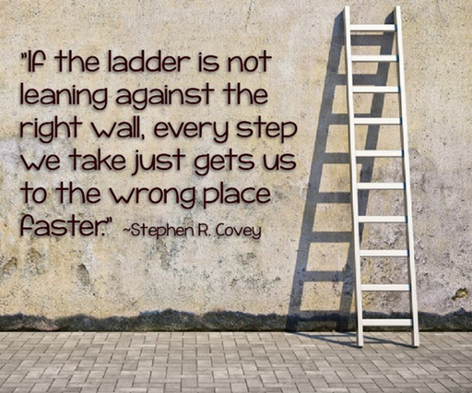To accomplish great things for God’s kingdom, we must first ensure our “ladder” is leaning against the right wall. Too many Christians spend their lives pursuing personal success, climbing higher and higher, only to realize too late that their efforts were directed toward worldly goals, not God’s purposes. How often do we exhaust ourselves trying to impress others—working hard, accumulating debt, and chasing things we think will bring validation from people we may not even like? This misplaced focus is especially evident in a culture overflowing with material abundance. We live in a land far more luxurious than one flowing with 'milk and honey,' yet we remain unsatisfied—fearing scarcity while coveting what we don’t need. The truth is, dissatisfaction stems from not knowing or pursuing God’s will for our lives. Paul reminds us in Ephesians 2:10, *“We are God’s handiwork, created in Christ Jesus to do good works, which God prepared in advance for us to do.”* God has uniquely designed us for His purposes, calling “ordinary” people (1 Corinthians 1:26-29) to do extraordinary things (John 14:12). This is His gift to us. In return, our obedience to *“seek first the kingdom of God”* is our gift to Him.

So, ask yourself: Is your ladder leaning against the wall of God’s will, or is it propped against the fading values of the world? Are you pursuing the role God has called you to fulfill, or are you distracted by chasing things that will ultimately amount to nothing more than vanity?

# **Everyday is a Masterpiece of God’s Design**

Once we align our goals with God’s will, we can begin to see each day as an opportunity to live out His divine purposes and bring glory to His name. If we are to live lives worthy of the Gospel, we must break free from complacency and worldly desires, recognizing each day as a masterpiece crafted by God and an opportunity to fulfill His purposes. Though we may feel small or insignificant, we can trust in the sovereign power of the Creator, who gives us life and equips us for His work. As Philippians 4:13 reminds us, “I can do all things through Him who gives me strength.” When doubts and fears arise, let us remember that the One who commands the earth to spin and holds the universe in place is more than able to use us, His frail and imperfect image-bearers, to accomplish extraordinary 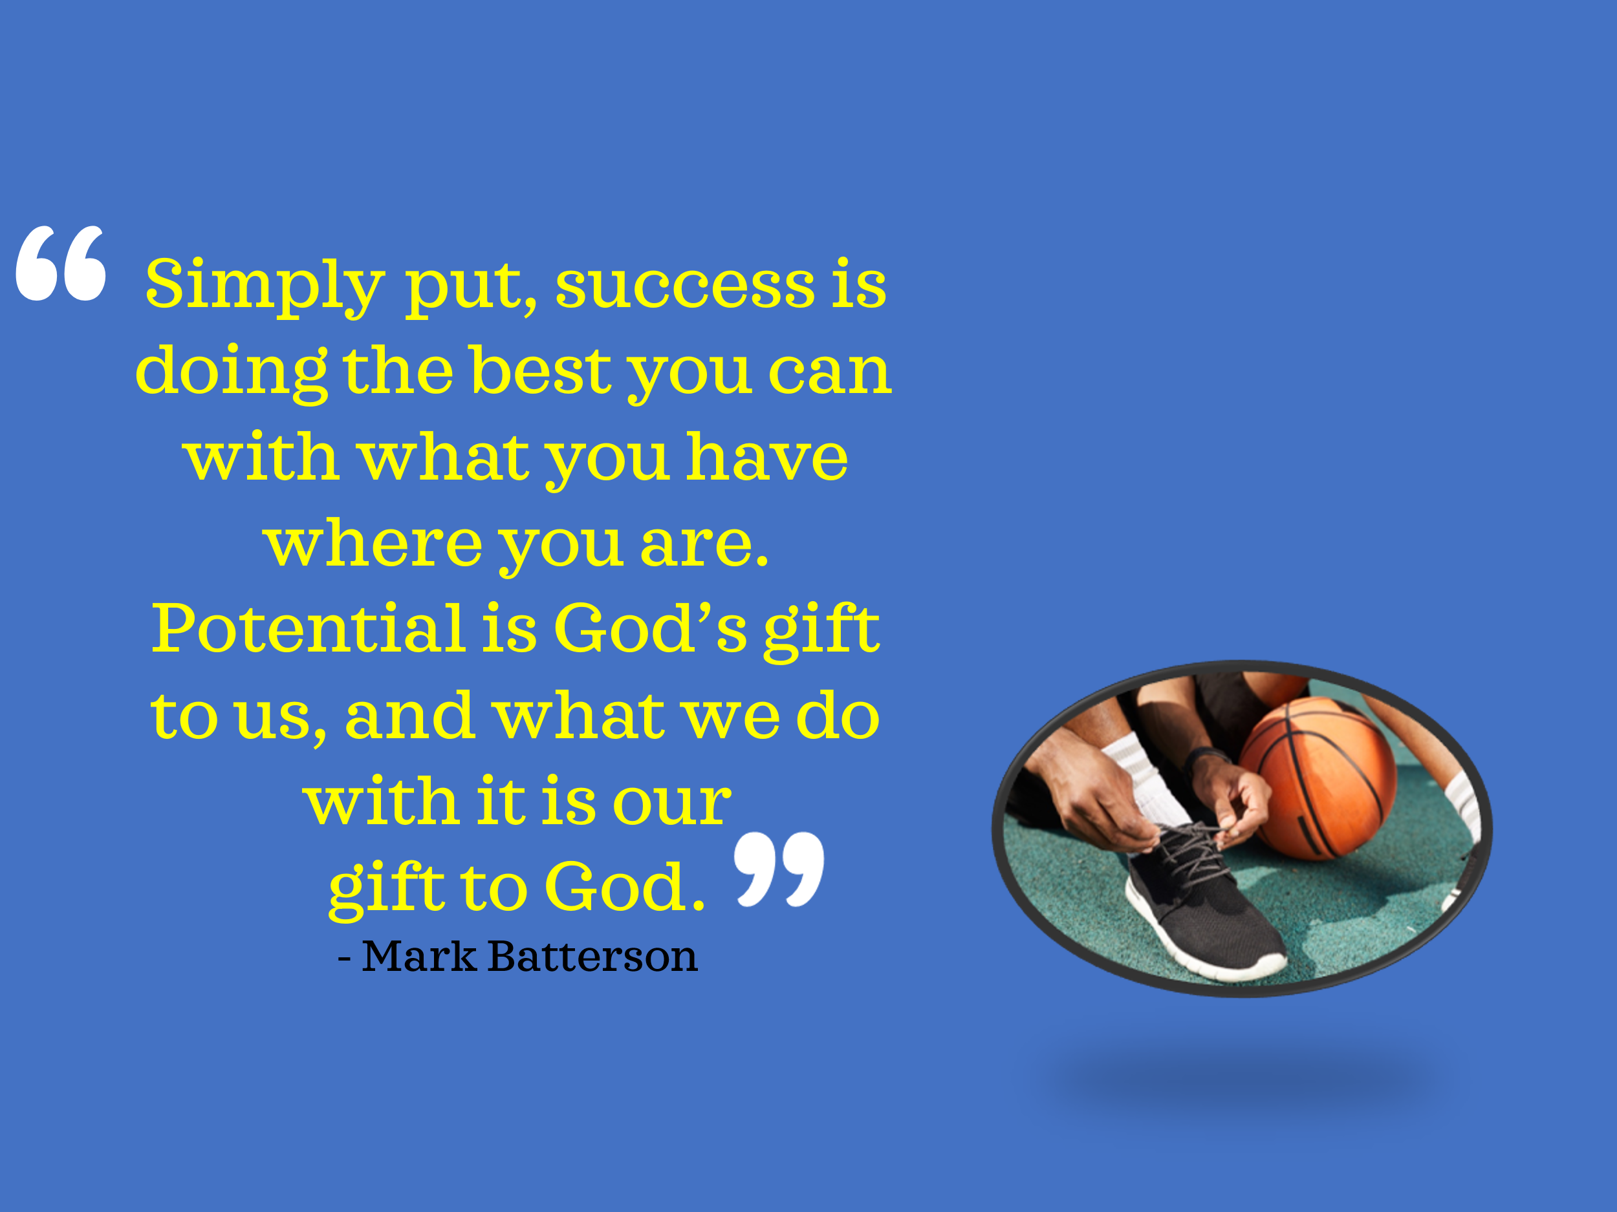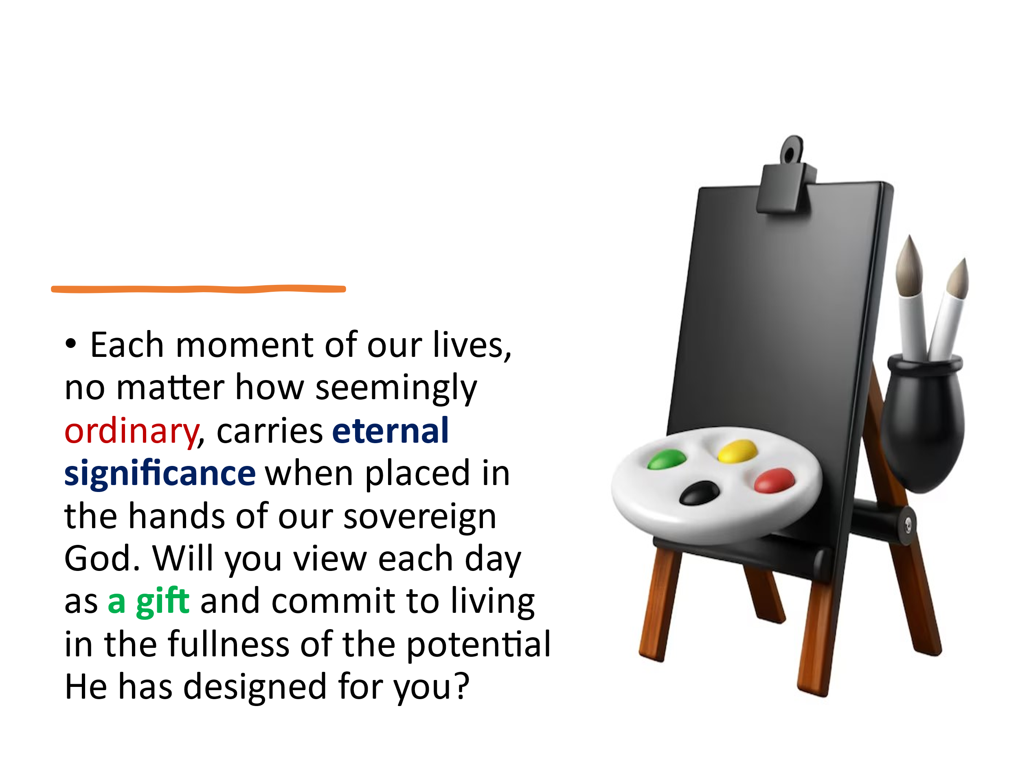things. Each moment of our lives, no matter how seemingly ordinary, carries eternal significance when placed in the hands of our sovereign God. Will you view each day as a gift and commit to living in the fullness of the potential He has designed for you?

# **Celebrating the Big Stuff and Sweating the Small Stuff**

Each day is God’s masterpiece, and even the smallest task carries eternal significance when surrendered to Him. As we marvel at the complexity of the universe, God’s simple yet profound words, *“Let there be light,”* remind us of His infinite power and wisdom. If we trust God to hold the universe in place, why do we doubt He can handle the details of our lives? Are not our daily tasks small in comparison to His works of creation? And yet, God uses the ordinary to accomplish the extraordinary. Romans 12:2 calls us to be transformed by renewing our minds, so we may live out His “good, pleasing and perfect will.” Legendary UCLA basketball coach John Wooden captured this truth through his emphasis on the basics. When asked about his team’s unprecedented success, Wooden credited something as simple as properly putting on socks and shoes, noting that small, trivial habits lay the foundation for great achievements. Likewise, Jesus teaches us in Luke 16:10, *“If you are faithful in the little things, you will be faithful in large ones.”* It is through our daily submission to Christ’s authority—faithfully handling the small, mundane tasks—that our faith grows, our spiritual maturity deepens, and we are equipped to accomplish great things for His glory. Never underestimate the significance of the small, for in God’s hands, they carry eternal weight.

# **The Audience of One**

Having embraced the significance of both great and small tasks, let’s shift our focus to who we’re truly working for—God, not the world. Life is not a competition or a comparison—we are each fearfully and wonderfully made, uniquely equipped with spiritual gifts to fulfill the specific purposes God has set before us. As Mark Batterson wisely reminds us, the only applause worth seeking comes from the One with nail-scarred hands.[2] Consider the story of the three bricklayers: when asked what they were doing, one replied, “I’m 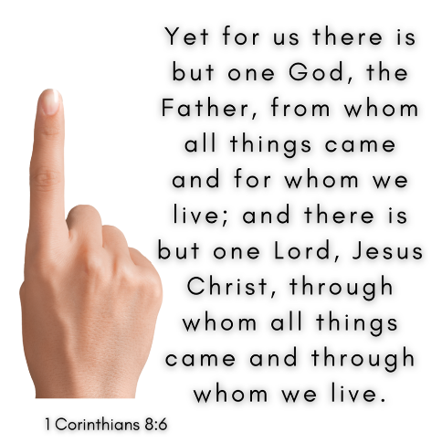laying bricks,” another said, “I’m building a wall,” but the third proclaimed, “I’m constructing a cathedral for the glory of God.” This perspective changes everything! Paul echoes this truth in Colossians 3:23: *“Whatever you do, work at it with all your heart, as working for the Lord, not for 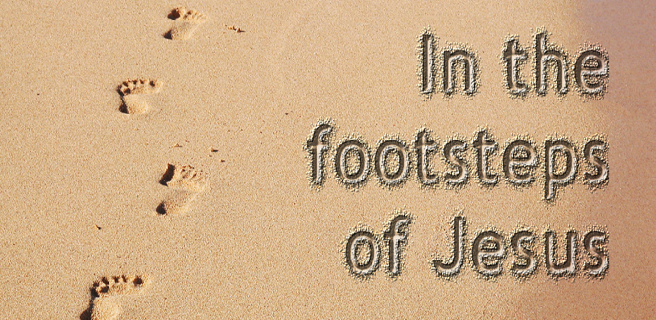human masters. It is the Lord Christ you are serving.”* Our calling is not to impress the crowd but to faithfully fly the kite God has placed in our hands, using the strength, gifts, and wisdom He provides to glorify Him. After all, we were bought at the price of Christ’s very life (1 Corinthians 6:19-20), and every day is an opportunity to live as His masterpiece. When we surrender the brush to the Master Artist, He enables us—His beloved children—to accomplish miracles in His name. What is one small act of faithfulness you can commit to today, knowing that God can use it for His eternal purposes? Will you trust Him to work through you as His masterpiece?

# **Step by Step but at Godspeed**

Once we focus on God’s will and commit to faithfulness in the small things, the next step is to set goals that challenge us—goals that stretch our faith and reliance on God’s strength yet remain realistic enough to keep us moving forward with perseverance. As a pastor, one of my roles is not just to comfort the afflicted but to lovingly afflict the comfortable,[3] urging us all to step out of complacency. If our goals are too easy, we risk boredom, stagnation, or quitting when the returns seem insignificant. Instead, we are called to prayerfully examine the spiritual gifts God has given us and seek His guidance in setting goals that align with His purposes.

There will be moments when God calls us, as He did Moses, to step far outside of our comfort zones and take on tasks so monumental that only divine strength and wisdom can accomplish them. Yet, God also knows that we all begin as spiritual infants (1 Corinthians 3:1-2). He understands that growth in faith is a process—we must crawl before we walk and walk before we run boldly in His kingdom. As Jesus teaches in the Parable of the Bags of Gold (Matthew 25:14-30), those who are faithful in small things will be entrusted with greater responsibilities. Whether God calls us to big assignments or small, we can rejoice, knowing that no task received from the Good Shepherd’s hand is insignificant (Zechariah 4:10). Instead, we are to work at every God-given task with all our hearts (Colossians 3:23-24), finding joy and purpose in honoring and glorifying Him, now and forever. Amen!

# This idea of faithfulness in small steps isn’t just theoretical—it’s something I’ve experienced in my own life. I remember the first time I was called to serve in a leadership role at church. As a young man, the pastor asked me to chair the Board of Finance, and I felt completely overwhelmed. Up to that point, my personal goals had been private and free of scrutiny, but this was different. My hands would sweat, and my heart would race at the thought of the responsibility. Being an accountant at work was one thing, but managing God’s finances during the gym’s construction felt like a weight I couldn’t bear. Yet, despite my fears, I said yes, and what I thought would be a burden turned out to be a profound blessing. Serving in that role strengthened my faith, taught me to trust God, and prepared me for something far greater. So, years later, when God called me to be a pastor, I didn’t hesitate. My answer was clear: “I’m all in, Lord—for Your honor and glory.”

# **Conclusion**

As we reflect on this message, let us remember that God’s extraordinary plans often begin with the smallest acts of faithfulness. Just as a kite string paved the way for a mighty bridge, so too can our obedience in the seemingly insignificant be used by God for His eternal purposes. Whether He calls you to take small, quiet steps of service or bold leaps of faith, trust that the Creator of the universe delights in working through you.

The world may measure success by wealth, status, or recognition, but as followers of Christ, we live for the applause of One—the One with nail-scarred hands. Each day is an opportunity to honor Him, to lean our ladders against the right wall, and to faithfully pursue the goals He has placed before us. This week, I challenge you to identify one small act of faithfulness—a conversation, a step of service, or a decision to trust God with your time. Whatever it is, do it with all your heart for the Lord.

So, let us step forward in faith, trusting the Good Shepherd to guide us, the Master Artist to paint His masterpiece through us, and the Savior who bought us with His very life to equip us for every good work. To Him be the glory, now and forever. Amen.

1. Mark Batterson, Win the Day: 7 Habits to Help You Stress Less & Accomplish More, Location 1811.
2. Ibid., Location 2013.
3. Mark Batterson, Location 2144.