Cut the Rope

  - Online Sermon: http://www.mckeesfamily.com/sermons/


Apostle Paul exhorts us to “take captive every thought to make it obedient to Christ” (2 Corinthians 10:5). While we often interpret this in terms of resisting sin, there’s a deeper truth here. Yes, with God’s help, we strive to align our thoughts with His holiness to keep sin—which is always "crouching at the door" of our hearts (Genesis 4:7)—at bay. But our task doesn’t end with merely avoiding sin. Once the house of our hearts has been swept clean (Matthew 12:43-45), we are also called to fill it with the presence of Christ, walking in His very footsteps (1 Peter 2:21). As God's "workmanship, created in Christ Jesus" (Ephesians 2:10), each of us has a unique purpose designed by the One who can do "immeasurably more than all we ask or imagine" (Ephesians 3:20). God invites us to pursue this purpose through fasting, prayer, and the daily renewal of our minds. Imagine for a moment the divine plans, the "unborn tomorrows," that God has prepared for you! Paul's words challenge us not only to resist sin but also to surrender every plan and thought to the authority of Christ. Without His guidance, even our greatest ambitions will ultimately fall short.
Today's message calls us to cut the rope of both complacency and the illusion of control over our lives. We were created to do good works—not according to our own limited and often self-centered understanding, but according to the perfect plans of our sovereign God. Sometimes, when doors close, we see them as failures to be avoided, grieved, or re-imagined. But could it be that these closed doors are God’s way of cutting ties to past endeavors, making space for a new chapter of faith? Jesus is the "Waymaker," guiding us into abundant, God-glorifying lives. So, as we listen today, let’s open our hearts fully—ready to surrender every thought, hope, and dream to the One who alone has the right to rule our lives!

Without Prayer Big Dreams and Plans Fail

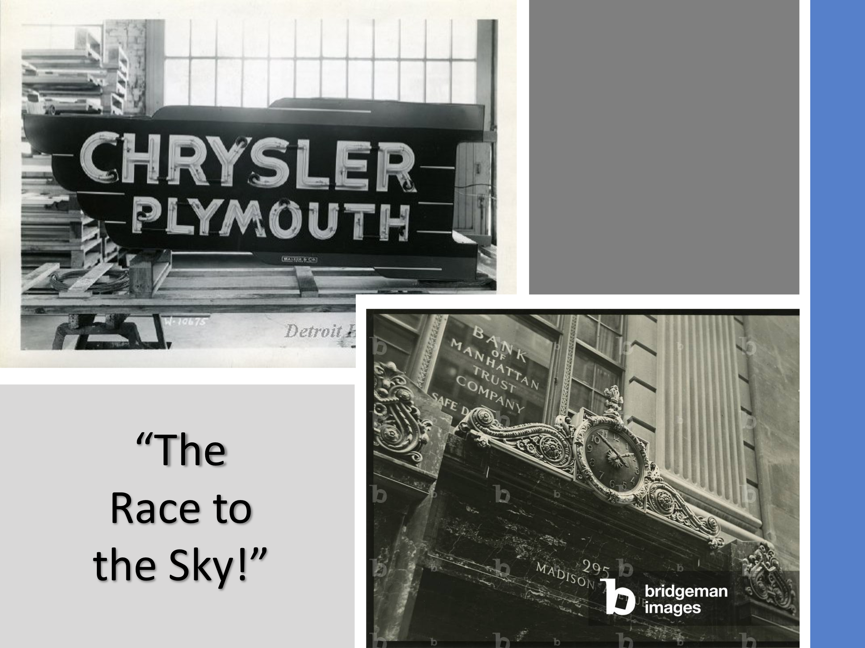
However, when we make decisions driven by self-interest, pride, or fear—without seeking God's guidance and aligning with His purpose—our plans are bound to falter, as God i s not at the center of them. Walter Chrysler dreamed of building the tallest skyscraper in the world. Competing with the Bank of Manhattan Trust in a press-fueled 'race to the sky,' his ambition was driven by pride—he admitted, 'I want to build a monument to me.' Though Chrysler succeeded, his achievement was quickly overshadowed by the Great Crash and the Great Depression, reminding us that worldly success without God is fleeting. This story reminds us that without God, even our greatest dreams will collapse. It challenges us to examine our own motives. Are your ambitions rooted in pride, or are they grounded in the desire to glorify God?

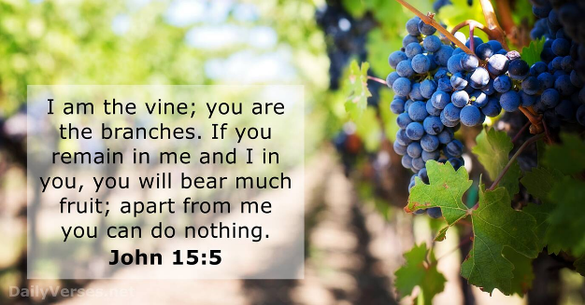
To be truly successful in God's kingdom, we must seek the will of the One who can accomplish far more than we could ever ask or imagine. As we dream of "unborn tomorrows," we must keep God's sovereignty at the forefront of our thoughts. Scripture teaches that when we act apart from Christ—the true Vine who sustains all things—our achievements may seem successful by the world's standards, but they are ultimately fleeting and meaningless (John 15:5, Matthew 6:19). Pursuing self-glorification is futile, as it depends on the approval of finite beings who have no control over the future. Therefore, before drafting our plans for success, we must first humbly bow before our Creator, seeking His guidance for what He desires us to accomplish in His kingdom.
Prayer is the key to discerning God's will. Consider Nehemiah: before undertaking the enormous task of rebuilding the walls of Jerusalem, he sought God's guidance through fasting and fervent prayer (Nehemiah 1:4-11). He didn’t rush into action but first aligned his heart with God’s plan. Because of his prayerful dependence, God gave him favor with the king and wisdom to lead. In the same way, when we seek God’s will and trust Him, we can move forward with boldness and passion. Though we neither know nor control the future, we can trust that God will guide us exactly where He wants us to go—not for our glory, but for His. God's guidance is the blueprint for true success!
Have you spent time in prayer seeking God's guidance for the dreams and plans you are pursuing? What areas of your life might need to be surrendered so that God can guide you toward His purpose?

God Opens and Closes Doors


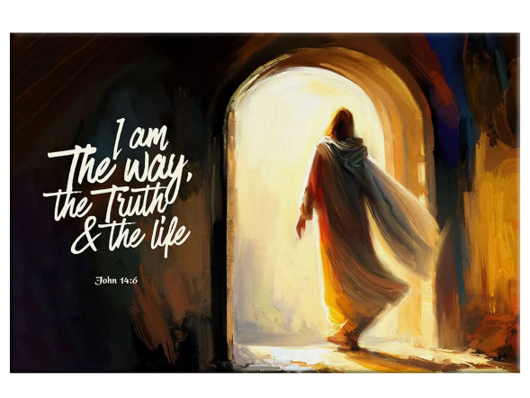
Even when we seek God’s guidance, we may still face closed doors. Yet these moments are not setbacks to fear—they may be part of God's greater plan to redirect and refine us. When we align our hearts with God's will through prayer and dependence on Him, we come to understand that He alone opens doors of opportunity and closes doors that no one else can shut (Revelation 3:7)—all in His perfect purpose and timing. Yet, failure often distorts this truth. Many internalize failure with negative thoughts, feeling shame, inadequacy, or fear of judgment. Others may view it as evidence that life is unpredictable and unfair, leading to frustration and disillusionment. Even Christians, in moments of failure, may question whether God has abandoned them. However, what if a closed door is not the end but rather an invitation to persevere—like the persistent widow who continued to seek justice until it was granted (Luke 18:1-8)? Trials, as James reminds us, develop perseverance and maturity in faith (James 1:2-4). Sometimes, God’s closing of a door may be His way of redirecting us to greater purposes. If God had not severed Moses' connection to Pharaoh's court, he would not have been the one to lead Israel and speak to God 'as one speaks to a friend (Exodus 33:11). If God had not prevented Paul from going to Bithynia, Paul would not have taken the Gospel to Macedonia. Even when failure results from sin, it offers an opportunity for repentance and spiritual growth, guiding us back to remain faithfully connected to Christ, the true Vine. As you reflect on your plans and dreams, seek God with renewed commitment. Trust Him to guide you through both open and closed doors, knowing His purpose is always greater than what we can imagine.

Jesus is the Way Maker

As we reflect on God's sovereignty in closing and opening doors, we are reminded that Jesus, the “Waymaker,” is always leading us toward God's perfect plan. He not only closes doors to redirect us but opens doors of opportunity, guiding us into God's perfect plan. John declares that Jesus is "the way, the truth, and the life" (John 14:6), emphasizing that when we follow His will, the doors He opens lead us to abundant, God-glorifying lives. Is anything too difficult for the Lord who spoke, "Let there be light," and there was light (Genesis 1:3), who commanded, "Lazarus, come out!" and the dead man rose (John 11:43), and who freed a man possessed by a legion of demons with a single word (Mark 5:8)? If we truly desire to please God and accomplish great things in His name, we must step forward in faith through the doors He opens for us, even when their purpose is not immediately clear. We must resist seeing these doors through the lens of past regrets, failures, or shame. We are not defined by the labels of our past or by our weaknesses. Instead, Christ reminds us that His grace is sufficient and His power is made perfect in our weakness (2 Corinthians 12:9). Since He alone defines our identity and potential, let us see His open doors as invitations to fulfill His purposes. What door has God opened for you that you may be hesitating to walk through? Trust in Jesus, the Waymaker. Step through the doors He opens with bold faith, knowing that His plans are far greater than you can imagine.

Cutting the Rope

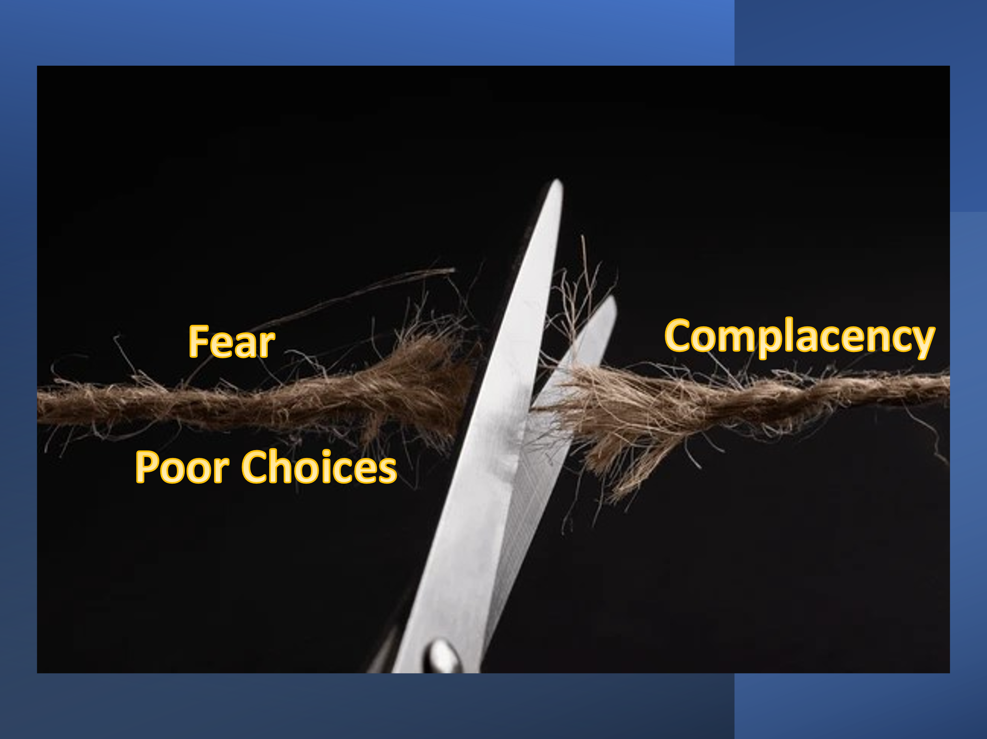
Trusting Jesus as the Waymaker means more than just waiting for opportunities—it requires action. Sometimes, stepping through the doors God opens means cutting the rope of complacency, fear, and poor choices that hold us back. We often fall into the trap of doing the same things repeatedly, expecting different results. Mark Batterson wisely states, “Your actions are perfectly designed to achieve the results you are getting.” Many Christians live as if their purpose is simply to avoid risk and arrive safely at death. But if we are to please our Master and do great things in His name, our knowledge of God must move from our heads to our hearts and be lived out in faith.
Apostle James warns us that merely listening to God's word without action is deceptive, giving a false sense of holiness (James 1:22-25). The Pharisees of Jesus’ time had vast knowledge of the Scriptures, yet their refusal to live out God’s word caused Jesus to call them “whitewashed tombs,” beautiful on the outside but filled with spiritual death and decay (Matthew 23:27). A lack of desire to let Christ rule your life can be an indication of spiritual separation from Him. Yet even those who have been born of the Spirit are not exempt from continually seeking God's will and walking through the doors He opens—especially when we do not fully understand what lies ahead. Therefore, let us “trust in the Lord with all our hearts and lean not on our own understanding. In all our ways, let us submit to Him, and He will make our paths straight” (Proverbs 3:5-6).
So, how can we cut the rope of complacency and fear and live a life worthy of the Gospel message (Philippians 1:27)? Breaking free from the routines and habits that trap us can be exceptionally difficult. Living for Jesus begins with intentional prayer and meditation, asking forgiveness for the ways we have been “neither hot nor cold” (Revelation 3:16) and often walking in sin. We are called to seek the One who promises to draw near to us when we draw near to Him (James 4:8). Since old routines will not produce new results, we must daily ask God through prayer to reveal His perfect and pleasing will for our lives (Romans 12:1-2).
When the Lord opens doors of opportunity for ministry, we must boldly approach the throne of grace (Hebrews 4:16), asking Him for the strength and courage to thrive in His kingdom for His glory. And when insecurity and fear from past failures arise, we must stand firm in faith, trusting that God’s plan is greater than our understanding. To continually remind ourselves of His sovereignty and faithfulness, let us keep a journal of the doors He has opened—recording both the challenges and victories He has granted in His name. This practice will help us remember that God is always at work, leading us step by step into His perfect plan.

Conclusion

As we close, let us reflect on the powerful truth that God is continually at work in our lives, opening and closing doors for His divine purposes. Jesus, the Waymaker, has the authority to lead us into abundant, God-glorifying lives. But walking through those doors requires action. It requires cutting the rope of complacency, fear, and sin that holds us back. Are you ready to trust Him fully and step into His plans for your life?
No matter what you face—closed doors, past failures, or uncertainty—trust in the Lord with all your heart. Surrender your thoughts, dreams, and plans to Him, knowing that His grace is sufficient and His power is made perfect in your weakness. Stand firm in faith and boldly approach the throne of grace. Remember, His plans for you are far greater than you can imagine. What step of faith is God calling you to take today?

Let’s commit to seek His will daily, trust His timing, and courageously walk through the doors He opens, bringing glory to His name. Amen.

Ibid., 2588.
Ibid., Location 2482.

