Prince of Peace

  - Isaiah 9:1-7
  - Online Sermon:
  - www.mckeesfamily.com/sermons/


The Oxford Dictionary defines peace as "freedom from disturbance; tranquility, and the cessation of war." Those who are at peace experience freedom from anxiety and distress. Yet, with such an all-encompassing definition, one cannot help but wonder: Is complete peace within one’s heart merely an illusion, destined never to be fully realized? In response to what experts call a "mental health crisis," Canada has allocated $2.5 billion over the next ten years, while the United States spends a staggering $282 billion annually. While genetics and chemical imbalances in the brain undoubtedly play a role in mental health challenges, life circumstances often serve as the primary triggers. We live in a world where one in four girls and one in six boys will experience some form of sexual abuse before the age of 18. Additionally, 29% of women and 10% of adult men report having experienced rape, physical violence, or stalking by a partner. According to the FBI Crime Clock, violent crimes occur with alarming frequency—murders, assaults, and thefts paint a sobering picture of our world’s deep unrest. Though these statistics may not be flawless, they undeniably expose a world profoundly lacking in peace. With the war between Israel and Gaza, the collapse of the Syrian government, the conflict between Russia and Ukraine, and the looming specter of global unrest, one must ask: Who among us can truly claim to feel tranquility and a deep sense of peace? Amid such turmoil, it’s no wonder so many feel overwhelmed by fear, anxiety, and hopelessness. Perhaps you’ve experienced moments where peace felt distant—whether through personal loss, illness, or unexpected hardship.


In the face of such overwhelming brokenness, where suffering and chaos seem unending, it becomes clear that humanity's greatest need is not another policy, treaty, or program—but a Savior. And amid this darkness, the Star of Bethlehem shines brightly, casting its light upon the Babe lying in a manger—a sign of God's divine intervention and a peace that surpasses all understanding. Seven hundred years before His arrival, God spoke through the prophet Isaiah, giving humanity a glimpse of the most precious gift it would ever receive. This child would not be ordinary; He would be born of a virgin and called Immanuel—God with us (Isaiah 7:14). Though He had no beauty or majesty to attract us to Him (Isaiah 53:2), and though He would be despised and rejected as a Man of Sorrows (Isaiah 53:3), He would also be our Redeemer (Isaiah 41:14), our Shepherd (Isaiah 40:11), our Sovereign Lord (Isaiah 40:10), and our King (Isaiah 32:1). Yet, among all His titles, the one that brings both profound hope and lingering confusion is Prince of Peace (Isaiah 9:6). In a world still marred by hatred, wars, famines, earthquakes, and diseases, many struggle to understand how this child in a manger could truly embody the title of Prince of Peace. But His peace was never about the absence of external conflict—it was always about the presence of God in the hearts of those who believe.
In today’s sermon, we will discover that the peace Christ offers is not the absence of all tribulations but rather a deep, abiding peace within our souls, anchored in the assurance that we are eternally part of His family. Just as King David declared in Psalm 23, though we may walk through the valley of the shadow of death, we will fear no evil, nor will our spirits be broken, for Christ is with us. His rod and staff comfort us, guiding and protecting us through every trial. The peace Christ gives transcends our understanding. In His birth, His miracles, and His words, we find comfort and strength amidst life’s storms, for He is our Lord, Savior, and King.

Peace at Jesus’ Birth



But amid the brokenness and despair of our world, God did not leave us without hope. The birth of Christ declared a peace unlike any other—a peace not rooted in circumstances but in the presence of God Himself, breaking into our reality with eternal hope. Luke recounts that on a quiet night, shepherds were "living out in the fields nearby, keeping watch over their flocks at night" (Luke 2:8). Suddenly, an "angel of the Lord appeared to them, and the glory of the Lord shone around them, and they were terrified" (Luke 2:9). But the angel’s words brought reassurance: "Do not be afraid. I bring you good news that will cause great joy for all the people. Today in the town of David a Savior has been born to you; He is the Messiah, the Lord. This will be a sign to you: You will find a baby wrapped in cloths and lying in a manger" (Luke 2:10-12). In an instant, "a great company of the heavenly host appeared with the angel, praising God and saying, 'Glory to God in the highest heaven, and on earth peace to those on whom His favor rests'" (Luke 2:13-14). Moved by this heavenly proclamation, the shepherds hurried to see the child and, upon finding Him just as the angel had said, they "returned, glorifying and praising God for all the things they had heard and seen, which were just as they had been told" (Luke 2:20). This encounter reminds us that Christ's peace isn’t the absence of conflict but the presence of God, bringing eternal hope, joy, and unshakable peace.
The story of Christ's birth declares joy and peace for everyone, regardless of status. In Jewish society, shepherds held one of the lowest positions, viewed as untrustworthy and considered ceremonially unclean by religious standards. Yet, in an extraordinary display of God's grace and intentionality, He chose these social outcasts to receive and proclaim the greatest announcement in history—the birth of His Son! In a world where voices often go unheard, we find joy in knowing the Good Shepherd calls us by name—not because of genealogy, race, or status, but because we are made in His image (Genesis 1:27). He is the one who searches for the lost sheep and rejoices when even one sinner repents (Luke 15:1-7), celebrating their radical transformation into a new creation (2 Corinthians 5:17-20) and their adoption into His eternal family (Romans 8:15). Having been rejected by His own people and unjustly sentenced to crucifixion under a government boasting the world’s most advanced legal system, Christ intimately understands injustice, suffering, and rejection. And just as we face temptation, hatred for His name, and the valleys of tribulation, our Good Shepherd offers us a peace that surpasses all understanding—a peace wrapped in forgiveness, grace, and mercy, a fortress to shield us, and a rock upon which we can stand, unshaken and secure (Psalm 18:2).

Peace from His Miracles

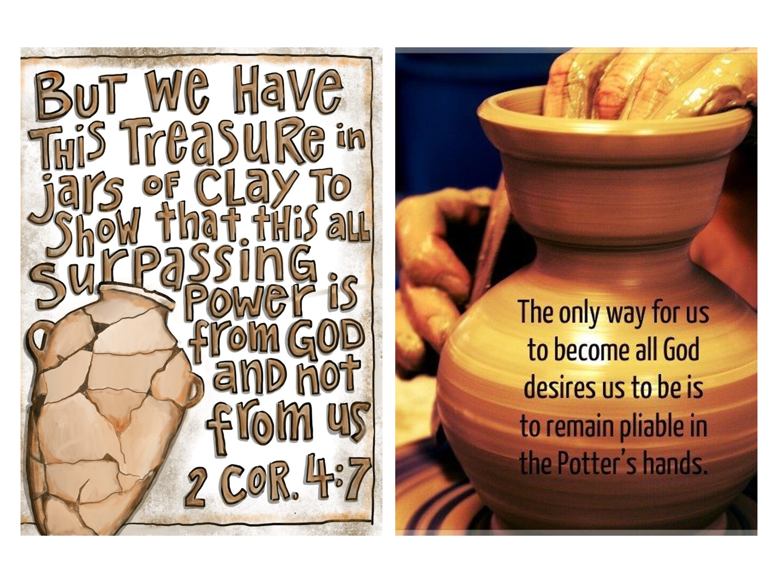
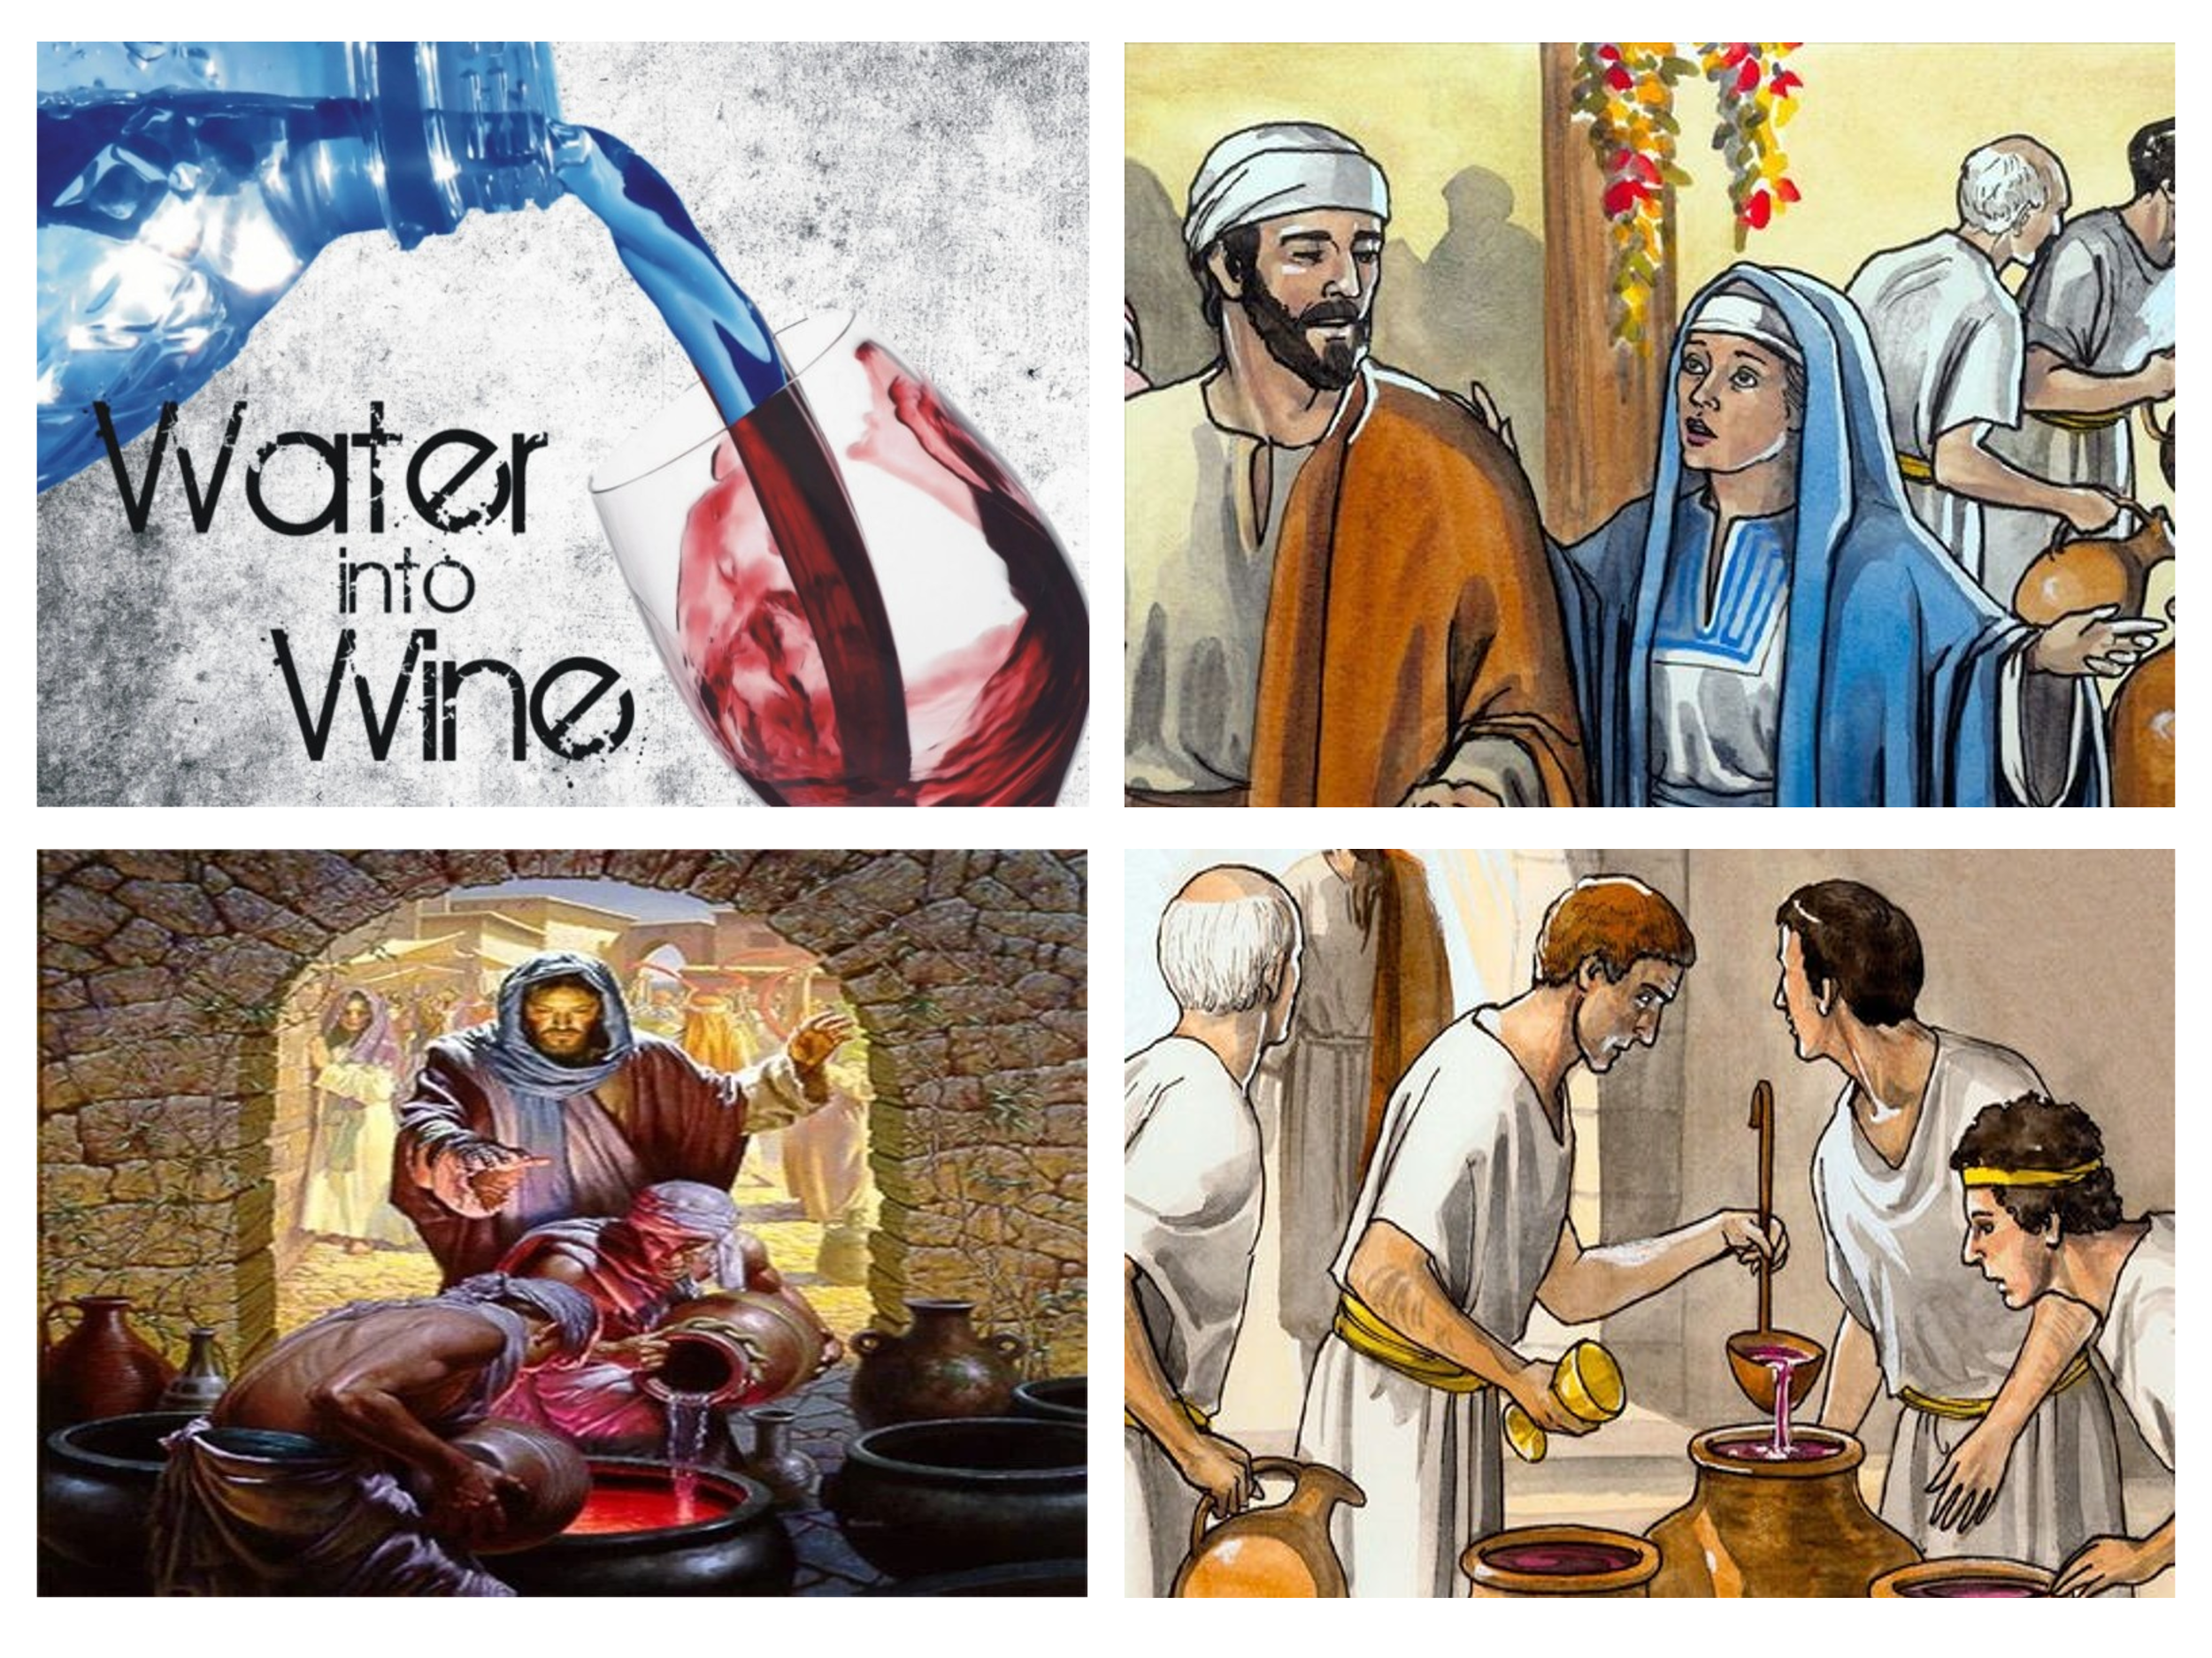
The peace Christ offers isn't confined to His birth alone. Throughout His ministry, Jesus performed miracles that demonstrated His authority, compassion, and power—each revealing His ability to bring peace into the chaos of life. This supremacy was displayed vividly at a wedding in Cana, where Jesus performed His first miracle—a sign of His divine authority and power. The Apostle John recounts this remarkable event, where Jesus, His disciples, and His mother Mary were present (John 2:1-2). As the celebration unfolded, Mary informed Jesus of a crisis: 'They have no more wine' (John 2:3). In Cana, running out of wine at a wedding was a community-wide disgrace. Despite reminding Mary that His time had not yet come (John 2:4), she faithfully instructed the servants, 'Do whatever He tells you' (John 2:5). At Jesus' command, the servants filled six stone water jars with water, which He then transformed into the finest wine (John 2:6-8). The master of the banquet marveled, saying, 'Everyone serves the best wine first, but you’ve saved the best till now' (John 2:10). Though the purpose isn’t explicitly stated, this miracle reveals Christ’s transformative power—'turning water into wine, sinners into saints.' This miracle was not merely about avoiding social embarrassment; it was a profound sign of Christ's ability to bring abundance, joy, and transformation to every aspect of our lives.
The miracle at Cana wasn’t just about meeting a need—it revealed Christ's authority, bringing transformation and peace into ordinary life. Yet, His miracles extended far beyond turning water into wine! In a world filled with sickness, pain, and despair, isn’t it comforting to know that we can appeal to the Great Physician? He healed the paralytic (Matthew 9:1-8), restored the sight of Bartimaeus (Matthew 20:29-34), freed a mute demon-possessed man (Matthew 9:32-33), cleansed ten lepers (Luke 17:11-19), and even raised the dead—Jairus’ daughter (Matthew 9:18-26), the widow’s son (Luke 7:11-17), and Lazarus (John 11:1-44). When we see natural disasters, storms, and scarcity in our world, isn’t it reassuring to know that Christ can calm raging storms (Matthew 8:23-27), feed multitudes with a few loaves and fish (Matthew 14:13-21), and even walk on water (Matthew 14:22-33)? Every miracle reveals Christ's divinity, compassion, and authority over all of life. Though we are fragile like jars of clay (2 Corinthians 4:7), it is by His mighty arm that we are sustained, strengthened, and enabled to flourish, even amidst life’s fiercest storms. What profound peace there is in knowing that nothing is too great for our Lord, Savior, and King to accomplish on our behalf!

Peace in His Words

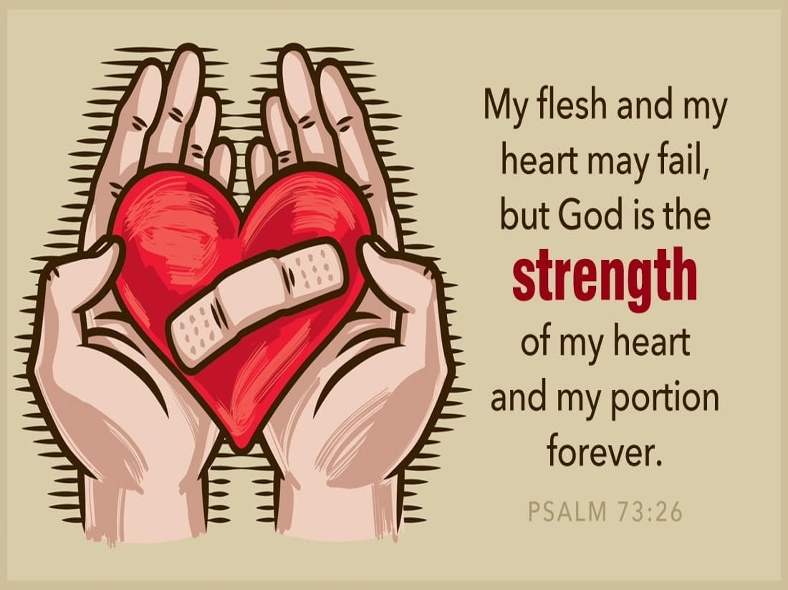
The peace of God that believers experience flows not only from Christ’s birth and miracles but also from His life-giving words. When we grow weary and burdened by life’s relentless demands, we can come to the Good Shepherd and receive His promised rest: “Take My yoke upon you and learn from Me, for I am gentle and humble in heart, and you will find rest for your souls. For My yoke is easy and My burden is light” (Matthew 11:28-30). In the face of life’s inevitable storms, we are assured that our Lord has sovereign power to rebuke the winds of tribulation, commanding them to be quiet and still (Mark 4:39). Though trials are difficult, James urges us to 'consider it pure joy... because the testing of your faith produces perseverance' (James 1:2-4). Our peace isn’t ignorance or blind optimism; it’s rooted in the truth that nothing can separate us from Christ's love. He alone is our portion, our strength, and our inheritance—now and forevermore (Romans 8:38-39; Psalm 73:26). In Him, we find true peace, a peace that surpasses all understanding and guards our hearts and minds (Philippians 4:7).

Conclusion

In a world filled with turmoil, brokenness, and uncertainty, the peace Christ offers stands as a beacon of unshakable hope. This peace is not tied to fleeting circumstances or temporary relief but is anchored in the eternal presence of God. Through His birth, His miracles, and His life-giving words, Christ has shown us that true peace is found not in the absence of conflict but in the presence of the Prince of Peace Himself. When life’s storms rage around us, and we are burdened by fear, grief, or uncertainty, we can cling to the promise of Jesus: “Peace I leave with you; My peace I give you. I do not give to you as the world gives. Do not let your hearts be troubled and do not be afraid” (John 14:27). The world may offer momentary distractions or fleeting comforts, but only Christ offers a peace that endures through every trial and every storm. Let us, therefore, fix our eyes on Jesus—the Author and Perfecter of our faith (Hebrews 12:2)—trusting in His promises, walking in His peace, and resting in His unfailing love. This week, I encourage you to intentionally seek Christ’s peace in your life. Whether it’s through prayer, spending time in God’s Word, or reaching out to someone in need, take a step towards embracing His peace. Ask yourself: In what area of my life do I need to surrender to Christ’s peace today? Start your day this week with prayer and Scripture focused on Christ’s peace.
No matter what we face, we can stand secure, knowing that Christ is our refuge, our strength, and our everlasting peace. May His peace guard your hearts and minds today and always. Amen.

Catherine Soanes and Angus Stevenson, eds., Concise Oxford English Dictionary (Oxford: Oxford University Press, 2004).
Taken from the following website: Budget 2023 Out Of Touch With Mental Health Crisis l CMHA National
Taken from the following website: Mental Health Is Costing the US Economy Billions — Increasing Access Could Be the Solution | Columbia Business School
Taken from the following website: 2015MediaPacketInsertsFINAL508.pdf
Taken from the following website: Domestic Violence Statistics by State (2024 Update) - Law Office of Louis J. Goodman
Taken from the following website: violent crime deaths per minute united states - Google Search
Walter L. Liefeld, “Luke,” in The Expositor’s Bible Commentary: Matthew, Mark, Luke, ed. Frank E. Gaebelein, vol. 8 (Grand Rapids, MI: Zondervan Publishing House, 1984), 845.

