Kiss the Wave

  - Exodus 14
  - Online Sermon: http://www.mckeesfamily.com/?page_id=3567

“The obstacle is not the enemy; the obstacle is the way”

With approximately 120 billion neurons, each capable of forming 10,000 or more synapses, the human brain is a marvel of divine craftsmanship. King David’s words resonate deeply: “I praise you because I am fearfully and wonderfully made; Your works are wonderful; I know that full well” (Psalm 139:14). Remarkably, neuroscientists like Dr. Wilder Penfield discovered that our brains could record every experience in vivid detail, much like an internal hard drive in our cerebral cortex. Yet, this God-given gift of memory often becomes a battleground where we struggle to recall events rightly and bury the pain of dead yesterdays. Mark Batterson captures this tension well, reminding us that while we may not be responsible for what happens to us, we are “response-able.” Trials, like raging hurricanes, are often beyond our control, but how we respond is not. Will we let pain own and destroy us, or will we choose to rely on God, allowing adversity to deepen our faith and love for our Creator? This sermon will explore how to transform our natural inclination to blame God during difficult times into opportunities to trust and grow in Him. Despite the astounding complexity of our God-designed minds, they often become the stage where we wrestle with pain, doubts, and the weight of past experiences.
Our memories, designed by God to recall His faithfulness, can instead magnify our pain and doubts. This was true for the Israelites, who, despite witnessing God’s miracles, struggled to trust Him in the wilderness.

Blaming God



Imagine what it must have been like to be an Israelite during the time of Moses. To hear him boldly proclaim to Pharaoh, “Let my people go,” in the face of the ruler who had enslaved, whipped, and worked your family into lives of misery and premature death, must have filled your heart with hope. Witnessing the power of God as the Nile, the lifeblood of Egypt’s gods, turned to blood, followed by plagues of frogs, gnats, flies, disease, boils, hail, locusts, darkness, and the death of the firstborn (Exodus 7–11), would have been undeniable proof that the God of Abraham, Isaac, and Jacob was not only real but had come to deliver His people. Leaving Egypt with the wealth of your oppressors in hand, granted by favor from the Egyptians, must have seemed like the pinnacle of faith. Yet, just three days into the journey, the desert heat and the bitter water at Marah eroded that newfound trust, leading to complaints against Moses and God (Exodus 15:22–24). By the fifteenth day of the second month, you were already longing for the predictability of Egyptian oppression, lamenting that death in slavery seemed preferable to starvation in freedom (Exodus 16:1–3). This pattern of doubt and rebellion ultimately culminated in Christ’s heartbreaking accusation centuries later: "O Jerusalem, Jerusalem, you who kill the prophets and stone those sent to you!" (Matthew 23:37–38), underscoring humanity's persistent failure to fully trust in God's power and promises. Yet, as incredible as these miracles were, the Israelites’ faith wavered almost immediately when faced with the harsh realities of the wilderness, revealing how quickly we forget God’s power in the face of new challenges.
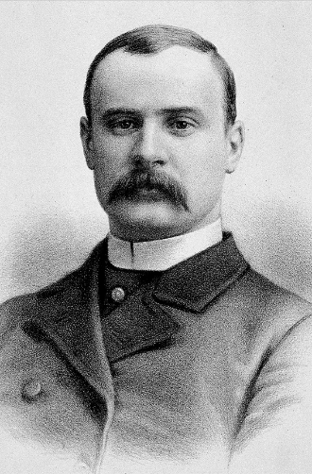
But how do we move from blaming God to trusting Him in our darkest moments? The answer lies in remembering His promises and leaning on His Word. When we find ourselves in tribulations, we often respond like the Israelites—forgetting God's past providence and instead blaming Him for our present struggles. How easily we, like Job, view our trials not only as injustices but as evidence of God’s neglect! Even if we refrain from directly blaming Him, we are often quick to torment ourselves with doubts, asking whether our "new normal" will have any semblance of dignity or joy. Yet, if we truly believe the promise that “in all things God works for the good of those who love Him, who have been called according to His purpose” (Romans 8:28), we can look beyond the pain and suffering to embrace the truth that God will never leave nor forsake us—He loves us so deeply that He gave His only Son, Jesus, to die for our sins (John 3:16). While God sometimes delivers us from suffering, more often He delivers us through it, transforming our valleys of tribulation into fertile grounds where faith and spiritual maturity can grow (James 1:2–4). When we choose to trust in the Lord with all our heart and lean not on our own understanding (Proverbs 3:5–6), we open ourselves to His sustaining grace. The obstacle is not the enemy, the obstacle is the way. Are you blaming God for your current circumstances, or are you trusting Him to carry you through?

Yet, just as the Israelites needed to trust God in their wilderness, so must we learn to ‘kiss the wave’ in our own trials, embracing the challenges that drive us closer to the Rock of Ages. Joseph Merrick and Charles Spurgeon offer powerful examples of how faith transforms suffering.

Kiss the Wave

Let me tell you about a man who exemplified being "response-able," persevering through profound challenges with remarkable grace. Joseph Merrick, born in Leicester, England, on August 5, 1862, endured severe physical deformities: his fingers were unusable stubs, his head was as large as a man's waist, his distorted mouth rendered his speech almost unintelligible, his right arm was twice the size of his left, and his legs struggled to support his weight. Despite these obstacles, Merrick sought work and was eventually hired as the "half-man, half-elephant" in a human circus. There, Dr. Frederick Treves, a compassionate surgeon, encountered Merrick and brought him to the London Hospital, where he would spend his remaining years. Initially, his appearance terrified the hospital staff, but over time, kindness broke through their fear. On one memorable day, Dr. Treves arranged for a woman to greet Merrick warmly, smile at him, and shake his hand—small gestures that moved him to tears, as he revealed this was the first time a woman had ever shown him such kindness. When Merrick passed away at the age of 27, Dr. Treves eulogized him, saying, "His troubles had ennobled him. He showed himself to be a gentle, affectionate, and lovable creature … without grievance and without an unkind word for anyone. I have never heard him complain." How could a man with such profound challenges and limited human connection find happiness?
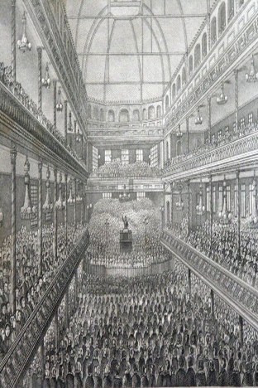
Perhaps Merrick's resilience, capacity for gratitude, and the kindness he received can be likened to lessons drawn from the life and writings of Charles Spurgeon. On October 19, 1856, Spurgeon was preaching to a crowd of ten thousand at London’s Surrey Gardens Music Hall when someone shouted “Fire!” The ensuing panic left seven people dead and twenty-eight seriously injured. The London press harshly blamed Spurgeon, and the tragedy weighed so heavily on him that even the sight of a Bible would bring him to tears, haunted by the memory of those who had suffered. How could someone marked by such devastating pain ever find the strength to carry on? Yet, despite his lingering melancholy, Spurgeon went on to pastor the largest church of his time, the Metropolitan Tabernacle, at the age of twenty, author 150 books, establish a college, and lead over sixty charities. When asked how he overcame such trials, he famously wrote, “I have learned to kiss the wave that throws me against the Rock of Ages.” For Spurgeon, the goal was not simply to escape adversity but to allow God to transform his heart through it, enabling him to guide others toward hope, peace, and assurance in the midst of their storms.
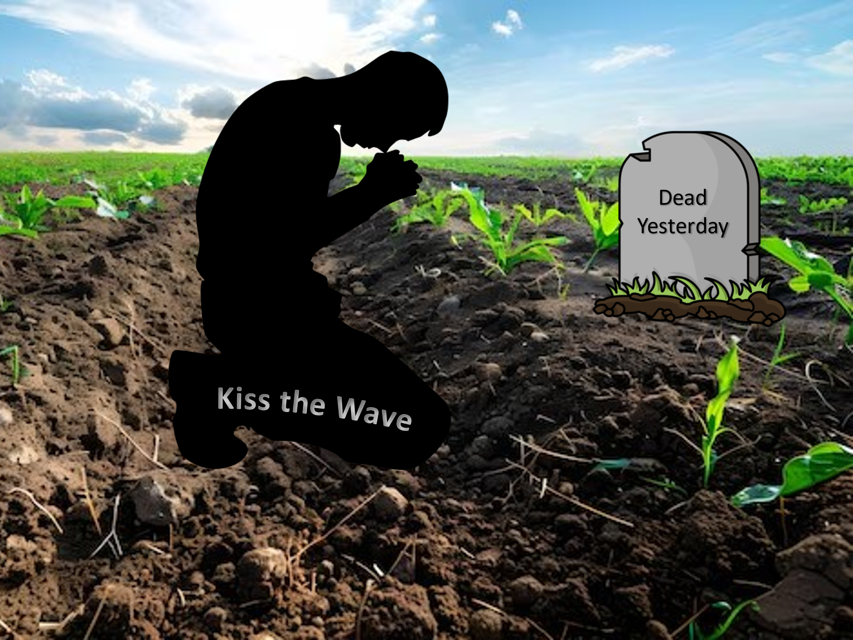
To "kiss the wave" is far from easy, as it demands placing our full trust in a sovereign God. In the face of trials, our “natural instinct” i s to escape—whether by trying to "buy" our way out, seeking advice from others, or relying on sheer willpower to endure until the storm passes. However, if we are to embrace Charles Spurgeon’s challenge to "kiss the wave," we must move beyond viewing tribulations as purely negative or conquerable through our efforts alone. Faith and spiritual maturity are cultivated in the fertile soil of adversity, where reliance on God’s grace becomes essential. As Mark Batterson rightly observes, "Christians often confuse self-sufficiency with spiritual maturity," when true growth comes through complete surrender. Only by entrusting our struggles to God can we redeem the darkest valleys of our lives and bury "dead yesterdays" for good. Imagine if David, pursued by King Saul, had not trusted God—he might never have survived to become Israel’s king and a "man after God’s own heart" (Acts 13:22). Likewise, had Noah lacked faith, could he have persevered through over a century of ridicule to complete the ark that would save his family? Trusting in God’s providence transforms trials into opportunities for spiritual growth and redemptive grace.

Dealing with the Scars

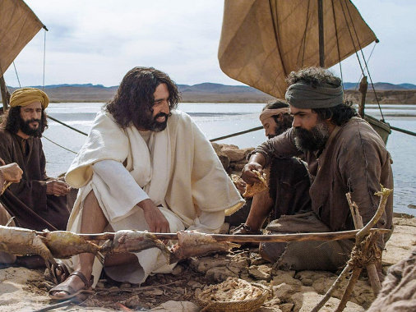
Learning to "kiss the wave" is not merely about enduring trials in the moment but also about living with the marks those trials leave behind. Scars, both physical and emotional, bear witness to God’s grace in the aftermath of pain. Yet, when tragedy strikes, we often adopt counterproductive coping mechanisms—clinging to the pain rather than releasing the scar tissue that forms in our hearts. This was the case for Peter. Despite Christ’s clear warning, “This very night, before the rooster crows, you will deny Me three times,” Peter, in his bold self-assurance, declared, “Even if I have to die with You, I will never disown You” (Matthew 26:31–35). Yet, he soon denied Christ and wept bitterly over his failure. Imagine the torment Peter endured as the morning rooster crowed, a daily reminder of his betrayal. Overwhelmed by disgrace and deeply wounded, Peter returned to his old life as a fisherman, abandoning the calling Christ had given him. But at the Sea of Galilee, Jesus restored Peter, asking three times if he loved Him and reaffirming his mission to serve (John 21:15–25). Remarkably, this restoration took place at dawn—the same time the rooster’s crow had marked Peter’s failure. From Peter’s story, we learn that the One pierced by nails offers grace, mercy, and forgiveness to His own, transforming scars into testimonies of healing and restoration. He invites us to flip the script, embracing the abundant life He intends for us, marked by joy, resilience, and the knowledge that He alone is our portion.

Conclusion

Our scars are reminders—not of defeat, but of God’s faithfulness. They bear witness to the waves we’ve kissed and the Rock we’ve clung to. Let us remember that the God who designed our minds to recall His goodness and power is the same God who uses our scars to shape us into His image. When we choose to trust Him amid pain, we declare His sovereignty over our lives and allow His strength to be made perfect in our weakness.

This week, I encourage you to take three practical steps to live out this message:
- Identify one ‘wave’ you’ve been resisting and choose to ‘kiss’ it by praying for God’s guidance instead of trying to escape it. Ask Him to show you what He wants to teach you through this challenge.

- Share your testimony of how God has brought you through a difficult time with one person. Let your scars become a testimony of His grace and encourage someone else who might be struggling.

- Spend 15 minutes each day reflecting on how God’s promises can reshape your perspective on pain. Meditate on Scriptures like Romans 8:28 or Psalm 34:18 and invite the Holy Spirit to bring comfort and clarity.

These steps will help you turn your trials into testimonies and your scars into stories of God’s redemptive power. Like Peter, Merrick, and Spurgeon, you are invited to move beyond blaming God or yourself and instead embrace His healing and restoration.

Will you trust Him today to redeem your trials and turn your scars into a story of hope, healing, and unwavering faith? Let us step forward together, proclaiming with confidence that the God who brings beauty from ashes will continue to transform our brokenness into something beautiful for His glory.

Mark Batterson, Win the Day: 7 Habits to Help You Stress Less & Accomplish More, Kindle Location 813.
Taken from the following website: https://neuroscience.ucdavis.edu/news/making-and-breaking-connections-brain
Ibid.
Ibid., Location 831
Ibid., Location 990.
Ibid., Location 844
Ibid., Location 861
Ibid., Location 923
Ibid., Location 883
Ibid., Location 1012
Ibid., Location 1194

