# **Flip the Script**

Genesis 50:20

Online Sermon: <http://www.mckeesfamily.com/?page_id=3567>

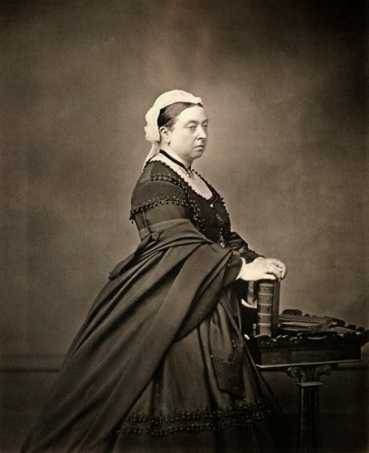Queen Victoria ruled over the British Empire from 1837 to 1901, marking a 63-year reign that not only set a record in Britain but also defined an era known as the Victorian Age. Shortly after ascending the throne, she fell deeply in love with Francis Albert Augustus Charles Emmanuel and, just five days after his arrival at Windsor Castle, proposed to him. On their wedding day, February 10, 1840, Queen Victoria wrote in her diary: “How can I ever be thankful enough to have a husband… to be called by names of tenderness I have never yet heard used for me – it was bliss beyond belief! Oh! This is the happiest day of my life!”[1]

The couple shared a profound love and had nine children together. However, tragedy struck 21 years into their marriage when Albert contracted typhoid fever and passed away. Overcome with grief, Victoria turned Albert’s room into a shrine, keeping it as though he might return. She even slept with his nightshirt in her arms. Though part of her died with Albert, she seemed to stop living altogether, becoming famously known as the 'Widow of Windsor.”

# **His Name, Our Story**

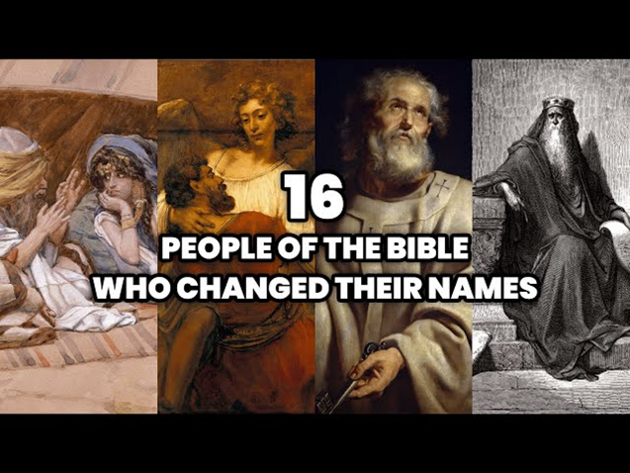Queen Victoria’s grief became her identity, binding her to loss rather than the vibrant life she once lived. But history reminds us of others who refused to let their circumstances or even their names define them. Michael King became Martin Luther King Jr. to honor a reformer’s legacy; Cassius Clay became Muhammad Ali to align with his faith; and Mozart continually reimagined himself through his name. Yet true and lasting transformation goes deeper—it requires divine intervention. In Scripture, God renamed Abram to Abraham, Sarai to Sarah, and Jacob to Israel, marking not just a change in name but in identity, purpose, and destiny. As the saying goes, “The difference between success and failure is the stories we tell ourselves.”[2] If we allow tragedy to dictate our narrative, like Queen Victoria, we risk living in defeat and despair. But when we anchor our identity in God’s unchanging character and trust Him with our destiny, even in our trials, we experience divine comfort (2 Corinthians 1:3-5), spiritual growth (James 1:2-4), and an indescribable, unspeakable joy (1 Peter 1:8). What stories are you telling yourself? Are they shaped by fear, doubt, or faith in God’s promises?

The stories we tell ourselves define not just our identity, but what we believe is possible through God’s power. The Australian sailing team serves as a powerful example of this principle, showing us what happens when determination meets faith.

# **Telling Yourself a Different Story**

On August 22, 1851, Queen Victoria watched as Commodore John Cox Stevens and his six-man crew claimed victory in the America's Cup, beginning the New York Yacht Club's unprecedented 132-year winning streak.[3] Imagine the challenge faced by the Australian team decades later as they prepared to face such giants. To overcome history, they needed to rewrite their story. For three years, each team member listened twice daily to a recording of a sailboat cutting through water, vividly imagining themselves winning the race—2,190 rehearsals of victory etched into their minds. On September 26, 1983, aboard Australia II, skippered by John Bertrand, they turned visualization into reality, shattering the New York Yacht Club's reign. What are the stories you are telling yourself? Are they accurate or inaccurate, helping or hurting you? Are they based on what doubters or haters of you say or like king David are you living a God-sized dream because you have given editorial and complete control of your life to the Author and Perfector of your faith? Their victory reminds us that rewriting our story requires vision, faith, and perseverance—qualities we see in David on the battlefield.

Just as the Australian sailors refused to let history dictate their fate and instead rewrote their story with vision, perseverance, and faith, David faced a similar choice on a very different battlefield. While others saw only an unbeatable giant and inevitable defeat, David saw an opportunity to trust God and change the narrative.

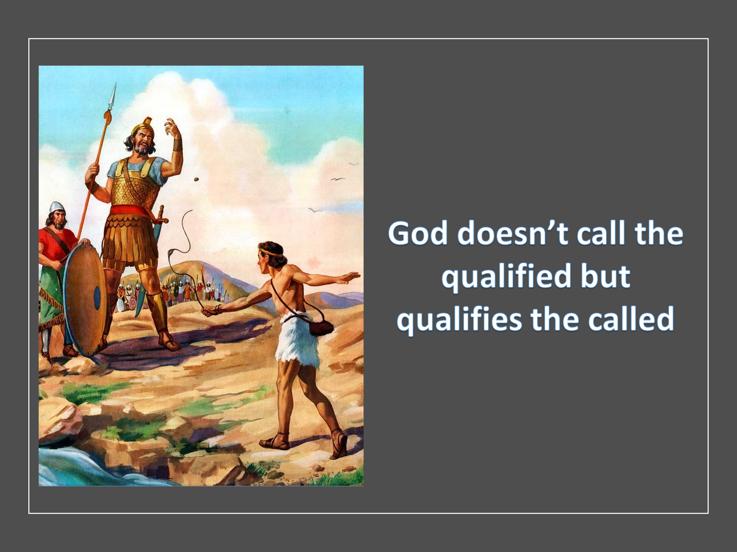 For forty days, the Philistine giant Goliath, a towering and fearsome warrior over nine feet tall, stepped onto the battlefield every morning and evening, taunting Israel and challenging any man to face him. Clad in armor weighing about 125 pounds, with bronze greaves on his legs, a bronze javelin slung across his back, and a spear whose tip alone weighed fifteen pounds, Goliath's imposing presence struck terror into the hearts of the Israelite army. But one day, a young shepherd boy named David arrived with food for his brothers and witnessed the Israelites fleeing in fear at the sight of the giant. To David, it was a disgrace that an "uncircumcised Philistine should defy the armies of the living God" (1 Samuel 17:26). Though he seemed the ultimate underdog, David's faith in God emboldened him to face Goliath without King Saul's armor, carrying only a staff, a sling, and five smooth stones.

As David declared, "You come against me with sword and spear and javelin, but I come against you in the name of the Lord," the crowd may have scoffed, but their laughter was short-lived. With one stone and divine intervention, David struck down Goliath, proving once again that God "doesn’t call the qualified but qualifies the called!" [4] What giants are you facing today? Fear, doubt, loss, or failure? Remember, God doesn’t call the qualified—He qualifies the called. Trust Him to author your story, and you’ll find victory in His strength.

# **Letting Go of the Past**

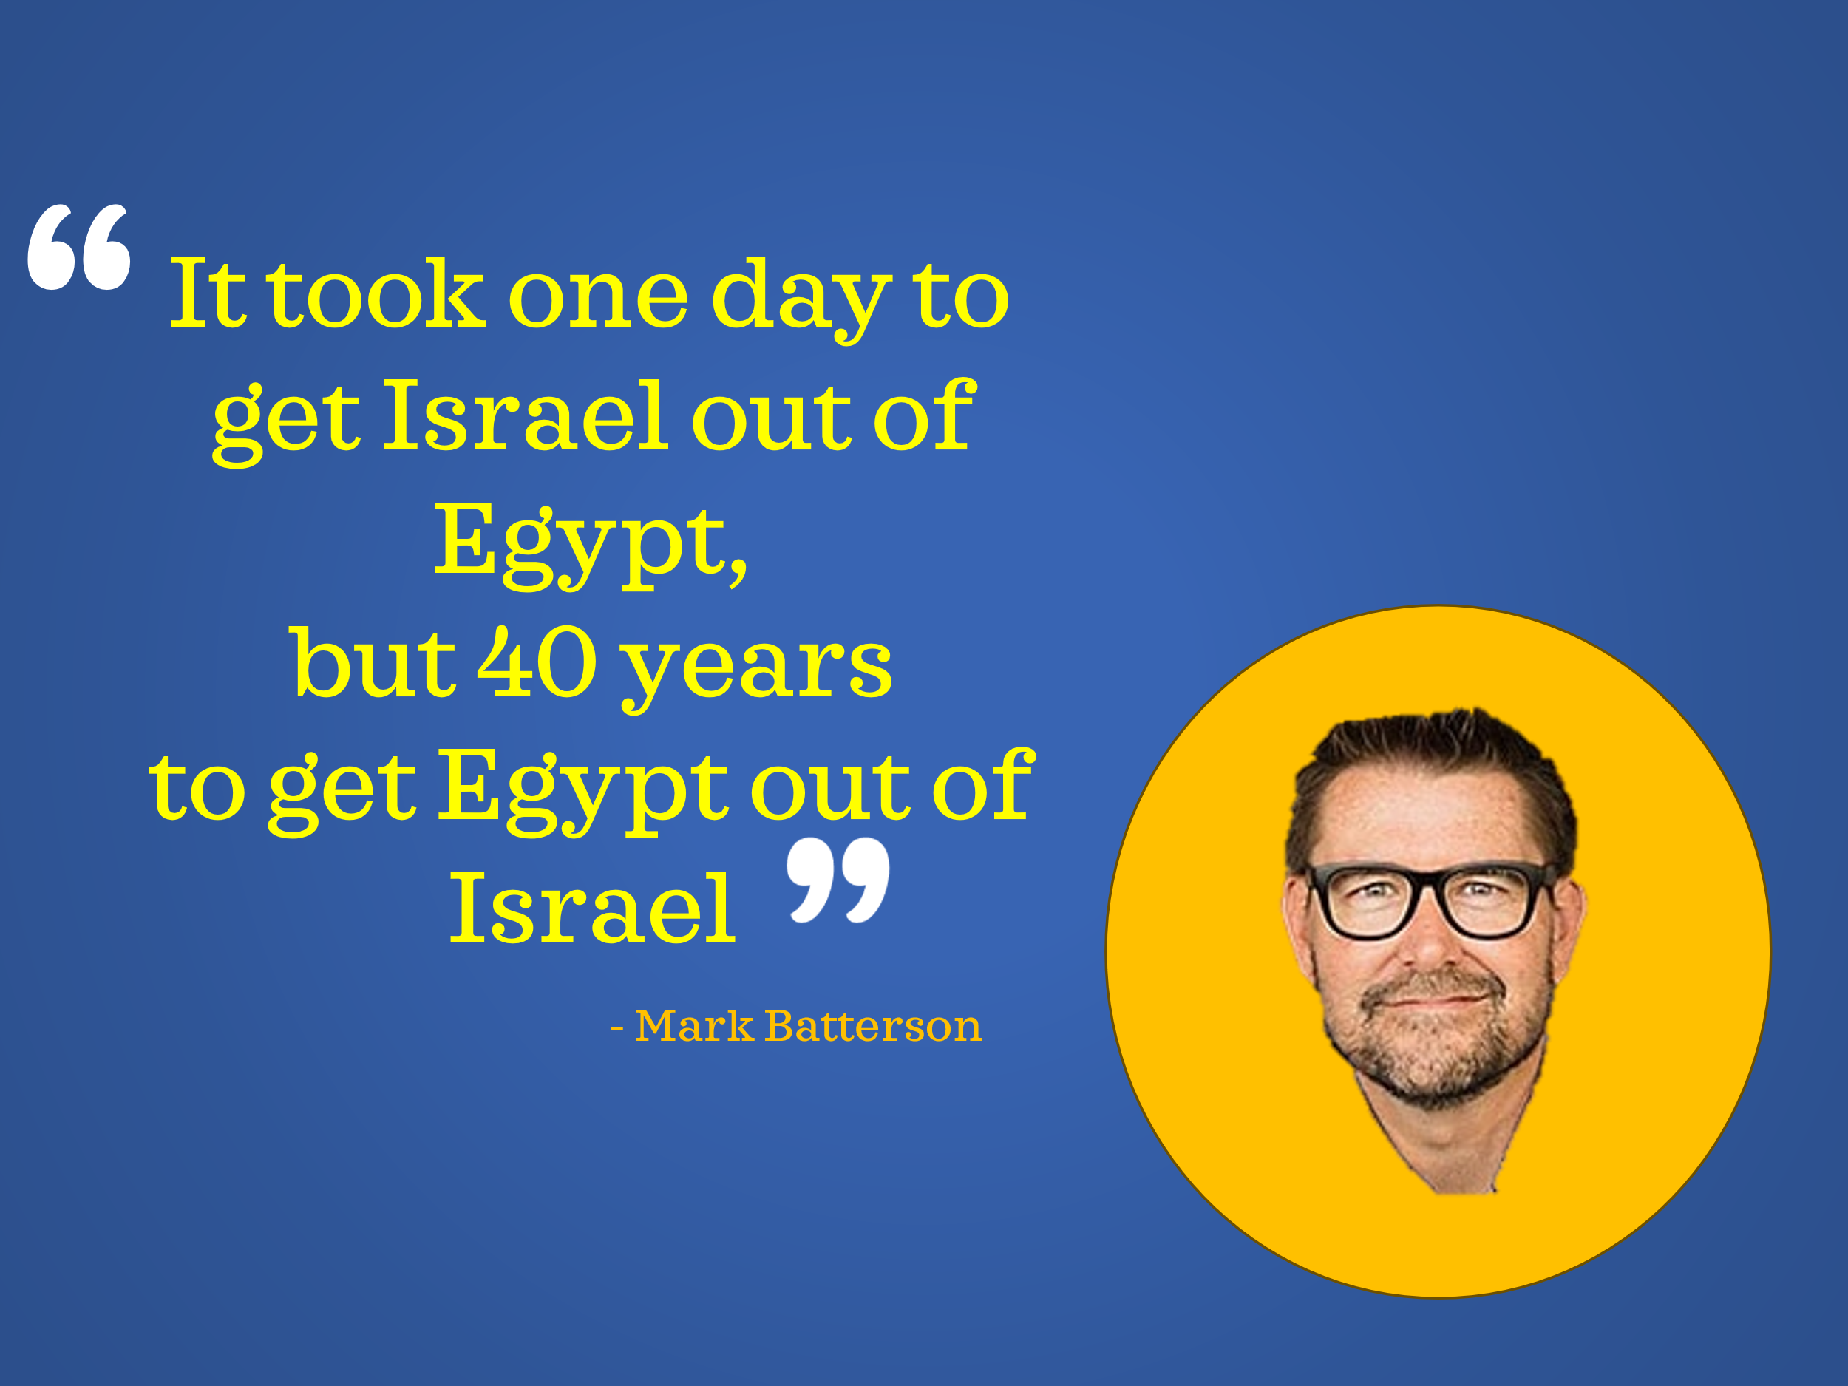 Despite his youth and size, David trusted God to rewrite his story on the battlefield. Similarly, the Israelites had their own story to rewrite—not against a physical giant, but against the invisible chains of a mindset still bound to their past. While the saying, ‘If you do not learn from the past, you are doomed to repeat it,’ holds truth, it doesn’t mean we should become so entangled in past experiences that we resist the Savior’s call to a life of hope and purpose (Jeremiah 29:11). The Israelites, after 400 years of slavery in Egypt, were miraculously delivered by Moses and witnessed God’s power through the ten plagues. Yet, despite their initial rejoicing, they soon grew weary of God’s provision of manna and longed for the food of their captivity—*“cucumbers, melons, leeks, onions, and garlic”* (*Numbers 11:5*). As Mark Batterson rightly states, “*It took one day to get Israel 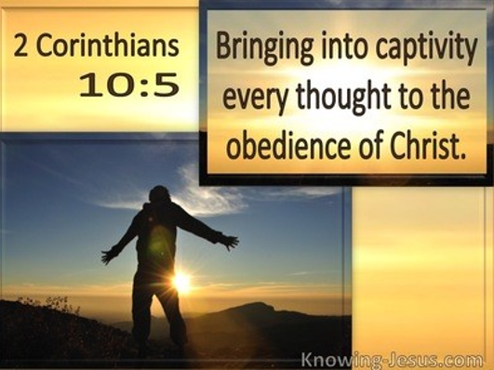out of Egypt, but 40 years to get Egypt out of Israel*.”[5] How long will it take you to let go of your past and step into God’s promises? The path is open—the choice is yours. Their story serves as a mirror to many Christians today who, though freed by Christ, remain ensnared by guilt, shame, and regret. How often do believers doubt their ability to do great things in Jesus’ name because their identity is still shaped by their past failures rather than Christ’s victory? On the cross, Jesus *“flipped the script on sin and death forever!”*[6] Living in the past dishonors God’s grace and rejects the new life He offers.

But the journey doesn’t stop at letting go of the past—it propels us into reaching for something greater. Letting go of past failures isn’t merely about finding peace; it’s about stepping boldly into the God-sized goals He has set before us.

# **Reaching for God-Sized Goals**

Letting go of past failures frees us to embrace God-sized goals with passion and tenacity. However, this is no easy task, considering that nearly 80% of our daily thoughts are negative,[7] often becoming self-fulfilling prophecies. No wonder so many of God’s children never reach their God-given goals! The Apostle Paul reminds us that the battlefield is in the mind (2 Corinthians 10:3-5), but thankfully, we have access to divine power to demolish every stronghold that holds us back. With God’s help, we can silence our inner critic and replace it with a voice of hope. When King Saul told David, *“You are not able to go out against this Philistine and fight him; you are only a young man”* (1 Samuel 17:33), David refused to let Saul’s words or his own doubts take root in his mind. Instead, he stood firm in faith, declaring that the Lord who delivered him from the paw of the lion and the bear would deliver him again (1 Samuel 17:34-37). Like David, when we face giants that seem impossible to defeat, we must remember Christ’s words: ‘My grace is sufficient for you, for my power is made perfect in weakness’ (2 Corinthians 12:9). The Goliath in front of us is not an insurmountable obstacle but an opportunity for God’s strength to shine through us.

# **Conclusion**

Every great story has a turning point—a moment when the protagonist refuses to let their circumstances, failures, or fears define them. Queen Victoria, despite her immense influence and authority, allowed grief to imprison her identity. In contrast, David, standing before Goliath, refused to let fear or the doubts of others dictate his story. The Australian sailing team rewrote history through vision, faith, and relentless perseverance. And the Israelites, though slow to break free from their past, eventually crossed into the Promised Land when they chose to trust God’s plan. The same God who guided David’s stone, who redefined Abraham’s legacy, and who strengthened the Australian sailors is the God who writes your story today. The giants you face—fear, doubt, regret, or failure—are not the end of your story but an opportunity for God’s grace and power to shine.

Will you surrender your story to the Author and Perfecter of your faith, trusting Him to flip the script, and free yourself from the weight of fear, doubt, and regret? When God writes the story, failure isn’t final, giants aren’t unbeatable, and our weaknesses become a platform for His strength. Let go of the past, silence the inner critic, and step boldly into the God-sized goals He has prepared for you. Giants fall, chains break, and victory is assured—because with God on your side, you are never the underdog.

“Now to him who is able to do immeasurably more than all we ask or imagine, according to his power that is at work within us, to him be glory in the church and in Christ Jesus throughout all generations, for ever and ever! Amen.” (Ephesians 3:20-21)

1. Mark Batterson, Win the Day: 7 Daily Habits to Help you Stress Less & Accomplish More, Kindle Location: 238.
2. Ibid., Location 343.
3. Ibid., Location 238.
4. Ibid., location 531.
5. Ibid., location 567.
6. Ibid.
7. Ibid., Location 705