Eat the Frog

  - Online Sermon: http://www.mckeesfamily.com/sermons/

Do you remember the day you were born again? That incredible moment when you, though still a babe in Christ (1 Corinthians 3:1-2), felt the overwhelming joy of passing from death to life, eternally sealed as a child of the Almighty Creator (Ephesians 1:13-14). But salvation was just the beginning. Like the Israelites standing on the shore of the Red Sea in Exodus 14, we face moments when God calls us to step forward in faith. Growth into spiritual maturity requires us to trust Him, even when the path ahead seems uncertain or daunting.
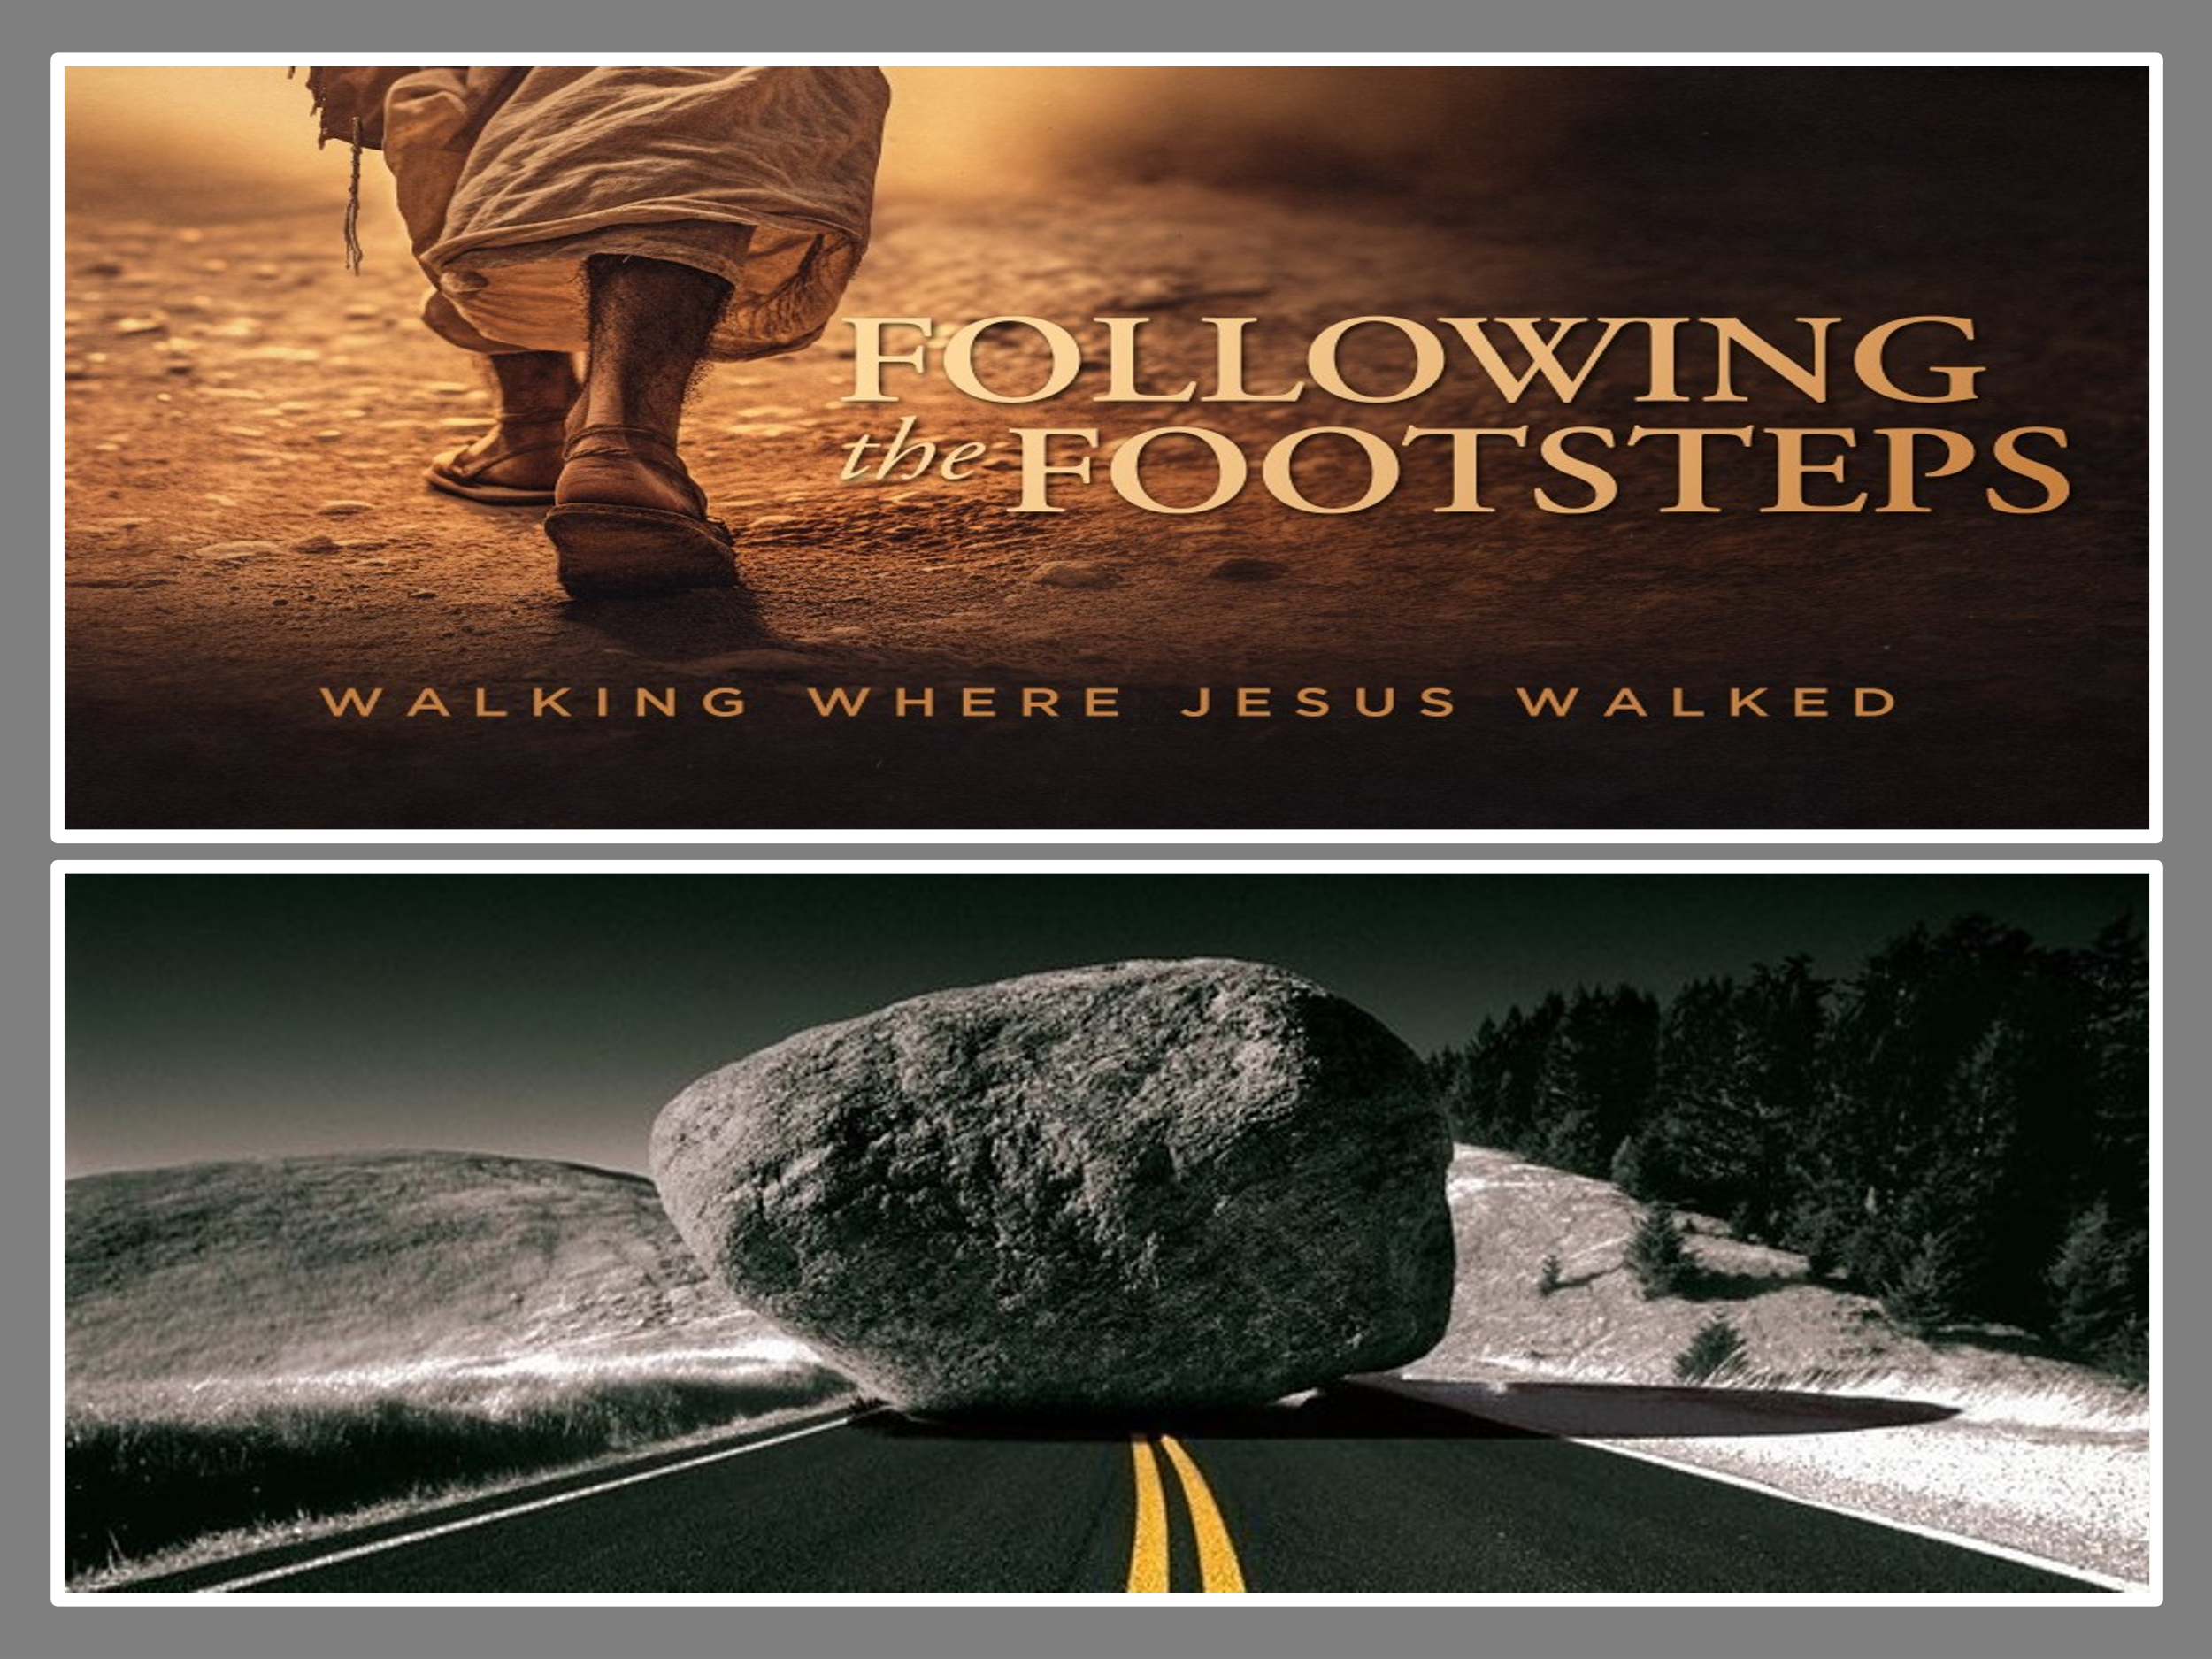
Mark Batterson describes 'eating the frog' as tackling the difficult tasks necessary for growth. Your 'frog' might be forgiving a deep hurt, sharing your faith, or committing to prayer and Bible study. Whatever form they take, these challenges represent opportunities to trust God and take deliberate steps closer to becoming the person He calls us to be. While salvation is a gift we cannot earn, God’s grace empowers us to step forward in obedience. Just as He parted the Red Sea for the Israelites, God provides the strength we need to overcome our own “frogs” and live a life worthy of the Gospel (Philippians 1:27). Like the Israelites, we often stand at the shores of our own Red Seas, facing obstacles that seem insurmountable. But God calls us to trust Him. Step forward and eat the 'frogs' in your path, knowing He will provide the strength and guidance you need
No matter how intensely one dreams of becoming spiritually mature, it cannot be realized until one intentionally follows in the footsteps of Jesus. As you reflect on the joy of your salvation, consider this: What are the challenges—those frogs—that God is asking you to face to grow deeper in your faith? Is it letting go of a grudge, stepping out in faith to serve, or finally setting aside time to be in His Word daily? Perhaps God has placed it on your heart to join a ministry, mentor someone in their faith, or dedicate more time to volunteering in your community. Or maybe your frog is setting aside distractions like social media to create space for deeper intimacy with Him. Striving to be holy as God is holy can feel overwhelming. But this challenge should invigorate us, not paralyze us. With God’s strength, we can grow beyond our current struggles to become who He has called us to be. Thankfully, we don’t climb this mountain alone—God provides the strength and guidance we need for each step.

Defining Your Frog


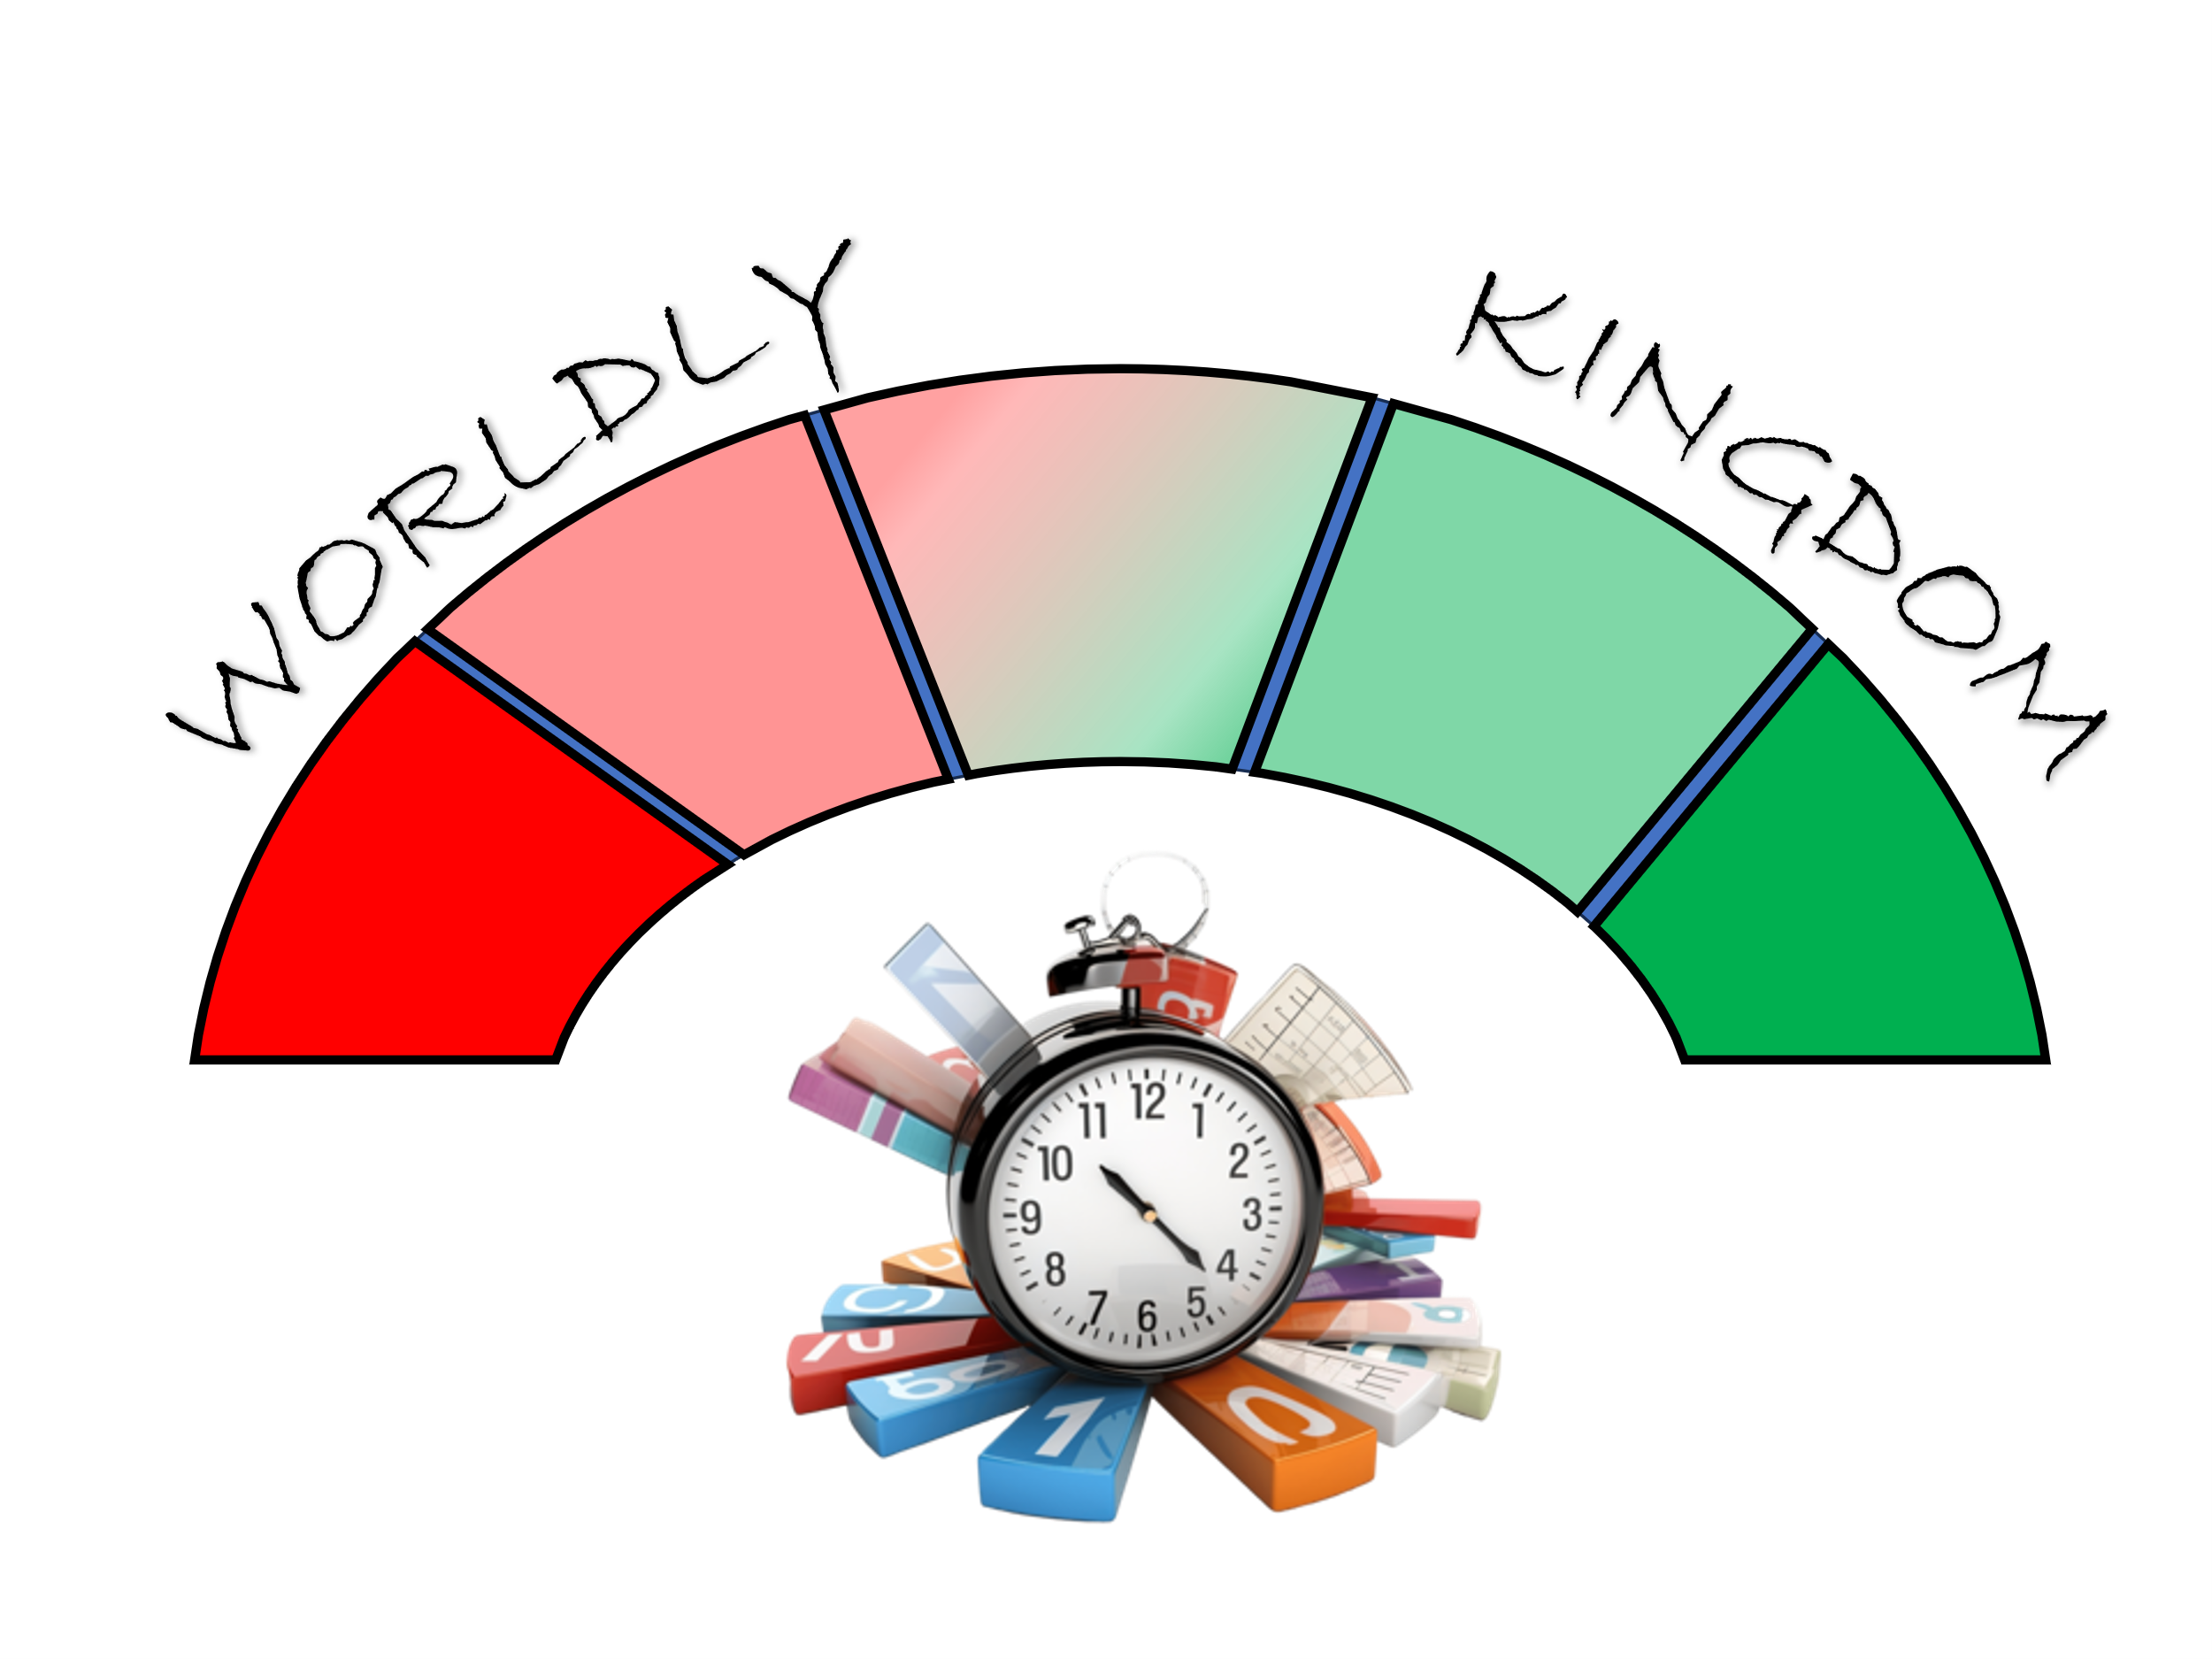
No matter how intensely one dreams of becoming spiritually mature, it cannot be realized until one intentionally follows in the footsteps of Jesus. But where does one begin? Striving to become holy as God is holy can feel like standing at the base of a towering mountain, its summit hidden in clouds and its steepness overwhelming. Doubts creep in, fueled by feelings of unworthiness and shame for loving the things of this world too much. And yet, while the vast distance between where we are now and where God wants us to be can feel paralyzing, it should instead invigorate us—for the potential for growth in the Lord is truly staggering! Thankfully, we don’t climb this mountain alone—God provides the strength and guidance we need for each step.

Mark Batterson encourages us to 'eat the frog' by taking small, deliberate steps toward total surrender to God. So, where do we begin? The “frog” we need to eat can be identified by reflecting on a few key questions. What spiritual goals has God placed on your heart that you’ve hesitated to pursue due to fear or lack of desire? What are the things you rarely do for God but, when you do, bring a sense of closeness and unspeakable joy in fulfilling His will? Perhaps God has placed it on your heart to join a ministry, mentor someone in their faith, or dedicate more time to volunteering in your community. Or maybe your frog is setting aside distractions like social media to create space for deeper intimacy with Him. Finally, as you consider the end of your life, what aspects of your walk with Christ would you regret neglecting if you continued to live with a “Que será será—whatever will be, will be” mindset? With those “frogs” in mind, let’s turn our attention to creating an action plan for spiritual success.

Intentional Planning

The key to sustained spiritual growth lies in intentionally structuring our days to reflect God's priorities. Each day is a divine gift, a fresh opportunity to glorify Him and accomplish meaningful work in His name. Have you ever paused to evaluate how you spend your time? How much of it is devoted to serving God versus indulging worldly pursuits? Mark Batterson insightfully observes that we are often unaware of counterproductive routines that dominate our lives. To redeem the time, we must be deliberate in replacing harmful habits with God-centered ones. For example, D.L. Moody made it a priority to rise at four in the morning to commune with God amidst life's distractions. Similarly, rabbinic tradition tells of King David waking to the sound of wind on his harp to study the Torah (Psalm 57:8). These examples remind us that the first moments of our day are crucial, setting the tone for everything that follows. When we anchor our mornings in worship and devotion, we align our lives with God's purposes and experience His sustaining grace throughout the day. Intentional planning provides the foundation for a life centered on Him, but to deepen our walk, we must move beyond structure to incorporate spiritual rituals that remind us of His presence in every moment.

Ritual Reminders


Once we have prioritized God in our plans, the next step is to incorporate spiritual practices that keep us centered on Him daily. In Deuteronomy 6:4-9, Moses commands the Israelites to engrave God’s laws on their hearts and make them central to their homes, workplaces, and conversations. Like the Israelites, we need regular reminders to stay anchored in God’s Word and presence as we navigate life’s challenges.

Consider starting with simple but powerful habits. For example:
Scripture Memorization: Choose a verse that speaks to your current “frog,” such as Philippians 4:13—“I can do all this through Him who gives me strength”—and repeat it throughout your day.
Gratitude in Prayer: Set aside a few minutes each morning to thank God for His blessings and seek His guidance for the challenges ahead. This small act can transform your perspective.
Moment-by-Moment Prayer: Before beginning any task, pause to ask God for wisdom and strength. This practice invites His presence into every aspect of your life.
By embedding God’s Word and presence into your daily rhythms, you cultivate a deep thirst for Him (Psalm 42:1). These rituals remind us that our lives are not our own and that true transformation comes when we surrender our time, desires, and efforts to His purposes.

Curse the Barren Fig Tree

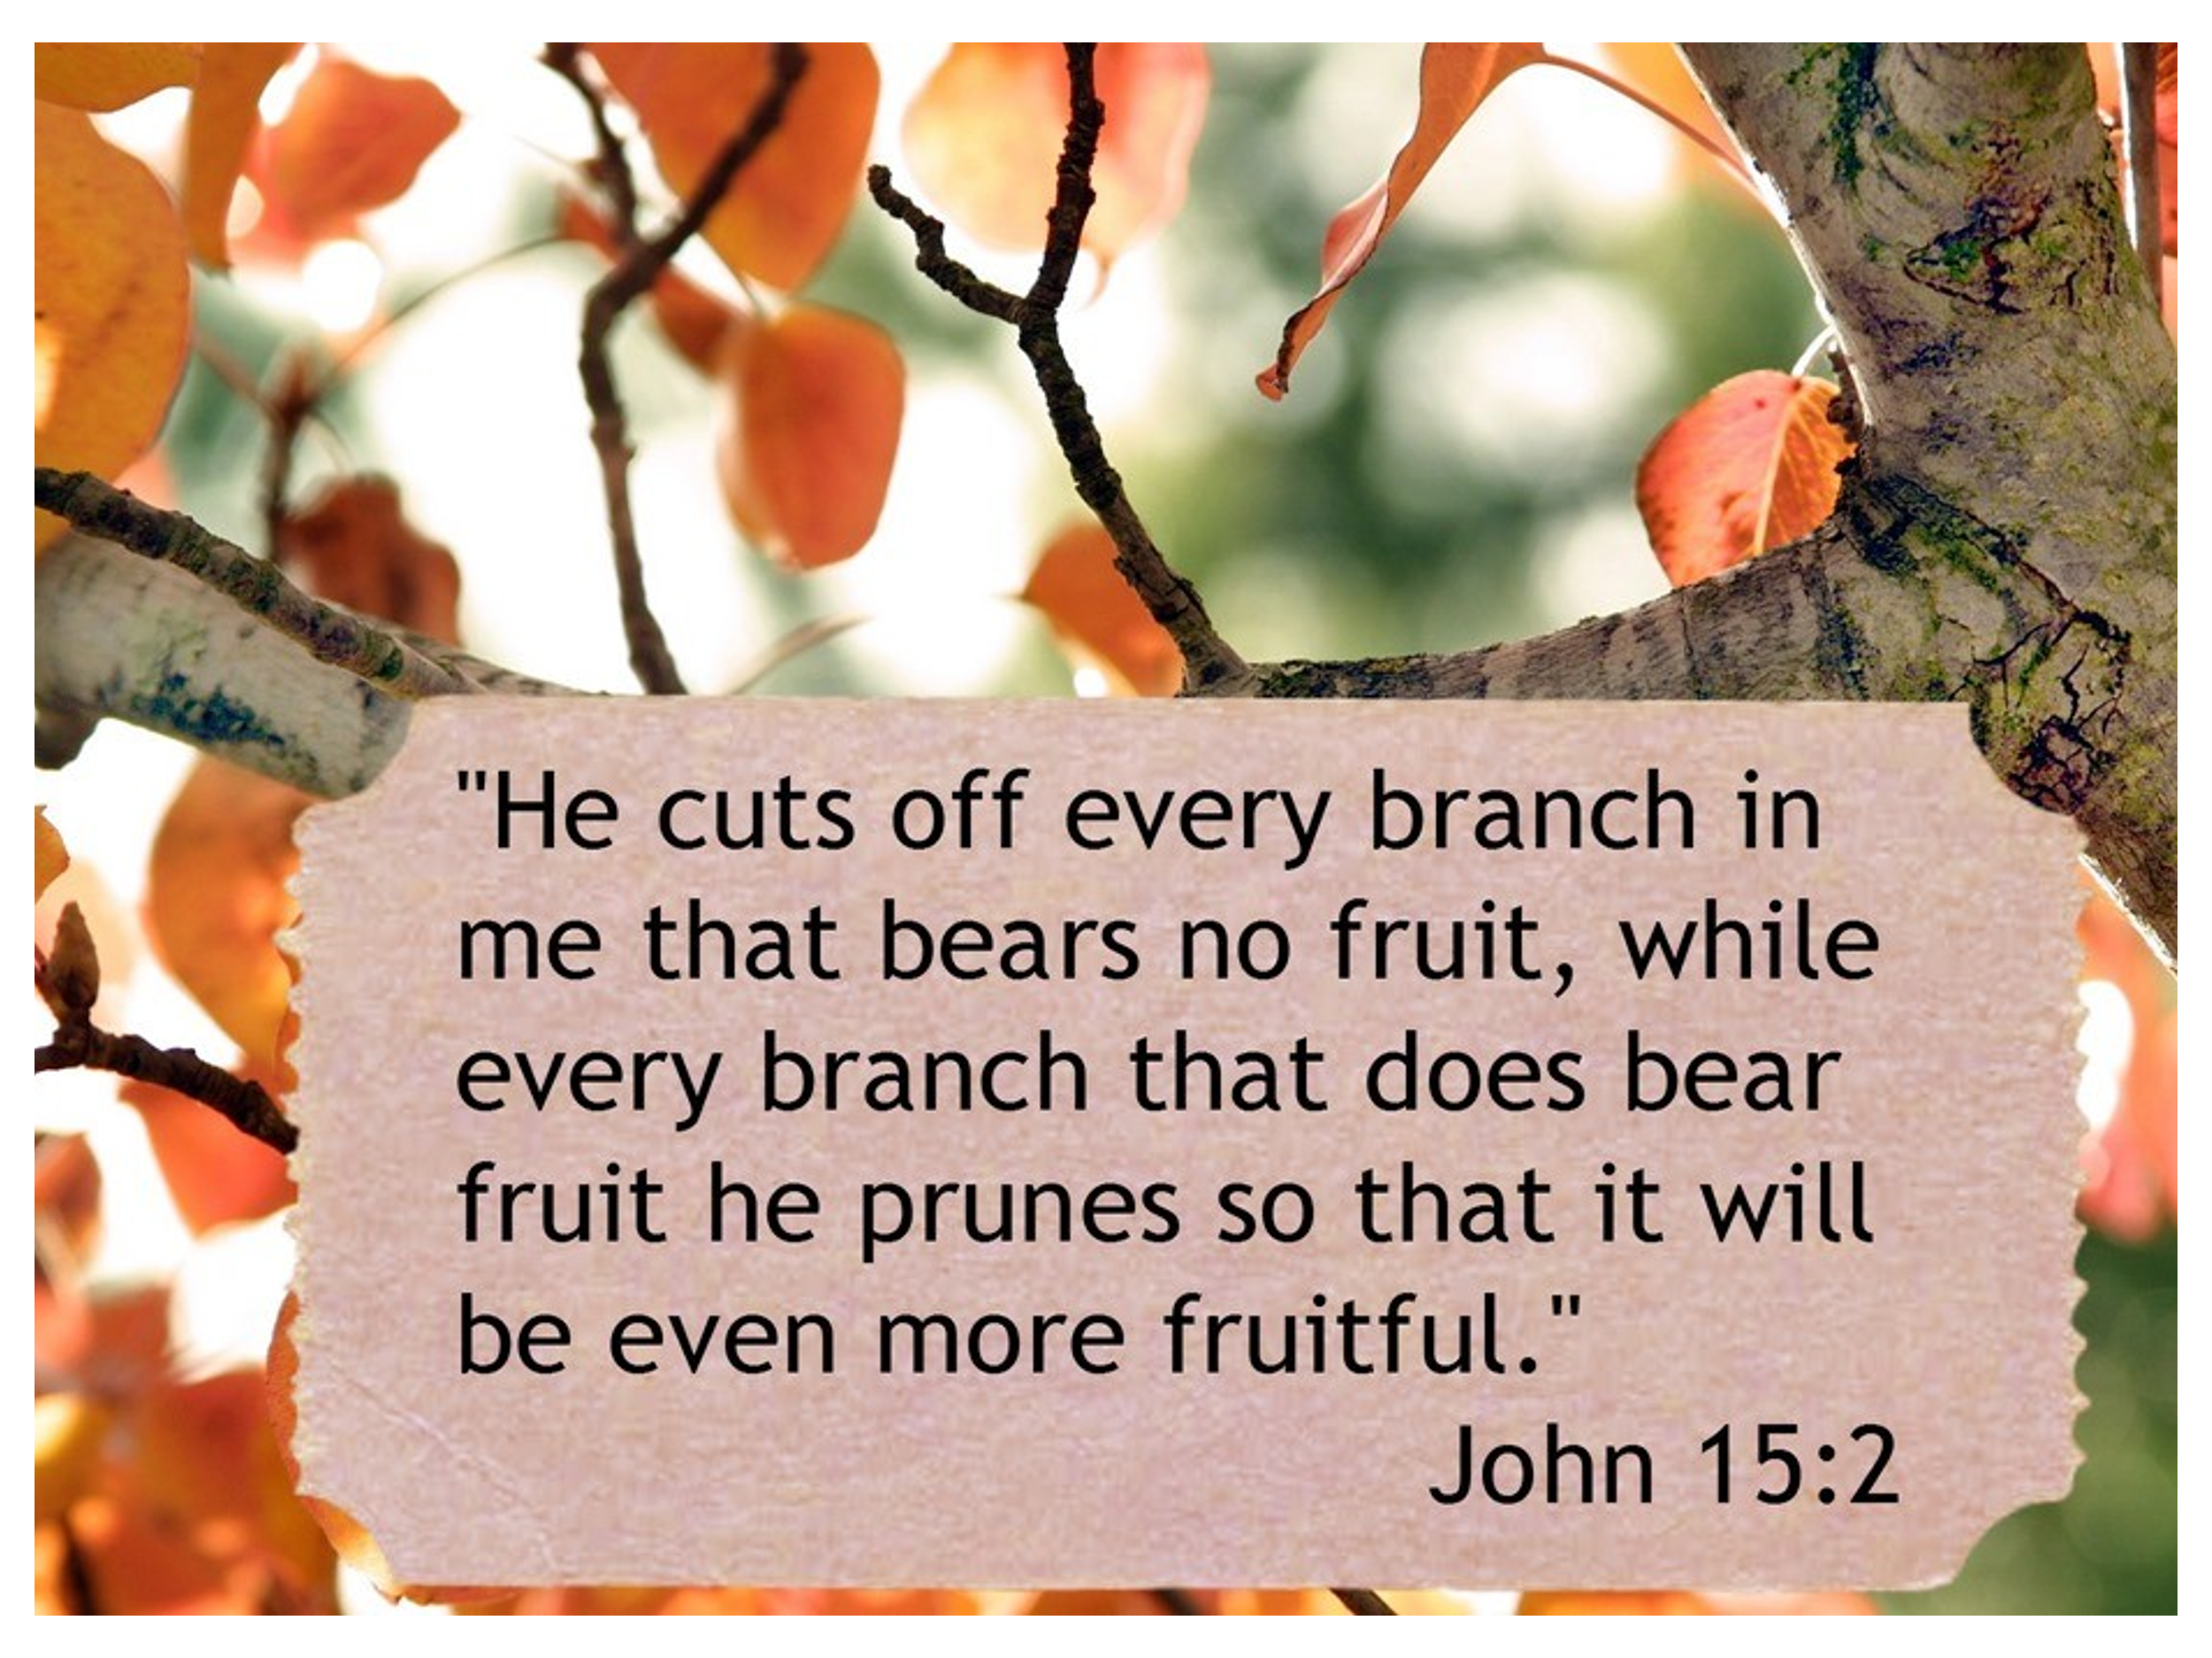

When we take intentional steps to align our lives with God's Word, we invite Him to redefine not just our time but our very purpose. Yet, as Jesus taught with the fig tree, merely going through the motions without bearing spiritual fruit is not enough. To truly live out our calling, we must examine our hearts and surrender any barren activities that hinder our growth and devotion to Him. To invite God to lead us beside still waters, calm our minds, and lovingly reveal His plans to prosper us and not harm us (Jeremiah 29:11), we must remain open to the Father “cutting off every branch in me that bears no fruit” (John 15:1-2). Though pruning can be a painful process—requiring us to accept God’s discipline or surrender sinful pleasures that conflict with His righteous ways (Hebrews 12:5-6; Psalm 119:128)—it is a profound expression of His eternal love and mercy. God desires for us, as recipients of His spiritual gifts, to thrive and bear abundant fruit in His kingdom. Trusting His promise that a loving Father will not give us a stone to eat or a snake to harm us (Matthew 7:7-12), we should begin each day by asking Him for clarity, wisdom, and a passion to seek first His kingdom (Matthew 6:33), even if it means letting go of worldly pursuits. Consider carving out 15 minutes each morning for prayer or committing to one evening a week to disciple someone. If we truly believe God is our portion, let us boldly ask Him to create in us a pure heart—one that is willing (Psalm 51:10-12), faithful, and obedient to His perfect will for our lives.

Excellence is Mundane

True spiritual excellence is not found in grand, one-time acts but in the quiet, consistent choices we make daily to align our lives with God’s will. It is in the seemingly mundane moments—choosing to pray instead of procrastinate, to read Scripture instead of scrolling on our phones, and to serve others rather than seek our own comfort—that our faith is truly transformed. Consistency builds a foundation of trust and obedience, training our hearts to prioritize God’s kingdom over worldly distractions. Like a farmer who patiently tends to crops, we cultivate faith that grows stronger over time, even when we don’t see immediate results. As James reminds us, “Let perseverance finish its work so that you may be mature and complete, not lacking anything” (James 1:4). This daily steadfastness allows the fruit of the Spirit—love, joy, peace, patience, kindness, goodness, faithfulness, gentleness, and self-control (Galatians 5:22-23)—to take root and flourish in our lives. With each small act of obedience, we strengthen our spiritual “muscles,” and what once felt difficult becomes second nature. God uses our persistence in these ordinary moments to accomplish extraordinary purposes, reminding us that true excellence in faith is not about perfection but about a renewed commitment each day to follow Christ and trust Him to work through us for His glory.

Conclusion

As we reflect on the journey of spiritual growth and the challenges we face, let us remember that the path to excellence in God's kingdom begins with small, intentional steps of obedience and surrender. The "frogs" we are called to eat may seem daunting, but with God's strength, they become opportunities for transformation. Just as He used ordinary people throughout history to accomplish extraordinary things, He invites us to step forward in faith, trusting that His plans are to prosper us and not to harm us (Jeremiah 29:11). True greatness lies not in seeking the applause of the world but in living for the approval of the One who gave His life for us. May we rise each day with renewed passion to seek first His kingdom (Matthew 6:33), pruning what hinders us, embracing His discipline with humility, and running the race set before us with perseverance (Hebrews 12:1). Just as God parted the Red Sea in Exodus 14, He will help us overcome even the most daunting challenges. Take time this week to pray and ask God: What ‘frog’ are You calling me to eat? Trust in His strength to face it. Let’s step out in faith and watch how God works through our obedience to accomplish more than we could ever imagine!

