# **Wonderful Counsellor**

Isaiah 9:1-7

Online Sermon:

[www.mckeesfamily.com/sermons/](http://www.mckeesfamily.com/sermons/)

With Christmas just weeks away, our hearts are warmed by thoughts of presents to be unwrapped, delicious meals to be shared, and embraces exchanged in love. Around the world, children dream of gifts they’ve eagerly wished for—cars, dolls, musical instruments, gaming devices, and more. Yet, as exciting as these gifts may be, they pale in comparison to the greatest gift of all—the babe lying in a manger. God has placed eternity in our hearts and revealed His power and presence through creation, leaving us no excuse to deny Him. The over 300 prophecies fulfilled in Jesus underscore that His arrival on that first Christmas was a divine miracle, an impossibility apart from God’s intervention. Over 700 years before Christ’s birth, the prophet Isaiah declared Him to be a Wonderful Counselor, Mighty God, Everlasting Father, and Prince of Peace. This Christmas, as we reflect on the Savior born to be slain for our sins, let us consider how this Wonderful Counselor brings hope, warmth, and security to a world filled with fear. Will you bow before Him and embrace the eternal joy only He can give?

# **Rejecting a Commercial Christmas - by Zacchaeus the Tax Collector**

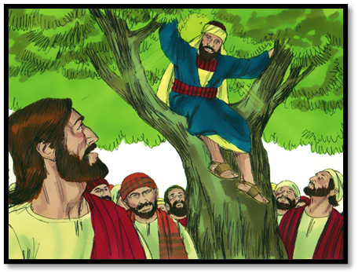Jesus is called the “Wonderful Counselor,” and those who truly listen to Him and obey His commands are forever transformed. A vivid example of this is found in Luke 19:1-10, where we read the story of Zacchaeus, a wealthy tax collector despised by his fellow Jews for collaborating with their Roman oppressors. Determined to see Jesus, Zacchaeus climbed a sycamore tree. When Jesus arrived, He surprised everyone by looking up and saying, “Zacchaeus, come down immediately. I must stay at your house today” (v. 5). This shocked and angered the crowd, who considered Zacchaeus not only a sinner but among the vilest of men. Instead of fleeing in shame, Zacchaeus experienced a profound change, declaring, “Look, Lord! Here and now, I give half of my possessions to the poor, and if I have cheated anybody out of anything, I will pay back four times the amount.” Jesus then proclaimed, “Today salvation has come to this house, because this man, too, is a son of Abraham. For the Son of Man came to seek and to save the lost” (vv. 9-10). Like Zacchaeus, when we respond to the call of our Wonderful Counselor, we are led to exchange earthly treasures for the eternal joy of a transformed heart and a restored relationship with God. Are there ‘trees’ you need to climb, like Zacchaeus, to see Jesus this Christmas?

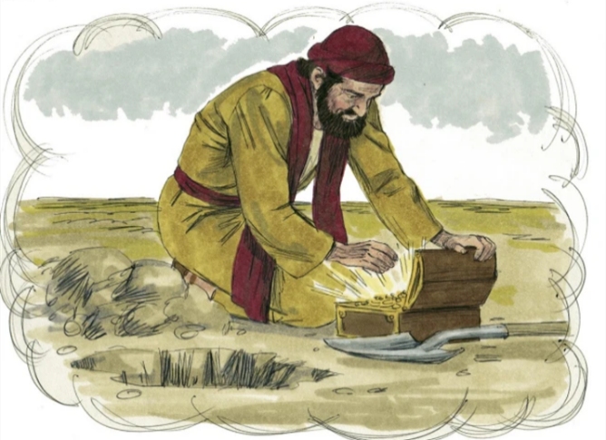As we drive past houses adorned with sparkling lights, navigate crowded malls, and endure an endless stream of holiday commercials, it’s easy to wonder if Christmas has lost its true meaning. Yet, the story of Zacchaeus reminds us that while gifts and celebrations are enjoyable, they must never become the treasures of our hearts (Matthew 6:19-21). Our Wonderful Counselor, Jesus, was born in a manger and died on a cross to offer salvation to all (Hebrews 10:10). Tragically, like the rich young ruler, many in this world remain ensnared by the fleeting allure of wealth and possessions, choosing what fades over the eternal gift of life in Christ (John 3:16). The true meaning of Christmas is this: though we deserve God’s righteous judgment, His great love and desire for none to perish (2 Peter 3:9) moved Him to give the greatest gift—Himself. Jesus invites us to see Him as the Treasure and Pearl of immeasurable worth (Matthew 13:44-46), far surpassing the food, lights, and trinkets that vie for our attention this season.

# **He Knows me - by the Apostle Nathanael**

While Zacchaeus’ story shows how Jesus transforms our priorities, Nathanael’s encounter reveals the depth of His knowledge and how He meets us where we are. Jesus is called the Wonderful Counselor because He knows our every thought and the deepest desires of our hearts. When Philip heard Jesus’ simple yet profound call, “Follow Me,” his heart leapt with joy, and he immediately left everything to follow his Savior. Filled with excitement, he sought out Nathanael to share the Good News. Knowing Nathanael’s devotion to the Scriptures, Philip declared, “We have found the one Moses wrote about in the Law, and about whom the prophets also wrote—Jesus of Nazareth, the son of Joseph” (John 1:45). However, Nathanael’s skepticism surfaced, as he questioned, “Can anything good come from Nazareth?” (v. 46). Undeterred, Philip invited him to meet Jesus. As Nathanael approached, Jesus revealed His divine knowledge, saying, “Here truly is an Israelite in whom there is no deceit” (v. 47). Surprised, Nathanael asked, “How do you know me?” Jesus replied, “I saw you while you were still under the fig tree before Philip called you” (v. 48). In that moment, Nathanael realized that the very thoughts he had pondered in solitude were known by Christ, the object of his meditation. His doubts melted away as he joyfully proclaimed, “Rabbi, you are the Son of God; you are the king of Israel” (v. 49). Like Nathanael, we can trust our Wonderful Counselor, who knows us fully, meets us where we are, and calls us into a faith that transforms doubt into joyful conviction.

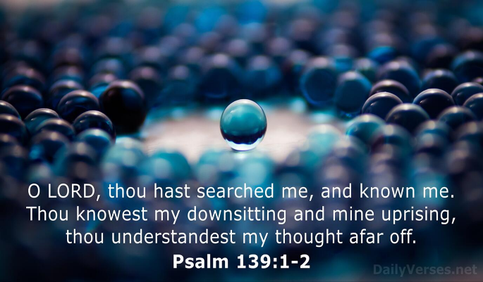This story reminds us that our Wonderful Counselor knows us intimately and meets us exactly where we are, calling us into faith and transformation. Unlike human counselors, Christ does not need to ask probing questions to uncover the depths of our souls. As King David proclaims in Psalm 139:1-2, “You have searched me, Lord, and you know me. You know when I sit and when I rise; you perceive my thoughts from afar.” While this divine knowledge may feel daunting, especially considering the sin within us, we are comforted by the boundless grace and mercy of God. He assures us that confessed sins are forgiven and cleansed entirely. With joy, we approach His throne to learn His ways—ways infinitely higher than ours—and to be equipped with His armor, exchanging our heavy burdens for His light and restful yoke when trials come. This Christmas season, rather than focusing solely on gifts and distractions, let us fulfill our role as ambassadors of Christ. Like Philip, let us offer even the skeptical a glimpse of the Gospel through lives that shine as beacons of hope, reflecting the transformative power of His grace and truth.

# **Our Counsellor Jesus can do Anything – by Jairus**

While Nathanael’s story reminds us of Jesus’ intimate knowledge, Jairus’ experience demonstrates His ability to do the unimaginable—even in the face of death. When Jairus, a respected synagogue ruler, faced the devastating reality of his only daughter’s illness and impending death, he knew he had to seek the One sovereign over all creation (Colossians 1:16). Casting aside his status and pride, Jairus humbly fell at Jesus’ feet, pleading for Him to come to his home (Luke 8:41-42). As Jesus made His way, the crowds pressed so tightly around Him that they nearly crushed Him. Amid this chaos, a woman who had suffered from bleeding for twelve years—despite countless failed treatments—touched the edge of His cloak in faith, and immediately her bleeding stopped (v. 44). Though Jairus must have felt desperate at the delay, Jesus paused with purpose, declaring, “Someone touched me; I know that power has gone out from me” (v. 46). The trembling woman stepped forward and confessed her act 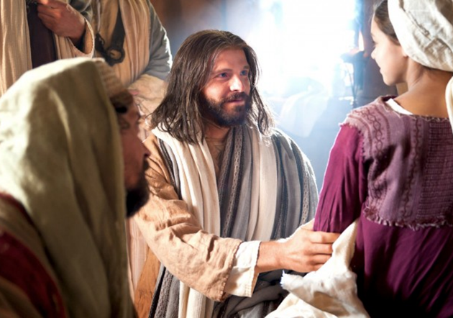of faith, and Jesus, the Wonderful Counselor, affirmed her healing and faith. Just then, devastating news arrived: Jairus’ daughter had died (v. 49). But Jesus, looking into Jairus’ broken heart, reassured him, “Don’t be afraid; just believe, and she will be healed” (v. 50). Arriving at Jairus’ home, Christ was met with ridicule when He proclaimed the child was merely asleep, but He was undeterred. Taking her by the hand, He commanded, “My child, get up!” and her spirit returned, restoring her to life (vv. 53-55). This powerful account shows that our Wonderful Counselor not only knows our deepest needs but also possesses divine power to transform despair into hope, sickness into healing, and even death into life.

Even in a skeptical world, miracles continue to reveal God’s power and love. Over 2,000 years ago, our Wonderful Counselor, Jesus, was born of a virgin—fully God and fully man. Though a descendant of Jesse and seemingly ordinary by worldly standards, He was filled with the Spirit of the Lord, wisdom, and might, as prophesied in Isaiah 11:1-3. Many today are broken—by circumstances beyond their control or the weight of sin. Like the suffering woman or Jairus clinging to hope, countless people seek solutions this world cannot provide. If you are facing struggles, remember the One who made the blind see and the lame walk knows your pain. In faith, He grants healing and hope, often in miraculous ways. If burdened by sin, take heart—He knows your every failure and welcomes you with open arms. This Christmas, remember the miracle of His sacrifice: ‘pierced for our transgressions’ and ‘by His wounds we are healed’ (Isaiah 53:5). Reflect on Zacchaeus’ transformation, Nathanael’s restored faith, and Jairus’ hope, and draw near to Jesus with humility, trusting Him for the forgiveness and transformation only He can give.

# **Conclusion**

As we celebrate Christmas, let us remember that the babe lying in the manger is our Wonderful Counselor, who came to transform our lives, know our hearts, and meet our deepest needs. Zacchaeus teaches us to let go of earthly treasures for eternal joy. Nathanael shows us that Jesus knows us fully and calls us to faith. Jairus reminds us that with Christ, there is no situation too hopeless, no burden too heavy, and no life beyond His power to restore. This Christmas, will you open your heart to the Wonderful Counselor? Let Him transform your priorities, replace your doubt with faith, and give you hope that endures. The greatest gift has already been given—Jesus, born to save us. This Christmas, will you respond to the Wonderful Counselor’s call? Whether it’s letting go of distractions, trusting His guidance, or believing in His power to restore, take the step of faith and receive the joy only He can give. Let us rejoice this Christmas, for the Wonderful Counselor has come to bring us life, peace, and everlasting hope.