Mighty God

  - Isaiah 9:1-7
  - Online Sermon:
  - www.mckeesfamily.com/sermons/

When you face an enemy that depletes your strength, resources, and abilities, where do you turn? The story of Gideon in the book of Judges provides a profound answer for those moments of despair. After Israel's repeated disobedience, God allowed the Midianites to oppress them for seven long years. The oppression was so severe that the Israelites hid in mountain clefts, caves, and strongholds just to survive (Judges 6:1-2). Every effort to prosper was crushed as their enemies, like swarms of locusts, invaded and destroyed their crops and livestock (Judges 6:3-5). In their desperation, they finally cried out to the Lord (Judges 6:6). This cry of humility shifted their focus from their weakness to God’s strength and provision.

In response, God chose an unlikely hero: Gideon. Feeling insignificant—belonging to the weakest clan and seeing himself as the least in his family (Judges 6:15)—Gideon was still met with God’s powerful promise, “I will be with you, and you will strike down all the Midianites” (Judges 6:16). Through Gideon’s obedience and faith, God orchestrated an extraordinary victory with just 300 men, showing that true deliverance comes not through human strength, but by God’s power (Judges 7:2-25). This story reminds us that God can use our weaknesses to display His might and turn impossible situations into testimonies of His glory.


God often uses what appears small and insignificant to reveal His might and power in extraordinary ways. Imagine the wonder that must have filled Isaiah’s heart as he prophesied about a baby lying in a manger—a baby who would be called “Mighty God” (Isaiah 9:6). Some may see Christ as a fragile infant, dependent and vulnerable. But this portrayal does not diminish His divine power. Born of a virgin and from the line of Jesse, Jesus established a kingdom whose entrance depends not on genealogy, temple rituals, or adherence to the Torah, but on faith. Only Christ could satisfy His Father’s righteous wrath, offering His life as a ransom for many (Mark 10:45).

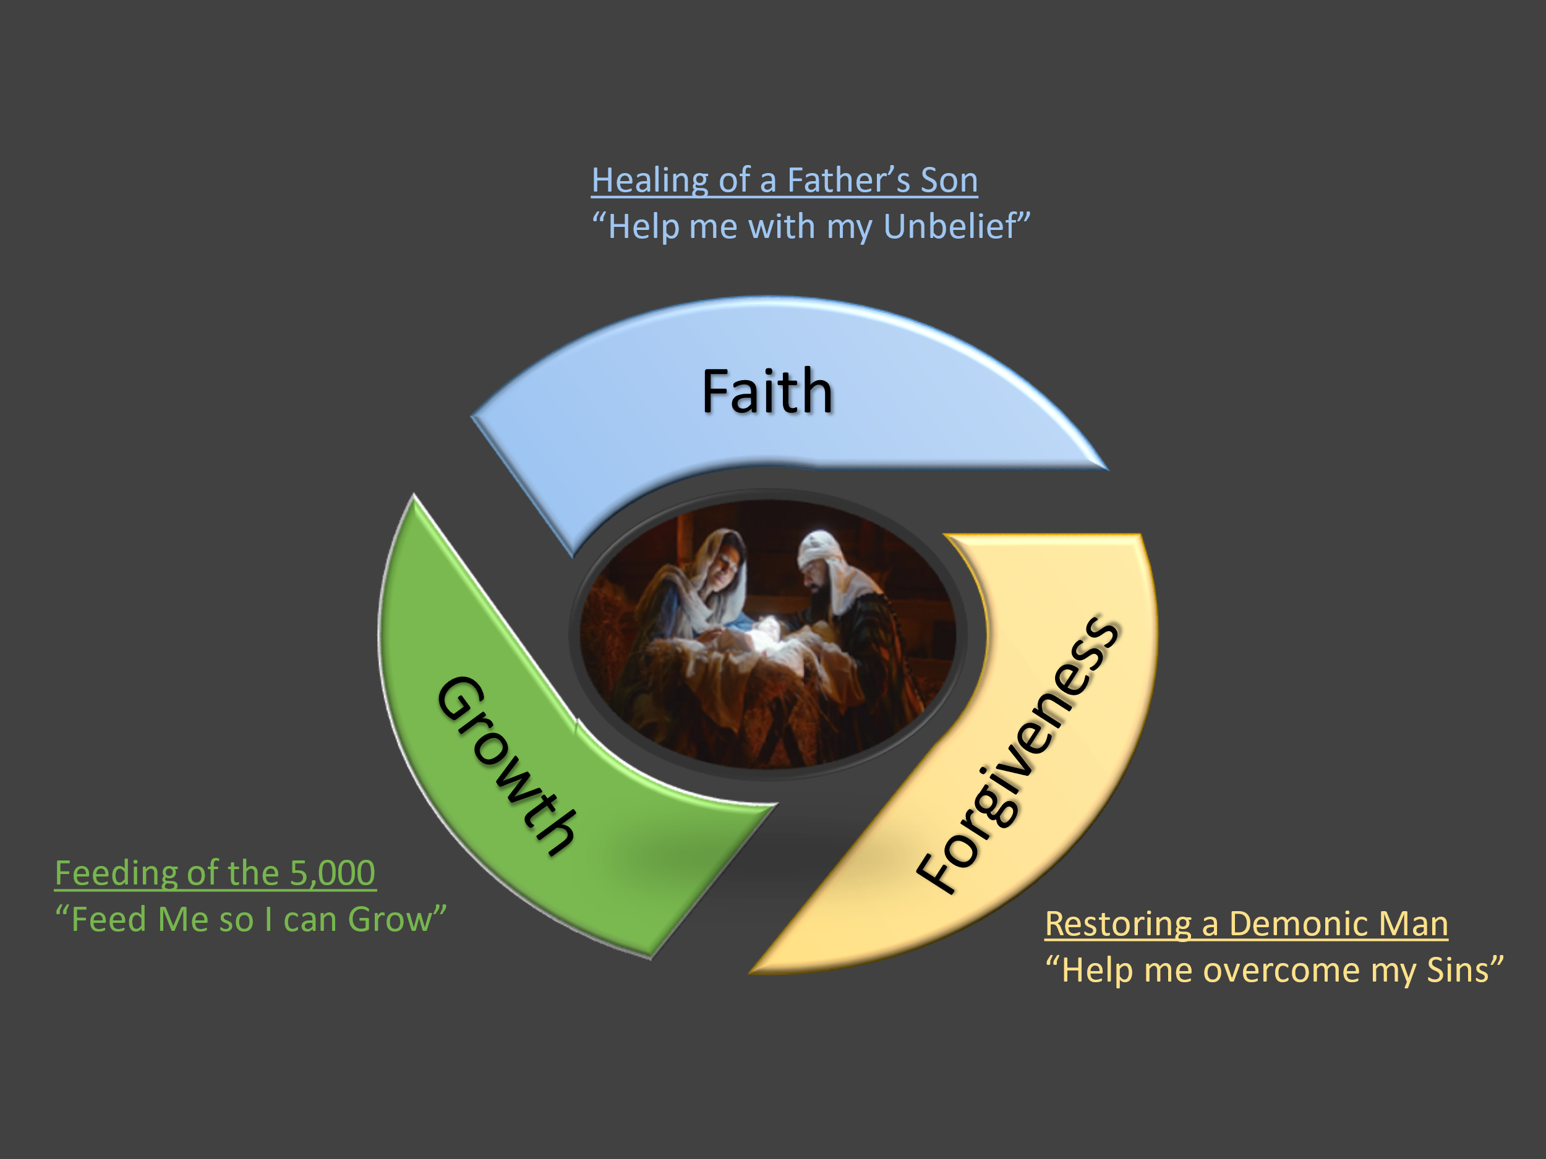
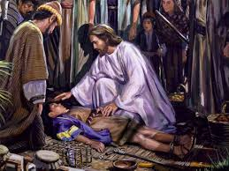
His virgin birth fulfilled over 300 prophecies. His authority extends over all things—visible and invisible (Colossians 1:16). These are profound demonstrations of His divine might. These miracles showcase different aspects of Christ’s power to heal, provide, and restore. As we reflect on Christ’s power this Christmas season, let us consider just three of His miracles: the healing of a desperate father’s son, the feeding of the five thousand, and the restoring of a demon-possessed man. Each of these miracles is more than a display of supernatural power. They are invitations to trust Him fully. Like the Israelites who cried out in desperation, let us come to Him with hearts that say: “Help me with my unbelief,” “Feed me,” and “Help me overcome my sins.” May these reflections inspire us to experience the transformative power of the Mighty God—who came to us not just in a manger, but in grace, truth, and saving power.

Help me with my Unbelief

When Peter, James, and John returned from witnessing Christ’s transfiguration, they joined the other nine disciples and found a large crowd gathered around them, with teachers of the law engaged in an argument (Mark 9:14). Jesus asked, “What are you arguing with them about?” (Mark 9:16). A man from the crowd explained that he had brought his son, who was possessed by a spirit that caused seizures, foaming at the mouth, and rigidity. The disciples had tried to cast out the spirit but failed (Mark 9:18). When the boy was brought to Jesus, the spirit convulsed him violently (Mark 9:20). The father, desperate, pleaded, “If you can do anything, take pity on us and help us” (Mark 9:21). Jesus replied, “Everything is possible for the one who believes,” prompting the father’s heartfelt cry, “I do believe; help me overcome my unbelief!” (Mark 9:24). Jesus then rebuked the spirit, commanding it to leave and never return, and it obeyed immediately (Mark 9:25-26). Later, when the disciples asked why they couldn’t drive it out, Jesus explained, “This kind can come out only by prayer” (Mark 9:29). This teaches us that, in the absence of Jesus’ physical presence, we must rely on faith in God and persevere through prayer in all our efforts. Just as Gideon learned to trust God’s might, this desperate father’s plea reminds us that the Mighty God is ready to act on our behalf when we place our faith in Him.

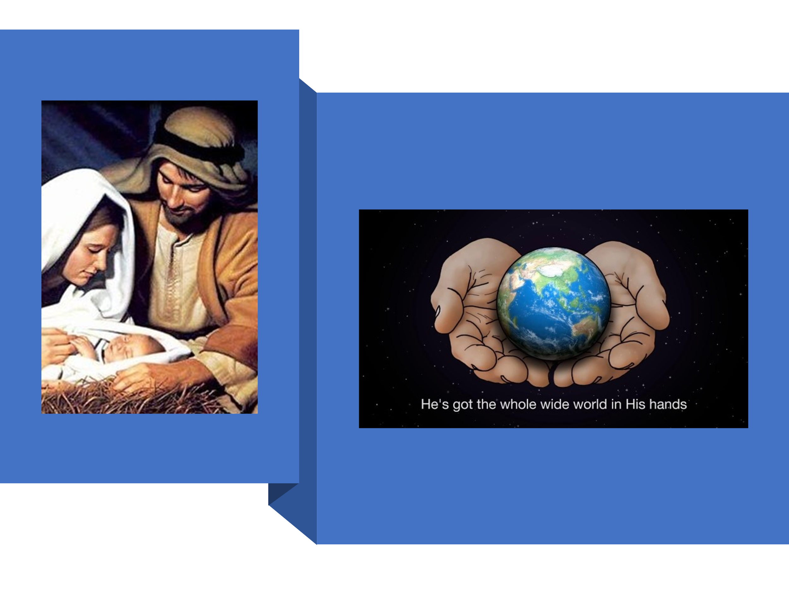
To see beyond the frailty of the baby lying in a manger and recognize Him as our Mighty God is essential to experience the miracle of Christmas. Amid the presents, festive food, twinkling lights, and family gatherings, it is easy to falter in faith, much like the father in Scripture who struggled to fully believe that all things are possible for those who trust. As the author of Hebrews reminds us, “Faith is confidence in what we hope for and assurance about what we do not see” (Hebrews 11:1). To please God, we must acknowledge His sovereignty, believing that He exists and rewards those who seek Him earnestly (Hebrews 11:6). In a world marred by decay and suffering (Romans 8:21-22), finding meaning and joy can be challenging. Yet the greatest gift at Christmas comes when we fix our eyes on Jesus, “the pioneer and perfecter of faith” (Hebrews 12:2). By trusting the Lord with all our hearts and leaning not on our understanding (Proverbs 3:5), we discover that His ways are infinitely higher than ours (Isaiah 55:8-9). Through His might, power, and wisdom, we can experience unspeakable joy regardless of our circumstances. Truly, we are blessed this Christmas, for the Lord is our portion forever (Psalm 73:26).

Feed me O Lord!

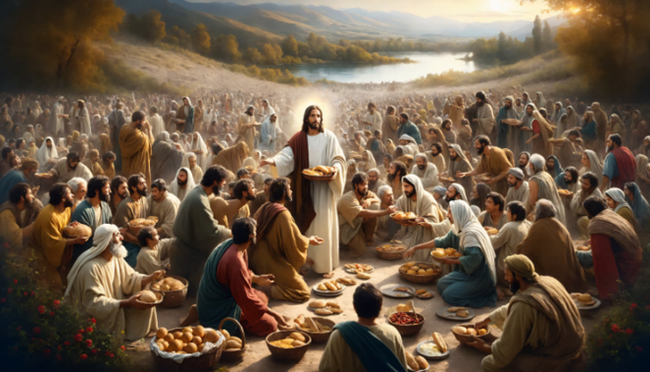
Just as God strengthens our faith, He also cares for our physical needs, as we see in the story of the feeding of the five thousand. His compassion and power extend not only to the unseen struggles of the heart but also to the tangible challenges of daily life. When Jesus heard of John the Baptist’s beheading by King Herod, He withdrew by boat to a solitary place to grieve. Yet, the crowds, eager for His presence, followed Him on foot from their towns (Matthew 14:13). As He landed on shore, He saw the large crowd and was moved with compassion, healing their sick (Matthew 14:14). When evening came, the disciples urged Jesus to send the people away to buy food, but He responded, “They do not need to go away. You give them something to eat” (Matthew 14:16). The disciples protested, pointing out that feeding the multitude would cost more than half a year’s wages to give them but a single bite (John 6:7). Then Andrew mentioned a boy offering his humble lunch of “five small barley loaves and two small fish,” though it was far from enough to feed so many (John 6:9). Jesus directed the crowd to sit in groups on the grass, took the loaves and fish, gave thanks, broke them, and distributed the food through the disciples. Miraculously, everyone ate until they were satisfied, and twelve baskets of leftovers remained (Matthew 14:18-21). In this moment, Christ not only met their physical hunger but revealed His divine power to provide abundantly in the face of scarcity. Yet, as we receive the nourishment Christ so freely gives, we must also recognize that our souls hunger for more than just His provision. They long for His cleansing and forgiveness. Just as our bodies cannot thrive without food, our spirits cannot flourish while burdened by sin. The same God who feeds us with His grace and love also invites us to experience the freedom of His pardon and restoration.
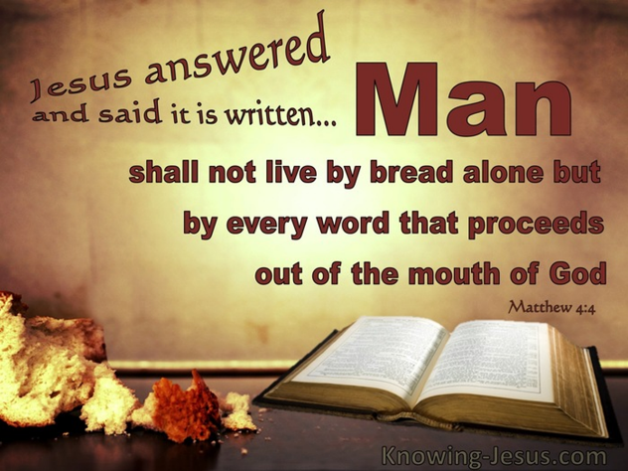
As we anticipate the turkey, ham, stuffing, potatoes, pies, cakes, cookies, and chocolates that fill our Christmas tables, our mouths water and our stomachs growl with anticipation. God has placed eternity within our hearts (Ecclesiastes 3:11). This reminds us of Christ’s words: ‘Man shall not live on bread alone, but on every word that comes from the mouth of God’ (Matthew 4:4). What if, this Christmas, we sought first His kingdom? Would not the Good Shepherd provide for our physical needs—food, clothing, and shelter (Matthew 6:25-34)—and, more importantly, nourishment for our souls? Jesus, the Bread of Life, promises that whoever comes to Him “will never go hungry, and whoever believes in Him will never be thirsty” (John 6:35). While lavish homes, cars, and jewelry may offer temporary smiles, nothing compares to the unspeakable joy of having “rivers of living water” flowing within us (John 7:37-38), a gift given and sustained by the Babe in the manger. Jesus is the Treasure and Pearl of great price (Matthew 13:44-46), the Great I AM (John 8:58), the Rock of our salvation (Psalm 18:2), and our Kinsman-Redeemer (1 Peter 1:18-19). This Christmas, let us give Him our hearts, our hurts, anxieties, and burdens, holding onto the glorious promise that He is always near to those who seek Him in faith (James 4:8). This Christmas, let us commit to seeking the Mighty God, trusting His provision, and sharing His love with others.

Help me Overcome my Sins!



As God meets our physical and spiritual needs, He also longs to cleanse our hearts, freeing us from the burdens of sin! When Jesus crossed the lake to the region of the Gerasenes, He encountered a man tormented by an impure spirit who lived among the tombs (Mark 5:1-2). This man’s suffering was so severe that no chains could hold him, and night and day, he cried out and cut himself with stones, trapped in a cycle of anguish, isolation, and despair (Mark 5:4-5). Perhaps he inflicted pain upon himself as a desperate release for his sadness, guilt, and anxiety or to remind himself that he was still alive. Yet when he saw Jesus, he ran and fell to his knees, recognizing Him as the “Son of the Most High God” (Mark 5:6-7). Jesus, in His mercy, commanded the demons—who called themselves “Legion” because they were many—to leave the man, allowing them to enter a herd of 2,000 pigs that rushed into the lake and drowned (Mark 5:9-13). The man, finally freed from his torment, longed to follow Jesus, but Christ instructed him to go home and tell others what the Lord had done for him (Mark 5:19). This Christmas, as we reflect on the pain and suffering of the lost and remember the depth of our own forgiveness, may we be compelled to shine the light of Christ through our words, deeds, and actions. Let us share the hope, healing, and deliverance found in our Mighty God!
May this Christmas be a time of deep reflection, heartfelt repentance, and joyful restoration. While gifts, festive meals, and cherished gatherings are delightful, they pale in comparison to the joy of walking closely with our Lord. Sin not only grieves the Holy Spirit within us (Ephesians 4:30) but also creates a barrier between us and God (Isaiah 59:2). The world may believe that anything is permissible if it doesn’t infringe on others, but we know that cherishing sin in our hearts hinders our prayers (Psalm 66:18) and may invite God’s loving discipline (Hebrews 12:4-13). Let our motivation for seeking forgiveness this Christmas not be fear alone, though the fear of the Lord is the beginning of wisdom, but also gratitude and love for the One who redeemed us. If we find ourselves wandering on dark paths of indifference or rebellion, may we hear the voice of the Good Shepherd who calls us by name (John 10:27). Let us fall to our knees, seeking His mercy, knowing with full assurance that there is no sin the blood of Christ does not cover (Colossians 2:13-14). While we cannot be sinless, we can strive to be righteous and humble before Him, approaching the manger with hearts cleansed by His grace and love.

God’s Mighty Hand

This Christmas, as we reflect on the Mighty God who came to us in a manger, may we humble ourselves before Him and cast all our burdens upon His capable shoulders, for “Humble yourselves, therefore, under God’s mighty hand, that he may lift you up in due time. Cast all your anxiety on him because he cares for you” (1 Peter 5:6-7). In moments of weakness, fear, and despair, let us remember that God’s strength is made perfect in our humility and surrender. Just as Gideon trusted God’s might, the father cried out for help with his unbelief, and the man possessed by Legion was restored, we too can experience His grace, power, and restoration. Let us not be consumed by temporary distractions, but seek first the Kingdom of God, knowing He forgives our sins, restores our hearts, and calls us by name. Whether we cry out, “Help me with my unbelief!” or “Feed me, O Lord!” or “Help me overcome my sins!” let us do so with confidence, assured that Christ’s blood covers all sin and His mercy never ends. As we draw near to Him, may we share His love, grace, and truth with others, shining His light into a world in need of hope. May this Christmas be one of renewed faith, restored joy, and deep intimacy with our Mighty God, who invites us to experience His unspeakable peace and eternal love. This Christmas, let us trust in our Mighty God, who strengthens our faith, meets our needs, and delivers us from sin.

