# **Everlasting Father**

Isaiah 9:1-7

Online Sermon:

[www.mckeesfamily.com/sermons/](http://www.mckeesfamily.com/sermons/)

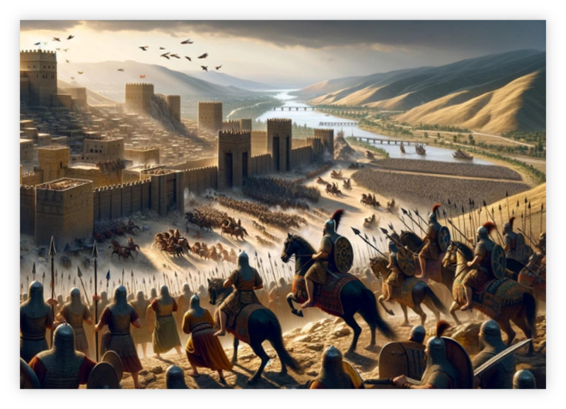 What do you do when life feels overwhelming and chaotic? When King Jehoshaphat faced the imminent threat of the Moabites, Ammonites, and Meunites marching against Judah (2 Chronicles 20:1-37), fear gripped the people’s hearts. But rather than relying on his own military strategy or succumbing to panic, Jehoshaphat sought the Lord’s help. He proclaimed a nationwide fast and led the people in earnest prayer, acknowledging their powerlessness and God’s supreme authority: “We have no power to face this vast army... Our eyes are on you” (v.12). In response, God assured them, “Do not be afraid or discouraged... For the battle is not yours, but God’s” (v.15). Acting in faith, Jehoshaphat sent men ahead of the army to sing praises: “Give thanks to the Lord, for His love endures forever” (v.21). As they worshiped, God caused their enemies to turn on each other, and Judah triumphed without lifting a sword (v.22). This story reminds us that when we seek the Lord with humility and trust, He hears our cries, fights our battles, and works all things for the good of those who love Him (Romans 8:28).

In Isaiah’s time, the people of Israel faced incredible fear and uncertainty, yet God offered them a promise of hope—a promise fulfilled in Jesus, our Everlasting Father. Over 2,700 years ago, around 700 years before the birth of Christ, the prophet Isaiah delivered a message that shook the very foundation of Israel’s existence. At the time, the mighty and feared Assyrian Empire was expanding its power westward and southward, and by 738 BC, the Assyrian king was demanding tribute from Israel. Despite Assyria's might, Israel and Damascus tried to resist through alliances. Assyria swiftly retaliated, and by 722 BC, the northern kingdom of Israel was destroyed. In 705 BC, King Hezekiah of Judah also withheld tribute, but this time, the angel of the Lord miraculously defeated 185,000 Assyrian soldiers. While Isaiah recorded these events with hope and joy, his heart must have been heavy when God revealed the coming Babylonian captivity of 586–539 BC. Yet even in this moment of despair, God showed Isaiah a future of redemption: Babylon’s defeat by Cyrus, king of Persia, and the subsequent release of Israel in 538 BC. This promise of restoration must have lifted the prophet’s spirit, reminding him and his people of God’s enduring faithfulness.

# **Jesus is Everlasting**

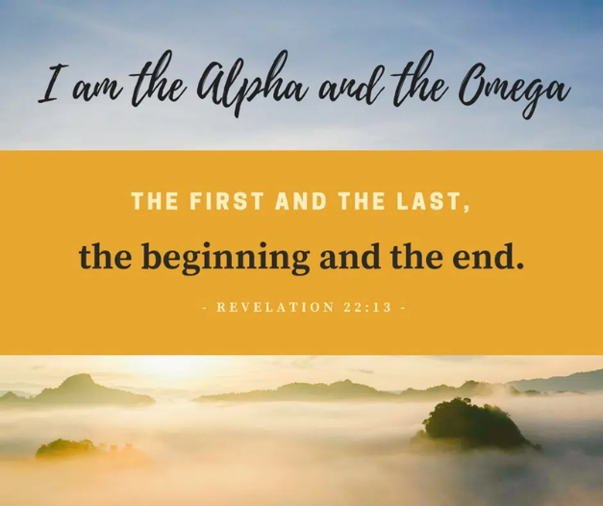Isaiah’s message of hope wasn’t just for his time. It pointed to an everlasting promise fulfilled in Jesus Christ. Yet the God who sustained them, offering hope and a future, remains the same today. Amid all the chaos, God’s message through Isaiah was clear: the brokenness of the moment would not last forever, and a greater hope would one day shine through. In the first half of the book of Isaiah, God warns Israel of their coming captivity, while the latter half speaks of the hope found in their Everlasting Father, Jesus. Though Israel would endure nearly two centuries of hardship, they needed to know that, despite their punishment for sin, God’s love would remain, and restoration would come. In Isaiah’s prophecies, the promised Messiah has “no beauty or majesty” (53:2), yet He springs forth as a shoot from Jesse’s line (11:1) and is born of a virgin (7:14). Though He would be “despised and rejected,” acquainted with suffering (53:3), He would be “pierced for our transgressions” and “crushed for our iniquities,” bringing us peace and healing by His wounds (53:5). These events happened millennia ago, yet the uncertainty and fear they experienced resonate with us today. We, too, live in turbulent times—surrounded by wars, rumors of wars, famines, and earthquakes—signs Jesus Himself forewarned in Matthew 24. Amid this instability, we must remember that Christ, the Alpha and Omega (Revelation 22:13), dwells at the Father’s right hand, sovereign over all creation (Colossians 1:16). Because He is everlasting, we can fully trust Him as our Lord and King.

# **Jesus is our Father**

Today more than ever, we need our heavenly Father’s guidance to navigate life’s uncertainties and challenges. Our Everlasting Father assures us that our identity is found in Him—not in race, status, or wealth, but in faith in Christ’s atoning sacrifice on the cross (Galatians 3:26–29; John 3:16). Those who believe are called by the Good Shepherd (John 10:14–15), set free by His truth (John 8:31), and adopted as His own children (John 1:12). Christ is the vine, and we are the branches; remaining in Him allows us to bear much fruit (John 15:5) and to use the spiritual gifts He gives us to do His work (1 Corinthians 12). Though we are servants of the Most High, we are also His friends and disciples (John 15), loved and cherished so deeply that we can approach His throne of grace to receive forgiveness, mercy, and love (Hebrews 4:16). Even as we experience poverty of spirit, mourning, and meekness, in Christ we are transformed into merciful, pure-hearted peacemakers—His precious children (Matthew 5:3–10).

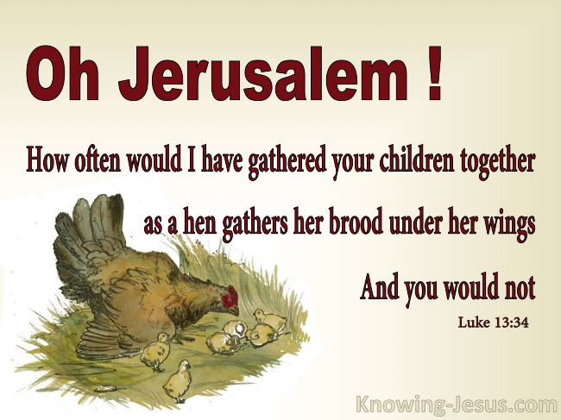 In our weakest moments, His comfort is matched by His understanding. When Mary and Martha faced the death of their brother, they were overwhelmed with grief. Jesus met them in their sorrow, weeping with them and demonstrating His compassion (John 11:35). Yet, He also revealed His power as the resurrection and the life by calling Lazarus out of the tomb (John 11:43-44). This story bridges the promise of Jesus’ everlasting nature with His role as our caring Father who comforts and restores. Knowing that Jesus is our Everlasting Father assures us of our identity in Him and brings us deep comfort in times of need. His compassion is beautifully illustrated in Luke 13:34. There, He longs to gather His people as a hen gathers her chicks. This tender image reveals His unconditional love and His desire to protect us. In moments of injustice, hatred, and persecution, He calls us to “take courage” and not be afraid (Mark 6:50), promising to work all things for our good (Romans 8:28). He invites us to exchange our burdens for His light yoke and find rest for our souls (Matthew 11:28-30), granting us the “peace of God, which transcends all understanding” to guard our hearts and minds (Philippians 4:6-7).

Having faced temptation Himself, Jesus empathizes with our struggle between flesh and spirit (Galatians 5:16-17), and in His mercy, offers grace and forgiveness to those who repent (1 John 1:9). As His beloved children, we can rest confidently in His presence, knowing He cares for us, strengthens us, and walks beside us through every challenge. This week, when you feel overwhelmed, remember that your Everlasting Father is with you. Lean on His promises, seek His peace, and rest in His unchanging love.

And finally, Jesus is our Father because He plans for our future! After having heard Christ say, “My children, I will be with you only a little longer” (John 13:33), the disciples’ hearts were greatly troubled (14:1). What would become of this tiny band of men who gave up everything to follow Jesus (Mark 10:28)? Would not those who yelled out “crucify Him, crucify Him” (Luke 23:20) and the Roman government who saw them as disturbers of the peace not seek their lives as well? And yet while they were being sent out lives “sheep amongst the wolves” (Matthew 10:16) and would suffer much for His name’s sake (Acts 9:15-16); their father, Jesus, would “never leave nor forsake” them (Hebrews 13:5). Because their light would shine and expose the darkness in others (John 3:19-21), the apostles were promised that, like Christ, since they ‘did not belong to this world’ (John 15:18-25) they would be persecuted and all, but John would be martyred. Lest these promises leave the apostles without hope, Christ reminded them that the reason He was going away was to secure their future! Jesus was going to heaven to be with God in heaven so that He might “prepare a place” for them (John 14:1-4) so that one day they might join Him forever at the Great Banquet in heaven (Luke 14:15-24). Until then, Christ would send them a Comforter. The Holy Spirit would lead them, guide them in truth, and equip them with spiritual gifts. Through Him, they would perform miracles even greater than those Jesus did on earth. Since Christ was their portion and being born again meant eternal life with Him, death lost all its sting so much that Apostle Paul never stopped looking heavenward!

# **Conclusion**

As we reflect on the promise of Jesus as our Everlasting Father, let us remember that His love, compassion, and guidance are unchanging and eternal. In a world filled with chaos, uncertainty, and suffering, we have a Father who never leaves us nor forsakes us. He is our source of hope, strength, and peace. Just as He comforted the disciples and prepared a future for them, He does the same for us today. When we feel overwhelmed, let us trust in His everlasting arms, knowing that He walks with us, understands our struggles, and carries our burdens.

This week, no matter what challenges you face, hold onto the truth that Jesus is with you. He invites you to lay down your anxieties and rest in His unchanging love. His grace is sufficient, His peace transcends understanding, and His plans for you are secure. As we await the glorious day when we join Him at the Great Banquet in Heaven, let us live boldly, shine our light in a dark world, and take courage in the presence of our Everlasting Father.

**Let us Pray**  
**Jesus, thank You for being our Everlasting Father. In moments of fear, uncertainty, and weakness, remind us of Your steadfast love and faithfulness. Help us to trust in Your promises, seek Your peace, and rest in Your unchanging love. May we live as Your beloved children, bringing light, hope, and grace to the world. In Jesus’ name, Amen.**