# **The Blessing of Hope**

Romans 15:13; 1 Peter 1:3-5

Online Sermon:

[www.mckeesfamily.com/sermons/](http://www.mckeesfamily.com/sermons/)

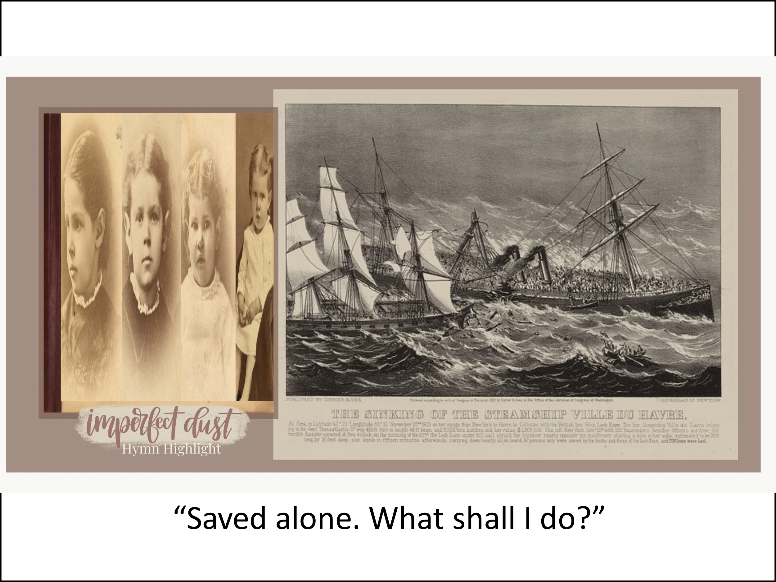Life can be so unpredictable—joys and sorrows, beautiful blessings and distressing difficulties can come unexpectedly. Our life’s dreams and plans can change in an instant. We all know this to be true. So how can we find peace amid such turbulence? Horatio Spafford knew something about life’s unexpected challenges. He was a successful attorney and real estate investor who lost a fortune in the great Chicago fire of 1871. Around the same time, his beloved four-year-old son died of scarlet fever. Thinking a vacation would do his family some good, he sent his wife and four daughters on a ship to England, planning to join them after he finished some pressing business at home. However, while crossing the Atlantic Ocean, the ship was involved in a terrible collision and sunk. More than 200 people lost their lives, including all four of Horatio Spafford’s precious daughters. His wife, Anna, survived the tragedy. Upon arriving in England, she sent a telegram to her husband that began: “Saved alone. What shall I do?”

Horatio immediately set sail for England. At one point during his voyage, the captain of the ship, aware of the tragedy that had struck the Spafford family, summoned Horatio to tell him that they were now passing over the spot where the shipwreck had occurred.As Horatio thought about his daughters, words of comfort and hope filled his heart and mind. He wrote them down, and they have since become a well-beloved hymn:

“When peace like a river, attendeth my way,

When sorrows like sea billows roll;

Whatever my lot, Though hast taught me to know

It is well, it is well, with my soul.”

Perhaps we cannot always say that everything is well in all aspects of our lives. There will always be storms to face, and sometimes there will be tragedies. But with faith in a loving God and with trust in His divine help, we can confidently say, “It is well, it is well with my soul.”[1]

Horatio Spafford’s faith reminds us of the unwavering trust demonstrated by heroes of the faith. Like Spafford, Joseph, Job, David, and Paul clung to God’s promises in the face of overwhelming trials. Let’s explore their stories to see how they found hope amid suffering. Imagine how you would feel if you were like Joseph, sitting in Pharaoh’s prison, left to wrestle with the betrayal of your own brothers who sold you into slavery, and falsely accused of the very crime committed by another. Or if you were like Job, who lost all his wealth in an instant, his children died in a violent storm, suffered devastating health issues, and was criticized and blamed by his closest friends. Picture living in David’s shoes, hunted by King Saul, carrying the weight of guilt for adultery and murder, and grieving the loss of his first child. Later, he faced betrayal by his own son, who seized his throne only to lose his life because of rebellion. Consider the Apostle Paul, to whom God said, *“I will show you how much you must suffer for my name’s sake.”* Paul endured beatings, stoning, shipwrecks, lashes, imprisonment, and more. How did these men not only survive such suffering but thrive amid unimaginable trials? How could Horatio Spafford, after losing his daughters in a tragic shipwreck, write the words *“It is well with my soul”?* How could Job declare, *“Blessed be the name of the Lord”* or Paul proclaim, *“I rejoice in my sufferings”?* How can we cultivate this hope in our own lives? By meditating on God’s promises, praying for His peace, and sharing our burdens with Christ. Let’s fix our eyes on Him, knowing He will sustain us.

Today, we will explore how these men of faith and countless others found unspeakable joy amid their suffering. They endured because their eyes were fixed on the pioneer and perfecter of their faith, Jesus Christ. Worldly hope is often fragile, rooted in circumstances or our own abilities. Christian hope, however, is unshakable because it rests on the promises of God and the finished work of Christ. Christian hope goes beyond the optimism of seeing light at the end of life’s dark tunnels. Christian hope is not mere optimism but confident assurance in Jesus, knowing our eternal home is secured by the Creator of all things. As we examine their lives and the unshakable hope they clung to, we will discover how we, too, can endure life’s trials with faith and emerge with a peace that transcends understanding.

# **Hope Rooted in the Promises of God**

At the heart of Christian hope lies the unwavering assurance that God always keeps His promises. King David reminds us that even as we walk through the darkest valleys of tribulation, we need not fear, for God is with us, His rod and staff providing comfort and guidance (Psalm 23:4). God promises to never leave nor forsake us (Hebrews 13:5), assuring us that even amidst the storms of life, He has plans to prosper us, to give us hope and a future (Jeremiah 29:11). Those who place their hope in the Lord will find their strength renewed; they will soar on wings like eagles, run without growing weary, and walk without fainting (Isaiah 40:31). When burdens become 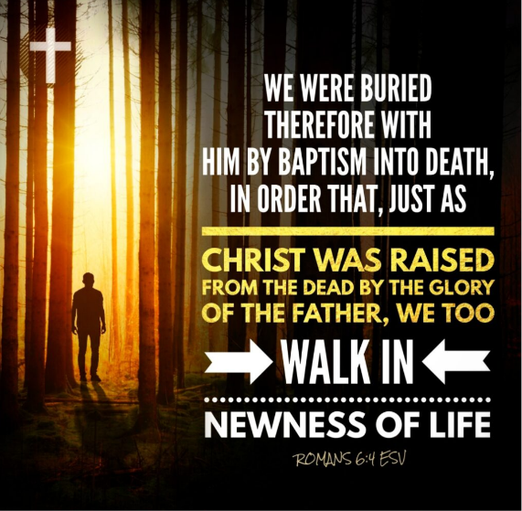overwhelming and our hearts grow heavy, Jesus invites us to trade our yokes for His, promising rest for our souls (Matthew 11:28-30). Through faith and hope in Christ, we are filled with a peace that surpasses all understanding, guarding our hearts and minds (Romans 15:13; Philippians 4:6-7). As those born of water and Spirit, we no longer fear even death, for we look forward to the Great Banquet in heaven, where Christ will wipe away every tear, and death, mourning, and pain will be no more (Revelation 21:4). With steadfast hope, we await the day we hear His welcoming words: "Well done, good and faithful servant—welcome home!" What storms are you facing today? How can you anchor yourself in God’s promises like Spafford and the heroes of faith?

# **The Source of our Hope**

Standing on the promises of God is not rooted in fleeting feelings or abstract ideas but in the concrete, historical reality of Christ’s resurrection. Just as a lighthouse, anchored on solid rock, guides ships through turbulent storms, our hope is firmly anchored in Christ, who conquered death. He died once for all (Hebrews 10:10), bearing God’s righteous wrath (Isaiah 53:5-6) and paying the penalty for our sins so that, through faith in Him, we might be born again—not by flesh and blood, but by the Spirit of God (John 3:5, 16). As Paul explains, we are united with Christ in His death and resurrection: “We were buried with Christ through baptism into death in order that, just as Christ was raised from the dead through the glory of the Father, we too may live a new life” (Romans 6:4). This new life is not marked by fear but by power, love, and self-discipline (2 Timothy 1:7), filled with the assurance that when the Lord descends with the voice of the archangel and the trumpet call of God, we will be caught up in the clouds to be with Him forever (1 Thessalonians 4:16). A believer’s hope is not dependent on circumstances—whether joyful or bleak—but on God’s mercy and the eternal glory He promises to His children. That is why Paul declares with joy, “I consider that our present sufferings are not worth comparing with the glory that will be revealed in us” (Romans 8:18).

# **The Strength of our Hope**

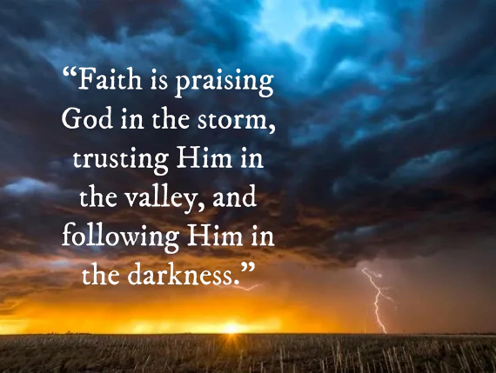 We often view suffering negatively, seeing it as either the result of a fallen world or as punishment from God. Yet, Scripture reveals that tribulations can have profound, positive effects on us, shaping our character and deepening our trust in God’s promises. James encourages us to “consider it pure joy… whenever you face trials of many kinds,” because such trials test our faith, producing perseverance that leads to spiritual maturity (James 1:2-4). Similarly, Paul reminds us that suffering produces perseverance, perseverance shapes character, and character births hope (Romans 5:3-4). Through these trials, we are refined like gold, with our faith growing stronger as we cling to the unshakable promises of God. Our strength comes not from our own efforts but from the Lord, our “rock of salvation” and “mighty fortress” (Psalm 28:7-8), who works all things for the good of those who love Him. The ability to endure and even thrive amid life’s storms rests on God’s grace, which Paul assures us is sufficient, for God’s power is made perfect in our weakness. That is why, in our hardships, we can declare, “When I am weak, then I am strong” (2 Corinthians 12:9-10), relying on the Lord who never fails His own. In the hands of our loving Creator, suffering is never wasted but becomes a tool for growth, shaping us into the image of Christ and preparing us for an eternal glory that far outweighs any trial we face. What challenges are you facing today that God might be using to refine your faith? Are you willing to trust His promises even when the path seems uncertain?

# **The Security of our Hope**

The treasure we hold within us, as jars of clay, is meant to be shared with others. As 1 Peter 3:15 exhorts, “But in your hearts revere Christ as Lord. Always be prepared to give an answer to everyone who asks you to give the reason for the hope that you have.” Like a candle dispelling darkness, the hope we carry has the power to ignite hope in others. Consider the despair of facing life’s tribulations without the comforting presence of the Good Shepherd. How terrifying it must be to confront an uncertain future, to face sleepless nights without the assurance of a sovereign God to hear one’s cries, or to grapple with the fear of death without the eternal hope of salvation. For those who reject the clear witness of creation—God’s eternal power and divine nature (Romans 1:20)—the prospect of eternity without Him is a sobering reality. They are like lost sheep, in desperate need of the Shepherd. As Christ’s ambassadors (2 Corinthians 5:20), we are called to let His light shine brightly through us by living and proclaiming His Word. Do we share in God the Father’s desire that none should perish (2 Peter 3:9)? We must not hide our light under the bushel of indifference (Matthew 5:14-16). Instead, let us boldly carry the Good News—the eternal hope found in Christ Jesus—to a world in desperate need of Him.

# **Conclusion**

In the storms of life, when sorrows like sea billows roll, we can rest in the assurance that our hope is secure in Christ. Like Horatio Spafford, we may face unimaginable trials, but through faith, we can declare with confidence, 'It is well with my soul.' The heroes of faith—Joseph, Job, David, Paul, and countless others—teach us that suffering is never wasted when placed in the hands of our loving Creator. Their lives remind us that God’s promises are unshakable, His grace is sufficient, and His power is made perfect in our weakness. But this hope is not meant to be kept to ourselves. We are called to share it with a world desperately searching for peace amid turbulence. As jars of clay carrying the treasure of the gospel, let us shine Christ’s light in the darkness, offering the same hope we have found to those who are lost, weary, and afraid. So, what storms are you facing today? Will you choose to anchor yourself in God’s promises and trust His unfailing love? And who around you need to hear the good news of eternal hope in Christ? This week, take one step to share Christ’s hope with someone in need—whether through prayer, a conversation, or a simple act of kindness and may you boldly proclaim, ‘It is well with my soul.’ For in Christ, our anchor holds firm, and our eternal home is secure.

1. Taken from the following website: [The Touching Story Behind "It Is Well With My Soul"](https://www.thetabernaclechoir.org/articles/it-is-well-with-my-soul.html?lang=eng)