The Blessing of Provision

  - Matthew 6:25-34; Philippians 4:19
  - Online Sermon:
  - www.mckeesfamily.com/sermons/


Jars of clay in ancient times were common, inexpensive, fragile, and easily broken, possessing little intrinsic value. When Apostle Paul describes us as jars of clay, it strikes a chord with our own sense of insignificance and vulnerability. Surrounded by headlines of wars, earthquakes, famines, divorces, illnesses, and financial crises, we often feel fragile and fearful about what the future may hold. While planning can spark hopes of success, it also invites fears that no amount of insurance or preparation can truly silence. The world tells us to hoard possessions and wealth, believing that material abundance can protect us from life’s inevitable storms, yet experience reveals that no accumulation of "stuff" can provide lasting joy or peace. True security is not found in what we can hold in our hands but in whom we place our trust. Today, we are reminded that the true key to peace is not in material security but in counting our blessings and placing our faith in the risen Savior, who not only gave His life for us but also meets our daily needs and satisfies the deepest longings of our souls. Like the psalmist, we can declare, "God is my portion forever," knowing that in Him, we have a source of strength, joy, and hope that no earthly trial can take away. Trusting in His unfailing provision allows us to live not in fear but with confidence in His eternal promises.

God Knows our Needs and Provides for Them

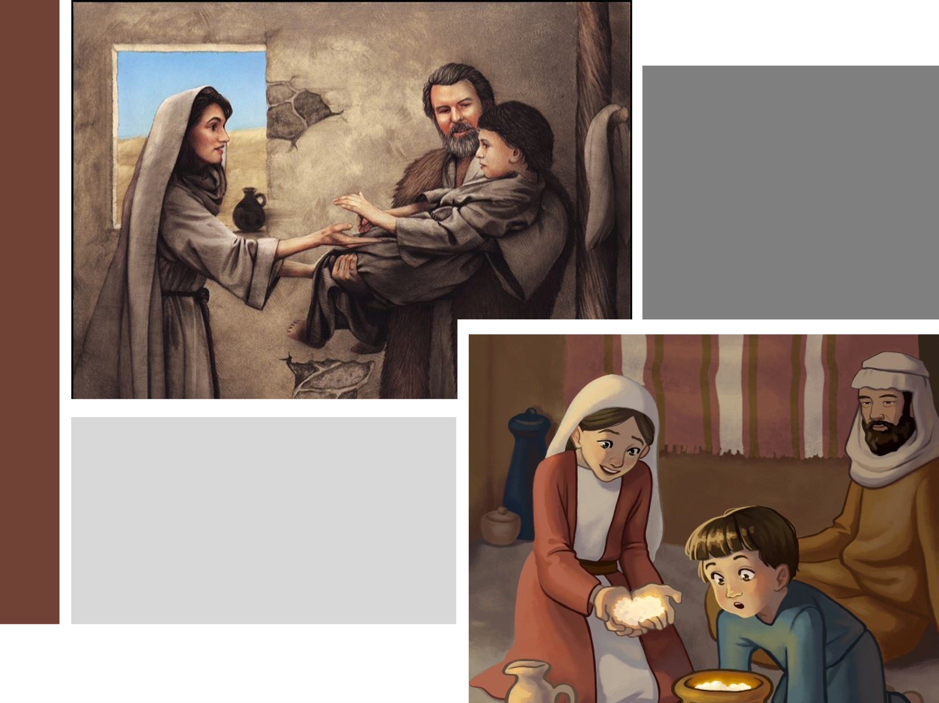
True security is not found in what we can hold in our hands but in whom we place our trust. This truth is beautifully illustrated in the story of the widow in 1 Kings 17, a poignant example of how God knows our needs and provides for them when we place our faith in Him. During a time of severe drought, brought about as judgment for King Ahab's wickedness, God directed the prophet Elijah to rely on miraculous means for survival. Initially, Elijah was sustained by ravens bringing him bread and meat and by a brook for water. When the brook eventually dried up, God sent Elijah to Zarephath, where a widow would provide for him. However, this widow was herself in desperate straits, with only enough flour and oil to prepare one last meal for herself and her son before they expected to die of starvation. When Elijah asked her to use her meager provisions to prepare food for him first, he reassured her with God's promise: the jar of flour and the jug of oil would not run out until the drought ended. Despite the enormity of the sacrifice and the apparent impossibility of the promise, the widow chose to trust God and obey. God rewarded her faith, miraculously sustaining her household throughout the famine. This story is a profound reminder that trusting God often requires us to step out in faith, even when the odds seem stacked against us. It demonstrates that true security is not found in the little we hold onto but in the abundant provision of a loving and faithful God who cares for His own. Just as the widow’s story highlights God’s faithfulness, Jesus builds on this truth, teaching us how to trust Him in the face of life’s worries.

The story of the widow in 1 Kings illustrates the teachings of Christ in Matthew 6:25-34. Life's trials often fill us with worry and fear, yet Christ calls us to trust in a sovereign God whose peace surpasses all understanding (Philippians 4:7). Jesus commands us not to be anxious about what we will eat, drink, wear, or even about our bodies (Matthew 6:25). He reminds us that the birds of the air, though they neither sow nor reap, are fed by God, and the flowers of the field, which do not labor or spin, are adorned in splendor far surpassing that of Solomon (6:26-29). Are we not much more valuable to Him than these? Christ challenges us to examine our faith, asking if our worrying can add even a single hour to our lives (6:27). Anxiety often stems from a lack of trust in God's provision, as if we could orchestrate a better future than the Good Shepherd has planned for us. True peace comes not from our own striving but from seeking first His kingdom and His righteousness, knowing that everything we need will be provided by His loving hand (6:33). Trusting God frees us to live in the confidence and rest only He can provide.

Living with Contentment



How does one place their trust in God during tribulations, especially when prayers seem unanswered? In such moments, it is easy to fall into the trap of comparing oneself with others who seem better off and to question God's fairness. The psalmist Asaph wrestled with this very struggle in Psalm 73. Troubled by the apparent prosperity of the wicked, he lamented how they lived free of struggles, flaunted their arrogance, and mocked God, all while he endured affliction and pain despite striving to remain righteous (vv. 1-14). This inner conflict brought Asaph to the brink of despair, questioning the value of his faith. However, everything changed when he entered the sanctuary of God. There, he gained divine perspective: the prosperity of the wicked is temporary, and their end is eternal ruin. Asaph realized that true fulfillment comes not from earthly ease or material wealth but from a life anchored in God. Jesus taught that one should not store up treasures on earth but seek first the kingdom of God, where eternal rewards await. Even when his heart and flesh failed, Asaph found that God was his strength and his portion forever (v. 26). Trusting in God means embracing His eternal justice and unfailing love, recognizing that a life lived in His will may not always be easy, but it will be profoundly joyful and purposeful. In eternity, the rewards for faithfulness will overshadow every memory of earthly suffering, for in God, we have everything we truly need.

As Asaph discovered, when we shift our focus from earthly struggles to God's eternal sufficiency, our fragility as jars of clay becomes an opportunity for His power to shine through us. Like Asaph, we may wrestle with despair, envying the prosperity of the wicked while we face trials and unanswered prayers. Yet, when he entered the sanctuary of God, his perspective shifted, and he realized that the prosperity of the wicked is fleeting, while true fulfillment comes from anchoring our lives in God's eternal goodness. Apostle Paul echoes this truth, teaching us the secret of contentment: to find peace in every circumstance through Christ's strength (Philippians 4:12-13). In tribulations, we often covet what others have, focusing on our lack—a failing marriage makes us envy loving couples, financial struggles turn our attention to the wealthy, and poor health makes us yearn for strength. Rarely do we pause to count the blessings we still possess, forgetting that while much may be lost, far more remains. Unspeakable joy is not found in fleeting treasures or false securities but in resting in God’s perfect provision. True contentment comes from basking in the grace, mercy, and love of our Savior. With God as our portion, what more could we ever ask for? True contentment is not rooted in what we lack or desire but in who God is—the One who fills our fragile jars of clay with His abundant grace, strength, and peace. Trusting in Him, we find a joy and fulfillment that no trial or tribulation can ever take away.

Trusting God’s Faithfulness


Just as God’s faithfulness sustained the widow and her household through the famine, and just as Jesus reminds us not to worry because our heavenly Father knows our needs, we, too, are called to place our trust in Him. Yet trusting God often requires us to confront the areas of our lives where fear and self-reliance dominate. What are the jars of oil in your life that you struggle to trust God with? Where is God calling you to take a leap of faith, even when it feels risky or uncomfortable, to serve His kingdom? Perhaps as you glance at your dwindling bank account or growing debts, God is inviting you to give generously, trusting that He will supply your needs. Or maybe your overcrowded calendar, packed with countless responsibilities, is preventing you from slowing down to seek His presence, to be holy, or to comfort someone in need. Do not let the noise of worry and the weight of life’s tribulations drown out the still, small voice of God. He promises never to leave or forsake you and assures you that He is working all things together for your good when you place your trust in Him. Take heart, and step forward in faith, knowing He is faithful to provide and guide. Though we may feel like fragile jars of clay, God fills us with His strength and sustains us through every trial, just as He did for the widow.

Conclusion

Surrounded by headlines of wars, disasters, and crises, it’s no wonder Paul called us “jars of clay.” Fragile and easily broken, our lives remind us not of the need to store up treasures on earth but to rely wholly on our sovereign Lord to provide for every need. Even in the valleys of great tribulation, we can experience unspeakable joy when we count our blessings and see the Lord as our portion. Here are three practical ways to live out this truth:

- Practice gratitude: Each day, thank God for specific ways He has provided—spiritually, emotionally, or materially. Count your blessings and name them one by one.
- Cultivate contentment: When tempted to compare or focus on what you lack, remember that in Christ, you already have enough. Trust God as your provider and let go of the need for more.
- Trust God with your future: Turn your worries into prayers. Trust that the same God who has provided in the past will continue to do so. Surrender your worries to Him and rest in His faithfulness.

Let us pray.
Lord, help us see ourselves as You see us. Though we are fragile jars of clay, with Your strength, guidance, mercy, and love, You have empowered us to accomplish great things for Your glory. Keep us from being consumed by the pursuit of worldly necessities or riches, and teach us to trust You fully, knowing that even in the darkest valleys, Your light shines unquenchable. We are forever Yours, Lord; guide us to serve You faithfully according to Your will. No matter what trials we face, may we always rejoice, for You alone are our portion and our eternal hope. Amen!

Taken from the Count Every Blessing Series.

