I am the Way, Truth, and the Life
John 12:12-36, 13:31-14:4, 14:5-7, 14:8-14
Online Sermon: http://www.mckeesfamily.com/?page_id=3567
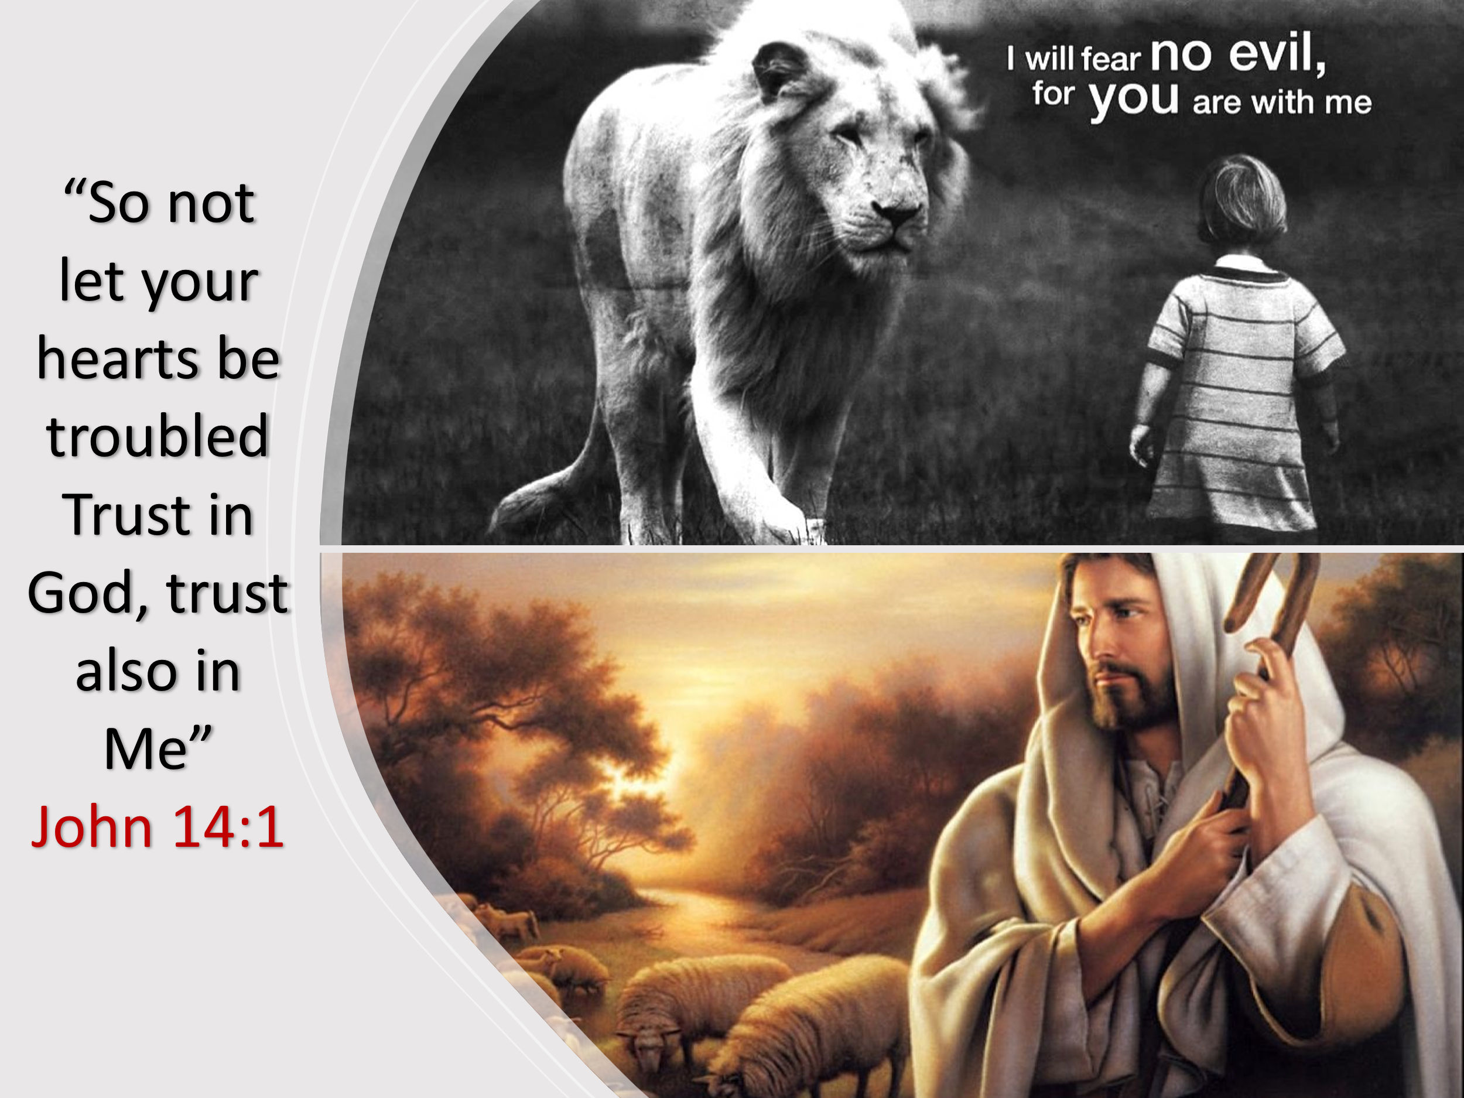
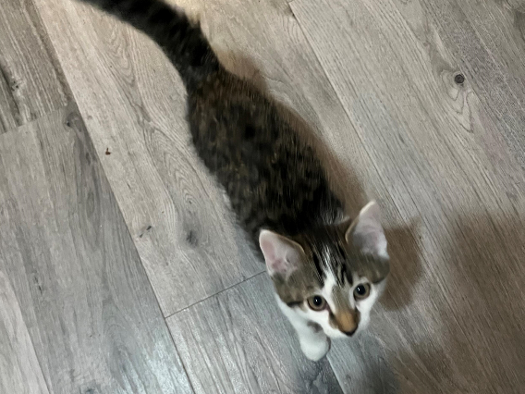
I recently adopted a kitten, and although my wife and I felt an instant attachment to the young feline, I couldn’t help but imagine how difficult the experience of going to a new home would be for her. While she enjoyed being held, the fast-moving images of telephone poles, the hustle and bustle of endless cars, and the scurry of strangers passing by the windows must have been strange and quite frightening. When we got home and I put her down on the floor, I noticed a remarkable transformation. As she explored the unknown reaches of her new environment, her fear was soon replaced with insatiable curiosity. Each step she took was cautious but led her into a space that quickly became familiar and comforting. The couch, which initially seemed large and scary, soon became a bouncy play toy of delight, and the large, Garfield-sized cat that was intimidating at first soon turned into a slow-moving playmate, perfect for tackling and running around with. Our kitten, whom we named Rosey, quickly came to know and love her new home.
Just as Rosey's fear gave way to curiosity and comfort, our journey as Christians mirrors her experience. We often find ourselves in unfamiliar and challenging situations, but we are called to trust in God's presence and guidance as we navigate this world, which is not our true home. “While life is filled with amazing and wonderful events, it is also fraught with trials, tribulations, and pitfalls that can shake us from our mountaintops of blessing and throw us into the deep valleys of anguish and despair. While some people thrive on experiencing the unknown, most of us are like Rosey, and our fear only dissipates with a full understanding of the new environment we are about to enter. Yet, as royal priests and ambassadors of the Most High God, are we not called to stand upon the rock of our salvation and fear no evil, for God is always with us? To obey the Lord’s command, “Do not let your hearts be troubled. Trust in God; trust also in Me,” requires us to venture into the unknown with confidence that our Shepherd will lead, guide, and protect us for His name’s sake. Jesus made this statement to the disciples as they faced their unknown futures in the wake of His impending crucifixion.

The Unknown

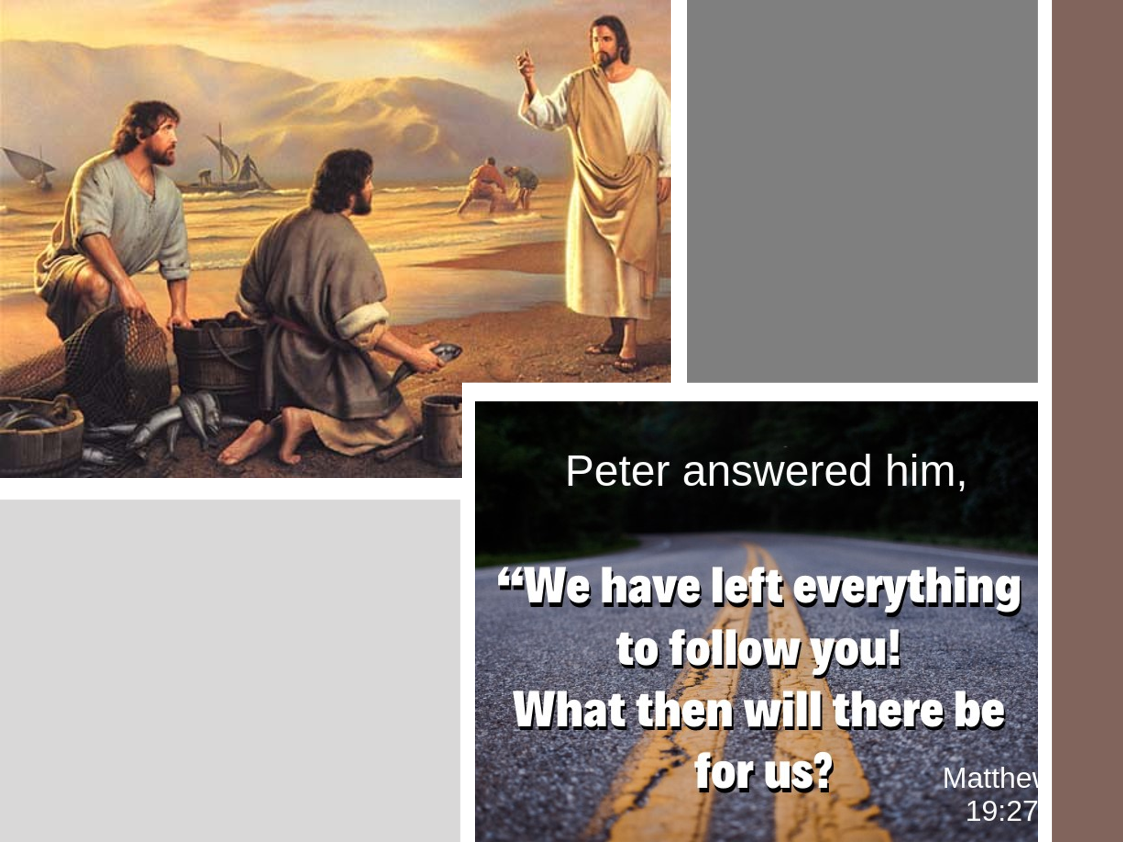
Handling a major life-changing event that raises more questions than answers can be daunting and unsettling. When the disciples heard Jesus declare, “the hour has come for the Son of Man to be glorified,” signifying that He would soon depart, and they could not follow Him (John 13:31-33); it must have struck them with profound fear and confusion. The One they believed had come to overthrow Rome and had legions of angels at His disposal (Matthew 26:53) was facing an impending and unjust crucifixion. They had abandoned everything to follow Him (Matthew 19:27), and now their aspirations of serving with Him in His kingdom were in jeopardy. The fear of being rejected and persecuted, as Jesus had warned, “If you belonged to the world, it would love you as its own. As it is, you do not belong to the world, but I have chosen you out of the world. That is why the world hates you” (John 15:18-19), loomed large in their confused and frightened minds. Questions about their future mission arose: without Christ, could they still exercise the authority to drive out impure spirits and heal diseases (Matthew 10:1) and fulfill the Great Commission to make disciples of all nations (Matthew 28:19)? Let’s explore how three of the disciples handled the unknown ramifications of the cross, starting with Peter.

Peter: Where are you going?

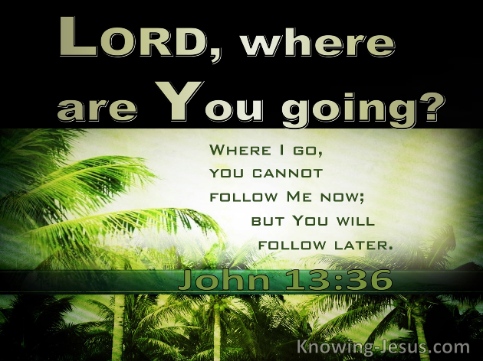
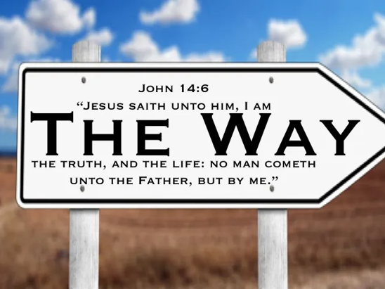
As Rosey looked out the window of my car, she was filled with anxiety because she did not know where she was going. Similarly, Peter asked Christ the same question. The confusion, anguish, and fear of the future that Peter experienced would only dissipate through exploration and knowledge. The dynamics of their relationship were about to change, and Peter insisted on exploring every aspect of this new reality with his Savior. Although Peter claimed he was ready to lay down his life to follow his Savior, Christ predicted Peter's denial, highlighting his fear of the unknown (John 13:36-38). The true significance of the cross would be revealed to the disciples only after being indwelled by the Holy Spirit. Only the sinless Lamb of God could atone for sin, satisfying God's righteous wrath. Christ's departure was necessary to prepare a place for them with the Father, and He would send the Holy Spirit to comfort and guide them (John 15:26-16:15). The new communities they were to create would have Christ as the cornerstone (Ephesians 2:20-22) and would be defined by love. Since they did not know all of this before His death and resurrection, the antidote to their current doubt and fear was to trust in Him (John 14:1). Despite not knowing everything, they were to trust the Good Shepherd that “all things work for the good of those who love Him” (Romans 8:28). Now let’s look at how Thomas handled the unknown future he faced after the cross.

Thomas: We Don’t Know the Way

Hearing about Christ going to be with the Father to prepare a place for them was not enough to quell Thomas' fears; he needed to know how to get there! Listen to the frustration and anxiety in Thomas' questioning of the Lord, "we don't know where you are going, so how can we know the way?" (John 14:5). His question was akin to that of the rich ruler in Mark 10:17-31, who asked, "what must I do to inherit eternal life?" Despite having kept God's commands "since he was a boy" (Mark 10:20), he still sensed that he had yet to find the path to heaven. He did not need intellectual clarity, good works, charity, or penance, but something far more precious, faith! To calm their anxieties and fears, Christ did not open their minds with divine wisdom that the prophets and angels longed to understand (1 Peter 1:10-12). Instead, He reassured them, "I am the way and the truth and the life. No one comes to the Father except through Me" (John 14:6). Since His ways and thoughts are higher than ours (Isaiah 55:8-9), the key to being born of water and Spirit (John 3:5) is not through knowledge or works but through faith in Christ's atoning sacrifice (Ephesians 2:8-9). The key to following Jesus to the Father is not just "knowledge of" but "knowing Him" as one's Lord, Savior, and King!

Philip: Show us the Father

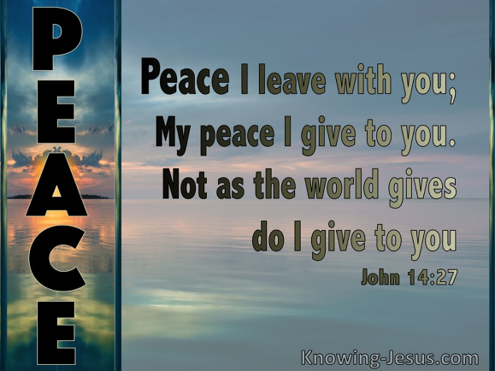
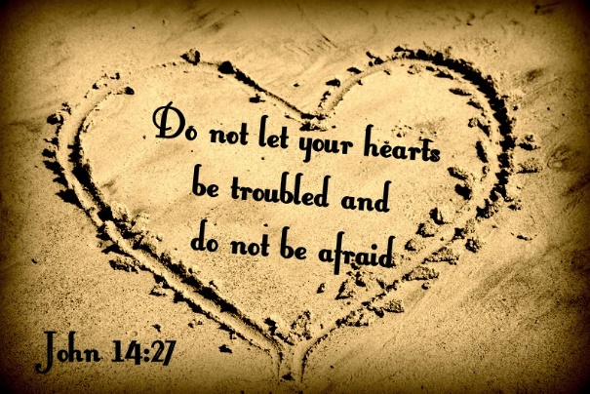
Phillip, not willing to wait to see the Father, asks Christ, “Lord, show us the Father and that will be enough for us” (John 14:8). Essentially, Phillip was saying that if they could not follow Christ to the Father, then the Father should be brought to them. Phillip was likely hoping for a theophany, as seen in the Old Testament (Exod. 24:10; 33:17ff.; Isa. 6:1). In response, Christ gently rebukes him, saying, “Don’t you know Me, Phillip, even after I have been with you such a long time? Anyone who has seen Me has seen the Father” (John 14:9). When I first put Rosey on the floor, she was timid and frightened by the unknown. However, as she explored her new home, her fear gave way to fascination as she came to feel safe. Similarly, Phillip and the other disciples needed reassurance as they faced the daunting prospect of life without Christ's physical presence. They needed to know that God would be with them in this new reality. Though the world would hate them, and they would be sent out like sheep among wolves (Matthew 10:16), they would fear no evil (Psalm 23) because they had a relationship with God the Father, His Son, and would soon receive the Holy Spirit (John 14). They would not be alone in this hostile world but would experience the joy of being guided and loved by God. Christ assured them that He was not abandoning them but empowering them to feel peace and perform miracles beyond their understanding.

Conclusion

In conclusion, just as Rosey, our new kitten, found her way through fear and uncertainty to a place of comfort and familiarity, we too are called to navigate the unknowns of life with faith and trust in our Shepherd. The disciples faced profound fear and confusion as they contemplated life without Jesus' physical presence, but Christ assured them—and us—that He is the way, the truth, and the life. We are never alone. Even when the path ahead seems daunting, we can take heart in knowing that God is with us, guiding us every step of the way. As we face our own trials and uncertainties, let us remember Jesus' comforting words: “Do not let your hearts be troubled. Trust in God; trust also in Me” (John 14:1). Our faith in Him transforms our fear into courage, our confusion into clarity, and our despair into hope. The Holy Spirit, who dwells within us, empowers us to perform miracles beyond our understanding and to experience the peace that surpasses all comprehension. Let us embrace each new challenge with the confidence that our God, who has overcome the world, walks beside us. Just as Rosey came to love her new home, we too can find joy and purpose in our journey, knowing that our true home is with our Heavenly Father. May we step forward in faith, trusting that all things work together for the good of those who love Him (Romans 8:28), and that we are always held in the loving hands of our Savior. Amen.

Matt Carter and Josh Wredberg, Exalting Jesus in John (Nashville, TN: Holman Reference, 2017), 273.
Matt Carter and Josh Wredberg, Exalting Jesus in John (Nashville, TN: Holman Reference, 2017), 276.
Matt Carter and Josh Wredberg, Exalting Jesus in John (Nashville, TN: Holman Reference, 2017), 276.
Taken from the I AM series on sermon central.
Ibid.
Leon Morris, The Gospel according to John, The New International Commentary on the New Testament (Grand Rapids, MI: Wm. B. Eerdmans Publishing Co., 1995), 571.

