The Light of the World
John 8:12; Matthew 5:14-16
Online Sermon: http://www.mckeesfamily.com/?page_id=3567

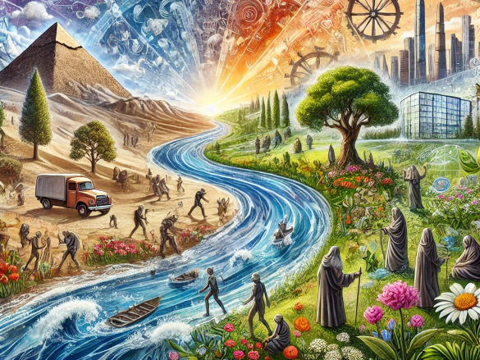
How can one cast a shadow of significance upon a world that is filled with constant change, ever evolving thought processes and constant innovation? In a world of quantum computers that can answer complex problems in just 200 seconds what would have taken the fastest supercomputer 10,000 years, where stem cells can be used to recreate all the cells in the bone marrow including the cancer ones that were destroyed by high doses of chemotherapy, where artificial intelligence can create images, answer questions, and perform complex tasks, and where genome editing give scientists the ability to change an organism’s DNA; standing out as “significant” seems like an exercise in futility! However, by stepping back and rejecting the common worldview that the temporal is all that matters, and by viewing both seen and unseen realms through the eyes of Christ, it becomes not only possible but divinely ordered to attain a level of significance beyond human comprehension. This perspective shifts the focus from transient achievements to eternal impact, rooted in divine purpose and understanding. Such a shift in worldview encourages contributions that transcend time, emphasizing spiritual and moral significance over merely technological or scientific accomplishments. In this light, true significance is found in actions and decisions aligned with our Creator!

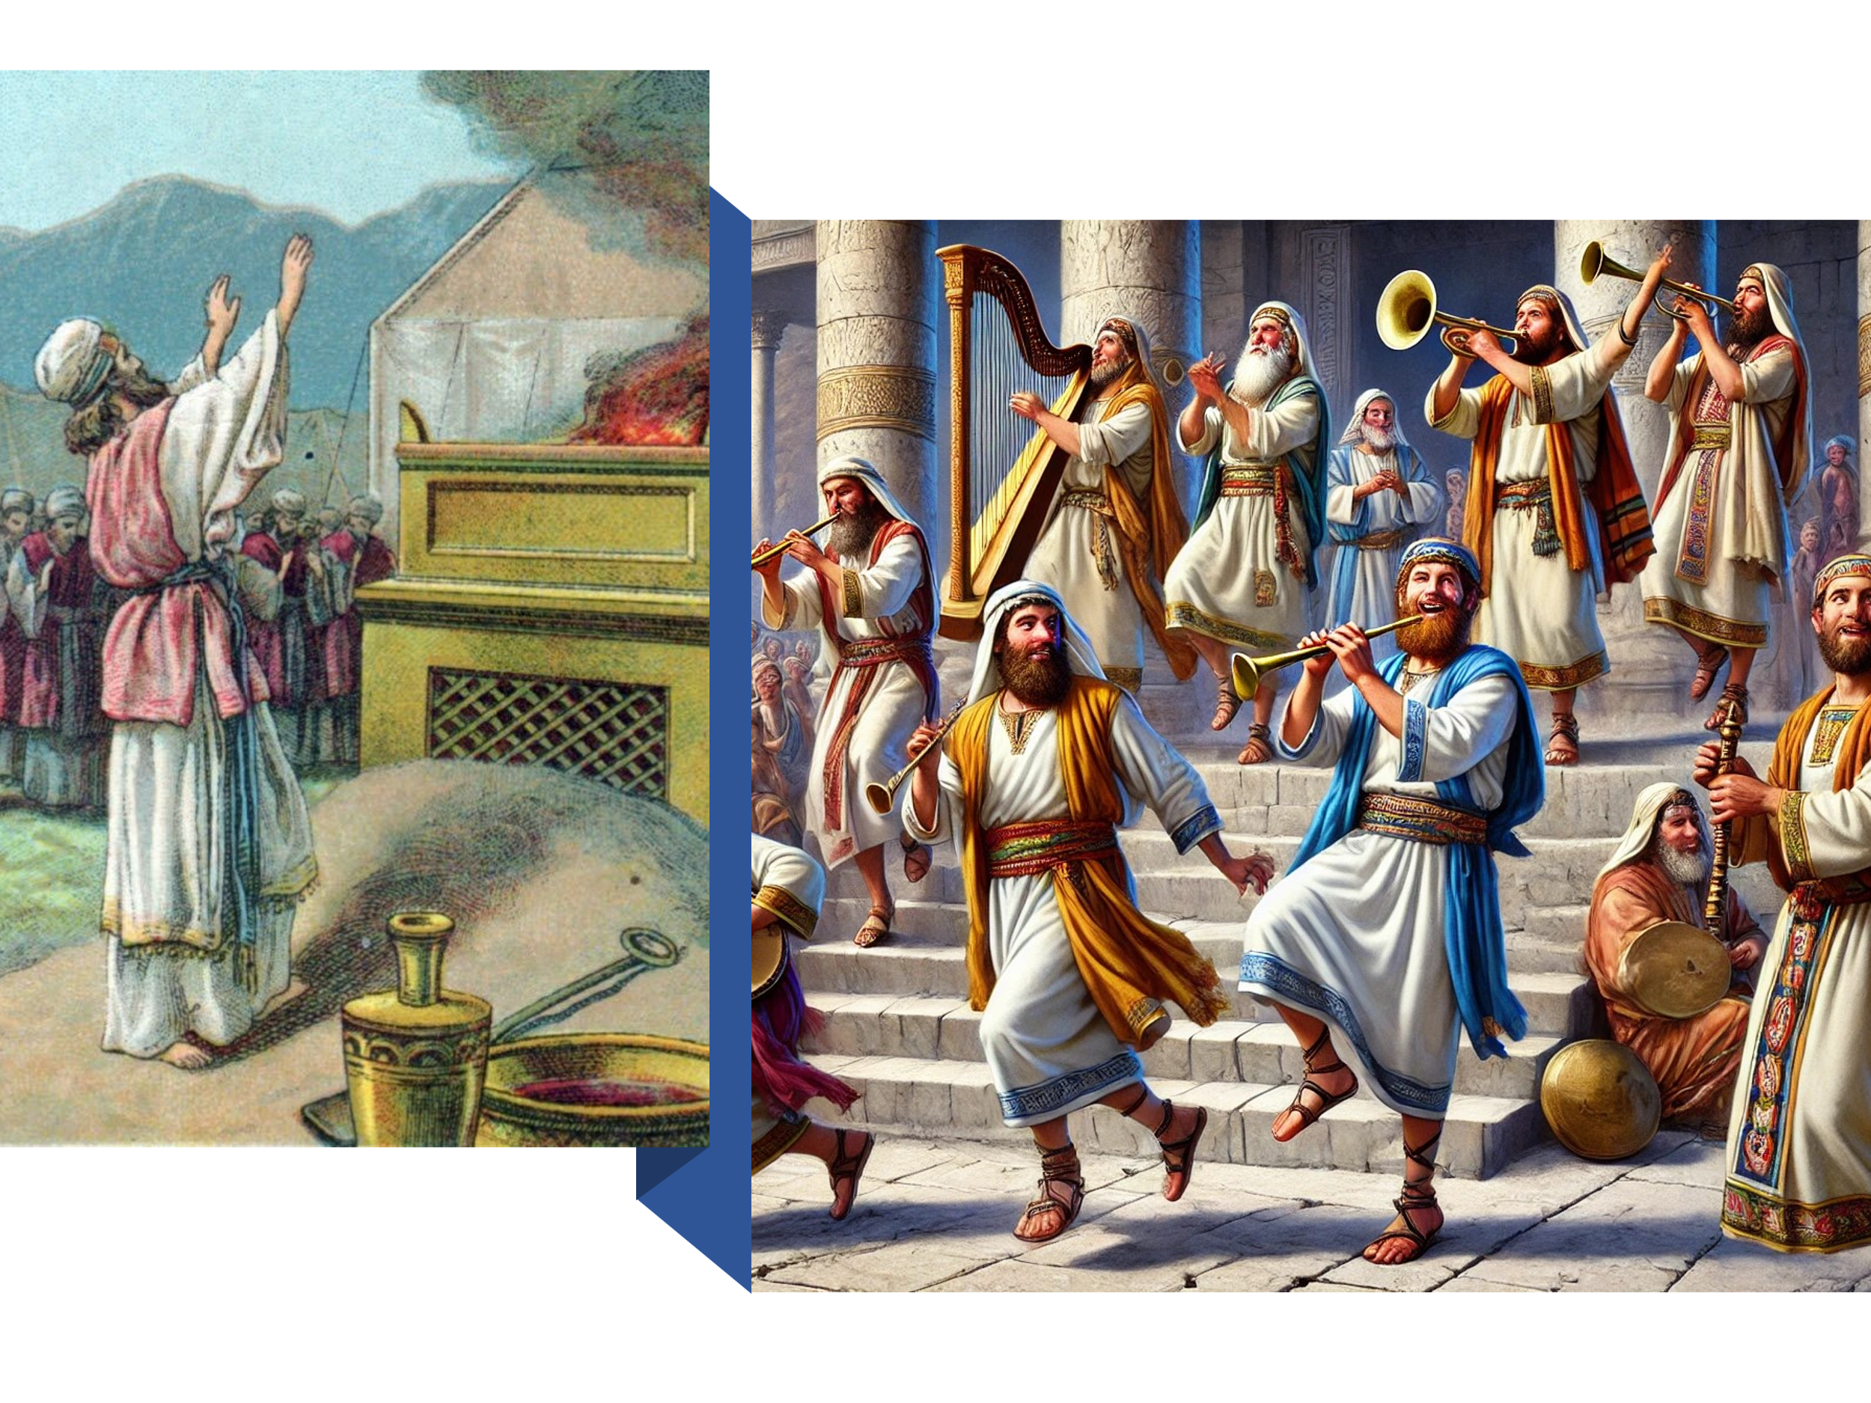
Since this world is not our ultimate home, our true significance lies not in earthly accomplishments but in living lives worthy of the Gospel message, allowing our light to shine and help others see the truth that sets them free. While earthly achievements can enhance our quality of life, they should not be idolized or seen as the ultimate source of comfort. Humanity suffers from an “humanly” incurable disease called sin, which, if left untreated by God, leads to eternal death in hell without reprieve. As Christ’s ambassadors, we must let our light shine in this fallen world, helping others see the cross not as foolishness but as the path to true salvation, moving them away from self-reliance as their ultimate god. In today’s sermon, I will review Christ’s declaration that He is the light of the world and emphasize that real significance comes from being a child of God and doing good deeds that glorify God the Father in heaven.

Biblical background

To truly understand what Jesus meant by His statement, “I am the light of the world,” it is important to learn about the context in which it was spoken. This statement was made during one of the three great pilgrimage festivals of the Jewish year, the Festival of the Tabernacle or Booths. This festival began five days after the Day of Atonement the fifteenth day of the seventh month, mid-October and lasted seven days. This Festival was “celebrated against the backdrop of rejoicing for divine blessings,” not only represented by the bounty of the year’s harvest but also it reminded the Jewish people of the time God took care of them while they lived in booths wandering in the wilderness for 40 years (Leviticus 23:43). Everyone born an Israelite were required once a year (Exodus 23:14-17, 34:23) to construct and live in booths made out of “boughs of trees and branches of palm trees” for seven days (Leviticus 23:42) while they attended the Festival. On the first and last day of the Festival the Israelites would offer burn offerings unto the Lord. During the middle five days men danced and sang in the courtyards, while the Levites stood on the steps leading down from the court and played harps, lyres, cymbals and other instruments. Two priests blew trumpets while walking towards the eastern gate and once there they said, “Our fathers when they were in this place turned with their backs toward the Temple of the Lord and their faces toward the east, and they worshiped the sun toward the east [referring to the apostasy of the Jews as described by Ezekiel]; but as for us, our eyes are turned toward the Lord” (m. Sukkah 5:4)

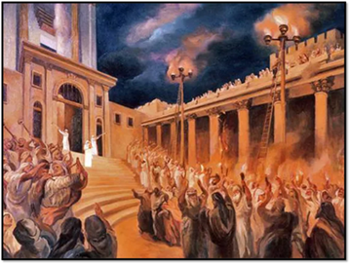
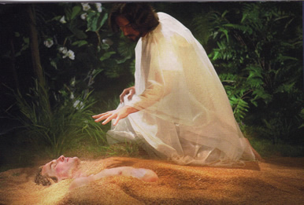
About halfway through the festival, Jesus went to the temple courts to preach (John 7:14). In the Court of Women, four large stands each holding four golden bowls were placed, and during the nighttime, these sixteen golden bowls were filled with oil and lit using the worn undergarments of the priests as wicks. Choirs of Levites would sing, and men would dance in the streets, singing hymns. It was also customary to visit the Pool of Siloam and return with water for a libation of thanksgiving to God. During this ceremony, Christ spoke to the crowds, declaring, “Whoever believes in Me, as Scripture has said, rivers of living water will flow from within them” (John 7:38) and proclaimed, “I am the Light of the world” (John 8:12). In Scripture, darkness symbolizes stumbling (Isaiah 59:10; Jeremiah 13:16) and signifies falling from the right way (Jeremiah 18:15; Malachi 2:8) or being destroyed (Psalm 27:2; Jeremiah 20:11). In contrast, light represents God’s saving work: His first creation was light (Genesis 1:3), He led the Israelites in the wilderness with light (Exodus 13:21-22), and the Israelites sang, “The LORD is my light and my salvation—whom shall I fear?” (Psalm 27:1). Jesus, who came to offer His life as a ransom for many (Mark 10:45), is the Light that offers salvation and eternal life to the world.

His Light, Our Significance

Our significance comes from being created in the image of God, divinely formed from the dust of the earth to have a relationship with Him. Despite our awe-inspiring human achievements, King Solomon was correct in stating, “there is nothing new under the sun” (Ecclesiastes 1:9). Since our lives are like vapor in the wind (James 4:14), true significance can only be found in what is unseen and eternal. Building a legacy based on worldly accomplishments is merely “dust building upon dust” because every person is destined to die (Hebrews 9:27) and this world will be consumed in fire (2 Peter 3:10). Our deeds, whether good or bad, will be judged not by this world but by He who formed us in our mother’s womb and wrote all our days before we even existed (Psalm 139). C. S. Lewis rightly states, “apart from Jesus, this world is unknowable. The parts only make sense because of Jesus. Your life will only make sense as you submit to Jesus. Until the light of the world illuminates your world, you’ll never make sense of the world.” True significance is found in being born of the water and the Spirit (John 3:5), living for Christ as part of His family, and crying out “Abba Father” and hearing Him respond, “My child.”


To those who have found the Treasure hidden in the field and the Pearl of great value (Matthew 13:44-46), Christ says they are to let their Light shine to the world. Though many in the world are indifferent to, or even hate Christians because of their belief in Jesus (John 15:18-25), this does not mean that God’s children should isolate themselves within the church. Instead, we are called to live our faith openly in society. Even though many have been given over to depraved minds (Romans 1:28), we should not withhold the Gospel message, considering it too precious to share (Matthew 7:6). “Like a candle in a cave, we as Christians are called by Christ to not be intimidated by the darkness” but to let our light shine before others, that they may see our good deeds and glorify our Father in heaven (Matthew 5:16). We are the dust of the earth, but we are also masterpieces of God’s grace, divinely enabled to implore the lost of this world to be reconciled to God through belief in the atoning sacrifice of Christ (2 Corinthians 5:20). Though our struggle is not against flesh and blood but against the authorities, powers of this dark world, and spiritual forces of evil in the heavenly realms (Ephesians 6:12), let us not hide our light. Instead, let it shine with the glorious promise that while the Yeast of righteousness might not reach many, the seeds that fall on good soil will produce a crop yielding a hundred, sixty, or thirty times what was sown (Matthew 13:23).

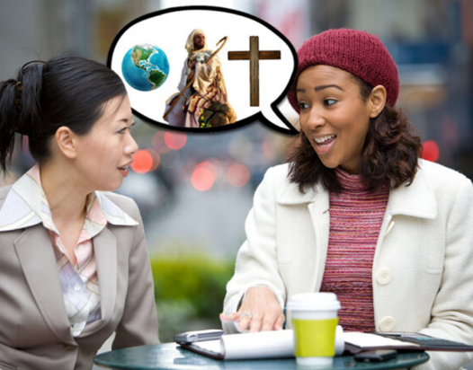
Let us cast off our attitudes of indifference and fear, and boldly live the Gospel message with passion and integrity. Sadly, many people seek significance through earthly accomplishments, unaware that they have a humanly incurable disease, sin, which leads to condemnation and eternal death (John 3:18; 2 Thessalonians 1:8-9). They desperately need salvation, and to “open their eyes and turn them from darkness to light” (Acts 26:18) requires both God’s call and messengers to plant seeds of righteousness (1 Corinthians 3:7-9). Since they will not heed the “whitewashed tombs” of those who know but do not live God’s words, we, as His ambassadors, must first examine ourselves, repent of our sins, and be cleansed from all unrighteousness. Only then can we effectively reach lost souls for Christ and make disciples of this world, ensuring we are not dismissed as hypocrites. We must live so passionately for Jesus that nothing in our words or deeds detracts from the glorious message of whom we serve—the Good Shepherd who gave His life as a ransom for many (Mark 10:45). This world needs to know that, created in the image of God, they are eternally loved and forever invited to become more than just flesh and blood, but children of the Most High God!

Conclusion

In a world marked by constant change, technological advancements, and evolving thought processes, achieving true significance can seem futile. Quantum computers solve complex problems in seconds, stem cells regenerate destroyed cells, AI performs sophisticated tasks, and genome editing alters DNA. However, by rejecting the temporal worldview and embracing an eternal perspective through the eyes of Christ, true significance becomes not only possible but divinely ordained. Building a legacy based on worldly accomplishments is merely dust building upon dust, for every person is destined to die, and this world will be consumed in fire. As we reflect on Christ, who declared “I am the light of the world” under the 16 golden bowls during the Festival of the Tabernacle, we must remember our obligation as His ambassadors to proclaim the Good News we have graciously received. Let us invite God to examine our hearts, confess our sins, and make the necessary course corrections to live rightly in His sight. Our words and deeds should not mimic the world’s futile search for significance but should instead reflect a passion for God so strong and divinely initiated that our good deeds point to the sinless One who holds the keys to both death and life. Since God wishes none to perish, let us relentlessly pursue those to whom God calls us to plant seeds of faith.

Taken from the following website: https://blog.google/technology/ai/computing-takes-quantum-leap-forward/
Taken from the following website: https://cancer.ca/en/cancer-information/cancer-types/multiple-myeloma/treatment/stem-cell-transplant
Taken from the following website: https://www.nature.com/articles/d41586-024-01442-5
Taken from the following website: https://medlineplus.gov/genetics/understanding/genomicresearch/genomeediting/
D. Freeman, “Tabernacles, Feast Of,” ed. D. R. W. Wood et al., New Bible Dictionary (Leicester, England; Downers Grove, IL: InterVarsity Press, 1996), 1148.
R. K. Harrison, “Booths, Feast of,” ed. Geoffrey W. Bromiley, The International Standard Bible Encyclopedia, Revised (Wm. B. Eerdmans, 1979–1988), 535.
R. K. Harrison, “Booths, Feast of,” ed. Geoffrey W. Bromiley, The International Standard Bible Encyclopedia, Revised (Wm. B. Eerdmans, 1979–1988), 535.
D. Freeman, “Tabernacles, Feast Of,” ed. D. R. W. Wood et al., New Bible Dictionary (Leicester, England; Downers Grove, IL: InterVarsity Press, 1996), 1148.
D. Freeman, “Tabernacles, Feast Of,” ed. D. R. W. Wood et al., New Bible Dictionary (Leicester, England; Downers Grove, IL: InterVarsity Press, 1996), 1148.
R. K. Harrison, “Booths, Feast of,” ed. Geoffrey W. Bromiley, The International Standard Bible Encyclopedia, Revised (Wm. B. Eerdmans, 1979–1988), 535.
Tremper Longman III, Peter Enns, and Mark Strauss, eds., The Baker Illustrated Bible Dictionary (Grand Rapids, MI: Baker Books, 2013), 585–586.
Gary M. Burge, “Gospel of John,” in John’s Gospel, Hebrews–Revelation, ed. Craig A. Evans and Craig A. Bubeck, First Edition., The Bible Knowledge Background Commentary (Colorado Springs, CO; Paris, ON; Eastbourne: David C Cook, 2005), 86.
R. K. Harrison, “Booths, Feast of,” ed. Geoffrey W. Bromiley, The International Standard Bible Encyclopedia, Revised (Wm. B. Eerdmans, 1979–1988), 535.
Craig S. Keener, John, ed. Clinton E. Arnold, vol. 2A, Zondervan Illustrated Bible Backgrounds Commentary (Grand Rapids, MI: Zondervan, 2019), 80.
Gary M. Burge, “Gospel of John,” in John’s Gospel, Hebrews–Revelation, ed. Craig A. Evans and Craig A. Bubeck, First Edition., The Bible Knowledge Background Commentary (Colorado Springs, CO; Paris, ON; Eastbourne: David C Cook, 2005), 86.
Taken from the I AM series from sermon central.com

