I am the Good Shepherd
John 10:11-18
Online Sermon: http://www.mckeesfamily.com/?page_id=3567

“Trust takes years to build, seconds to break, and forever to repair”
unknown author


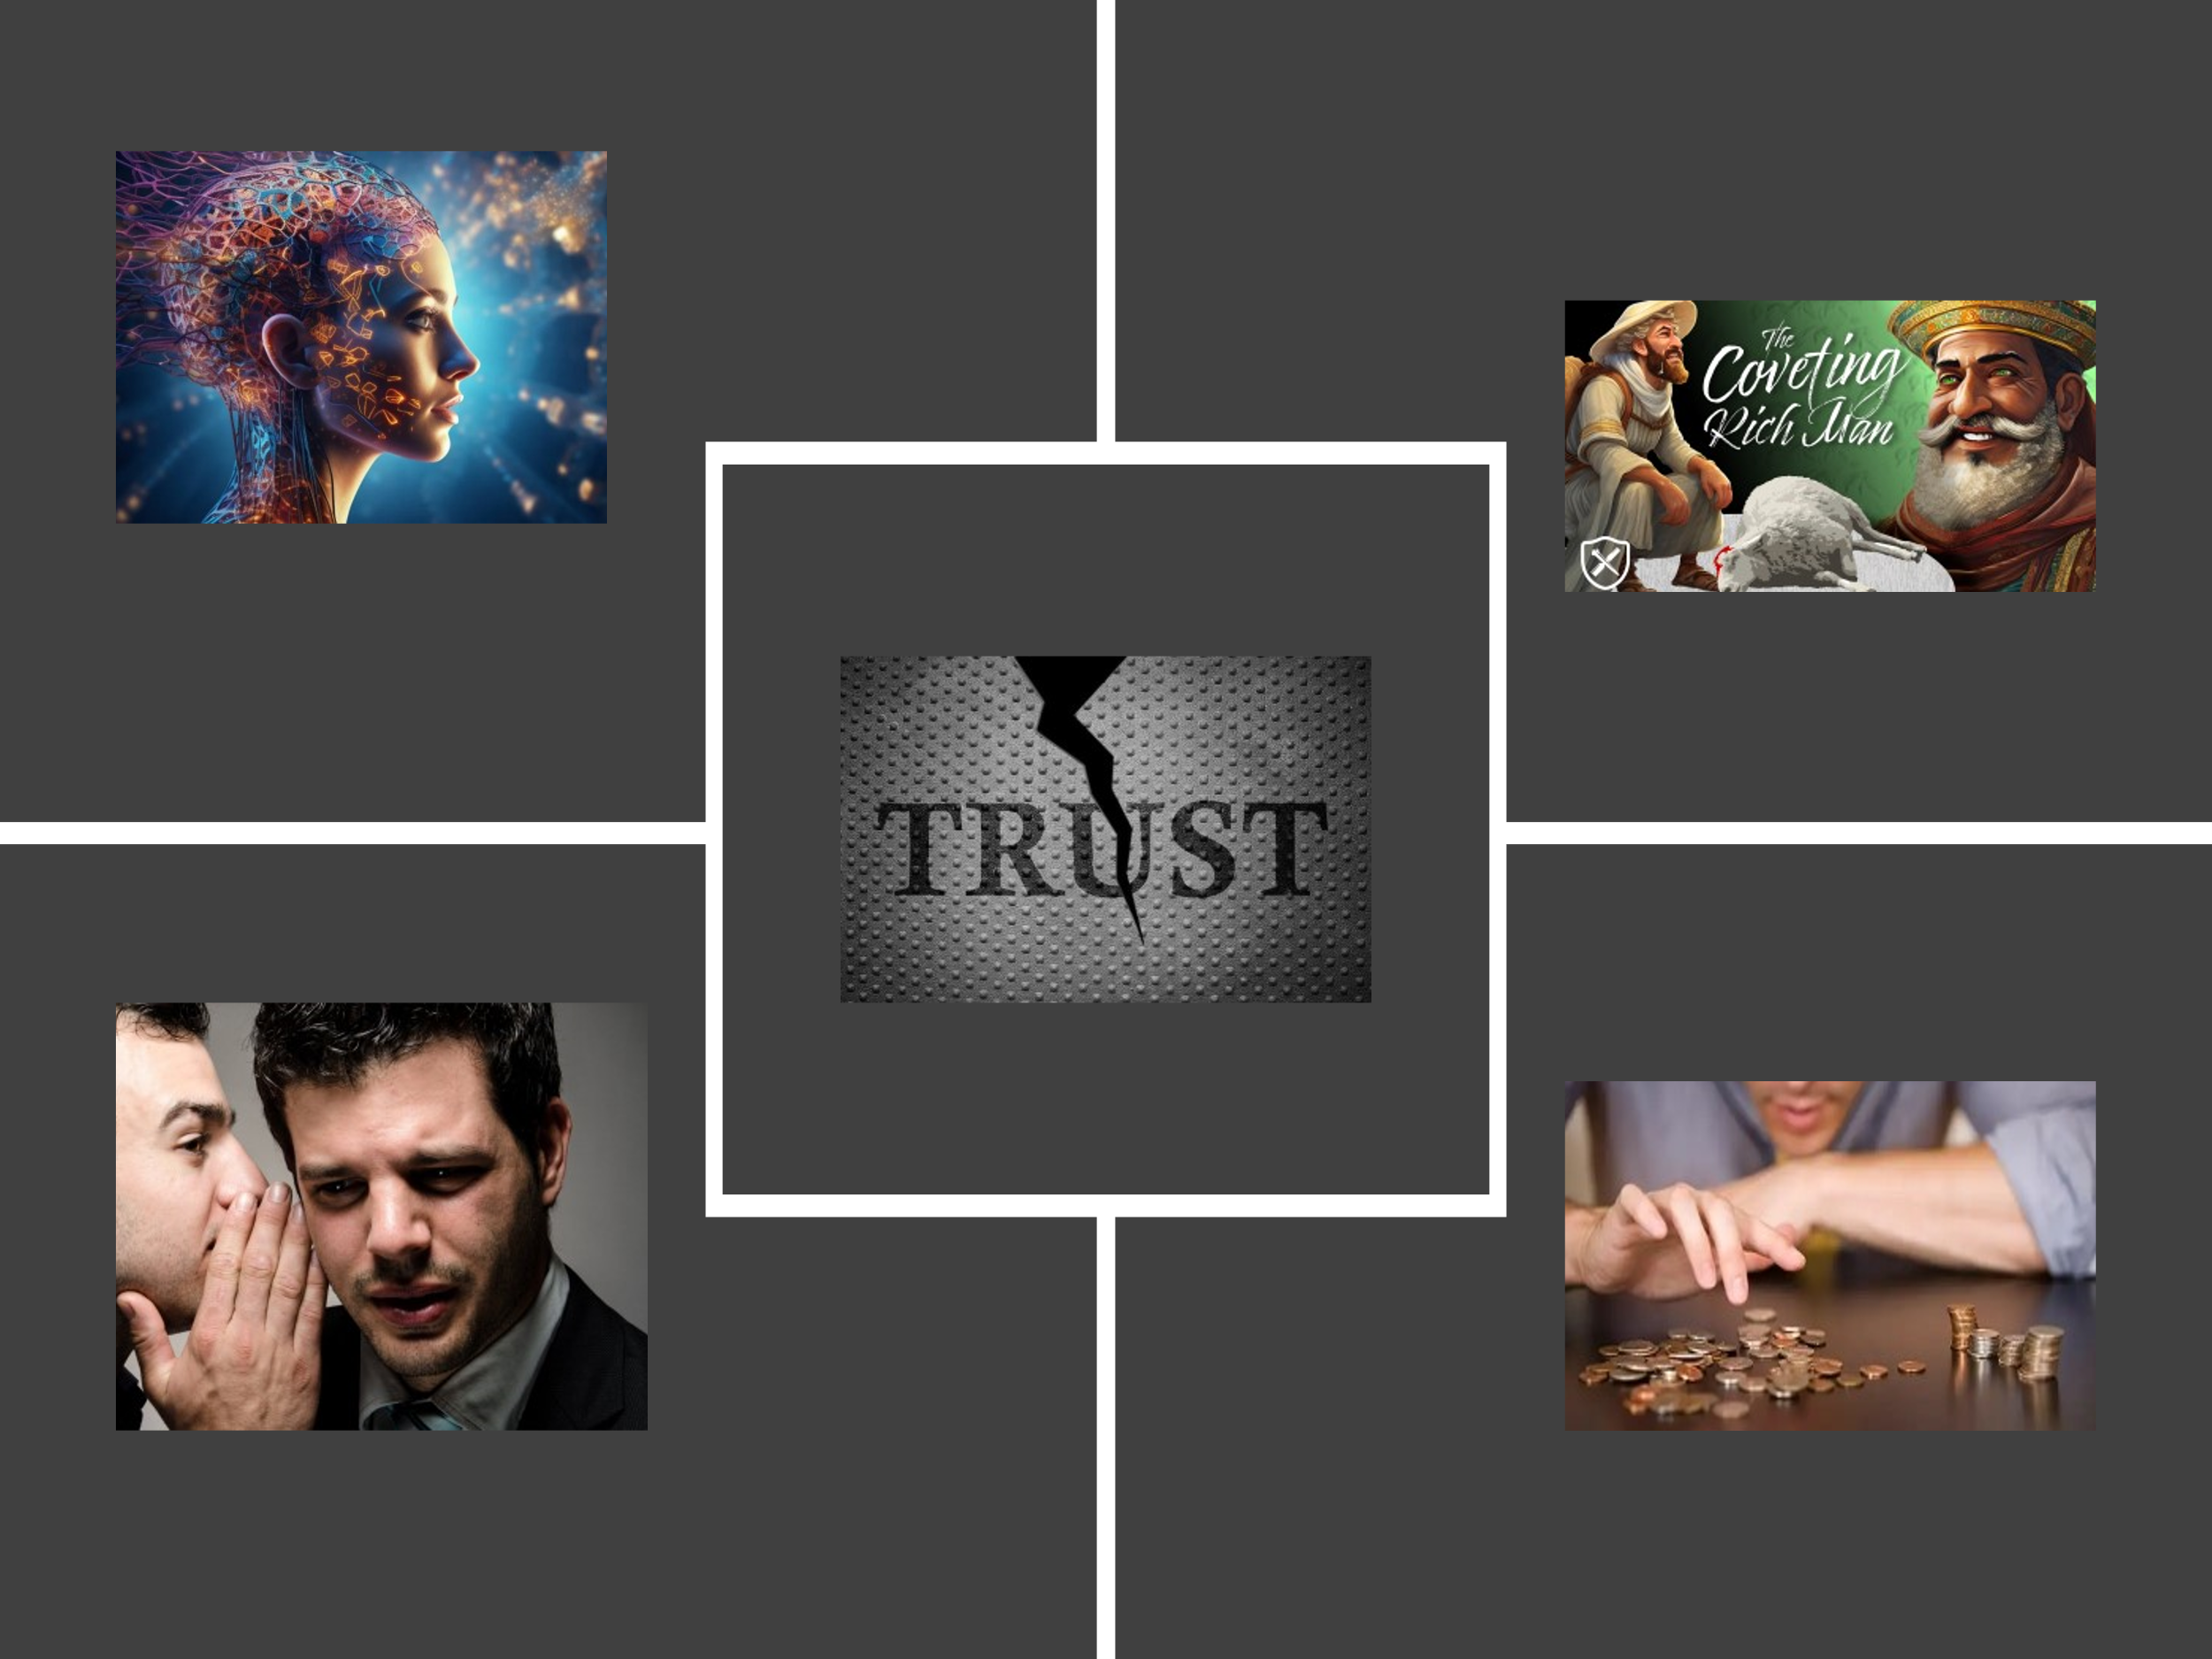
We live in a world where trust if often sought, rarely received, and often thrown away in a garbage heap of broken dreams and promises. For example, every 22 seconds, someone is scammed by phone or email into revealing personal information, allowing fraudsters to steal from their present and future. And despite finding their soul mate and saying the words, “to have and to hold, from this day forward, for better, for worse, for richer, for poorer, in sickness and health, to love and to cherish, until death due us part,” almost one in two marriages end in divorce. Living in this world that is not our home where truth is contingent upon one’s imagination, secrecy and gossiping are weapons to attain power, neglecting others is justified by indifference and coveting for oneself, betrayal is seen a cunning strategy for success, dishonesty in financial matters is often called being shrewd; it is through the eyes of broken relationships that many come to see trust as a commodity far more rare than gold or silver!
If we allow it, this world can become a dark and dreary place filled with self-absorption, idolatry, and covetousness, leaving our souls starved for relationships built on empathy, compromise, commitment, interdependence, respect, and trust. Though cynicism is often justified by our experiences, we must remember that we are created in the image of a loving, kind, gentle, and forgiving God who wishes none to perish. There is hope for us, these jars of clay, to build relationships that are lasting, peaceful, and filled with reciprocal trust. Jesus, our Good Shepherd, knows each of us by name, and we can trust Him fully because He created us and gave His life as a ransom for many. From Him, we learn that the way to build trusting relationships is by emulating His love, grace, and mercy to those around us, even when they do not deserve it. In today’s sermon, I will suggest that by seeking Jesus in the green pastures and by the still waters of life, and keeping our focus heavenward, we can learn from the Good Shepherd how to extend our love and trust to others and, in turn, receive the same.

The Good Shepherd

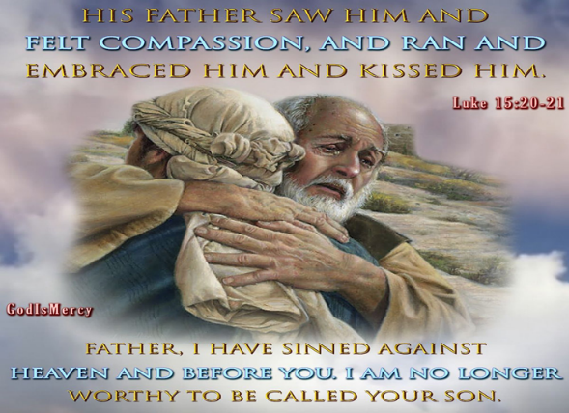
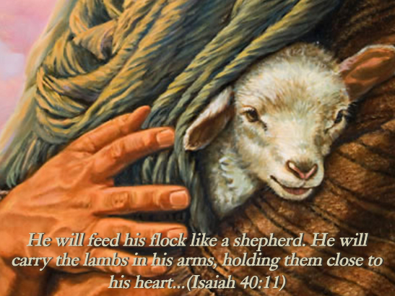
When Jesus stated, "I am the Good Shepherd," it carried profound significance for the Israelite people, who were familiar with God being depicted as a shepherd in the Old Testament. For instance, the Psalmist declares, "Know that the Lord is God. It is He who made us, and we are His; we are His people, the sheep of His pasture" (Psalm 100:3-4). Therefore, we are to "enter His gates with thanksgiving and His courts with praise; give thanks to Him and praise His name." It is because the Lord is our Shepherd that we "shall lack nothing," for "He makes us lie down in green pastures, He leads us beside quiet waters, He refreshes our souls." God "guides us along the right paths for His name’s sake," and even "though we walk through the darkest valleys, we will fear no evil, for You are with us; Your rod and staff comfort us" (Psalm 23). When the Israelites heard the phrase "Good Shepherd," they likely thought of God, who promised to "tend His flock like a shepherd, gathering the lambs in His arms and carrying them close to His heart" (Isaiah 40:11).

While most Old Testament references depict God as a shepherd, the Messianic prophecy in Micah 5:2-4 would have resonated deeply with the Israelites. This prophecy speaks of a Shepherd from Bethlehem, whose origins are from ancient times, who would “stand and shepherd His flock in the strength of the Lord, in the majesty of the name of the Lord His God.” Unlike the negligent shepherds of Israel who failed to care for their flock, strengthen the weak, heal the sick, or seek the lost (Ezekiel 34), Jesus embodied the true Good Shepherd. He could not be accused of self-interest, for He “made Himself nothing by taking on the nature of a servant” (Philippians 2:7) and came to “save the lost” (Luke 19:10), giving “His life as a ransom for many” (Matthew 20:28). Jesus sought out all sinners, regardless of their past, wishing for none to perish (Matthew 9:13, 2 Peter 3:9). His love is so vast that, should one of His sheep be lost, He will search tirelessly and, upon finding it, joyfully carry it on His shoulders as heaven rejoices in the sinner’s repentance (Luke 15:1-7). Even if the sheep remains defiant, like Jerusalem (Matthew 23:37-39), He weeps but keeps His arms open, ready to extend grace and mercy the moment they repent. Like the prodigal son, He forgives and restores, placing His best robe on their shoulders, a ring on their finger, and sandals on their feet (Luke 15:11-32).


Though cynicism is often justified by our broken relationships in a world filled with self-absorption, idolatry, and covetousness, we can trust in the Good Shepherd. While we may use cynicism as a defense mechanism to drown out the incessant voices dictating how we should live, the sheep of Christ’s pasture gladly follow Him because He knows them intimately (John 10:14). To answer Nathanael's question, "How do you know me?" (John 1:48), King David would reply that while such knowledge is too wonderful to comprehend (Psalms 139:6), what can be known is that the Lord who knit him in his mother’s womb (Psalms 139:13) had written all his days in His book before one came to be (Psalms 139:16). There is nowhere His creation can flee from His Spirit (Psalms 139:7), for He is present from the highest heavens to the depths of the sea (Psalms 139:8-9). Amid all the voices clamoring for our attention, the sheep listen to His voice alone, for He is their Lord, Savior, and King. They trust the Good Shepherd implicitly because, despite our shortcomings and deserving excommunication, He loves us unconditionally, offering grace, mercy, forgiveness, and restoration in His loving arms. And when the wolves of the powers of this dark world and spiritual forces of evil in heavenly realms (Ephesians 6:10-12) come to sift us like wheat (Luke 22:31-32), we will fear no evil, for even in the darkest valley, His light shines and serves as a mighty fortress for those who love Him (Psalms 23, 91).

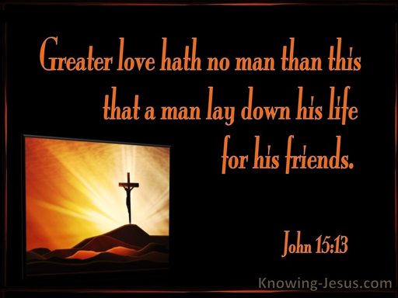
The sheep trust Him implicitly because "greater love has no one than this: to lay down one’s life for one’s friends" (John 15:13). This stands in stark contrast to the bad shepherds in Ezekiel 34 who cared only for themselves. Christ chose to be born of a virgin and lie in a manger (Matthew 1:18, Luke 2:12), to proclaim the Good News to those in desperate need of a divine physician for their souls, fully aware that His own people would reject Him (John 1:11), His family would think He was out of His mind (Mark 3:21), and all but John would abandon Him as He hung upon the cross. In a world where good deeds are often performed through a quid-pro-quo system of selfishness, relationships frequently lack trust, with promises shattering as easily as a glass vase struck by a freight train. Yet, even though we often treat Christ with indifference or outright defy His laws and decrees, His love toward us remains unaffected. Despite our thoughts, feelings, and deeds often being vile in His sight, the Good Shepherd remains unflinching in His desire to seek the lost and embrace the repentant. Those who are born again need not fear that He will ever break a single promise made to them, nor do they need to ever fear their relationship being severed from Him, for they have been forever sealed with His Spirit, washed by His blood, and adopted to spend eternity in His kingdom.

The Family of God


As we reflect on the times we were dismissed by others, wounded and crushed by their agendas, and above all, grieved, dismayed, and utterly shattered by betrayal from their broken promises or outright attacks, today's passage reminds us of that relationships in Christ's kingdom not only exist but thrive in unity amidst diversity. Thankfully, it is not just the richest, most famous, charismatic, and influential who have a seat at His banquet table, but also the poor, insignificant, pitiful, and helpless. In a world where love is often based on a quid-pro-quo system, and when that fails, people tear down others to gratify their own agendas, it is comforting to know that the lost sheep have infinite value in the Father’s eyes. This is demonstrated by the Son, who seeks the lost to bring them back into the fold of His pasture, even when they have sinned and fallen short of His glory! Considering the varied social statuses, economic conditions, and political landscapes that shape individuals' lives, it can be challenging for people to celebrate diversity. Yet, unity within the body of Christ is attainable because the same Spirit that bestows spiritual gifts upon each person also convicts them to bow to one Lord and pursue one purpose: to seek first the kingdom of God!

Conclusion

In conclusion, while trust may be scarce in our world, it is abundant in the kingdom of God. Our experiences of betrayal and broken promises can make us cynical and guarded, creating deep wounds that hinder our ability to trust. Yet, amid this brokenness, Jesus Christ, the Good Shepherd, offers hope, healing, and restoration. He knows us intimately, loves us unconditionally, and seeks the lost, demonstrating that no one is beyond His reach. In His kingdom, relationships thrive on unity amidst diversity, with every individual finding a place at His table. We are called to emulate His love, grace, and mercy, fostering relationships built on empathy, commitment, and trust. By focusing on Jesus and seeking first His kingdom, we can overcome the world's darkness and build lasting, trusting relationships that reflect His glory. As we strive to love and trust others, our hearts are healed and our lives enriched, creating communities that shine as beacons of hope in a world desperate for authentic, trustworthy relationships. By seeking Jesus in the green pastures and by the still waters of life, and keeping our focus heavenward, we can learn from the Good Shepherd how to extend our love and trust to others and, in turn, receive the same!

Taken from the following website: 2024 Identity Theft Facts and Statistics
Taken from the following website: Divorce Statistics and Facts | What Affects Divorce Rates in the U.S.? (wf-lawyers.com)

