I am the Door
John 10:1-10, 9:13-34
Online Sermon: http://www.mckeesfamily.com/?page_id=3567

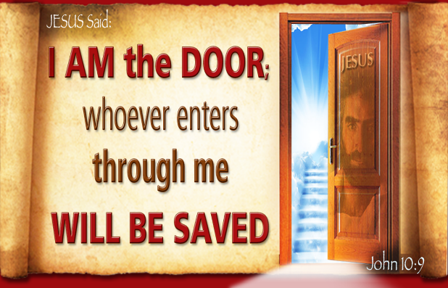

Doors are powerful symbols that represent a myriad of meanings to different people. To the adventurous, courageous, inquisitive, bold, and daring, a door signifies an entrance into a new realm brimming with opportunities. Although it entails a certain level of risk, it remains enticing, offering the potential to explore new paths and unending possibilities. For many, a door symbolizes welcome, hospitality, and inclusion, opening access to others' thoughts, feelings, and emotions, which in turn helps cultivate warm and personal relationships. For some, doors represent the opportunity to escape their current reality. For those crushed by the pain, anguish, and uncertainty of their trials and tribulations, a door often symbolizes hope, suggesting that the mountains of blessings are just a few steps away. Conversely, for others, a door signifies secrets and mysteries that, once revealed, might threaten their peaceful existence with horrifying realities, shattering their worldview and replacing anticipated blessings with pain. For them, doors serve as a means of protection in a selfish and violent world. By equipping their doors with locks, they create a barrier to feel safe, maintain privacy, and keep out unwanted guests, threats, and influences.
Above all, doors represent the need to make choices in life that profoundly impact one's well-being. Since opening and walking through a door can usher in both positive and negative consequences, people often put significant effort into understanding what lies behind the door before opening it. Yet, to live the best life possible, one cannot stand before the closed doors of life in ignorance, unwilling to open them. Doing so limits one's potential, especially when the Lord has created the door, and it is His will that one ventures through it. In a sharp debate with the Pharisees Jesus said, “I am the gate (door); whoever enters through me will be saved. They will go in and out and find pasture” (John 10:9). In today’s sermon we are going to reflect on the dangers of letting others define the doors of our religious beliefs and activities. We are going to acknowledge that since God’s ways are higher than our ways (Isaiah 55:8-9), the secret to boldly opening the “mysterious” and often “frightening” doors of life is to understand them in context of Scripture and through the power of the Holy Spirit. By faith one can venture into what was initially “unknown” with boldness, courage, and joy because God promises to always work for the good of those who love Him (Romans 8:28)!

Story of the Blind Person Healed

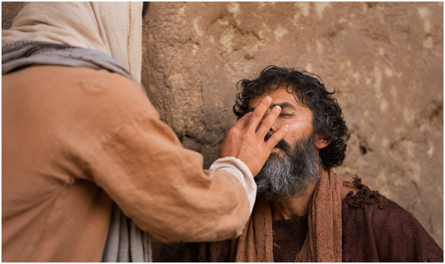
To fully grasp the significance of Jesus' declaration, "I am the door," let's examine the event during which these profound words were spoken. While walking, Jesus encountered a man blind from birth (John 9:1). The disciples asked, “Rabbi, who sinned, this man or his parents, that he was born blind?” (John 9:2). Jesus clarified that the man’s blindness was not due to sin but so “the works of God might be displayed in him” (John 9:3). Jesus then made mud with His saliva, applied it to the man's eyes, and instructed him to wash in the pool of Siloam, resulting in the man’s sight being restored (John 9:6-7). The astonished neighbors wanted to meet Jesus, but the man did not know His whereabouts (John 9:12). The Pharisees, upon hearing of the miracle, debated whether Jesus could be from God since He healed on the Sabbath, while others wondered how a sinner could perform such a miracle (John 9:16). They questioned the man's parents about his blindness but due to their fear of being put out of the synagogue they merely said our son “is of age, ask him” (9:23). When they asked the son about Christ he boldly replied, “Whether he is a sinner or not, I don’t know. One thing I do know. I was blind but now I see!” (John 9:25).

Assumed Role of the “Guardians of Scripture”

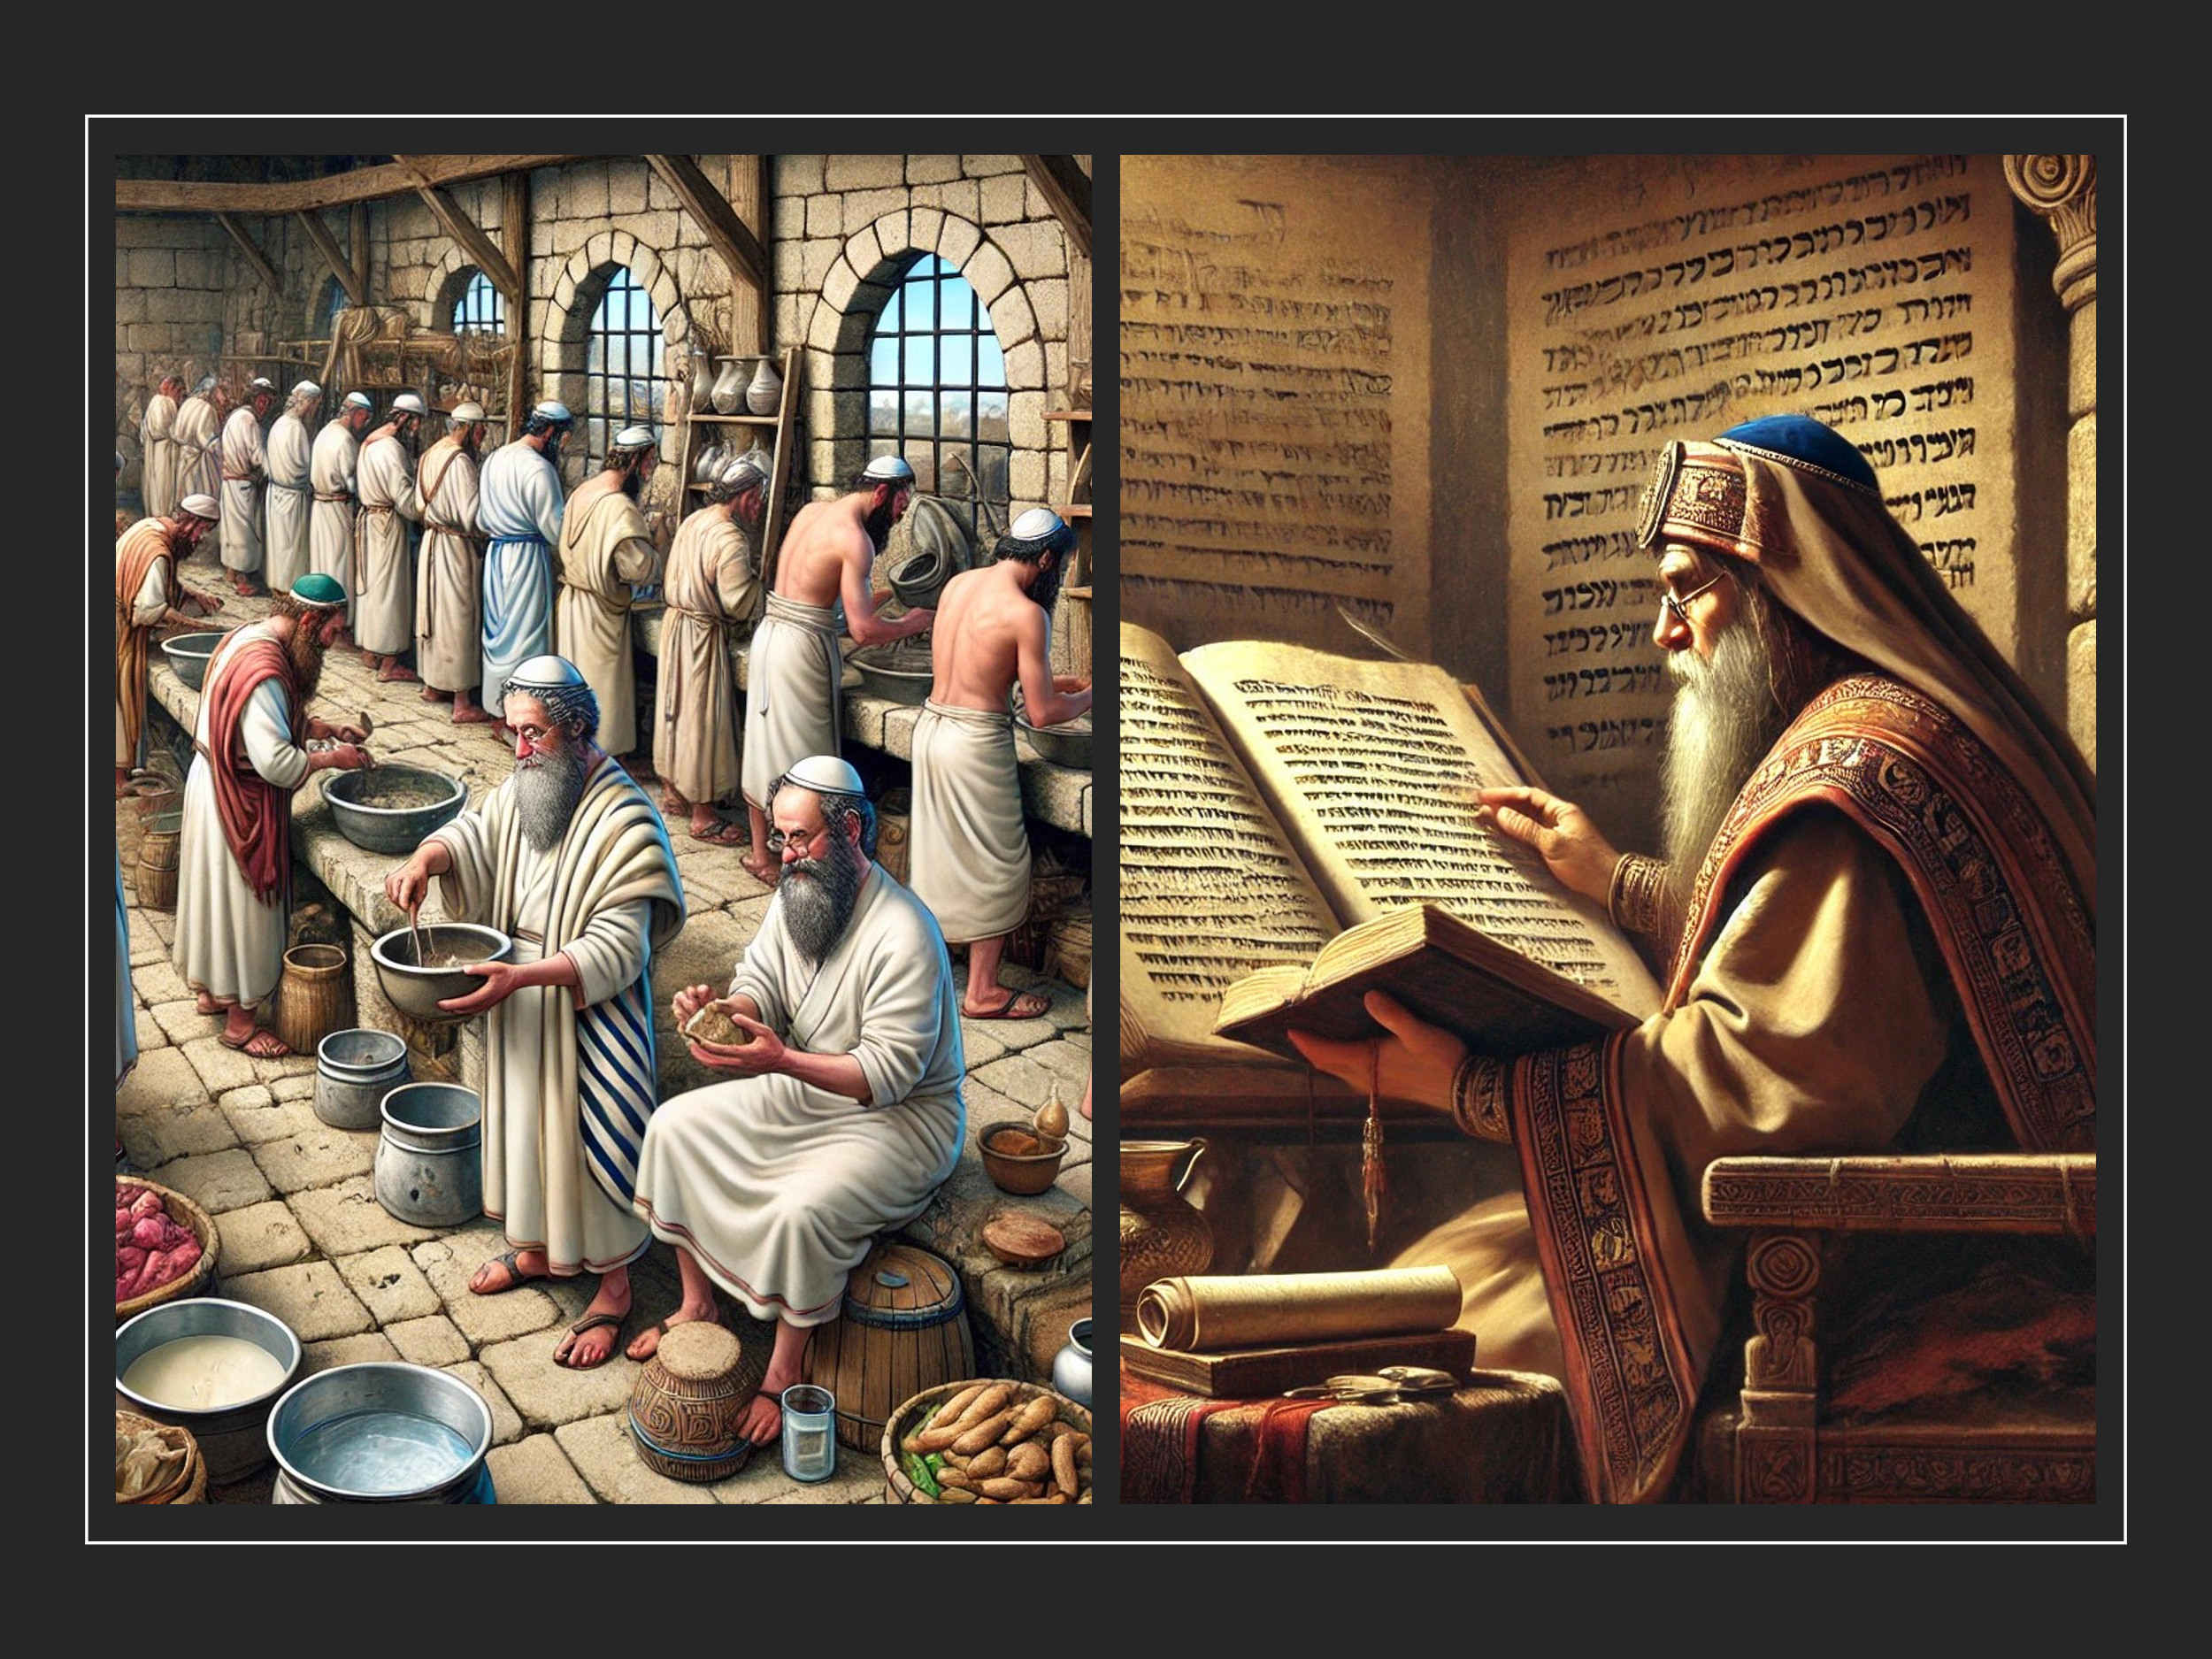
Before we can fully grasp the significance of blind man healed on the Sabbath, it is essential to briefly examine the Pharisees' assumed role as the gatekeepers of Israel's religious beliefs and practices. The Pharisees were a sect within Judaism who, despite lacking the formal authority of the Sadducean aristocracy to control the temple, emerged as prominent religious leaders after the temple's destruction in AD 70. They were widely recognized as the “primary voice of Judaism” and represented a lay movement competing with the priesthood, whom they criticized for failing to teach Israel how to remain separate from the world's general uncleanliness. To address this, the Pharisees developed an extensive set of oral traditions based on the Mosaic Law to guide everyday life, governing activities like marketplace interactions and the washing of cups, pots, and other utensils (Mark 7:4). Over time, these traditions became more detailed and were eventually compiled into the Mishna. Although these traditions were often seen as numerous and burdensome, the Pharisees contended that they could be fulfilled by the average Israelite. However, Jesus accused them of hypocrisy and spiritual insensitivity to the Laws of God, likening them to whitewashed tombs full of dead men's bones and all things unclean (Matthew 23:27), for elevating the "traditions of men" above the divine standards of God's word. Now let’s get back to the story!

Jesus Christ as the Door

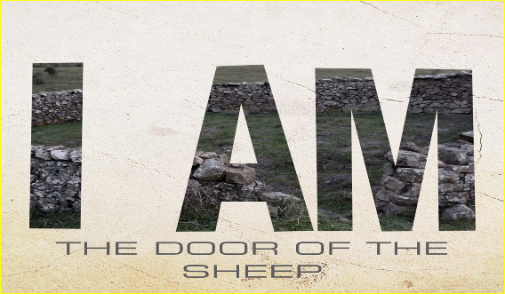
When the man told the Pharisees how Jesus had opened his eyes, they asked him to describe again the method by which Christ had performed this miracle. The man then responded, “Why do you want to hear it again? Do you want to become His disciples too?” (John 9:27). The Pharisees were furious, not only because this man had the audacity to admit he was now a follower of Christ, but also because he implied that these guardians of Israel’s beliefs were wrong to reject Him as the Messiah. For the Pharisees entrance into God's presence was so entrenched in the letter of the Mosaic Law and the traditions of men relating to Sabbath regulations, dietary restrictions, and ethnic, national, and cultural purity that Scripture became only understood only through their pious lens of religious superiority. Jesus pointed out how seriously flawed their understanding was by stating that “the Sabbath was made for man, not man for the Sabbath. So, the Son of Man is Lord even of the Sabbath” and that “one who is greater than the temple is here,” who desires “mercy, not sacrifice” (Matthew 12:7). Jesus rightly called the Pharisees hypocrites, for they had forgotten the importance of adhering to the spirit and intent of the Old Testament Law rather than merely following human traditions that overshadowed God's divine standards (Matthew 23:23-24, Mark 7:6-8).

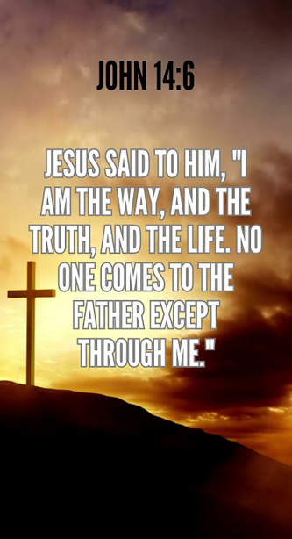
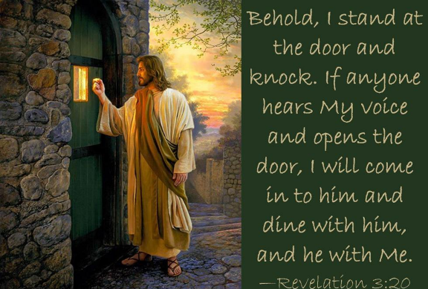
To the Pharisees and those listening, Christ emphasized that He alone is the door by which one approaches and is accepted by a holy God. Jesus told the Pharisees that their rejection of God’s righteous decrees through their traditions meant they were trying to enter the “sheep pen” of God’s kingdom improperly, thus making them like thieves and robbers (John 10:1). The Pharisees were not the guardians of the door to God’s kingdom; only Christ could call the sheep by name, and they would hear His voice and follow Him (John 10:2-5). Jesus was not dismissing the value of divinely gifted teachers but warning against false prophets who come in sheep’s clothing but are inwardly ferocious wolves (Matthew 7:15). In these end times, many will attempt to deceive even the elect, if that were possible (Matthew 24:24). Since Christ alone is the way, the truth, and the life (John 14:6); the Lamb of God who atoned for our sins and appeased God’s righteous wrath (Romans 3:24-25), He is the only means by which one can be saved (John 3:16). The door to God’s kingdom is not through works of piety or traditions of men, as the Pharisees suggested, but through God’s grace and faith in a risen Savior (Ephesians 2:8-9).

Hear His Voice and Open Doors
We are constantly faced with doors representing new paths and opportunities, offering both enticing possibilities and the potential for pain and anguish that could disrupt our relatively peaceful lives. The secrets and mysteries behind closed doors can instill such fear that one becomes paralyzed, preferring to remain in familiar, albeit mediocre or dire, circumstances. To mature in our faith and please God, we cannot refuse to open the doors the Good Shepherd places before us. If we had not answered when Christ said, “Here I am! I stand at the door and knock” (Revelation 3:20), we would not have undergone the radical transformation of being born again (2 Corinthians 5:17). Salvation is just the beginning of our transformation. To avoid remaining babes in Christ, we must cast off the shackles of fear and open every door He presents to us. With the spiritual gifts we have been given, let us boldly venture into the unknown, trusting in His will for our lives. Although many doors the Good Shepherd leads us to may bring persecution and tribulations, we should joyfully move forward, looking not at the past but toward our God-given potential as His children.

Allen C. Myers, The Eerdmans Bible Dictionary (Grand Rapids, MI: Eerdmans, 1987), 824.
Bradley T. Johnson, “Pharisees,” ed. John D. Barry et al., The Lexham Bible Dictionary (Bellingham, WA: Lexham Press, 2016).
John M. Rea, “Pharisees,” ed. Charles F. Pfeiffer, Howard F. Vos, and John Rea, The Wycliffe Bible Encyclopedia (Moody Press, 1975).
Bradley T. Johnson, “Pharisees,” ed. John D. Barry et al., The Lexham Bible Dictionary (Bellingham, WA: Lexham Press, 2016).
Walter A. Elwell and Barry J. Beitzel, “Pharisees,” Baker Encyclopedia of the Bible (Grand Rapids, MI: Baker Book House, 1988), 1671.
Walter A. Elwell and Barry J. Beitzel, “Pharisees,” Baker Encyclopedia of the Bible (Grand Rapids, MI: Baker Book House, 1988), 1670.
Walter A. Elwell and Barry J. Beitzel, “Pharisees,” Baker Encyclopedia of the Bible (Grand Rapids, MI: Baker Book House, 1988), 1671.

