I AM

  - Exodus 2:1-3:14
  - Online Sermon: http://www.mckeesfamily.com/?page_id=3567

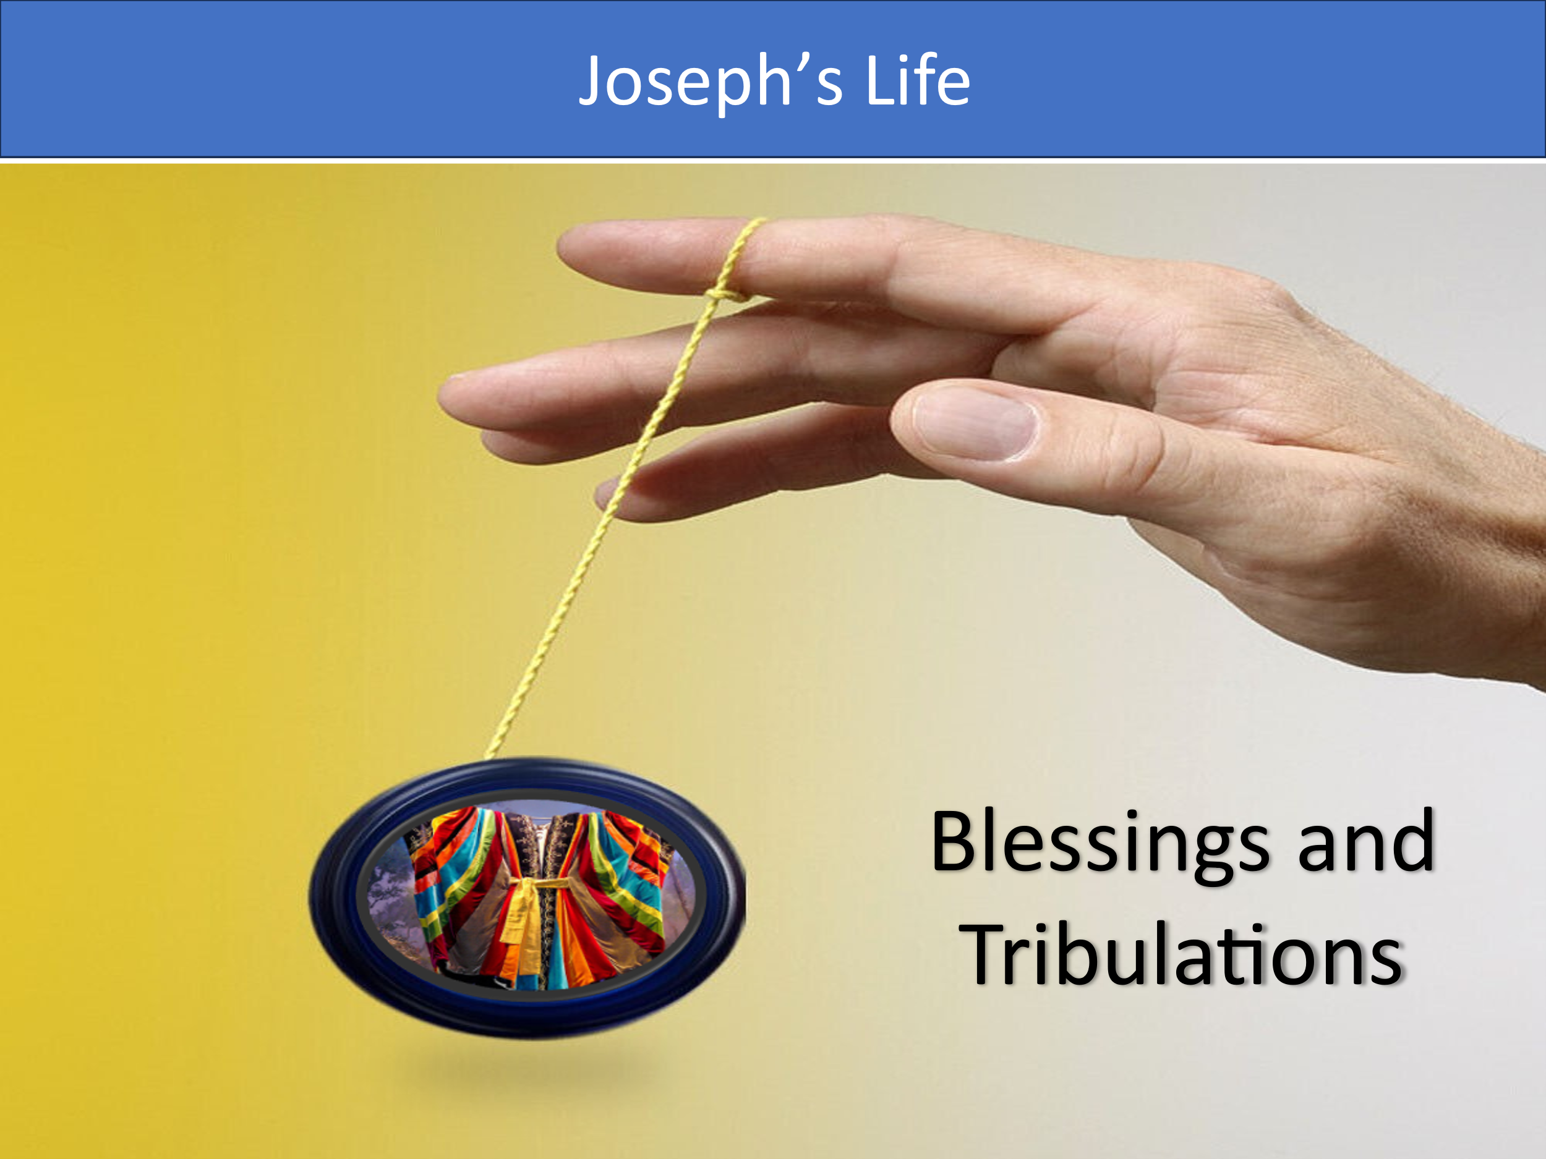
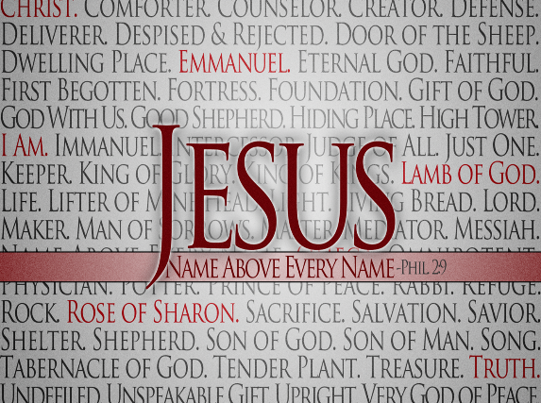
There is something about the name of Jesus that evokes both mystery and consolation. While we cannot and dare not define Christ solely through our imaginations, lest we create a god in our own image, we, as masterpieces of God’s grace, can come to know Him in a limited yet profound way. If this were not possible, how could we ever worship Him—not perfectly, but rightly? It is true that our feeble and sinful minds struggle to fully comprehend or relate to Him in whom there is no darkness at all. Yet, we must remember that God, in His grace and mercy, has chosen to reveal Himself to us through His holy word and His very own Spirit. Though there are days when, like Moses, we cry out for just a glimpse of who God is, there are many more days when the Comforter not only guides us into all truth but also intercedes for us with wordless groans. This sermon will explore the identity of Christ as “I AM,” so that what can be known will be revealed and understood by those who call Him by name.

God Has a Name – “I AM”

I often wonder if Joseph’s coat of many colors symbolized the tumultuous "Yo-Yo" of his life, filled with both blessings and tribulations. Despite being sold into slavery by his brothers (Genesis 37), Joseph rose to become the head of Potiphar’s household (Genesis 39). Although he was later falsely accused of attempted rape and imprisoned, he eventually ascended to be second in command of all Egypt (Genesis 41). Joseph’s story is marked by remarkable highs and lows. He managed to acquire all the land in Egypt for Pharaoh by selling the grain he had advised Pharaoh to store during the seven years of abundance (Genesis 41). Pharaoh even gave Joseph’s family the fertile plains of Goshen to raise their herds (Genesis 47). Yet, despite Joseph’s contributions, his descendants found themselves persecuted by the very people they had helped save. When a new Pharaoh, who did not know Joseph, came to power, he felt threatened by the increasingly numerous Israelites and enslaved and oppressed them with forced labor (Exodus 1). When this failed to curb their growth, Pharaoh ordered the Hebrew midwives to kill every newborn Hebrew boy. This harsh decree sets the stage for the birth and rise of Moses.
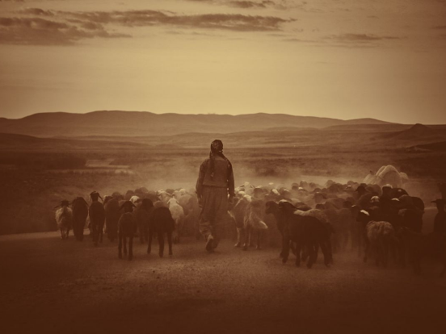
Much like Joseph, Moses experienced numerous ups and downs in his life. When Moses' mother, Jochebed, could no longer hide him, she placed him in a papyrus basket among the reeds along the Nile River (Exodus 2:1-3). His older sister, Miriam, watched from a distance. Pharaoh’s daughter discovered Moses and asked Miriam to find someone to nurse the baby. Miriam promptly brought Jochebed, their mother, who was miraculously paid to care for her own child (Exodus 2:4-7). Though Moses was raised as a grandson to Pharaoh and enjoyed Egypt's riches and finest education, he faced an identity crisis and refused to be known as the son of Pharaoh’s daughter (Hebrews 11:24-25). At the age of 40, Moses saw an Egyptian beating a Hebrew and, taking matters into his own hands, killed the Egyptian and hid the body in the sand (Exodus 2:11-12). The next day, when he saw two Hebrews fighting, he asked, “Why are you hitting your fellow Hebrew?” They retorted, “Who made you ruler and judge over us? Are you thinking of killing me as you killed the Egyptian?” (Exodus 2:13-14). When Pharaoh learned of this, he tried to kill Moses, but Moses fled to Midian, where he tended sheep for 40 years.
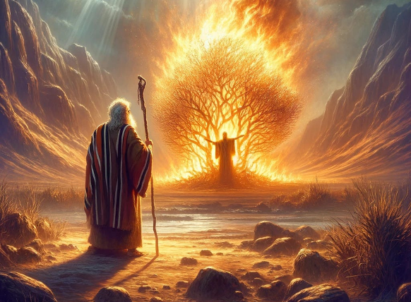
One day, while Moses was tending the flock of his father-in-law Jethro, he led the sheep to the far side of the wilderness and came to Horeb, the mountain of God (Exodus 3:1). There, the angel of the Lord appeared to him in flames of fire from within a bush (Exodus 3:2). Noticing that the bush was on fire but did not burn up, Moses approached it. From within the bush, God called to Moses, declaring, “I am the God of your father, the God of Abraham, the God of Isaac, and the God of Jacob” (Exodus 3:6). God told Moses that He had seen the suffering of His people under Egyptian oppression and was sending Moses to bring them out of Egypt (Exodus 3:10). In response, Moses asked, “Who am I that I should go to Pharaoh and bring the Israelites out of Egypt?” (Exodus 3:11). God reassured him, explaining that it wasn’t about who Moses was, but about who God is. God instructed Moses to tell the people, “I AM WHO I AM has sent me to you.” This name, “I AM,” signified God's eternal existence and His limitless nature. God is the same yesterday, today, and forever (Hebrews 13:8), sovereign over all things seen and unseen (Colossians 1:16). He is our portion (Lamentations 3:24); whom could we ever desire except the One who created us in His image out of love?

Jesus Shares the Same Name

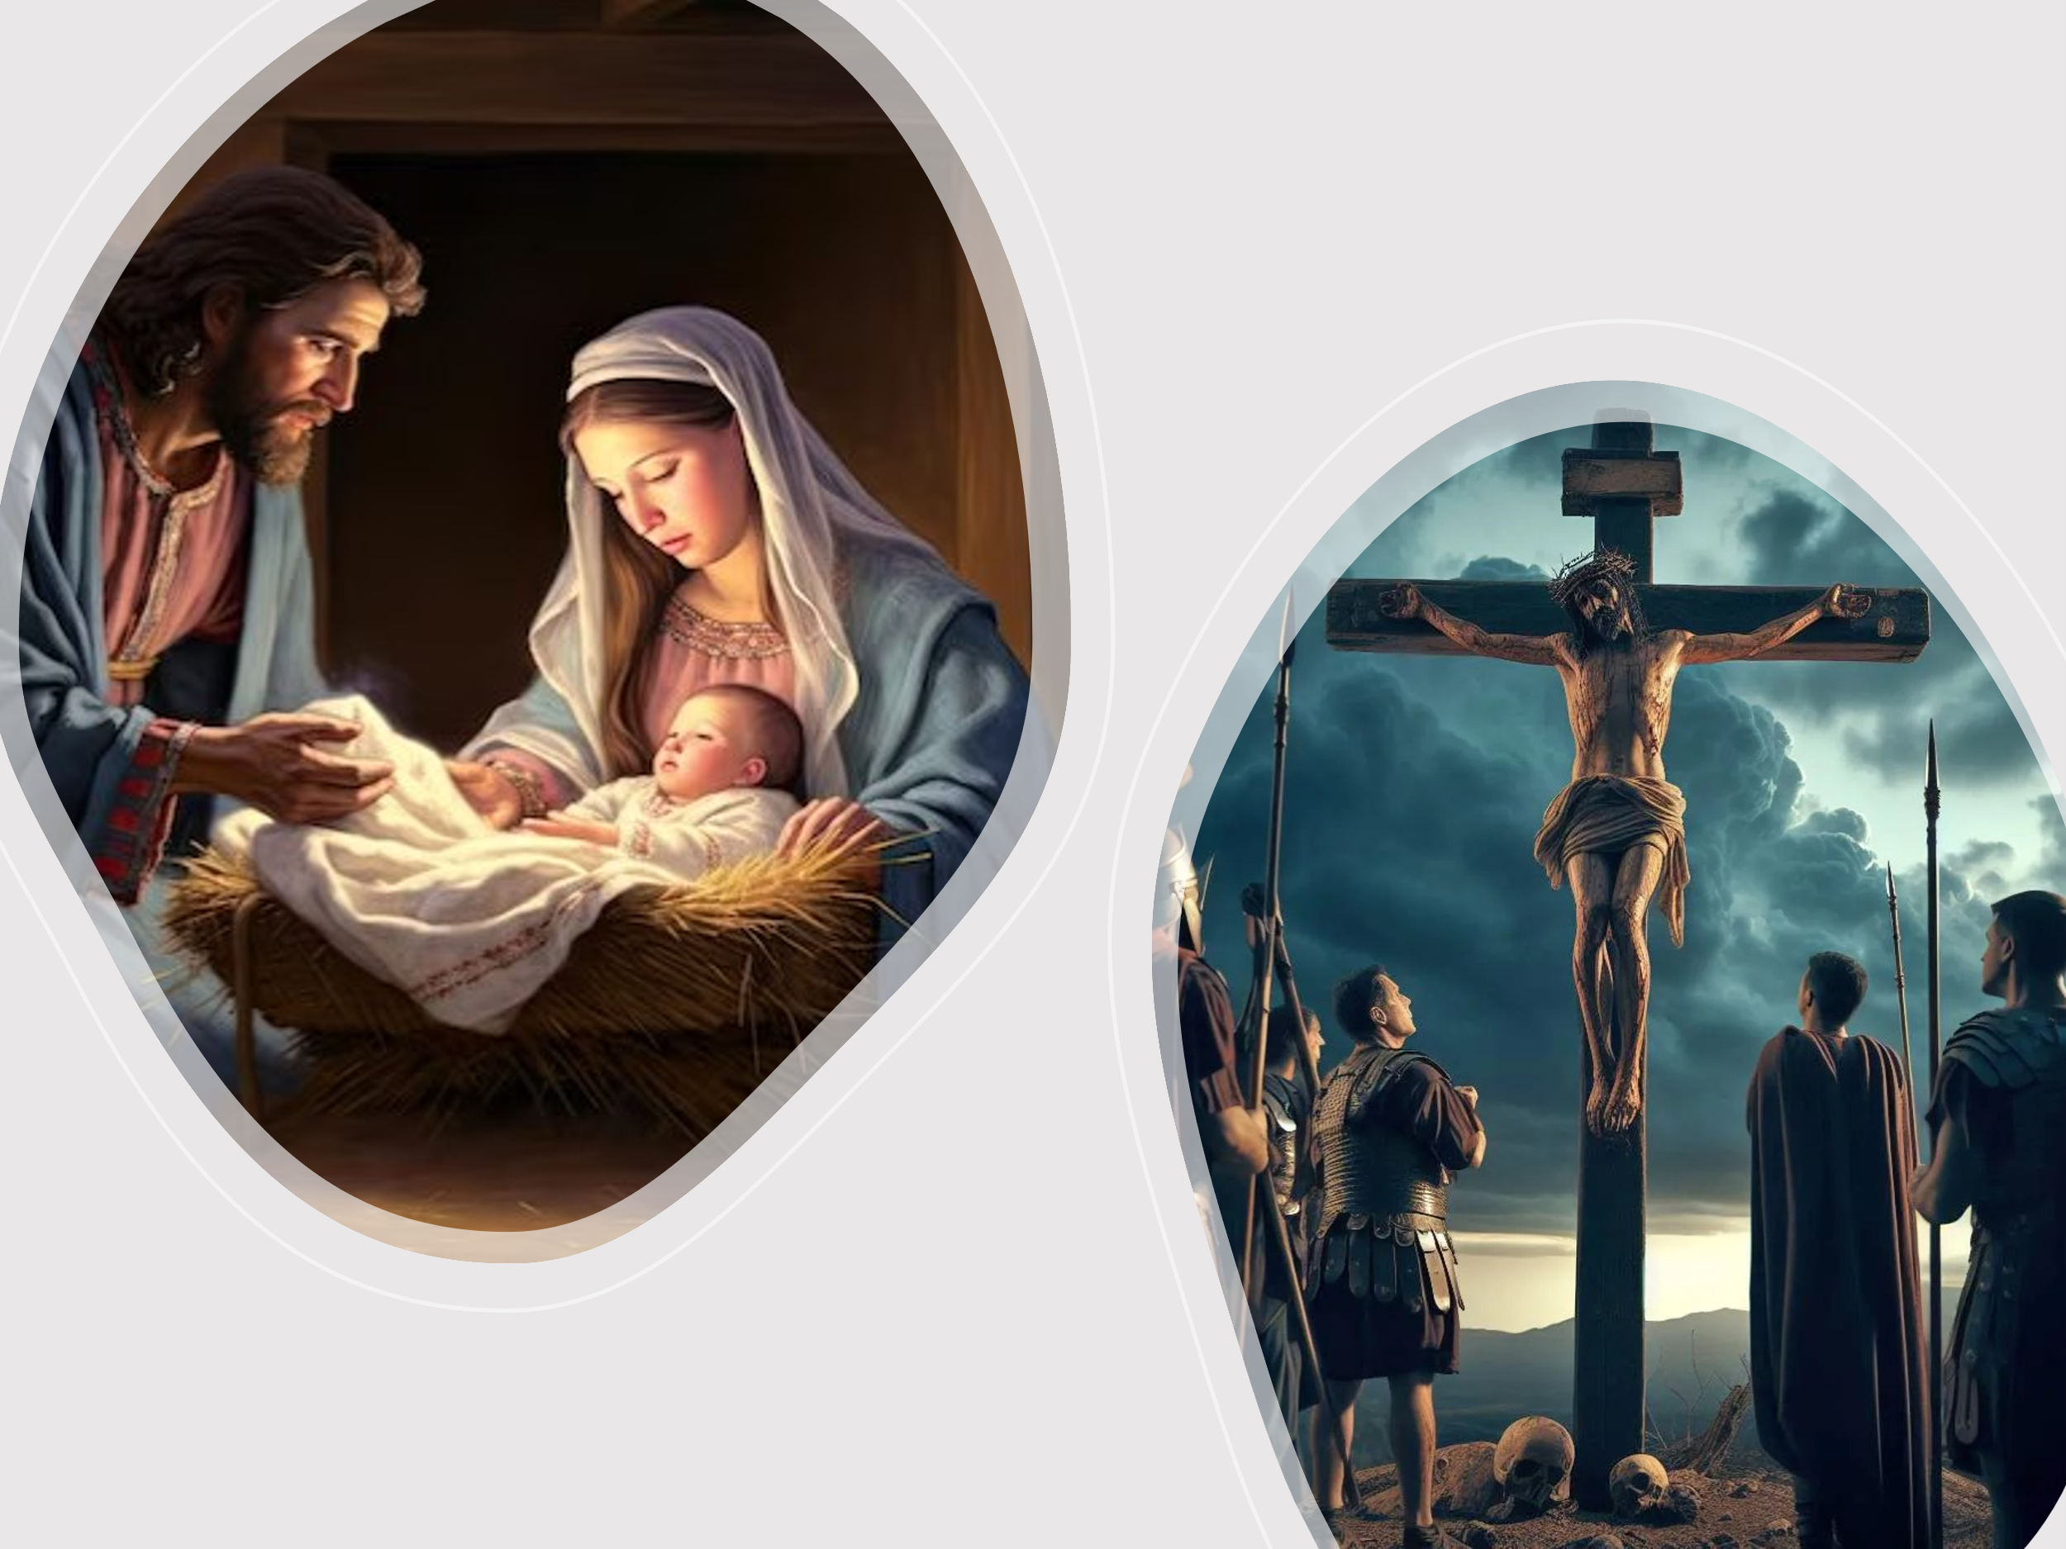

To deepen our understanding of Christ, we can use the metaphor of an hourglass to represent different levels of our knowledge of God's identity. The top of the hourglass signifies aspects of God that are beyond human comprehension. A. W. Tozer aptly states that having an accurate idea of God is crucial for responding properly to His presence. Our lifelong duty is to love God, obey Him perfectly, and worship Him acceptably. One of the gravest sins is idolatry, which includes creating a false image of God, or imagining Him in our likeness. This is a challenging task because we often understand new concepts by comparing them to what we already know. However, God is incomparable and beyond any human analogy. While Scripture tells us we are created in God's image, it does not mean we are exact replicas of God. Assuming so diminishes His true essence. Despite God's infinite attributes being beyond our finite minds, we are not left without hope. Scripture and the Holy Spirit reveal what we can know about the infinite, providing us with guidance and understanding.

As we move to the narrow part of the hourglass, our understanding of God deepens through His Son, Jesus. When Christ used the name "I AM" in the New Testament, it was a clear declaration of His divine identity as God Himself. Though we cannot fully comprehend the Triune God, we accept by faith the eternal truth of the pre-existent Christ and Apostle Paul’s assertion that He is the image of the invisible God, the firstborn over all creation. "For in Him all things were created: things in heaven and on earth" (Colossians 1:15-16). Many prefer to envision Jesus as either a fictional baby in a manger or a condemned criminal on a cross, thus dismissing Him as irrelevant or reducing His divine stature to human limitations. However, we cannot ignore that He is the "Son of Man" from Daniel’s prophecy, who has been given "authority, glory, and sovereign power" and whose "everlasting dominion will never pass away" (Daniel 7:13-14). Christ did not consider equality with God something to be exploited; instead, He took on the nature of a servant and was made in human likeness (Philippians 2:6-7). While His incarnation is beyond our comprehension this does not negate the truth that Christ was both God and man at the same time!
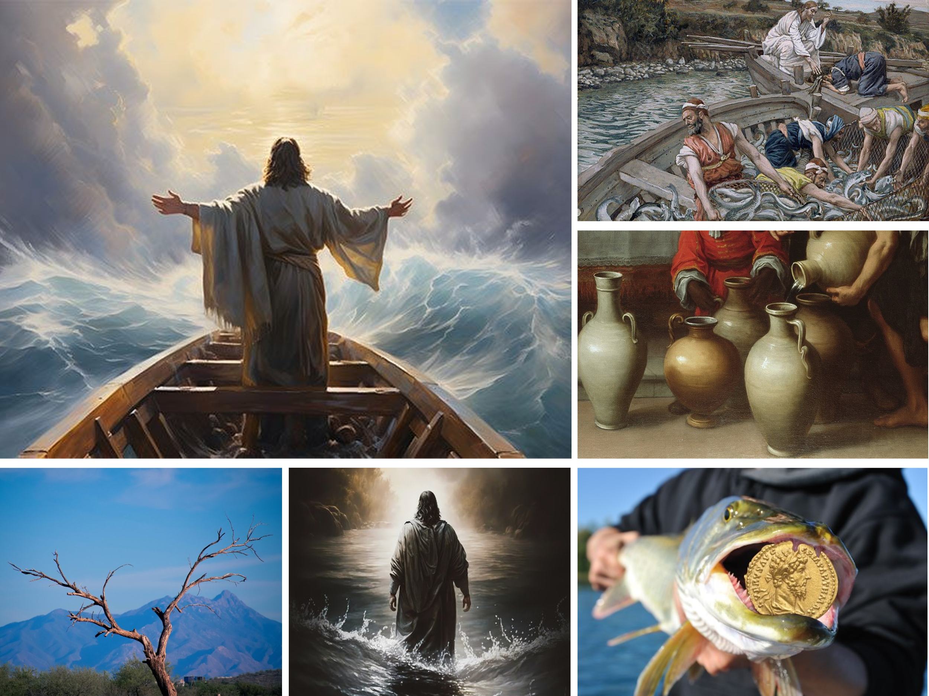
As we read about the Babe in the manger who later grew in wisdom and stature (Luke 2:52), we witness through His many miracles the person of Christ, who was filled with grace, mercy, and absolute sovereignty. Immersing ourselves in the grand narrative of God’s holy word, we encounter Christ's miracles, such as turning water into wine (John 2:1-11), the miraculous catch of fish at both the lake of Gennesaret and the sea of Tiberias (Luke 5:1-11; John 21:4-11), calming a storm on the sea (Matthew 8:23-27), walking on water (Matthew 14:22-33), retrieving the temple tax from a fish’s mouth (Matthew 17:24-27), and withering a fig tree on the road from Bethany (Matthew 21:18-22). These acts clearly demonstrate our Lord’s sovereignty over nature.
As we read about Christ healing an official’s son (John 4:43-54), Peter’s mother-in-law (Matthew 8:14-15), ten men with leprosy (Luke 17:11-19), a paralytic (Matthew 9:1-8), a man’s withered hand (Matthew 12:9-14), the woman with the issue of blood (Matthew 9:20-22), a man unable to speak (Matthew 9:32-34), an invalid (John 5:1-15), the blind and the deaf (Matthew 9:27-31; Mark 7:31-37), and raising back to life Jairus’ daughter, the widow’s son, and Lazarus (Matthew 9:18, 23-26; Luke 7:11-17; John 11:1-45), we discover the Good Shepherd’s grace and mercy toward our ailments, along with His divine power to heal.
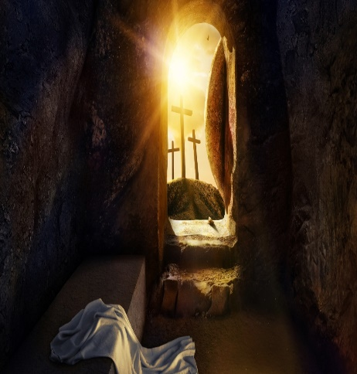
When we read about Christ driving out an evil spirit from a man in Capernaum (Mark 1:21-27), a legion of demons from a man in Gerasenes (Mark 5:1-17), a boy with an unclean spirit (Matthew 17:14-20), and a demon-possessed man who was blind and mute (Matthew 12:22-23), we learn that even demons must obey the command of Him who is sovereign over all things seen and unseen. Finally, and most importantly, when we read that Christ came to give His life as a ransom for many (Mark 10:45), we understand the depths of His love for His own.
And finally, as we move once again to the broad part at the bottom of the hourglass, our understanding of Christ’s role in the end times, we find while much has been revealed, much more remains hidden! As we look up, eagerly waiting for the Lord’s return may we rejoice in both our blessings now and future ones. For instance, let us rejoice that the Lord has gone to prepare a place for His children. Let us rejoice that the promised Spirit of God, our Comforter has come who leads and empowers us to know and the live the truth (John 16:8-11)! While we do not know the day or hour, let us rejoice that the Spirit has sealed us as a deposit guaranteeing our inheritance, God’s possession to the praise of His glory (Ephesians 1:13-14)! Though the Scripture states, “what no eye as seen, what no ear has heard, and what no human mind has conceived, the things God has prepared for those who love Him” (1 Corinthians 2:9), may we rejoice that while we are not aware of “the glory that will one be revealed in us” (Romans 8:18) until we go home to meet Jesus; we can rejoice that the Lord in the here and now has blessed us beyond all measure with every spiritual blessing possible in the Lord Jesus Christ (Ephesians 1:3)!

Conclusion
While there are many things about God beyond our comprehension, what we can know about Him fills us with a profound sense of peace and joy. May we earnestly seek to understand God’s nature and His requirements for us, His creation, so that we might live lives worthy of the Gospel message. Before the beginning of time, Christ voluntarily planned to empty Himself of the glory He had in heaven, live among us as an unknown carpenter’s son, and be crucified on the cross to atone for our sins. When God revealed His name to Moses as “I AM,” Christ adopted this title for Himself, signifying His divine nature and identity as God. As we strive to know the unknowable, may we humbly approach His throne of grace, asking our Lord, Savior, and King to continually shape our words, thoughts, and deeds so that we rightly praise His name to the best of our abilities. Even when we do not understand God’s ways, which are higher than our ways, may we pray to the Spirit of Truth, asking that our understanding and prayers not be limited to this temporal world, which is not our true home. God is our portion, our legacy, and our hope, sustaining us through tribulations and lifting us on the mountaintops of blessings. May we keep our focus heavenward, for one day very soon, we will go home to meet Jesus and live in His presence—not as slaves, but as dearly beloved children who have received a glorious inheritance from Him. We will be in the presence of and loved by “I AM” forever.

Taken from the I AM series from Sermon Central.
Taken from The Knowledge of the Holy by A.W. Tozer.

