**7S of Being Ready**[1]

**1 Thessalonians 5:1-11**

Online Sermon: <http://www.mckeesfamily.com/?page_id=3567>

Ever since Christ promised that He was going to prepare a place for His own- and one-day return, Christians have been “looking up” and speculating as to when this glorious day will occur. When faced with a crisis[2] or upon getting elderly human beings who are naturally curious about the future[3] are more likely to speculate that the “end times” are near. While hearing Jack Van Impe, Ronald Weinland, Jean Dixon[4] and others make the case that Christ will appear during one’s lifetime is quite invigorating, does not predicting that which not even the angels or Christ knows (Matthew 24:36) not only seem arrogant but foolish for when the predicted date comes and goes it often leads many to question the accuracy of the entire Gospel message?[5] In today’s passage Apostle Paul states that since the date cannot be predicted then the best humanity can do is to be alert and self-controlled,[6] always living one’s life in certainty that the Day of the Lord will come.[7] While this will be a day of judgment and wrath for unbelievers, for God’s own they will rejoice for on that day they will receive their new bodies and be taken to spend an eternity in heaven with Jesus! The following sermon is going to look at Paul’s seven S’s of being ready to meet Jesus: sudden, sorrow, sound, sleeping, sober, salvation and solace.

**Sudden: Will Come as a Thief in the Night (verses 1-2)**

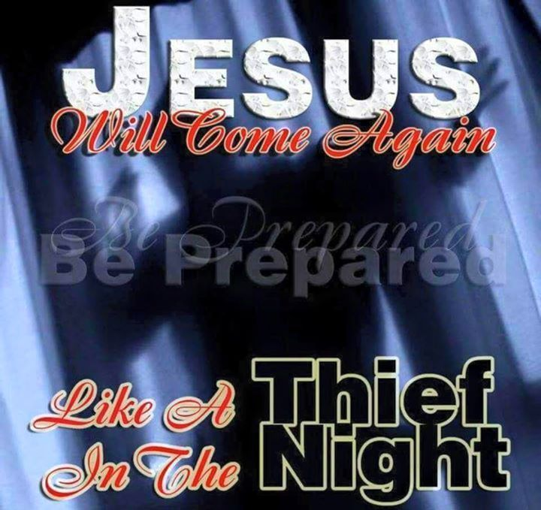Paul told the believers at Thessalonica that he did not need to write about the date of the Day of the Lord because, as they were fully aware, such a date would inevitably come[8] but at a time and hour that only the Father knows. “We cannot fully understand the New Testament picture of the Second Coming unless we first explore their OT background.”[9] The Day of the Lord in the Old Testament was to be sudden (Mal. 3:1; Job 24:14; Joel 2:9; Obad. 5; cf. Euripides)[10] and seen as “God’s decisive and final intervention. Most prevalent from the time of Amos onward, the expression is used to refer to the time of God’s judgment on the wicked (Amos 5:8–10; Joel 1:15; Isa. 13:6) as well as deliverance for the faithful (Joel 2:32; 3:18; Obad. 15–17; Zech. 14:1–21).”[11] Paul applied this Yahweh tradition to that of Christ.[12] The New Testament writers “for all intents and purposes identified the Day of the Lord with the Second Coming of Christ.”[13] Since the timing of Christ’s return was to be compared to a thief in the night, who was unknown and unpredictable,[14] Paul implored the Thessalonians to channel their “eschatological fervor”[15] away from estimating the date to responsibly serving the Lord continuously[16] so that upon His return they would be found faithfully doing God’s will.

**Sorrow: False Peace and Security (verse 3)**

Paul warned the Thessalonians that when the Day of the Lord comes those who feel secured in their safety and peace would soon face sudden destruction and pain like that of a pregnant woman giving birth. In verse three Paul sharply critiqued the “slogans and propaganda about the Pax Romana of his time.[17] From the era of Augustus Caesar 27 BC to Marcus Aurelius in 180 AD, the political stability, cultural advances and military might[18] of the Roman empire enabled its members to move about easily and with relative safety.[19] In verse three Paul stated how foolish it was for the unbelievers, even if they were part the Pax Romana, to think that peace and safety could ever be secured by their accomplishments.[20] “God in Christ is the one who will bring justice, peace, and security once and for all, not the emperor with his slogans.”[21] Like the people in Noah’s or Sodom’s day unbelievers of Paul’s day will feel they have peace[22] right up until the moment Christ arrives and judges the living and the dead! Anyone found on that day not “with the Lord” (cf 4:17)[23] will experience great sorrow and pain because it will be too late for them to escape the judgement of being eternally separated from God. Paul is not trying to scare the Thessalonian believers but to encourage them that the Day of the Lord poses no threat to them[24] but is only to be seen as assurance that their enemies will one day be judged[25] and in the mean time they ought to pray for them that they might come to know the Lord.

**Sound: Christians Know what to Expect (verses 4-5)**

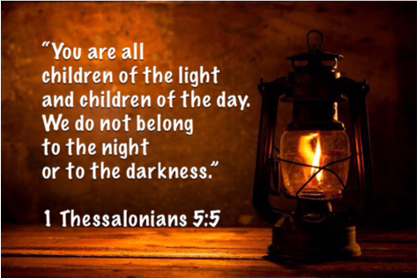In verses four and five Apostle Paul used dark/light imagery to reassure the Thessalonians that as children of the light they knew what to expect upon the Coming of the Lord. Darkness and light are not to be taken literally but as metaphors contrasting those who are still spiritually ignorant and under the rule of Satan (darkness)[26] versus those who have been born again through their faith in the atoning sacrifice of Christ (light).[27] Light and darkness for Paul pointed to the truth that some people are “insiders” and others “outsiders” of God’s kingdom (Luke 16:8; John 12:36; Eph. 5:8; 1 John 1:6–7; 2:9–11).[28] “Night for Paul was a time for thieves whereas daylight was the time for truth.[29] The “thief in the night” suddenness of Christ’s return will not “catch insiders off guard”[30] because when they walk in the truth as “children of the day,”[31] darkness cannot overtake them! [32]  Since one cannot have fellowship with God while walking in darkness (1 John 1;5-6),[33] Paul implored the Thessalonians to not be “careless or indifferent to what they have received”[34] but to “be ready” for Christ’s return by “putting on the armour of light”[35] so that they might be found faithfully walking in the very steps of Christ who purchased them at a price (1 Corinthians 6:20)!

**Sleeping: Christians Should be Awake (verses 6-7)**

Paul now uses “sleep/awake” and “drunkenness/sober” as further metaphors to encourage the Thessalonians to be ready for Christ’s return that will come like a thief in the night. A thief can get away with a lot of stuff if the occupants are either asleep or drunk![36] Sleep for Paul does not mean physical death[37] but moral indifference to the light in which one professes whereas drunkenness means a lack of moral self-control[38] and therefore a lack of preparedness (Matt 24:48–51 par. Luke 12:45, 46).[39] While sleep and drunkenness is natural to those perishing in their sins, [40] Paul told 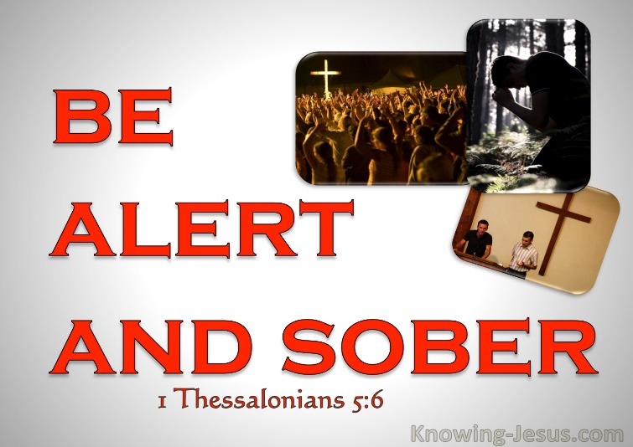the Thessalonians as children of the light they needed to be awake and sober at all times. To be drunk with the ways of this world and indifferent to the things of God[41] is not acceptable because the “believer’s status as sons of the light demands a morality, a holiness, in keeping with Him who is light (cf. John 8:12; 11:9f.; 12:46; 1 John 1:5f.).”[42] To constantly reject the views of those given over to their reprobate minds (Romans 1:28)[43] is not an easy task but though the power of the Spirit of God it can be accomplished when one stays awake and sober. Paul encouraged the Thessalonians that they will be found faithful only if they constantly hold onto God’s standards by thinking about[44] whatever is true, noble, right, pure, lovely and admirable in His kingdom (Philippians 4:8).

**Sober: Christians Should Always be Alert (verse 8)**

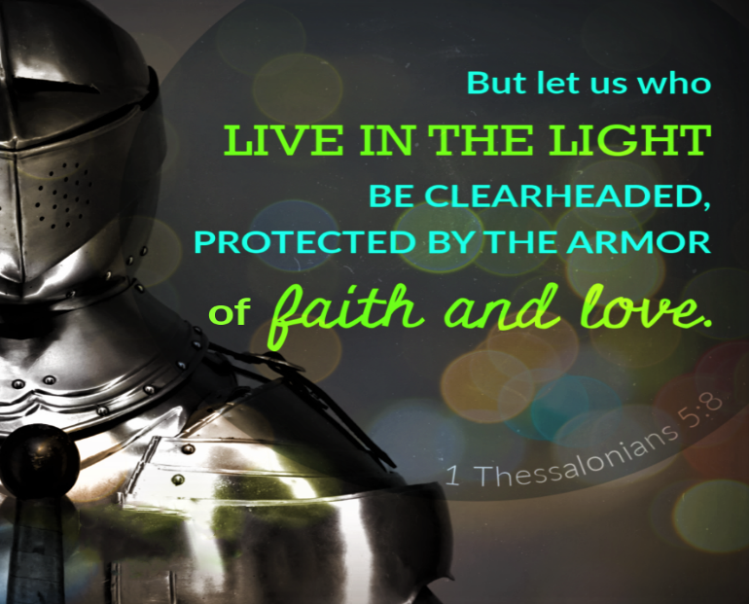 To be found ready when Christ returns Paul recommended the Thessalonians remain sober by putting “on faith and love as a breastplate and the hope of salvation as a helmet.” Though darkness was all around them[45] by wearing the right clothing[46] the Thessalonians could be sober, self-controlled and walk in the light as God is light! Paul implored the Thessalonians to imitate God’s example in Isaiah 59:17 where He puts on the breastplate of righteousness and helmet of salvation before doing battle against the ungodly.[47] Faith and love helps “protect the believer from the attacks of doubt.”[48] The helmet of hope helps protects one’s faith[49] when life comes crashing down with persecutions and injustices by constantly reminding the believer one day Christ will return and make all things right.[50] By putting on the full armor of God (Ephesians 6:14-17) the Thessalonians can remain sober and alert, conquering any conflict that the realm of darkness might throw at them.[51] This armor was not to be put on so that they could sit in their houses with Bible in hand[52] and be paralyzed with fear and inaction[53] but to constantly walk in the light so that they might please Christ (Matthew 24:45-46) [54] when He returns, immediately or sometime in the distant future.

**Salvation: Christians Escape Tribulation (verses 9-10)**

Once again Paul reassured the Thessalonians that “God did not appoint them to suffer judgment and wrath in the future, but rather to receive salvation through “our Lord Jesus Christ.”[55] It was God’s initiative to send His Son Jesus (John 3:16)[56] to live amongst us and ultimately to pore His wrath upon His Son so that through Jesus’ atoning sacrifice all who believe in Him might pass from death to life.[57] To empty the severity of God’s wrath from salvation is to rob “real life” [58] of much of its meaning because grace has been minimalized.[59] “God made He who had no sin to be sin for us so that we might become the righteousness of God” (2 Corinthians 5:21). Christ in His resurrection was the beginning of the new creation (Rev 3:14; John 1:1–5; 2 Cor 5:14–17; Gal 6:14–15; Col 1:15–18).[60] Paul did not say that salvation came independent of the action of human beings[61] but that through believing in the atoning sacrifice of the Son one becomes saved and subsequently a child of God (1 Thess. 5:10a; cf. Rom. 5:6, 8; 8:3; 14:15; 1 Cor. 15:3; 2 Cor. 5:14–15).[62] The fact that the return of Christ was nearer than when they first believed (Romans 13:11)[63] should not scare the Thessalonians but should be a source of great joy that those physically dead or alive upon Christ’s return will eternally enter the new life that has been prepared for them by their Lord! [64]

**Solace: Comfort one Another with Hope (verse 11)**

Having put on the armor of God and having stayed fully alert for Christ’s return through holy living was to be both an individual and a communal goal.[65] Within the bonds of the Christian community[66] Paul commended and also encouraged the Thessalonians to never stop comforting[67] and helping each other to attain spiritual maturity.[68] The Day of the Lord will come suddenly like a thief in the night. Since no one knows the day or hour of Christ’s return except God, the only way to be found faithful upon His return is to always be doing what is right in His sight. Even as alert, sober children of the Light wearing the armor of faith, hope and Text
love[69] the Thessalonians still needed the helping hands of other believers who were also trying to attain the full measure of Christ. With all the trails and tribulations, persecutions and injustices one inevitable has to face living in this fallen world that is not our home, isn’t it nice to know that we can get great a helping hand from other believers who like us are trying to remain faithful until Christ comes again! Christ died so that His people might live[70] … so with great faith and in an abundance of grace let’s build each other up so that upon His return we might hear the words “good and faithful servant” (Matthew 25:14-30)!

1. Sermon outline was taken from the following source: Croft M. Pentz, [*Sermon Outlines on the Epistles: Galatians–II Timothy*](https://ref.ly/logosres/so69ga?ref=Page.p+35&off=75&ctx=PARATION%E2%80%94vv.+1%E2%80%9311%0a1.~+Sudden%E2%80%94vv.+1%E2%80%932.+Wil), Dollar Sermon Library Series (Grand Rapids, MI: Baker Book House, 1971), 35.
2. Michael Holmes, [*1 and 2 Thessalonians*](https://ref.ly/logosres/nivac73th?ref=Bible.1Th5.1-11&off=22024&ctx=urse%E2%80%94are+in+place.%E2%80%9D+~The+danger+%E2%80%9Cis+that+), The NIV Application Commentary (Grand Rapids, MI: Zondervan Publishing House, 1998), 174.
3. Michael Holmes, [*1 and 2 Thessalonians*](https://ref.ly/logosres/nivac73th?ref=Bible.1Th5.1-11&off=19933&ctx=ce+of+this+passage.%0a~The+proper+preparati), The NIV Application Commentary (Grand Rapids, MI: Zondervan Publishing House, 1998), 173.
4. Taken from the following website: <https://en.wikipedia.org/wiki/Predictions_and_claims_for_the_Second_Coming_of_Christ>
5. Michael Holmes, [*1 and 2 Thessalonians*](https://ref.ly/logosres/nivac73th?ref=Bible.1Th5.1-11&off=21060&ctx=ergy%2c+or+money.%0a(3)+~Speculation+about+da), The NIV Application Commentary (Grand Rapids, MI: Zondervan Publishing House, 1998), 173.
6. Michael Holmes, [*1 and 2 Thessalonians*](https://ref.ly/logosres/nivac73th?ref=Bible.1Th5.1-11&off=1522&ctx=me+of+the+Parousia%3b+~here+he+reassures+th), The NIV Application Commentary (Grand Rapids, MI: Zondervan Publishing House, 1998), 164.
7. Gordon D. Fee, [*The First and Second Letters to the Thessalonians*](https://ref.ly/logosres/nicnt73th1?ref=Bible.1Th5.4-11&off=872&ctx=fact+you+are+doing.%0a~Paul+now+comes+to+th), The New International Commentary on the New Testament (Grand Rapids, MI: Wm. B. Eerdmans Publishing Co., 2009), 191.
8. Ernest Best, [*The First and Second Epistles to the Thessalonians*](https://ref.ly/logosres/black73th?ref=Bible.1Th5.1-11&off=1553&ctx=etaphors+(vv.+2%2c+3)+~which+bring+out+its+), Black’s New Testament Commentary (London: Continuum, 1986), 203.
9. William Barclay, [*The Letters to Philippians, Colossians, and Thessalonians*](https://ref.ly/logosres/ndsb71php?ref=Bible.1Th5.1-11&off=1235&ctx=deed+you+are+doing.%0a~We+shall+not+fully+u), 3rd ed. fully rev. and updated., The New Daily Study Bible (Louisville, KY; London: Westminster John Knox Press, 2003), 236.
10. Daniel M. Gurtner, [“1 Thessalonians,”](https://ref.ly/logosres/bkbc65ac?ref=Bible.1Th5.2&off=540&ctx=or+this+expression%2c+~Jews+of+the+Old+Test) in *The Bible Knowledge Background Commentary: Acts–Philemon*, ed. Craig A. Evans and Craig A. Bubeck, First Edition. (Colorado Springs, CO: David C Cook, 2004), 623.
11. Daniel M. Gurtner, [“1 Thessalonians,”](https://ref.ly/logosres/bkbc65ac?ref=Bible.1Th5.2&off=67&ctx=thief+in+the+night.+~Day+of+the+Lord+(hem) in *The Bible Knowledge Background Commentary: Acts–Philemon*, ed. Craig A. Evans and Craig A. Bubeck, First Edition. (Colorado Springs, CO: David C Cook, 2004), 623.
12. Ben Witherington III, [*1 and 2 Thessalonians: A Socio-Rhetorical Commentary*](https://ref.ly/logosres/sorhet73th1?ref=Bible.1Th5.2&off=1049&ctx=(Phil.+1%3a10%3b+2%3a16).+~Paul+has+adopted+and) (Grand Rapids, MI: Wm. B. Eerdmans Publishing Co., 2006), 145.
13. William Barclay, [*The Letters to Philippians, Colossians, and Thessalonians*](https://ref.ly/logosres/ndsb71php?ref=Bible.1Th5.1-11&off=2277&ctx=a+time+of+judgment.%0a~Very+naturally%2c+the+), 3rd ed. fully rev. and updated., The New Daily Study Bible (Louisville, KY; London: Westminster John Knox Press, 2003), 237.
14. Ben Witherington III, [*1 and 2 Thessalonians: A Socio-Rhetorical Commentary*](https://ref.ly/logosres/sorhet73th1?ref=Bible.1Th5.2&off=2031&ctx=+very+well+that+the+~timing+of+the+parous) (Grand Rapids, MI: Wm. B. Eerdmans Publishing Co., 2006), 146.
15. Michael Holmes, [*1 and 2 Thessalonians*](https://ref.ly/logosres/nivac73th?ref=Bible.1Th5.1-2&off=226&ctx=%2c+what+prompted+it.+~It+is+often+suggeste), The NIV Application Commentary (Grand Rapids, MI: Zondervan Publishing House, 1998), 165.
16. Tim Shenton, [*Opening up 1 Thessalonians*](https://ref.ly/logosres/openup73th1?ref=Bible.1Th5.1-3&off=31&ctx=the+night+(vv.+1%E2%80%933)%0a~The+Lord+Jesus+Chris), Opening Up Commentary (Leominster: Day One Publications, 2006), 94.
17. Ben Witherington III, [*1 and 2 Thessalonians: A Socio-Rhetorical Commentary*](https://ref.ly/logosres/sorhet73th1?ref=Bible.1Th5.2&off=4957&ctx=+(SIG+685%3a14%E2%80%9315).92%0a~Paul+must+have+thoug) (Grand Rapids, MI: Wm. B. Eerdmans Publishing Co., 2006), 147.
18. Ben Witherington III, [*1 and 2 Thessalonians: A Socio-Rhetorical Commentary*](https://ref.ly/logosres/sorhet73th1?ref=Bible.1Th5.2&off=3539&ctx=ders%2c+not+insiders.%0a~There+were+inscripti) (Grand Rapids, MI: Wm. B. Eerdmans Publishing Co., 2006), 146.
19. Nathan P. Feldmeth, [*Pocket Dictionary of Church History: Over 300 Terms Clearly and Concisely Defined*](https://ref.ly/logosres/pcktdctchrchhst?ref=Page.p+120&off=426&ctx=d+cultural+advance.+~There+is+little+doub), The IVP Pocket Reference Series (Downers Grove, IL: IVP Academic, 2008), 120.
20. Ben Witherington III, [*1 and 2 Thessalonians: A Socio-Rhetorical Commentary*](https://ref.ly/logosres/sorhet73th1?ref=Bible.1Th5.2&off=4957&ctx=+(SIG+685%3a14%E2%80%9315).92%0a~Paul+must+have+thoug) (Grand Rapids, MI: Wm. B. Eerdmans Publishing Co., 2006), 147.
21. Ben Witherington III, [*1 and 2 Thessalonians: A Socio-Rhetorical Commentary*](https://ref.ly/logosres/sorhet73th1?ref=Bible.1Th5.2&off=6096&ctx=ovement+for+reform.+~Rather%2c+he+is+a+beli) (Grand Rapids, MI: Wm. B. Eerdmans Publishing Co., 2006), 147.
22. F. F. Bruce, [*1 and 2 Thessalonians*](https://ref.ly/logosres/wbc45?ref=Bible.1Th5.3&off=181&ctx=ion+comes+on+them.%E2%80%9D+~In+Jesus%E2%80%99+warning+ab), vol. 45, Word Biblical Commentary (Dallas: Word, Incorporated, 1982), 110.
23. Michael Holmes, [*1 and 2 Thessalonians*](https://ref.ly/logosres/nivac73th?ref=Bible.1Th5.3&off=356&ctx=+which+they+begin).+~Anyone+who+is+not+%E2%80%9Cw), The NIV Application Commentary (Grand Rapids, MI: Zondervan Publishing House, 1998), 166.
24. Gordon D. Fee, [*The First and Second Letters to the Thessalonians*](https://ref.ly/logosres/nicnt73th1?ref=Bible.1Th5.3&off=3&ctx=+God+the+Father.%0a3++~Although+there+are+s), The New International Commentary on the New Testament (Grand Rapids, MI: Wm. B. Eerdmans Publishing Co., 2009), 188.
25. Gordon D. Fee, [*The First and Second Letters to the Thessalonians*](https://ref.ly/logosres/nicnt73th1?ref=Bible.1Th5.3&off=3987&ctx=%E2%80%9D+to+righteousness.%0a~One+of+the+unfortuna), The New International Commentary on the New Testament (Grand Rapids, MI: Wm. B. Eerdmans Publishing Co., 2009), 190.
26. G. K. Beale, [*1–2 Thessalonians*](https://ref.ly/logosres/ivnt1th?ref=Bible.1Th5.4-7&off=4275&ctx=ation+in+Christ.+In+~contrast+to+the+ligh), The IVP New Testament Commentary Series (Downers Grove, IL: InterVarsity Press, 2003), 147.
27. G. K. Beale, [*1–2 Thessalonians*](https://ref.ly/logosres/ivnt1th?ref=Bible.1Th5.4-7&off=3170&ctx=tion+and+to+Christ%3f+~Christ+in+his+resurr), The IVP New Testament Commentary Series (Downers Grove, IL: InterVarsity Press, 2003), 146–147.
28. Michael Holmes, [*1 and 2 Thessalonians*](https://ref.ly/logosres/nivac73th?ref=Bible.1Th5.4-8&off=118&ctx=+%E2%80%9Cthief%2c%E2%80%9D+%E2%80%9Cnight%E2%80%9D).+~The+imagery+of+light), The NIV Application Commentary (Grand Rapids, MI: Zondervan Publishing House, 1998), 167.
29. Ben Witherington III, [*1 and 2 Thessalonians: A Socio-Rhetorical Commentary*](https://ref.ly/logosres/sorhet73th1?ref=Bible.1Th5.3&off=821&ctx=+the+imagery+here%3a+%E2%80%9C~Night+is+the+time+fo) (Grand Rapids, MI: Wm. B. Eerdmans Publishing Co., 2006), 148.
30. G. K. Beale, [*1–2 Thessalonians*](https://ref.ly/logosres/ivnt1th?ref=Bible.1Th5.4-7&off=201&ctx=rprised+by+a+thief.+~Thieves+sometimes+do), The IVP New Testament Commentary Series (Downers Grove, IL: InterVarsity Press, 2003), 145.
31. Gordon D. Fee, [*The First and Second Letters to the Thessalonians*](https://ref.ly/logosres/nicnt73th1?ref=Bible.1Th5.4-11&off=2060&ctx=e+who+oppose+them.+%E2%80%9C~The+day+%5bof+judgment), The New International Commentary on the New Testament (Grand Rapids, MI: Wm. B. Eerdmans Publishing Co., 2009), 192.
32. G. K. Beale, [*1–2 Thessalonians*](https://ref.ly/logosres/ivnt1th?ref=Bible.1Th5.4-7&off=1858&ctx=out+John%E2%80%99s+Gospel).+~In+particular%2c+in+Jo), The IVP New Testament Commentary Series (Downers Grove, IL: InterVarsity Press, 2003), 146.
33. F. F. Bruce, [*1 and 2 Thessalonians*](https://ref.ly/logosres/wbc45?ref=Bible.1Th5.5&off=829&ctx=ly+prominent+there.+~Since+God+is+light%2c+), vol. 45, Word Biblical Commentary (Dallas: Word, Incorporated, 1982), 111.
34. Ben Witherington III, [*1 and 2 Thessalonians: A Socio-Rhetorical Commentary*](https://ref.ly/logosres/sorhet73th1?ref=Bible.1Th5.6&off=411&ctx=t+of+%E2%80%9Cthe+rest.%E2%80%9D105+~Lightfoot+distinguis) (Grand Rapids, MI: Wm. B. Eerdmans Publishing Co., 2006), 149.
35. G. K. Beale, [*1–2 Thessalonians*](https://ref.ly/logosres/ivnt1th?ref=Bible.1Th5.4-7&off=1326&ctx=+for+%E2%80%9CLord%E2%80%9D+in+5%3a5.+~This+is+implied+by+n), The IVP New Testament Commentary Series (Downers Grove, IL: InterVarsity Press, 2003), 146.
36. G. K. Beale, [*1–2 Thessalonians*](https://ref.ly/logosres/ivnt1th?ref=Bible.1Th5.4-7&off=5257&ctx=1%3b+Bruce+1982%3a112).+~Like+sleepy+people%2c+), The IVP New Testament Commentary Series (Downers Grove, IL: InterVarsity Press, 2003), 147.
37. G. K. Beale, [*1–2 Thessalonians*](https://ref.ly/logosres/ivnt1th?ref=Bible.1Th5.4-7&off=4779&ctx=ers+to+unbelievers.+~Ironically%2c+in+5%3a6+t), The IVP New Testament Commentary Series (Downers Grove, IL: InterVarsity Press, 2003), 147.
38. Harold W. Hoehner, Philip W. Comfort, and Peter H. Davids, [*Cornerstone Biblical Commentary: Ephesians, Philippians, Colossians, 1&2 Thessalonians, Philemon.*](https://ref.ly/logosres/cstonecm70eph?ref=Bible.1Th5.7&off=4&ctx=3%3b+1+Pet+1%3a13).%0a5%3a7+~sleep+%E2%80%A6+get+drunk.+S), vol. 16 (Carol Stream, IL: Tyndale House Publishers, 2008), 364.
39. F. F. Bruce, [*1 and 2 Thessalonians*](https://ref.ly/logosres/wbc45?ref=Bible.1Th5.7&off=322&ctx=herefore+reckless).+~In+association+with+), vol. 45, Word Biblical Commentary (Dallas: Word, Incorporated, 1982), 112.
40. Tim Shenton, [*Opening up 1 Thessalonians*](https://ref.ly/logosres/openup73th1?ref=Bible.1Th5.4-8&off=2324&ctx=ldren+of+the+light.+~Sleep+is+natural+to+), Opening Up Commentary (Leominster: Day One Publications, 2006), 98.
41. Gordon D. Fee, [*The First and Second Letters to the Thessalonians*](https://ref.ly/logosres/nicnt73th1?ref=Bible.1Th5.6-7&off=2655&ctx=+of+these+others.44%0a~Thus+the+two+nightti), The New International Commentary on the New Testament (Grand Rapids, MI: Wm. B. Eerdmans Publishing Co., 2009), 194.
42. David J. Williams, [*1 and 2 Thessalonians*](https://ref.ly/logosres/nibcnt73th?ref=Bible.1Th5.6&off=561&ctx=ymous+with+koima%C5%8D).+~The+believer%E2%80%99s+statu), Understanding the Bible Commentary Series (Grand Rapids, MI: Baker Books, 2011), 89.
43. Gordon D. Fee, [*The First and Second Letters to the Thessalonians*](https://ref.ly/logosres/nicnt73th1?ref=Bible.1Th5.6-7&off=3296&ctx=roughout+Scripture.+~But+drunkenness+as+s), The New International Commentary on the New Testament (Grand Rapids, MI: Wm. B. Eerdmans Publishing Co., 2009), 194–195.
44. Ben Witherington III, [*1 and 2 Thessalonians: A Socio-Rhetorical Commentary*](https://ref.ly/logosres/sorhet73th1?ref=Bible.1Th5.7&off=367&ctx=+ethical+plane.%E2%80%9D112+~Christians+are+held+) (Grand Rapids, MI: Wm. B. Eerdmans Publishing Co., 2006), 149.
45. G. K. Beale, [*1–2 Thessalonians*](https://ref.ly/logosres/ivnt1th?ref=Bible.1Th5.4-7&off=6344&ctx=harm+to+themselves.+~God%E2%80%99s+people+are+to+), The IVP New Testament Commentary Series (Downers Grove, IL: InterVarsity Press, 2003), 148.
46. G. K. Beale, [*1–2 Thessalonians*](https://ref.ly/logosres/ivnt1th?ref=Bible.1Th5.8-11&off=2212&ctx=3%3a12%3b+Eph+6%3a10%E2%80%9317).%0a~On+the+basis+that+th), The IVP New Testament Commentary Series (Downers Grove, IL: InterVarsity Press, 2003), 151.
47. F. F. Bruce, [*1 and 2 Thessalonians*](https://ref.ly/logosres/wbc45?ref=Bible.1Th5.8&off=890&ctx=e+helmet+salvation.+~The+armor+metaphor+m), vol. 45, Word Biblical Commentary (Dallas: Word, Incorporated, 1982), 112.
48. Harold W. Hoehner, Philip W. Comfort, and Peter H. Davids, [*Cornerstone Biblical Commentary: Ephesians, Philippians, Colossians, 1&2 Thessalonians, Philemon.*](https://ref.ly/logosres/cstonecm70eph?ref=Bible.1Th5.8&off=133&ctx=faith+and+love.+The+~image+of+spiritual+a), vol. 16 (Carol Stream, IL: Tyndale House Publishers, 2008), 364.
49. G. K. Beale, [*1–2 Thessalonians*](https://ref.ly/logosres/ivnt1th?ref=Bible.1Th5.4-7&off=10668&ctx=%2c+love+and+hope.+If+~we+do+not+have+the+h), The IVP New Testament Commentary Series (Downers Grove, IL: InterVarsity Press, 2003), 149–150.
50. Ben Witherington III, [*1 and 2 Thessalonians: A Socio-Rhetorical Commentary*](https://ref.ly/logosres/sorhet73th1?ref=Bible.1Th5.8&off=453&ctx=y+chosen+carefully.+~The+most+vulnerable+) (Grand Rapids, MI: Wm. B. Eerdmans Publishing Co., 2006), 150.
51. G. K. Beale, [*1–2 Thessalonians*](https://ref.ly/logosres/ivnt1th?ref=Bible.1Th5.8-11&off=3525&ctx=+and+to+avoid+harm.%0a~Hence%2c+the+latter+da), The IVP New Testament Commentary Series (Downers Grove, IL: InterVarsity Press, 2003), 152.
52. G. K. Beale, [*1–2 Thessalonians*](https://ref.ly/logosres/ivnt1th?ref=Bible.1Th5.4-7&off=8554&ctx=a+safe+deposit+box.+~Most+people+take+ord), The IVP New Testament Commentary Series (Downers Grove, IL: InterVarsity Press, 2003), 149.
53. G. K. Beale, [*1–2 Thessalonians*](https://ref.ly/logosres/ivnt1th?ref=Bible.1Th5.4-7&off=8771&ctx=our+everyday+lives.%0a~Christ+will+come+in+), The IVP New Testament Commentary Series (Downers Grove, IL: InterVarsity Press, 2003), 149.
54. G. K. Beale, [*1–2 Thessalonians*](https://ref.ly/logosres/ivnt1th?ref=Bible.1Th5.4-7&off=9484&ctx=ding+the+%E2%80%9Cclothes.%E2%80%9D+~The+clothes+are+obvi), The IVP New Testament Commentary Series (Downers Grove, IL: InterVarsity Press, 2003), 149.
55. Ben Witherington III, [*1 and 2 Thessalonians: A Socio-Rhetorical Commentary*](https://ref.ly/logosres/sorhet73th1?ref=Bible.1Th5.9&off=5&ctx=an+actions.117%0aV.+9+~reassures+the+conver) (Grand Rapids, MI: Wm. B. Eerdmans Publishing Co., 2006), 151.
56. David J. Williams, [*1 and 2 Thessalonians*](https://ref.ly/logosres/nibcnt73th?ref=Bible.1Th5.9&off=341&ctx=%C5%8Dt%C4%93rias%3b+see+note).+~The+initiative+lies+), Understanding the Bible Commentary Series (Grand Rapids, MI: Baker Books, 2011), 90.
57. F. F. Bruce, [*1 and 2 Thessalonians*](https://ref.ly/logosres/wbc45?ref=Bible.1Th5.10&off=420&ctx=ters+of+Paul.+It+is+~Christ+%E2%80%9Cwho+gave+him), vol. 45, Word Biblical Commentary (Dallas: Word, Incorporated, 1982), 113.
58. Leon Morris, [*1 and 2 Thessalonians: An Introduction and Commentary*](https://ref.ly/logosres/tntc73thus?ref=Bible.1Th5.9&off=896&ctx=aving+them+from+it.+~In+modern+times+some), vol. 13, Tyndale New Testament Commentaries (Downers Grove, IL: InterVarsity Press, 1984), 98.
59. Leon Morris, [*1 and 2 Thessalonians: An Introduction and Commentary*](https://ref.ly/logosres/tntc73thus?ref=Bible.1Th5.9&off=531&ctx=evil%3b+see+on+1%3a10).+~Salvation+is+salvati), vol. 13, Tyndale New Testament Commentaries (Downers Grove, IL: InterVarsity Press, 1984), 97–98.
60. F. F. Bruce, [*1 and 2 Thessalonians*](https://ref.ly/logosres/wbc45?ref=Bible.1Th5.10&off=420&ctx=ters+of+Paul.+It+is+~Christ+%E2%80%9Cwho+gave+him), vol. 45, Word Biblical Commentary (Dallas: Word, Incorporated, 1982), 113.
61. Ben Witherington III, [*1 and 2 Thessalonians: A Socio-Rhetorical Commentary*](https://ref.ly/logosres/sorhet73th1?ref=Bible.1Th5.9&off=1823&ctx=of+final+salvation.+~Paul+%E2%80%9Cdoes+not+sugge) (Grand Rapids, MI: Wm. B. Eerdmans Publishing Co., 2006), 152.
62. Michael Holmes, [*1 and 2 Thessalonians*](https://ref.ly/logosres/nivac73th?ref=Bible.1Th5.9-11&off=883&ctx=ith%E2%80%9D+Jesus%2c+5%3a10b).+~This+salvation+comes), The NIV Application Commentary (Grand Rapids, MI: Zondervan Publishing House, 1998), 169.
63. F. F. Bruce, [*1 and 2 Thessalonians*](https://ref.ly/logosres/wbc45?ref=Bible.1Th5.9&off=765&ctx=+view+here+includes+~salvation+from+escha), vol. 45, Word Biblical Commentary (Dallas: Word, Incorporated, 1982), 112–113.
64. Ben Witherington III, [*1 and 2 Thessalonians: A Socio-Rhetorical Commentary*](https://ref.ly/logosres/sorhet73th1?ref=Bible.1Th5.10&off=1819&ctx=tion+to+a+close.125+~Here+again+he+touche) (Grand Rapids, MI: Wm. B. Eerdmans Publishing Co., 2006), 153.
65. Tim Shenton, [*Opening up 1 Thessalonians*](https://ref.ly/logosres/openup73th1?ref=Bible.1Th5.11&off=172&ctx=er%E2%80%99+with+its+truth.+~They+must+allay+each), Opening Up Commentary (Leominster: Day One Publications, 2006), 100.
66. Ben Witherington III, [*1 and 2 Thessalonians: A Socio-Rhetorical Commentary*](https://ref.ly/logosres/sorhet73th1?ref=Bible.1Th5.10&off=3392&ctx=one+in+their+midst.+~He+here+encourages+t) (Grand Rapids, MI: Wm. B. Eerdmans Publishing Co., 2006), 153.
67. F. F. Bruce, [*1 and 2 Thessalonians*](https://ref.ly/logosres/wbc45?ref=Bible.1Th5.11&off=4&ctx=nd+concealed%E2%80%9D).%0a11.+~%CE%94%CE%B9%CE%BF%CC%80+%CF%80%CE%B1%CF%81%CE%B1%CE%BA%CE%B1%CE%BB%CE%B5%CE%B9%CD%82%CF%84%CE%B5+%CE%B1%CC%93), vol. 45, Word Biblical Commentary (Dallas: Word, Incorporated, 1982), 115.
68. F. F. Bruce, [*1 and 2 Thessalonians*](https://ref.ly/logosres/wbc45?ref=Bible.1Th5.11&off=553&ctx=or+2+Thessalonians.%0a~The+eschatological+h), vol. 45, Word Biblical Commentary (Dallas: Word, Incorporated, 1982), 115.
69. Gordon D. Fee, [*The First and Second Letters to the Thessalonians*](https://ref.ly/logosres/nicnt73th1?ref=Bible.1Th5.11&off=2300&ctx=on+but+affirmation.+~The+exhortation+that), The New International Commentary on the New Testament (Grand Rapids, MI: Wm. B. Eerdmans Publishing Co., 2009), 200.
70. Harold W. Hoehner, Philip W. Comfort, and Peter H. Davids, [*Cornerstone Biblical Commentary: Ephesians, Philippians, Colossians, 1&2 Thessalonians, Philemon.*](https://ref.ly/logosres/cstonecm70eph?ref=Bible.1Th5.10&off=469&ctx=+is+an+interchange%3a+~Christ+died+so+that+), vol. 16 (Carol Stream, IL: Tyndale House Publishers, 2008), 365.