The Man of Lawlessness

  - 2 Thessalonians 2:1-12
  - Online Sermon: http://www.mckeesfamily.com/?page_id=3567


Ever since the Lord ascended into heaven, believers have been patiently awaiting His return. Jesus foretold signs of His coming, including wars and rumors of wars, famines, earthquakes in various places, and the persecution of Christians for their unwavering faith in one God (Matthew 24:4-13). As these signs unfold, many Christians believe that Christ's return is imminent and will occur within their lifetimes. However, this reasoning is problematic. Even the Thessalonians in Paul's day witnessed the same signs, drew the same conclusion, and yet Christ did not return in their lifetimes. One sign remains: the rebellion led by the Antichrist. This individual will embody pure evil and will exalt himself above everything associated with God, even proclaiming himself to be God. The identity of this person has led to much speculation. For instance, while Pelagius saw the Antichrist being Satan himself, early church fathers like Theodore, Irenaeus, and Cyril saw him being an individual man, a corporate figure, and a magician-like being. Over the centuries there have been many people identified as the antichrist such as emperor Caligula who in A.D. 40 tried “to set up a statue of himself in the temple and assert his claim to divinity,” dictators such as Napolean, Hitler, Stalin, and various popes, or “the Roman empire of the secessionist (Protestant) church!” And while none of these predictions were correct, speculation remains rampant.
In today’s sermon, we reflect on Apostle Paul's warning to the Christians in Thessalonica. He cautions them against being deceived by the devil, emphasizing that the Day of the Lord will not come until the "man of lawlessness" is revealed. In 2 Thessalonians 2, Paul begins by reminding the congregation to hold firmly to the truth about the Day of the Lord so that they will not be misled.

Deception Distorts Reality


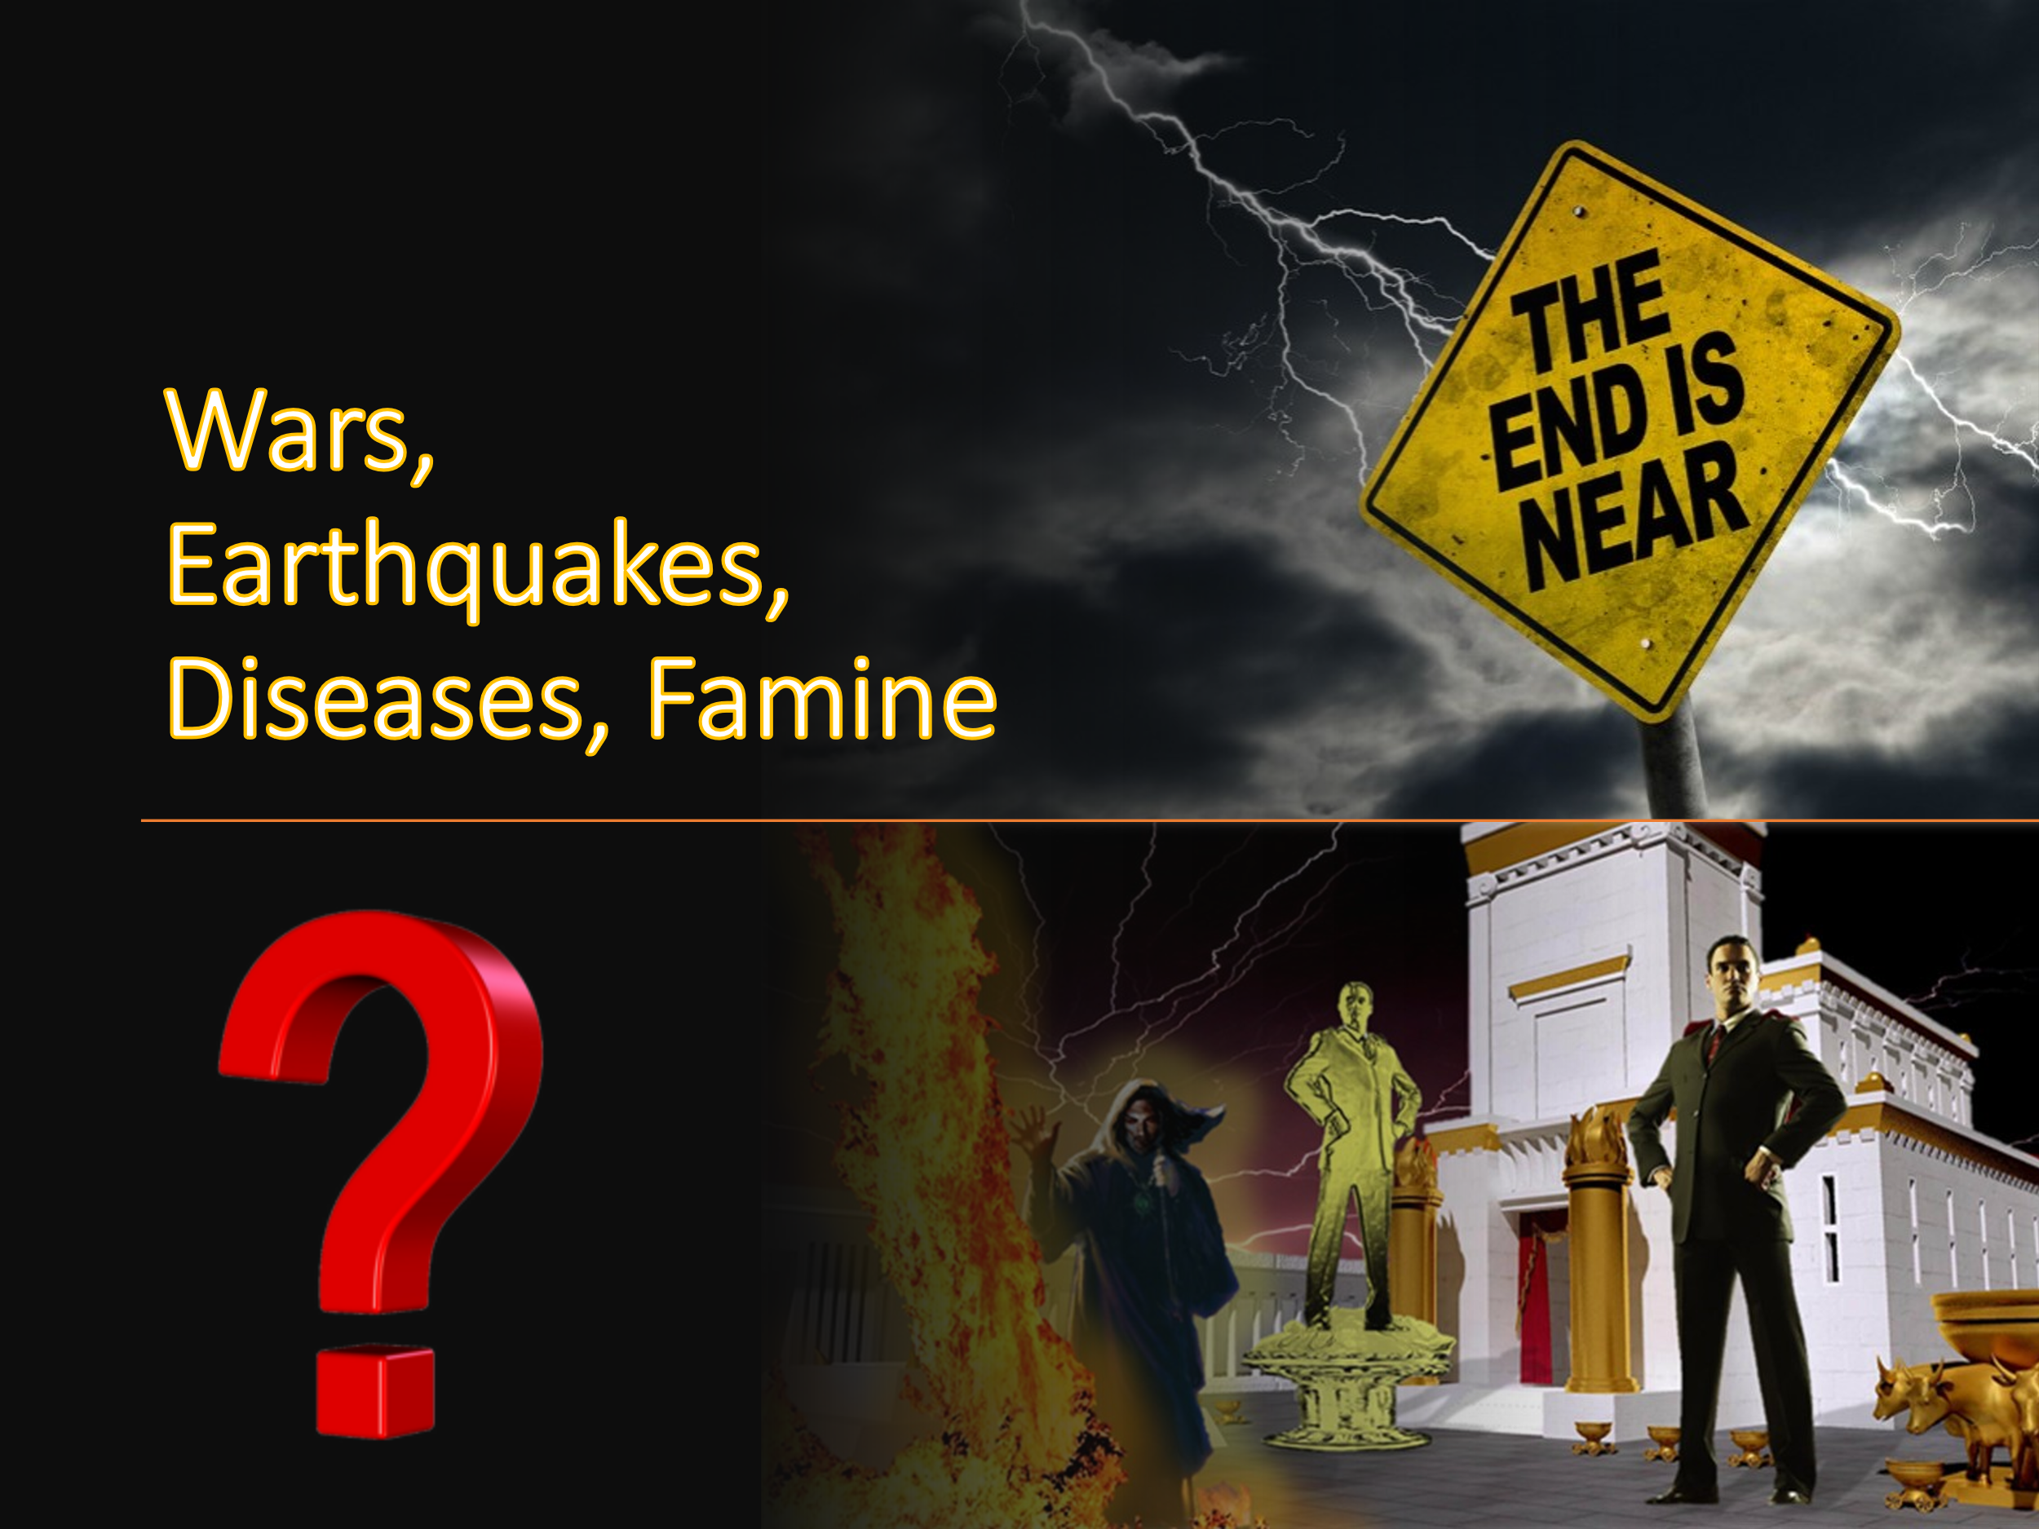
How does Satan lead a church like Thessalonica, which faced intense persecution for its monotheistic belief in one God, to waver in its faith? While Satan roars like a lion, seeking to devour his prey (1 Peter 5:8), his weapon of choice is deception. He exploits our weaknesses and blinds us to God's truth (Gen 3:1; John 8:44). Apparently, through prophecy, word of mouth, or a letter, someone was spreading the falsehood that the Day of the Lord had already arrived, falsely claiming the authority of Apostle Paul. Already weary from their trials and persecution and intensely “apprehensive of their eschatological fate (1 Thessalonians 5:1-11),” to hear that they had missed the rapture and now would have to experience the wrath of God of the End Times instilled fear and depression into their hearts! “Needless to say, upset, troubled, and deceived people are not part of God’s formula for a healthy, vibrant, and growing church!

To address their fear and anxiety Apostle Paul told the church that “their fretfulness about their glorious future was directly related to their forgetfulness about what he had taught them!” While many signs of the end times had already appeared and many prophecies fulfilled, the return of the Lord had not already occurred nor was it imminent. To combat the heresy Paul invited the Thessalonians to remember what he taught them concerning the return of the Lord. From the prophecy of Daniel to the words of Christ Himself, they were told that the Lord would not return until the “raise of the antichrist and the abomination of desolation (Dan 7:8, 24–25; 9:27; 11:31; 12:11; Matt 24:15–28)! This individual, likely Satan, will be “the personification of evil like this world has never seen!” He will deceive the people and entice them to revolt against not only Rome but also against God Himself, attempting to “thwart God’s purpose” for His people (Genesis 3:1, John 8:44)! Paul reassured the church they had not missed the rapture because the man of lawlessness had not yet been revealed.

Raise of the Antichrist

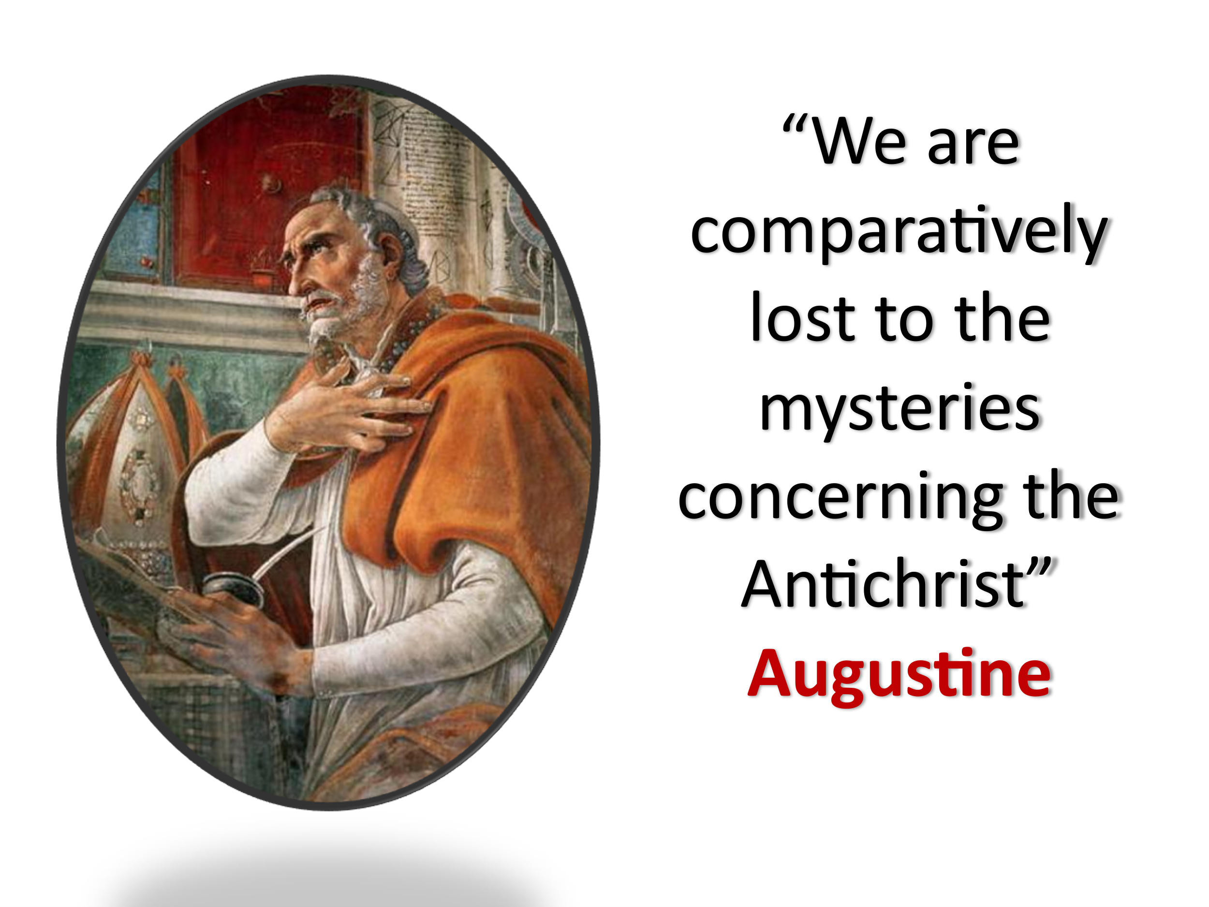
While Paul does not reveal the identity of the Man of Lawlessness, he does provide several characteristics to help identify him. First, he will “exalt himself over everything that is called God or is worshipped” (verse 4). As part of the counterfeit trinity (the dragon, the beast, and the false prophet), the antichrist will receive his power and ability to deceive the nations from Satan himself (Revelation 13). His goal is to get those who are perishing to lead a revolt against God by getting them to exalt and worship him alone above “any other god or object of worship.” This rebellion against God will happen in the future and will be massive, likely gaining world-wide attention and its focus will be on receiving eternal life by seeking sensual pleasures and bowing to the beast. Second, the Antichrist will sit on the throne of God in His temple. While figures such as the king of Tyre (Ezekiel 28:2), Antiochus IV Epiphanes, Emperor Gaius Caligula, and Herod Agrippa I have either claimed to be divine or desecrated the Jerusalem temple during their lifetimes, the Antichrist will go further. He will publicly and defiantly enter the temple of God, assuming a role that rightfully belongs only to God. While he will fail to seize God’s temple in heaven (Revelation 12:7), he will be successful in either seizing a newly rebuilt temple in Jerusalem, the church, or more likely the hearts of the fallen. Instead of being the temple of the Holy Spirit, the antichrist wants everyone to be temples of his master, Satan. And lastly, the antichrist will be identified by miraculous signs (verse 9). Once the restrainer is removed, he will be given power from Satan to deceive the nations by performing signs and wonders. Since miracles were seen as evidence of true apostleship (2 Corinthians 12:12), identifying the beast won’t be easy! Jesus taught that the only way one can identify this imposter of God is by recognizing the fruits of his words and deeds (Matthew 7:15-25) that directly oppose God’s teachings.

Removal of Restrainer

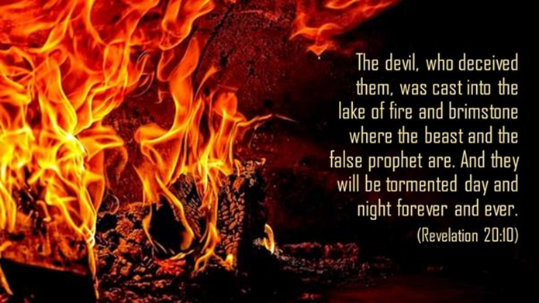
In one of the most challenging passages to interpret in the New Testament, Paul now shifts from “what must take first in the future (verse 3), before the day of the Lord comes, to what is currently taking place now.” Apparently from his thorough instruction the church of Thessalonica knew what was holding back the Antichrist from being revealed. Someone is “restraining” the Antichrist from appearing until the appointed time. The various interpretations regarding the "restrainer" in 2 Thessalonians 2 are speculative and highlight the uncertainty surrounding the passage. Suggestions include the Roman Empire, principles of law and order, the gospel and its proclaimers, the power of God, the presence of the church and the Holy Spirit, an angel such as Michael and various other figures and forces. While the restrainer’s identity remains a mystery, Paul discloses that the “secret power of lawlessness is already at work in the present” (verse 7). This is also supported by Apostle John who states that the spirit of the Antichrist is already at work in this world (1 John 4:3). Satan is already propagating lawlessness and is working against the apostles (1 Thessalonians 2:8), is trying to deceive Christians (2:1-3) and is blinding unbelievers to the truth of the Gospel message (2 Corinthians 4:4). While like Augustine we must admit we are completely lost to the mysteries concerning the Antichrist, joyfully we can take solace that at least signs of the End Times are given in Scripture and all events, even if opaque, will unfold not in Satan’s control but solely in the manner and timing of our sovereign God!

Antichrist Destroyed and Rebellious Judged

While there is much that cannot be known about the arrival of the Day of the Lord there are visible signs announcing its arrival. No one but the Father knows the day or the hour Christ will return but the moment we see a great rebellion against God by the Man of Lawlessness, we will know the time is vastly approaching. While Paul does not state why this evil messenger of Satan is held back from coming it is likely to give humanity abundant chances to repent. While believers need not fear the coming of the Lord, Paul gives unbelievers a dire warning that eventually “God will give those who refuse to love the truth” (verse 12) over to the reprobate minds, and will send them a delusion (verse 11) to harden their hearts (Isaiah 6:9-10). “Due to the high-handed nature of their rejection, God gives up on them and deepens their rejection. Their doom is certain.” With the imagery of Revelation 19:11-21 and Isaiah 11:4 in mind, Paul reveals the fate of the Man of Lawlessness and all those who join him, by the word of God’s mouth they will be eternally condemned! So, we as the readers are left with a solemn reality and choice, either choose God or be condemned with Satan! Once the Lord returns the consequences of your choice are eternal!

Mark Howell et al., Exalting Jesus in 1 & 2 Thessalonians (Nashville, TN: Holman Reference, 2015), 217.
Mark Howell et al., Exalting Jesus in 1 & 2 Thessalonians (Nashville, TN: Holman Reference, 2015), 217.
Jeffrey A. D. Weima, Baker Exegetical Commentary on the New Testament: 1–2 Thessalonians, ed. Robert W. Yarbrough and Robert H. Stein (Grand Rapids, MI: Baker Academic, 2014), 489.
Jeffrey A. D. Weima, Baker Exegetical Commentary on the New Testament: 1–2 Thessalonians, ed. Robert W. Yarbrough and Robert H. Stein (Grand Rapids, MI: Baker Academic, 2014), 489.
Mark Howell et al., Exalting Jesus in 1 & 2 Thessalonians (Nashville, TN: Holman Reference, 2015), 219.
Mark Howell et al., Exalting Jesus in 1 & 2 Thessalonians (Nashville, TN: Holman Reference, 2015), 219.
Mark Howell et al., Exalting Jesus in 1 & 2 Thessalonians (Nashville, TN: Holman Reference, 2015), 218.
Gary Steven Shogren, 1 & 2 Thessalonians, Zondervan Exegetical Commentary on the New Testament (Grand Rapids, MI: Zondervan, 2012), 277.
Mark Howell et al., Exalting Jesus in 1 & 2 Thessalonians (Nashville, TN: Holman Reference, 2015), 217.
Anthony C. Thiselton, 1 & 2 Thessalonians through the Centuries, ed. John Sawyer et al., Wiley Blackwell Bible Commentaries (West Sussex, UK: Wiley-Blackwell, 2011), 216–217.
Mark Howell et al., Exalting Jesus in 1 & 2 Thessalonians (Nashville, TN: Holman Reference, 2015), 216.
Anthony C. Thiselton, 1 & 2 Thessalonians through the Centuries, ed. John Sawyer et al., Wiley Blackwell Bible Commentaries (West Sussex, UK: Wiley-Blackwell, 2011), 213.
Gary Steven Shogren, 1 & 2 Thessalonians, Zondervan Exegetical Commentary on the New Testament (Grand Rapids, MI: Zondervan, 2012), 291.
F. F. Bruce, 1 and 2 Thessalonians, vol. 45, Word Biblical Commentary (Dallas: Word, Incorporated, 1982), 173.
Grant R. Osborne, 1 & 2 Thessalonians: Verse by Verse, ed. Elliot Ritzema and Danielle Thevenaz, Osborne New Testament Commentaries (Bellingham, WA: Lexham Press, 2018), 182.
Jeffrey A. D. Weima, Baker Exegetical Commentary on the New Testament: 1–2 Thessalonians, ed. Robert W. Yarbrough and Robert H. Stein (Grand Rapids, MI: Baker Academic, 2014), 516.
Grant R. Osborne, 1 & 2 Thessalonians: Verse by Verse, ed. Elliot Ritzema and Danielle Thevenaz, Osborne New Testament Commentaries (Bellingham, WA: Lexham Press, 2018), 182–183.
Daniel M. Gurtner, “2 Thessalonians,” in The Bible Knowledge Background Commentary: Acts–Philemon, ed. Craig A. Evans and Craig A. Bubeck, First Edition. (Colorado Springs, CO: David C Cook, 2004), 631.
Gary Steven Shogren, 1 & 2 Thessalonians, Zondervan Exegetical Commentary on the New Testament (Grand Rapids, MI: Zondervan, 2012), 282.
Gary Steven Shogren, 1 & 2 Thessalonians, Zondervan Exegetical Commentary on the New Testament (Grand Rapids, MI: Zondervan, 2012), 283.
Gary Steven Shogren, 1 & 2 Thessalonians, Zondervan Exegetical Commentary on the New Testament (Grand Rapids, MI: Zondervan, 2012), 283.
Gary Steven Shogren, 1 & 2 Thessalonians, Zondervan Exegetical Commentary on the New Testament (Grand Rapids, MI: Zondervan, 2012), 290.
Jeffrey A. D. Weima, Baker Exegetical Commentary on the New Testament: 1–2 Thessalonians, ed. Robert W. Yarbrough and Robert H. Stein (Grand Rapids, MI: Baker Academic, 2014), 525.
Mark Howell et al., Exalting Jesus in 1 & 2 Thessalonians (Nashville, TN: Holman Reference, 2015), 222.
Daniel M. Gurtner, “2 Thessalonians,” in The Bible Knowledge Background Commentary: Acts–Philemon, ed. Craig A. Evans and Craig A. Bubeck, First Edition. (Colorado Springs, CO: David C Cook, 2004), 631.
Jeffrey A. D. Weima, Baker Exegetical Commentary on the New Testament: 1–2 Thessalonians, ed. Robert W. Yarbrough and Robert H. Stein (Grand Rapids, MI: Baker Academic, 2014), 525–526.
Clinton E. Arnold, Zondervan Illustrated Bible Backgrounds Commentary: Romans to Philemon., vol. 3 (Grand Rapids, MI: Zondervan, 2002), 438.
Gary Steven Shogren, 1 & 2 Thessalonians, Zondervan Exegetical Commentary on the New Testament (Grand Rapids, MI: Zondervan, 2012), 288.
Gary Steven Shogren, 1 & 2 Thessalonians, Zondervan Exegetical Commentary on the New Testament (Grand Rapids, MI: Zondervan, 2012), 286.
Gary Steven Shogren, 1 & 2 Thessalonians, Zondervan Exegetical Commentary on the New Testament (Grand Rapids, MI: Zondervan, 2012), 286.
James Denney, “The Epistles to the Thessalonians,” in The Expositor’s Bible: Ephesians to Revelation, ed. W. Robertson Nicoll, vol. 6, Expositor’s Bible (Hartford, CT: S.S. Scranton Co., 1903), 369.
Daniel M. Gurtner, “2 Thessalonians,” in The Bible Knowledge Background Commentary: Acts–Philemon, ed. Craig A. Evans and Craig A. Bubeck, First Edition. (Colorado Springs, CO: David C Cook, 2004), 632.
Marvin Richardson Vincent, Word Studies in the New Testament, vol. 4 (New York: Charles Scribner’s Sons, 1887), 64.
Grant R. Osborne, 1 & 2 Thessalonians: Verse by Verse, ed. Elliot Ritzema and Danielle Thevenaz, Osborne New Testament Commentaries (Bellingham, WA: Lexham Press, 2018), 177.
Gary Steven Shogren, 1 & 2 Thessalonians, Zondervan Exegetical Commentary on the New Testament (Grand Rapids, MI: Zondervan, 2012), 289.
Gary Steven Shogren, 1 & 2 Thessalonians, Zondervan Exegetical Commentary on the New Testament (Grand Rapids, MI: Zondervan, 2012), 293.
Grant R. Osborne, 1 & 2 Thessalonians: Verse by Verse, ed. Elliot Ritzema and Danielle Thevenaz, Osborne New Testament Commentaries (Bellingham, WA: Lexham Press, 2018), 183.
F. F. Bruce, 1 and 2 Thessalonians, vol. 45, Word Biblical Commentary (Dallas: Word, Incorporated, 1982), 173.
Jeffrey A. D. Weima, Baker Exegetical Commentary on the New Testament: 1–2 Thessalonians, ed. Robert W. Yarbrough and Robert H. Stein (Grand Rapids, MI: Baker Academic, 2014), 535.

