# **Your Life as Bread**

**Luke 9:10-17**

Online Sermon: <http://www.mckeesfamily.com/?page_id=3567>

Across the diverse cultures of the world, unique as they may be, commonalities often emerge. While initiation rituals, traditions, histories, values, principles, and boundaries vary, a universal theme unites them—the fundamental need for survival. Take, for example, the prevalence of some form of bread in most cultures worldwide. The French are known for their baguettes and croissants, Latin countries for their tortillas, Indians for their naan, China for their stuffed steamed buns, and North Americans for their sliced white bread.[1] In the commonness of bread we find a profound metaphor for our lives. While some people prefer living thrill seeking, chaotic, fluid lives on the edge of constant change and exhilaration; the majority prefer their lives being characterized by the day-to-day routine of ordinariness. We rise at a designated hour, dedicate approximately eight hours to work, shop for groceries that always seem way too expensive, chauffeur kids around to their various events, mow the lawn that never stops growing, and if we are lucky spend some time tinkering at our hobbies and just plain relaxing. While the comfort of routine provides a sense of simplicity to our lives, there's an inherent desire within us to reach for something more, to contemplate whether the breath of life God has granted us is meant for a greater purpose. Is not the dust of the earth (Genesis 3:19), created in the image of God (Genesis 1:27) and a little lower than the angels (Psalms 8:5), the masterpieces of His grace (Ephesians 2:8) been given the Spirit and spiritual giftings necessary to do more than we could ever ask or imagine (Ephesians 3:20-21).

We're launching a fresh series called "Blessed Broken Given," delving into the revelation that God utilizes ordinary individuals, such as us, to accomplish extraordinary feats in His kingdom! As the hands and feet of Christ, we are summoned to have faith that with His strength, all things are possible (Philippians 4:13). Turning to our Bibles, specifically Luke 9:10-17, the account of the Feeding of the Five Thousand, we'll unearth the realization that our shortfall in accomplishing the extraordinary, as promised by God, is rooted in our lack of faith.

# **Overwhelmed by the Needs of the Many**

After Jesus had given the apostles the power and authority to drive out demons and cure diseases they went from village to village, proclaiming the Good News and healing the sick (1-6). When they returned and started reporting to Jesus what they had done, they began to be “peopled to death” by those who had either seen or experienced their great ministries.[2] Likely to get much needed rest and relaxation, Jesus and the apostles got into a boat and sail from “Capernaum around the northern edge of the lake to Bethsaida.”[3] This attempt to get to solitude was soon thwarted due to many people seeing their departure and running ahead to get to their destination first (Mark 6:33).[4] Instead of being frustrated with them, Jesus, the Good Shepherd, welcomed them with teachings about the kingdom of God and healed their sick (11). Due to their long journey and it becoming late in the day the crowds grew tired and hungry (12).[5] Though the disciples likely knew of God providing manna in the desert (Exodus 16), His multiplying Elisha’s twenty loaves to feed a hundred people (2 Kings 4), not to mention the countless miracles Christ and even they had performed; they asked Christ, “send the crowd away so they can go to the surrounding villages and countryside and find food and lodging because we are in a remote place” (12).

If we genuinely reflect on our responses to the needs of our family, friends, colleagues, and neighbors in this fallen world, which is not our permanent home (Hebrews 13:14-15), we, like the apostles, must acknowledge that our reaction is not always filled with hope but often tinged with a sense of desperation and being overwhelmed. Though we are “surrounded by such a great cloud of witnesses” (Hebrews 12:1), and the countless miracles performed by Christ and His followers; even the born-again find it difficult to see beyond the “laws of nature,” and by His will and name perform the miraculous! When exposed to distressing news of earthquakes, diseases running rampant, warring nations, famines, a depleting ozone, and constant predictions of a financial market collapse, it's easy to feel helpless and, like a tortoise, desire to retreat into our own “little shell of normalcy”! And yet while hording material possessions as insurance against likely tribulation might seem highly practical, surely, the born-again can offer the world prayers that are more than mere words but also accompanied by faith and action?

# **Blessed, Broken, Given**

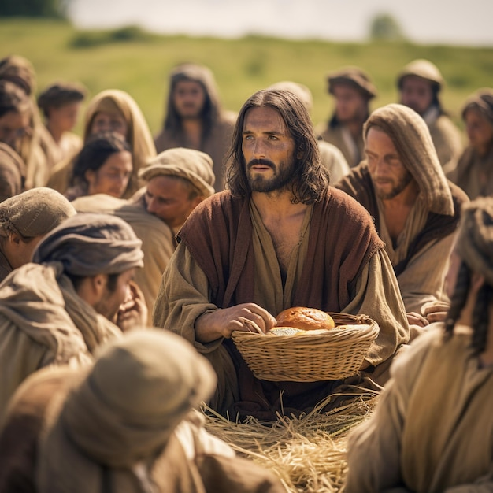 In the response to the disciples’ request to send the crowd to the surrounding villages and countryside to purchase their own food and lodging, Christ simply said, “you give them something to eat” (13). While in ancient times one who hosts a large crowd is also “responsible to provide for their nourishment and safety,”[6] apostle John tells us that Phillip objected to such a request on practical grounds by saying, “it would take more than a half year’s wages to buy enough bread for each one to have a bite” (6:7)! The disciples simply did not have the funds in their treasury to feed 5,000 men plus women and children! Why did the disciples lack faith? Would not He who provided the miraculous catch of fish (5:1-11), who provided for their mission needs (9:3-5), who multiplied Elisha’s five barley loaves and fresh ears of grains enough to feed one hundred (2 Kings 4:42-44), and whose Father provided manna and quail for the people of Israel while in the desert (Exodus 16, Numbers 11); not provide for them once again?[7] Jesus asked the disciples to have the crowd sit down in groups of fifty each, “organized in ranks like armies,”[8] and “lifted His eyes to Heaven and probably gave the traditional blessing that is preserved in the *Mishnah*: “Blessed be You, O Lord our God, king of the world, who causes bread to come forth from the earth” (Berakcot 6:1). This was followed by a thunderous 5,000-voiced “Amen.”[9] “From the food of the poor (barley loaves and fish paste)”[10] the people ate a glorious feast and were not only satisfied but there “were twelve basketfuls of broken pieces left over” (17)!

There are many lessons we can learn from the feeding of the five thousand. First, “blessedness is not about accumulating or achieving more. Blessedness is about having your identity recovered and your true calling revealed.”[11] Thou none of us are righteous, not even one (Romans 3:10-18), those who believe in the atoning sacrifice of Christ are born-again of the water and the Spirit (John 3:5, 16), and are eternally adopted as God’s very own children (Galatians 3:26-29). When we as Christ’s ambassadors and royal priests (2 Corinthians 5:20; 1 Peter 2:9) 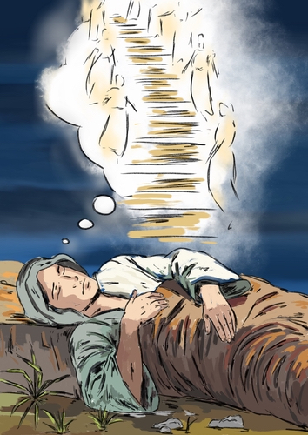lean not unto our own understanding but instead put our trusts in Him by seeking first His kingdom (Proverbs 3:5-6; Matthew 6:33), then we come to understand that the “divinity and transcending sufficiency of Christ”[12] is the key to accomplishing more than we could ever ask or imagine! Second, while we “jars of clay,” are often filled with sin, frailty, suffering and the paralyzing fear of the unknown, it is precisely in our weakness and brokenness that God’s grace and power are perfected in our lives (2 Corinthians 4:7-9)! It is in our utter dependence on Him that we cry out Abba Father forgive me of my transgressions and help me with my unbelief (Mark 9:24)! Third, may when we are called out of our shells of normalcy to perform the miraculous in His name and will, not be like the disciples in this story and look at His requests as unmovable mountains but instead as a glorious, undeserved invitation to be the hands and feet of the One whom all things were created and sustained (Colossians 1:16)!

# **God is Here**

Let’s finish today’s sermon with a story about Jacob who was on the run with a stolen blessing and wondering what kind of destiny might lay before him (Genesis 28).[13] One night, using a stone as a pillow, Jacob had an incredible dream. He saw a stairway resting on earth with its top reaching heaven. There were angels ascending and descending on the ladder. He heard the voice of God say, “I am the Lord, the God of Abraham and the God of Isaac” (13). When Jacob woke up from his sleep that night he thought, “Surely the Lord was in this place, and I was unaware of it” (16). In many ways we are like Jacob, the mots of sin in our eyes and our frailty and weakness, has left us unable to see the presence of God who is indivisibly present all around us! If only we could get a glimpse of whom God has created, empowered, and gifted us to be in His kingdom! In our singular journey through life, we encounter numerous trials and tribulations each day, accompanied by genuine risks and concerns for our very existence. However, this doesn't imply a need to hoard resources in a bid for survival or withdraw into the comfort of routine, attempting to avoid the inevitable uncertainties that befall us all. Rather, it invites us to recognize the omnipresence of God, firmly in control of both the visible and the unseen. In this acknowledgment, we find strength to stand still, confess our shortcomings, and experience a renewal of our minds in the assurance that our calling is guaranteed to succeed under His supreme authority. We are truly like bread, blessed and broken but given many blessings and power form God to do great things in His name!

1. Taken from the Blessed, Broken, and Given series on Sermon Central.
2. R. Kent Hughes, [*Luke: That You May Know the Truth*](https://ref.ly/logosres/prwdlk1?ref=Bible.Lk9.10-17&off=1237&ctx=%C2%A0%E2%80%9D+(Mark+6%3a30%2c+31).+~Evidently+by+the+tim), Preaching the Word (Wheaton, IL: Crossway Books, 1998), 328–329.
3. Grant R. Osborne, [*Luke: Verse by Verse*](https://ref.ly/logosres/vbv63lu?ref=Bible.Lk9.10-11&off=154&ctx=uccessful+ministry.+~Jesus+apparently+dec), ed. Jeffrey Reimer, Elliot Ritzema, and Danielle Thevenaz, Awa Sarah, Osborne New Testament Commentaries (Bellingham, WA: Lexham Press, 2018), 245.
4. R. Kent Hughes, [*Luke: That You May Know the Truth*](https://ref.ly/logosres/prwdlk1?ref=Bible.Lk9.10-17&off=2542&ctx=come+along%2c+so+that+~finally+thousands+co), Preaching the Word (Wheaton, IL: Crossway Books, 1998), 330.
5. Thabiti Anyabwile, [*Exalting Jesus in Luke*](https://ref.ly/logosres/9781462740826?ref=Page.p+161&off=1631&ctx=a+wilderness+place.+~Crowds+come+out+to+J), Christ-Centered Exposition Commentary (Nashville, TN: Holman Reference, 2018), 161.
6. Grant R. Osborne, [*Luke: Verse by Verse*](https://ref.ly/logosres/vbv63lu?ref=Bible.Lk9.12-14a&off=566&ctx=rn+for+hospitality.+~Jesus+is+hosting+a+g), ed. Jeffrey Reimer, Elliot Ritzema, and Danielle Thevenaz, Awa Sarah, Osborne New Testament Commentaries (Bellingham, WA: Lexham Press, 2018), 245–246.
7. Joel B. Green, [*The Gospel of Luke*](https://ref.ly/logosres/nicnt63lu?ref=Bible.Lk9.12-14&off=641&ctx=mon%E2%80%99s+boat+that+had+~led+to+a+miraculous+), The New International Commentary on the New Testament (Grand Rapids, MI: Wm. B. Eerdmans Publishing Co., 1997), 363.
8. Craig S. Keener, [*The IVP Bible Background Commentary: New Testament*](https://ref.ly/logosres/bbackcom?ref=Bible.Lk9.14&off=6&ctx=ad+assembled.%0a9%3a14.+~The+people+are+organ) (Downers Grove, IL: InterVarsity Press, 1993), Lk 9:14.
9. R. Kent Hughes, [*Luke: That You May Know the Truth*](https://ref.ly/logosres/prwdlk1?ref=Bible.Lk9.13-16&off=3975&ctx=he+twelve+apostles.+~Jesus+lifted+his+eye), Preaching the Word (Wheaton, IL: Crossway Books, 1998), 333.
10. Grant R. Osborne, [*Luke: Verse by Verse*](https://ref.ly/logosres/vbv63lu?ref=Bible.Lk9.17&off=199&ctx=+(as+in+Rev+19%3a21).+~The+food+of+the+poor), ed. Jeffrey Reimer, Elliot Ritzema, and Danielle Thevenaz, Awa Sarah, Osborne New Testament Commentaries (Bellingham, WA: Lexham Press, 2018), 247–248.
11. Taken from the Blessed Broken Given series from Sermon Central.
12. R. Kent Hughes, [*Luke: That You May Know the Truth*](https://ref.ly/logosres/prwdlk1?ref=Bible.Lk9.13-16&off=3485&ctx=ss+(cf.+Mark+6%3a40).%0a~The+impact+of+all+of), Preaching the Word (Wheaton, IL: Crossway Books, 1998), 333.
13. Taken from the Blessed Broken Given series from Sermon Central.