# **If You Remain in Me**

**John 15:1-8**

Online Sermon: <http://www.mckeesfamily.com/?page_id=3567>

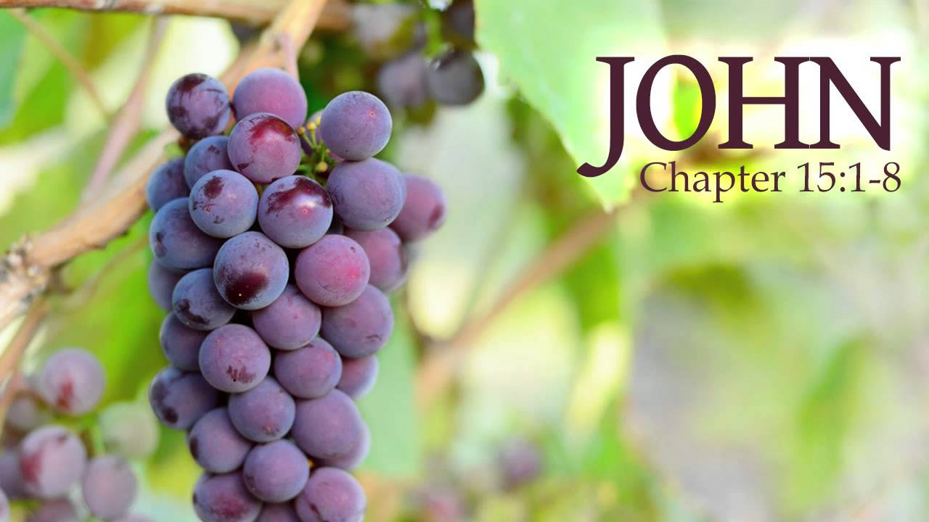As time unfolds, providing us with the opportunity for retrospective contemplation over weeks, years, and decades, we often find ourselves questioning the impact we've had on the world around us. Do you remember the profound moment when you surrendered your life to Christ, when the old faded away, and the new emerged? Do you remember the exhilarating sensation of being sealed by the Holy Spirit, adopted into God's family for eternity? In that pivotal moment of transition from death to life, acquiring titles like royal ambassadors and priests, we felt destined to make a significant difference in God's kingdom. We engaged in worship with heartfelt praise, delved into His word seeking wisdom application, and prayed with such fervor that it seemed the Good Shepherd Himself held our hands, guiding our words through the Spirit.

Yet, with the passage of time, one may wonder if all we've gained is a collection of aches, pains, and a reliance on medications. In John 15, Jesus likens himself to the vine, with his Father as the gardener. He assures that if we abide in him, he will abide in us, leading to abundant fruit-bearing in his kingdom. While achieving much in God's realm is a shared aspiration among believers, it prompts reflection on the costs of true abidance. If the goal is to become more like Jesus, are you willing to invite the Gardener to scrutinize your soul, pruning away anything that competes for your heart's allegiance? Are you open to being crucified with Christ, allowing the self to die so that he may reign over your passions, goals, and dreams?

Meditating on God's word is one thing, but are you willing to let it be your guiding compass, obeying every word not just out of obligation but also as a demonstration of love, initially expressed by Him to you? To experience the fruits of love, joy, peace, forbearance, kindness, goodness, faithfulness, gentleness, and self-control, cultivating an intimate, personal, and obedient relationship with Him is crucial. Imagine drawing so close to Jesus that His words, thoughts, and goals seamlessly merge with your own, transforming your prayers into prophetic utterances, consistently offered in His name and according to His will. Join me in turning to John 15:1-8 in our Bibles to explore how one can truly bear fruit in God's kingdom.

# **Remaining in Christ**

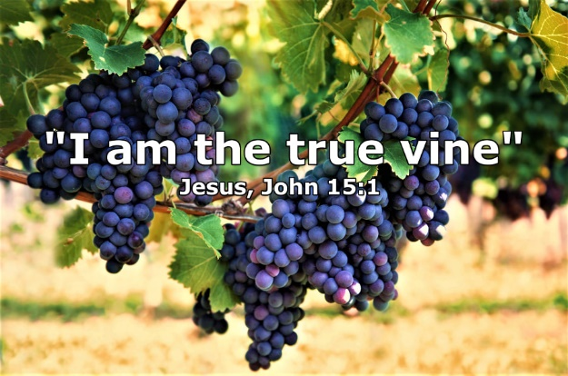**“I am the true vine, and my Father is the gardener. 2He cuts off every branch in me that bears no fruit, while every branch that does bear fruit he prunes so that it will be even more fruitful. 3You are already clean because of the word I have spoken to you. 4Remain in me, as I also remain in you. No branch can bear fruit by itself; it must remain in the vine. Neither can you bear fruit unless you remain in me.**

After the Lord’s Supper in the upper room[1] Jesus proceeded to prepare the disciples for His upcoming death, resurrection, and ascension to heaven.[2] Jesus had already told them many things about His identity. He told them He was the “bread of life” (6:35), “the light of the world” (8:12), “the gate” (10:9), “the good shepherd” (10:11), “the resurrection and the life” (11:25), and “the way, the truth, and the life” (14:7). Now in His sixth and final “I am” statement in the Gospel of John He told the disciples that He is “the true vine” (15:1).[3] Vine imagery was very common in the ancient world.[4] In the OT vine was a “preeminent symbol of Israel.”[5] The best-known passage being Psalms 80:8-10 that states, “You transplanted a vine from Egypt; you drove out the nations and planted it. You cleared the ground for it, and it took root and filled the land. The mountains were covered with its shade, the mighty cedars with its branches.” Isaiah said that Israel was the vineyard of the Lord Almighty, and the people of Judah are the gardens of His delight (5:7).[6] Though God had planted and tended the vine, His covenant people, to bear fruit (Hos. 10:1–2; Isa. 5:1–7; Jer. 2:21; 12:10–11),[7] God chastised them for “running wild and producing sour grapes” (Isaiah 5:4), for persecuting the prophets, and for crucifying “God’s final messenger.”[8] In the context of this metaphorical vineyard, Christ emerges as the true vine, surpassing the previous representation of the old Israel.[9] This authentic vine is identified as the sinless Lamb of God who sacrificed His life as a ransom for many (Matthew 20:28). In His final teachings before the cross, Christ instructs the disciples that the path to God is not solely through the 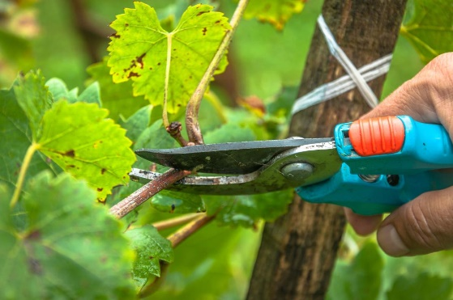nation of Israel but through faith in His atoning sacrifice. The disciples' mission, symbolized by being "fishers of men," is an ongoing call to the world to be reconciled unto God through Christ (2 Corinthains 5:20). It is emphasized that reconciliation and eternal adoption into God's family can only be achieved through Him, the true vine.

Jesus tells us that the Father is the gardener who applies His pruning shears to the branches.[10] In horticulture the role of the gardener is to cut away all useless branches and shoots so that the “main branches receive more nutrients and produce more fruit.”[11] In a comparable fashion, just as allowing a vine to grow untamed would result in the production of wild, undesirable fruit,[12] akin to what Israel was yielding, the Gardener, driven by love, prunes away anything within the vine that hinders spiritual fruitfulness within His kingdom. While Jesus does not define fruit, elsewhere fruit is defined as an offshoot of loving the Lord your God with all your heart, soul, mind, and loving others (Matthew 22:37-40). The Apostle Paul further expounds that this love manifests in believers through the fruits of the Spirit, namely love, joy, peace, patience, kindness, goodness, faithfulness, gentleness, and self-control (Galatians 5:22-23). If the evidence of such fruit does not exist within one’s life, then one must face the fact that one is unlikely a true believer, for since creation the Gardener has intended His own to be fruitful (Genesis 1:11-12, 22, 28).[13] For those who merely pretend to be “religious” but do not have a genuine relationship with the Lord,[14] the Father may allow them to stay in the church for a while and grow like tares amongst the wheat (Matthew 13:24-30) but they do not belong to the vine and their final destination is to be “thrown into the fire and burned” (John 15:6). If you are born-again then brace yourself for “God’s commitment for your fruit bearing is greater than your commitment to comfort!”[15] God will prune out anything within your life that does not emulate walking in the footsteps of His Son. Since we are not good at seeing and removing the motes within our own eyes (Matthew 7:1-6), it is the Gardener’s role to search our hearts, identify sin, and remove any rival passions 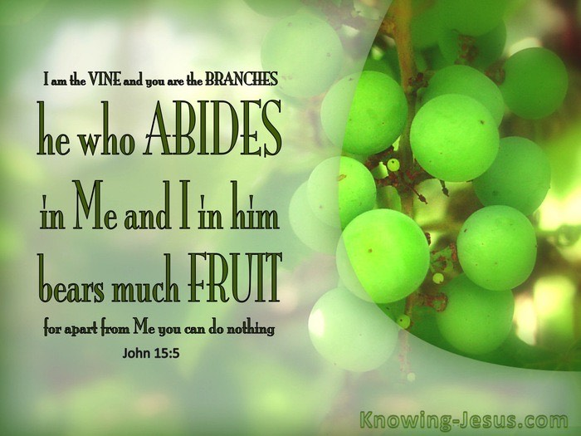within our hearts that is not focused on loving Him and others. While this process of pruning is painful, as king David admits, it is necessary to help us to follow His ways (Psalms 119:67, 71)[16] and spiritually grow to be more like Him! The bearing of fruit in God's kingdom depends on the Father's compassionate and meticulous pruning.

**Reflection**. Does your life produce evidence of being born-again? Those who exist in the vine receive the life-giving sap of Christ not to sin freely and make grace appear cheap, but to be transformed daily by the renewing of one’s mind (Romans 12:1-2) to focus on loving Him and others. If upon examining your inner character you do not see evidence of love, joy, peace, patience, kindness, goodness, faithfulness, gentleness, and self-control then ask yourself … are you truly saved?

In verse five Jesus said, “I am the vine; you are the branches. If you remain in Me and I in you, you will bear much fruit; apart from Me you can do nothing.” Since “no one can bear fruit for the glory of the Lord unless they are attached to the Vine,” in this verse Jesus is specifically talking to those who are already born again.[17] Those who have been sealed by the Holy Spirit possess the capability to cease from sin,[18] serve others, trust in God, and effectively proclaim the Gospel message to the world.[19] The production of spiritual fruit goes beyond mere knowledge and faith in the Lord;[20] it involves a continual process of inviting the Father to prune oneself while passionately walking in His footsteps. Merely engaging in activities such as reading the Bible, praying, singing worship songs, or performing charitable acts, without a genuine dependence on the Vine, can lead to ineffectiveness in God's kingdom. It's crucial to recognize that spiritual accomplishment is not achievable through human effort alone, as stated in Philippians 2:13: "for it is God who works in you to will and to act to fulfill his good purpose." Despite our humble beginnings (1 Corinthians 1:26-31), now as temples of the Holy Spirit (6:19) and connected to the Vine, the life-giving sap of Christ flows through our veins. Through His strength and power, we can accomplish anything He asks of us. It's a testament to God's choice of us, frail jars of clay, to perform miracles in His name (2 Corinthians 4:7). This underscores the importance of relying on God's strength rather than our own, ensuring that the fruit we bear is aligned with the true essence of the Gospel.

**Reflection**. When you serve the Lord in His kingdom are you trying to do His will or that of your own? Are your works intentionally pointing to the Father or do they tend to point to yourself to gain the reputation of being a holy person? If you are getting burned out, is it because you are doing too much or due to doing too little in His strength and name? Abide in Him and He will abide in you!

# **Bearing Fruit**

**5“I am the vine; you are the branches. If you remain in me and I in you, you will bear much fruit; apart from me you can do nothing. 6If you do not remain in me, you are like a branch that is thrown away and withers; such branches are picked up, thrown into the fire and burned. 7If you remain in me and my words remain in you, ask whatever you wish, and it will be done for you.**

In verse seven Jesus says, “If you remain in Me and My words remain in You, ask whatever you wish, and it will be done for you.” This astounding command and promise are not “without its conditions and limitations.”[21] Remaining in Christ requires one to “do things that constantly expose ourselves to Him and keep ourselves in contact with Him.”[22] This is where a book like Robert Foster, *Celebration of Discipline: The Path to Spiritual Growth*” can be an incredible resource! It is through practicing the inward disciplines of meditation, prayer, fasting, study, and the outward disciplines of simplicity, solitude, submission, service, and the corporate disciplines of confession, worship, guidance, and celebration that one is invited and moves towards a holy God who is always near (James 4:8). For prayers to transform into a "prophecy and pledge"[23] of a positive response, they must align with and adhere strictly to the words of the Shepherd, whose sheep recognize His voice (John 10:1-6). Charles Spurgeon rightly states, “We cannot separate Christ from the Word; for, in the first place, he is the Word; and, in the next place, how dare we call him Master and Lord and do not the things which he says and reject the truth which he teaches.”[24] Though the act of meditating on His word, accurately interpreting it, and implementing His ways, which surpass our own, may appear daunting for the "dust of the earth" (Genesis 2:7) to achieve, the believer is not without substantial divine assistance to support their endeavor to walk in His footsteps. For instance, when a person becomes saved, they become a new creation in Christ, the old is gone and the new is here (2 Corinthians 5:17). By partaking in the divine nature (2 Peter 1:4), believers are guided by the Holy Spirit, who reveals the truth about Christ (John 16:13) and empowers them not only to cease from sinning (Romans 6) but also to strive for holiness, mirroring the holiness of God (1 Peter 1:15-16). For the believer, His commands are not heavy burdens but serve as a spiritual compass for those desiring to yield abundant fruit in His kingdom. When a believer earnestly seeks and obeys the Lord with their entire being—heart, mind, soul, and strength—they draw so near to Jesus that they discern God's will, and consequently, whatever they ask is granted.

**Reflection**. Are you passionately pursuing He that is indivisibly present everywhere? How much time do you spend in spiritual disciplines so that your mind might be renewed daily (Romans 12:1-2)? Can you see the evidence of the Holy Spirit’s fruit within your life? And are the commands a burden to you instead of a beautiful roadmap to holy living?

# **True Life in Jesus**

**8This is to my Father’s glory, that you bear much fruit, showing yourselves to be my disciples.**

As you reflect on weeks, years, and decades of your life, what has been your footprints in the sands of time? When your body returns to the dust in which it was formed will all you have gained in life be a mere collection of aches, pains, and reliance on many medications? To live a righteous and fruitful life does not happen by mere chance but is the product of being in the Vine, faithful, obedient, and striving to get closer to Jesus! Even though it is countercultural Apostle Paul is right to say that the goal of every believer is to be crucified with Christ so that our goals and dreams might give was to His ways that are always higher than our ways! None of us were much when we were called, enslaved by sin, unrighteous, and incapable of pleasing a holy God. And yet, the Spirit called out into the darkness of our stoney hearts, and we responded in faith in Christ’s atoning sacrifice and became born again, not of the flesh but of the Spirit. While believers are connected to the Vine, it doesn't mean they've automatically achieved spiritual maturity. Bearing fruit in God's kingdom requires a continual plea to the Gardener to search, identify, and prune out sin. Those who engage in spiritual disciplines to draw closer to the Son will encounter Him. By inviting His transformative grace, they can exercise the mind of Christ and successfully walk in His footsteps. Such individuals need not worry about their lives not producing fruit, for as His disciples what they ask for in prayer becomes prophetic utterances! Let me finish with this final question: as you reflect upon your life can you truly say that you living in the Vine and drawing closer to Him?

1. A.T. Robertson, [*Word Pictures in the New Testament*](https://ref.ly/logosres/rwp?ref=Bible.Jn15.1&off=100&ctx=+vine+the+genuine.%E2%80%9D+~Assuming+that+the+Lo) (Nashville, TN: Broadman Press, 1933), Jn 15:1.
2. Matt Carter and Josh Wredberg, [*Exalting Jesus in John*](https://ref.ly/logosres/9781433648618?ref=Bible.Jn15.1-17&off=329&ctx=D.+Sacrificial+love%0a~In+John+15+Jesus+is+) (Nashville, TN: Holman Reference, 2017), 303.
3. Matt Carter and Josh Wredberg, [*Exalting Jesus in John*](https://ref.ly/logosres/9781433648618?ref=Bible.Jn15.1-6&off=48&ctx=l+Fruit%0ajohn+15%3a1%E2%80%936%0a~Jesus+begins+with+hi) (Nashville, TN: Holman Reference, 2017), 303.
4. D. A. Carson, [*The Gospel according to John*](https://ref.ly/logosres/pntcjohn?ref=Bible.Jn15.1&off=282&ctx=runes+the+branches.%0a~Vine+imagery+is+so+c), The Pillar New Testament Commentary (Leicester, England; Grand Rapids, MI: Inter-Varsity Press; W.B. Eerdmans, 1991), 513.
5. James Montgomery Boice, [*The Gospel of John: An Expositional Commentary*](https://ref.ly/logosres/boicecm64djn?ref=Bible.Jn15.1-5&off=2752&ctx=aped+the+disciples.+~The+vine+is+the+pree) (Grand Rapids, MI: Baker Books, 2005), 1160.
6. James Montgomery Boice, [*The Gospel of John: An Expositional Commentary*](https://ref.ly/logosres/boicecm64djn?ref=Bible.Jn15.1-5&off=3247&ctx=ed+only+bad+fruit.%E2%80%A6+~The+vineyard+of+the+) (Grand Rapids, MI: Baker Books, 2005), 1160.
7. Gary M. Burge, [“Gospel of John,”](https://ref.ly/logosres/bkbc64jn?ref=Bible.Jn15.1-17&off=1359&ctx=rranean+societies).+~The+vine+represented) in *John’s Gospel, Hebrews–Revelation*, ed. Craig A. Evans and Craig A. Bubeck, First Edition., The Bible Knowledge Background Commentary (Colorado Springs, CO; Paris, ON; Eastbourne: David C Cook, 2005), 131.
8. Paul Barnett, [*John: The Shepherd King*](https://ref.ly/logosres/rtbt64jn?ref=Bible.Jn15.1-17&off=991&ctx=ress%E2%80%99+(Isaiah+5%3a7).+~Jesus+also+used+Isai), Revised., Reading the Bible Today Series (Sydney, South NSW: Aquila Press, 2011), 201.
9. Paul Barnett, [*John: The Shepherd King*](https://ref.ly/logosres/rtbt64jn?ref=Bible.Jn15.1-17&off=466&ctx=re+the+%E2%80%98true+vine%E2%80%99.%0a~Why+is+the+word+%E2%80%98tru), Revised., Reading the Bible Today Series (Sydney, South NSW: Aquila Press, 2011), 201.
10. Paul Barnett, [*John: The Shepherd King*](https://ref.ly/logosres/rtbt64jn?ref=Bible.Jn15.1-17&off=1552&ctx=-centred+and+total.%0a~Jesus+tells+us+that+), Revised., Reading the Bible Today Series (Sydney, South NSW: Aquila Press, 2011), 201.
11. Andreas J. Köstenberger, [“John,”](https://ref.ly/logosres/bkrllstrtdbccmm?ref=Bible.Jn15.2&off=75&ctx=s+here+are+twofold%3a+~cutting+off+dry+and+) in *The Baker Illustrated Bible Background Commentary*, ed. J. Scott Duvall and J. Daniel Hays (Grand Rapids, MI: Baker Books, 2020), 989.
12. Leon Morris, [*The Gospel according to John*](https://ref.ly/logosres/nicnt64jn?ref=Bible.Jn15.2&off=513&ctx=+timber+(Ezek.+15).+~In+a+vineyard+fruitf), The New International Commentary on the New Testament (Grand Rapids, MI: Wm. B. Eerdmans Publishing Co., 1995), 594.
13. R. Kent Hughes, [*John: That You May Believe*](https://ref.ly/logosres/prwdjohn?ref=Bible.Jn15.1-2&off=1370&ctx=vine+in+the+branch.+~Jesus+is+looking+for), Preaching the Word (Wheaton, IL: Crossway Books, 1999), 353.
14. Matt Carter and Josh Wredberg, [*Exalting Jesus in John*](https://ref.ly/logosres/9781433648618?ref=Bible.Jn15.1-6&off=2737&ctx=ike+Judas+Iscariot.+~They+hang+around+Jes) (Nashville, TN: Holman Reference, 2017), 304.
15. Matt Carter and Josh Wredberg, [*Exalting Jesus in John*](https://ref.ly/logosres/9781433648618?ref=Bible.Jn15.1-6&off=3654&ctx=e+and+more+healthy.+~God%E2%80%99s+commitment+to+) (Nashville, TN: Holman Reference, 2017), 305.
16. R. Kent Hughes, [*John: That You May Believe*](https://ref.ly/logosres/prwdjohn?ref=Bible.Jn15.2-3&off=1491&ctx=the+Christian+life.%0a~What+is+involved+in+), Preaching the Word (Wheaton, IL: Crossway Books, 1999), 354.
17. Alan Carr, [“Lessons from the Lord’s Vineyard (John 15:1–8),”](https://ref.ly/logosres/sermonnotebooknt?ref=Bible.Jn15.1-8&off=3077&ctx=ionship+to+Himself.+~He+is+speaking+to+th) in *The Sermon Notebook: New Testament* (Lenoir, NC: Alan Carr, 2015), 1768.
18. Matt Carter and Josh Wredberg, [*Exalting Jesus in John*](https://ref.ly/logosres/9781433648618?ref=Bible.Jn15.1-6&off=5724&ctx=hing+to+please+God.+~But+because+of+his+l) (Nashville, TN: Holman Reference, 2017), 306.
19. Matt Carter and Josh Wredberg, [*Exalting Jesus in John*](https://ref.ly/logosres/9781433648618?ref=Bible.Jn15.1-6&off=5157&ctx=ooks+like+to+abide.+~A+branch+is+only+ali) (Nashville, TN: Holman Reference, 2017), 305–306.
20. George R. Beasley-Murray, [*John*](https://ref.ly/logosres/wbc36?ref=Bible.Jn15.2-4&off=180&ctx=e+Comment+on+13%3a10.+~To+%E2%80%9Cremain%E2%80%9D+in+Jesus), vol. 36, Word Biblical Commentary (Dallas: Word, Incorporated, 1999), 272.
21. A.T. Robertson, [*Word Pictures in the New Testament*](https://ref.ly/logosres/rwp?ref=Bible.Jn15.7&off=248&ctx=%CE%B5%CF%89+%5baite%C5%8D%5d%2c+to+ask.+~This+astounding+comm) (Nashville, TN: Broadman Press, 1933), Jn 15:7.
22. James Montgomery Boice, [*The Gospel of John: An Expositional Commentary*](https://ref.ly/logosres/boicecm64djn?ref=Bible.Jn15.6-7&off=4336&ctx=When+our+Lord+says%3a+~Abide+in+me+he+is+ta) (Grand Rapids, MI: Baker Books, 2005), 1166.
23. H. D. M. Spence-Jones, ed., [*St. John*](https://ref.ly/logosres/tpc40?ref=Bible.Jn15.7&off=1406&ctx=th+the+Divine+will.+~Then+faith+is+possib), vol. 2, The Pulpit Commentary (London; New York: Funk & Wagnalls Company, 1909), 270.
24. James Montgomery Boice, [*The Gospel of John: An Expositional Commentary*](https://ref.ly/logosres/boicecm64djn?ref=Bible.Jn15.6-7&off=6201&ctx=p+his+commandments.+~Spurgeon+once+wrote+) (Grand Rapids, MI: Baker Books, 2005), 1167.