# **Getting out of the Boat**

**Matthew 14:22-36**

Online Sermon: <http://www.mckeesfamily.com/?page_id=3567>

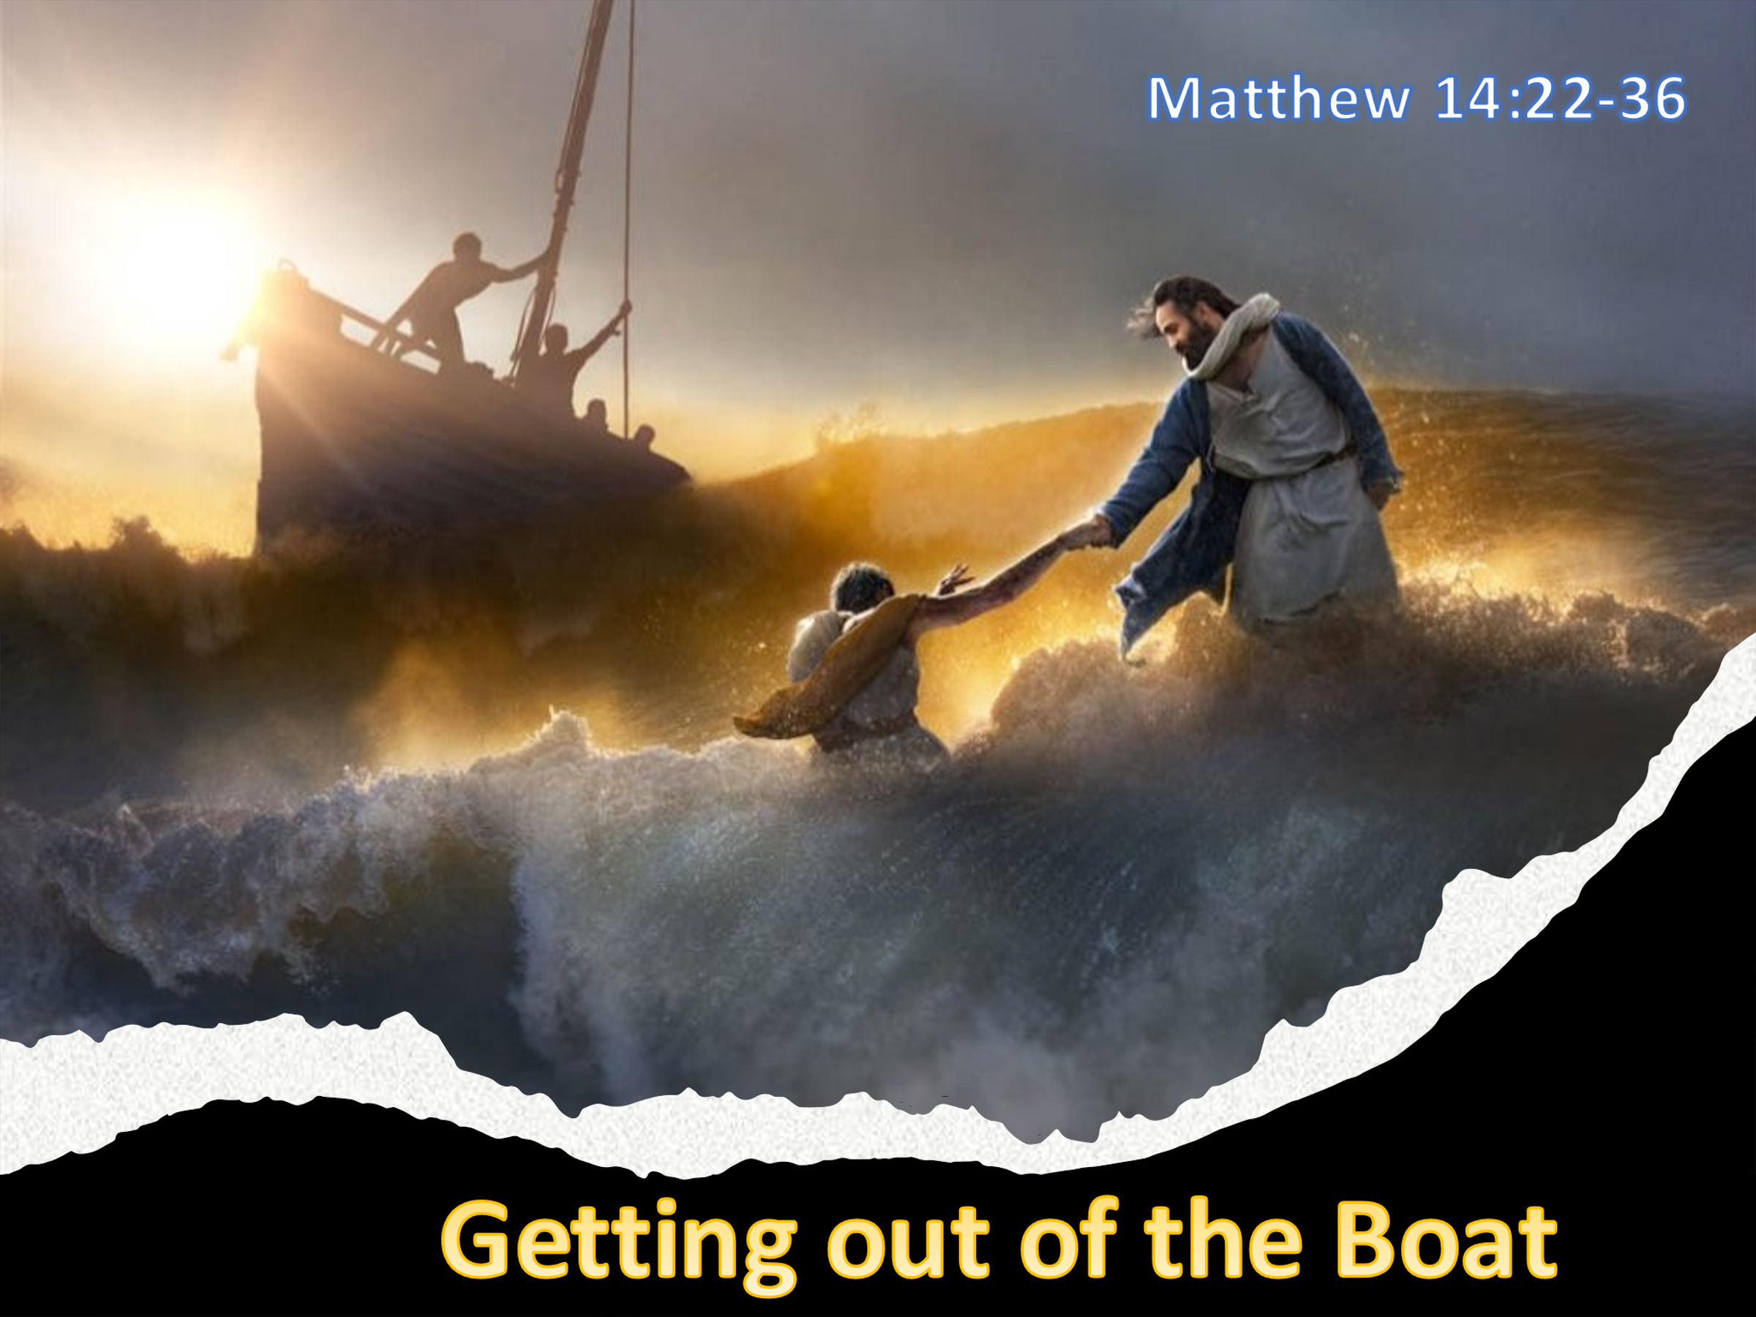The Britannica Dictionary defines risk as doing something that has the potential to have harmful consequences. There are many things in life that many people consider to be too risky in nature. To invest in penny stocks, to walk on a tight rope, to climb a mighty mountain, bungee jump from a high cliff, surf on the waves, go on a first date, share your intimate life stories with another or take on a task that is likely beyond your abilities truly require a boatload of grit and courage. While some people truly love the adrenaline rush of risk-taking others much prefer to carve out routines and live a more simplistic lifestyle. Do Christians in general tend to be risk takers? Surrounded by a cloud of witnesses who performed many miracles and having the Holy Spirit living inside of us, you would think believers would be a bold, fierce, unstoppable force in this world. After all, does not the Lord say with faith as tiny as a mustard seed nothing will be impossible for us to achieve (Matthew 17:20-21), and should we ever meet a foe that is too powerful for us to subdue all we need to do is stand still and the Lord will fight for us (Exodus 14:14)? With the belt of truth around our waste, with the breastplate of righteousness on our chests, with helmet of salvation on our heads and the shield of faith in our hand we can be victorious even over the spiritual forces of evil in the heavenly realms (Ephesians 6:1-17)! And yet while we would like to say we live with the holy courage of king David; the truth is that rarely do we run to meet the giant challenges of this fallen world but instead choose to become sleeping giants. Though we have spiritual gifts and are empowered by divine might most Christians tend to live their lives enslaved by sin and complacency!

And as boat of life gets repeatedly struck by incessant waves of both opportunities and tribulations, instead of being more than conquerors we tend to be lulled into a deep sleep of foolishly believing getting out of the boat of our comfortable lives is simply a risk not worth taking.

In today’s sermon I am going to review the familiar story of Jesus walking on the water in Matthew 14:22-36 in hope that the Scripture might compel you to accept and live the truth, you are who God says and through the power of the Holy Spirit you can do anything He asks!

# **Priorities in Life**

After having heard that John the Baptist was beheaded by Herod (Matthew 14:1-12) and after the dramatic healing of the sick and feeding of the five thousand (14:13-18),[1] Matthew tells us that Jesus made His disciples get into a boat and sail away so that He could dismiss the crowd and go to the mountainside and pray. While Matthew does not state the reason why Jesus commanded the disciples to get into the boat and sail across the Sea of Galilee,[2] it was likely to keep them from being “swept off their feet by the mob psychology,”[3] who after seeing Christ’s power to perform many miracles,[4] desired to make Him king of their political kingdom (John 6:15)! Maybe separation from Christ and the physical work of rowing a boat would get His disciple’s minds off being part of a “political revolution that would defeat all the plans of Jesus about His kingdom!”[5] While Matthew does not reveal the “burden of Jesus’ prayer time,”[6] there are several likely possibilities. For instance, Jesus just heard of John the Baptist’s beheading and likely wanted to be alone to not only reflect on future potential threats from Herod Antipas[7] but also to grieve for his friend as he did when Lazarus died.[8]

Also, the mob offering a “smaller version of what the devil offered in the wilderness, all the kingdoms of the world and their splendor (Matthew 4:8),”[9] likely brought to His mind the “the thirty-nine lashes, the crown of thorns, the falling on the road to Golgotha, the nails, the thirst, the laughter at the foot of the cross, the rejection, and the loneliness”[10] that He was about to endure!

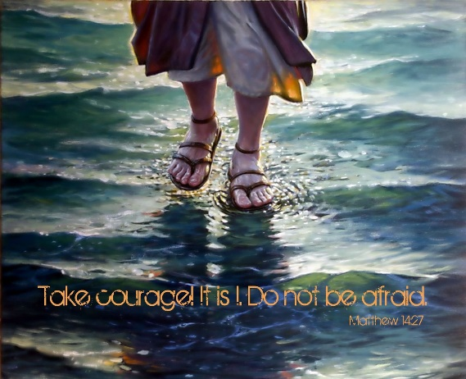Whatever the reasons clearly Christ’s prayer in the time of crises teaches us how important it is to take time to be holy by seeking the Father in prayer! It is far from easy to know what to do in good times much less bad ones. Instead of relying on our foolish thoughts and ways, pray to God to reveal His good and perfect will!

**Reflection**. When we go through difficult times, we often look for our own solutions. It is only when we have exhausted all possibilities that we finally come to the Lord and ask for help. Instead of imaging and even living the worst-case scenarios in our minds, why not give the unknown future to Jesus with the assurance that He works all things for the good of those love Him (Romans 8:28)?

# **The Storms of Life**

While the pious might set aside up to two hours a day for prayer, Matthew tells us that Jesus went up the mountain and spent the whole night praying![11] As was often the case with the Sea of Galilee the disciples were not long on the lake and a harsh storm arose.[12] For the next at least six hours[13] these mostly experienced fishermen battled the winds head-on and were exhausted from rowing frantically to get back on course! Unlike the “furious storm” in chapter eight in which the disciples feared for their very lives, this time they were petrified by what they saw walking on the water towards them! Since they were roughly in the middle of the lake where the water was exceptionally deep, when they saw Jesus, they assumed He was some kind of deception.[14] This makes sense considering the fact that many “first-century people believed that the waters were the ancient abode of malevolent powers” or “those who had drowned” and now sought to haunt the living.[15] Since humans can’t literally walk on water, what else would a ration person think but a ghost had appeared! Though the footprints of God had once “led them through the Red Sea and through to the promised land (Psalms 77:19-20),”[16] due to shear exhaustion and lack of faith the disciples could not imagine even Christ, who had just recently commanded the seas to be still, to be able to walk on such turbulent waters! Little did they know that while the disciples were battling the fierce winds of the Galilean Sea their sovereign, Good Shepherd had both the sea and the winds 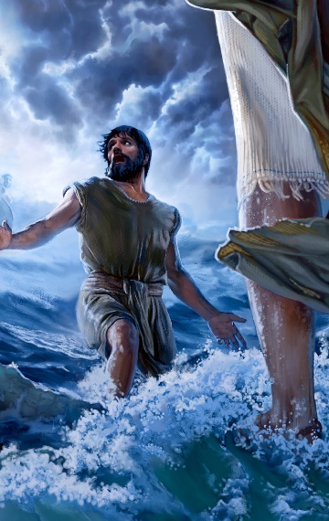firmly in His hands![17]

**Reflection**. All of us have gone through raging storm in life that are so fierce that one can’t help but wonder if survival is possible or even desirable! You might this very moment be walking in darkness, scared, and frightened by the raging seas of pain and agony. It is in the darkest moments of life that our faith is best forged because it is in the grim valleys of tribulations that our faith either in self or God is revealed and cultivated!

# **Getting out of the Boat**

To reassure them that they were not seeing a ghost or evil spirit wishing them great harm Jesus states, “take courage! It is I, don’t be afraid” (27). Jesus’ answer, “it is I,” “alludes back to God’s self-revelation in Exodus 3:14 and Isaiah 43:10-13.[18] This self-declaration plus His miraculous walking on the water was intended to “illicit faith in His true identity and mission as the Son of God.”[19] Though Peter and the other disciples had been “trained for some time and given power to do exact the sort of miracles Jesus was now doing,”[20] it would only be with faith in Jesus’ true identity as Son of God that Peter[21] would ever dare venture out on the fierce waters! So, Peter asks Christ to command him to go onto the water (28). This simple request reminds us that through the Lord’s power and authority we can do anything that is in accordance with His will (1 John 5:14)! Though Peter was a fisherman and likely a great swimmer (John 21:7)[22] it still required an incredible amount of faith to get out of the boat and proceed to walk on water towards Jesus (29). When Peter “sees the wind, meaning the effects of the wind, produce billowing whitecaps, surging seas, and wind-blown spray, and realizes where he is he becomes afraid.”[23] It was one thing to respond to a fierce storm with faith while inside the safety of the boat but quite another to put one’s faith solely in the hands of the Lord![24]

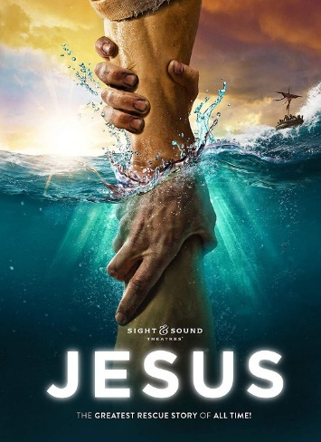When Peter’s faith in the Lord wavered and he began to sink into the water he cried out, “Lord save me” (30)! Peter was so close to the Lord that he could have easily touched Him and yet his faith had wavered for he forgot it was not by his own but the Lord’s authority that he was granted this amazing miracle!

**Reflection**. We often look at this story and only see Peter’s lack of faith, but the truth is many Christians rarely ever leave the security of their boats! We struggle in the fiercest of storms to merely survive in our boats of self-sufficiency that are easily torn apart. Even in still waters we are in danger for complacency lulls many of a Christian into a deep sleep of disobedience! If we are to serve the Lord as His ambassadors and royal priests rightly then we simply must get out our boats and in faith venture out to do more than we could ever ask or imagine by relying on His might and power!

# **Being Sustained by His Hand**

Matthew continues telling us this remarkable story by stating that in response to Peter’s cry to be saved “immediately Jesus reached out His hand and caught Peter and said, “You of little faith why did you doubt” (31)? Peter’s faith had not completely failed[25] for if it had the moment, he started sinking he would not have cried out to Jesus to be saved but instead would have “started to flail his arms about, desperately trying to get back into the boat.” [26] Our faith tends to be like Peter’s, trusting in Christ for our salvation but somewhat distant, abstract, or peripheral because we tend to trust more in our own abilities.[27] When the Lord told Peter his faith was little He did not mean it was small but that it was “undermined by the circumstances” of a fierce storm that diverted his attention from the object of his faith, His Savior![28] When our eyes remain focused on “Christ, the all-sovereign, gracious, loving, and merciful Savior and King of creation” our feet are on the Rock of an eternally secure foundation that cannot be shaken![29] Ironically, it was in that moment that Christ reached out His hand and caught Peter that he was truly closest to Him![30] Matthew tells us that when Jesus and Peter climbed into the boat the wind died down and the disciples worshipped Christ saying, “truly you are the Son of God” (33)!

Though their hearts were hardened and had not gained insight from the earlier miracle of the loaves,[31] this incident provoked in them a greater understand of Jesus’ identity for this was the very first time they had addressed Jesus by His full title![32]

Though they had not yet received a post-resurrection understanding of Christ as the Messiah and the great “I AM” who would give His life a ransom for many (Mark 10:45), their understanding and faith in Him grew astoundingly that day!

**Reflection**. When we are going through a fierce storm in life it is very difficult to keep our eyes fixed on the pioneer and perfector of our faith! We tend to rely on our own abilities and only when we have exhausted all possible solutions then we join Peter and cry out, save me O Lord! Ineffective or wavering faith is believing one is saved but not relying on the Good Shepherd to lead, guide, protect, and rescue one from life’s harsh circumstances. Genuine faith realizes that when we are at our weakest moments Christ is still sovereign and willing to show up, strengthen and rescue us from dangers both seen and unseen. And even when our tribulations are long term, we can still experience peace because our Lord is carrying us through the storm!

# **Whom we Have Faith**

Matthew finishes by stating that once they arrived safely on the shores of Gennesaret the people brought the sick and begged to touch His cloak to be healed! The lame, blind, deaf and spirit possessed had just enough faith to receive a miracle by Jesus’ mighty hand. We are left to wonder if any of them received the most precious gift the Lamb was offering, salvation! Did meeting Jesus change more than just their physical well being? This story is not just about the unsaved receiving a crumb from the Master’s table, it is also an invitation to evaluate our own response to our sovereign Lord. While there are many things in life that are too risky for some to partake, the truth is that we as Christians are not taking risks when our actions and adventures align with the perfect and pleasing will 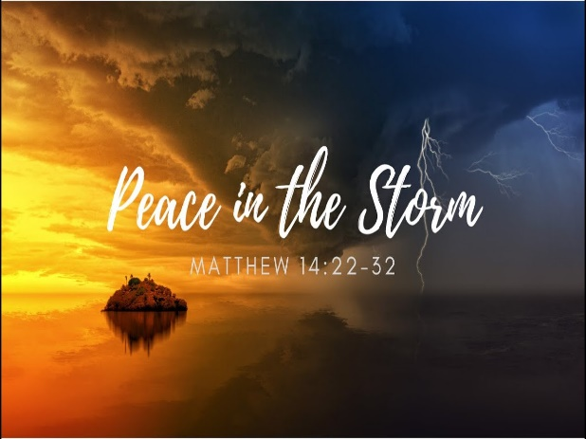of God! With the Holy Spirit living inside of us and the armour of God placed upon us are we not more than conquerors? To whom do we have to fear when we need merely to stand still and the Lord fights for us? Our most fierce enemy is not the spiritual forces of evil in the heavenly realms but our own complacency to stay inside the rocky boats of life and foolishly believe we can navigate the storms of life far better than God can or will! In great faith Peter got out of the boat and had he just kept his eyes fixed on the pioneer and perfector of his faith Jesus, the Lord would have continued to hold his feet above the water! We were not much when we were called, foolish and weak we were, but by relying on the Lord we receive His strength and wisdom to do good deeds that praise God the Father in heaven. So, just imagine what you could accomplish and the peace you would receive if only you stopped being too complacent or scared to venture out of the boat of self-sufficiency but instead choose to be led by the Lord’s hand to serve and do miracles in His name!

1. Michael J. Wilkins, [*Matthew*](https://ref.ly/logosres/nivac61mt?ref=Bible.Mt14.22-36&off=39&ctx=orshiped+(14%3a22%E2%80%9336)%0a~After+the+dramatic+f), The NIV Application Commentary (Grand Rapids, MI: Zondervan Publishing House, 2004), 515.
2. R. T. France, [*The Gospel of Matthew*](https://ref.ly/logosres/nicnt61mt?ref=Bible.Mt14.22&off=947&ctx=+of+John%E2%80%99s+account.+~Matthew+does+not+dra), The New International Commentary on the New Testament (Grand Rapids, MI: Wm. B. Eerdmans Publication Co., 2007), 568.
3. A.T. Robertson, [*Word Pictures in the New Testament*](https://ref.ly/logosres/rwp?ref=Bible.Mt14.22&off=428&ctx=e+reached+a+climax.+~The+disciples+were+e) (Nashville, TN: Broadman Press, 1933), Mt 14:22.
4. David Platt, [*Exalting Jesus in Matthew*](https://ref.ly/logosres/9781433681301?ref=Bible.Mt14.22-32&off=157&ctx=n+the+face+of+fear.+~We+know+from+John%E2%80%99s+), ed. Daniel L. Akin, David Platt, and Tony Merida, Christ-Centered Exposition Commentary (Nashville, TN: Holman Reference, 2013), 193.
5. A.T. Robertson, [*Word Pictures in the New Testament*](https://ref.ly/logosres/rwp?ref=Bible.Mt14.22&off=211&ctx=given+in+John+6%3a15.+~It+is+the+excited+pu) (Nashville, TN: Broadman Press, 1933), Mt 14:22.
6. D. A. Carson, [“Matthew,”](https://ref.ly/logosres/ebc08?ref=Bible.Mt14.23-24&off=216&ctx=+23)%2c+see+on+5%3a1%E2%80%932.+~The+burden+of+Jesus%E2%80%99) in *The Expositor’s Bible Commentary: Matthew, Mark, Luke*, ed. Frank E. Gaebelein, vol. 8 (Grand Rapids, MI: Zondervan Publishing House, 1984), 343.
7. Michael J. Wilkins, [*Matthew*](https://ref.ly/logosres/nivac61mt?ref=Bible.Mt14.22-27&off=96&ctx=+and+his+disciples.+~He+intended+to+go+aw), The NIV Application Commentary (Grand Rapids, MI: Zondervan Publishing House, 2004), 515.
8. Douglas Sean O’Donnell, [*Matthew: All Authority in Heaven and on Earth*](https://ref.ly/logosres/prwdmt?ref=Bible.Mt14.13-23&off=4049&ctx=bout+John%E2%80%99s+death.5+~Not+only+did+he+grie), ed. R. Kent Hughes, Preaching the Word (Wheaton, IL: Crossway, 2013), 403.
9. James Montgomery Boice, [*The Gospel of Matthew*](https://ref.ly/logosres/boicecm61amt?ref=Bible.Mt14.22-36&off=4000&ctx=for+serious+prayer.+~The+people+were+offe) (Grand Rapids, MI: Baker Books, 2001), 273.
10. Douglas Sean O’Donnell, [*Matthew: All Authority in Heaven and on Earth*](https://ref.ly/logosres/prwdmt?ref=Bible.Mt14.13-23&off=4601&ctx=y+lose+a+loved+one.+~I+also+think+he+thou), ed. R. Kent Hughes, Preaching the Word (Wheaton, IL: Crossway, 2013), 403.
11. Craig S. Keener, [*The IVP Bible Background Commentary: New Testament*](https://ref.ly/logosres/bbackcom?ref=Bible.Mt14.23&off=7&ctx=crowds+home.%0a14%3a23.+~The+pious+normally+s) (Downers Grove, IL: InterVarsity Press, 1993), Mt 14:23.
12. Craig S. Keener, [*The IVP Bible Background Commentary: New Testament*](https://ref.ly/logosres/bbackcom?ref=Bible.Mt14.24&off=7&ctx=nd+solitude.%0a14%3a24.+~Harsh+storms+often+a) (Downers Grove, IL: InterVarsity Press, 1993), Mt 14:24.
13. R. T. France, [*The Gospel of Matthew*](https://ref.ly/logosres/nicnt61mt?ref=Bible.Mt14.24&off=166&ctx=oat+to+rescue+them.+~If+the+disciples+are), The New International Commentary on the New Testament (Grand Rapids, MI: Wm. B. Eerdmans Publication Co., 2007), 569.
14. Clinton E. Arnold, [*Zondervan Illustrated Bible Backgrounds Commentary: Matthew, Mark, Luke*](https://ref.ly/logosres/zibbcnt01?ref=Bible.Mt14.26&off=139&ctx=%E2%80%9Cghost%E2%80%9D+(phantasma)+~is+used+for+dream+ap), vol. 1 (Grand Rapids, MI: Zondervan, 2002), 92–93.
15. R. T. France, [*The Gospel of Matthew*](https://ref.ly/logosres/nicnt61mt?ref=Bible.Mt14.25-27&off=1054&ctx=and+may+reflect+the+~popular+belief+that+), The New International Commentary on the New Testament (Grand Rapids, MI: Wm. B. Eerdmans Publication Co., 2007), 569.
16. Peter G. Bolt, [*Matthew: A Great Light Dawns*](https://ref.ly/logosres/rtbt61mt?ref=Bible.Mt14.22-33&off=687&ctx=me+above+all+names.%0a~Long+ago+in+the+exod), ed. Paul Barnett, Reading the Bible Today Series (Sydney, South NSW: Aquila Press, 2014), 157.
17. David Platt, [*Exalting Jesus in Matthew*](https://ref.ly/logosres/9781433681301?ref=Bible.Mt14.22-32&off=1546&ctx=ode+was+His+design.+~During+the+time+that), ed. Daniel L. Akin, David Platt, and Tony Merida, Christ-Centered Exposition Commentary (Nashville, TN: Holman Reference, 2013), 194.
18. Craig S. Keener, [*The IVP Bible Background Commentary: New Testament*](https://ref.ly/logosres/bbackcom?ref=Bible.Mt14.27&off=7&ctx=om+the+dead.%0a14%3a27.+~Jesus%E2%80%99+answer+is+lit) (Downers Grove, IL: InterVarsity Press, 1993), Mt 14:27.
19. Michael J. Wilkins, [*Matthew*](https://ref.ly/logosres/nivac61mt?ref=Bible.Mt14.22-27&off=2987&ctx=lming+of+the+storm.%0a~Jesus%E2%80%99+walk+on+the+w), The NIV Application Commentary (Grand Rapids, MI: Zondervan Publishing House, 2004), 516.
20. D. A. Carson, [“Matthew,”](https://ref.ly/logosres/ebc08?ref=Bible.Mt14.28&off=776&ctx=t+%E2%80%9Csince+it%E2%80%99s+you.%E2%80%9D+~The+request+is+bold%2c) in *The Expositor’s Bible Commentary: Matthew, Mark, Luke*, ed. Frank E. Gaebelein, vol. 8 (Grand Rapids, MI: Zondervan Publishing House, 1984), 344.
21. Michael J. Wilkins, [*Matthew*](https://ref.ly/logosres/nivac61mt?ref=Bible.Mt14.28-32&off=587&ctx=s+no+need+for+fear.+~Peter%E2%80%99s+focused+fait), The NIV Application Commentary (Grand Rapids, MI: Zondervan Publishing House, 2004), 517.
22. Marvin Richardson Vincent, [*Word Studies in the New Testament*](https://ref.ly/logosres/vincents?ref=Bible.Mt14.30&off=20&ctx=30.+He+was+afraid.+%E2%80%9C~Although%2c%E2%80%9D+says+Beng), vol. 1 (New York: Charles Scribner’s Sons, 1887), 86.
23. Michael J. Wilkins, [*Matthew*](https://ref.ly/logosres/nivac61mt?ref=Bible.Mt14.28-32&off=1094&ctx=water+toward+Jesus.+~We+are+not+told+how+), The NIV Application Commentary (Grand Rapids, MI: Zondervan Publishing House, 2004), 517.
24. A.T. Robertson, [*Word Pictures in the New Testament*](https://ref.ly/logosres/rwp?ref=Bible.Mt14.30&off=146&ctx=%CE%BD%CE%B7%CE%BD+%5bt%C4%93n+ph%C5%8Dn%C4%93n%5d).+%E2%80%9C~It+is+one+thing+to+s) (Nashville, TN: Broadman Press, 1933), Mt 14:30.
25. James Montgomery Boice, [*The Gospel of Matthew*](https://ref.ly/logosres/boicecm61amt?ref=Bible.Mt14.22-36&off=10056&ctx=t+to+recognize+that+~Peter%E2%80%99s+faith+did+no) (Grand Rapids, MI: Baker Books, 2001), 275.
26. James Montgomery Boice, [*The Gospel of Matthew*](https://ref.ly/logosres/boicecm61amt?ref=Bible.Mt14.22-36&off=10492&ctx=most+of+us+is+like.+~If+Peter+had+no+true) (Grand Rapids, MI: Baker Books, 2001), 275.
27. James Montgomery Boice, [*The Gospel of Matthew*](https://ref.ly/logosres/boicecm61amt?ref=Bible.Mt14.22-36&off=11664&ctx=ing+along+smoothly%2c+~we+may+be+genuinely+) (Grand Rapids, MI: Baker Books, 2001), 275.
28. David Platt, [*Exalting Jesus in Matthew*](https://ref.ly/logosres/9781433681301?ref=Bible.Mt14.22-32&off=6356&ctx=hat+we+must+create.+~Instead%2c+what+matter), ed. Daniel L. Akin, David Platt, and Tony Merida, Christ-Centered Exposition Commentary (Nashville, TN: Holman Reference, 2013), 196.
29. David Platt, [*Exalting Jesus in Matthew*](https://ref.ly/logosres/9781433681301?ref=Bible.Mt14.22-32&off=6839&ctx=ll+sooner+or+later.%0a~On+the+other+hand%2c+w), ed. Daniel L. Akin, David Platt, and Tony Merida, Christ-Centered Exposition Commentary (Nashville, TN: Holman Reference, 2013), 196.
30. James Montgomery Boice, [*The Gospel of Matthew*](https://ref.ly/logosres/boicecm61amt?ref=Bible.Mt14.22-36&off=11293&ctx=was+wrong+to+do+it.+~Yet+Spurgeon+said+so) (Grand Rapids, MI: Baker Books, 2001), 275.
31. Craig A. Evans, [*The Bible Knowledge Background Commentary: Matthew–Luke*](https://ref.ly/logosres/bkbc61mt?ref=Bible.Mt14.32&off=90&ctx=od%E2%80%99s+Son!%E2%80%9D+(v.+32)%3a+~Matthew+has+omitted+), ed. Craig A. Evans and Craig A. Bubeck, First Edition. (Colorado Springs, CO: David C Cook, 2003), 303–304.
32. D. A. Carson, [“Matthew,”](https://ref.ly/logosres/ebc08?ref=Bible.Mt14.32-33&off=6&ctx=%3a1%E2%80%933%3b+144%3a7).%0a32%E2%80%9333+~The+climax+of+the+st) in *The Expositor’s Bible Commentary: Matthew, Mark, Luke*, ed. Frank E. Gaebelein, vol. 8 (Grand Rapids, MI: Zondervan Publishing House, 1984), 345.