How to Know you are Saved

  - 1 John 5:1-12
  - Online Sermon: http://www.mckeesfamily.com/?page_id=3567


“AT SOUTHWESTERN BAPTIST THEOLOGICAL SEMINARY, we have an evangelistic program called “Taking the Hill.” Students and faculty periodically team up in groups of two or three to do door-to-door evangelism. On one occasion a lovely young lady from China and a young Hispanic man were on my team. One of the people we talked to was an elderly gentleman of ninety-two who lived alone and who said he was a Christian. His wife of sixty-seven years had recently passed away, and his son had died of kidney failure. We spent some time encouraging him. One of the comments he made to us was, “You have to do the best you can in life, because even though you are a Christian, you just don’t know for sure you are saved until you get to Heaven and find out.” The three of us tried in the best way we knew how to say to him that you don’t have to wait until you get there to know. You can know now that you have eternal life. We talked to him about the assurance we can have from what John says about this in the letter of 1 John. Can you really know that you are a Christian and going to Heaven when you die? John says absolutely you can know!”

How to Become Saved

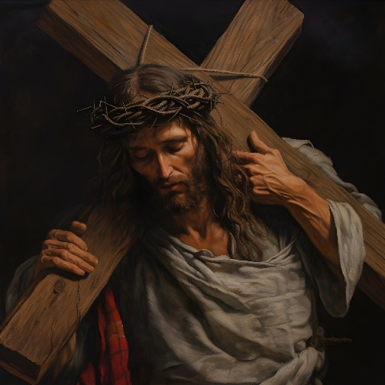
John’s first letter begins with a litmus test on how one can tell if one is saved or not. In a world that is interconnected to billions of people both on TV and on the internet, we are constantly being bombarded with many points of view. Debates rage, especially when it comes to the existence or the identity of God! Since the message of the cross is foolishness to those perishing (1 Corinthians 1:18) and no one can become righteous by their own effort (Ephesians 2:8-9), salvation only occurs by the initiative of God Himself! Our first birth of flesh and blood is perishable, corrupted, and therefore cannot enter the kingdom of God (1 Corinthians 15:50), so we need to be born again. The second birth is spiritual, God initiates it through His Spirit, it comes from the living and enduring word of God (1 Peter 1:23) and belief atoning sacrifice of God’s one and only Son Jesus! John 3:16 says that “God so loved the world that He gave His one and only Son, that whoever believes in Him shall not perish but have eternal life.” For John the first litmus test of salvation is faith in Christ because belief in the way, truth, and life (John 14:6) can only be obtained and sustained by being a child of God! When John says “faith” he is not talking about a mental decision and temporary fad of saying one loves Jesus but a “full surrender to Jesus Christ as one’s Lord, Savior, and King! It is by faith in Christ and through the Holy Spirit that a person experiences the spiritual birth and becomes born of God (John 1:12-13)!
Reflection. Do you believe that Jesus Christ is “the one who came in the flesh (John 1:14), is fully human, and divine Son of God (John 20:31), the one who came from heaven (John 13:3; 16:28) as Revealer (John 1:18) and Redeemer (John 3:16–17)? It is by your belief in Christ that you become and know that you are truly saved!

How to Know You are Saved – “Three Tests”

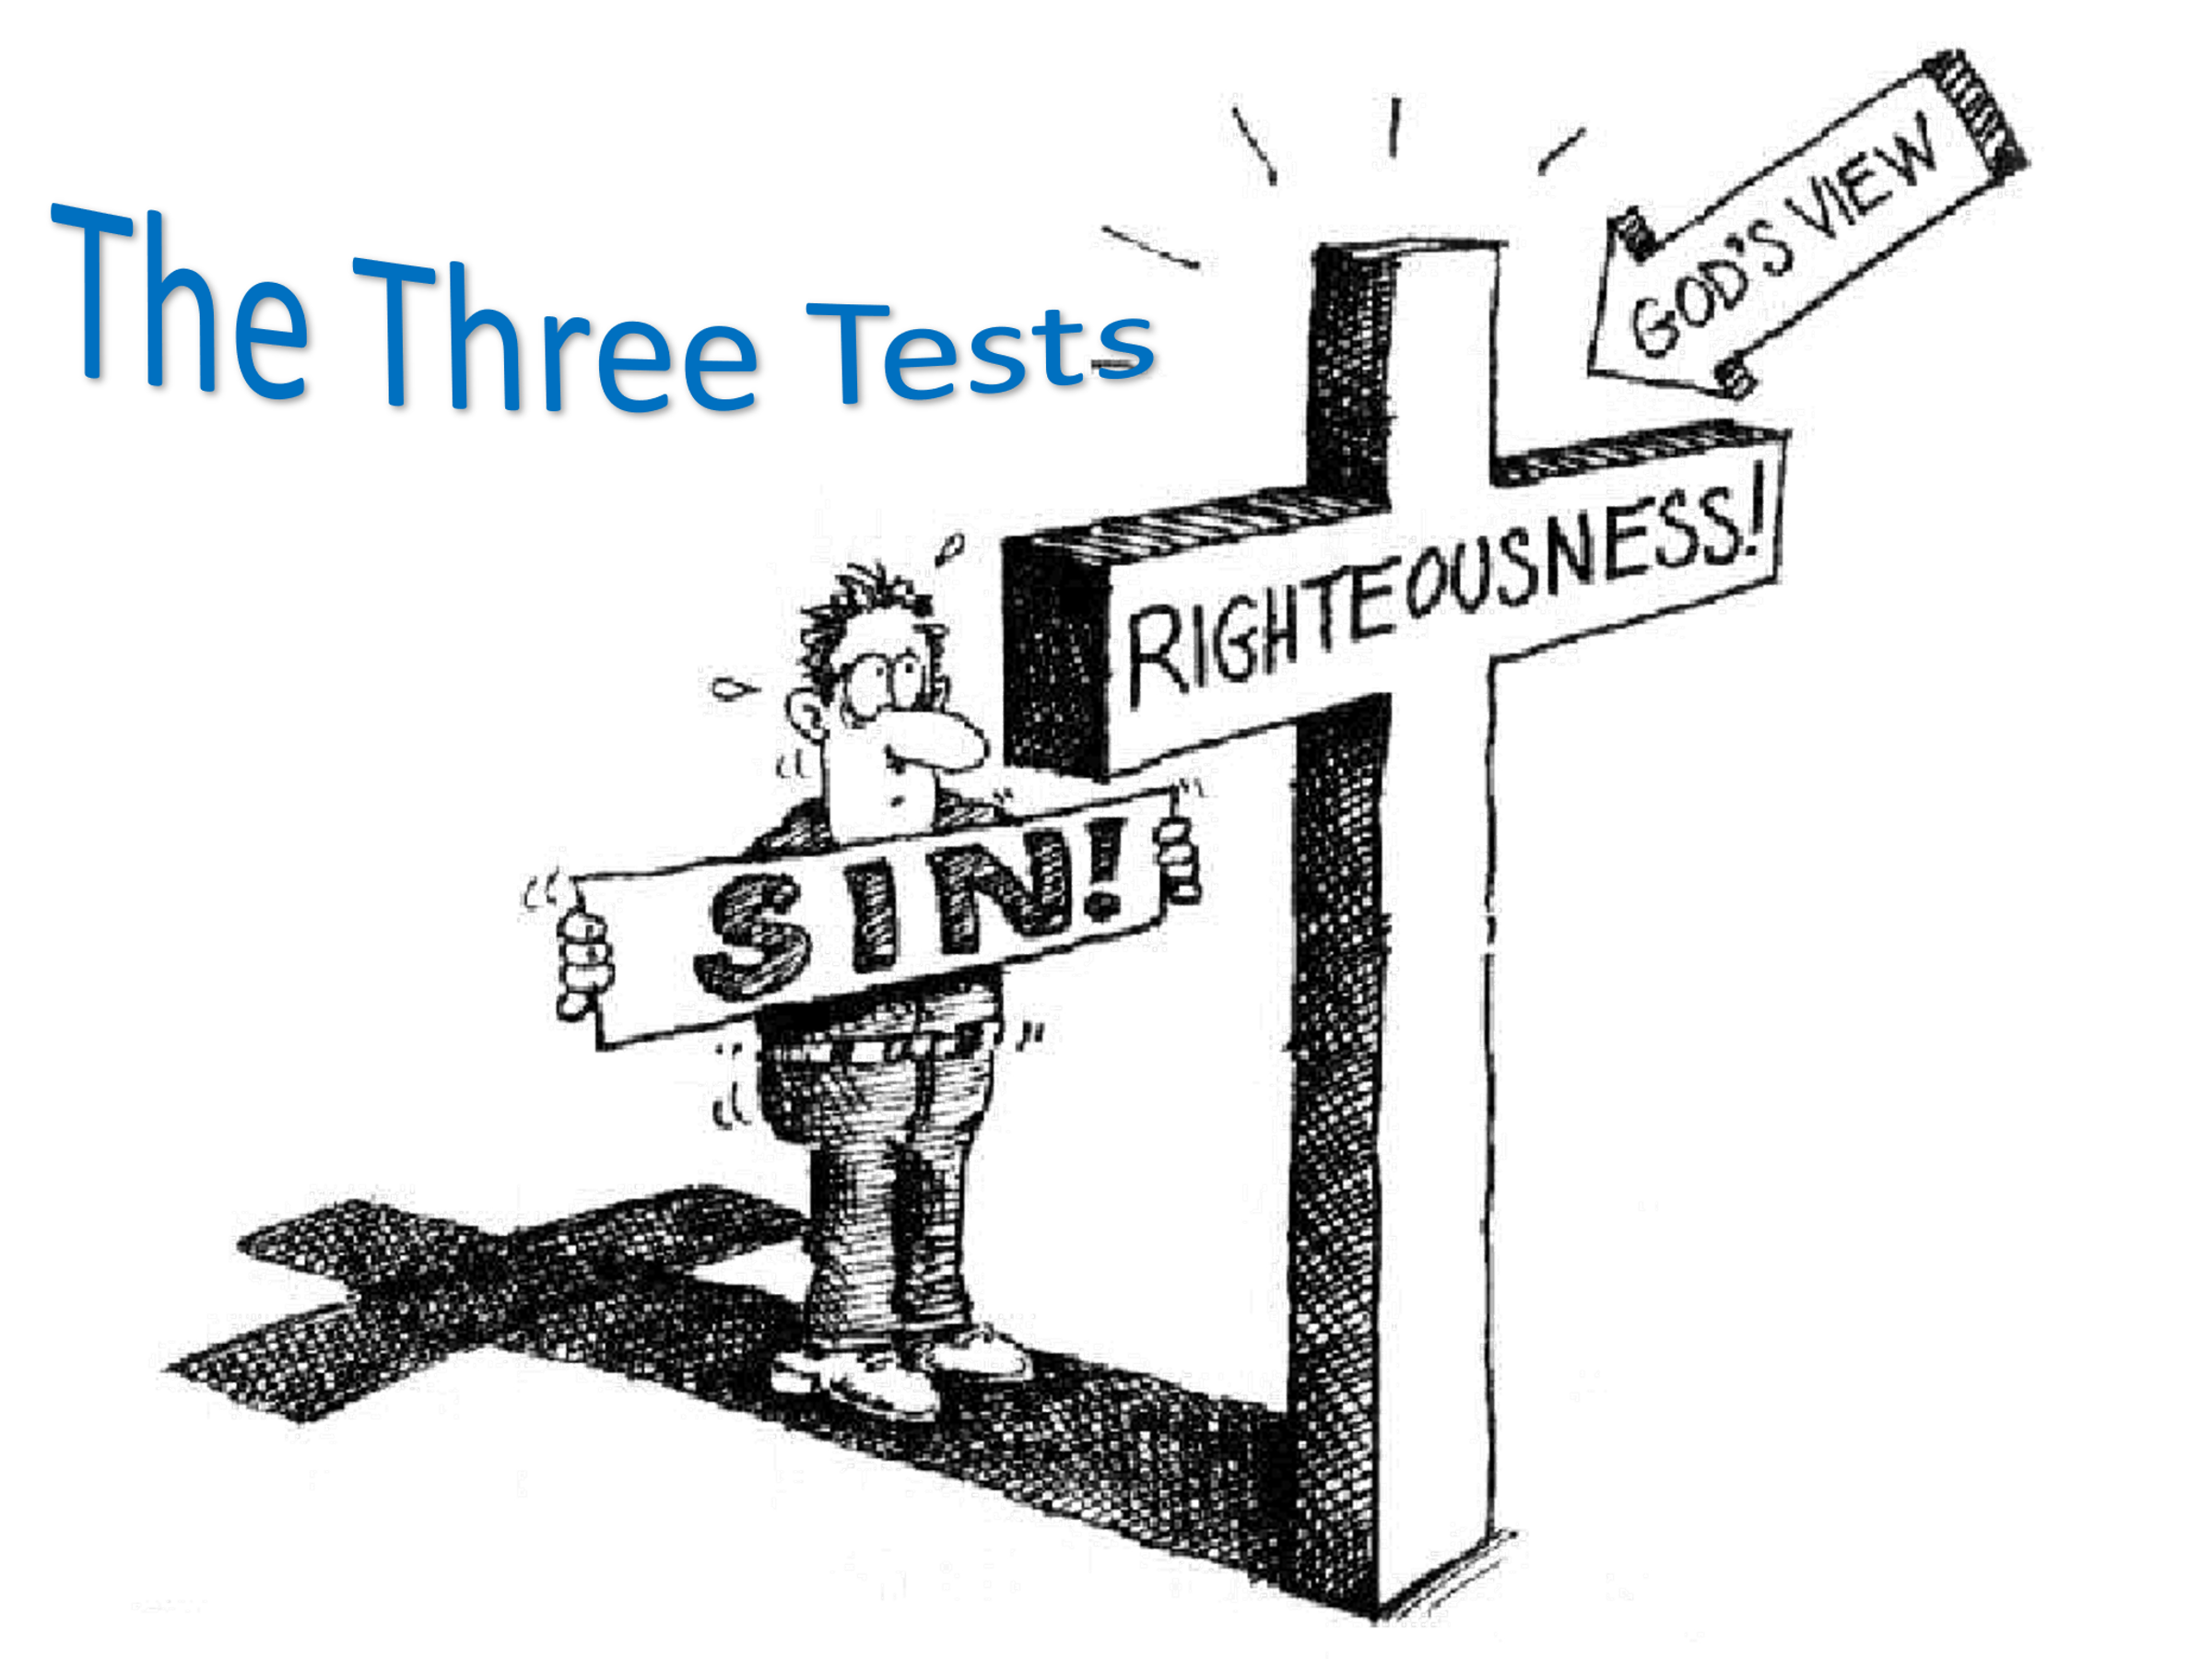
John gives three litmus tests that one is saved. First, becoming a new creation only comes from having been given the Spirit of God through faith in His Son Jesus (Romans 8:14-15). To be born of God means loving not only Him but also those who have been adopted into His family. At the end of chapter four John states, “whoever claims to love God yet hates a brother or sister is a liar. For whoever does not love their brother and sister, whom they have seen, cannot love God whom they have not seen” (4:20). Not keeping records of wrongs (1 Corinthians 13) but instead with “actions and in truth (3:18)” putting the interest of other believers first; is evidence one is saved because one is sharing God’s love with one another! Second, John says and we know we love other believers by keeping God’s commands. “Love divorced from obedience to the commands of God is not love.” Those whom His commands have been written on their hearts (Deuteronomy 30:11-14) do not find obedience a burden but an easy yoke (Matthew 11:30). “The commands of God become burdensome only when we desire to do something else.” Blessed is the person who does not follow the ways of the wicked (Psalms 1:1-2) but instead is so in love with their Creator and Father that their only desire is to do His will (Psalms 40:8), for His honor and glory (Matthew 5:14-16). And the third litmus test of salvation is victory over this world through faith in Christ.
A person is truly born again rejoices that in God’s strength the shackles of the lust of the eyes, flesh, and pride of life have been broken; freeing the believer to see obedience as another chance to show his/her love to God!
“Jesus won the victory over the world (John 16:33) and God in us (1 John 4:4) gives us too the victory.” This does not mean we as believers no longer sin but that we are now through the power of the Holy Spirit able to say no to evil for the “sinful desires and attractions are no longer beautiful; God and His will are!”
Reflection. Do you pass these three litmus tests: do you love the children of God, do you joyfully obey God’s commands, and have you claimed victory over sin and death by seeking and doing the will of God in your life? If these three items are evident in your life, then John says you are indeed saved! If any are three of these litmus tests are not present in your life this ought to provoke prayer and fasting to find out your status before God for you very well might still be on the broad path that leads to destruction (Matthew 7:13-14)!

God’s Testimony of Concerning Christ

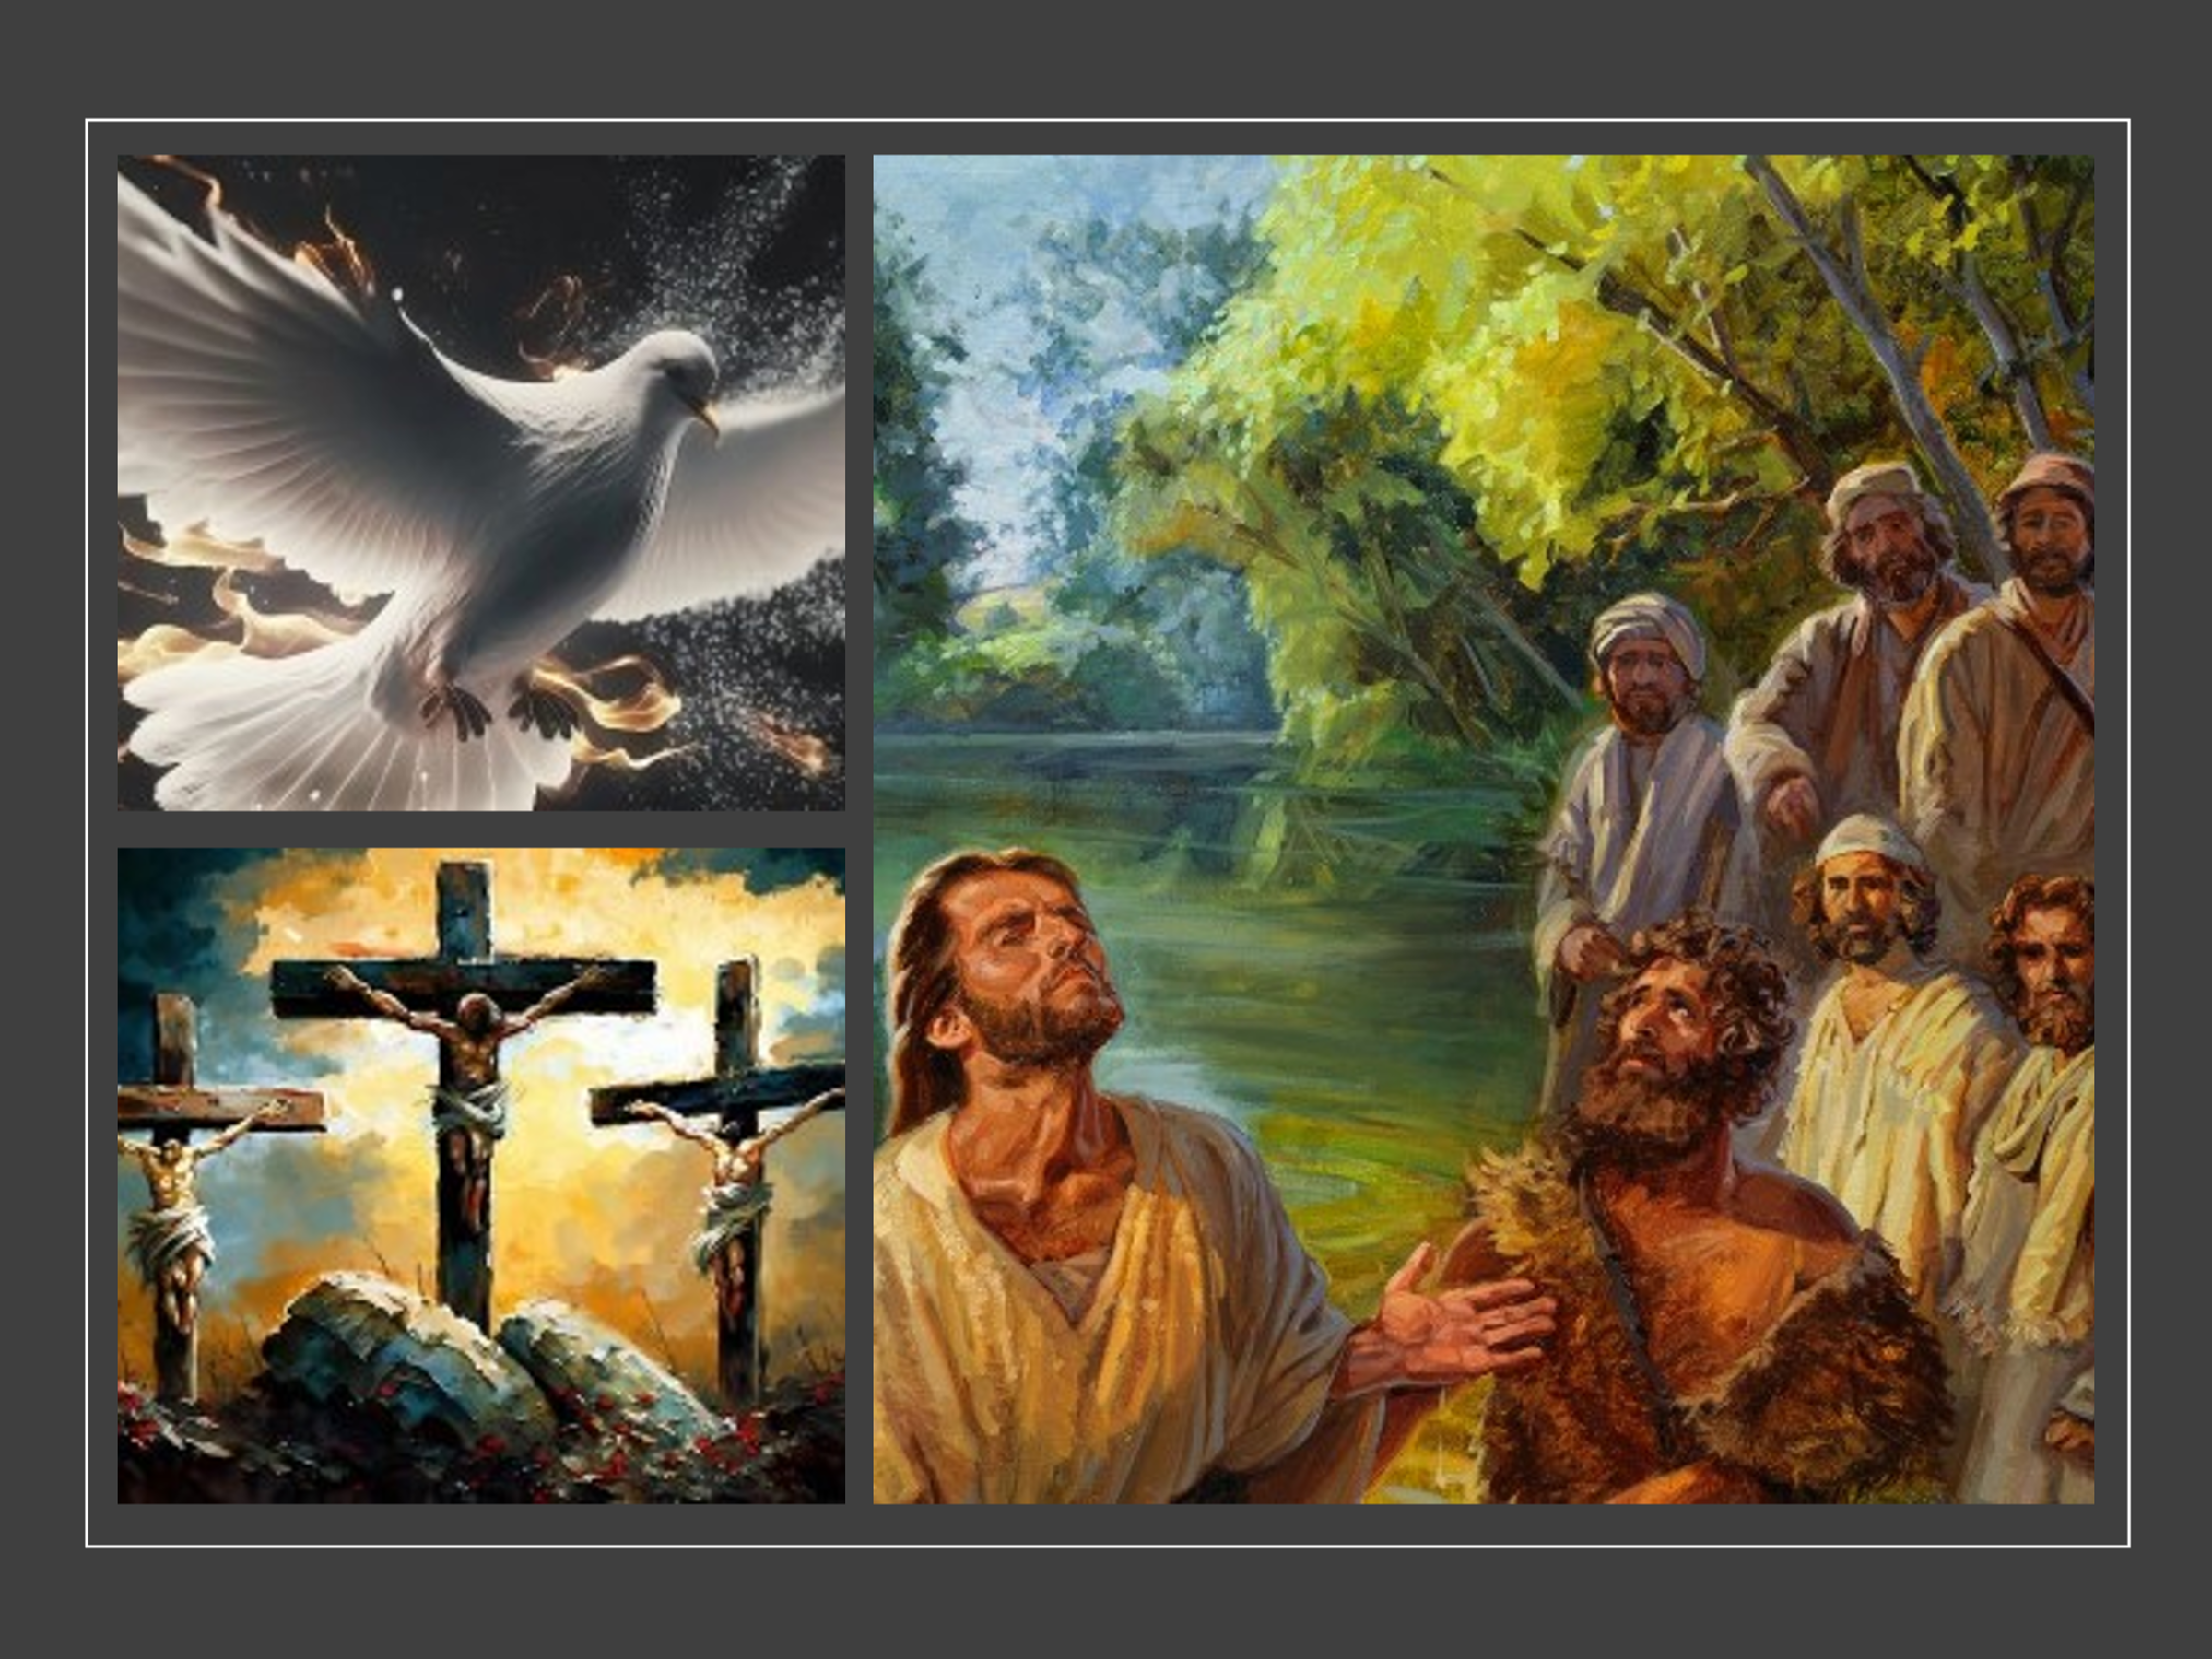
Since salvation is contingent upon faith in the atoning sacrifice of Christ, John proceeds to give the testimony of three crucial witnesses proclaiming Jesus is “the Son of God who is the Lamb of God who takes away the sin of the world (John 1:29). John was combating the false doctrine of Cerinhtus who taught that “Christ was born a mere man and it was only upon His baptism that the divine Christ came upon the human Jesus and empowered Him for service, then the divine Christ left the human Jesus before the cross and a mere man died on Calvary.” Believing like this has huge ramifications because if this were true and Christ was a mere man then this would mean that He could not have atoned for our sins and therefore faith in Him is futile! The first crucial witness that the eternal Logos (John 1:1-4) became the incarnate Christ, both fully human and fully God, can be found at His baptism by the Spirit. The “historical factualness of the incarnation” can be found in Matthew 3:17 when Jesus went up out of the water and the heavens was opened and God testified, “this is My Son, whom I love, with Him I am well pleased”! The second crucial witness that John mentions is the crucifixion of Christ. The Son’s death was not an accident, not an act of martyrdom, but a “divine saving substitution for sinners with redeeming value and worth.”
When Christ said it is finished and died the curtain of the temple was torn in two (Matthew 27:51) signifying Christ’s atoning death removed separation between God and humanity for it is by faith in Christ that a person is adopted as the Father’s child and can boldly approach His throne of grace (Hebrews 4:16)!
The final witness John mentions that Christ is the Messiah, the Son of God is the testimony of the Spirit of God Himself. For those born again the Holy Spirit lives inside of them as “God’s internal witness to us, in us, and through us.” “The Spirit was involved at Jesus’ conception (Matt. 1:18, 20; Luke 1:35), baptism (Matt. 3:16), temptation (Mark 1:12, Luke 4:1), and throughout His ministry.” He is our Advocate and Counselor who proceeds from the Father and testifies to us that Christ is God incarnate, the second person of the Trinity; the only way, truth, and life (John 14:6, 15:26). This threefold witness, water (baptism), blood (cross) and Spirit, passes Deuteronomy 19:15’s legal requirement of three witnesses and therefore one can boldly and rightly declare Christ to be our Savior!
Reflection. Have you ever had doubts concerning Christ’s identity. Ever wonder if the world right in saying that Christ was just a prophet or good man? Ever wonder if there are not many gods and paths to reach them? John says when doubt floods our minds, we are to read God’s love letter, the Bible, and see how God confirms Christ as His Son and Messiah of His people through the witness of His baptism and crucifixion. As we read the Bible, we are also to listen to the testimony of the Holy Spirit who boldly and rightly declares Jesus is our Redeemer, Lord, Savior and King!

Accepting God’s Testimony


Prosecutors charged that in 2001 Stewart was tipped off by Bacanovic that ImClone’s stock was going to drop after the company’s owner received inside information that the Food and Drug Administration was going to decline to review an application for the company’s cancer drug. Stewart shed her nearly 4,000 ImClone shares—worth $230,000—one day before the FDA decision was announced. After 27 witnesses 19 days of testimony and arguments a federal jury found Stewart, who maintained her innocence, guilty of conspiracy, obstruction and two counts of lying to federal investigators (a securities fraud charge was dismissed) on March 5, 2004. Bacanovic was found guilty on four of his five charges. Martha Stewart was given a sentence of five months in prison, two years of supervised release, and a fine of $30,000.

John at this point argues if we accept human testimony in matters in life then how much more ought we accept God’s testimony concerning His Son? When it comes to discerning the truth Deuteronomy 19:15 states that it must be established by “the testimony of two or three witnesses.” We accept human testimony, however, only when it is established by reputable persons. In Jewish law if a person was either a “thief, shepherd, violent person, or suspected of financial dishonesty” then their testimony would be invalid. If the person is of noble, pure, righteous character then their testimony is accepted. God’s testimony that Jesus is the Messiah given through reference to the water, blood, and the Holy Spirit is far greater than any human testimony for God is our Creator, sustainer, holy and incapable of lying (Hebrews 6:18)! “One word of God ought to sweep away ten thousand words of men, whether they be philosophers of today or sages of antiquity. God’s word is against them all, for he knows infallibly!”
To willfully not believe God’s divine testimony that His Son Jesus, as both fully human and fully divine, atoned for the sins of humanity is to say God’s testimony is false and to make Him out to be liar.
This is not only a grievous sin but proof that one is not saved, for who could ever come to the Father except through belief in the Son? “The internal witness of God’s Spirit in the heart confirms to the child of God that he or she was right to believe that Jesus is the Son of God who alone gives the gift of eternal life (1 John 5:11–12).”
Reflection. When you read about the water and the blood of Christ do you hear the Holy Spirit speak into your very heart the truth concerning the atoning sacrifice of Jesus? If the cross is no longer foolishness to you and you believe in Christ then you are indeed saved through faith and by His grace … rejoice in the Lord, again I say rejoice!

Conseqences of Being Saved

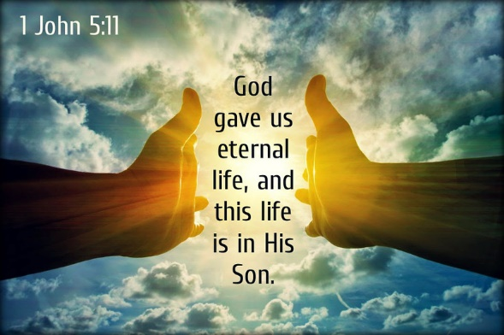
John finishes this part of his letter by stating that the testimony of God is this, “God has given us eternal life, and this life is in His Son. Whoever has the Son has life; whoever does not have the Son of God does not have life” (11-13). The witnesses that Christ is the only way, truth, and life; His baptism, His crucifixion, the gift of the Holy Spirit are all key assurances that one is truly saved. The most important witness of all, however, is God who states that with Christ one has eternal life but without Him one simply does not! Eternal life is not to be seen as “merely unending life!” Scripture clearly states that while we have a beginning upon death the spirit returns to God who gave it life (Ecclesiastes 12:7). Jesus tells us that, “when He returns and the angels with Him, He will sit on His glorious throne. All the nations will be gathered before Him, and He will separate the sheep from the goats” (Matthew 25:31-32). Those who believe in Jesus, He will say, “come you who are blessed by My Father; take your inheritance, the kingdom prepared for you since the creation of the world” (25:34). For those who do not believe in Jesus He will say, “depart from Me you who are cursed, into the eternal fire prepared for the devil and his angels” (25:41). To be certain one believes in Jesus and thus a sheep heading for eternal life in heaven is a matter of “believing, of exercising faith in the apostolic proclamation about Jesus Christ’s life, death, and resurrection (1:1–4).” So John asks all of us to answer the most important question we will ever be asked: do you know for certain you are saved?

How can you know beyond a doubt that you are indeed saved? By loving God, having faith in the atoning sacrifice of Jesus, by being able to obey His commands and love all believers of His family; one can be assured one has victory over the world and eternally adopted into His family as His very own child!

David L. Allen, 1–3 John: Fellowship in God’s Family, ed. R. Kent Hughes, Preaching the Word (Wheaton, IL: Crossway, 2013), 211.
Douglas J. Moo, “The Letters and Revelation,” in NIV Biblical Theology Study Bible, ed. D. A. Carson (Grand Rapids, MI: Zondervan, 2018), 2264.
James Montgomery Boice, The Epistles of John: An Expositional Commentary (Grand Rapids, MI: Baker Books, 2004), 125.
James Montgomery Boice, The Epistles of John: An Expositional Commentary (Grand Rapids, MI: Baker Books, 2004), 125.
A.T. Robertson, Word Pictures in the New Testament (Nashville, TN: Broadman Press, 1933), 1 Jn 5:1.
Thomas F. Johnson, 1, 2, and 3 John, Understanding the Bible Commentary Series (Grand Rapids, MI: Baker Books, 2011), 119.
David L. Allen, 1–3 John: Fellowship in God’s Family, ed. R. Kent Hughes, Preaching the Word (Wheaton, IL: Crossway, 2013), 212.
H. D. M. Spence-Jones, ed., 1 John, The Pulpit Commentary (London; New York: Funk & Wagnalls Company, 1909), 139.
David L. Allen, 1–3 John: Fellowship in God’s Family, ed. R. Kent Hughes, Preaching the Word (Wheaton, IL: Crossway, 2013), 213.
James Montgomery Boice, The Epistles of John: An Expositional Commentary (Grand Rapids, MI: Baker Books, 2004), 126.
James Montgomery Boice, The Epistles of John: An Expositional Commentary (Grand Rapids, MI: Baker Books, 2004), 127.
James Montgomery Boice, The Epistles of John: An Expositional Commentary (Grand Rapids, MI: Baker Books, 2004), 128.
James Montgomery Boice, The Epistles of John: An Expositional Commentary (Grand Rapids, MI: Baker Books, 2004), 128.
James Montgomery Boice, The Epistles of John: An Expositional Commentary (Grand Rapids, MI: Baker Books, 2004), 127.
A.T. Robertson, Word Pictures in the New Testament (Nashville, TN: Broadman Press, 1933), 1 Jn 5:4.
Daniel L. Akin, Exalting Jesus in 1,2,3 John (Nashville, TN: Holman Reference, 2014), 126.
Daniel L. Akin, Exalting Jesus in 1,2,3 John (Nashville, TN: Holman Reference, 2014), 131.
Alan Carr, “How Can I Know for Sure? (1 John 5:1–13),” in The Sermon Notebook: New Testament (Lenoir, NC: Alan Carr, 2015), 3370.
James Montgomery Boice, The Epistles of John: An Expositional Commentary (Grand Rapids, MI: Baker Books, 2004), 132.
Daniel L. Akin, Exalting Jesus in 1,2,3 John (Nashville, TN: Holman Reference, 2014), 131.
Daniel L. Akin, Exalting Jesus in 1,2,3 John (Nashville, TN: Holman Reference, 2014), 132.
Daniel L. Akin, Exalting Jesus in 1,2,3 John (Nashville, TN: Holman Reference, 2014), 133.
Daniel L. Akin, Exalting Jesus in 1,2,3 John (Nashville, TN: Holman Reference, 2014), 133.
James Montgomery Boice, The Epistles of John: An Expositional Commentary (Grand Rapids, MI: Baker Books, 2004), 134–135.
Daniel L. Akin, Exalting Jesus in 1,2,3 John (Nashville, TN: Holman Reference, 2014), 134.
Daniel L. Akin, Exalting Jesus in 1,2,3 John (Nashville, TN: Holman Reference, 2014), 134.
Daniel L. Akin, Exalting Jesus in 1,2,3 John (Nashville, TN: Holman Reference, 2014), 135.
James Montgomery Boice, The Epistles of John: An Expositional Commentary (Grand Rapids, MI: Baker Books, 2004), 136.
Clinton E. Arnold, Zondervan Illustrated Bible Backgrounds Commentary: Hebrews to Revelation., vol. 4 (Grand Rapids, MI: Zondervan, 2002), 205.

