God’s Grace is For Us!

  - Genesis 50:14-20; Romans 8:28; 1 Corinthians 12:27; Acts 2:44; Romans 12:1; Joshua 1:9b
Do you believe that God is always working for your good and for His glory? While no one is righteous (Romans 3:10-18), our hearts are above all are deceitful (Jeremiah 17:9), and like the Israelites we tend to be a stiff-necked people (Exodus 32:9); God still sees His image in us and enables us to “become mature, attaining the whole measure of the fullness of Christ” (Ephesians 4:13). Though we sin and fall short of His glory the Lord never stops inviting those who partake in the divine nature (2 Peter 1:4), His ambassadors (2 Corinthians 5:20) and royal priest (2 Peter 2:9), to have Him plant furrows of righteousness in their hearts! While it would be nice if our journey towards holiness was only one on the mountain tops of blessings and by still waters, the truth is that the transformation process of having our minds renewed (Romans 12:1) and conformed to His will often happens in a fiery furnace of affliction (Isaiah 48:10). I guess we should not be surprised for we not only live in a fallen world but also tend to only seek and rely on God when our trust in our own abilities has been diminished! While we “know that in all things God works for the good of those who love Him” (Romans 8:28a); when we are being refined by the fires of affliction, we rarely see God’s providential care for us! We tend to be like the Psalmist and cry out “how long Lord, will you forget me forever? How long will you hide your face from me? How long must I wrestle with my thoughts and day after day have sorrow” (Psalms 13:1-2)? It is incredibly hard to trust in God when our vision of His will for our lives is unclear and we feel like we have been abandoned to drown in our sorrows! Whom amongst us in such dire circumstances could ever put on the full armor of God (Ephesians 6) needed to withstand the fiery darts of depression and desperation that the Devil constantly throws our way?
When the “spiritual forces of evil in the heavenly realms (6:12) seems to be always sinking new fiery darts of affliction into us fragile jars of clay how can one stand firm in the faith (1 Corinthians 16:13) and boldly declare “blessed be the Lord, I can see how You are working in and through my life?”
Last week we talked about how God’s grace is with us and in this sermon, we are going to review the story of Joseph so that we might see how God’s grace is also for us in all circumstances that we face in life!

The Story of Joseph

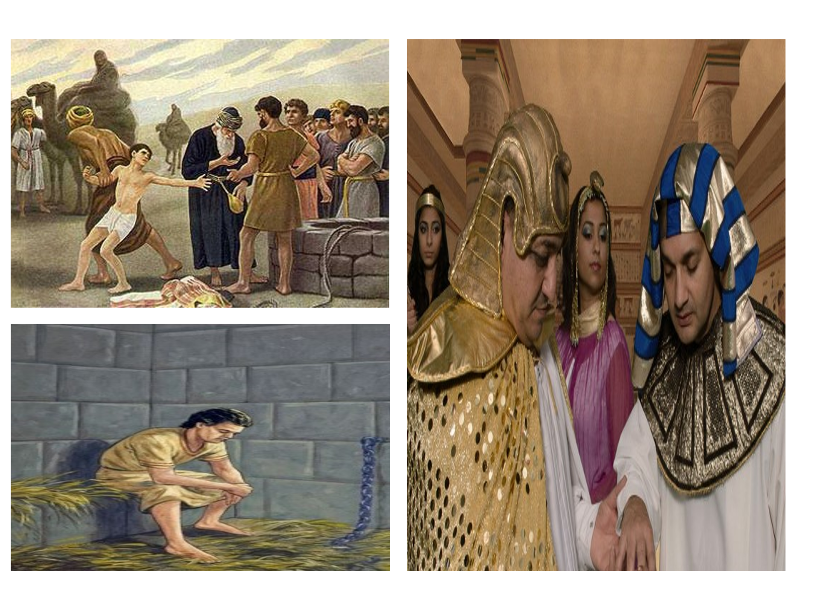
The story of Jospeh is a great example of God’s grace being extended amid tribulation for the good of those who love Him. At a tender age of 17 Joseph learned that blessings, especially favoritism, often provokes in others envy and hatred towards the recipient. Joseph was one of twelve sons of Jacob. His father made him a robe of many colors to express the truth that due to being born to him in his old age Jacob loved him more than his other sons (Genesis 37:3). Due to this favoritism and Joseph sharing a dream that his entire family would one day bow down to him (37:7), this provoked such intense jealousy that his brothers hated him, would not speak a kind world to him, and eventually even plotted to kill him (37:18). Realizing that they would not gain anything by killing him and covering up his blood, Joseph’s brothers decided to sell him to the Ishmaelites as a slave for twenty shekels of silver (37:26-28). They then slaughtered a goat and dipped Joseph’s robe in the goat’s blood so that their father would think that a ferocious animal had torn Joseph to pieces, and he was not more (37:31-34)! The Midianites then sold Joseph in Egypt to Potiphar, one of Pharoah’s officials (37:36). How difficult it must have been for Joseph to go from being the favored son to being despised as a slave but despite his bleak circumstances the Lord was with Joseph and granted him success in everything that he did (39:3). Potiphar saw his success and placed Jospeh in charge of his entire household! But after Joseph refused to be seduced by Potiphar’s wife, she promptly blamed him for trying to seduce her and Joseph was thrown into prison (37:11-23). Talk about bleak circumstances, first a slave and now a prisoner! This roller coaster of blessings and tribulations was far from done! God gave Jospeh the interpretation of Pharoah’s dream that there would be seven good years of bountiful harvest and then seven years of great famine. Joseph’s suggestion to Pharoah that he ought to save one-fifth of the harvest in the good years to prepare the bad ones seemed so wise that Pharoah put Joseph in charge of this plan and made him second in command over all Egypt (41:1-43)!

Joseph stored up huge quantities of grain, like the sand of the sea, during the good times that was so great that he “stopped keeping records of it because it was beyond measure” (41:49). When the famine hit Joseph opened all the storehouses and “all the world came to Egypt to buy grain from Joseph, for the famine was everywhere” (41:57). When Jacob heard there was grain in Egypt, he sent all his sons except Benjamin to purchase grain (42:3-4). When Joseph saw his brothers come before him, he not only pretended to not recognize them but also “spoke harshly to them” and accused them of being spies (42:8-9). After Joseph had placed his brothers in custody for three days, he released all but one of them and demanded they bring Benjamin, the youngest, to prove they were telling the truth about their family (42:14-23). Joseph then gave orders to fill their sacks with grain and put each brother’s silver back in their sacks (42:25). Upon realizing their silver had been returned Joseph’s brothers were filled with fear and they returned home and told their father everything that had happened (42:28-34). Feeling that “everything was against him,” Jacob refused to let the brothers take Benjamin from his side for he feared for his very life (42:36-38). Once they had eaten all the grain from Egypt and after Judah said, “hold me personally responsible for Benjamin,” Jacob finally agreed to let the rest of his sons make the journey to buy more grain (43:1-14). When they arrived, they explained to Joseph that their silver had been returned to them during the last visit to which Joseph said, “don’t be afraid. Your God, the God of your father, has given you the treasure in your sacks, I received your silver” (43:23). The brothers all bowed before Joseph and offered him gifts (43:26) and had a meal with him. When morning dawned again Joseph ordered his brother’s sacks to be filled with grain, returned their silver in the sacks, and placed his silver cup in Benjamin’s sack (44:1-5). When the cup was found in Benjamin’s sack and Joseph stated he was going to make him a slave Judah offered himself to take his brother’s place (44:33-34).
Joseph could not hold back his emotions any longer, forgave his bothers and told them the real reason why he went through so many tribulations, “God sent me ahead of you to preserve for you a remnant on earth and to save your lives by a great deliverance” (44:7).

In Grace we are to Forgive Others
The first lesson we learn from the roller coaster of Joseph’s life is that the grace God gives a person is meant to be given to others. They plotted to kill him, sold him into slavery, and made his father think a wild animal had torn him apart! Locked up in a dungy prison Joseph had every reason to hate his brothers. When the brothers realized that it was Joseph who was second in command of Egypt they were “terrified at his presence” (45:3) because they were afraid, he would be angry with them and seek revenge. But instead of being filled with rage Joseph was filled with gratitude for in the roller coaster of life’s blessings and tribulations he had experienced firsthand God’s grace and was truly grateful. Billy Graham once stated, “It’s the Fathers job to judge, the Spirit’s job to convict, and my job to love.” We live in a world where grace is often seen as a sign of weakness. Many of the world believe that if you don’t “beat down” your enemies then they will not respect but instead choose to abuse you! To this the Lord says, “you have heard it was said, eye for an eye, and tooth for tooth. But I tell you, do not resist and evil person. If anyone slaps you on the right cheek, turn to them the other cheek also” (Matthew 5:38).
If retribution needs to be paid by the perpetrator, then God will decide what it will be, not you (Romans 12:19). Like Joseph when we are wrongly persecuted by another our role is not revenge but to extend the grace of God we have received to the perpetrator.
Peter asked, how many times shall I forgive my brother or sister who sins against me, and the response was seventy-seven times which meant as many times as asked (Matthew 18:21-22). Think about all the times Christ forgave you for having sinful thoughts, words, and actions the moment you asked (1 John 1:9)! We need to take Christ’s warning to heart, “if you do not forgive others their sins, your Father will not forgive your sins” (Matthew 6:15).
Grace is not Just Words but Action

The second lesson we learn from the roller coaster of Joseph’s life is that a true extension of grace to another must be accompanied by action. Joseph did not merely send his brothers on their way with hollow words but instead “invited his brothers into his life, his story, and into his family,” to share in the bounty of God’s blessings that he had received! Joseph did not seek revenge but instead asked his family to move to “the best of the land of Egypt” so that they might “enjoy the fat of the land” (45:18). While we are to extend grace to the body of Christ of which we are all part of (1 Corinthians 12:27), we are also to offer grace to those who are the fallen image-bearers of God that are yet to be adopted into His family. Peter states that the Lord is not slow in returning but instead “is patient, not wanting anyone to perish, but everyone come to repentance” (2 Peter 3:9). Jesus tells us that “we are to love our enemies and pray for those who persecute us, that you may be children of your Father in heaven” (Matthew 5:43-48). Instead of ridiculing and seeking revenge against those who wrong us, should not those who were Christ’s enemies and yet saved by grace through faith be more than willing to be the “beautiful feet” (Romans 10:15) of those who make an appeal to the lost to be reconciled unto God (2 Corinthians 5:20)? Do you believe like Apostle Paul that “now is the time of God’s favor, now is the day of salvation” (6:2)? What if in the persecuting hands of one’s perpetrator you offered grace through both word and deed and in doing so your light shined so brightly that it penetrated his/her spiritual blindness and deafness and that person cried out Abba, Father save me! Would not tears of joy run down your face as you witness an enemy of the cross become a redeemed masterpiece of God’s grace?
And when you see this person in heaven, and they say thank you for being the hands and feet of Christ will not the uncomfortable moment of their persecution be worth it?
To serve in such a manner in the kingdom of God is a privilege and honor beyond any money, fame, or power that this world could ever offer!

In View of God’s Mercy


The last thing that I want to point out concerning Joseph’s life is that he lived the future words of Apostle Paul who said, “In view of God’s mercy, we are to offer our bodies as a living sacrifice, holy and pleasing to God – this is your true and proper worship” (Romans 12:1). For God to “work all things for the good of those who love Him” (Romans 8:28), this requires one to know and submit to His good, pleasing, and perfect will. But how does one, in the throws of affliction, be like Joseph and see the mighty hand of God at work both in the good and bad times of our lives? It is in our commune with the Holy Spirit who “searches all things, even the deep things of God” (1 Corinthians 2:11) that we in some small measure come to realize how God takes the circumstances of our lives, both good and bad, and redeems them for His honor and glory. In hindsight Joseph came to understand his brother’s jealousy, his being sold into slavery, and later being held in a dungy prison was meant to lead him down a path that resulted in him becoming second in command of Pharoah’s court so that he might “save lives by a great deliverance” (Genesis 45:7). It was not necessarily the circumstances that Joseph experienced but his trust in the Lord that led “God working all things for his good.” Had Joseph cursed God for being sold into slavery or had he slept with Potipher’s wife the good God offered him would not likely have happened. Joseph was blessed because in all situations he took Solomon’s words to heart, “trust in the Lord with all your heart and lean not unto your own understanding; in all ways submit to Him, and He will make your paths straight” (Proverbs 3:5-6). Being a living sacrifice also means trusting God to guide one’s steps even when they take one towards a lifetime of persecution and affliction. The Biblical heroes of Hebrews 11 were “commended for their faith and yet none of them received what had been promised” (11:39).

In view of God’s mercy His living sacrifices are to deny themselves, take up their crosses and follow the Lord (Matthew 16:24), even when the reasons for every step of the journey must wait until we go home to see Jesus!
Conclusion
God is always working for our good and His glory. The unshakeable truth is that while our hearts are above all deceitful, no one is righteous but instead often time stiff-necked; God still sees His image in us and enables us to attain the whole measure of Christ in our lives. If only the journey of life was always on the mountain tops of blessings, then we would be more readily able to see the “good” God is doing but living in a fallen world means that our lives are often filled with affliction which muddies the waters of His purpose. Like Job and many of the heroes of the Bible, we do not get, nor would we likely understand the reasons why tribulations come knocking at our door. In such times one must have faith that God in His infinite wisdom has done good to you even when the mind still wants to cry out, “how long Lord will you forget me?” For all the times we see God working for our good, we as ambassadors of Christ and His royal priests are obligated to share the grace we have received with others. God’s grace that we have received is to profoundly affect our relationships with one another! For instance, when others wrong us, we are to show them the same grace we, initially Christ’s enemies, received when He died on the cross for our sins, by forgiving them! Billy Graham was right to say, “It’s the Fathers job to judge, the Spirit’s job to convict, and my job to love.” If there be any retribution for an enemy’s attacks that is the Lord’s decision. Our responsibility is to forgive and love them the way Christ forgave and loves us. Above all the grace we have received ought to compel the partakers in the divine nature to share in His view that none should perish.
Instead of ridiculing or seeking revenge against the lost of this world should not the image of Christ within them, though it be marred and ignored, compel us to be the beautiful feet that says to them, “God saved a wretch like me, He will save you the moment you believe in His Son Jesus?”
So, while we may not always know how God works for our good, let us never stop sharing the grace we have received and trust that God is always for us and not against us!

Taken from Grace Under Fire video series from Sermon Central.

