# **Two Model of Living one’s Life**

**Philippians 3:17-21**

Online Sermon: <http://www.mckeesfamily.com/?page_id=3567>

To live one’s life worthy of the Gospel of Christ is far from an easy task! Though the believer has passed from death to life and is now sealed by the Holy Spirit does not mean one has arrived at spiritual perfection! Even though as a believer we can say “NO” to sin this does not mean that we have become sinless. We have the mind of Christ and participate in the divine nature yet find the lure of earthly pleasures of this world often leads us down many paths that do not honor Christ, our Lord, Savior, and King! To make matters worse believers are near so many contradictory points of view from both the saved and unsaved that ascertaining the truth is near impossible to determine in the sea of “grey” in which we live! So, to learn how to be holy as God is holy, we courageously open our Bibles and invite the Spirit to show us the giant motes in our eyes that are keeping us from seeing and obeying our Lord! And yet while God’s word is not difficult to understand, after all the Spirit of truth lives inside of us, it certainly is difficult to head the words of James; do not be hearers of the word but doers (1:22-25)! As human beings we have the tendency to imitate the words and deeds of others when doing so gives us pleasure. While it is easier to imitate those on the broad path where all choices are acceptable; surely there are believers around us that shine like stars in the sky because they have learned how to take God’s Road map to holy living, the Bible, and put it into action for His honor and glory, that we can imitate! In today’s passage in Philippians 3:17-21 Apostle Paul states the key to holy living is found in imitating the words and deeds of other Christians but only to the extent that their lives personify Christ! To accomplish this our mindset must be on our citizenship being in heaven and the eager expectation of the Lord who will one day give us glorious bodies that will at last be like Him.

As we go through today’s passage ask yourself if you are an example of Christlikeness to be emulated by others or an enemy of the cross to be avoided because your glory is being found in your shame?

# **Nothing but the Gospel**

Successfully running to win the prize of living a life worthy of the Gospel of Christ requires one to have the right mindset. No matter how successful the believer is at proclaiming the Gospel message (1:5), seeking unity in the Spirit (2:1), and suffering for Christ’s names sake when asked (3:10);[1] one must never become so arrogant that one foolishly believes one has arrived at perfection (3:15)! Even if one forgets what is behind and gives all the honor and glory for one’s current 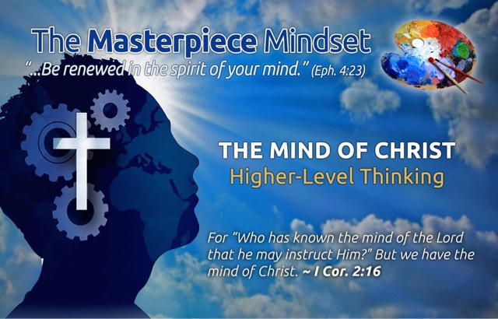successes to the Lord (3:13-14), the mature in Christ know full well that they have indeed not reached the pinnacle of “spiritual attainment.”[2] The truth is that even though God promises the believer if we draw nearer to Him He will draw nearer to us (James 4:8), we tend to get weary on His race track and often wander away! Considering the intense persecution, the Philippians faced and the lure of the Greco-Roman culture that placed such high value on self-indulgences; some of the Philippians were starting to fall away from living the Gospel message (3:16). While we don’t know specifically what Paul meant by those who “at some point you think differently” there are several likely meanings.[3] First, there were false teachers such as the Judaizers who were preaching inclusion into the kingdom of God was through circumcision and the keeping of the law (3:1-4).[4] Second, “perhaps some Philippians were experiencing a loss of confidence in God’s promises for the future, as was the case in Corinth (1 Corinthians 15:12—‘How can some of you say there is no resurrection of the dead?’).[5] Third, since Paul talked a lot about unity it is likely that there were disagreements over how to live a life worthy of the Gospel.[6] To combat the tendency to wander away Paul told the told the Philippians they should be “open-minded and teachable” by God who would reveal His truth to them.[7] Like the Galatians they were to be “keep in step with the Spirit” (Galatians 5:25)[8] and be “confident that He who began a good work in them would carry it on to completion” (1:6). If we are to run the race and honor God we simply must run in His way with our eyes fixed on the Son who bought our atonement at the price of His very life.[9]

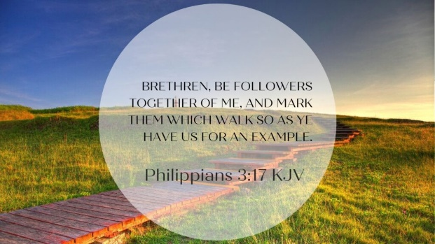Should not our life song be to “turn your eyes upon Jesus, look full in His wonderful face, and the things of earth will grow strangely dim, in the light of His glory and grace!”[10]

**Reflection**. How well are you running the race in which God has set out before you? Are you walking in step with the Holy Spirit in both learning and living the Gospel message? Have you wandered away from the truth that has set you free and are you still teachable by the Potter who wants to continuously mold the clay? How much of “your” understanding of God’s word comes from the world and how much from direct revelation from God Himself?

# **Following Faithful Examples**

To accomplish the goal of living one’s life worthy of the Gospel Paul told the Philippians, “Join together in following my example, brothers and sisters, and just as you have us a model, keep your eyes on those who live as we do” (3:17). While reading, meditating, and prayerfully taking in the words of the Bible is critical in knowing what the road map to holy living is, much can be learned by watching and imitating the righteousness “whom God’s grace has shone”[11] very brightly. To stand firm in the faith we are to imitate the great biblical heroes of the faith who were known to walk with God such as Enoch, Noah, and Abraham,[12] but specifically in Apostle Paul’s declaration, himself! This was not an act or egotism on Paul’s part,[13] after all he just finished telling the Philippians that he had not achieved perfection and had just finished suggesting the imitation of others such as Timothy and Epaphroditus. We are only to imitate others how they live their lives for and a reflection of Christ’s absolute perfection and holiness![14] Imitate other believers when they don’t preach Christ out of selfish ambition (1:15), when they stand firm in the one Spirit, striving together as one for the faith of the gospel (1:27), when they suffer for Christ’s names sake, when they are like-minded having the same love, being one in spirit and mind (2:1), when they do nothing out of selfish ambition or vain conceit but look out for the interests of others (2:3-4), when they have the same mindset as Christ (2:5), when they don’t grumble or argue (2:14), when they hold onto the word of life (2:16), when they honor other believers (2:29), when they see past gains a loss for the sake of Christ (3:7), when they see their righteousness through faith in Christ (3:9), and when they forget was is behind and press on to win the prize for which God has called them heavenward in Christ Jesus (3:14). Not only is one to imitate Christlikeness as found in other believers but one is also to live one’s life “blameless and pure, children of God” so that one might shine like stars in the sky (2:15-16)!

As an ambassador of Christ and royal priest you are called to “set an example by your passions, affections, emotions,”[15] words, and deeds by being knowledgeable of the Bible and putting those Spirit inspired words into action. “Those who pursue Christ will produce those who pursue Christ.

And it is only those who continue to run after Christ who will stand firm.”[16] You don’t need an influential position in the church to be a living, breathing example of living the Gospel message. As believers we are all called to avoid anything that might cause anyone to stumble in their walk with God[17] by passionately pursuing knowledge and obedience to His Son!

**Reflection**. Do you know that other believers examine how you are living your life for Jesus? Are you striving to know Christ more so that you might be a shining example of what it means to deny oneself, take up one’s cross and follow the Lord? Have you identified other believers that personify Christlikeness and are inviting them to build you up in the faith and spur you onto good deeds? Or do you feel you are such an amazing teacher and so spiritually mature that other believers have nothing to teach you?

# **Do not Follow Pretenders of the Faith**

It is at this point that Paul warned the Philippians of the dangers of imitating those who “live as enemies of the cross” (3:18). While Paul does not identify who those enemies were there are[18] three likely possibilities. First, Paul could be referring to the “opponents of Christianity in antiquity who regularly mocked Christians for their worship of a man who died by crucifixion.”[19] The Epicurean antinomians for instance “loose living”[20] was in stark contrast to denying oneself, taking up one cross and follow Jesus. Second, Paul could be referring to the Judaizers who he earlier called the “dogs, evil doers, and mutilators of the flesh (3:2).[21] While they made a profession of faith in Christ,[22] they were enemies of the Gospel message due to their insistence on adding circumcision and “observation of the Jewish calendar and dietary laws”[23] as necessary requirements for entrance into heaven. And third, Paul could be referred to nominal Christians who do not have a “theological denial of the cross” but have a “ethical divergence from the way of the cross of Christ.”[24] Self-denial,[25] putting the interests of others above that of one’s own, and a “cross-centered life of suffering”[26] is furthest thing from their minds. As Paul thought about the thrown away potential of these image-bearers of God he could not help but weep for his love for even his opponents was great![27] Even though Paul does not identify those enemies of the cross he was referring too, he gave three of their main characteristics so they could be identified, and their example not followed! First, their god was their stomach. For the Judaizers their “food laws had become their religion”[28] and for pagans and the nominal Christians their “bodily desires and sensual delights had displaced the divine and became their god.”[29] Second, ruled by their passions they not only gratified their sexual desires, greed, disrespect, gluttony, and laziness[30] but third they glorified these sins[31] when their sins that should have brought them shame and repentance!

With tears in his eyes Paul rendered his verdict on them that their destiny is destruction because their mind was set on earthy things rather than the “upward call of God in Christ Jesus” (3:14)![32] Paul warned the Philippians to not imitate wayward, disobedient attitude towards Christ lest they too share in their fate.

**Reflection**. There is a great danger in imitating those who are not living for Jesus! When you look up to another believer do you discern what in their life comes from Christ and is worthy of imitating? Do you often foolishly say to yourself, “I am doing the best I can and considering the sins of others, I am doing great”? Are you a nominal Christian more in love with the god of self rather than the Savior who purchased you at the price of His very life?

# **Live as Citizens of Heaven**

Paul concluded this part of his letter to Philippi by stressing how important it was for the believers in Philippi to have the right mindset. Instead of focusing on earthly things and imitating the enemies of the cross and be destroyed, the Philippians were to stand firm keeping their focus on the return of Christ and the future reality that He will transform their lowly bodies to be like His glorious body (3:20)! Living one’s life worthy of the Gospel message of Christ (1:27) requires one to “realize this world is not our home.”[33] Though the “little Roman polis,”[34] Philippi, had much to be proud of with its Roman status as a clone of Italy, they were not to boast in Caesar but the Lord as their only source of joy, hope, and peace.[35] “The true Savior was not the deeply flawed Caesar, but the heavenly Lord Jesus Christ!”[36] When the Philippians were humiliated and persecuted for Christ’s name sake by the elite of Roman society they were to remember that they are already citizens of heaven of Jesus, the Messiah, who is Yahweh, the God who created the heavens and the earth![37] “Writing from a Roman prison to a Roman colony, Paul spelled out a greater vision of the future than any Caesar could ever accomplish.[38]

While the groanings of this life were not easy to endure (Romans 8:18-27), the Philippians were to eagerly await the Lord’s return who “unlike the murderous Nero”[39] can and will “by the power that enables Him to bring everything under His control, transform our lowly bodies so that they will be like His glorious body” (3:21).

Though Paul referred to the body “as the “body of sin” (Romans 6:6) and the “body of death” (Romans 7:24), he did not express Gnostic or dualist contempt for the body, as if the body itself were inherently corrupt and evil.”[40] Instead Paul was rejoicing that our old bodies that were born corruptible, frail, vulnerable, and destructible,[41] will one day be transformed by the One who is sovereign over all things visible and invisible (Colossians 1:16) into spiritual bodies that are imperishable, raised in glory and in power (1 Corinthians 15:42-44).

**Reflection**. When life gets hard and the valleys of persecution exceptionally deep and painful are you able to feel incredible joy because you know you have been sealed by the Holy Spirit and as such are already a citizen of heaven? Are you looking forward to the new spiritual body that you are about to receive that is not subject to decay and cannot sin? What is the first thing you will say to the Lord when you meet Him face to face … why not say it now?

# **Conclusion**

To live one’s life worthy of the Gospel of Christ requires one to have the right mindset. Even though we have been washed by the blood of the Lamb and sealed by the Spirit of God Himself, this does not mean we have reached a pinnacle of spiritual attainment! The truth is that despite God’s promise if we draw nearer to Him, He will draw nearer to us, in the face of persecution and the lure of self-indulgences we tend to wander away from God, forever struggling to become holy as He is holy! While reading, meditating, and prayerfully taking in the words of the Bible is critical in knowing what the road map to holy 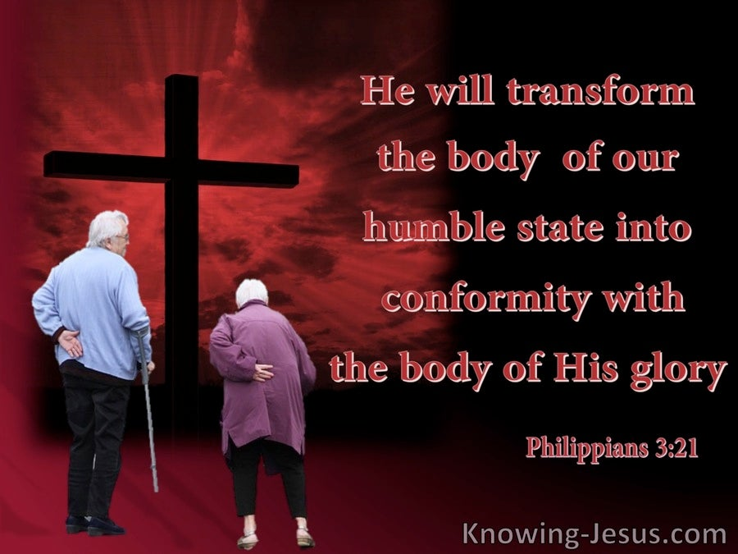living is, much can be learned by watching and imitating the righteousness of other believers when they reflect Christ’s absolute perfection and holiness. Those who pursue Christ will produce those who pursue Christ. Since there are many pretenders of the faith and lukewarm, nominal Christians that exists we must be careful to not emulate those who have their minds set on earthly things and those who the cross-centered life of suffering and obedience is the furthest thing from their minds! Those who are ruled by their passions to gratify their sexual desires, greed, disrespect, gluttony, and laziness should not be emulated but instead wept over for they truly are enemies of the cross who have glorified sin that should have brought them shame and repentance. Running the race of life to win the prize means standing firm keeping our focus on the return of Christ and the future reality that He will transform our lowly bodies to be like His glorious body! So, let’s live in the present as citizens of heaven who are about to go home in a new spiritual body that imperishable, incapable of sinning, raised in His glory and power.

1. G. Walter Hansen, [*The Letter to the Philippians*](https://ref.ly/logosres/pntcphp?ref=Bible.Php3.16&off=2092&ctx=ship+in+the+gospel.+~They+have+already+at), The Pillar New Testament Commentary (Grand Rapids, MI; Nottingham, England: William B. Eerdmans Publishing Company, 2009), 261.
2. Roger Ellsworth, [*Opening up Philippians*](https://ref.ly/logosres/openup71php?ref=Bible.Php3.15-16&off=758&ctx=same+mind%E2%80%99+(v.+16).%0a~In+other+words%2c+they), Opening Up Commentary (Leominster: Day One Publications, 2004), 68–69.
3. Ralph P. Martin, [*Philippians: An Introduction and Commentary*](https://ref.ly/logosres/tntc71phpus?ref=Bible.Php3.15&off=133&ctx=und+of+controversy.+~Apparently%2c+in+the+P), vol. 11, Tyndale New Testament Commentaries (Downers Grove, IL: InterVarsity Press, 1987), 162.
4. G. Walter Hansen, [*The Letter to the Philippians*](https://ref.ly/logosres/pntcphp?ref=Bible.Php3.15&off=500&ctx=historical+context.+~Behind+the+entire+pa), The Pillar New Testament Commentary (Grand Rapids, MI; Nottingham, England: William B. Eerdmans Publishing Company, 2009), 258.
5. Paul Barnett, [*Philippians & Philemon: Joy in the Lord*](https://ref.ly/logosres/rtbt71php?ref=Bible.Php3.15-16&off=1096&ctx=re+forced+to+guess.+~Perhaps+some+Philipp), ed. Paul Barnett, Reading the Bible Today Series (Sydney, South NSW: Aquila Press, 2016), 97.
6. Gordon D. Fee, [*Philippians*](https://ref.ly/logosres/ivntphp?ref=Bible.Php3.15-16&off=1963&ctx=+make+clear+to+you.+~Although+some+have+s), vol. 11, The IVP New Testament Commentary Series (Westmont, IL: IVP Academic, 1999), 159.
7. Ralph P. Martin, [*Philippians: An Introduction and Commentary*](https://ref.ly/logosres/tntc71phpus?ref=Bible.Php3.16&off=233&ctx=ier+in+the+chapter.+~The+apostle+is+confi), vol. 11, Tyndale New Testament Commentaries (Downers Grove, IL: InterVarsity Press, 1987), 163.
8. G. Walter Hansen, [*The Letter to the Philippians*](https://ref.ly/logosres/pntcphp?ref=Bible.Php3.16&off=907&ctx=progress+so+far.216+~He+uses+the+same+ter), The Pillar New Testament Commentary (Grand Rapids, MI; Nottingham, England: William B. Eerdmans Publishing Company, 2009), 260.
9. Alan Carr, [“Running for the Prize (Philippians 3:12–16),”](https://ref.ly/logosres/sermonnotebooknt?ref=Bible.Php3.12-16&off=9131&ctx=+differently!%0aConc%3a+~If+we+are+to+succeed) in *The Sermon Notebook: New Testament* (Lenoir, NC: Alan Carr, 2015), 3014.
10. Alan Carr, [“Running for the Prize (Philippians 3:12–16),”](https://ref.ly/logosres/sermonnotebooknt?ref=Bible.Php3.12-16&off=9634&ctx=ll+be+worth+it+all!%0a~How+well+are+you+run) in *The Sermon Notebook: New Testament* (Lenoir, NC: Alan Carr, 2015), 3014.
11. Ralph P. Martin, [*Philippians: An Introduction and Commentary*](https://ref.ly/logosres/tntc71phpus?ref=Bible.Php3.17&off=809&ctx=ring+of+the+Hebrew.+~For+us+today%2c+access), vol. 11, Tyndale New Testament Commentaries (Downers Grove, IL: InterVarsity Press, 1987), 163–164.
12. G. Walter Hansen, [*The Letter to the Philippians*](https://ref.ly/logosres/pntcphp?ref=Bible.Php3.17&off=2846&ctx=commands+of+God.228+~The+heroes+of+faith+), The Pillar New Testament Commentary (Grand Rapids, MI; Nottingham, England: William B. Eerdmans Publishing Company, 2009), 262.
13. Richard R. Melick, [*Philippians, Colossians, Philemon*](https://ref.ly/logosres/nac32?ref=Bible.Php3.17&off=282&ctx=sent-day+Christian.+~There+is+no+egotism+), vol. 32, The New American Commentary (Nashville: Broadman & Holman Publishers, 1991), 142.
14. F. F. Bruce, [*Philippians*](https://ref.ly/logosres/nibcnt71php?ref=Bible.Php3.17&off=1177&ctx=1+Cor.+10%3a32%E2%80%9311%3a1).%0a~These+last+words+are), Understanding the Bible Commentary Series (Peabody, MA: Baker Books, 2011), 127.
15. Tony Merida and Francis Chan, [*Exalting Jesus in Philippians*](https://ref.ly/logosres/9780805497595?ref=Bible.Php3.17&off=4048&ctx=n+affectionate+man.+~You+don%E2%80%99t+set+an+exa), ed. David Platt, Daniel L. Akin, and Tony Merida, Christ-Centered Exposition Commentary (Nashville, TN: Holman Reference, 2016), 159.
16. R. Kent Hughes, [*Philippians: The Fellowship of the Gospel*](https://ref.ly/logosres/prwdphil?ref=Bible.Php3.17&off=3194&ctx=children%E2%80%99s+workers.+~Those+who+pursue+Chr), Preaching the Word (Wheaton, IL: Crossway Books, 2007), 156.
17. F. F. Bruce, [*Philippians*](https://ref.ly/logosres/nibcnt71php?ref=Bible.Php3.17&off=898&ctx=e+equally+careful%3a+%E2%80%9C~Do+not+cause+anyone+), Understanding the Bible Commentary Series (Peabody, MA: Baker Books, 2011), 127.
18. Tony Merida and Francis Chan, [*Exalting Jesus in Philippians*](https://ref.ly/logosres/9780805497595?ref=Bible.Php3.18-19&off=69&ctx=ed+People+(3%3a18%E2%80%9319)%0a~In+verses+18%E2%80%9319+Paul), ed. David Platt, Daniel L. Akin, and Tony Merida, Christ-Centered Exposition Commentary (Nashville, TN: Holman Reference, 2016), 159.
19. Clinton E. Arnold, [*Zondervan Illustrated Bible Backgrounds Commentary: Romans to Philemon.*](https://ref.ly/logosres/zibbcnt03?ref=Bible.Php3.18&off=39&ctx=s+of+Christ+(3%3a18).+~Opponents+of+Christi), vol. 3 (Grand Rapids, MI: Zondervan, 2002), 361.
20. A.T. Robertson, [*Word Pictures in the New Testament*](https://ref.ly/logosres/rwp?ref=Bible.Php3.18&off=392&ctx=rou+tou+Christou%5d).+~Either+the+Judaizers) (Nashville, TN: Broadman Press, 1933), Php 3:18.
21. Paul Barnett, [*Philippians & Philemon: Joy in the Lord*](https://ref.ly/logosres/rtbt71php?ref=Bible.Php3.17-19&off=134&ctx=church+in+Philippi.+~Those+whom+earlier+h), ed. Paul Barnett, Reading the Bible Today Series (Sydney, South NSW: Aquila Press, 2016), 98.
22. Tony Merida and Francis Chan, [*Exalting Jesus in Philippians*](https://ref.ly/logosres/9780805497595?ref=Bible.Php3.18-19&off=250&ctx=hem+with+certainty.+~Carson%2c+O%E2%80%99Brien%2c+and), ed. David Platt, Daniel L. Akin, and Tony Merida, Christ-Centered Exposition Commentary (Nashville, TN: Holman Reference, 2016), 159.
23. Paul Barnett, [*Philippians & Philemon: Joy in the Lord*](https://ref.ly/logosres/rtbt71php?ref=Bible.Php3.17-19&off=550&ctx=g%E2%80%99+(see+on+vv+2%E2%80%933).+~Why+were+they+%E2%80%98enemi), ed. Paul Barnett, Reading the Bible Today Series (Sydney, South NSW: Aquila Press, 2016), 98.
24. G. Walter Hansen, [*The Letter to the Philippians*](https://ref.ly/logosres/pntcphp?ref=Bible.Php3.18&off=2479&ctx=m+9%3a4%E2%80%935%3b+11%3a29).238%0a~A+more+plausible+ide), The Pillar New Testament Commentary (Grand Rapids, MI; Nottingham, England: William B. Eerdmans Publishing Company, 2009), 264.
25. H. D. M. Spence-Jones, ed., [*Philippians*](https://ref.ly/logosres/tpc47a?ref=Bible.Php3.18&off=332&ctx=arning+with+tears.+%E2%80%9C~Paul+weeps%2c%E2%80%9D+says+Ch), The Pulpit Commentary (London; New York: Funk & Wagnalls Company, 1909), 115.
26. R. Kent Hughes, [*Philippians: The Fellowship of the Gospel*](https://ref.ly/logosres/prwdphil?ref=Bible.Php3.18&off=777&ctx=+%E2%80%9CI+speak+weeping.%E2%80%9D+~There+were+tears+as+), Preaching the Word (Wheaton, IL: Crossway Books, 2007), 157.
27. Craig S. Keener, [*The IVP Bible Background Commentary: New Testament*](https://ref.ly/logosres/bbackcom?ref=Bible.Php3.18&off=167&ctx=er+than+%E2%80%9Cweeping.%E2%80%9D+%E2%80%9C~With+tears%E2%80%9D+(NIV%2c+NR) (Downers Grove, IL: InterVarsity Press, 1993), Php 3:18.
28. Paul Barnett, [*Philippians & Philemon: Joy in the Lord*](https://ref.ly/logosres/rtbt71php?ref=Bible.Php3.17-19&off=2053&ctx=osen+%E2%80%98destruction%E2%80%99.+~Second%2c+what+they+co), ed. Paul Barnett, Reading the Bible Today Series (Sydney, South NSW: Aquila Press, 2016), 99.
29. R. Kent Hughes, [*Philippians: The Fellowship of the Gospel*](https://ref.ly/logosres/prwdphil?ref=Bible.Php3.18&off=1709&ctx=s-denying+behavior.%0a~Paul+explained+that+), Preaching the Word (Wheaton, IL: Crossway Books, 2007), 157.
30. Tony Merida and Francis Chan, [*Exalting Jesus in Philippians*](https://ref.ly/logosres/9780805497595?ref=Bible.Php3.18-19&off=1557&ctx=is+in+their+shame.%E2%80%9D+~They+show+off+things), ed. David Platt, Daniel L. Akin, and Tony Merida, Christ-Centered Exposition Commentary (Nashville, TN: Holman Reference, 2016), 160.
31. A.T. Robertson, [*Word Pictures in the New Testament*](https://ref.ly/logosres/rwp?ref=Bible.Php3.19&off=243&ctx=ho+abdomini+servit.+~Sensuality+in+food%2c+) (Nashville, TN: Broadman Press, 1933), Php 3:19.
32. R. Kent Hughes, [*Philippians: The Fellowship of the Gospel*](https://ref.ly/logosres/prwdphil?ref=Bible.Php3.18&off=3414&ctx=rist+and+the+cross%2c+~their+minds+once+aga), Preaching the Word (Wheaton, IL: Crossway Books, 2007), 158.
33. Tony Merida and Francis Chan, [*Exalting Jesus in Philippians*](https://ref.ly/logosres/9780805497595?ref=Bible.Php3.20-21&off=59&ctx=PHILIPPIANS+3%3a20%E2%80%9321%0a~Paul+concludes+by+re), ed. David Platt, Daniel L. Akin, and Tony Merida, Christ-Centered Exposition Commentary (Nashville, TN: Holman Reference, 2016), 161.
34. R. Kent Hughes, [*Philippians: The Fellowship of the Gospel*](https://ref.ly/logosres/prwdphil?ref=Bible.Php3.20&off=1380&ctx=part+from+Philippi.+~This+was+particularl), Preaching the Word (Wheaton, IL: Crossway Books, 2007), 158.
35. Osvaldo Padilla, [“Philippians,”](https://ref.ly/logosres/bkrllstrtdbccmm?ref=Bible.Php3.20&off=328&ctx=se+social+dynamics.+~To+those+Philippian+) in *The Baker Illustrated Bible Background Commentary*, ed. J. Scott Duvall and J. Daniel Hays (Grand Rapids, MI: Baker Books, 2020), 1182.
36. Paul Barnett, [*Philippians & Philemon: Joy in the Lord*](https://ref.ly/logosres/rtbt71php?ref=Bible.Php3.20-21&off=1152&ctx=d+line+the+streets.%0a~Paul%E2%80%99s+words+are+gen), ed. Paul Barnett, Reading the Bible Today Series (Sydney, South NSW: Aquila Press, 2016), 100.
37. G. Walter Hansen, [*The Letter to the Philippians*](https://ref.ly/logosres/pntcphp?ref=Bible.Php3.20&off=4580&ctx=+Lord+Jesus+Christ.+~In+the+Roman+Empire%2c), The Pillar New Testament Commentary (Grand Rapids, MI; Nottingham, England: William B. Eerdmans Publishing Company, 2009), 269–270.
38. G. Walter Hansen, [*The Letter to the Philippians*](https://ref.ly/logosres/pntcphp?ref=Bible.Php3.21&off=535&ctx=d+Lord+from+heaven.+~Writing+from+a+Roman), The Pillar New Testament Commentary (Grand Rapids, MI; Nottingham, England: William B. Eerdmans Publishing Company, 2009), 272.
39. Paul Barnett, [*Philippians & Philemon: Joy in the Lord*](https://ref.ly/logosres/rtbt71php?ref=Bible.Php3.20-21&off=1630&ctx=ven%E2%80%99%2c+Jesus+Christ.+~Unlike+the+murderous), ed. Paul Barnett, Reading the Bible Today Series (Sydney, South NSW: Aquila Press, 2016), 101.
40. G. Walter Hansen, [*The Letter to the Philippians*](https://ref.ly/logosres/pntcphp?ref=Bible.Php3.21&off=1201&ctx=dily+experience.276+~Although+Paul+does+r), The Pillar New Testament Commentary (Grand Rapids, MI; Nottingham, England: William B. Eerdmans Publishing Company, 2009), 272.
41. Paul Barnett, [*Philippians & Philemon: Joy in the Lord*](https://ref.ly/logosres/rtbt71php?ref=Bible.Php3.20-21&off=2286&ctx=re+think+this+way+%E2%80%A6%0a~The+advent+of+the+Lo), ed. Paul Barnett, Reading the Bible Today Series (Sydney, South NSW: Aquila Press, 2016), 101.