# **No Confidence in the Flesh**

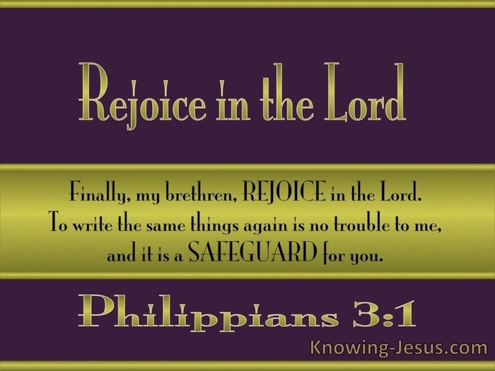

**Philippians 3:1-6**

Online Sermon: <http://www.mckeesfamily.com/?page_id=3567>

When Christ is preached (1:18) and even when being poured out like a drink offering in suffering and persecution (2:17-18), Paul says we are to “rejoice in the Lord, again I say rejoice” (4:4). “The golden thread of spiritual joy runs through this Epistle!”[1] As the Psalmist so eloquently stated, we are to go the altar of God, rejoice with exceeding joy and sing to God who is our strength and refuge in times of trouble (32:11, 33:1, 43:4, 46:1). Paul does not hesitate to repeat this command[2] for not only was it essential for “transcending all the sorrows and sufferings caused by living for Christ”[3] and the key to standing firm in the Gospel (1:27),[4] but rejoicing is also essential to safeguarding one’s faith in the Lord (3:1)! To keep the church of Philippi from succumbing to the “same cracks and weaknesses”[5] of legalism that Paul saw at the church of Galatia,[6] he implored them to stand fast and rejoice in the Lord. Being a former Pharisee Paul knew all too well of the dangers of legalism[7] and the devastating effects it was having on some of the Galatians. Legalism is “a self-salvation project that only leads to pride or despair. We must resist the Gospel of human achievement.”[8] “Being acquitted before God’s tribunal on the final day”[9] has nothing to do with one’s superior knowledge of His word, nor is it about doing religious activities to earn acceptance.

Being accepted and forgiven by God is not based on works,[10] for all have sinned and fallen short of the glory of God and no one is righteous not even one (Romans 3:10-18,23). Acceptance and adoption into God’s family is only attainable through faith in the atoning sacrifice of His Son Jesus!

In the first verse of chapter three Paul echoes his prior appeal to the Philippians to “stand firm in one spirit, with one mind, striving side by side for the faith of the Gospel” (1:27).[11] Paul implored the Philippians to “Hold firmly onto the word of life” (2:16) so that they might be “protected from legalism and false Gospels” that they would inevitably be tempted to put their trust. Let “the joy of the Lord arm us against the assaults of our spiritual enemies and put our mouths out of taste for those pleasures with which the tempter baits his hooks!”[12]

**Reflection**. Our standing before a holy is adoption into His very family but only by the blood of the Lamb. While we are to be holy as God is holy this does not mean that human effort can save a person. The believer can confidently approach God’s throne because it is one of mercy and grace. He who did not get what He deserved, God’s wrath and punishment for our sins, through saved us from the punishment we deserved but could never atone for or bear!

# **Watching out for the Dogs**

Holding firmly onto the word of life will help safeguard the Philippians against the false teachings of those whom Paul called dogs, evildoers, and mutilators of the flesh” (32)! Paul was referring a group of “Pharisee-influenced believers (15:5)”[13] who insisted that “Christ’s kingdom could be entered only through the gate of Judaism”[14] by becoming circumcised and following the Law of Moses.[15] With a “satirical twist, Paul gave these “Judaizers” a bitter taste of their own poisonous prejudice” using three descriptive adjectives.[16] First, he called them “dogs.” While today a dog connotates thoughts of loyal, friendly, cherished companionship; in Paul’s time dogs were not pets but were “nasty, unclean, and dangerous;”[17] “coyote- like scavengers who fed on roadkill, carrion, filth, garbage,” [18] “human corpses and even their own vomit!”[19] In the Old Testament dogs were viewed as unclean animals and in the New Testaments dog was a term often given to the Gentiles[20] who were outside of the covenant (Mark 7:27-29). Using their own slogans[21] against them Paul called the Judaizers “dogs” and the second adjective “evildoers” because by emphasizing conformity to the “purity laws and ceremonies of the Jewish Law”[22] they were preaching a Gospel of self-reliance rather than faith in a risen Savior.[23] The third adjective (phrase) Paul used to describe the Judaizers was “mutilators of the flesh” due to their insistence that without circumcision as described by Moses the believer would not be part of the covenant and therefore would not be saved (Acts 15:1).[24] To this Paul argued that circumcision of the heart by the Holy Spirit is what defined the covenant people of the Lord (Romans 2:29; Colossians 2:11–12).[25] “Since circumcision was not necessary for salvation, those who promoted it were only mutilating their flesh, something that Leviticus 21:5 forbids as a pagan ritual!”[26] What people needed to be saved was not “mutilation but regeneration.”[27] Even though there is no evidence these Judaizers where already at the church of Philippi, Paul warned them to stay clear of their false teachings whenever they sought to make them a proselyte![28]

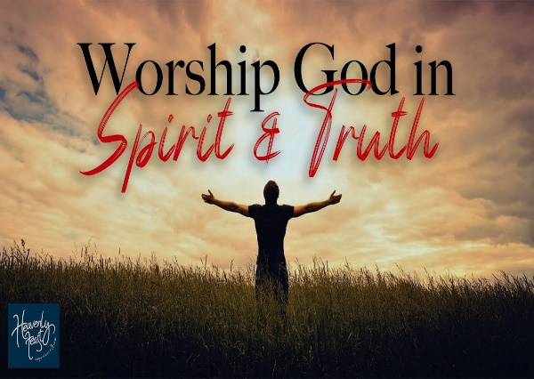**Reflection**. While circumcision and following the strict dietary laws of Moses are often far from a believer’s mind, are we not tempted to try and earn the approval of God through our good deeds? How easily we forget that it is by grace we are saved through faith and not works lest anyone should boast. It is not our deeds that make us holy before God but our belief in the atoning sacrifice of His Son, Jesus! Furthermore, our deeds only bear fruit when in the vine, so the goal of pleasing God is not attained by one’s effort but one’s surrender … Lord take my life and let it be!

# **Mark 1: Serving God by His Spirit**

To the dogs, evildoers, and mutilators of the flesh Paul boldly defined what circumcision meant considering the New Covenant. Circumcision in the Old Testament was a “physical sign of belonging to the covenant people of God.”[29] Since many of the Israelites tended to “stray after other gods” [30] because of their false belief that circumcision was a mark guaranteeing their salvation; many prophets of the Old Testament were sent by God to implore them to become “spiritually circumcised”[31] as well (Jeremiah 9:25). The “physical rite should be symbolic of a deeper commitment. They called this commitment “circumcision of the heart.”[32] True members of the Old Testament covenant were based on faith (Genesis 15:6, 18). Those who believe in the atoning sacrifice of Christ are born again and are a new creation under a New Covenant (2 Corinthians 5:17).[33] The sign of true circumcision is not found in the flesh but in the Spirit of God that dwells inside the believer (Romans 8:9).[34] Paul was not stating that the Jewish people were being excluded from the covenant[35] but merely that membership, both Jews and Gentiles, was defined by the circumcision of the Spirit. Paul gave three characteristics of true circumcision. First, those who are true members can be known by their service to God by His Spirit. To offer God a broken and contribute heart like King David (Psalms 51:17),[36] and worship the Lord in spirit and truth (John 4:24) requires the empowering of the Holy Spirit who is our comforter, teacher, and the one who “helps us with our weakness, granting us acceptable wordship, and prayer (Romans 8:26-27)[37] to a holy God!

Since no one is righteous and all continue to sin, circumcision of the heart can only be done by Christ who grants His own “inward purification and consecration” through the power of the Spirit who transforms, seals, and enables one to live a life worthy of the Gospel message.

For Paul, the seal of the Spirit is “irrefutable proof” one has passed from death to life and are forever sealed as a covenant member of God’s family!

**Reflection.** Are you born again by the water and the Spirit? Your philanthropic deeds will not get you into heaven no matter how impressive they are! Neither does your cherry disposition, popularity, prestige, or earthly possesions. Only by faith in the atoning sacrifice of Christ does one pass from death to life and become a child of God. So, I ask you again are you born again?

# **Mark 2: Boasting in Christ**

The second mark of true circumcision is “boasting in Christ Jesus” (3:3b). Paul used the verb “boasting” to contrast two “extreme religious attitudes: proud self-confidence and humble submission to God’s grace.”[38] Circumcision is not found in “conformity to the external demands of the Mosaic Law,”[39] in one’s genealogy, or “any other human social privilege.”[40] Those whose hearts have been circumcised by the Spirit do not do things out of selfish ambition or vain conceit (2:3) but for the glory of the Lord who purchased them at the price of His very life (1 Corinthians 6:20). It is not our earthly status, achievements, or spiritual gifting[41] but Christ who is the center of our boasting. God who “exalted Christ to the highest place and gave Him the name that is above every name” alone is worthy to be acknowledged and worshipped to the glory of God 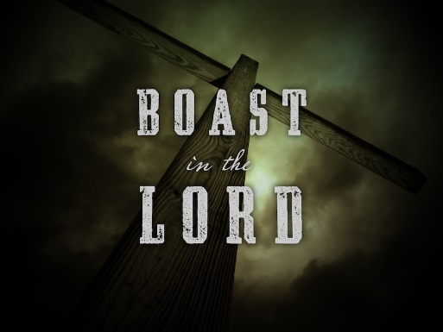(2:5-11). “Boasting is not in ourselves, which is the essence of sin!”[42] Echoing the words of the prophet Jeremiah (9:24) [43] Paul told the church of Galatia, “But as for me, I will never boast about anything except the cross of our Lord Jesus Christ. The world has been crucified to me through the cross, and I to the world” (Galatians 6:14).[44] “The Christian life is a Christ-exalting life.”[45] Our union with Christ is the great source of rejoicing for in Him because our sins have been atoned, we have passed from death to life, and are forever sealed by the Spirit as one of His Father’s very own children. When a believer stands before a holy God their sins condemn them but thankfully Christ fulfilled the Law’s requirement and as such there is no condemnation for those who have faith in Him for His blood covers all our sins (Romans 8:1-4)! “Christ is the center of all Heaven and the Obsession of every son or daughter who worships Him by the Spirit of God.[46] The truly circumcised boast in Christ Jesus for our glory is found in Him alone![47]

**Reflection**. It is so easy to feel pride in one’s accomplishments. Sometimes we take pride in our vast money, nice homes, good looks, health, spouse, children, and even our spiritual giftings! And yet upon our last heartbeat what of all our boastings will be left to enjoy? Will not meeting Jesus make all our sufferings nothing and our joy so overwhelming that it will be like rivers of living waters pouring fourth from our souls? And once in heaven will we ever stop boasting in the Lord for the grace and mercy He has granted us?

# **Mark 3: No Confidence in the Flesh**

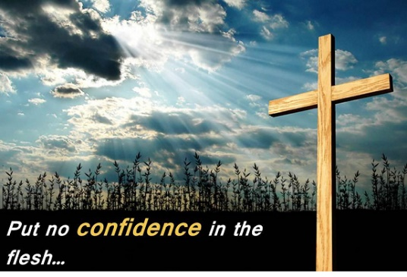 The third mark of true circumcision is having no confidence in the flesh. In the next few verses Paul boldly stated to the Judaizers for them to look at his outstanding credentials, four of them inherited and three personal accomplishments[48] that far surpassed those of his generation. First, Paul was not “grafted into the covenant race”[49] with a “lower social status”[50] but was circumcised as the Mosaic Law demanded (Genesis 17:12; Leviticus 121:3) on the eighth day of his life![51] “He was a pure-blooded Israelite.”[52] Second, being a descended of the Benjamin, who was the only son of Rachel and Jacob born in the Promised Land (Genesis 35:16-18) and was a member of the only tribe who “remained faithful to Judah and the house of David after the death of Solomon (1 Kings 12:21),”[53] Paul’s genealogy was undoubtably impeccable! Third, Paul was a Hebrew of Hebrews for unlike the Diaspora Jews who only knew Greek,[54] Paul also knew the “native language of first-century Judaism,” [55] Aramaic, and Hebrews as well. Fourth, Paul belonged to a Jewish sect, the Pharisees, who “were the most impressive and respected of groups in Israel.”[56] Fifth, as for passion for the Law Paul was no ordinary Pharisee for by his own testimony he was advancing in Judaism beyond many of his own age (Galatians 1:13-14).[57] Paul’s zeal for the traditions of his Jewish ancestors was unmatched for he likely saw himself as a “latter-day Phinehas in his zeal for the Law (Numbers 25:6-8),”[58] the ringleader in the persecution of the early church “from the death of Stephen till his own conversion (Acts 8:1-9:9).[59] And lastly, as “for his righteousness based on the law” Paul boldly stated he was faultless (3:6). Paul was not stating he was sinless but that when it came to following the Torah’s 613 commands whenever he broke one of them, he immediately partook in the Law’s 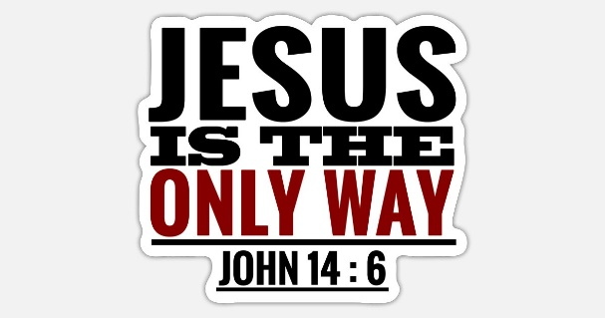“procedures to receive forgiveness and purification.”[60]

If anyone had the right to boast in the flesh it was Apostle Paul and yet he told his former colleagues and friends that all of his accomplishments meant nothing for without faith in the atoning sacrifice of Christ he would not on judgment day stand before a holy God and be accepted into His kingdom!

# **Conclusion**

When the Lord returns are you confident that you will be accepted and spend eternity with Him in heaven? “Are you trusting in your rituals, your ethnicity, your rank, your tradition, your rule keeping, your zeal, or your obedience to the law?”[61] Is your confidence in your morality or philanthropic deeds? The truth is that we have no justification before a holy God. All have sinned and fallen short of His glory and as such we deserve the wages of sin which is death! Salvation simply cannot be earned and none of us can withstand God’s righteous wrath. Though we are image-bearers this does not mean we are automatically accepted into heaven. Just because we sing worship songs, memorize, and live the Bible message does mean we are entitled to heaven either, any more than the Pharisees! When we bow low, and we all will, God will only separate us as His sheep if our hearts have the seal of His Spirit living inside of us. Thankfully the Lord as our advocate will speak on judgement day on our behalf. With a voice of thunder, grace, and mercy He will boldly declare His own to be righteous not on the bases of personal merit but on our faith in His atoning sacrifice. All of heaven, especially us, will rejoice as the Good Shepherd declares to His Father, this one is Your child for I purchased him/her at the price of My very own blood. To this the Father will agree with His one and only Son for not only is there no condemnation for those who believe in Christ Jesus, there is also eternal acceptance into His family forever! So, I finish with this one final question to ponder: where are you placing your confidence?

1. H. D. M. Spence-Jones, ed., [*Philippians*](https://ref.ly/logosres/tpc47a?ref=Bible.Php3.1&off=368&ctx=more+suitable+here.+~The+golden+thread+of), The Pulpit Commentary (London; New York: Funk & Wagnalls Company, 1909), 111.
2. G. Walter Hansen, [*The Letter to the Philippians*](https://ref.ly/logosres/pntcphp?ref=Bible.Php3.1&off=1332&ctx=tation%E2%80%9D+expression%E2%80%94I~+do+not+hesitate+to+), The Pillar New Testament Commentary (Grand Rapids, MI; Nottingham, England: William B. Eerdmans Publishing Company, 2009), 213.
3. G. Walter Hansen, [*The Letter to the Philippians*](https://ref.ly/logosres/pntcphp?ref=Bible.Php3.1&off=1738&ctx=adding+in+the+Lord.+~The+Lord+is+the+sour), The Pillar New Testament Commentary (Grand Rapids, MI; Nottingham, England: William B. Eerdmans Publishing Company, 2009), 214.
4. G. Walter Hansen, [*The Letter to the Philippians*](https://ref.ly/logosres/pntcphp?ref=Bible.Php3.1&off=6147&ctx=ability+for+them.20+~The+stability+or+fir), The Pillar New Testament Commentary (Grand Rapids, MI; Nottingham, England: William B. Eerdmans Publishing Company, 2009), 215.
5. Frank Thielman, [*Philippians*](https://ref.ly/logosres/nivac71php?ref=Bible.Php3.1&off=1626&ctx=e+as+a+%E2%80%9Csafeguard.%E2%80%9D+~His+purpose%2c+then%2c+i), The NIV Application Commentary (Grand Rapids, MI: Zondervan Publishing House, 1995), 167.
6. Tony Merida and Francis Chan, [*Exalting Jesus in Philippians*](https://ref.ly/logosres/9780805497595?ref=Bible.Php3.1&off=673&ctx=t+the+gospel+daily.+~They+have+a+tendency), ed. David Platt, Daniel L. Akin, and Tony Merida, Christ-Centered Exposition Commentary (Nashville, TN: Holman Reference, 2016), 133.
7. Osvaldo Padilla, [“Philippians,”](https://ref.ly/logosres/bkrllstrtdbccmm?ref=Bible.Php3.1-6&off=263&ctx=it%E2%80%94were+impeccable.+~From+the+perspective) in *The Baker Illustrated Bible Background Commentary*, ed. J. Scott Duvall and J. Daniel Hays (Grand Rapids, MI: Baker Books, 2020), 1180.
8. Tony Merida and Francis Chan, [*Exalting Jesus in Philippians*](https://ref.ly/logosres/9780805497595?ref=Bible.Php3.1&off=673&ctx=t+the+gospel+daily.+~They+have+a+tendency), ed. David Platt, Daniel L. Akin, and Tony Merida, Christ-Centered Exposition Commentary (Nashville, TN: Holman Reference, 2016), 133.
9. Clinton E. Arnold, [*Zondervan Illustrated Bible Backgrounds Commentary: Romans to Philemon.*](https://ref.ly/logosres/zibbcnt03?ref=Bible.Php3.1-4.1&off=215&ctx=to+the+Corinthians.+~In+Galatians+Paul+ap), vol. 3 (Grand Rapids, MI: Zondervan, 2002), 359.
10. Tony Merida and Francis Chan, [*Exalting Jesus in Philippians*](https://ref.ly/logosres/9780805497595?ref=Bible.Php3.1&off=47&ctx=You%0aPHILIPPIANS+3%3a1%0a~This+passage+is+also), ed. David Platt, Daniel L. Akin, and Tony Merida, Christ-Centered Exposition Commentary (Nashville, TN: Holman Reference, 2016), 132–133.
11. Paul Barnett, [*Philippians & Philemon: Joy in the Lord*](https://ref.ly/logosres/rtbt71php?ref=Bible.Php3.1&off=1642&ctx=lvation+and+my+God.%0a~Paul%E2%80%99s+second+appeal), ed. Paul Barnett, Reading the Bible Today Series (Sydney, South NSW: Aquila Press, 2016), 83.
12. R. Kent Hughes, [*Philippians: The Fellowship of the Gospel*](https://ref.ly/logosres/prwdphil?ref=Bible.Php3.1-3&off=4826&ctx=+expositor%2c+wrote%2c+%E2%80%9C~The+joy+of+the+Lord+), Preaching the Word (Wheaton, IL: Crossway Books, 2007), 122.
13. Paul Barnett, [*Philippians & Philemon: Joy in the Lord*](https://ref.ly/logosres/rtbt71php?ref=Bible.Php3.2-3&off=2212&ctx=+to+be+circumcised.+~This+group+of+Pharis), ed. Paul Barnett, Reading the Bible Today Series (Sydney, South NSW: Aquila Press, 2016), 85.
14. Marvin Richardson Vincent, [*Word Studies in the New Testament*](https://ref.ly/logosres/vincents?ref=Bible.Php3.2&off=85&ctx=e+21%3a8.%0aDogs.+Rev.%2c+~correctly%2c+the+dogs%2c), vol. 3 (New York: Charles Scribner’s Sons, 1887), 443.
15. Tony Merida and Francis Chan, [*Exalting Jesus in Philippians*](https://ref.ly/logosres/9780805497595?ref=Bible.Php3.2-6&off=542&ctx=own+as+%E2%80%9CJudaizers.%E2%80%9D+~During+the+time+of+t), ed. David Platt, Daniel L. Akin, and Tony Merida, Christ-Centered Exposition Commentary (Nashville, TN: Holman Reference, 2016), 134.
16. G. Walter Hansen, [*The Letter to the Philippians*](https://ref.ly/logosres/pntcphp?ref=Bible.Php3.2&off=3979&ctx=he+Jewish+people.27+~They+heaped+scorn+up), The Pillar New Testament Commentary (Grand Rapids, MI; Nottingham, England: William B. Eerdmans Publishing Company, 2009), 217.
17. Tony Merida and Francis Chan, [*Exalting Jesus in Philippians*](https://ref.ly/logosres/9780805497595?ref=Bible.Php3.2-6&off=264&ctx=+different+context.+~Dogs+weren%E2%80%99t+viewed+), ed. David Platt, Daniel L. Akin, and Tony Merida, Christ-Centered Exposition Commentary (Nashville, TN: Holman Reference, 2016), 134.
18. R. Kent Hughes, [*Philippians: The Fellowship of the Gospel*](https://ref.ly/logosres/prwdphil?ref=Bible.Php3.2&off=2236&ctx=o+use+for+dog+food.+~Dogs+were+coyote-lik), Preaching the Word (Wheaton, IL: Crossway Books, 2007), 123.
19. G. Walter Hansen, [*The Letter to the Philippians*](https://ref.ly/logosres/pntcphp?ref=Bible.Php3.2&off=6578&ctx=ling+near+Philippi.%0a~Dogs+were+not+lovabl), The Pillar New Testament Commentary (Grand Rapids, MI; Nottingham, England: William B. Eerdmans Publishing Company, 2009), 218.
20. Tony Merida and Francis Chan, [*Exalting Jesus in Philippians*](https://ref.ly/logosres/9780805497595?ref=Bible.Php3.2-6&off=1213&ctx=m+works+of+the+law.%0a~The+reference+to+dog), ed. David Platt, Daniel L. Akin, and Tony Merida, Christ-Centered Exposition Commentary (Nashville, TN: Holman Reference, 2016), 134.
21. R. Kent Hughes, [*Philippians: The Fellowship of the Gospel*](https://ref.ly/logosres/prwdphil?ref=Bible.Php3.2&off=4045&ctx=is+that+he+took+the+~Judaizers%E2%80%99+rhetoric+), Preaching the Word (Wheaton, IL: Crossway Books, 2007), 124.
22. H. D. M. Spence-Jones, ed., [*Philippians*](https://ref.ly/logosres/tpc47a?ref=Bible.Php3.2&off=112&ctx=as+given+in+ver.+3%2c+~Rejoice+in+the+Lord%2c), The Pulpit Commentary (London; New York: Funk & Wagnalls Company, 1909), 111.
23. G. Walter Hansen, [*The Letter to the Philippians*](https://ref.ly/logosres/pntcphp?ref=Bible.Php3.2&off=8661&ctx=ldoers+in+two+ways.+~First%2c+they+are+evil), The Pillar New Testament Commentary (Grand Rapids, MI; Nottingham, England: William B. Eerdmans Publishing Company, 2009), 219.
24. R. Kent Hughes, [*Philippians: The Fellowship of the Gospel*](https://ref.ly/logosres/prwdphil?ref=Bible.Php3.2&off=3803&ctx=O%E2%80%99Brien+concludes%2c+%E2%80%9C~Circumcision%2c+their+), Preaching the Word (Wheaton, IL: Crossway Books, 2007), 124.
25. Alan Carr, [“The Possessions of a Covenant People (Phil. 3:1–3),”](https://ref.ly/logosres/sermonnotebooknt?ref=Bible.Php3.1-3&off=1455&ctx=es+today!)%0aB.+Ill.+%E2%80%9C~We+are+the+circumcis) in *The Sermon Notebook: New Testament* (Lenoir, NC: Alan Carr, 2015), 3006.
26. Clinton E. Arnold, [*Zondervan Illustrated Bible Backgrounds Commentary: Romans to Philemon.*](https://ref.ly/logosres/zibbcnt03?ref=Bible.Php3.2&off=1044&ctx=+in+the+next+verse.+~Since+circumcision+w), vol. 3 (Grand Rapids, MI: Zondervan, 2002), 360.
27. Tony Merida and Francis Chan, [*Exalting Jesus in Philippians*](https://ref.ly/logosres/9780805497595?ref=Bible.Php3.2-6&off=2462&ctx=nson%2c+Letter%2c+220).+~They+didn%E2%80%99t+need+mut), ed. David Platt, Daniel L. Akin, and Tony Merida, Christ-Centered Exposition Commentary (Nashville, TN: Holman Reference, 2016), 134.
28. H. D. M. Spence-Jones, ed., [*Philippians*](https://ref.ly/logosres/tpc47a?ref=Bible.Php3.2&off=1132&ctx=deceitful+workers.%E2%80%9D+~The+Judaizers+were+a), The Pulpit Commentary (London; New York: Funk & Wagnalls Company, 1909), 111.
29. G. Walter Hansen, [*The Letter to the Philippians*](https://ref.ly/logosres/pntcphp?ref=Bible.Php3.3&off=446&ctx=e+the+circumcision.+~This+name+points+to+), The Pillar New Testament Commentary (Grand Rapids, MI; Nottingham, England: William B. Eerdmans Publishing Company, 2009), 220.
30. Frank Thielman, [*Philippians*](https://ref.ly/logosres/nivac71php?ref=Bible.Php3.2-4a&off=1704&ctx=ly+to+circumcision.+~Physical+circumcisio), The NIV Application Commentary (Grand Rapids, MI: Zondervan Publishing House, 1995), 167–168.
31. R. Kent Hughes, [*Philippians: The Fellowship of the Gospel*](https://ref.ly/logosres/prwdphil?ref=Bible.Php3.3&off=56&ctx=CIRCUMCISION+(v.+3)%0a~The+Old+Testament+pr), Preaching the Word (Wheaton, IL: Crossway Books, 2007), 124.
32. Frank Thielman, [*Philippians*](https://ref.ly/logosres/nivac71php?ref=Bible.Php3.2-4a&off=2095&ctx=inded+them+that+the+~physical+rite+should), The NIV Application Commentary (Grand Rapids, MI: Zondervan Publishing House, 1995), 168.
33. R. Kent Hughes, [*Philippians: The Fellowship of the Gospel*](https://ref.ly/logosres/prwdphil?ref=Bible.Php3.3&off=1202&ctx=the+Spirit+of+God.%E2%80%9D+~Those+who+are+in+Chr), Preaching the Word (Wheaton, IL: Crossway Books, 2007), 125.
34. Tony Merida and Francis Chan, [*Exalting Jesus in Philippians*](https://ref.ly/logosres/9780805497595?ref=Bible.Php3.3b&off=361&ctx=ice+(cf.+Rom+12%3a1).%0a~True+Christians+poss), ed. David Platt, Daniel L. Akin, and Tony Merida, Christ-Centered Exposition Commentary (Nashville, TN: Holman Reference, 2016), 135.
35. G. Walter Hansen, [*The Letter to the Philippians*](https://ref.ly/logosres/pntcphp?ref=Bible.Php3.3&off=921&ctx=de+with+his+people.%0a~Paul%E2%80%99s+bold+claim+th), The Pillar New Testament Commentary (Grand Rapids, MI; Nottingham, England: William B. Eerdmans Publishing Company, 2009), 220–221.
36. Ralph P. Martin, [*Philippians: An Introduction and Commentary*](https://ref.ly/logosres/tntc71phpus?ref=Bible.Php3.3&off=2395&ctx=d+be+the+dominating+~feature+of+worship%2c+), vol. 11, Tyndale New Testament Commentaries (Downers Grove, IL: InterVarsity Press, 1987), 147.
37. R. Kent Hughes, [*Philippians: The Fellowship of the Gospel*](https://ref.ly/logosres/prwdphil?ref=Bible.Php3.3&off=2139&ctx=nets%2c+XV%2c+lines+1%E2%80%934%0a~And+when+God+indwell), Preaching the Word (Wheaton, IL: Crossway Books, 2007), 125.
38. Ralph P. Martin, [*Philippians: An Introduction and Commentary*](https://ref.ly/logosres/tntc71phpus?ref=Bible.Php3.3&off=3178&ctx=+the+New+Testament.+~It+is+used+chiefly+t), vol. 11, Tyndale New Testament Commentaries (Downers Grove, IL: InterVarsity Press, 1987), 148.
39. Homer A. Kent Jr., [“Philippians,”](https://ref.ly/logosres/ebc11?ref=Bible.Php3.3&off=954&ctx=ry+in+Christ+Jesus.+~Satisfaction+comes+f) in *The Expositor’s Bible Commentary: Ephesians through Philemon*, ed. Frank E. Gaebelein, vol. 11 (Grand Rapids, MI: Zondervan Publishing House, 1981), 139.
40. Frank Thielman, [*Philippians*](https://ref.ly/logosres/nivac71php?ref=Bible.Php3.2-4a&off=4668&ctx=lippians+3%3a3%2c+then%2c+~Paul%E2%80%99s+point+is+that), The NIV Application Commentary (Grand Rapids, MI: Zondervan Publishing House, 1995), 169.
41. Tony Merida and Francis Chan, [*Exalting Jesus in Philippians*](https://ref.ly/logosres/9780805497595?ref=Bible.Php3.3c&off=402&ctx=e+world.+(Gal+6%3a14)%0a~We+don%E2%80%99t+glory+in+ou), ed. David Platt, Daniel L. Akin, and Tony Merida, Christ-Centered Exposition Commentary (Nashville, TN: Holman Reference, 2016), 136.
42. Ralph P. Martin, [*Philippians: An Introduction and Commentary*](https://ref.ly/logosres/tntc71phpus?ref=Bible.Php3.3&off=3540&ctx=+his+finished+work.+~Our+%E2%80%98boasting%E2%80%99+is+no), vol. 11, Tyndale New Testament Commentaries (Downers Grove, IL: InterVarsity Press, 1987), 148.
43. G. Walter Hansen, [*The Letter to the Philippians*](https://ref.ly/logosres/pntcphp?ref=Bible.Php3.3&off=3915&ctx=+boasting+in+Christ+~Jesus+exemplifies+th), The Pillar New Testament Commentary (Grand Rapids, MI; Nottingham, England: William B. Eerdmans Publishing Company, 2009), 222.
44. Tony Merida and Francis Chan, [*Exalting Jesus in Philippians*](https://ref.ly/logosres/9780805497595?ref=Bible.Php3.3c&off=225&ctx=+says+it+like+this%3a%0a~But+as+for+me%2c+I+wil), ed. David Platt, Daniel L. Akin, and Tony Merida, Christ-Centered Exposition Commentary (Nashville, TN: Holman Reference, 2016), 136.
45. Tony Merida and Francis Chan, [*Exalting Jesus in Philippians*](https://ref.ly/logosres/9780805497595?ref=Bible.Php3.3c&off=921&ctx=ous+of+their+claim.+~The+Christian+life+i), ed. David Platt, Daniel L. Akin, and Tony Merida, Christ-Centered Exposition Commentary (Nashville, TN: Holman Reference, 2016), 136.
46. R. Kent Hughes, [*Philippians: The Fellowship of the Gospel*](https://ref.ly/logosres/prwdphil?ref=Bible.Php3.3&off=3338&ctx=r+of+My+Soul%2c%E2%80%9D+1740%0a~Christ+becomes+the+f), Preaching the Word (Wheaton, IL: Crossway Books, 2007), 125.
47. Tony Merida and Francis Chan, [*Exalting Jesus in Philippians*](https://ref.ly/logosres/9780805497595?ref=Bible.Php3.3c&off=40&ctx=Christ+Jesus+(3%3a3c)%0a~Paul+adds+that+the+t), ed. David Platt, Daniel L. Akin, and Tony Merida, Christ-Centered Exposition Commentary (Nashville, TN: Holman Reference, 2016), 136.
48. R. Kent Hughes, [*Philippians: The Fellowship of the Gospel*](https://ref.ly/logosres/prwdphil?ref=Bible.Php3.4-6&off=522&ctx=ich+he+could+boast.%0a~The+first+four+are+i), Preaching the Word (Wheaton, IL: Crossway Books, 2007), 130.
49. Marvin Richardson Vincent, [*Word Studies in the New Testament*](https://ref.ly/logosres/vincents?ref=Bible.Php3.5&off=353&ctx=he+stock+of+Israel.+~Not+a+proselyte%2c+but), vol. 3 (New York: Charles Scribner’s Sons, 1887), 445.
50. Craig S. Keener, [*The IVP Bible Background Commentary: New Testament*](https://ref.ly/logosres/bbackcom?ref=Bible.Php3.5&off=298&ctx=nents+later+in+life%E2%80%94~proselytes+had+lower) (Downers Grove, IL: InterVarsity Press, 1993), Php 3:5.
51. Clinton E. Arnold, [*Zondervan Illustrated Bible Backgrounds Commentary: Romans to Philemon.*](https://ref.ly/logosres/zibbcnt03?ref=Bible.Php3.5&off=37&ctx=e+eighth+day+(3%3a5).+~The+Mosaic+law+manda), vol. 3 (Grand Rapids, MI: Zondervan, 2002), 360.
52. R. Kent Hughes, [*Philippians: The Fellowship of the Gospel*](https://ref.ly/logosres/prwdphil?ref=Bible.Php3.4-6&off=1273&ctx=hild+of+proselytes.+~Racially+he+was+a+pu), Preaching the Word (Wheaton, IL: Crossway Books, 2007), 130.
53. R. Kent Hughes, [*Philippians: The Fellowship of the Gospel*](https://ref.ly/logosres/prwdphil?ref=Bible.Php3.4-6&off=1514&ctx=as+a+total+insider.%0a~Third%2c+he+was+%E2%80%9Cof+th), Preaching the Word (Wheaton, IL: Crossway Books, 2007), 130.
54. R. Kent Hughes, [*Philippians: The Fellowship of the Gospel*](https://ref.ly/logosres/prwdphil?ref=Bible.Php3.4-6&off=2442&ctx=1%3a40%3b+22%3a2%3b+26%3a14).+~Paul+spoke+Hebrew+or), Preaching the Word (Wheaton, IL: Crossway Books, 2007), 130.
55. Clinton E. Arnold, [*Zondervan Illustrated Bible Backgrounds Commentary: Romans to Philemon.*](https://ref.ly/logosres/zibbcnt03?ref=Bible.Php3.5&off=734&ctx=h-century+bishop+of+~Antioch+John+Chrysos), vol. 3 (Grand Rapids, MI: Zondervan, 2002), 360.
56. R. Kent Hughes, [*Philippians: The Fellowship of the Gospel*](https://ref.ly/logosres/prwdphil?ref=Bible.Php3.4-6&off=3461&ctx=accabean+times%2c+and+~by+the+first+century), Preaching the Word (Wheaton, IL: Crossway Books, 2007), 131.
57. Paul Barnett, [*Philippians & Philemon: Joy in the Lord*](https://ref.ly/logosres/rtbt71php?ref=Bible.Php3.4-7&off=3513&ctx=ee%2c+Rabbi+Gamaliel.%0a~Paul+was+no+ordinary), ed. Paul Barnett, Reading the Bible Today Series (Sydney, South NSW: Aquila Press, 2016), 88.
58. R. Kent Hughes, [*Philippians: The Fellowship of the Gospel*](https://ref.ly/logosres/prwdphil?ref=Bible.Php3.4-6&off=4629&ctx=%3a7%2c+8%3b+26%3a14%2c+15).5+~Paul%E2%80%99s+self-appointe), Preaching the Word (Wheaton, IL: Crossway Books, 2007), 131.
59. A.T. Robertson, [*Word Pictures in the New Testament*](https://ref.ly/logosres/rwp?ref=Bible.Php3.6&off=236&ctx=%C5%8Dn+t%C4%93n+ekkl%C4%93sian%5d).+~He+was+the+ringleade) (Nashville, TN: Broadman Press, 1933), Php 3:6.
60. R. Kent Hughes, [*Philippians: The Fellowship of the Gospel*](https://ref.ly/logosres/prwdphil?ref=Bible.Php3.4-6&off=5011&ctx=ct+but+%E2%80%9Cblameless.%E2%80%9D+~The+Pharisees+assume), Preaching the Word (Wheaton, IL: Crossway Books, 2007), 131.
61. Tony Merida and Francis Chan, [*Exalting Jesus in Philippians*](https://ref.ly/logosres/9780805497595?ref=Bible.Php3.3d-6&off=8656&ctx=is+your+confidence%3f+~Are+you+trusting+in+), ed. David Platt, Daniel L. Akin, and Tony Merida, Christ-Centered Exposition Commentary (Nashville, TN: Holman Reference, 2016), 139.