# **I Want to Know Christ**

**Philippians 3:7-11**

Online Sermon: <http://www.mckeesfamily.com/?page_id=3567>

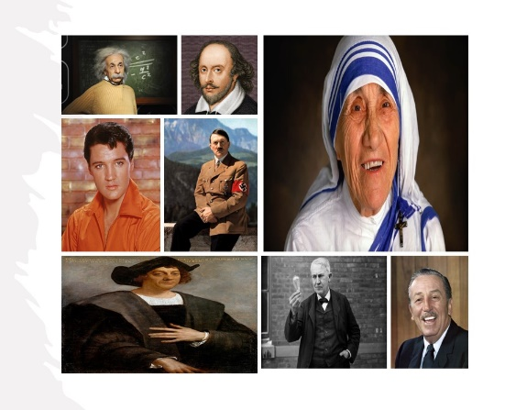Please look at the screen and tell me what all the people shown have in common. They all accomplished much in life and are written in the annals of history. Albert Einstein is known for developing the theory of relativity and his important contributions to the theory of quantum mechanics. William Shakespeare is known for the beautiful poetry he wrote. Elvis Presley is known as the “King of Rock and Roll.” Adolf Hitler is known as the dictator of Nazi Germany who initiated World War II and was responsible for the Holocaust. Christopher Columbus is known as the principal European who discovered the Americas. Thomas Edison is known for getting electricity directly into people’s homes and the inventing the light bulb. Walt Disney is known for his movies, parks, and cartoon characters such as Mickey Mouse and Donald Duck. And Mother Theresa is known for finding the Missionaries of Charity who devoted their time helping the poor of Calcutta, India. All of us have one life to live and want to make the most of our time here on earth. Your goals might not be as lofty as the people mentioned in the history books but as one sits upon one’s deathbed the last think one wants to experience are regrets! The Bible states money, fame, power, and beauty are fleeting and chasing after these things is pure vanity for each of the famous, historical people I mentioned have returned to the dust in which they were formed.

In today’s passage, Philippians 3:7-11, we are going to hear how one of the most famous of Israel’s religious leaders, Apostle Paul, described the true meaning of life!

He traded in his fame, power, and money for suffering and persecution in God’s kingdom because for Paul nothing mattered in life except knowing and living for Christ Jesus our Lord! As you hear the words of Paul, please ask yourself if you too will have peace, security, and assurance that your life mattered because you are filled with and look forward too meeting your Lord!

# **The Right Perspective on Human Achievement**

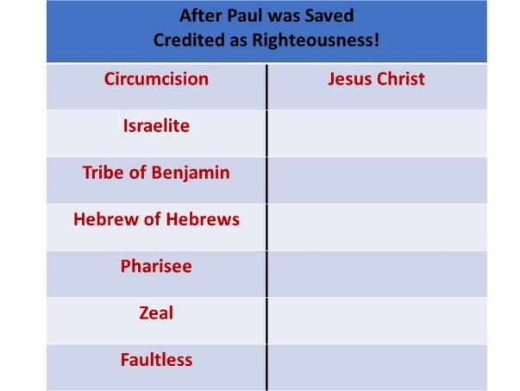 Paul did a “heavenly audit”[1] of his life and with boldness and humility stated, “whatever were gains to me I now consider a loss for the sake of Christ” (3:7). “Gain” and “loss” are accounting terms that Paul used to help us understand the source of a person’s righteousness. What does a sinful, albeit image-bearer, offer to a holy God to be accepted by Him? I am an CPA by trade. When sales are credited, they add to the profit.[2] What does a person do to be credited as righteous in God’s sight? Before Paul was saved, he credited circumcision, being an Israelite, of the tribe of Benjamin, a Hebrew of Hebrews, a Pharisee, zeal, and faultless in following the Mosaic Law (3:4-6) and felt he was “right” before God. Foolishly he thought, surely the “star hope for Gamaliel and the Sanhedrin”[3] had a guaranteed ticket into heaven! Paul’s boasting and confidence in the flesh ended on the road to Damascus when he met Christ and realized he made a serious accounting blunder, “he had still fallen short of what God demanded” [4] and as such his good works were truly to be seen as a loss in God’s sight! But how can this be true? How could one ever count trying to be holy by memorizing and obeying God’s word, Sabbath-keeping, Passover observance, or dietary scrupulosity”[5] as a loss? Is Paul truly suggesting that our attempts at holiness by reading the Bible, praying, worshipping, and feeding the poor are to be considered irrelevant to our standing before a holy God? Yes, they are a loss when one places one faith in human effort rather than faith in a risen Savior![6] Since there is no one righteous not even one and “nothing that is unrighteous or defiling will ever enter heaven” (Revelation 21:27),[7] there is no human accomplishment that can ever be credited to a person. After Paul met Christ, he soon came to realize that Christ alone is the only one that can ever stand in the credit column of our right standing before God![8] Paul is not stating that our attempts at living holy lives are irrelevant but merely that one must be born again, or one simply is not even running the race to win the prize (1 Corinthians 9:24-27)!

Since all human effort is “fleshly and therefore fallible and due to be tainted with sin,”[9] a person’s righteousness can only be imputed upon them through faith in the atoning sacrifice of God’s one and only Son, Jesus!

In Christ alone there is no condemnation (Romans 8:1) because He paid the price for our sin by appeased God’s righteous wrath on the cross! So, Paul rightly said that if one was to boast in anything it would only be in the Lord (1 Corinthians 1:31)!

**Reflection**. Upon what foundation are you standing upon? While it is important to read your Bible, pray, and worship God so that one might become more like Christ, have you ever sat back and reflected upon the mercy and grace of being born again? Just take a moment and close your eyes. As I read John 3:16 let the words flow through your soul and be eternally grateful that through Christ we have been credited as righteous before a holy God! “For God so loved this world that He gave His one and one begotten Son, that whoever believes in Him shall not perish but have eternal life. For God did not send His Son into the world to condemn the world, but to save the world through Him.”

# **The Surpassing Worth of Knowing Christ**

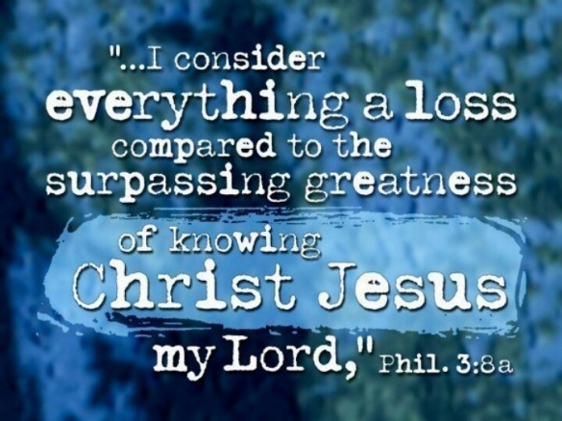 Going back to the heavenly audit Paul emphatically told the Philippians, “What is more, I consider everything a loss because of the surpassing worth of knowing Christ Jesus my Lord, for whose sake I have lost all things. I consider them garbage, that I may gain Christ” (3:8). When the Lord revealed Himself on the road to Damascus to Saul, the Christian terrorist;[10] he was so captivated by Him that he became the Lord’s bondservant for the rest of his life![11] Though the Lord promised Paul that he would proclaim His name to the Gentiles and their kings which might seem prestigious service to most, he also told Paul that He would suffer greatly for doing so (Acts 9:15-16) … and yet Paul said YES! So, as Paul sat in a Roman prison facing possible execution, he reviewed both his losses and gains in ministry. Paul had lost his status, friendships, wealth, and position as a Pharisee in the Jewish community.[12] Had he remained a Pharisee he would have been set for life with money, power, and prestige![13] But what did he gain? The Lord’s promise of suffering for His name’s sake. Five times he received from the Jews forty lashes minus one, three times he was beaten with rods and shipwrecked, once he was pelted with stones, and was always had his life threatened by bandits, Jews, and Gentiles (2 Corinthians 11:24-29)!

And yet as Paul added up his losses, he still found that what he gained, a personal relationship and privilege of calling Jesus Christ Lord, surpassed all he had lost!

What would it benefit him to gain the whole world and, in the end, lose his very life for an eternity (Matthew 16:26)?[14] After Paul became saved, he abhorred his earlier life’s accomplishments[15] as mere “crumbs thrown to dogs in comparison with the rich blessings of the Gospel.” [16] What happened on the road to Damascus was truly a miracle, by faith in the atoning sacrifice of Christ Paul had passed from death to life and now was sealed by the very Spirit of God Himself! The Yahweh of Scripture whom Paul had intently studied about as a Pharisee had now been revealed to him not as knowledge only but in a personal relationship that far outshined anything else he could ever accomplish in life![17] What a privilege it is to know Jesus who “reveals Himself in the storm and in the sunshine”[18] and enables the sinful people we are to be holy and shine like stars in the sky, testifying to His grace and mercy!

**Reflection**. With Jesus we truly have everything and without Him nothing! As I read this quote from Alan Carr ask yourself is this how you view your relationship with the Lord. “Every mile reveals more of His glory to the seeking pilgrim! Every valley proves His sweetness. Every burden His grace. Every step is fragrant with His power and presence in the life of the believer. Yes. All of life is but dung compared with the knowledge of Him!”[19]

# Justification by faith: what does it mean? | Bibleinfo.com

# **Justification by Faith**

Though his reputation with the religious elite was ruined, for “many would have regarded him as a traitor, and an outcast,”[20] and though he was exhausted from the “demeaning work of a tentmaker,” and not only flogged[21] but was constantly in danger of losing his very life; Paul boldly rejoiced for he was right in God’s sight due to his faith in His one and only Son, Jesus! Though Paul felt his righteousness under the law was faultless (3:6), on the road to Damascus he soon came to realize that human righteousness could ever satisfy God’s standards of holiness![22] Every descendent of Adam is under a death sentence for all have sinned and fallen short of the glory of God and the wage of sin is death (Romans 3:10, 3:23, 6:23).[23] Even if Paul thought he had an unbroken record, it was not only self-conferred and tainted by sin but was also impossible to maintain until judgement day![24] To the Philippian church and countless generations since Paul humbly admitted in verse nine that he in fact did not have “righteousness of his own that came from the law (9a)!”[25] Paul knew that God’s demand of “sinless perfection”[26] was not attainable and therefore he could only be justified through another plan. “For God so loved the world that He gave His one and only Son, that whoever believes in Him shall not perish but have eternal life” (John 3:16). Salvation is not based on human effort or achievements but on the perfect obedience of Christ on the cross.[27] As Paul so eloquently stated to the church of Corinth, “He made the One who did not know sin to be sin for us, so that we might become the righteousness of God in Him” (2 Cor 5:21).[28] Though Paul’s “credentials were faultless and unassailable”[29] in his Jewish comrades eyes; until he had faith in the atoning sacrifice of Christ Jesus our Lord Paul would one face judgment before a holy God, be found guilty, and as a son of “the first man Adam” (1 Corinthians 15:45) be casted into hell.

But because of the righteousness imputed upon him by faith in “the last Adam, the life-giving spirit,” Paul knew beyond doubt he would be acquitted and counted as one of God’s very own children! So, “we rejoice in those wonderful words, “It is finished!” (John 19:30)![30]

**Reflection**. The day of the Lord’s return is vastly approaching. On that day “you can either stand there as a Christian at the Judgment Seat of Christ, or you can stand there as a sinner at the Great White Throne!”[31] Which one have you chosen, for not to choose Christ is to reject Him!

# **Becoming More Like Jesus**

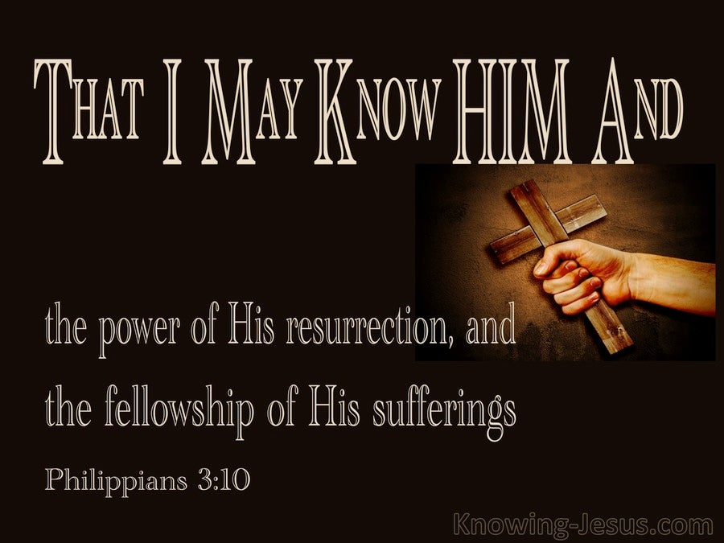 Though it had been about thirty years since Paul met Christ on the road to Damascus,[32] he told the Philippians that he had not adopted an attitude of complacency but an all-encompassing desire to know Him more! Paul did not yearn to just theologically know Christ[33] but to continuously submit to His will and by grace and through faith grow into “the deepest personal intimacy and union”[34] with Him possible! “As we experience His grace, His presence, His power, His glory and His blessings,”[35] our desire to know Christ will continue to intensify so that the “I” of our passions and the “I” of the desires of our flesh will die and Christ will live abundantly in one’s circumcised heart (Galatians 2:20, 5:24). What Paul specifically wanted to know about Christ was the “power of His resurrection and participation in His sufferings, becoming like Him in His death” (3:10). Paul wanted to experience more of the same power of God that raised Jesus Christ from the dead (Ephesians 1:18-23) and raised his dead spirit to life as His very own child!

“It takes nothing less than God’s creational power” to enable the “unrighteous” to be so radically changed that Light shines into the darkest regions of one’s heart and upon confession grants personal crosses[36] of sin to occur and the resurrection of new, holy habits to form!

The power of the Holy Spirit that God has granted to us leads us unto truth, comforts, prays earnestly, and enables us to experience such a radical transformation that we not only participate in the divine nature but have the mind of Christ Himself! Paul yearns to not only better understand God’s great love and mercy (Col 1:11–12)[37] but also to participate in His suffering as well. “Flying in the face of prosperity theology, that says if you have faith, you will be healthy, be wealthy and have no trials;”[38] Paul reminded the Philippians that they had been given the gift of suffering for His name’s sake (1:29). Paul told the church of Rome, “we indeed share in His sufferings in order that we may also share in His glory” (Romans 8:17). “The power of Christ’s resurrection provides the strength and motivation for suffering.”[39] As one walks in the footsteps of the Man of Sorrows it “brings deeper fellowship”[40] and intimacy with the One who purchased one’s salvation at the cost of His very life!

**Reflection**. Do you know Christ as your personal Savior? If so, are you living your life worthy of the Gospel message through the power of His resurrection, especially in face of suffering and persecution? Has the “I” of self that you used to glorify and pay so much attention too been crucified and are you know living for Jesus as your true heart’s passion and desire?

# **Resurrection from the Dead**

 If you were told this was to be your final day on this earth, how would you spend your last few moments? Maybe you would gather your entire family together for a meal or maybe you would take a long walk on the beach with your spouse. Paul who was being “poured out like a drink offering” (2:17) chose to spend his last precious few days on earth the same way that he had since his conversion, “becoming like Christ in His death, and so, somehow, attaining the resurrection of the dead” (3:11). When Paul said “somehow” he was not saying that he was uncertain of his salvation before a holy God[41] but merely that he was unsure if Christ would return in his lifetime, and he would receive his new resurrected body or have to wait until after his physical body had been dead quite some time. Paul lived with this “glorious end, the final resurrection” in mind! As he approached his final days, he would not be like the Judaizers and foolishly stand on human achievement[42] but would only stand upon his faith in the atoning sacrifice of Christ to be his seal and guaranteed pass into heaven, of which he was already a citizen (3:20-21)! In our lifetimes we are given every spiritual blessing in Christ Jesus our Lord but even this is but a mere taste of what is to come.[43] Even Paul who coveted knowing Christ intellectually, relationally, and spiritually; stated his ultimate prize that he desired with all his heart was Christ Himself![44] Yes, Paul cherished receiving a new body that was not subject to sorrow, pain, death, and incapable of sinning; but nothing would satisfy him as much as bowing low to his Lord and basking in His presence!

Whatever days we might have left let us not be “content with putting a mere toe” into the “ocean of glory in Christ Jesus” our Lord but instead let us strive to know Him better and may we never stop inviting Him to transform our hearts into the glorious image in which we were created!

May every day of our lives we put the fingers of hearts, minds, and deeds into the nail prints of our Saviour’s hands and feet and rejoice that He truly has saved a wretch like me!

1. Daniel M. Gurtner, [“Philippians,”](https://ref.ly/logosres/bkbc65ac?ref=Bible.Php3.7&off=156&ctx=e+accounting+terms%2c+~here+suggesting+the+) in *The Bible Knowledge Background Commentary: Acts–Philemon*, ed. Craig A. Evans and Craig A. Bubeck, First Edition. (Colorado Springs, CO: David C Cook, 2004), 583.
2. Of course, if they have lower costs than the sale itself.
3. A.T. Robertson, [*Word Pictures in the New Testament*](https://ref.ly/logosres/rwp?ref=Bible.Php3.7&off=123&ctx=+(ethical+dative).%E2%80%9D+~Paul+had+natural+pri) (Nashville, TN: Broadman Press, 1933), Php 3:7.
4. Roger Ellsworth, [*Opening up Philippians*](https://ref.ly/logosres/openup71php?ref=Bible.Php3.7-9&off=42&ctx=the+flesh+(vv.+7%E2%80%939)%0a~Paul%E2%80%99s+confidence+in), Opening Up Commentary (Leominster: Day One Publications, 2004), 60.
5. Paul Barnett, [*Philippians & Philemon: Joy in the Lord*](https://ref.ly/logosres/rtbt71php?ref=Bible.Php3.4-7&off=5704&ctx=%E2%80%99s+%E2%80%98righteousness%E2%80%99.+~He+could+point+to+a+), ed. Paul Barnett, Reading the Bible Today Series (Sydney, South NSW: Aquila Press, 2016), 89.
6. H. D. M. Spence-Jones, ed., [*Philippians*](https://ref.ly/logosres/tpc47a?ref=Bible.Php3.7&off=176&ctx=+for+Christ%E2%80%99s+sake.+~He+used+to+regard+th), The Pulpit Commentary (London; New York: Funk & Wagnalls Company, 1909), 112.
7. Roger Ellsworth, [*Opening up Philippians*](https://ref.ly/logosres/openup71php?ref=Bible.Php3.7-9&off=198&ctx=+what+God+demanded.%0a~And+what+does+God+de), Opening Up Commentary (Leominster: Day One Publications, 2004), 60.
8. R. Kent Hughes, [*Philippians: The Fellowship of the Gospel*](https://ref.ly/logosres/prwdphil?ref=Bible.Php3.7-9&off=927&ctx=+in+a+very+odd+way.+~Everything+was+on+th), Preaching the Word (Wheaton, IL: Crossway Books, 2007), 132.
9. Frank Thielman, [*Philippians*](https://ref.ly/logosres/nivac71php?ref=Bible.Php3.7-11&off=350&ctx=aim+Paul+righteous.+~But+when+God+apprehe), The NIV Application Commentary (Grand Rapids, MI: Zondervan Publishing House, 1995), 170.
10. R. Kent Hughes, [*Philippians: The Fellowship of the Gospel*](https://ref.ly/logosres/prwdphil?ref=Bible.Php3.7-9&off=1747&ctx=+the+Damascus+Road.+~There+the+grace+of+t), Preaching the Word (Wheaton, IL: Crossway Books, 2007), 132.
11. F. F. Bruce, [*Philippians*](https://ref.ly/logosres/nibcnt71php?ref=Bible.Php3.8&off=3055&ctx=hom+one+never+knew%3f%0a~When+God+chose%2c+on+t), Understanding the Bible Commentary Series (Peabody, MA: Baker Books, 2011), 114.
12. G. Walter Hansen, [*The Letter to the Philippians*](https://ref.ly/logosres/pntcphp?ref=Bible.Php3.8&off=4999&ctx=+suffered+hardship.+~Paul+is+not+speaking), The Pillar New Testament Commentary (Grand Rapids, MI; Nottingham, England: William B. Eerdmans Publishing Company, 2009), 236.
13. R. Kent Hughes, [*Philippians: The Fellowship of the Gospel*](https://ref.ly/logosres/prwdphil?ref=Bible.Php3.7-9&off=2934&ctx=in+Christ%E2%80%9D+(v.+8b).+~Paul+lost+not+only+h), Preaching the Word (Wheaton, IL: Crossway Books, 2007), 133.
14. Tony Merida and Francis Chan, [*Exalting Jesus in Philippians*](https://ref.ly/logosres/9780805497595?ref=Bible.Php3.7-11&off=1362&ctx=m+Jesus%E2%80%99+question%2c+%E2%80%9C~What+will+it+benefit), ed. David Platt, Daniel L. Akin, and Tony Merida, Christ-Centered Exposition Commentary (Nashville, TN: Holman Reference, 2016), 140.
15. R. Kent Hughes, [*Philippians: The Fellowship of the Gospel*](https://ref.ly/logosres/prwdphil?ref=Bible.Php3.7-9&off=3332&ctx=-century+standards.+~Paul%E2%80%99s+former+accomp), Preaching the Word (Wheaton, IL: Crossway Books, 2007), 133.
16. H. D. M. Spence-Jones, ed., [*Philippians*](https://ref.ly/logosres/tpc47a?ref=Bible.Php3.8&off=1555&ctx=+of+the+comparison%3b+~the+legal+privileges), The Pulpit Commentary (London; New York: Funk & Wagnalls Company, 1909), 113.
17. Alan Carr, [“How to Develop a Normal Christian Life (Philippians 3:7–11),”](https://ref.ly/logosres/sermonnotebooknt?ref=Bible.Php3.7-11&off=6359&ctx=ause+us+to+see+that+~knowing+Jesus+is+mor) in *The Sermon Notebook: New Testament* (Lenoir, NC: Alan Carr, 2015), 3008.
18. Alan Carr, [“How to Develop a Normal Christian Life (Philippians 3:7–11),”](https://ref.ly/logosres/sermonnotebooknt?ref=Bible.Php3.7-11&off=8308&ctx=come+to+God.+(Note%3a+~To+know+Jesus+in+a+p) in *The Sermon Notebook: New Testament* (Lenoir, NC: Alan Carr, 2015), 3008.
19. Alan Carr, [“How to Develop a Normal Christian Life (Philippians 3:7–11),”](https://ref.ly/logosres/sermonnotebooknt?ref=Bible.Php3.7-11&off=8689&ctx=just+the+beginning!+~Every+mile+reveals+m) in *The Sermon Notebook: New Testament* (Lenoir, NC: Alan Carr, 2015), 3008.
20. Paul Barnett, [*Philippians & Philemon: Joy in the Lord*](https://ref.ly/logosres/rtbt71php?ref=Bible.Php3.8b-9a&off=318&ctx=Hebrew+of+Hebrews%E2%80%99.%0a~All+his+kudos+as+a+l), ed. Paul Barnett, Reading the Bible Today Series (Sydney, South NSW: Aquila Press, 2016), 91.
21. Paul Barnett, [*Philippians & Philemon: Joy in the Lord*](https://ref.ly/logosres/rtbt71php?ref=Bible.Php3.8b-9a&off=670&ctx=d+disinherited+him.+~He+was+now+a+ragged+), ed. Paul Barnett, Reading the Bible Today Series (Sydney, South NSW: Aquila Press, 2016), 91.
22. Paul Barnett, [*Philippians & Philemon: Joy in the Lord*](https://ref.ly/logosres/rtbt71php?ref=Bible.Php3.9b-c&off=293&ctx=om+the+law%E2%80%99+(v+9a).+~He+knew+that+because), ed. Paul Barnett, Reading the Bible Today Series (Sydney, South NSW: Aquila Press, 2016), 91.
23. Alan Carr, [“How to Develop a Normal Christian Life (Philippians 3:7–11),”](https://ref.ly/logosres/sermonnotebooknt?ref=Bible.Php3.7-11&off=10973&ctx=+%E2%80%9CAdam%E2%80%9D%2c+Rom.+5%3a12.+~All+of+Adam%E2%80%99s+childr) in *The Sermon Notebook: New Testament* (Lenoir, NC: Alan Carr, 2015), 3008.
24. J. A. Motyer, [*The Message of Philippians*](https://ref.ly/logosres/bstus71php?ref=Bible.Php3.9-12&off=3786&ctx=ming+to+a+standard.+~Now%2c+such+a+righteou), The Bible Speaks Today (Downers Grove, IL: InterVarsity Press, 1984), 165.
25. Paul Barnett, [*Philippians & Philemon: Joy in the Lord*](https://ref.ly/logosres/rtbt71php?ref=Bible.Php3.9b-c&off=49&ctx=+in+Christ+(3%3a9b%E2%80%93c)%0a~Why+was+Paul+so+dete), ed. Paul Barnett, Reading the Bible Today Series (Sydney, South NSW: Aquila Press, 2016), 91.
26. Tony Merida and Francis Chan, [*Exalting Jesus in Philippians*](https://ref.ly/logosres/9780805497595?ref=Bible.Php3.9&off=164&ctx=%E2%80%9Cblameless%E2%80%9D+(v.+6).+~However%2c+he+couldn%E2%80%99t), ed. David Platt, Daniel L. Akin, and Tony Merida, Christ-Centered Exposition Commentary (Nashville, TN: Holman Reference, 2016), 141.
27. H. D. M. Spence-Jones, ed., [*Philippians*](https://ref.ly/logosres/tpc47a?ref=Bible.Php3.9&off=1190&ctx=usness+of+his+own%2c+%E2%80%9C~Not+by+works+of+righ), The Pulpit Commentary (London; New York: Funk & Wagnalls Company, 1909), 113.
28. Tony Merida and Francis Chan, [*Exalting Jesus in Philippians*](https://ref.ly/logosres/9780805497595?ref=Bible.Php3.9&off=889&ctx=od%E2%80%99s+righteousness.+~To+the+Corinthians%2c+), ed. David Platt, Daniel L. Akin, and Tony Merida, Christ-Centered Exposition Commentary (Nashville, TN: Holman Reference, 2016), 142.
29. R. Kent Hughes, [*Philippians: The Fellowship of the Gospel*](https://ref.ly/logosres/prwdphil?ref=Bible.Php3.7-9&off=5185&ctx=he+gospel+of+grace.+~Paul%E2%80%99s+credentials+w), Preaching the Word (Wheaton, IL: Crossway Books, 2007), 133.
30. Tony Merida and Francis Chan, [*Exalting Jesus in Philippians*](https://ref.ly/logosres/9780805497595?ref=Bible.Php3.9&off=3205&ctx=hrist+did+the+work.+~We+rejoice+in+those+), ed. David Platt, Daniel L. Akin, and Tony Merida, Christ-Centered Exposition Commentary (Nashville, TN: Holman Reference, 2016), 142.
31. Alan Carr, [“How to Develop a Normal Christian Life (Philippians 3:7–11),”](https://ref.ly/logosres/sermonnotebooknt?ref=Bible.Php3.7-11&off=10708&ctx=14%3a12%3b+2+Cor.+5%3a10.+~You+can+either+stand) in *The Sermon Notebook: New Testament* (Lenoir, NC: Alan Carr, 2015), 3008.
32. R. Kent Hughes, [*Philippians: The Fellowship of the Gospel*](https://ref.ly/logosres/prwdphil?ref=Bible.Php3.10a&off=67&ctx=at+I+may+know+him.%E2%80%9D+~It+had+been+thirty+y), Preaching the Word (Wheaton, IL: Crossway Books, 2007), 137–138.
33. H. D. M. Spence-Jones, ed., [*Philippians*](https://ref.ly/logosres/tpc47a?ref=Bible.Php3.10&off=965&ctx=nto+the+same+image.+~For+the+knowledge+he), The Pulpit Commentary (London; New York: Funk & Wagnalls Company, 1909), 113.
34. J. A. Motyer, [*The Message of Philippians*](https://ref.ly/logosres/bstus71php?ref=Bible.Php3.9-12&off=11388&ctx=ractical+dimension.+~Nothing+is+truly+kno), The Bible Speaks Today (Downers Grove, IL: InterVarsity Press, 1984), 169.
35. Alan Carr, [“How to Develop a Normal Christian Life (Philippians 3:7–11),”](https://ref.ly/logosres/sermonnotebooknt?ref=Bible.Php3.7-11&off=12374&ctx=about+Jesus+Christ.+~As+we+experience+His) in *The Sermon Notebook: New Testament* (Lenoir, NC: Alan Carr, 2015), 3009.
36. R. Kent Hughes, [*Philippians: The Fellowship of the Gospel*](https://ref.ly/logosres/prwdphil?ref=Bible.Php3.10c&off=651&ctx=rmed+to+his+death.9+~Paul%E2%80%99s+language+indi), Preaching the Word (Wheaton, IL: Crossway Books, 2007), 141.
37. Tony Merida and Francis Chan, [*Exalting Jesus in Philippians*](https://ref.ly/logosres/9780805497595?ref=Bible.Php3.10&off=2502&ctx=+Let%E2%80%99s+unpack+this.%0a~Note+first%2c+believer), ed. David Platt, Daniel L. Akin, and Tony Merida, Christ-Centered Exposition Commentary (Nashville, TN: Holman Reference, 2016), 144.
38. Tony Merida and Francis Chan, [*Exalting Jesus in Philippians*](https://ref.ly/logosres/9780805497595?ref=Bible.Php3.10&off=3279&ctx=hrist%E2%80%99s+sufferings.+~Earlier%2c+he+told+the), ed. David Platt, Daniel L. Akin, and Tony Merida, Christ-Centered Exposition Commentary (Nashville, TN: Holman Reference, 2016), 145.
39. R. Kent Hughes, [*Philippians: The Fellowship of the Gospel*](https://ref.ly/logosres/prwdphil?ref=Bible.Php3.10b&off=8462&ctx=of+his+sufferings.%E2%80%9D+~The+power+of+Christ%E2%80%99), Preaching the Word (Wheaton, IL: Crossway Books, 2007), 141.
40. John D. Barry et al., [*Faithlife Study Bible*](https://ref.ly/logosres/fsb?ref=Bible.Php3.10&off=80&ctx=Resurrection+NDBT%0a++~Paul+seems+to+recogn) (Bellingham, WA: Lexham Press, 2012, 2016), Php 3:10.
41. Paul Barnett, [*Philippians & Philemon: Joy in the Lord*](https://ref.ly/logosres/rtbt71php?ref=Bible.Php3.10-11&off=875&ctx=m+the+dead%E2%80%99+(v+11).+~Is+Paul+uncertain+of), ed. Paul Barnett, Reading the Bible Today Series (Sydney, South NSW: Aquila Press, 2016), 92–93.
42. Tony Merida and Francis Chan, [*Exalting Jesus in Philippians*](https://ref.ly/logosres/9780805497595?ref=Bible.Php3.11&off=161&ctx=er+that+assumption.+~Rather%2c+he%E2%80%99s+either+), ed. David Platt, Daniel L. Akin, and Tony Merida, Christ-Centered Exposition Commentary (Nashville, TN: Holman Reference, 2016), 145.
43. Tony Merida and Francis Chan, [*Exalting Jesus in Philippians*](https://ref.ly/logosres/9780805497595?ref=Bible.Php3.11&off=1621&ctx=elf.+(Phil+3%3a20%E2%80%9321)%0a~We+have+a+taste+of+t), ed. David Platt, Daniel L. Akin, and Tony Merida, Christ-Centered Exposition Commentary (Nashville, TN: Holman Reference, 2016), 146.
44. R. Kent Hughes, [*Philippians: The Fellowship of the Gospel*](https://ref.ly/logosres/prwdphil?ref=Page.p+142&off=876&ctx=teral+translation).+~And+what+would+be+hi), Preaching the Word (Wheaton, IL: Crossway Books, 2007), 142.