# **For God so Loved the World**

**John 3:14-21**

Online Sermon: <http://www.mckeesfamily.com/?page_id=3567>

**“How can someone be born when they are old?”**

**Nicodemus, John 3:4**

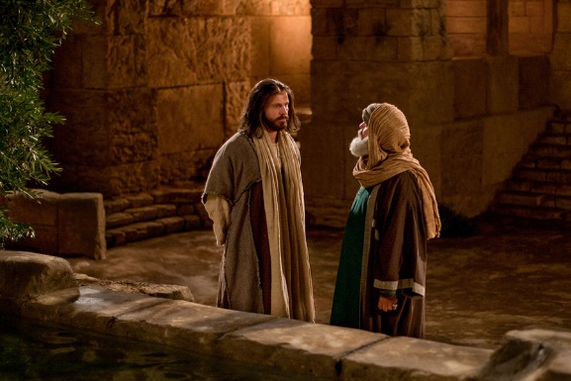Though humanity has had over 2,000 years to reflect on the significance of Nicodemus’ question on how to be born again there are still many people in this world who do not know or are unwilling to embrace the answer to this question! Nicodemus was a distinguished Jew, a pharisee and a member of the Sanhedrin,[1] and yet the pathway to God remained for him elusive. He had always been taught the criteria for salvation was to be a descendent of Abraham and faithfully keep the Law of Moses[2] but now One whose sandals that even John the Baptist was unworthy to tie (John 1:27) was stating that the only prerequisite to entering the kingdom of God was to be born again![3] Even to an astute theologian like Nicodemus this seemed ridiculous for how could a person enter their mother’s womb a second time (1:4)? It is at Easter that we remember, profess, and celebrate the answer to this life altering question.

None are righteous and salvation cannot be earned by any amount of human effort (Romans 3:10-18; Ephesians 2:8-9)! Christ told Nicodemus to pass from death to life one simply must be born again by the water and the Spirit which only happens when a person has faith in the atoning sacrifice of God’s one and only Son, Jesus!

While this does not seem like much of a price to feast at the Lord’s table for all of eternity it came at price of Christ’s very life! Easter is upon us, and the goal of this sermon is twofold. First, for those who have not stepped in the Lord’s glorious light I implore you on Christ’s behalf become born again by the Spirit so that you might be reconciled unto God (2 Corinthians 5:20) for all of eternity! And second, for those who are born again, know and cherish the Gospel message in your hearts so that you will always be ready to give the reasons why you have hope in the Lord (1 Peter 3:15)!

# Pin on BRONZE SNAKE OF MOSES !!!**The Reality of God’s Love**

At the heart of the Easter message is one of the most famous and loved verses of all the Bible, John 3:16.[4] The key to understanding this verse can be found in the last thing Jesus told Nicodemus. Referring to Numbers 21, Jesus told him that “just as Moses lifted up the snake in the wilderness, so the Son of man must be lifted up, that everyone who believes may have eternal life” (3:14-15). “The command to look to that uplifted serpent was a gracious foreshadowing of looking to Christ for our salvation.”[5] Jesus became sin (or serpent, Romans 8:3)[6] for us so that in graciously bearing the venom of God’s wrath and by belief in Him the old would be gone and a new nature, born of the Spirit, would be given to us (2 Corinthians 5:17)![7] This miraculous gift of salvation was not earned but received through faith and thankfully even the “most degraded and miserable of sinner who looks upon Christ will be saved!”[8] Though the people of this world are filled with “disbelief and hostility (15:18–19; 16:8)[9] and were His enemies (Romans 5:10), Christ chose to die once and for all (John 10:18, Romans 6:10). God not only said the words “I love you” but demonstrated them by giving us the most precious thing to Him, the life of His one and only Son, Jesus.[10] Salvation to us is a free gift from God but by no means was it cheap![11] While Christ alone is “unquestionably righteous”[12] and we are stilled flawed by our sinful nature, having been sealed by God’s Spirit means that we can approach His throne of grace as His children because He first loved us (1 John 4:19).[13] The heart of the Gospel message is that God’s love is like a “vast, inbounded, bottomless sea”[14] in which all are invited to be born again and feast in His kingdom!

# **The Reason Jesus Came**

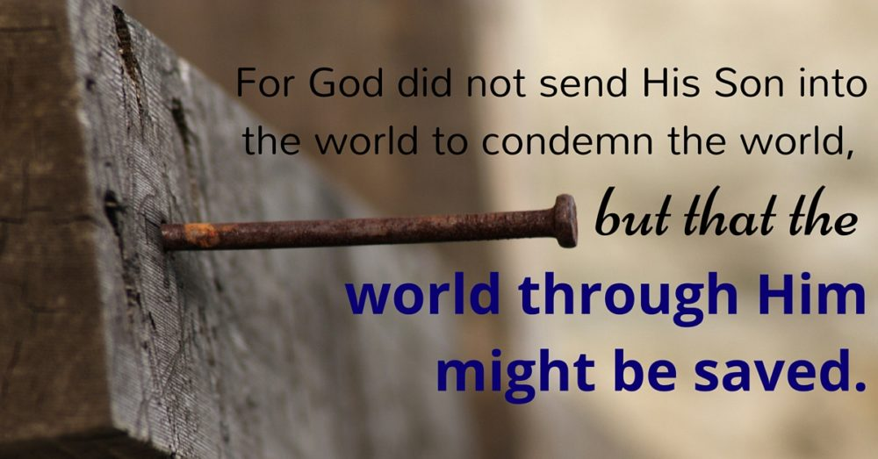 Even though there is no one righteous and all deserve the wages of sin, which is death (Romans 6:23), John states that “God did not send His Son to condemn the world, but to save the world through Him” (3:17). Ever since “Adam and Eve foolishly stepped out from under God’s perfect and wise rule, deciding what they knew was best”[15] no amount of “human ingenuity”[16] or effort could ever result in humanity being righteous in God’s sight. “We could no more save ourselves than a baby could birth himself.”[17] Though there is no darkness in Him at all (1 John 1:5) God’s desire was not to condemn but provide the means of our salvation by sending His Son into the world to atone for our sins upon the cross. This statement for the Jews would have been alarming for while they believed that God’s desire was to “save rather than to judge (Ezekiel 18:23)”[18] during the Second Temple period most of them believed that salvation was for the Jews and judgment was for all others, especially Rome who were persecuting them![19] While this was likely offensive to many Jewish people the truth remained that God sent “Someone unique into the world who was both God and man”[20] to provide the means of salvation for all of humanity, not just a segment of it![21] But how can this truth be reconciled with other statements about Jesus judging the world? Did not Jesus say, “be afraid of the One who can destroy both soul and body in hell” (Matthew 10:28) and did he not say, “the Father judges no one, but has entrusted all judgment to the Son” (John 5:22)? By saying that Jesus came to save, not condemn the word this is not a contradiction of His prior statements. “The Son of Man came into an already lost and condemned world in order to save those”[22] who chose to believe in Him and in contrast those who chose to reject Him remain condemned. While “His judgment is just (5:30) and true (8:16)”[23] His preference is that none might perish, and everyone come to repentance and be reconciled unto God (2 Peter 3:9).

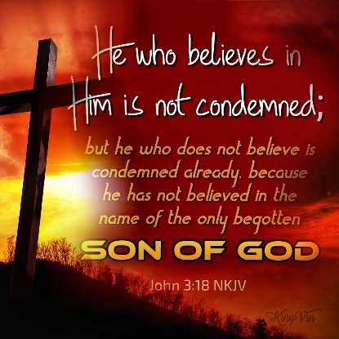While His “winnowing fork” of judgment is in His hand (Matthew 3:12) so too is a gracious, merciful invitation to be eternally adopted as His Father’s very own child!

Now that our bondage to sin was broken on the cross joyfully everyone gets the choice, death, or life!

**Reflection**. When you think about the Lord do you only see Him as a judge of both the living and the dead, which He is, or do you also reflect and rejoice over the truth that He is kind, gracious and merciful to us who deserve condemnation but instead are offered eternal life? While trying to live a good life for the Lord is key to pleasing Him do you know that salvation is a gift that cannot be earned but only received through faith in Christ Jesus our Lord? The more you reflect on the depravity of your sins the more you get a glimpse of His grace and mercy!

# **Our Response Matters**

God mercifully and graciously sent His one and only Son Jesus into the world to be “lifted up for our salvation.”[24] We could try to “stand before God and proclaim our innocence,”[25] based on our efforts to follow His laws or being a descendent of Abraham, but the truth is that “all have sinned and fallen short of the glory of God” (Romans 3:23) and deserve His “awful and terrifying judgment,”[26] an eternal place in hell (Romans 6:23)! Not wanting His image bearers to perish God sent His Son to “take our place” and take on the full wrath of God for our sins![27] While Christ’s sacrifice on the cross was “once and for all” this does not mean that everyone is automatically saved [28] but merely that one chooses one’s own eternal destiny. Those who have faith in Jesus the “righteous demands of the law are fulfilled,”[29] their sins and guilt are washed away,[30] and they are sealed by God’s very own Spirit signifying their innocence and eternal adoption as His very own child. Joyfully John tells those who believe in Jesus do not need to worry that their sin will send them to hell[31] for the believer is no longer condemned for who could ever have the right to charge us with sin that Christ already paid the price for (Romans 8:34)?[32] However John also says that those who refuse God’s gracious gift of salvation through belief in His Son stand condemned already for there is no other way, truth, and life except Christ (John 14:6).

“To refuse his good gift is to call down judgment on oneself”[33] for “God’s mind is already made up concerning the eternal state of those who refuse to believe in His Son.”[34]

This does not mean that unbelief due to sin blinding one’s eyes, closing one’s ears, and hardening of one’s heart is irreversible,[35] if that were the case then Apostle Paul would never have had his “Damascus road” experience and subsequent salvation. God gives us a lifetime to choose to believe in His Son and sends many of His servants to reveal the Gospel message to us. To ignore the message is to reject Christ and to be condemned but the moment a person believes in Jesus they become born again all condemnation is removed and eternal life as God’s very own child is granted![36] What will you choose, death of life?

# **Rejecting the Light**

Yet despite haven been given the choice to live, many will choose death rather than life because they love darkness rather than light! God’s great saving act of sending His one and only Son Jesus as light into the world was meant for one’s salvation but for many it has become their means of judgment.[37] Even though Jesus died once and for all to make a way for salvation and adoption into God’s family, many will reject Him and continue to do evil because they truly love the darkness and prefer to remain[38] living to satisfy the god of self. God gives such a person over to the depraved minds because their true heart’s desire is to be gossips, slanderers, God-haters, insolent, arrogant, boastful, without understanding, fidelity, love, or mercy (Romans 1:29-30)! The god of this world has blinded 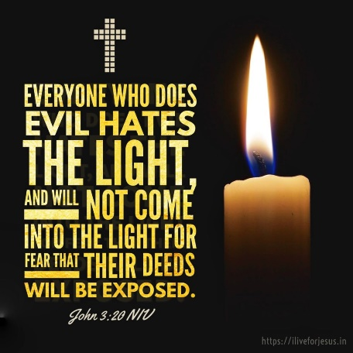their minds so that they can no longer see the light of the Gospel (2 Corinthians 4:4).[39] They live their lives on the broad path of choice constantly waging war against the light[40] but only from afar lest they approach the light, and the Lord reveals to them their eternal choice of death over life! I often hear unbelievers ask, “how could a gracious, loving, merciful God sentence a person made in His own image to an eternity in hell, where there is wailing and gnashing of teeth” (Matthew 13:42)? To this I answer, “people will face the consequences of their sin not because God’s gift of Jesus is insufficient but because they refuse to turn from their sin and trust in Jesus to save them from sin’s penalty,” death.[41] You might be like Nicodemus and object, “I’m a good person, a church goer, read my Bible and pray frequently, surely this means I am going to heaven,” and to this Christ says you stand condemned already for until you believe in His atonement for your sins you remain in bondage to them and will receive sin’s wages, the burning lake of hell!

**Reflection**: Do you know beyond a doubt that you are born again, or do you feel like you are living more for yourself and are afraid to pray, read God’s word, and praise Him in fear that He might expose your evil deeds and boldly state you stand condemned already because you have rejected His one and only Son?

# **Coming into the Light**

In conclusion the answer to Nicodemus’ question on how one can be born is the reason why we are here at Easter time! The difference between a believer and unbeliever is not “guilt or innocence”[42] but one’s reaction too the Light God sent into this world. We have a spiritual disease called sin that keeps us estranged from God who has no darkness in Him at all. Like Nicodemus no matter how much one prays, reads the Bible, feeds the poor, takes care of widows, or obtains a high status in the church; one cannot become saved based on one’s own merits for all are unrighteous, all have sinned, all fallen short of God’s glory, and all rightfully receive the wages of sin, death. The answer to Nicodemus’ question, how to be born again, is found in one the most cherished and memorized verses in all Scripture, “For God so loved the world that He gave His one and only Son, that whoever believes in Him shall not perish but have eternal life” (John 3:16). Condemnation of humanity was earned by our sin, but salvation can only be received through belief in the atoning sacrifice of Jesus Christ on the cross! Though God wishes that none perish, and Christ died once and for all, this does not mean everyone is saved. Christ in essence was telling Nicodemus and us today to reject the darkness lest we become enslaved to it and start hating the light because it exposes our evil deeds! Apostle John warns us that those who reject the Son reject God and remain condemned to hell despite their effort or good deeds. Conversely those who have belief in Christ become born again and in passing from death to life gladly approach the light because they might plainly and joyfully see the sole source of their eternal salvation, Christ! So, before we come to the communion table I implore you on behalf of Christ, be reconciled unto God through faith in His Son before its too late!

1. Paul Barnett, [*John: The Shepherd King*](https://ref.ly/logosres/rtbt64jn?ref=Bible.Jn2.23-3.36&off=833&ctx=m%E2%80%99+was+superficial.%0a~Now+follows+the+acco), Revised., Reading the Bible Today Series (Sydney, South NSW: Aquila Press, 2011), 35.
2. Gary M. Burge, [“Gospel of John,”](https://ref.ly/logosres/bkbc64jn?ref=Bible.Jn3.1-21&off=5400&ctx=+(42%3a1%E2%80%939%3b+49%3a1%E2%80%9326).+~Judaism+taught+that+) in *John’s Gospel, Hebrews–Revelation*, ed. Craig A. Evans and Craig A. Bubeck, First Edition., The Bible Knowledge Background Commentary (Colorado Springs, CO; Paris, ON; Eastbourne: David C Cook, 2005), 52.
3. Gary M. Burge, [“Gospel of John,”](https://ref.ly/logosres/bkbc64jn?ref=Bible.Jn3.1-21&off=5681&ctx=+separate+contexts.%0a~But+Jesus+gives+a+ne) in *John’s Gospel, Hebrews–Revelation*, ed. Craig A. Evans and Craig A. Bubeck, First Edition., The Bible Knowledge Background Commentary (Colorado Springs, CO; Paris, ON; Eastbourne: David C Cook, 2005), 52.
4. Matt Carter and Josh Wredberg, [*Exalting Jesus in John*](https://ref.ly/logosres/9781433648618?ref=Bible.Jn3.14-16&off=39&ctx=s+Love%0ajohn+3%3a14%E2%80%9316%0a~John+3%3a16+may+be+the) (Nashville, TN: Holman Reference, 2017), 61.
5. R. Kent Hughes, [*John: That You May Believe*](https://ref.ly/logosres/prwdjohn?ref=Bible.Jn3.9-21&off=5210&ctx=e+snake%2c+he+lived.%E2%80%9D+~The+command+to+look+), Preaching the Word (Wheaton, IL: Crossway Books, 1999), 83.
6. R. Kent Hughes, [*John: That You May Believe*](https://ref.ly/logosres/prwdjohn?ref=Bible.Jn3.9-21&off=4509&ctx=+perfect+if+he+had.+~Our+Lord+became+sin+), Preaching the Word (Wheaton, IL: Crossway Books, 1999), 83.
7. R. Kent Hughes, [*John: That You May Believe*](https://ref.ly/logosres/prwdjohn?ref=Bible.Jn3.9-21&off=6298&ctx=Then+he+understood.%0a~So+Jesus+has+set+dow), Preaching the Word (Wheaton, IL: Crossway Books, 1999), 83.
8. R. Kent Hughes, [*John: That You May Believe*](https://ref.ly/logosres/prwdjohn?ref=Bible.Jn3.9-21&off=5710&ctx=alvation+was+there.+~Even+the+most+degrad), Preaching the Word (Wheaton, IL: Crossway Books, 1999), 83.
9. Gary M. Burge, [“Gospel of John,”](https://ref.ly/logosres/bkbc64jn?ref=Bible.Jn3.1-21&off=12727&ctx=of+race+and+nation.+~Second%2c+John+tells+h) in *John’s Gospel, Hebrews–Revelation*, ed. Craig A. Evans and Craig A. Bubeck, First Edition., The Bible Knowledge Background Commentary (Colorado Springs, CO; Paris, ON; Eastbourne: David C Cook, 2005), 54.
10. Matt Carter and Josh Wredberg, [*Exalting Jesus in John*](https://ref.ly/logosres/9781433648618?ref=Bible.Jn3.14-16&off=2207&ctx=s+them+I+love+them.+~We+can+be+confident+) (Nashville, TN: Holman Reference, 2017), 62.
11. Matt Carter and Josh Wredberg, [*Exalting Jesus in John*](https://ref.ly/logosres/9781433648618?ref=Bible.Jn3.14-16&off=2819&ctx=his+little+brother.+~God%E2%80%99s+love+is+displa) (Nashville, TN: Holman Reference, 2017), 62.
12. Matt Carter and Josh Wredberg, [*Exalting Jesus in John*](https://ref.ly/logosres/9781433648618?ref=Bible.Jn3.14-16&off=3916&ctx=+of+the+punishment.+~When+Jesus+took+upon) (Nashville, TN: Holman Reference, 2017), 63.
13. Matt Carter and Josh Wredberg, [*Exalting Jesus in John*](https://ref.ly/logosres/9781433648618?ref=Bible.Jn3.14-16&off=3703&ctx=ne+who+loves+first.+~The+apostle+John+wou) (Nashville, TN: Holman Reference, 2017), 63.
14. R. Kent Hughes, [*John: That You May Believe*](https://ref.ly/logosres/prwdjohn?ref=Bible.Jn3.9-21&off=9245), Preaching the Word (Wheaton, IL: Crossway Books, 1999), 84.
15. Matt Carter and Josh Wredberg, [*Exalting Jesus in John*](https://ref.ly/logosres/9781433648618?ref=Bible.Jn3.17&off=415&ctx=the+garden+of+Eden.+~Adam+and+Eve+foolish) (Nashville, TN: Holman Reference, 2017), 63.
16. Matt Carter and Josh Wredberg, [*Exalting Jesus in John*](https://ref.ly/logosres/9781433648618?ref=Bible.Jn3.17&off=1348&ctx=The+Last+Enemy%2c+13)%0a~We+needed+something+) (Nashville, TN: Holman Reference, 2017), 64.
17. Matt Carter and Josh Wredberg, [*Exalting Jesus in John*](https://ref.ly/logosres/9781433648618?ref=Bible.Jn3.17&off=1681&ctx=from+sin+and+death%3f+~We+could+no+more+sav) (Nashville, TN: Holman Reference, 2017), 64.
18. Andreas J. Köstenberger, [“John,”](https://ref.ly/logosres/bkrllstrtdbccmm?ref=Bible.Jn3.17&off=104&ctx=through+him+(3%3a17).+~The+OT+emphasizes+th) in *The Baker Illustrated Bible Background Commentary*, ed. J. Scott Duvall and J. Daniel Hays (Grand Rapids, MI: Baker Books, 2020), 960–961.
19. Matt Carter and Josh Wredberg, [*Exalting Jesus in John*](https://ref.ly/logosres/9781433648618?ref=Bible.Jn3.17&off=103&ctx=+the+world+(v.+17).+~The+Jews+were+lookin) (Nashville, TN: Holman Reference, 2017), 63.
20. Matt Carter and Josh Wredberg, [*Exalting Jesus in John*](https://ref.ly/logosres/9781433648618?ref=Bible.Jn3.17&off=1918&ctx=Son+into+the+world.+~No+mere+man+could+ev) (Nashville, TN: Holman Reference, 2017), 64.
21. George R. Beasley-Murray, [*John*](https://ref.ly/logosres/wbc36?ref=Bible.Jn3.17-21&off=330&ctx=the+world+be+saved.+~The+incarnation%2c+dea), vol. 36, Word Biblical Commentary (Dallas: Word, Incorporated, 1999), 51.
22. D. A. Carson, [*The Gospel according to John*](https://ref.ly/logosres/pntcjohn?ref=Bible.Jn3.17&off=1411&ctx=and+more+important%2c+~the+Son+of+Man+came+), The Pillar New Testament Commentary (Leicester, England; Grand Rapids, MI: Inter-Varsity Press; W.B. Eerdmans, 1991), 207.
23. Leon Morris, [*The Gospel according to John*](https://ref.ly/logosres/nicnt64jn?ref=Bible.Jn3.17&off=1193&ctx=ing+people+(12%3a48).+~His+judgment+is+just), The New International Commentary on the New Testament (Grand Rapids, MI: Wm. B. Eerdmans Publishing Co., 1995), 205.
24. Colin G. Kruse, [*John: An Introduction and Commentary*](https://ref.ly/logosres/tntc64jnus?ref=Bible.Jn3.18&off=265&ctx=+condemned+already.+~He+then+explains+why), vol. 4, Tyndale New Testament Commentaries (Downers Grove, IL: InterVarsity Press, 2003), 118–119.
25. Matt Carter and Josh Wredberg, [*Exalting Jesus in John*](https://ref.ly/logosres/9781433648618?ref=Bible.Jn3.18&off=332&ctx=y+do+for+ourselves.+~We+could+stand+befor) (Nashville, TN: Holman Reference, 2017), 65.
26. Matt Carter and Josh Wredberg, [*Exalting Jesus in John*](https://ref.ly/logosres/9781433648618?ref=Bible.Jn3.18&off=2204&ctx=+penalty+of+death.+%E2%80%9C~For+the+wages+of+sin) (Nashville, TN: Holman Reference, 2017), 66.
27. A.T. Robertson, [*Word Pictures in the New Testament*](https://ref.ly/logosres/rwp?ref=Bible.Jn3.18&off=82&ctx=passive+indicative.+~Trust+in+Christ+prev) (Nashville, TN: Broadman Press, 1933), Jn 3:18.
28. Leon Morris, [*The Gospel according to John*](https://ref.ly/logosres/nicnt64jn?ref=Bible.Jn3.18&off=55&ctx=mportance+of+faith.+~He+has+said+that+Chr), The New International Commentary on the New Testament (Grand Rapids, MI: Wm. B. Eerdmans Publishing Co., 1995), 206.
29. Matt Carter and Josh Wredberg, [*Exalting Jesus in John*](https://ref.ly/logosres/9781433648618?ref=Bible.Jn3.18&off=707&ctx=+declared+innocent.%0a~The+righteous+demand) (Nashville, TN: Holman Reference, 2017), 65.
30. Matt Carter and Josh Wredberg, [*Exalting Jesus in John*](https://ref.ly/logosres/9781433648618?ref=Bible.Jn3.18&off=588&ctx=y+marked+for+death.+~But+when+we+place+ou) (Nashville, TN: Holman Reference, 2017), 65.
31. Matt Carter and Josh Wredberg, [*Exalting Jesus in John*](https://ref.ly/logosres/9781433648618?ref=Bible.Jn3.18&off=31&ctx=of+Belief%0ajohn+3%3a18%0a~Whoever+believes+in+) (Nashville, TN: Holman Reference, 2017), 65.
32. Matt Carter and Josh Wredberg, [*Exalting Jesus in John*](https://ref.ly/logosres/9781433648618?ref=Bible.Jn3.18&off=893&ctx=annot+be+condemned.+~If+God+has+declared+) (Nashville, TN: Holman Reference, 2017), 65.
33. Leon Morris, [*The Gospel according to John*](https://ref.ly/logosres/nicnt64jn?ref=Bible.Jn3.18&off=1670&ctx=them+to+a+decision.+~To+refuse+his+good+g), The New International Commentary on the New Testament (Grand Rapids, MI: Wm. B. Eerdmans Publishing Co., 1995), 206.
34. Alan Carr, [“Jesus: The Divine Teacher (John 3:1–21),”](https://ref.ly/logosres/sermonnotebooknt?ref=Bible.Jn3.1-21&off=34668&ctx=+18+A+Present+State%E2%80%94~According+to+this+ve) in *The Sermon Notebook: New Testament* (Lenoir, NC: Alan Carr, 2015), 1591.
35. H. D. M. Spence-Jones, ed., [*St. John*](https://ref.ly/logosres/tpc39?ref=Bible.Jn3.18&off=1307&ctx=egotten+Son+of+God.+~Such+non-belief+reve), vol. 1, The Pulpit Commentary (London; New York: Funk & Wagnalls Company, 1909), 124.
36. H. D. M. Spence-Jones, ed., [*St. John*](https://ref.ly/logosres/tpc39?ref=Bible.Jn3.18&off=2455&ctx=+the+supreme+Judge.+~The+final+judgment+i), vol. 1, The Pulpit Commentary (London; New York: Funk & Wagnalls Company, 1909), 124–125.
37. George R. Beasley-Murray, [*John*](https://ref.ly/logosres/wbc36?ref=Bible.Jn3.17-21&off=1568&ctx=elt+in+the+present.+~But+the+tragedy+of+t), vol. 36, Word Biblical Commentary (Dallas: Word, Incorporated, 1999), 51.
38. Leon Morris, [*The Gospel according to John*](https://ref.ly/logosres/nicnt64jn?ref=Bible.Jn3.19&off=111&ctx=+of+condemnation.88+~Faced+with+the+light), The New International Commentary on the New Testament (Grand Rapids, MI: Wm. B. Eerdmans Publishing Co., 1995), 206–207.
39. A.T. Robertson, [*Word Pictures in the New Testament*](https://ref.ly/logosres/rwp?ref=Bible.Jn3.19&off=1460&ctx=rld+by+Jesus+(7%3a7).+~In+the+end+the+god+o) (Nashville, TN: Broadman Press, 1933), Jn 3:19.
40. Gary M. Burge, [“Gospel of John,”](https://ref.ly/logosres/bkbc64jn?ref=Bible.Jn3.1-21&off=14000&ctx=+God+and+the+world.+~Evil+and+darkness+do) in *John’s Gospel, Hebrews–Revelation*, ed. Craig A. Evans and Craig A. Bubeck, First Edition., The Bible Knowledge Background Commentary (Colorado Springs, CO; Paris, ON; Eastbourne: David C Cook, 2005), 54.
41. Matt Carter and Josh Wredberg, [*Exalting Jesus in John*](https://ref.ly/logosres/9781433648618?ref=Bible.Jn3.19-21&off=200&ctx=+accept+God%E2%80%99s+gift.+~People+will+face+the) (Nashville, TN: Holman Reference, 2017), 66.
42. Merrill C. Tenney, [“John,”](https://ref.ly/logosres/ebc09?ref=Bible.Jn3.19-21&off=6&ctx=spel+unfolds.%0a19%E2%80%9321+~The+difference+betwe) in *The Expositor’s Bible Commentary: John and Acts*, ed. Frank E. Gaebelein, vol. 9 (Grand Rapids, MI: Zondervan Publishing House, 1981), 50.