Spiritual Rhythm

Summer: A Foretaste of Heaven

Revelation 22:1-5

  - Online Sermon: http://www.mckeesfamily.com/?page_id=3567

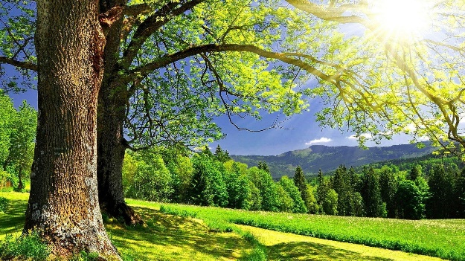
Summertime is a glorious time of “fruit, warmth, light, rest, play, wonder, festival, joy, reunion, and holidays” (113). It is a time to walk on the beach and let the hot sand run through your toes, a time to lie on a hammock and soak in the sun’s rays, a time to fish, hunt, and go on long walks enjoying nature in all its soothing sounds and beauty! While in winter it is easy to only see darkness as one’s closest friend, summer flips that, God and others draw intimately near, light and life around us, and night and mourning flee away” (113). In the beauty of summer, it is often easier to get close to God. King David said, “the heavens declare the glory of God; the skies proclaim the works of His hands. Day after day they pour fourth speech; night after night they reveal knowledge. They have no speech; they use no words; no sound is heard from them. Yet their voice goes into all the earth, their words to the end of the world” (Psalms 19:1-4). Not only is God’s glory easier to see from nature in summer but also fruits of drawing near to Him can be seen easier as well. “Most of the seasons of our hearts demand something from us, some sacrifice, some labor, some deep wrenching adjustment. But summer just wants to give and give. The only demand is that we surrender to it, bask in it” (113). And yet while summer is often marked by effortless fruit it also comes with the warnings to not loose our first love, to not be overcome by nostalgia or become so infatuated in summer’s beauty and ease that one becomes dehydrated, and the word of God becomes secondary to worldly pleasures.

Warnings of Summertime


In the heat of the summer with all its effortless and pleasurable sights, smells, tastes, and fruit it is easy to forget the hard work of pruning of winter and planting in the spring. It was the Good Shepherd who carried you over the thresholds of anguish, pain, and loneliness so intense that darkness became your closest friend. God did not pick you up and mend your brokenness in the bad times merely to have you ignore Him in the good times. James says we only become “mature and complete, not lacking in anything” when we “persevere in the faith” (James 1:2-4) which does not finish with the trial but extends into every part of our lives forever! With its hot summer days and abundance of fruit it is easy to stand upon the mountain tops of blessings and forget the lessons of our trials in the valleys. On the Island of Patmos Apostle John was instructed to write the following to the angel of the church of Ephesus: though they worked hard and persevered great hardships in Jesus’ name, “yet this I hold against you, you have forsaken the love you had at the first. Consider how far you have fallen! Repent and to the things you did at first” (Revelation 2:1-7)! Life in all seasons is meant to be lived with God at the center of all of one’s thoughts, words, and deeds! While it is easier to see our dependence on God in the winter’s fierce storms, this does not negate the truth that like the children of Israel in the book of judges we tend to fall the hardest when on the highest mountaintops of blessings!
Having been freed from the crushing effects of winter, summer is the perfect time to reflect on His goodness and to surrender one’s goals and dreams to kingdom goals as one basks in the mercy of His bounty to one saved by grace through faith (Ephesians 2:8).
Summertime is also the time when Christians most battle the feelings of nostalgia. In all its beauty and effortless pleasure, summertime can become a burden. “If we don’t fathom that summer’s beauty is a rumor of heaven, we’ll make fetish of the rumor and miss what it’s pointing too” (119). The Bible is clear that this world is not our home (Hebrews 13:14-16) and as such the eternity God has placed in our hearts (Ecclesiastes 3:11) is to keep us looking forward to the place the Lord went to prepare for us as described in Revelation 22:1-5.
Then the angel showed me the river of the water of life, as clear as crystal, flowing from the throne of God and of the Lamb down the middle of the great street of the city. On each side of the river stood the tree of life, bearing twelve crops of fruit, yielding its fruit every month. And the leaves of the tree are for the healing of the nations. No longer will there be any curse. The throne of God and of the Lamb will be in the city, and His servants will serve Him. They will see His face, and His name will be on their foreheads. There will be no more night. They will not need the light of a lamp or the light of the sun, for the Lord God will give them light. And they will reign for ever and ever.


Imagine going to heaven not only being there with God but also having His name written on your forehead and the curse of the garden of Eden fully removed! It is in summer that we are most in danger of seeing the splendor and beauty of the world and foolishly try to imprint it into our memories as perfection. When nostalgia paints the past as golden then “the way it was done back then” becomes the model of superiority and standard of excellence to strive towards (117). Songs and church rituals written in the past become icons of holiness, stifling the Holy Spirit’s voice in the present and the church’s ability to become all things to all people to win some to Christ (1 Corinthians 9:19-23)! Holding the past as an icon of holiness often leads to sadness and dare, I say bitterness when one realizes that circumstances by which made it glorious are not going to ever return!
Summer, then, is a time not to have a “back there” but “up there” experience (120). It is a time to be thankful for God’s saving grace and mercy in the past but more importantly it is an invitation in faith to change as God asks.
Summertime is the perfect time to look forward to living considering the eternity He has placed in our hearts in the place the Lord is preparing for His own (John 14:1-4)!


And the final warning of summertime that I want to deal with is dehydration. How I love to go to the beach and merely lie in the hot sand and feel the rays of the sun pour onto my body! I would lie there for hours if it were not for the danger of getting dried out and burnt to a crisp! Apostle Paul states the following about our bodies, “we have this treasure in jars of clay to show that the all-surpassing power is from God and not us” (2 Corinthians 2:7). Left to our own abilities we can do nothing for God but with Him all things are possible (Matthew 19:26)! In the Parable of the Sower, it states that the seed that sprang up quickly in shallow soil had no root and therefore when the sun came up it got scorched (Matthew 13:5-6). This is how it is in the summertime. Our jars of clay are easily broken and need to be constantly nourished by God.
Without a continuous inpouring of the Holy Spirit through prayer and meditating on God’s word our roots will be shallow and the sun of summertime blessings will get us drunk on worldly pleasures rather than having utter dependence on He who placed on the mountaintop in the first place!
When we get our eyes fixed on this world rather than heaven the sun of temptations becomes brutal and relentless, constantly distracting us from the Living waters and source of our very lives, Jesus! “We can become so accustomed to the bounty of God that we grow indifferent about seeking His gifts and stewarding them. The lake brims and is so refreshing we fail to notice that the river that feeds it has dwindled to a trickle” (136)! So, to keep from “drying up” in the summertime of God’s blessings we simply must drink steadily from the fountain of prayer and meditation on His word!

Summertime Activities


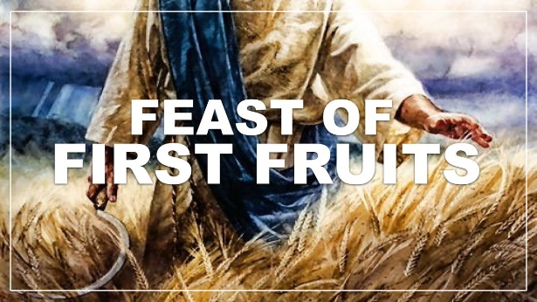
The first activity of summertime is to seek first the kingdom of God. As born-again believers our identity is already secured as citizens of heaven (125). For many people summer is a time of business, not only in “working for a living” but especially in relaxing and enjoying the fruits that are plentiful during this season. If we are not careful, however, our times of blessings can drown out our time with the Lord! In summer there is always the temptation to fill our calendars with pleasurable things such as walks in the park, resting at a beach, going on exotic vacations, and planning parties with our friends and family. “Busy” is often described as Being Under Satan’s Yoke because pleasurable, worldly things distract us from living as if we were already in our eternal home! While winter in its “enforced silence and stillness and waiting” is seldom restful, summertime is the perfect time to take time to be holy, be still, know and submit to God’s good, pleasing, and perfect will for our lives (Romans 12:2). Summer’s calm waters and abundance of provision makes it fertile ground for developing the spiritual disciples needed to draw nearer to God that is so desperately needed in the darker seasons (126). The second activity of summertime is to not worry but trust God and take whatever path He wants you to travel on. In winter one must walk by faith and not by sight and the goodness of God becomes “our creed, true always, seen or unseen, recited regardless of feelings. In summer, its our testimony, true because it is obvious, and deeply felt.

Summer is when we walk in the light – we can see, at every step, that God is good, and near, and for me” (128). In the evidence of such blessings, one is not to worry but have faith that while taking a leap for the Lord is often into the unknown and untraveled path it ought to be rejoiced for His mighty hand will enable all He asks us to do!
The final activity of summertime I would like to address is to gather in the first fruits of blessings. In the book of Proverbs it states, “he who gathers in summer is a prudent son, but he who sleeps during the harvest is a disgraceful son” (10:5). While fall is the primary time of the harvest there are crops to be harvested in the summer as well (136). These crops are called the first fruits and in the Old Testament they belong solely to God! Summertime in all its abundance is the perfect time to “give ourselves as a first fruit unto God” (136). He who has given you “exceedingly more than you can ask or imagine” (Ephesians 3:20) and proven to you that He always does good to those who love Him (Romans 8:28), has every right to ask to for your very best service in His kingdom! In abundance it is easy to become a spiritual consumer, picky wasteful, ungrateful, and always coveting more than one has received! To serve God faithfully in His kingdom requires His own to be so thankful of having received His gracious provisions that it propels the heart to no longer “crave and complain but instead live in the mode of giving and thanksgiving” (132). To be good stewards and recipients of God’s grace means feeding the poor, giving them something to drink and providing clothes on their backs with the attitude that if we do unto the least in His kingdom, we have done it unto Christ Himself (Matthew 25:31-46).
So, as we count our blessings and name them one by one may we be thankful and carve out to the Lord the very best of our time, talents, money, and efforts to accomplish great things in His name.
In bringing in the first fruits let us not forget how important it is to prune out any activities that are not bearing fruit. In summer it is easy to become so busy doing “what we want to do” that we forget to make sure God has approved of these activities by sending us fruit! Not only pray that God would show and give you the courage to cut out the barren leaves of service but also for you to see and embrace those spiritual activities that He wants you to do! Summertime is glorious time of fruit, warmth, light, rest, play, wonder, festival, joy, reunion, and holidays but best of all it is the perfect time to reorient one’s service to God in accordance with His will!

