# **Spiritual Rhythm**

Walking in Step with the Spirit

Online Sermon: <http://www.mckeesfamily.com/?page_id=3567>

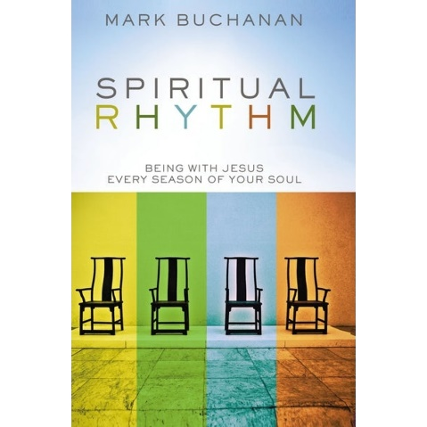 Many Christians believe that the key to serving God faithfully is to seek a good balance between work, play, and worship. They feel that those who attain this balance will be filled with much spiritual fruit. As we have already seen in the prior four sermons none of the seasons are inherently balanced nor do they require the same response. Solomon was correct in stating there is a season for everything (Ecclesiastes 3:1). In all its brokenness, pain, and suffering winter is one of the best times to pray, prune that which bears little or no fruit, wait upon the Lord to seek and know His will, and to reflect on those things unseen. In all its newness, growth, and splendor Spring is the perfect time to listen attentively to the Lord and plow new fields, plant new spiritual seeds of righteousness, and clean the inside of the cup of one’s soul. In all its fruit, warmth, light, rest, play, wonder, festival, joy, reunion, and holidays Summertime is the perfect time to seek the kingdom of God, and to gather in the first fruits of blessings. And Fall is the perfect time to bring in the lost, to thank God for one’s prosperity, and to become right in His sight. Basking in its harvests Fall tends to be the perfect time to memorize God’s word and to ask Him to search one’s heart so that one might know and confess one’s sins.

Since every season has different spiritual activities that excel during their times, what we truly need is not balance but rhythm.

Though every season be different, our attitude towards the Lord must remain the same. This series is going to conclude by discussing six things that will help us in any season to keep a spiritual rhythm that honors God!

# **Abiding**

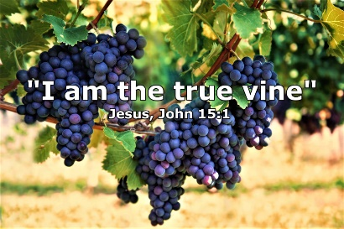 To first thing one can do to keep a good spiritual rhythm is abide in Christ! In John 15:5 Jesus tells us, “I am the vine; you are the branches. If you remain in Me and I in you, you will bear much fruit; apart from Me you can do nothing.” Whether one be in the cold, dark, painful winter or basking in the harvests of the Fall; the key to honoring the Lord is in all that we think or do, to remain the vine! Being “in Christ” means our identities, abilities, and destinies (208) are shaped by the One who gave His life so that the branches, i.e., believers, might have the opportunity to be transformed into His glorious image. “We are saints in Christ. We are confident in Christ. We are called heavenward in Christ. We stand firm in Christ, rejoice in Him, hope in Him, agree in Him, glory in Him, are found in Him, are 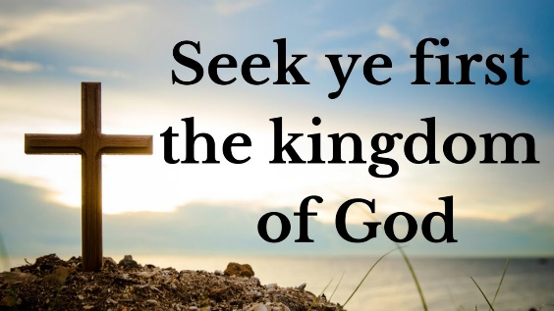guarded, heart and mind, in Him, have all our needs met in Him, and welcome others in Him” (208). No matter what season that one goes through without life in the vine one simply cannot bear fruit … even in the fall seasons of life! While we can all produce something in any season without Christ it will be fruit that does not last or worse, yet it does, and we wish we could get rid of it (209)!

Apart from Christ we can do nothing but can do everything through Him who strengthens me (Philippians 4:13). If we are to live for Jesus with integrity, not duplicity, then we simply must take every word, thought, or deed captive to the One who gives us branches life.

To keep our service from being nothing more than filthy rags of pretend righteousness then the roots of our efforts must be deeply entrenched in His word, grace, and mercy! And to remain in the vine, we must pray without ceasing, “search me O Lord and when find sin in me give me the courage to repent and keep my heart utterly dependent on You!”

# **Seeking**

The second thing one can do to keep a good spiritual rhythm in any season is to seek ye first the kingdom of God (Matthew 6:33). Those who are intimate with the King, faithfully and joyfully serve in His kingdom. They are not interested in chasing after some kind of “American dream” where the objective is self pleasure but rather in doing good deeds that point to God the Father in heaven (Matthew 5:16)! I can only imagine what it was like to hear Jesus when He first announced His kingdom would not be based on genealogy, temple, Torah, politics, good looks, or even riches but on faith in a risen Savior. He told us that the first must become the last and that children, tax collectors and prostitutes would enter His kingdom (Matthew 21:28-32) quicker than the most pretentious of religious leaders who only wanted to please “men rather than God.” Not only is the invitation to join His kingdom inclusive to all so is His demand of allegiance!

While faith alone in the atoning sacrifice of Christ is how one becomes born again and enters His kingdom this does not negate our obligation to give our whole hearts to the Lord. Jesus said, “whoever wants to be My disciple must deny themselves and take up their cross and follow Me” (Luke 9:23)!

Jesus wants us to seek Him for He is always near and obey His will in everything that we do! “If Jesus wants us to both bear much fruit and to pursue the kingdom of God first – if to do one is, indeed, to do the other, and vise versa – then one of the best shifts we could make in our churches is to dismantle the model of spirituality that equates busyness with faithfulness and replace it with the simple idea that fruit alone denotes faithfulness, and fruit requires seasons” (221). Seeking the Lord means no longer being transformed by the ways of this world but instead being transformed by the renewing of our minds so that we might test, approve, and live in accordance with His good, pleasing, and perfect will (Romans 12:2)!

# **Walking in the Spirit**

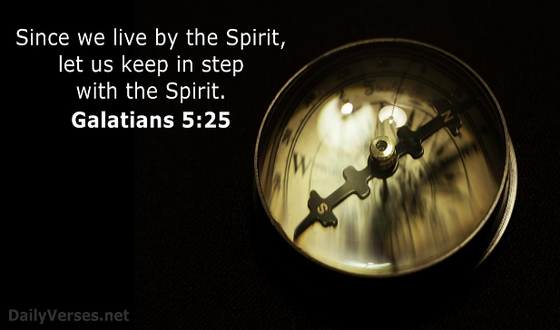 The third thing one can do to keep a good spiritual rhythm is to walk in step with the Holy Spirit. “The strangeness of the kingdom life is that its both arduous, agonizing and invigorating. It’s a labour and a struggle, but also a tapping of a powerful energy” (228). Since our “struggle is not against flesh and blood but the powers of this dark world and against the spiritual forces in heavenly realms” (Ephesians 6:12); who amongst us believers would be foolish enough to face Satan’s fiery darts without the full armour of God and the assurance that He who is in us is far greater (1 John 4:4) than this ruler of this world that is not our home (Ephesians 2:2; 2 Corinthians 4:4). To keep from being devoured by the roaring lion by becoming an imitator of his self-glorifying indulgences, Paul told the church of Galatia that, “since we live by the Spirit, let us keep in step with the Spirit” (5:25). Apostle John states, “this is a message we have heard from Him and declare to you: God is light; in Him there is no darkness at all. If we claim to have fellowship with Him and yet walk in the darkness, we lie and do not live out the truth. But if we walk in the light, as He is in the light, we have fellowship with one another, and the blood of Jesus, His Son, purifies us from all sin” (1 John 1:5-7). John is not stating that when a Christian commits a sin it proves they are not saved but merely that once saved we are born again and with the Spirit living inside of us then the truth by which we were set free will reign in our thoughts, minds, and deeds! Since “divine power liberates us to live in and for God, we are no longer defeated or enslaved by sin” (235).

In every season and situation, we are to choose to do God’s will and not that of the world or even that of our own! This of course is only possible by listening, submitting too, and thanking God who is sovereign with the assurance that saints are empowered to do whatever the Lord asks them to do!

Those who let the Spirit chose their steps stand on a firm foundation that will not be shook by the cruelness of winter or the leisure of fall.

# **Sustaining**

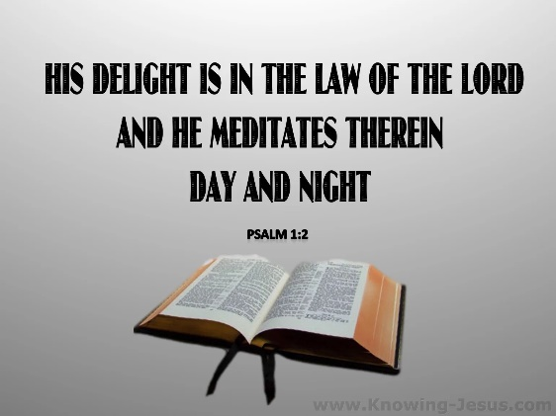 The fourth thing one can do to keep a good spiritual rhythm in any season is to put every effort into sustaining our spiritual lives. When it comes to our natural resources such as air, water, forests, fish, and so on most of us are concerned about doing what we can so that the next generation has something left (255). To sustain the fruit of being in the Vine means our roots must always be found in the right place! Let’s look at Psalms 1.

**“Blessed is the one who does not walk in step with the wicked or stand in the way that sinners take or sit in the company of mockers, but whose delight is in the law of the LORD, and who meditates on his law day and night. That person is like a tree planted by streams of water, which yields its fruit in season and whose leaf does not wither — whatever they do prospers.  Not so the wicked! They are like chaff that the wind blows away.  Therefore, the wicked will not stand in the judgment, nor sinners in the assembly of the righteous. For the LORD watches over the way of the righteous, but the way of the wicked leads to destruction.”**

Psalms 1 presents to us two contrasting choices on how we are to live our lives. One can walk in step with the wicked but if one does so then life will become as meaningless as chaff that is blown away in the winds of cultural change. In contrast, if one chooses to walk in delight of the Law of God that person will be like tree planted by streams of water and produce much fruit regardless of the season. Those who have their roots deeply planted in the word of God will not have their lives “blown about by every wind of teaching” but instead will be firmly rooted in the “right way” that God says we are to honor Him. When we first become born again the instinctual desire to know God’s word was real but over time it lessens because we tend to gorge ourselves on worldly things like trashy books, gory movies, rounds of gossip, and coveting our neighbor’s money, power, and possessions (262). To sustain our walk with the Lord we need to read His word and meditate on it day and night for it is only here that we can find the answers to life’s biggest questions: why am I here, where am I going and how am I to get there? The more we read His word the more we see the truth and find solace in this beautiful love letter from our Father. To become more like Jesus, we need to hide His word in our hearts (Psalms 119:11) and make every effort to live not by bread alone but every word that comes from the mouth of God (Matthew 4:4)!

# **Persevering**

The fifth thing one can do to keep a good spiritual rhythm is to persevere. The Man of all Seasons Jesus is familiar with suffering. The prophet Isaiah stated this about the crucifixion, “Surely, He took up our pain and bore our suffering, yet we considered Him punished by God, stricken by Him, and afflicted. But He was pierced for our transgressions, He was crushed for our iniquities; the punishment that brought us peace was on Him, by His wounds we are healed” (53:4-5). “We met the man who, for the joy set before Him, endured the cross, scorning its shame. In meeting Jesus here, even here, we also experience a similar joy set before us. It didn’t make the sorrow any less – the Man of all Seasons, after all, gives life to the full, nothing muted, nothing watered down, nothing by halves – but it did impart a peace beyond our understanding” (275). It is in the fiercest of storms, you know those winter storms where it seems like darkness, pain, and sorrow are our only friends that our character is tested the most. Such times “either sweetens or softens people, or sours and hardens them, with scarcely any in-between” (276). Those who take every thought captive for the Lord heed the words of James, “consider it pure joy, my and brothers and sisters, whenever you face trials of many kinds, because you know that the testing of your faith produces perseverance. Let perseverance finish its work so that you will be mature and complete, lacking in nothing” (1:2-4). God’s strength is made perfect in weakness.

“Determination works best in the soil of pain” for it is in our weakness that we remember we are utterly dependent on the Good Shepherd who makes us the strongest when left to our own devices we would not even be able to lift our heads.

# **Knocking on Heavens Door**

The final thing one can do to keep a good spiritual rhythm in any season is to always look up and forward to the eternal home the Lord is preparing for you! “There is nothing in this world that infuses us with hope, joy, and strength – so wild and pure it can intoxicate with a single sip – like the thought of the next world” (268). While no human can fathom the beginning to the end, the eternity God has placed in our hearts is only satisfied by remembering our Father who art in heaven. “It is God who stuck a homing device right in the middle of you, so that every pulse triggers it. It’s God who, knitting you in your mother’s womb and numbering your days before one came to pass, left a gaping hole inside you that only He can fill, and only fully when you see Him face-to-face” (270). Paul says this about heaven, “what no eye has seen, nor ear heard, nor the heart of man imagined, what God has prepared for those who love Him” (1 Corinthians 2:9). While there is much, we cannot know about heaven there is much that is told to us in Scripture! Imagine being in heaven where there is no sun or moon to shine on it, for the glory of God gives it light, and its lamp is the Lamb” (Revelation 21:22-23)! Imagine seeing the tree of life with its twelve kinds of fruit whose leaves are for the healing of the nations (22:1-2). What storm on earth could ever be so intense to rob us of the truth that the day is coming very soon when the Lord will “wipe away every tear from our eyes, and death shall be no more, neither shall there be mourning, nor crying, nor pain, anymore, for the former things have passed away” (21:4).

And above all imagine what it will be like to have Christ open the Lamb’s book of life, find your name, and declare that you are no longer capable of sinning against Him (21:27)!

So, though are outwardly wasting away (2 Corinthians 4:16) may we in all seasons be inwardly renewed with hope and the glorious promise that God will always do good to those who love Him (Romans 8:28)!