# **Spiritual Rhythm**

**Fall: Reaping what You have Sown**

**Galatians 6:7-10**

Online Sermon: <http://www.mckeesfamily.com/?page_id=3567>

Fall is a glorious time of bringing in the harvest that we had worked so hard for during the other seasons of our lives. “It is a time of thanksgiving, a time to acknowledge God as provider: rainmaker, sun-keeper, storm-quencher” (150). It is a time to praise and deepen our faithfulness to God in whom we are utterly dependent. And yet while fall is meant to be a time of great rejoicing it is also one in which the “heart fills up with anticipation” (152) and dare I say anxiety, for the Lord has promised we will reap what we have sown! Let’s look at Galatians 6:7-10 to get a better understanding of the connection between reaping and sowing.

**“Do not be deceived: God cannot be mocked. A man reaps what he sows.  Whoever sows to please their flesh, from the flesh will reap destruction; whoever sows to please the Spirit, from the Spirit will reap eternal life. Let us not become weary in doing good, for at the proper time we will reap a harvest if we do not give up.  Therefore, as we have opportunity, let us do good to all people, especially to those who belong to the family of believers.”**

Apostle Paul makes it clear that we simply cannot fool God by putting on a “holy mask” while wearing worldly clothing! Having one foot in God’s and Satan’s kingdom is not possible for in living to please one’s flesh, i.e., the sinful nature, one cannot please the Holy Spirit. Giving into the cravings of one’s sinful desires only intensifies such cravings until one’s whole life is consumed with “ME,” my wants, my goals, and my desires. The good news is that since “greater is He who is in you than in the world” (1 John 4:4), to sow righteousness is not only possible but easily attainable by listening and obeying the Spirit who “not only prompts us to be holy as God is holy” (1 Peter 1:16), but also enables us to reject the sin that so easily entangled us (Hebrews 12:1)! Through the Spirit’s power we can take captive every word, thought, and deed for the Lord (2 Corinthians 10:5)!

Those who surrender their time, talents, money and very lives to He who purchased them at the price of His life (1 Corinthians 6:20) will plant seeds of righteousness and have of crops 100-fold (Matthew 13:8).

There are three spiritual harvests that we are to strive to obtain: a harvest of souls, a harvest of prosperity, and a harvest of righteousness.

# **Harvests of the Fall**

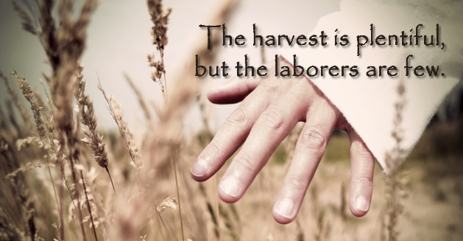 The first harvest that believers are to strive to attain is to gather in the lost. We are told in Matthew that when Jesus saw the crowds, He had compassion on them, because they were harassed and helpless, like sheep without a shepherd. He then told His disciples, “the harvest is plentiful but the workers few” (Matthew 9:36-37). The assumption in this passage is that someone else has already planted the seeds and now the Lord needs someone to water and bring them in (1 Corinthians 3:6-7)! If we are to perform our part in soul harvesting, then we must not only be ready (1 Peter 3:15) but also willing to witness to the lost the glorious message that the thirst of the eternity that God has placed in their hearts (Ecclesiastes 3:11) will only be satisfied the moment they believe in the atoning sacrifice of the Son (John 3:16)! Jesus also told the disciples that we are to pray that God would send workers willing to join Him in His kingdom work. Prayer is critical “for it commits us at a heart level what we endorse at a head level” (163). It often makes us see that the ripe fields without any workers a problem that God is calling us to solve through standing up and saying, “here I am, take me.”

While the Holy Spirit is the only one who can convert a person from death to life, we are still called to be the hands and feet of our Savior. The Lord wants us to sometimes sow, and other times reap, and to always be glad that we have been called to serve in His harvest that has eternal consequences!

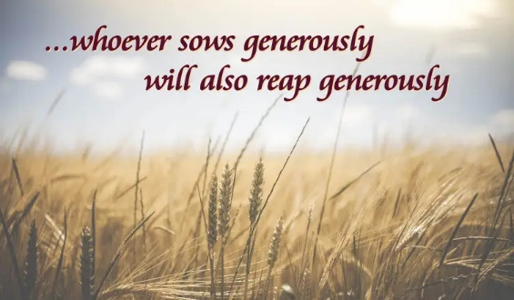 The second harvest that believers are to strive to attain is that of prosperity. To the church of Corinth Paul wrote, “whoever sows sparingly will also reap sparingly, and whoever sows generously will also reap generously” (2 Corinthians 9:6). Paul in this passage is not promoting health and wealth gospel that says give more and God will multiple it a 100-fold and you can become rich and always be healthy (164). We should never see God as a genie in the bottle waiting to do our bidding! When Paul says we will reap generously we must understand what rewards God will give us for doing His pleasing and perfect will. While God promises to supply us with our basic needs for survival (Matthew 6:25-27), as a Good Father, He will not give us the stones (Matthew 7:9-11) of carnal pleasure but instead a harvest of grace, good works, and righteousness (164)! Think about it, which is better to receive “treasures on earth, where moths and vermin destroy” (Matthew 6:19) or eternal crowns of righteousness? I am not saying that God does not bless us materially as well as spiritually but merely that His preference is to give us gifts that have eternal, rather than temporal consequences. After all, if God is to fulfill His promise to do good to those who love Him (Romans 8:28), then why give more 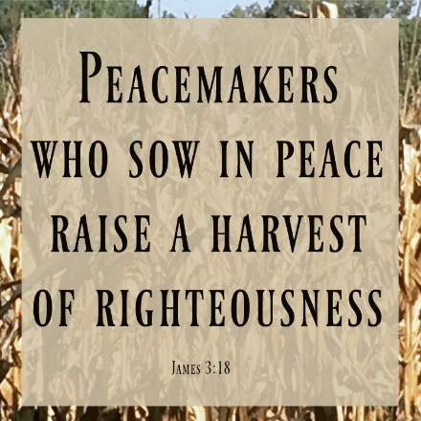temporal things that often ensnare people in covetousness when what believers truly need is follow in the footprint of their Savior! When God gives material things it is to be good stewards and share with the poor.

Paul is saying to not be stingy with our wealth, time, and spiritual giftings but instead to give generously as if giving to the Lord Himself (Ephesians 6:7-9). Look for opportunities to serve and fill your life with good deeds that point to God the Father in heaven (Matthew 5:16) so that your life might be a living, an honorable sacrifice unto the Lord filled with crowns that never fade or spoil!

The final harvest that believers are to strive for that I would like to mention is one of righteousness. When we first became born again the “old has gone, the new is here” (2 Corinthians 5:17). I often hear believers ask, “why don’t we see more miracles today,” to which I respond, “if you are saved then you have experienced one of the greatest miracles God has ever given to the human race!” Even though those who have experienced this miracle are masterpieces of God’s grace, none of us start out spiritually mature but instead mere babes in Christ (1 Corinthians 3:1-3). We are still worldly in many areas of our lives and like Apostle Paul in that while we desire to do what is good, we tend to keep doing the evil we did before we were saved (Romans 7:18-20). Paul asks, who can save us from this body that is subject to death, and he responds that only Christ can sanctify and deliver us from our carnal desires (7:24-25)! We have the mind of Christ and with the Holy Spirit living inside and empowering us we can become more like the One who died to set us free from our slavery to sin. We are to strive to achieve a harvest of righteousness and by this, I mean living right in God’s sight! This of course can only be obtained when we invite the Spirit to transform “our thoughts, our desires, our attitudes, our actions, our even our character” to be like Jesus! To be right in God’s sight requires one to see His discipline as the Good Shepherd doing good and loving us. Since discipline is “painful and often misery producing” (167) our temptation is to run away and avoid it at all costs. Those who want to experience spiritual growth, however, are to see God’s discipline as an opportunity to be corrected and trained in holiness so that they might receive a harvest of righteousness and peace (Hebrews 12:7-11). To be righteous also requires us believers to seek peace in His kingdom (Matthew 5:9). We are to seek peace in relations to the world but not at the cost of doing what is right in God’s sight. In the church Apostle Paul states we are to “bear and forgive one another” and “clothe ourselves with compassion, kindness, humility, gentleness, and patience” (Colossians 3:12-14).

It is when we let the peace of Christ rule in our hearts that unity in the body of Christ is maintained and great things are done in His name! James rightly points out the undeniable truth, “peacemakers who sow in peace reap a harvest of righteousness (James 3:18)!

Now that we have looked at the three spiritual harvests of fall let’s turn our attention to some of the activity’s believers are to do during this glorious fall season.

# **Fall Activities**

 Fall is one of the best times in our lives to thank God and memorize His word. Fall is when we feast. “To refuse to feast is to refuse the bounty is to refuse the gift is to refuse the giver. Fasting when you should be feasting is sheer ingratitude” (174). When we receive more than we can ask or imagine we are to praise “Him from whom all blessings flow.” “If anyone can look upon such abundance and not want to weep, or laugh, or both, with pure thankfulness, they’re worse than Scrouge” (175)! We thank the One whom we have received our blessings not because we covet them but due to the bountiful harvest being evidence of God’s love, grace, and mercy to those who do not deserve it! In the fall’s plentifulness we also store up for the spiritual wintertime of hardships that are about to fall upon us. This is done by hiding God’s word in our hearts so that we can draw from the bountiful riches of His directions on how to survive and thrive in all seasons. Winter times of tribulations tend to be in the darkest of valleys when we are not prepared to stand upon the firm foundation of God’s word. To read passages that our God is one of compassions and comfort (2 Corinthians 1:3-11), that we can take shelter under His wings (Psalms 91:4), and that His Son Jesus is our high priest who not “empathizes with our weaknesses” (Hebrews 4:14-15) but also invites us to trade our burdens with His yoke that is easy and light (Matthew 11:28-30); is of incredible comfort when dark storms of pain and tribulations are all around us! Like the Psalmist we are to meditate (Psalms 1:2) and hide, i.e., memorize, God’s word not only so that we might not sin against God (Psalms 119:11) but also so that we might draw on the fountains of His promises to always do good to those who love Him (Romans 8:28).

The “spiritual winter times are so long and hard and deep and grim because our spiritual autumns are so lean” (176)! With a deepening of our knowledge of how wide and long and high and deep the love of Christ is (Ephesians 3:18) as outlined in His holy word, we can not only survive by thrive in winter’s harshest of climates!

During the fall when blessings come with little effort, it truly is one of the best times to ask God to search our hearts and show and enable us to remove idols in our lives. In the book of Judges, we learn about the call of Gideon. He lived during a time when all of Israel was worshipping Baal, the ancient Canaanite god (183). Gideon’s story narrates the truth that in times of great blessings God’s own tend to forget the Provider of their blessings and fall deeply in love with and make a god what they have received! As both a sex god and one that promised prosperity, Baal was very alluring. While most Christians don’t have idols made of wood, stone, or even one’s that can be physically touched; they still have idols. When it comes to sex many believers worship the god of internet and movie porn and still others worship the god that says working hard enough, with the right skillset and politics will lead to a happy and abundant life. Whatever or whoever we believe holds the power over our unknown future and keeps us from trusting God is an idol just as devasting as Baal! Since we are often unaware of the sinful desires controlling us like King David, we need to ask God to search our hearts, test us, and know our anxious thoughts. See if there are any offensive ways in us, so that we might be led in the way everlasting (Psalms 119:23-24). Fall with all its leisure is the perfect time to with the Spirit’s help flesh out “anything that rivals our devotion to God” (190)! We are to declare, confess such things as idols and turn from this evil.

While sanctification often leads to persecution both within and outside of the church (189) we are to tear down the pretend holiness masks of worldliness so that we might please God, even at the expense of alienating those who are still in love with that which is now repulsive not only to God but us as well!

Even though being right in God’s sight often invites persecution, we must not forget our witness of being freed from sin by the grace of God has incredible liberating affects on those still in bondage to the god of their choice!