Trading Yokes and Finding Rest

  - Online Sermon: http://www.mckeesfamily.com/?page_id=3567

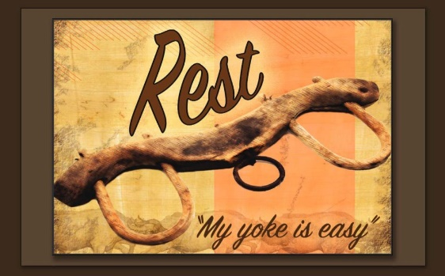
Ever get so tired that your bones ache and your mind so exhausted that you can barely think? You know one of those days that all you want to do is crawl into bed and sleep? Are you weary from the struggles of life? Are you weary from the storms that rage all around you threatening to strangle out normalcy and decency in your daily routines? Or maybe you are simply exhausted due to having worked too many hours at your job and have filled your calendar with way too many obligations? If physical and mental struggles were not challenging and energy draining enough, maybe you are simply worn out from trying to serve the sinless Lamb of God by your own effort and the burden of sin is crushing your soul? One can’t help but wonder … are we not “looking, running, seeking, struggling, fighting, loving, rushing, searching all to find what only Jesus Christ can give?” Today’s passage found in Matthew 11:28-30 appeals to us because it is the Great Shepherd’s invitation for those who are “weary in their spirit” to come to Jesus and receive rest! St Augustine stated that there is nothing sweeter than this, “thou have made us, O God, and our heart is restless till it rests in Thee.”
The following sermon is going to show how true rest begins with faith in a risen Savior and once born again is cultivated in the fertile soil of the humble and gentle hands of the Master.
We will learn that the crushing weight of sin is alleviated not through more “human effort” but through partnering, learning, and receiving the divine yoke of our sympathetic high priest Jesus who when invited moulds the clay of our lives back into His image whence we came! The sermon will finish by describing divine rest both now and our final resting place in heaven in Jesus’ arms, a place that is more peaceful and joyful than we could ever ask or imagine!

Coming to Jesus - Salvation


The journey of finding rest for one’s soul begins with faith in the Lord’s vicarious sacrifice! All have fallen short of the glory of God, and all have become altogether worthless and incapable of either knowing or pleasing God (Ephesians 3:23; Romans 3:9-18)! By our own efforts we cannot earn our salvation, nor can we know the Unknowable for our intelligence and wisdom can not lead to the way, truth and life but remains the dust’s foolish attempt (Isaiah 55:8-9) to receive what can only be obtained by faith and grace (Ephesians 2:8-9)! When Jesus states, “come to Me, all you who are weary and burdened and I will give you rest,” He is pointing out the truth that He alone is the epicentre of God’s self-disclosure and the only means of approaching the Father’s throne of grace (Hebrews 4:16). The burden of being simultaneously “under the dominion of Satan” and the righteous wrath of God can only be removed through faith in the divinely appointed Lamb who was slain before the foundation of this world (Revelation 13:8). “Your sin was not pardoned by a violation of divine justice, just was satisfied in Jesus, He alone gives you rest.”
True rest comes from being born of the water and the Spirit (John 3:5) for it is only upon passing from spiritual death to life that the burden of guilt is removed and one gets the privilege of crying out Abba, Father as His very own child!
Since Jesus died once and for all, the first part of this passage is nothing less than an invitation to everyone to believe in the Bread of Life and Living Waters (John 6:35, 7:37-39) necessary to redeem, sustain and provide rest for their souls!

Coming to Jesus – Escape Legalism

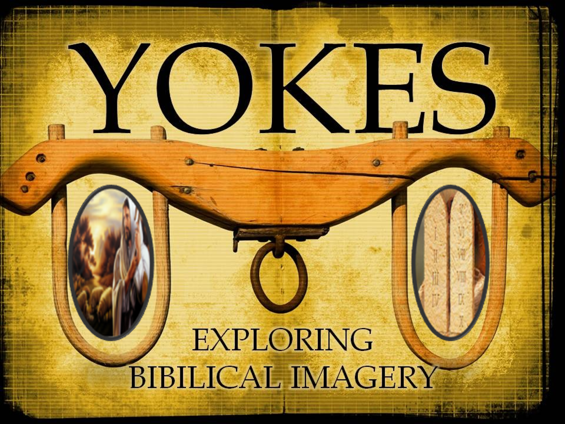
Upon salvation the journey to further cultivate rest in one’s soul is found in taking on “Jesus’ yoke to relieve the burdens and weariness of life (Matthew 11:28). Often people are weary because they are trying to satisfy the laws of God based on their own effort! While the wicked are in a troubled sea and cannot experience rest too many God-fearing believers cannot find rest either because they have taken up the “yoke” of Pharisaic legalism that foolishly states that through obedience to the Law and by performance of certain rites and ceremonies one is not only saved but can please God. While the oral traditions and written Law appealed to the Pharisees it was a yoke too burdensome to bear and gave false hope because it was weakened by the sinful nature that could not stop from breaking the Lord’s righteous decrees (Romans 8:1-3). Jesus invites us to take up the yoke of pleasing a holy God by learning and being empowered by His Son to throw off the shackles of sin that so easily entangles us (Hebrews 12:1). Jesus is telling us to “come not to the Pharisees, who will instruct you in tradition, and in the jots and tittles of the Law, but go past these to Me (Jesus), the God, the Mediator, the Redeemer, and the propitiation for human guilt.” Jesus is not saying the Law is irrelevant or that He demands any less from His followers but instead that He will teach and empower those who seek Him to go even further towards holiness by obeying the spirit in which the Law was given (Matthew 5:17-48)!
It is only when one gives up one’s “futile attempts to satisfy God’s demand to be holy by one’s own self-made energy” that obedience becomes possible because one is motivated by an act of devotion and submission rather than one of duty!
Without any money or merit Jesus is inviting all of us to come with the open hands of faith to be transformed and renewed daily by His sustaining grace and mercy (Romans 12:1-2)!

Partnering and learning from Jesus

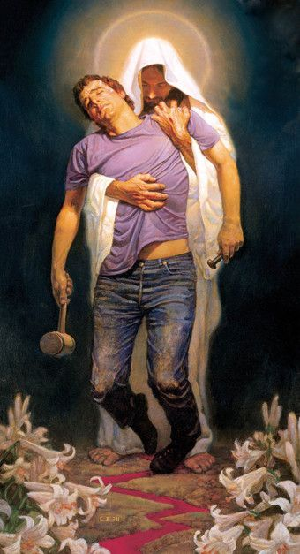
In verse 29 Jesus states that to obtain divine rest in our souls we must “take His yoke upon ourselves and learn from Him.” A yoke mentioned in the New Testament was a “wood implement designed to allow two oxen to pull a load together.” Metaphorically it was used to “signify some sort of bondage or submission to authority of some kind.” Jesus uses the word yoke to point us to the truth that after having received the gracious gift of salvation through faith and grace, those purchased at the price of the Son’s life are obligated to commit themselves to the Master to learn how to be holy by walking side by side with Him. It is almost like Jesus is saying when you are “tired of pushing, and pulling, and jerking, and jumping, and trying to obtain what no person ever can;” seek and surrender to My will and I will give you rest. What a beautiful invitation to partner with the infinitely stronger ox, our Lord who was tempted and went through trials (Hebrews 4:14-15) so difficult that He even sweat like drops of blood and yet in all remained faithful and pleased the Father in heaven (Matthew 17:5)! Jesus invites those who are weary and burdened, the rich and poor, the cultured and the simple, the saints and the sinners to learn what only can be taught by the very One who controls all things seen and unseen (Colossians 1:16). Jesus is not saying that by coming to Him our burdens in life will disappear, for not even Christ was without burdens in His incarnation! The yoke Christ gives us requires great faith for we who participate in the Divine nature (2 Peter 1:4) also are required to deny ourselves, take up our crosses, and follow Him (Matthew 16:24)! Though there be much suffering and persecution for those who follow the One hated by the world (John 15:18-25), there is unspeakable joy because His mighty arm sustains, guides and turns “every difficulty in life to our good by His grace” (Romans 8:28).
As God’s handiwork we were redeemed by the blood of the Lamb (Ephesians 1:7, 2:10) not to waist the precious treasure we have received but to find rest in serving Him as the epicenter of His will for our lives!
So, we gladly press on towards the goal to please our Lord by submitting to His right to rule over our hearts in the assurance that since nothing is impossible for God (Mark 10:27) our Mediator Christ will mold and remake us into His image that is truly a sweet aroma unto Him!

Meekness and Servanthood

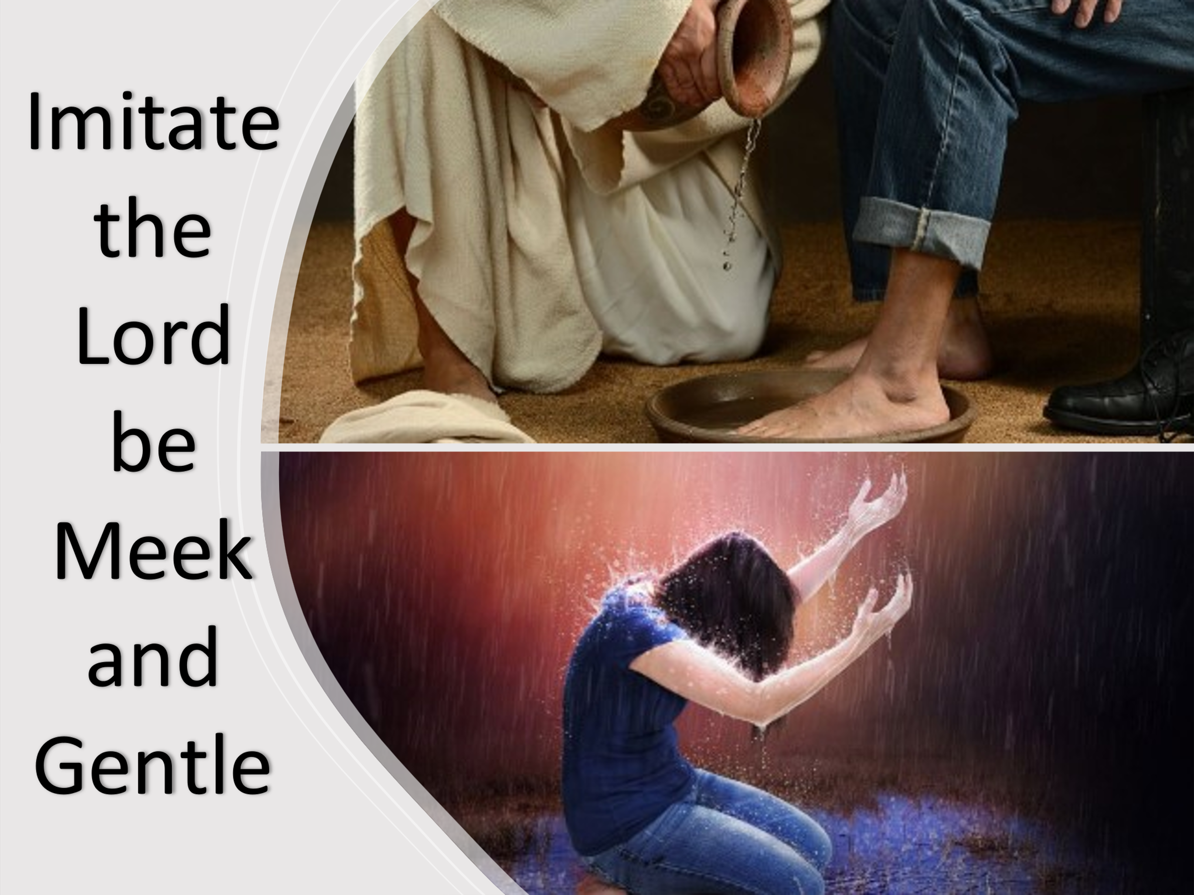
If one is to truly find rest in the Lord, then one must follow in His footsteps of meekness and servanthood. When Jesus “made Himself nothing by taking on the nature of a servant being made in human likeness” (Philippians 2:7) His life, death, and resurrection clearly showed He was not only the sin-bearer but the burden bearer as well. The prophet Isaiah wrote that though Christ was despised by mankind He chose to be pierced for our transgressions and by His wounds we are healed (53:1-5). “If Jesus is meek, the people in whose lives He rules cannot be proud or self-centered either, for the kingdom belongs to the meek (Matthew 5:3, 5). To learn and follow in the footsteps of our Master requires us to no longer seek positions of power and authority (Luke 22:24-30) but instead in seeing others better than ourselves (Philippians 2:3) to always ask how can I help them see and realize God’s plan in their lives. Meekness is not seeking human praise as a reward but instead looking to store treasures in heaven where moth and rust cannot destroy (Matthew 6:2-4, 19-21). While the “proud spirit gets tired of doing good if it finds its labours are not appreciated, the brave, the meek in spirit, finds the yoke easy” because the object of their desire is to please the One who also served the many (Mark 10:45).
To become humble and gentle in heart means giving up the perception that past trials and tribulations are the foundation for complaints and the source of future expectations but instead being content but looking forward to “Thy will being done on earth as it is in heaven” (Matthew 6:10).
It is in humility and meekness that we learn of how precious it truly is to be under His wings and stand upon the firm rock of our salvation (Psalms 91:4; 62:6)! It is precisely by following Jesus that we get so carried away with His grace, mercy, and power that we can cast our anxieties upon Him that are choking out the joy of serving Him (Philippians 4:6-7)!

Receiving Rest

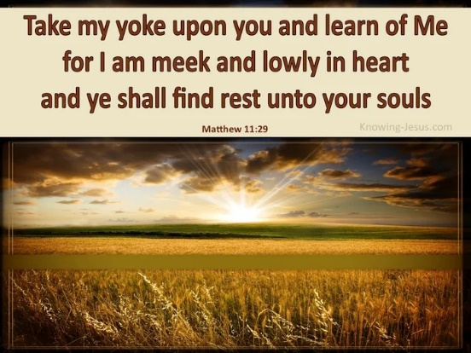
Let me finish by describing the best I can the rest Jesus offers us today. Divine rest is something that is at best hard to explain but an unspeakable joy to experience. This is the kind of soul rest that comes from knowing one is redeemed by the blood of the Lamb (Revelation 5:9-14) and because of one’s faith in Jesus and from His mercy one has passed from death to eternal life, forever adopted into God’s family (Ephesians 2:8-9; Romans 8:15). This is also the kind of rest that knows beyond doubt that while a redeemed masterpiece of His grace cannot slavishly obey God’s commands out of a sense of duty alone, by casting one’s burdens on the Lord one can partner with, submit too, and be empowered to be holy as God is holy (1 Peter 1:16)! It is by allowing Him to lead us by the still waters that our souls rest and are renewed with vigor (Psalms 23) so that we might soar like wings on eagles to accomplish His perfect will (Isaiah 40:31; Romans 12:1-2). The yoke Jesus offers you today is not one that is easy, for His invitation invites us to obey not the letter but the reasons for the Law and in doing so will invite much persecution by this world who hates the Lord (John 15:18-24). And yet for the lowly and meek trusting and leaning upon the Lord is the key to finding peace not just in this lifetime but in the next as well. It is precisely in His sovereignty that one is no longer anxious about anything but in all things through prayer and petition, with thanksgiving one can make one’s requests to the Father knowing that He always does good to those who love Him and will always grant those who seek Him the peace that transcends all understanding, guarding our hearts and minds in the Lord, Christ Jesus (Philippians 4:6-7). Let me finish with one final quote from Charles Spurgeon that sums up much of what I have said today.

“Let but your mind be like the mind of Christ, and you shall find rest unto your souls: a deep rest, a growing rest, a rest found out more and more, an abiding rest, not only which you have found, but which you shall go on to find. Justification gave you rest from the burden of sin, sanctification will give you rest from molesting cares; and in proportion as it becomes perfect, and you are like your Saviour, your rest shall become more like that of heaven.”

Alan Carr, “There Is a Place of Rest (Matt. 11:28–30),” in The Sermon Notebook: New Testament (Lenoir, NC: Alan Carr, 2015), 171.
Alan Carr, “There Is a Place of Rest (Matt. 11:28–30),” in The Sermon Notebook: New Testament (Lenoir, NC: Alan Carr, 2015), 170.
Alan Carr, “There Is a Place of Rest (Matt. 11:28–30),” in The Sermon Notebook: New Testament (Lenoir, NC: Alan Carr, 2015), 170.
Alan Carr, “There Is a Place of Rest (Matt. 11:28–30),” in The Sermon Notebook: New Testament (Lenoir, NC: Alan Carr, 2015), 170.
D. L. Moody, The Overcoming Life and Other Sermons (New York; Chicago; Toronto: Fleming H. Revell, 1896), 99.
C. H. Spurgeon, “Rest, Rest,” in The Metropolitan Tabernacle Pulpit Sermons, vol. 17 (London: Passmore & Alabaster, 1871), 17.
Michael Green, The Message of Matthew: The Kingdom of Heaven, The Bible Speaks Today (Leicester, England; Downers Grove, IL: InterVarsity Press, 2001), 141.
Michael Green, The Message of Matthew: The Kingdom of Heaven, The Bible Speaks Today (Leicester, England; Downers Grove, IL: InterVarsity Press, 2001), 142.
C. H. Spurgeon, “Rest, Rest,” in The Metropolitan Tabernacle Pulpit Sermons, vol. 17 (London: Passmore & Alabaster, 1871), 18.
C. H. Spurgeon, “Rest, Rest,” in The Metropolitan Tabernacle Pulpit Sermons, vol. 17 (London: Passmore & Alabaster, 1871), 16.
C. H. Spurgeon, “Rest, Rest,” in The Metropolitan Tabernacle Pulpit Sermons, vol. 17 (London: Passmore & Alabaster, 1871), 17.
C. H. Spurgeon, “Rest, Rest,” in The Metropolitan Tabernacle Pulpit Sermons, vol. 17 (London: Passmore & Alabaster, 1871), 17.
Michael Green, The Message of Matthew: The Kingdom of Heaven, The Bible Speaks Today (Leicester, England; Downers Grove, IL: InterVarsity Press, 2001), 141.
R. T. France, Matthew: An Introduction and Commentary, vol. 1, Tyndale New Testament Commentaries (Downers Grove, IL: InterVarsity Press, 1985), 204.
D. L. Moody, The Overcoming Life and Other Sermons (New York; Chicago; Toronto: Fleming H. Revell, 1896), 98.
Leon Morris, The Gospel according to Matthew, The Pillar New Testament Commentary (Grand Rapids, MI; Leicester, England: W.B. Eerdmans; Inter-Varsity Press, 1992), 296.
Michael J. Wilkins, Matthew, The NIV Application Commentary (Grand Rapids, MI: Zondervan Publishing House, 2004), 423.
C. H. Spurgeon, “Rest, Rest,” in The Metropolitan Tabernacle Pulpit Sermons, vol. 17 (London: Passmore & Alabaster, 1871), 16.
Leon Morris, The Gospel according to Matthew, The Pillar New Testament Commentary (Grand Rapids, MI; Leicester, England: W.B. Eerdmans; Inter-Varsity Press, 1992), 296.
Michael J. Wilkins, Matthew, The NIV Application Commentary (Grand Rapids, MI: Zondervan Publishing House, 2004), 424.
Tony Evans, “‘The Call of Discipleship,’” in Tony Evans Sermon Archive (Tony Evans, 2015), Mt 11:28–30.
Michael Green, The Message of Matthew: The Kingdom of Heaven, The Bible Speaks Today (Leicester, England; Downers Grove, IL: InterVarsity Press, 2001), 143.
C. H. Spurgeon, “Rest, Rest,” in The Metropolitan Tabernacle Pulpit Sermons, vol. 17 (London: Passmore & Alabaster, 1871), 16.
Alan Carr, “There Is a Place of Rest (Matt. 11:28–30),” in The Sermon Notebook: New Testament (Lenoir, NC: Alan Carr, 2015), 171.
Leon Morris, The Gospel according to Matthew, The Pillar New Testament Commentary (Grand Rapids, MI; Leicester, England: W.B. Eerdmans; Inter-Varsity Press, 1992), 296.
Leon Morris, The Gospel according to Matthew, The Pillar New Testament Commentary (Grand Rapids, MI; Leicester, England: W.B. Eerdmans; Inter-Varsity Press, 1992), 296.
Alan Carr, “There Is a Place of Rest (Matt. 11:28–30),” in The Sermon Notebook: New Testament (Lenoir, NC: Alan Carr, 2015), 171.
Tony Evans, “‘The Call of Discipleship,’” in Tony Evans Sermon Archive (Tony Evans, 2015), Mt 11:28–30.
Tony Evans, “‘The Call of Discipleship,’” in Tony Evans Sermon Archive (Tony Evans, 2015), Mt 11:28–30.
D. L. Moody, The Overcoming Life and Other Sermons (New York; Chicago; Toronto: Fleming H. Revell, 1896), 100.
Michael J. Wilkins, Matthew, The NIV Application Commentary (Grand Rapids, MI: Zondervan Publishing House, 2004), 424.
C. H. Spurgeon, “Rest, Rest,” in The Metropolitan Tabernacle Pulpit Sermons, vol. 17 (London: Passmore & Alabaster, 1871), 20.
Alan Carr, “There Is a Place of Rest (Matt. 11:28–30),” in The Sermon Notebook: New Testament (Lenoir, NC: Alan Carr, 2015), 171.
Alan Carr, “There Is a Place of Rest (Matt. 11:28–30),” in The Sermon Notebook: New Testament (Lenoir, NC: Alan Carr, 2015), 171.
D. L. Moody, The Overcoming Life and Other Sermons (New York; Chicago; Toronto: Fleming H. Revell, 1896), 101.
Craig S. Keener, Matthew, vol. 1, The IVP New Testament Commentary Series (Downers Grove, IL: InterVarsity Press, 1997), Mt 11:28–30.
Leon Morris, The Gospel according to Matthew, The Pillar New Testament Commentary (Grand Rapids, MI; Leicester, England: W.B. Eerdmans; Inter-Varsity Press, 1992), 297.
C. H. Spurgeon, “Rest, Rest,” in The Metropolitan Tabernacle Pulpit Sermons, vol. 17 (London: Passmore & Alabaster, 1871), 21.
C. H. Spurgeon, “Rest, Rest,” in The Metropolitan Tabernacle Pulpit Sermons, vol. 17 (London: Passmore & Alabaster, 1871), 21.
D. L. Moody, The Overcoming Life and Other Sermons (New York; Chicago; Toronto: Fleming H. Revell, 1896), 102.
Tony Evans, “‘The Call of Discipleship,’” in Tony Evans Sermon Archive (Tony Evans, 2015), Mt 11:28–30.
Leon Morris, The Gospel according to Matthew, The Pillar New Testament Commentary (Grand Rapids, MI; Leicester, England: W.B. Eerdmans; Inter-Varsity Press, 1992), 295.
Leon Morris, The Gospel according to Matthew, The Pillar New Testament Commentary (Grand Rapids, MI; Leicester, England: W.B. Eerdmans; Inter-Varsity Press, 1992), 297.
C. H. Spurgeon, “Rest, Rest,” in The Metropolitan Tabernacle Pulpit Sermons, vol. 17 (London: Passmore & Alabaster, 1871), 22.

