# **Confidence in What we Hope For**

**Hebrews 11:1-3**

Online Sermon: <http://www.mckeesfamily.com/?page_id=3567>

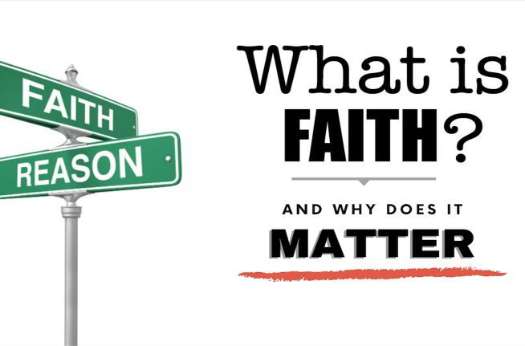 “Faith” is one of those words that is often misunderstood, amongst God’s own people and even worse amongst unbelievers! For example, some Christians believe faith is a blind leap into the unknown,[1] groping in what one cannot see in hope that the free falling of one’s decisions might result in being caught up into great heights of blessings in the arms of our Creator. For others faith is confidence and assurance that filling in the “blank cheque” of God’s mercy and grace is all that is necessary to “claim”[2] the desires of one’s heart! How utterly disappointed these believers become when they find out faith is not “a lasso we throw around God’s neck to make Him do our will!”[3] Then there is the perspective of the unbelievers of this world. Do they not see putting one’s “utter dependence upon an unseen God as being irrational?[4] In their minds what evidence is there that Christ exists, much less controls all things seen and unseen (Colossians 1:16)? Is not faith for them in the “god of self” who is their main source of obtaining great wealth, power, and fame? While we as Christians quickly reject this kind of worldly theology concerning faith if we are truthful with ourselves the lost souls of this world have placed so many “worldly planks of untruth” in our eyes that in our blurry vision God’s definition of faith has been lost in a sea of obscurity!

Since it is by faith that we are saved (Ephesians 2:8-9) and without faith we cannot please God (11:6) it is critical for our spiritual health that we define faith rightly.

The following sermon is going to review Hebrews 11 to help us define faith and through the testimonies of the ancients learn how to live in a manner that pleases our Lord!

# **What Faith Is**

“Now faith is confidence in what we hope for and assurance about what we do not see” (11:1). The word “hypostasis” or “being sure” means “substance, firmness, confidence, a collection of documents establishing ownership, a guarantee, or a proof.” [5] Faith is not a feeling or hope based on what is seen but what is unseen (Romans 8:24).[6] For example, by faith we believe the universe is the footprints of God’s invisible 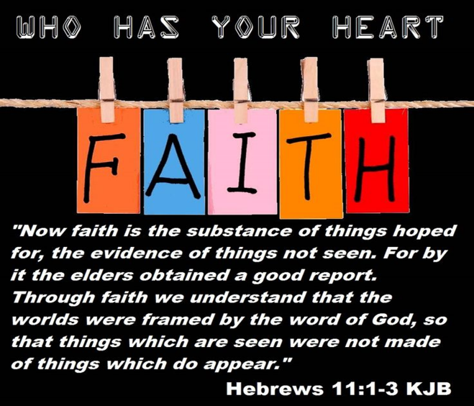qualities,[7] His eternal power and divine nature (Romans 1:20) that were made from nothing at His command (Genesis 1)! Charles Spurgeon rightly states that true faith contains three levels: knowledge of God and His holy word (Romans 10:14-15),[8] understanding and accepting Scriptures as being the “very truth of the living God,”[9] and belief in Christ as our atoning sacrifice to pay for the penalty of our sins.

Faith is not about its size, for even the faith as tiny as a mustard seed can move mighty mountains (Matthew 17:20),[10] but about the integrity of the person you are placing your faith![11]

Jesus who is our once and for all sacrifice for our sins (9:14, 10:14), intercedes and is our sympathetic high priest before God (4:14-16), removes our sins upon confession (1 John 1:9, Hebrews 8:12),[12] and promises to always do good to those who love Him alone is worthy to be praised as our Lord, Saviour, and King! Faith in Jesus calms our fears (1 Corinthians 15:27), cushions our falls (John 10:28) and by it we are adopted into God’s family and our home in heaven eternally secured (John 14:1-3)![13] Faith is living as if God’s promise is already in hand, especially when the blessing is impossible by human effort alone![14] Without faith it is impossible to please God for only those works done in His name and will are acceptable sacrifices unto Him!

# **Lessons from the Faithful**

The story is told of a policeman who was doing his rounds, and this policeman had to cross a bridge. As this policeman crossed the bridge, his eyes riveted on a young man who was about to jump. This young man was about to jump to his death on one of these one hundred-foot bridges that would surely mean, he would die. The policeman softly pulled the car over, and said to the young man, “What are you doing?” The young man says, “I am going to die, I am going to kill myself.”

He says, “Well, why do you want to do that?” He said, “Because life is not worth living. Life is meaningless, empty. There’s no reason for living. I just exist.” The policeman said, “Well, I’ll tell you what to do. Before you jump, I want you to give me five minutes of your time to explain to me why life is so meaningless. Then after I listen to you, I want you to give me five minutes of your time, for me to tell you why life has meaning. So I’ll give you five minutes to tell me why life is meaningless. You give me five minutes to tell you why life is meaningful. And after our ten-minute time together, if you still want to jump, I won’t stop you.”

The young man agreed to that five-minute switch. So for five minutes he discussed the emptiness of life. For five minutes the policeman torridly discussed why life is meaningful, no matter what problems you have. When the ten minutes were up, the policeman reached out his hand to the young man, the young man grasped his hands, and both of them jumped.

We are living in a time now where not only is meaninglessness in the eyes of those who have it, but don’t hang around them too long, it will rub off.[15]

If we are to have confidence and assurance of what we hope for then our role models of genuine faith must be chosen very carefully! For the rest of Hebrews chapter eleven the author points to “many men and women who had nothing but the promises of God to rest upon, without any visible evidence that these promises would ever be fulfilled; yet so much did these promises mean to them that they regulated the whole course of their lives in their light!”[16] By faith Abel offered a better sacrifice than Cain and is still spoken of even though he is dead (v 4). By faith Enoch was taken from this life but did not experience death (v 5). By faith when warned of the flood to come Noah built an ark that not only saved his family and 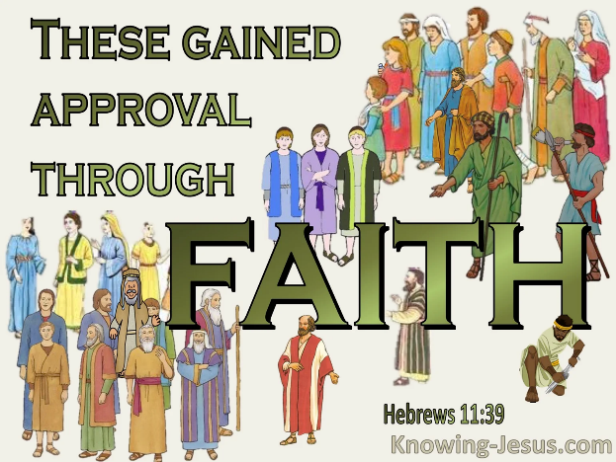condemned the world but also became the heir of righteousness (v 7). By faith Abraham went on a journey not knowing where he was going, lived like a stranger in a foreign land and when God tested him, he offered Isaac as a sacrifice based on God’s promise that He would make him into a great nation (v 8-19). By faith Joseph spoke of the coming Exodus and by faith Moses’ parents hid him for three months. By faith Moses refused to be known as the son of Pharoah’s daughter and later would be God’s arm ushering in the Ten Plagues of Egypt (v 23-39). By faith the walls of Jericho fell, and the prostitute Rahab was not killed (v 30-31). These great ancients (v 1) did not try “to figure out how God was about to make His request happen but merely trusted and obeyed that Christ who created and controls this world always acts according to His will and certainly can produce something truly amazing out of nothing![17] The author finishes off this section on faith in chapter twelve by concluding that

“since we are surrounded by such a great cloud of witnesses, let us throw off everything that hinders and sin that so easily entangles. And let us run with perseverance the race marked out for us, fixing our eyes on Jesus, the pioneer and perfecter of faith” (12:1-2a)!

# **Getting Through the Stormy Days of Life**

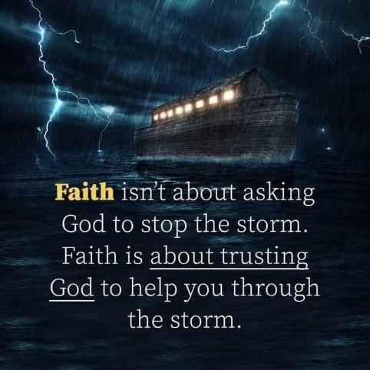 How easy it is to have faith when standing upon the mountaintop of blessings but true faith trusts in the integrity of God to keep His promise to do good to you even in the darkest valleys of tribulations! When you are waiting, praying, reading His word, waiting, and praying some more[18] that you might hear even a whisper of His voice, the author of Hebrews says we are to endure, steadfast in God’s will (10:36) [19] with “confidence in what we hope for and assurance” (v 1) even if we can’t see the light at the end of the tunnel! It is almost like God is saying “don’t quit on Me, I understand it’s taking longer than you thought. I understand you are tired of waiting. I understand you’re frustrated, irritated, aggravated and exacerbated. I understand, but don’t quit on Me!”[20] Even if there is no money in the bank to pay one’s bills, your job is in jeopardy, your health is failing, and even when God feels like He is a million miles away, trust that He has not left nor forsaken you and offers a yoke that is easy, a burden that is light (Matthew 29:30-31) and shelter under His wings (Psalms 91)! When you “can’t see a solution, feel trapped, harnessed and hooked,” [21] and free falling in tribulations 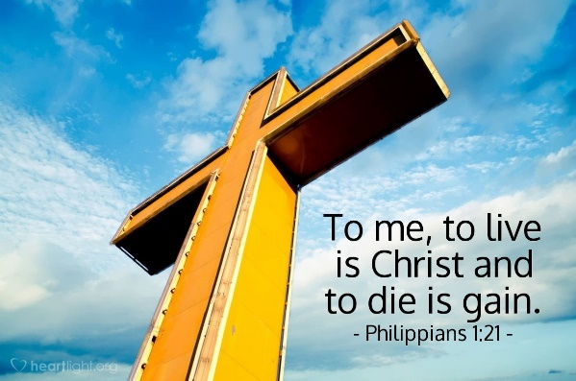do not allow yourself to be like the policeman in the story and be consumed by despair of living in this fallen world but instead look up and forward to your eternal destination which will make your mountains look like molehills (2 Corinthians 4:17-18)![22]

Even though trusting God in the valley of tribulation is one of the hardest things of all to do[23] for us jars of clay that are so easily broken (2 Corinthians 4:7-9), trust that God will always catch you when you fall[24] and lift you to heights that are inconceivable, peaceable and filled with divine love!

May our life prayer be “take my life and let it be consecrated Lord unto Thee.”

**Assurance of Where we are Going**

Above all faith is found in knowing that God alone is our portion and heart’s desire! God does not promise us an easily life filled with roses and non-stop sensual pleasure. “All human beings live by faith, not least in our technological age. What matters is where we place our trust, and on what grounds. Faith is firstly trust in the future, moving into the realm of hope.”[25] Since we live in a fallen world where bad things still happen to good people, the key to living up to the potential we have in Christ Jesus is by having faith that His presence is more than sufficient not only to sustain but provide unspeakable joy of being in His Vine. Apostle Paul was able to state that even amidst life of persecution for Jesus’ sake he considered his “present sufferings not worth anything” when compared to the glory we as God’s very own children are about to receive (Romans 8:18). Paul was able to rejoice for to him “to live is Christ and to die is gain” (Philippians 1:21).

The ancients also had such great confidence and assurance in the integrity of God that though they did not receive what was promised in their lifetimes they still rejoiced for they knew beyond a doubt that not even death could stop the Father’s merciful and gracious hands from fulfilling His word (v 13).

So even in the muck of tribulations we are not to give into terror or despair but instead feel unspeakable joy for the voice of the archangel is about to be heard (1 Thessalonians 4:16-18) and we will be taken to be forever with our Great Shepherd in the paradise He has prepared for His own!

1. Alan Carr, [“An Anatomy of Faith (Hebrews 11:1–2),”](https://ref.ly/logosres/sermonnotebooknt?ref=Bible.Heb11.1-2&off=1863&ctx=URROUNDING+FAITH%0aA.+~Faith+Is+Not+A+Blind) in *The Sermon Notebook: New Testament* (Lenoir, NC: Alan Carr, 2015), 3235.
2. Alan Carr, [“An Anatomy of Faith (Hebrews 11:1–2),”](https://ref.ly/logosres/sermonnotebooknt?ref=Bible.Heb11.1-2&off=2618&ctx=een+it+by+faith.%0aB.+~Faith+Is+Not+A+Blank) in *The Sermon Notebook: New Testament* (Lenoir, NC: Alan Carr, 2015), 3235–3236.
3. Alan Carr, [“An Anatomy of Faith (Hebrews 11:1–2),”](https://ref.ly/logosres/sermonnotebooknt?ref=Bible.Heb11.1-2&off=7231&ctx=oing+to+die!)%0a(Ill.+~Many+people+have+bec) in *The Sermon Notebook: New Testament* (Lenoir, NC: Alan Carr, 2015), 3237–3238.
4. Tony Evans, [“‘The Concept of Faith,’”](https://ref.ly/logosres/tnyvnssrmnrchv?ref=Bible.Heb11.1-3&off=19592&ctx=h+irrational+stuff.+~Faith+is+not+irratio) in *Tony Evans Sermon Archive* (Tony Evans, 2015), Heb 11:1–3.
5. George Guthrie, [*Hebrews*](https://ref.ly/logosres/nivac79heb?ref=Bible.Heb11.1-3&off=182&ctx=hat+we+do+not+see.%E2%80%9D+~The+word+hypostasis%2c), The NIV Application Commentary (Grand Rapids, MI: Zondervan Publishing House, 1998), 374.
6. F. F. Bruce, [*The Epistle to the Hebrews*](https://ref.ly/logosres/nicnt79heb?ref=Bible.Heb11.1&off=2845&ctx=e+adopting+it+here.+~Our+author+is+making), Rev. ed., The New International Commentary on the New Testament (Grand Rapids, MI: Wm. B. Eerdmans Publishing Co., 1990), 277.
7. George Guthrie, [*Hebrews*](https://ref.ly/logosres/nivac79heb?ref=Bible.Heb11.1-3&off=2374&ctx=pects+of+creation.8+~Faith+is+what+looks+), The NIV Application Commentary (Grand Rapids, MI: Zondervan Publishing House, 1998), 375.
8. C. H. Spurgeon, [“Faith,”](https://ref.ly/logosres/npspserms03?ref=Page.p+2&off=3267&ctx=e+they+cannot+tell.+~Now%2c+I+hold+no+man%E2%80%99s) in *The New Park Street Pulpit Sermons*, vol. 3 (London: Passmore & Alabaster, 1857), 2.
9. C. H. Spurgeon, [“Faith,”](https://ref.ly/logosres/npspserms03?ref=Page.p+3&off=690&ctx=+the+verity+of+God.+~Now%2c+in+order+to+fai) in *The New Park Street Pulpit Sermons*, vol. 3 (London: Passmore & Alabaster, 1857), 3.
10. Tony Evans, [“‘The Concept of Faith,’”](https://ref.ly/logosres/tnyvnssrmnrchv?ref=Bible.Heb11.1-3&off=5613&ctx=bulldozer+to+do+it.+~In+other+words%2c+the+) in *Tony Evans Sermon Archive* (Tony Evans, 2015), Heb 11:1–3.
11. Tony Evans, [“‘The Concept of Faith,’”](https://ref.ly/logosres/tnyvnssrmnrchv?ref=Bible.Heb11.1-3&off=5064&ctx=principle+of+faith.+~He+says+faith+is+bei) in *Tony Evans Sermon Archive* (Tony Evans, 2015), Heb 11:1–3.
12. John Piper, [*Sermons from John Piper (1990–1999)*](https://ref.ly/logosres/srmpiper1990?art=sermon.999&off=980&ctx=een+about+Christ%3a%0a%E2%80%A2+~giving+himself+once+) (Minneapolis, MN: Desiring God, 2007).
13. Alan Carr, [“An Anatomy of Faith (Hebrews 11:1–2),”](https://ref.ly/logosres/sermonnotebooknt?ref=Bible.Heb11.1-2&off=10116&ctx=+those+who+will!%0aC.+~Faith+Confirms+Our+F) in *The Sermon Notebook: New Testament* (Lenoir, NC: Alan Carr, 2015), 3239.
14. Tony Evans, [“‘The Concept of Faith,’”](https://ref.ly/logosres/tnyvnssrmnrchv?ref=Bible.Heb11.1-3&off=7631&ctx=to+be+good+enough.%E2%80%9D%0a~God+is+saying+you+do) in *Tony Evans Sermon Archive* (Tony Evans, 2015), Heb 11:1–3.
15. Tony Evans, [“‘The Concept of Faith,’”](https://ref.ly/logosres/tnyvnssrmnrchv?ref=Bible.Heb11.1-3&off=84&ctx=s%0aSeptember+4%2c+2002%0a~The+story+is+told+of) in *Tony Evans Sermon Archive* (Tony Evans, 2015), Heb 11:1–3.
16. F. F. Bruce, [*The Epistle to the Hebrews*](https://ref.ly/logosres/nicnt79heb?ref=Bible.Heb11.1&off=245&ctx=th+in+earlier+days.+~In+Old+Testament+tim), Rev. ed., The New International Commentary on the New Testament (Grand Rapids, MI: Wm. B. Eerdmans Publishing Co., 1990), 276.
17. Tony Evans, [“‘The Concept of Faith,’”](https://ref.ly/logosres/tnyvnssrmnrchv?ref=Bible.Heb11.1-3&off=23339&ctx=ve+to+do+with+that%3f%0a~Watch+it+now%2c+my+Bib) in *Tony Evans Sermon Archive* (Tony Evans, 2015), Heb 11:1–3.
18. Tony Evans, [“‘The Concept of Faith,’”](https://ref.ly/logosres/tnyvnssrmnrchv?ref=Bible.Heb11.1-3&off=2250&ctx=ews+wrote+the+book.+~How+do+you+make+it+w) in *Tony Evans Sermon Archive* (Tony Evans, 2015), Heb 11:1–3.
19. Tony Evans, [“‘The Concept of Faith,’”](https://ref.ly/logosres/tnyvnssrmnrchv?ref=Bible.Heb11.1-3&off=2928&ctx=ok%2c+don%E2%80%99t+you+quit.+~Don%E2%80%99t+you+throw+in+t) in *Tony Evans Sermon Archive* (Tony Evans, 2015), Heb 11:1–3.
20. Tony Evans, [“‘The Concept of Faith,’”](https://ref.ly/logosres/tnyvnssrmnrchv?ref=Bible.Heb11.1-3&off=3416&ctx=rving+of+the+soul.%E2%80%9D%0a~He+says%2c+don%E2%80%99t+go+ba) in *Tony Evans Sermon Archive* (Tony Evans, 2015), Heb 11:1–3.
21. Tony Evans, [“‘The Concept of Faith,’”](https://ref.ly/logosres/tnyvnssrmnrchv?ref=Bible.Heb11.1-3&off=16438&ctx=B%E2%80%94my)+high+places.%E2%80%9D%0a~He+said+even+though+) in *Tony Evans Sermon Archive* (Tony Evans, 2015), Heb 11:1–3.
22. Philip H Hacking, [*Opening up Hebrews*](https://ref.ly/logosres/openup79heb?ref=Bible.Heb11.1-3&off=1135&ctx=ne+out+of+business.%0a~Such+faith+changes+o), Opening Up Commentary (Leominster: Day One Publications, 2006), 71.
23. Tony Evans, [“‘The Concept of Faith,’”](https://ref.ly/logosres/tnyvnssrmnrchv?ref=Bible.Heb11.1-3&off=26177&ctx=His+time+not+yours.%0a~Trust+Him+when+dark+) in *Tony Evans Sermon Archive* (Tony Evans, 2015), Heb 11:1–3.
24. Tony Evans, [“‘The Concept of Faith,’”](https://ref.ly/logosres/tnyvnssrmnrchv?ref=Bible.Heb11.1-3&off=28709&ctx=oing+to+catch+them.%0a~Somebody+know+where+) in *Tony Evans Sermon Archive* (Tony Evans, 2015), Heb 11:1–3.
25. Philip H Hacking, [*Opening up Hebrews*](https://ref.ly/logosres/openup79heb?ref=Bible.Heb11.1-3&off=268&ctx=+a+matter+of+genes.+~All+human+beings+liv), Opening Up Commentary (Leominster: Day One Publications, 2006), 70.