# The Desire to do Good

**2 Thessalonians 3:6-13**

Online Sermon: <http://www.mckeesfamily.com/?page_id=3567>

**“It is a loss, perhaps, to give to a man who wastes, but it will be a greater loss not to give at all!”**[1]

**Charles Spurgeon**

Jesus told believers that “from the one who has been entrusted with much, much more will be asked” (Luke 12:48). When we count our blessings and name them one by one are we not blessed beyond all measure? As redeemed masterpieces of His grace who have received every spiritual blessing (Ephesians 2:8-9, 1:3) and divine comfort of inestimable value (2 Corinthians 1:4), surely Christ’s command to take care of the widows, feed, and cloth the poor of this world are the least we ought to do in His name to please Him (Matthew 25:40)! And yet there is a hesitancy even in the “eminently peaceable, honest, upright, gracious and Christlike church”[2] to give out of their abundance to a world that is steeped in sin. While we know it is through our generosity that we not only fulfill Christ’s command to love our neighbor but also point them to God’s love (Matthew 22:37-40), is it right to provide for the necessities of life such as food, water, clothes, paying a hydro bill, or buying a tank of gas for someone who in the past used our generosity as the means to free up funds to buy drugs, alcohol or other frivolous items of great pleasure? And if the person is not receptive to the Gospel message through our giving, are we not casting our precious pearls of hard-earned treasures before the swine of indifference (Matthew 7:6)?

Does Christ really want us to give to the “takers” of this world who can work but refuse to do so to support themselves? But on the flip side if we only give to those “we deem worthy” are we not judging them harshly and even hypocritically when we won’t offer others an ounce of grace when we have received from our Master the unmerited, eternal, and unspeakable grace of our salvation?

The following sermon is going to review Apostle Paul’s words to the church of Thessalonica concerning how to give in a God honoring way that is both generous but at the same time as good stewards of all that we have received from our Lord!

# The “Takers” at Thessalonica

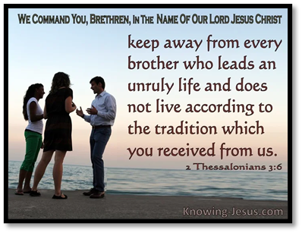 In his letter to the church of Thessalonica Apostle Paul wrote concerning what to do with those who could work but instead chose to “live” off the generosity of the church. There arose within the church a “class of people”[3] that were “idle” refusing to work for a variety of reasons. For some they were simply lazy and preferred to be taken care of. Others felt the Day of the Lord was rapidly approaching so why work?[4] Some were influenced by Greek culture that saw manual labour as demeaning[5] and yet others refused to work because they wanted to spend all their time promoting the spiritual welfare of the church.[6] While the last reason seems to have some merit the fruits of their labor proved that their motives were not holy for Paul called them unproductive, irresponsible, “busy-bodies” (verse 11)[7] that were disrupting the body of Christ while “feeding off of their generosity.” Paul told them if they truly wanted to promote the spiritual well being of the church then they ought to follow his example and do so without compensation from the body of Christ to prove that they were indeed not motivated by avarice (1 Thessalonians 2:5).[8] Paul is not saying that ordained servants of the Lord were not worthy of being paid (1 Corinthians 9:4-14) but merely that those wanted to be busy-bodies[9] and get paid for doing so should not be compensated but disciplined.

Paul instructed the body of Christ to neither “eject or excommunicate the minority nor to admire them secretly and adopt the same practices”[10] but instead to warn those “brothers and sisters”[11] and to no longer associate with them to bring them to shame and repentance (verses 14-15).

“In the name of the Lord Jesus Christ” and with a ring of authority like that of a military commander,[12] as God’s servant through Christ[13] Paul commands the church of Thessalonica to discipline those who refuse to work. This command did not come from the “cold rule of an autocrat”[14] but from the warm affection of a friend who truly desired the church to embrace their “corporate responsibility”[15] as one body to do what they could to get the fallen to conform to Christian moral teaching in this matter (Matthew 18:7; Romans 16:17; 1 Corinthians 5:9-13).[16] Paul did not want the church at Thessalonica to become bitter at the “takers” and excommunicate them,[17] or become envious and join them, or become frustrated or bitter and stop giving to anyone at all;[18] but instead Paul instructed them to do all they could to bring the offenders to repentance. The process of correction in the Bible is called discipline.[19] We are shown we are part of God’s family when the Father in love “puts on spiritual braces” in our mouths, hearts, and minds to realign our character to reflect His glory.[20] Since it was a necessary part of their spiritual development[21] Paul recommended the church to be God’s arm of discipline by reading his letter publically to shame them, refuse to give to them any money of food and to have limited contact with them.[22]

This discipline was not to be done to be harsh or in a sense of presumed holiness but was to be humbly applied to the offenders to spur them on to repentance and subsequent restoration.

Since the “identity of a person was bound intimately with the group to which he or she belonged to” [23] public shame and little interaction with the body of Christ was in Paul’s mind sufficient to discipline and promote the repentance of the “takers.”

# Those who do not Work do not Eat

 Paul’s insistence, “the one who does not work does not eat” comes from other Biblical sources. “The necessity of working formed part of the ethical tradition of the church (Ephesians 4:28; 1 Thessalonians 4:11-12), finding its roots both in the OT (Psalms 128:2; Proverbs 10:4, 12:11, 19:15) and in Jewish literature.”[24] In the very first book of the Bible, Genesis, we learn that God worked at creation for six days and on the seventh day rested.[25] When God placed Adam in the Garden of Eden the first command, He gave him was “to work it and take care of it” (Genesis 2:15). “Work was not despised but rather was honored by the people of God as good (Prov. 22:29; 31:13–27; 2 Thess. 3:6–12; cf. Prov. 6:6–11; 10:4–5; Eccl. 10:18), even though the pain and seeming futility of work was recognized (e.g., Eccl. 1:3; 2:11, 18–23; 5:15–17 [MT 14–16]; Heb. *˓āmāl*). Only with God’s blessing on it could work be productive (Ps. 127:1–2; cf. 107:35–38).”[26] In the NT we find that even Jesus worked as a carpenter up until age 30.[27]

Not only does the Bible teach that we are to work but also when do so unto the Lord it is holy and acceptable in His sight.[28] It is a sin to be idle and live off the generosity of others but only when one has the mental and physical capabilities to do so and the opportunity to work![29]

Apostle Paul is not saying we refuse to give to the needy, widows and fatherless if they are idle but merely that we are not to give to those who refuse to accept their obligation if able to work to take care of themselves and their families.[30]

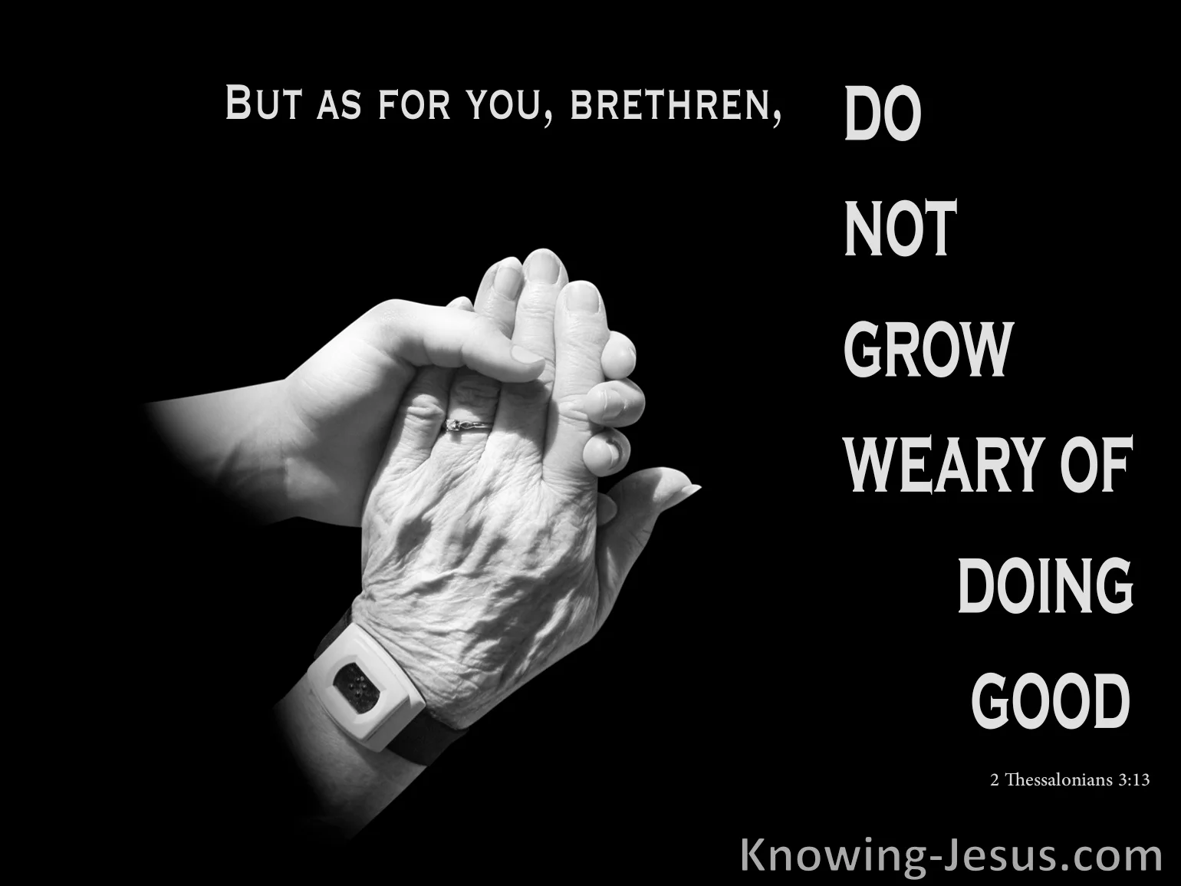When it comes to the “takers” of this world we are not to ostracize them lest in the mire of the planks in our own eyes we become condescending and invite judgement upon ourselves (Matthew 7:1-3). We are to offer the “takers” grace and mercy by teaching them the importance of working in the Bible and upon their repentance and actively look for work providing their needs.

# Never Tire Doing Good Work

Although Apostle Paul absolved the church from the responsibility to give to the “takers” who refused to work, this “in no way implied they should quit giving to those in need.”[31] How frustrating it truly is to think one is offering a “cup of cold water” (Matthew 10:42) unto the poor and needy of this world only to find out that the fruit of one’s labour was to feed the drinking, drug and tattoo fetish of the fallen! It is very tempting to say that “there are so many imposters that I shall not give nothing at all, I have been deceived so many times, and have given to persons who only made a bad use of my gift, that I do not intend to open my purse-strings ever again.”[32] Just because “takers” exist again I say that this does not absolve us from our responsibility to feed the poor, widows and fatherless of this world (Matthew 25:31-46)! We do good deeds unto others not to earn their gratitude[33] but to point them to the unspeakable, unconditional love the Father has given us, sinners saved by grace through faith (Ephesians 2:8-9)! Surely the “bowels of compassion for our brothers and sisters who are in need”[34] far outweigh the possibility of casting our pearls before swine (Matthew 7:6) when we ourselves in the presence of a holy God have nothing to offer but mere filthy rags of righteousness (Isaiah 64:6). We cannot and simply must not grow weary doing good for if Christ who knows all things concerning their hearts (1 Corinthians 2:11-13) still sees good in this world, then so should we! May we pray and fast to discern whom the Lord wants us to give and then place our hard earned, but God given treasures before the needy of His choosing!

We give what is here today and gone tomorrow (Matthew 6:19-24) not to receive earthly praise but to be good stewards of His resources and to receive eternal crowns of righteousness (2 Timothy 4:6-8).

**Conclusion**

In conclusion never tire from doing good! Yes, there will always be takers in this world and as such when we give out of our abundance, we risk casting our pearls of hard earned, God given abundance before those who will only squander away or worse yet use it to gratify their sinful pleasures. Even though we risk being prey to the piranhas of generosity this does not absolve God’s own from the responsibility to offer a cup of cold water in Jesus’ name! This does not mean God wants us to indiscriminately squander the abundance He has entrusted to us. With much prayer and fasting we are to ask our Lord to help us discern to whom He wants us to give. Unto those who can but refuse to work to provide a living for themselves and their families Apostle Paul states we are not to ostracize them from our social network but are to refuse to give unto them, warn them of God’s displeasure, and pray for their repentance! Above when God asks us to cast our abundance on someone, we are not to judge them too harshly for they too are created in the image of God and in the eyes of the Lord we too often appear as a taker of His grace! So, when instructed by our Lord we give with thanksgiving in our hearts with the glorious hope and expectation that a cup of cold water offered in His name is never done in vanity even if we must wait a lifetime to see the fruit of His glorious request! Never tire doing good for unto much is given much more is expected!

1. C. H. Spurgeon, [“Facing the Wind,”](https://ref.ly/logosres/mtpserms51?ref=Page.p+30&off=2799&ctx=o+harden+thy+heart.+~It+is+a+loss%2c+perhap) in *The Metropolitan Tabernacle Pulpit Sermons*, vol. 51 (London: Passmore & Alabaster, 1905), 30.
2. C. H. Spurgeon, [“Facing the Wind,”](https://ref.ly/logosres/mtpserms51?ref=Page.p+25&off=253&ctx=Thessalonians+3%3a13.%0a~The+Christian+church) in *The Metropolitan Tabernacle Pulpit Sermons*, vol. 51 (London: Passmore & Alabaster, 1905), 25.
3. C. H. Spurgeon, [“Facing the Wind,”](https://ref.ly/logosres/mtpserms51?ref=Page.p+25&off=727&ctx=in+Israel+evermore.+~It+was+so+in+the+chu) in *The Metropolitan Tabernacle Pulpit Sermons*, vol. 51 (London: Passmore & Alabaster, 1905), 25.
4. Gene L. Green, [*The Letters to the Thessalonians*](https://ref.ly/logosres/pntcthes?ref=Bible.2Th3.6-15&off=1901&ctx=+the+Thessalonians.+~Their+view+is+that+t), The Pillar New Testament Commentary (Grand Rapids, MI; Leicester, England: W.B. Eerdmans Pub.; Apollos, 2002), 341.
5. Ernest Best, [*The First and Second Epistles to the Thessalonians*](https://ref.ly/logosres/black73th?ref=Bible.2Th3.6&off=6480&ctx=egative+or+passive.%0a~We+are+not+told+why+), Black’s New Testament Commentary (London: Continuum, 1986), 334.
6. Gene L. Green, [*The Letters to the Thessalonians*](https://ref.ly/logosres/pntcthes?ref=Bible.2Th3.11&off=2641&ctx=hough+the+noun+form+~is+found+in+Acts+19%3a), The Pillar New Testament Commentary (Grand Rapids, MI; Leicester, England: W.B. Eerdmans Pub.; Apollos, 2002), 351.
7. Michael Holmes, [*1 and 2 Thessalonians*](https://ref.ly/logosres/nivac73th?ref=Bible.2Th3.11-12&off=260&ctx=f+the+congregation.+~Paul%E2%80%99s+opinion+of+su), The NIV Application Commentary (Grand Rapids, MI: Zondervan Publishing House, 1998), 273.
8. Gene L. Green, [*The Letters to the Thessalonians*](https://ref.ly/logosres/pntcthes?ref=Bible.2Th3.8&off=2&ctx=les+to+follow.%EF%BB%BF36%0a8+~The+apostle+continue), The Pillar New Testament Commentary (Grand Rapids, MI; Leicester, England: W.B. Eerdmans Pub.; Apollos, 2002), 347.
9. David J. Williams, [*1 and 2 Thessalonians*](https://ref.ly/logosres/nibcnt73th?ref=Bible.2Th3.10&off=1541&ctx=+denial+of+support.+~The+implication+in+t), Understanding the Bible Commentary Series (Grand Rapids, MI: Baker Books, 2011), 146.
10. Ernest Best, [*The First and Second Epistles to the Thessalonians*](https://ref.ly/logosres/black73th?ref=Bible.2Th3.6&off=3899&ctx=y+of+consideration.+~As+for+the+others+he), Black’s New Testament Commentary (London: Continuum, 1986), 333.
11. Gene L. Green, [*The Letters to the Thessalonians*](https://ref.ly/logosres/pntcthes?ref=Bible.2Th3.6&off=3876&ctx=bey+this+tradition.+~As+we+will+see+furth), The Pillar New Testament Commentary (Grand Rapids, MI; Leicester, England: W.B. Eerdmans Pub.; Apollos, 2002), 344.
12. Leon Morris, [*1 and 2 Thessalonians: An Introduction and Commentary*](https://ref.ly/logosres/tntc73thus?ref=Bible.2Th3.6&off=3&ctx=ven+intensified.%0a6.+~Paul%E2%80%99s+opening+is+au), vol. 13, Tyndale New Testament Commentaries (Downers Grove, IL: InterVarsity Press, 1984), 140.
13. Ernest Best, [*The First and Second Epistles to the Thessalonians*](https://ref.ly/logosres/black73th?ref=Bible.2Th3.6&off=1694&ctx=+Th.+1%3a5%3b+2%3a4%2c+13).+~Paul+is+God%E2%80%99s+servan), Black’s New Testament Commentary (London: Continuum, 1986), 332.
14. Leon Morris, [*1 and 2 Thessalonians: An Introduction and Commentary*](https://ref.ly/logosres/tntc73thus?ref=Bible.2Th3.6&off=545&ctx=her+church+members.+~They+are+to+be+dealt), vol. 13, Tyndale New Testament Commentaries (Downers Grove, IL: InterVarsity Press, 1984), 141.
15. Leon Morris, [*1 and 2 Thessalonians: An Introduction and Commentary*](https://ref.ly/logosres/tntc73thus?ref=Bible.2Th3.6&off=872&ctx=lding+aloof+(BAGD).+~But+such+a+withdrawa), vol. 13, Tyndale New Testament Commentaries (Downers Grove, IL: InterVarsity Press, 1984), 141.
16. Gene L. Green, [*The Letters to the Thessalonians*](https://ref.ly/logosres/pntcthes?ref=Bible.2Th3.6&off=4684&ctx=+and+Hebrews+10%3a38.+~Social+separation+wa), The Pillar New Testament Commentary (Grand Rapids, MI; Leicester, England: W.B. Eerdmans Pub.; Apollos, 2002), 344–345.
17. Ernest Best, [*The First and Second Epistles to the Thessalonians*](https://ref.ly/logosres/black73th?ref=Bible.2Th3.6&off=3252&ctx=+the+Lord+had+come.+~The+majority+might+g), Black’s New Testament Commentary (London: Continuum, 1986), 333.
18. C. H. Spurgeon, [“Facing the Wind,”](https://ref.ly/logosres/mtpserms51?ref=Page.p+30&off=2253&ctx=+of+our+good+deeds.+~As+I+have+already+sa) in *The Metropolitan Tabernacle Pulpit Sermons*, vol. 51 (London: Passmore & Alabaster, 1905), 30.
19. Tony Evans, [“‘Caring Enough to Correct,’”](https://ref.ly/logosres/tnyvnssrmnrchv?ref=Bible.2Th3.10-15&off=1326&ctx=thing+that%E2%80%99s+wrong.%0a~This+process+of+corr) in *Tony Evans Sermon Archive* (Tony Evans, 2015), 2 Th 3:10–15.
20. Tony Evans, [“‘Caring Enough to Correct,’”](https://ref.ly/logosres/tnyvnssrmnrchv?ref=Bible.2Th3.10-15&off=534&ctx=need+of+correction.%0a~What+is+true+of+teet) in *Tony Evans Sermon Archive* (Tony Evans, 2015), 2 Th 3:10–15.
21. Tony Evans, [“‘Caring Enough to Correct,’”](https://ref.ly/logosres/tnyvnssrmnrchv?ref=Bible.2Th3.10-15&off=3172&ctx=et+us+back+in+line.%0a~Discipline+is+a+nece) in *Tony Evans Sermon Archive* (Tony Evans, 2015), 2 Th 3:10–15.
22. Michael Holmes, [*1 and 2 Thessalonians*](https://ref.ly/logosres/nivac73th?ref=Bible.2Th3.13-15&off=1855&ctx=ken+off+is+unclear.+~At+first+glance+3%3a14), The NIV Application Commentary (Grand Rapids, MI: Zondervan Publishing House, 1998), 275.
23. Gene L. Green, [*The Letters to the Thessalonians*](https://ref.ly/logosres/pntcthes?ref=Bible.2Th3.6&off=6310&ctx=+act+as+one+should.+~If+we+also+understan), The Pillar New Testament Commentary (Grand Rapids, MI; Leicester, England: W.B. Eerdmans Pub.; Apollos, 2002), 345.
24. Gene L. Green, [*The Letters to the Thessalonians*](https://ref.ly/logosres/pntcthes?ref=Bible.2Th3.10&off=1518&ctx=+he+shall+not+eat.%E2%80%9D+~The+necessity+of+wor), The Pillar New Testament Commentary (Grand Rapids, MI; Leicester, England: W.B. Eerdmans Pub.; Apollos, 2002), 349.
25. M. Coppenger, [“Work and Play,”](https://ref.ly/logosres/bkrencypsyc?ref=CT.Work&off=15&ctx=Work+and+Play.+~From+earliest+times+work+) ed. David G. Benner and Peter C. Hill, *Baker Encyclopedia of Psychology & Counseling*, Baker Reference Library (Grand Rapids, MI: Baker Books, 1999), 1265.
26. Allen C. Myers, [*The Eerdmans Bible Dictionary*](https://ref.ly/logosres/eerdbibdct?ref=Page.p+634&off=2829&ctx=%E2%80%939%3b+Col.+3%3a22%E2%80%934%3a1).%0a~Work+was+not+despise) (Grand Rapids, MI: Eerdmans, 1987), 634–635.
27. C. H. Spurgeon, [“Facing the Wind,”](https://ref.ly/logosres/mtpserms51?ref=Page.p+29&off=2509&ctx=+not+be+well+doing.+~In+the+name+of+the+L) in *The Metropolitan Tabernacle Pulpit Sermons*, vol. 51 (London: Passmore & Alabaster, 1905), 29.
28. C. H. Spurgeon, [“Facing the Wind,”](https://ref.ly/logosres/mtpserms51?ref=Page.p+27&off=606&ctx=+other+things%2c+that+~even+the+most+menial) in *The Metropolitan Tabernacle Pulpit Sermons*, vol. 51 (London: Passmore & Alabaster, 1905), 27.
29. Ian McNaughton, [*Opening up 2 Thessalonians*](https://ref.ly/logosres/openup74th2?ref=Bible.2Th3.6-13&off=1651&ctx=anned+for+humanity.+~It+is%2c+therefore%2c+si), Opening Up Commentary (Leominster: Day One Publications, 2008), 68–69.
30. Michael Holmes, [*1 and 2 Thessalonians*](https://ref.ly/logosres/nivac73th?ref=Bible.2Th3.6-18&off=8323&ctx=+atakteo+elsewhere%3a+~The+primary+emphasis), The NIV Application Commentary (Grand Rapids, MI: Zondervan Publishing House, 1998), 272.
31. Gene L. Green, [*The Letters to the Thessalonians*](https://ref.ly/logosres/pntcthes?ref=Bible.2Th3.13&off=754&ctx=%3a9%3b+Eph.+3%3a13).%EF%BB%BF59%EF%BB%BF+~Although+the+apostle), The Pillar New Testament Commentary (Grand Rapids, MI; Leicester, England: W.B. Eerdmans Pub.; Apollos, 2002), 353.
32. C. H. Spurgeon, [“Facing the Wind,”](https://ref.ly/logosres/mtpserms51?ref=Page.p+28&off=1008&ctx=ary+in+well+doing.%E2%80%9D+~Do+not+say%2c+as+some+) in *The Metropolitan Tabernacle Pulpit Sermons*, vol. 51 (London: Passmore & Alabaster, 1905), 28.
33. C. H. Spurgeon, [“Facing the Wind,”](https://ref.ly/logosres/mtpserms51?ref=Page.p+35&off=948&ctx=me%2c+even+from+me.%E2%80%9D%0a%E2%80%9C~Still%2c%E2%80%9D+says+one%2c+%E2%80%9CI) in *The Metropolitan Tabernacle Pulpit Sermons*, vol. 51 (London: Passmore & Alabaster, 1905), 35.
34. C. H. Spurgeon, [“Facing the Wind,”](https://ref.ly/logosres/mtpserms51?ref=Page.p+30&off=3175&ctx=to+Christian+gifts.+~It+is+not+so+much+a+) in *The Metropolitan Tabernacle Pulpit Sermons*, vol. 51 (London: Passmore & Alabaster, 1905), 30–31.