**Going Beyond Human Sickness**

**Matthew 11:28-30, 16:21-27**

Online Sermon: <http://www.mckeesfamily.com/?page_id=3567>

What do you do when you get sick? For many of us our first response is to look for an “over-the-counter” solution to see if we can find a cure for whatever ails us on our own![1] I remember a few years ago, before Covid, I got a nasty cold. My throat was sore, my head pounded, I figuratively coughed up a lung every hour, and my nose refused to stop running so I tried my usual home remedies to get better. I ate lots of chicken noodle soup, slept for many hours, used a Neti Pot to clear out my sinuses, and popped Fisherman’s Friends like they were candy! After several days of what this “baby” thought was intense suffering, I went to the Pharmacy to get some better drugs. I thought to myself “I am a grown man who knows his own body so surely I can find my own solution!” With Buckley’s Cough, Cold and Flu Medicine, NeoCitran, extra strength Tylenol and other medicines that I don’t even remember their names, I confidently headed home with the expectation that this “home physician” would quickly heal himself! After a few more days of intense suffering and with great humility I called my doctor for an appointment. She questioned my “wisdom” of not asking her advice sooner for now my cold had become bronchitis and a sinus infection was so bad that even my teeth and jaw hurt when I was walking! I happily took the prescription she wrote and when the pharmacist went out back to get drugs not accessible to the public without a prescription, I sighed relief for I knew I now had a cure, and my suffering was about to end!



But what does one do when something is seriously broken within one’s mind and very soul? What do you do when you feel empty, alone and incapable of finding any purpose for living? When life becomes pure vanity and meaningless where does one turn to be healed? Like a broken body[2] most tend to look for “over-the-counter” remedies to heal their fractured minds and restore happiness and peace to their lives. Surely by strengthening one’s family relationships, increasing one’s wealth, fame, and power, or just indulging in the pleasurable activities of life should cure and fill our minds with joy and peaceful thoughts? But what does one do when the void in one’s heart cannot be filled with such worldly strategies? After all most people no matter how hard they try will not become “successful” by worldly standards, and even if they do, rarely by acquiring whatever the lust of the eyes sees, satisfies them, nor does it make a dent in filling the gapping hole within their heart with any sense of purpose! And while one could go and get help from a psychiatrist, they are not always able to provide a cure because when the hole in one’s heart is distance from one’s Creator … well then only He who knit us in our mother’s womb (Psalms 139) can show us the way, truth, and life (John 14:6)!

**The Great Physician Jesus**

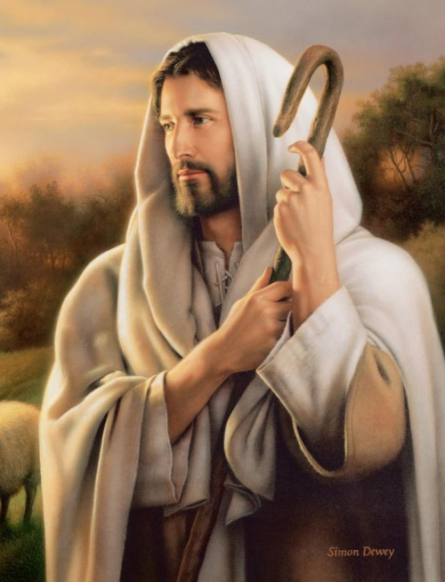 Saint Augustine once said, “our heart is forever restless until it rests in God!” This makes sense considering that we are all created in the image of God (Genesis 1:27) and are meant to have a relationship with our Creator. Our soul thirsts for the living God and as such Dallas Willard rightly states it becomes sick and diseased by our sin and our wandering on the dark path of infinite choice and loving the ways of this world.[3] It is by coming into the presence of God with a humble, regenerate, and submissive heart that one finds one’s true purpose is to do His will for one’s life! But what does one do when going to church, reading the Bible and praying still leaves one feeling sick, empty, alone, distant and broken? Should not our solution be to come before the Great Physician whose potter hands alone can forgive our sins and grant us the joy of receiving every spiritual blessing in His name (Ephesians 1:3)? Is it not Christ who leads us by the still waters? And when we get under His wings and rely on His providential care, do we not receive refuge and the peace of God that transcends all understanding because His hand provides what is truly good for us (Psalms 23, 91, Romans 8:28)? And even if what is trying to crush one’s soul is the spiritual forces of evil in the heavenly realms (Ephesians 6:12) our cure is still guaranteed for our Great Physician is no one other than Jesus who is sovereign over all things seen and unseen (Colossians 1:16)! So, then why do so many Christians live with “sick souls” when they have access to divine healing 24/7?

**Requirements of the Cure**

We often do not approach the Great Physician because to do so would expose our darkness by His glorious light and in turn require us to change! Fear or reverence of God is the beginning of wisdom (Psalms 9:10) but only when it is done with an attitude of joyful submission! Too often Christians try to appease God with small sums of money, time and service[4] but refuse to draw nearer to He who has no darkness in Him at all (1 John 1:5) in fear that His holy light will expose the tension within their heart to love both Him and the ways of this world (1 John 2:15-16)! For example, in 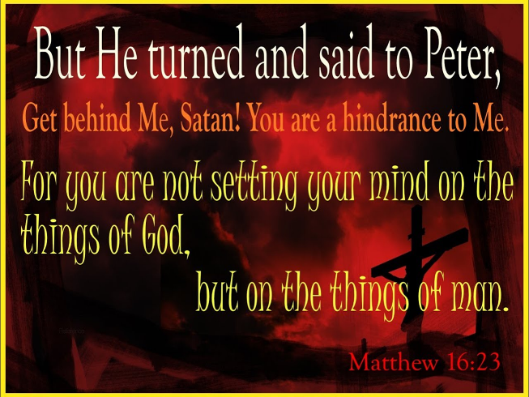verse 21 of Matthew 16 it states that Jesus told the disciples that He was about to go to Jerusalem where He would suffer greatly at the hands of the elders, chief priests and teachers of the law that would be so intense that it would result in Him being killed but in three days raised from the dead. For those who “gave up everything to follow Jesus” (Matthew 19:27) this news, even though Christ had told them it before,[5] was so heart breaking that Peter, who likely thought he “knew more about God’s will for the Messiah than the Messiah did,”[6] foolishly stated, “this shall never happen to You” (verse 22)![7] Christ responded by saying to Peter, “get behind me Satan, you are a stumbling block to me, you do not have in mind the concerns of God, but merely human concerns” (verse 23). Like Peter it is easy for us to approach the Great Physician with the “expectation of glory, honor, comfort and security.:[8] But if we are to be truly healed of the debilitating affects of being distant from our Creator then we simply must adopt an attitude of seeking first the kingdom of God (Matthew 6:33), even when it means suffering, pain, persecution[9] and confession that we are often more interested in pleasing ourselves and think we are better equipped to choose the best path to live our lives than the Physician could ever provide! To hold onto human concerns rather than submitting to God’s will is the reason why so many Christians have sickness within their souls!

To keep the concerns of God our primary focus and become a true disciple of Christ one must deny oneself, take up one’s cross and follow Him (verse 24)! One of the biggest reasons believers feel they lack a sense of purpose or are suffering from various soul diseases is due to their reluctance to take “self” to the cross to be crucified![10] Though we are “surrounded by a world that says NO to nothing,”[11] until one has a funeral[12] and experience death of one’s own self-interests, goals, and ambitions[13] then approaching the light of the Great Physician Jesus will always be terrifying for who could ever walk in the darkness and claim to be in the light (1 John 1)? It was almost like Jesus was telling Peter that he must decide, “you can have you or you can have Me, but you can’t have you and Me!”[14] To 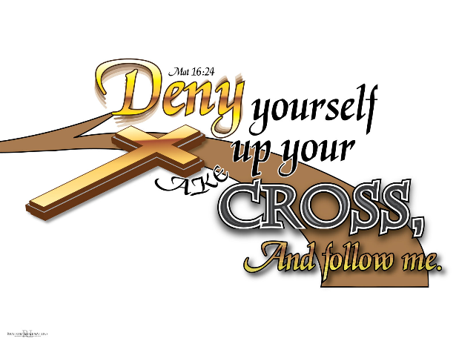give up that which we cannot keep, our very lives, to receive that which we cannot loose, our salvation, will be painful but must be done for anything we love more than God is an idol that will keep us separated from Him, left to drown in our own sinful desires (James 1:13-15). “For the law of sin is the force of habit, by which the mind is carried along and held prisoner against its will, deservedly, of course, because it slid into the habit by its own choice.[15]The “cross we must take up” is us to be living sacrifices (Romans 12:1-2) who daily say NO to self ambition[16] and YES to finding and obeying the will of God for our lives. Taking up one’s cross can be found in loving the Lord and joyfully helping one another. Even though “feeding the hungry, giving drink to the thirsty, receiving the stranger, clothing the naked, caring for the sick, and visiting those in prison (Matthew 25:31-46)”[17] requires voluntarily[18] giving up human nature preferred, temporary pleasures; by seeking first the kingdom, God promises us not an easy life but one filled with unspeakable joy because one is living in His glorious presence not in fear of the Light but in adoration and submission to it!

Denying oneself and taking up one’s cross is hard for the “strongest saint as well for the weakest sinner”[19] because there is constantly a battle of wills going on inside of every believer. The sinful nature wants to exercise its freedom of choice to indulge in the lust of the flesh, eyes, and pride of life (1 John 2:16) while the new nature wants to only do the will of God (Romans 6)! This conflict can be so intense that sometimes it feels like our souls are being ripped into a million pieces, especially when sin and guilt rein within our hearts! But if we want to be healed and feel unspeakable joy then Christ asks us to follow Him which means being like Jesus and being willing to give up everything to do the will of God the Father in heaven.[20] “We are God’s: let us therefore live for Him and die for Him. We are God’s: let His wisdom and will therefore rule all our actions. We are God’s: let all the parts of our life accordingly strive toward Him as our only lawful goal (Rom. 14:8; cf. 1 Cor. 6:19)!”[21] To run the race and win the crowns of righteousness then one simply must choose to sacrifice self-interests daily.[22] Instead of giving God platitudes of a lazy and drowsy believer[23] whose conflicted mind says the right things but, in the end, does not obey; His word, voice and Spirit must become lamps unto our feet[24] and lights that illuminate and guide every step we take in life (Psalms 119). It is precisely by giving up our desire to please our human nature that wants the things of this world that are here today and gone tomorrow (Mathew 6:19-20) that one is freed from such unhealthy obsessions[25] so that one can embrace the eternity God has placed within one’s heart (Ecclesiastes 3:11)! So, the cure to a sense of lack of purpose or other soul disease is to approach the Great Physician with self-interests crucified and kingdom goals resurrected and in their place!

**The Burden of the Cure is Truly Light**

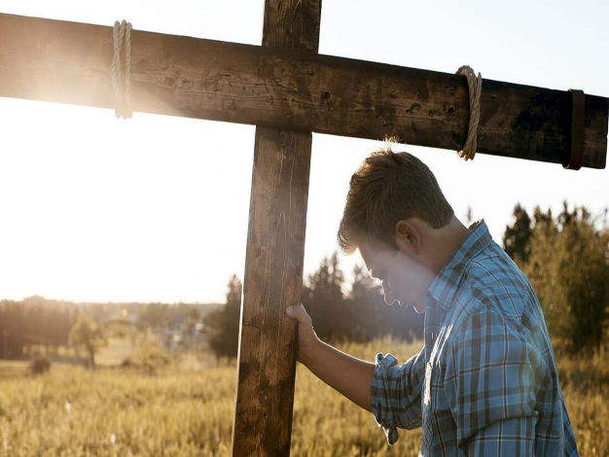 While denying oneself, taking up one’s cross and following Jesus sounds like a cure that is more difficult than living with the disease of sin, this is far from the truth! Those Christians who want a “domesticated Jesus who blesses, satisfies, fills, thrills, and strengthens His followers” [26] while allowing them to indulge in their every carnal pleasure, are warned in today’s passage that the Son of Man is going to return to judge and reward them according to what they have done while on this earth (verse 27). Furthermore, “the acquisition of all the world has to offer cannot match the blessed riches of finding true life through obeying God’s will in following Jesus’ summons to the kingdom of God.”[27] And while the yoke of the cure of total surrender and service in His kingdom from a “human nature” perspective no one can bear, we must not forget that we have spiritual gifts and Divine aid that makes the impossible a joyful reality (Mark 10:17-31)! The burdens Christ places on His children are difficult, yes,[28] but at the same time are very light because if the Good Shepherd is for us who could ever be against us (Romans 8:31)? The fear of the Lord is truly the beginning of wisdom and unspeakable joy for those who approach the Light with obedient and willing hearts will be transformed and molded by His hands! So, where do we go when something is seriously broken in our souls and we feel empty, alone and incapable of finding any purpose in life ... we go to the only One who has the cure, our Lord who always does good to those who love Him and submit to His right to rule in their lives!

1. Anthony T. Evans, [“‘Ruling Your Personal World’ (Part 9),”](https://ref.ly/logosres/tnyvnssrmnrchv?ref=Bible.Mt16.21-26&off=89&ctx=vans%0aApril+13%2c+2008%0a~Glory+and+anticipati) in *Tony Evans Sermon Archive* (Tony Evans, 2008), Mt 16:21–26.
2. Anthony T. Evans, [“‘Ruling Your Personal World’ (Part 9),”](https://ref.ly/logosres/tnyvnssrmnrchv?ref=Bible.Mt16.21-26&off=1333&ctx=ns+did+not+resolve.%0a~What+is+true+often+o) in *Tony Evans Sermon Archive* (Tony Evans, 2008), Mt 16:21–26.
3. Dallas Willard, *Renovation of the Heart*, page 215.
4. James Montgomery Boice, [*Foundations of the Christian Faith: A Comprehensive & Readable Theology*](https://ref.ly/logosres/foundtnchrfaith?ref=Page.p+465&off=2436&ctx=+not+given+himself.%0a~That+is+what+we+do.+) (Downers Grove, IL: InterVarsity Press, 1986), 465–466.
5. James Montgomery Boice, [*The Gospel of Matthew*](https://ref.ly/logosres/boicecm61amt?ref=Bible.Mt16.21-28&off=2501&ctx=oint+in+the+Gospel.+~Before+this%2c+Jesus+h) (Grand Rapids, MI: Baker Books, 2001), 312.
6. James Montgomery Boice, [*The Gospel of Matthew*](https://ref.ly/logosres/boicecm61amt?ref=Bible.Mt16.21-28&off=4363&ctx=s+was+Peter%E2%80%99s+Lord.+~But+immediately+afte) (Grand Rapids, MI: Baker Books, 2001), 312.
7. James Montgomery Boice, [*The Gospel of Matthew*](https://ref.ly/logosres/boicecm61amt?ref=Bible.Mt16.21-28&off=3301&ctx=es+(Luke+24%3a13%E2%80%9335).+~Not+one+of+them+unde) (Grand Rapids, MI: Baker Books, 2001), 312.
8. Leon Morris, [*The Gospel according to Matthew*](https://ref.ly/logosres/pntcmatt?ref=Bible.Mt16.23&off=1631&ctx=God%E2%80%99s+side%2c%E2%80%9D+%EF%BB%BFAB%EF%BB%BF)%2c+~Peter%E2%80%99s+mind+was+set), The Pillar New Testament Commentary (Grand Rapids, MI; Leicester, England: W.B. Eerdmans; Inter-Varsity Press, 1992), 430.
9. James Montgomery Boice, [*The Gospel of Matthew*](https://ref.ly/logosres/boicecm61amt?ref=Bible.Mt16.21-28&off=9552&ctx=+is+probably+worse.+~What+is+the+problem%3f) (Grand Rapids, MI: Baker Books, 2001), 314.
10. Anthony T. Evans, [“‘Ruling Your Personal World’ (Part 9),”](https://ref.ly/logosres/tnyvnssrmnrchv?ref=Bible.Mt16.21-26&off=11687&ctx=st+deny+yourself+%E2%80%A6%E2%80%9D+~You+must+say+no+to+y) in *Tony Evans Sermon Archive* (Tony Evans, 2008), Mt 16:21–26.
11. James Montgomery Boice, [*Foundations of the Christian Faith: A Comprehensive & Readable Theology*](https://ref.ly/logosres/foundtnchrfaith?ref=Page.p+461&off=1761&ctx=+in+which+we+live.+%E2%80%9C~We+are+surrounded+by) (Downers Grove, IL: InterVarsity Press, 1986), 461.
12. Anthony T. Evans, [“‘Ruling Your Personal World’ (Part 9),”](https://ref.ly/logosres/tnyvnssrmnrchv?ref=Bible.Mt16.21-26&off=37683&ctx=+stand+to+our+feet.%0a~Ruling+your+personal) in *Tony Evans Sermon Archive* (Tony Evans, 2008), Mt 16:21–26.
13. Robert H. Mounce, [*Matthew*](https://ref.ly/logosres/nibcnt61mt?ref=Bible.Mt16.24-26&off=833&ctx=y%2c+vol.+2%2c+p.+251).+~For+a+person+to+carr), Understanding the Bible Commentary Series (Grand Rapids, MI: Baker Books, 2011), 164.
14. Anthony T. Evans, [“‘Ruling Your Personal World’ (Part 9),”](https://ref.ly/logosres/tnyvnssrmnrchv?ref=Bible.Mt16.21-26&off=12360&ctx=st+saying+no+to+me.+~Jesus+says%2c+then+you) in *Tony Evans Sermon Archive* (Tony Evans, 2008), Mt 16:21–26.
15. James Montgomery Boice, [*Foundations of the Christian Faith: A Comprehensive & Readable Theology*](https://ref.ly/logosres/foundtnchrfaith?ref=Page.p+463&off=2152&ctx=rs%2c+the+law+of+sin.+~For+the+law+of+sin+i) (Downers Grove, IL: InterVarsity Press, 1986), 463.
16. James Montgomery Boice, [*Foundations of the Christian Faith: A Comprehensive & Readable Theology*](https://ref.ly/logosres/foundtnchrfaith?ref=Page.p+461&off=2156&ctx=it+speak+to+us.%E2%80%9D%EF%BB%BF3%EF%BB%BF%0a~To+experience+death+) (Downers Grove, IL: InterVarsity Press, 1986), 461–462.
17. James Montgomery Boice, [*The Gospel of Matthew*](https://ref.ly/logosres/boicecm61amt?ref=Bible.Mt16.21-28&off=11595&ctx=ght+humanly+prefer.%0a~Cross-bearing+involv) (Grand Rapids, MI: Baker Books, 2001), 315.
18. James Montgomery Boice, [*The Gospel of Matthew*](https://ref.ly/logosres/boicecm61amt?ref=Bible.Mt16.21-28&off=11316&ctx=ey+are+not+crosses.+~Real+crosses+involve) (Grand Rapids, MI: Baker Books, 2001), 315.
19. James Montgomery Boice, [*Foundations of the Christian Faith: A Comprehensive & Readable Theology*](https://ref.ly/logosres/foundtnchrfaith?ref=Page.p+462&off=2493&ctx=d%3f+Yes%2c+it+is+hard.+~It+is+hard+for+the+s) (Downers Grove, IL: InterVarsity Press, 1986), 462–463.
20. James Montgomery Boice, [*Foundations of the Christian Faith: A Comprehensive & Readable Theology*](https://ref.ly/logosres/foundtnchrfaith?ref=Page.p+467&off=676&ctx=%E2%80%99%C2%A0%E2%80%9D+(Mk.+10%3a32%E2%80%9334).%0a~Jesus+was+asking+the) (Downers Grove, IL: InterVarsity Press, 1986), 467.
21. James Montgomery Boice, [*Foundations of the Christian Faith: A Comprehensive & Readable Theology*](https://ref.ly/logosres/foundtnchrfaith?ref=Page.p+461&off=0&ctx=d+all+that+is+ours.%0a~Conversely%2c+we+are+G) (Downers Grove, IL: InterVarsity Press, 1986), 461.
22. James Montgomery Boice, [*Foundations of the Christian Faith: A Comprehensive & Readable Theology*](https://ref.ly/logosres/foundtnchrfaith?ref=Page.p+466&off=600&ctx=robably+have+to+be.+~But+the+battle+is+no) (Downers Grove, IL: InterVarsity Press, 1986), 466.
23. James Montgomery Boice, [*Foundations of the Christian Faith: A Comprehensive & Readable Theology*](https://ref.ly/logosres/foundtnchrfaith?ref=Page.p+463&off=1637&ctx=ruth+of+your+words.+~You+had+me+under+con) (Downers Grove, IL: InterVarsity Press, 1986), 463.
24. James Montgomery Boice, [*The Gospel of Matthew*](https://ref.ly/logosres/boicecm61amt?ref=Bible.Mt16.21-28&off=12954&ctx=at+path+to+the+end.+~David+wrote+about+it) (Grand Rapids, MI: Baker Books, 2001), 315.
25. James Montgomery Boice, [*Foundations of the Christian Faith: A Comprehensive & Readable Theology*](https://ref.ly/logosres/foundtnchrfaith?ref=Page.p+467&off=1694&ctx=are+willing+to+die.%0a~When+we+give+up+tryi) (Downers Grove, IL: InterVarsity Press, 1986), 467.
26. James Montgomery Boice, [*The Gospel of Matthew*](https://ref.ly/logosres/boicecm61amt?ref=Bible.Mt16.21-28&off=18343&ctx=Lift+High+the+Cross%0a~We+live+in+a+day+whe) (Grand Rapids, MI: Baker Books, 2001), 317.
27. Michael J. Wilkins, [*Matthew*](https://ref.ly/logosres/nivac61mt?ref=Bible.Mt16.26&off=593&ctx=+kingdom+of+heaven.+~We+come+into+this+li), The NIV Application Commentary (Grand Rapids, MI: Zondervan Publishing House, 2004), 573.
28. Anthony T. Evans, [“‘Ruling Your Personal World’ (Part 9),”](https://ref.ly/logosres/tnyvnssrmnrchv?ref=Bible.Mt16.21-26&off=36326&ctx=brought+in+harmony.+~Not+only+will+I+give) in *Tony Evans Sermon Archive* (Tony Evans, 2008), Mt 16:21–26.