What Child is This?
Micah 5:1-5
Online Sermon: http://www.mckeesfamily.com/?page_id=3567

Zion’s Distress
When King Herod gathered the people’s chief priests and teachers of the law and asked where the Messiah was to be born (Matthew 2:3-6) they quoted the Messianic prophesy of Micah 5:2:
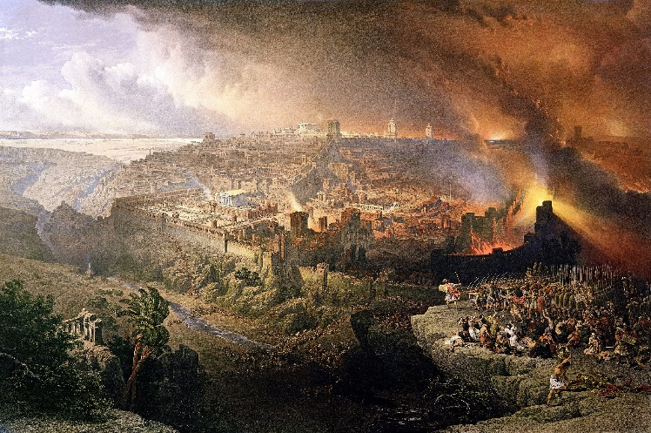
“but you Bethlehem, in the land of Judah, are by no means least among the rulers of Judah; for out of you will come a ruler who will shepherd my people Israel.”
While this familiar Christmas passage provokes peaceful thoughts of a babe lying in a manger wrapped in swaddling clothes I want to invite you to go back in time to reflect on the dire circumstances and great hope given in this prophecy. Micah told Jerusalem to “marshal their troops” for a “time of deep degradation” would fall upon them right before the coming of the Messiah. Even though they had through divine intervention survived the invasion of Judah by Sennacherib in 701 B.C., the Babylonian king Nebuchadnezzar laying siege to Jerusalem would succeed in destroying the temple and exiling most of their inhabitants. To add even further humiliation the ruler of Israel, Zedekiah would not only be their last king (from this earth) but also would have his eyes blinded by Nebuchadnezzar (2 Kings 25:7; Jeremiah 39:6-7)! This was a striking blow to the cheek, one of the grossest insults a king could ever receive (comp. 1 Kings 22:24; Job 16:10; Luke 22:64). And yet despite their utter humiliated and desperation there was still hope for God would soon come good on His promise to always have a Davidic heir sit upon the throne (2 Samuel 7:8-17).

The Coming Ruler
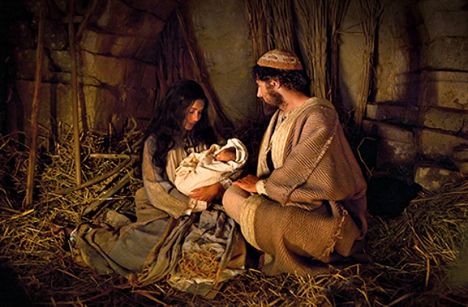
The statement of doom in verse one is followed by one of hope for out of Bethlehem would come a King who would usher in everlasting peace to the ends of the world! Jesus chose to be borne out of Bethlehem for two main reasons. First, Jesus was to be born in the same town that David was born (1 Samuel 17:12) to fulfill the prophecy that the Messianic King would come from the same lineage (Psalms 132:11; Matthew 2:6). Second, Jesus was born in Bethlehem to ensure God was given all the glory. Like Saul (1 Samuel 9:21), and Gideon (Judges 6:15) God chose to do great things through a place that by human standards was insignificant! “Bethlehem, too insignificant to be mentioned by the cartographer of the book of Joshua or in Micah’s catalogue of Judah’s cities of defense (Mic. 1:10–15; cf. 2 Chr. 11:5–12), is today incredibly the center of pilgrimages from around the world and is universally renowned because Jesus Christ fulfilled this verse.” An insignificant place was chosen to bring forth the “most pre-eminent person” so that no “one could boast in the merits of their own cities achievements” but instead accept the truth that Christ willfully emptied Himself of His glory in heaven to be born in a lowly place so that “no human being might boast in the presence of God” (1 Corinthians 1:27-29)! The innkeeper could not boast, He chose the comfort of my inn,” nor could Jerusalem with all its magnificent buildings claim prominence of His presence. He who was to be slain before the foundation of the world (Revelation 13:8) did not demand regalities and comforts of earthly kings but instead chose to be born in a lowly manger and to become a servant of all (Matthew 20:28)!

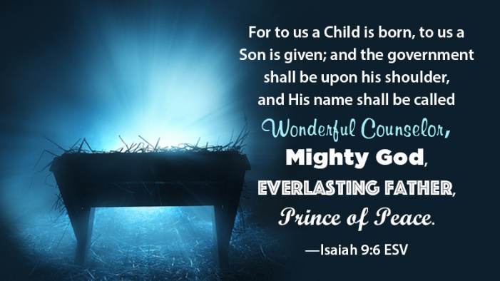
At a time when Israel was about to go through abandonment by God due to her sin (1:5–6; 2:1–5; 3:4, 9–12; 4:10; 6:9–16), that was so intense that it threatened to throw her into a sinkhole of oblivion, the prophet Micah stated there was great hope for a new ruler whose origins were from old, from ancient times was about to arrive to redeem His people! The origins of this ruler is in many ways “mysterious and beyond human comprehension,” because He comes from and is God from all eternity past, present and future! This Ruler who “had gone out of heaven on many occasions to lead and shepherd His people, was none other than the Mighty Counselor, Mighty God, Everlasting Father and Prince of Peace predicted by Isaiah (9:6-7)! His arrival inaugurated the kingdom of His Father that would not only “signal the beginning of the end of the nation’s oppression” but would also forever change her identity! Since her Messiah, the fulfiller of both the Davidic and Abrahamic covenants, gave His life as a ransom for many, no longer would Israel’s identity include only those of direct descendants of Abraham, but instead anyone who had faith in the atoning sacrifice of the Son (Galatians 6:16; Romans 9:6–29)! Micah’s prophesy gave the people of Israel great hope for while Babylon was about to decimate her lands and take them captive, when the Messiah arrived Israel would be gathered from all the lands of dispersion as a “restored, reunified, complete nation” under the banner of the church ending the hostility between them and God! This church would also unite both Jew and Gentile together as one, both gladly bowing their knees to their Chief Cornerstone of their new formed family (Ephesians 2:14-22)!

A Glorious Reign
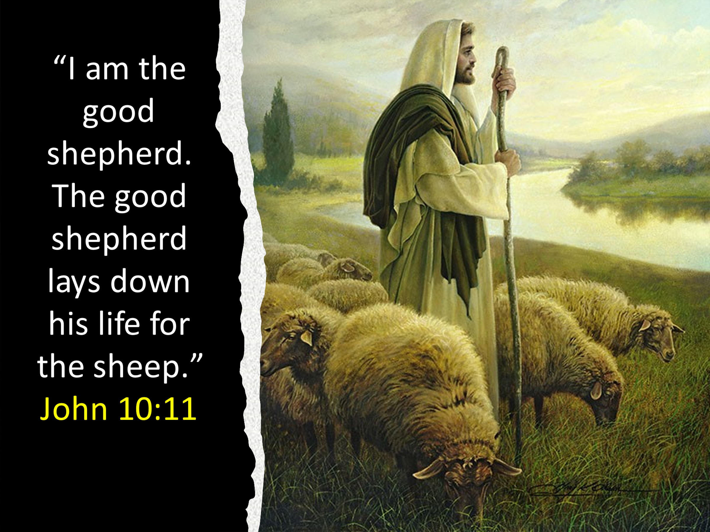
In verse four Micah told the Israelites that despite their bleak circumstances when the Messiah arrives, He “will stand and shepherd the flock in the strength of the Lord.” “Unlike David’s unfaithful sons who broke covenant with the Lord by trusting in their military might (cf. 5:10–11), the Messiah, like David (1 Sam. 17:38–47), will keep the covenant by trusting God (cf. Palms 91:14; 20:2–3, 6, 8; passim). His government is depicted under the imagery of shepherding, which again evokes memories of David’s government (2 Samuel 5:2; 7:7; cf. Matt. 2:6).” Through the “strength given to Him by God” (Psalms 18:32-35, 20:6), He will feed, lead and protect His own (Samuel 5:2; 7:8; Palms 23:1; 95:7; 100:3; Isa 40:11; Jeremiah 23:2–6). The sheep who recognize His voice will trust and follow Him because He not only removes “every obstacles of their purification and joy forever” but also leads them by the still waters and satisfies the “deep longing of the human soul and mind” to have a loving relationship with their Creator and sustainer of all life! He will not be like the earthly kings that “exercise lordship over them” but instead will offer His own a yoke that is light. “Those eyes never slumber, and those hands never rest; that heart never ceases to beat with love, and those shoulders are never weary of carrying his people’s burdens.” He will be called the “Good Shepherd” (John 10:11, 14) for not only will He establish peace, green pastures and protection for those who chose to follow Him but will also demonstrate His eternal love by giving His life up for a ransom for the many (Mark 10:45)! Those who submit to His right to rule over their lives will not only receive every spiritual blessing possible but also adoption and eternal life in His kingdom (Ephesians 1:3-6)!

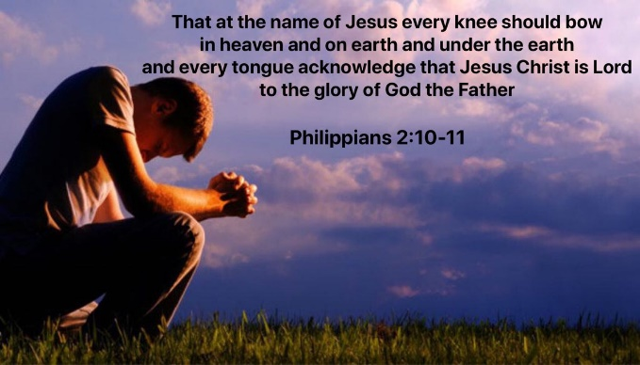
With the ferocious Babylonian army besieging their precious city Micah tells Israel there is great hope for the Good Shepherd is also a king and ruler unmatched in His glory and power! The familiarity that we approach this Shepherd must always be “tapered with the deepest and most reverent adoration” for He is God and the “nature of his rule has been set forth in the royal psalms (Psalms 2, 18, 20, 21, 45, 72, 101, 110, 132, 144:1–11). In contrast to the promised land of David’s kingdom, Christ would inaugurate the kingdom that is universal (Deuteronomy 33:17; Palms 2:8; 22:28; 59:13; 72:8). He who has taken His seat at the right hand of the Father and made the earth His footstool (Isaiah 66:1-2; Mark 14:62) will cry out to the leaders of this world “mene, mene, tekel, parsin” which means the number of their days to rule is about to end! Micah told the people of Israel to rejoice for they were about to receive a “fit ruler,” one that is not “subject to human weakness” but instead in the strength of the Lord will be everyone’s Judge, Lawgiver, and King. There will be no pockets of resistance for He shall “beat their swords into plowshares, and their spears into pruning hooks; nation shall not lift up sword against nation, neither shall they learn war anymore (Isaiah 2:4). The “false doctrine without, heresy and schism within, hypocrisy, formalism, fanaticism, pretenses of high spirituality, and worldliness” that has plagued God’s people over the centuries will be crushed by the Lamb who was slain before the creation of the world (Revelation 13:8). Yes, there was great hope even amidst the horrendous Babylonian siege for a day was soon coming when “every knee should bow, in heaven and on earth and under the earth, and every tongue acknowledge that Jesus Christ is Lord, to the glory of God the Father (Philippians 2:10-11)!


As a result of the divine power and sacrifice of the Good Shepherd those who acknowledge His right to rule over their lives will live not only in security but peace as well! “Christ will not only bring peace, and be the Author of peace, but be Himself Peace; as Isaiah (9:5) calls Him “Prince of Peace,” and St. Paul (Ephesians 2:14) “our Peace.” Peace personified (comp. Zech. 9:9).” For there to be peace on earth there must be peace between us and a holy God. “Christ is made great in the conversion of every sinner. When the suppliant penitent cries, “God be merciful to me a sinner,” and the peace-speaking blood comes dropping upon the troubled conscience, and the soul bows meekly to accept the finished righteousness, then is Christ (seen as) great.” To this end the peace under King Solomon (1 Kings 4:24) was nothing in comparison to the peace of the One who through belief in His atoning sacrifice has freed us from the power of sin and its consequences, spiritual death! No longer are the fiery darts of the “spiritual forces of evil in the heavenly realms” (Ephesians 6:12) to be feared for greater is He who is in you than he who is in the world (1 John 4:4)! Not only will the hostility between His own and Himself be eliminated but so will hostility between one another! When the new heaven and new earth comes the Good Shepherd will wipe every tear and forever remove the sting of sorrow, pain, and death for they will be no more (Revelation 21:1-4)! Because His greatness, mercy and power are over all things seen and unseen (Colossians 1:16) the groaning of Creation will end (Romans 8:19-23), the lion will lay with the lamb (Isiah 11:6-9) and all will live in peace and forever shout “Hosanna in the highest.”

Conclusion
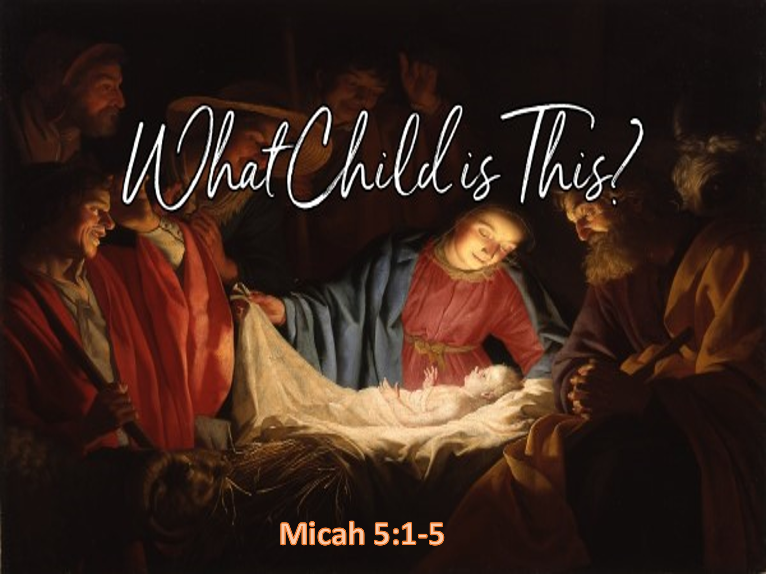
At a time when the king of Babylon was laying siege to Jerusalem the prophet Micah told Israel to not lose hope for the King predicted in the royal psalms and Isaiah was about to arrive! He would come from the same town that King David was born. Ironically it would be out of Bethlehem a place so insignificant in human eyes that it was not even listed amongst the cities of Judah that this pre-eminent King would come! This incarnate Good Shepherd would demonstrate His undying love, strength, power, wisdom, and mercy by giving His life as a ransom for many. In doing so He provided the path, faith in His atoning sacrifice, that would end the hostility between sinful humanity and a holy God! He was no ordinary King for His origins are from of old, ancient times, the Lamb that would be slain before the creation of the world. He came to also end the hostility between the Jews and Gentiles for He became the cornerstone of a new church whose membership was not based on genealogy, national identity but on faith in a risen Savior! As Judge, Lawgiver, and King, and one who is not subject to human sin, He will one day assert His authority over all things and unseen and in doing so every knee shall bow and every tongue confess Him to be the Lord over all! While we like to see this Jesus as a babe lying in a manger, wrapped in swaddling clothes, completely dependent on us; may we rejoice this Christmas season to know by His stripes we have been healed and given the glorious opportunity to not only be part of His family but to spend an eternity with Him in peace!

Outline of the sermon was taken from: James E. Smith, The Minor Prophets, Old Testament Survey Series (Joplin, MO: College Press, 1994), 329.
H. D. M. Spence-Jones, ed., Micah, The Pulpit Commentary (London; New York: Funk & Wagnalls Company, 1909), 67.
James E. Smith, The Minor Prophets, Old Testament Survey Series (Joplin, MO: College Press, 1994), 329.
James E. Smith, The Minor Prophets, Old Testament Survey Series (Joplin, MO: College Press, 1994), 330.
Elizabeth Achtemeier, Minor Prophets I, ed. W. Ward Gasque, Robert L. Hubbard Jr., and Robert K. Johnston, Understanding the Bible Commentary Series (Grand Rapids, MI: Baker Books, 2012), 338.
James E. Smith, The Minor Prophets, Old Testament Survey Series (Joplin, MO: College Press, 1994), 330.
Kenneth L. Barker, Micah, Nahum, Habakkuk, Zephaniah, vol. 20, The New American Commentary (Nashville: Broadman & Holman Publishers, 1999), 95.
H. D. M. Spence-Jones, ed., Micah, The Pulpit Commentary (London; New York: Funk & Wagnalls Company, 1909), 67.
Elizabeth Achtemeier, Minor Prophets I, ed. W. Ward Gasque, Robert L. Hubbard Jr., and Robert K. Johnston, Understanding the Bible Commentary Series (Grand Rapids, MI: Baker Books, 2012), 338.
Thomas E. McComiskey, “Micah,” in The Expositor’s Bible Commentary: Daniel and the Minor Prophets, ed. Frank E. Gaebelein, vol. 7 (Grand Rapids, MI: Zondervan Publishing House, 1986), 427.
Thomas E. McComiskey, “Micah,” in The Expositor’s Bible Commentary: Daniel and the Minor Prophets, ed. Frank E. Gaebelein, vol. 7 (Grand Rapids, MI: Zondervan Publishing House, 1986), 427.
D. A. Carson, ed., NIV Biblical Theology Study Bible (Grand Rapids, MI: Zondervan, 2018), 1596.
John Piper, Sermons from John Piper (2000–2014) (Minneapolis, MN: Desiring God, 2014).
Elizabeth Achtemeier, Minor Prophets I, ed. W. Ward Gasque, Robert L. Hubbard Jr., and Robert K. Johnston, Understanding the Bible Commentary Series (Grand Rapids, MI: Baker Books, 2012), 339.
Donald J. Wiseman, T. Desmond Alexander, and Bruce K. Waltke, Obadiah, Jonah and Micah: An Introduction and Commentary, vol. 26, Tyndale Old Testament Commentaries (Downers Grove, IL: InterVarsity Press, 1988), 200.
Donald J. Wiseman, T. Desmond Alexander, and Bruce K. Waltke, Obadiah, Jonah and Micah: An Introduction and Commentary, vol. 26, Tyndale Old Testament Commentaries (Downers Grove, IL: InterVarsity Press, 1988), 199–200.
John Piper, Sermons from John Piper (2000–2014) (Minneapolis, MN: Desiring God, 2014).
Elizabeth Achtemeier, Minor Prophets I, ed. W. Ward Gasque, Robert L. Hubbard Jr., and Robert K. Johnston, Understanding the Bible Commentary Series (Grand Rapids, MI: Baker Books, 2012), 339.
John Piper, Sermons from John Piper (2000–2014) (Minneapolis, MN: Desiring God, 2014).
John Piper, Sermons from John Piper (2000–2014) (Minneapolis, MN: Desiring God, 2014).
James E. Smith, The Minor Prophets, Old Testament Survey Series (Joplin, MO: College Press, 1994), 331.
Elizabeth Achtemeier, Minor Prophets I, ed. W. Ward Gasque, Robert L. Hubbard Jr., and Robert K. Johnston, Understanding the Bible Commentary Series (Grand Rapids, MI: Baker Books, 2012), 339.
H. D. M. Spence-Jones, ed., Micah, The Pulpit Commentary (London; New York: Funk & Wagnalls Company, 1909), 67–68.
James E. Smith, The Minor Prophets, Old Testament Survey Series (Joplin, MO: College Press, 1994), 332.
James Montgomery Boice, The Minor Prophets: An Expositional Commentary (Grand Rapids, MI: Baker Books, 2002), 344.
James E. Smith, The Minor Prophets, Old Testament Survey Series (Joplin, MO: College Press, 1994), 332.
Kenneth L. Barker, Micah, Nahum, Habakkuk, Zephaniah, vol. 20, The New American Commentary (Nashville: Broadman & Holman Publishers, 1999), 98.
Donald J. Wiseman, T. Desmond Alexander, and Bruce K. Waltke, Obadiah, Jonah and Micah: An Introduction and Commentary, vol. 26, Tyndale Old Testament Commentaries (Downers Grove, IL: InterVarsity Press, 1988), 201.
Thomas E. McComiskey, “Micah,” in The Expositor’s Bible Commentary: Daniel and the Minor Prophets, ed. Frank E. Gaebelein, vol. 7 (Grand Rapids, MI: Zondervan Publishing House, 1986), 428.
Kenneth L. Barker, Micah, Nahum, Habakkuk, Zephaniah, vol. 20, The New American Commentary (Nashville: Broadman & Holman Publishers, 1999), 99.
James E. Smith, The Minor Prophets, Old Testament Survey Series (Joplin, MO: College Press, 1994), 331.
Donald J. Wiseman, T. Desmond Alexander, and Bruce K. Waltke, Obadiah, Jonah and Micah: An Introduction and Commentary, vol. 26, Tyndale Old Testament Commentaries (Downers Grove, IL: InterVarsity Press, 1988), 201–202.
Elizabeth Achtemeier, Minor Prophets I, ed. W. Ward Gasque, Robert L. Hubbard Jr., and Robert K. Johnston, Understanding the Bible Commentary Series (Grand Rapids, MI: Baker Books, 2012), 340.
Kenneth L. Barker, Micah, Nahum, Habakkuk, Zephaniah, vol. 20, The New American Commentary (Nashville: Broadman & Holman Publishers, 1999), 100.
John Piper, Sermons from John Piper (2000–2014) (Minneapolis, MN: Desiring God, 2014).
John Piper, Sermons from John Piper (2000–2014) (Minneapolis, MN: Desiring God, 2014).
James Montgomery Boice, The Minor Prophets: An Expositional Commentary (Grand Rapids, MI: Baker Books, 2002), 346.
C. H. Spurgeon, “Christ Is Glorious—Let Us Make Him Known,” in The Metropolitan Tabernacle Pulpit Sermons, vol. 10 (London: Passmore & Alabaster, 1864), 158.
C. H. Spurgeon, “Christ Is Glorious—Let Us Make Him Known,” in The Metropolitan Tabernacle Pulpit Sermons, vol. 10 (London: Passmore & Alabaster, 1864), 159.
James Montgomery Boice, The Minor Prophets: An Expositional Commentary (Grand Rapids, MI: Baker Books, 2002), 345.
C. H. Spurgeon, “Christ Is Glorious—Let Us Make Him Known,” in The Metropolitan Tabernacle Pulpit Sermons, vol. 10 (London: Passmore & Alabaster, 1864), 158.
James Montgomery Boice, The Minor Prophets: An Expositional Commentary (Grand Rapids, MI: Baker Books, 2002), 346.
C. H. Spurgeon, “Christ Is Glorious—Let Us Make Him Known,” in The Metropolitan Tabernacle Pulpit Sermons, vol. 10 (London: Passmore & Alabaster, 1864), 160.
Elizabeth Achtemeier, Minor Prophets I, ed. W. Ward Gasque, Robert L. Hubbard Jr., and Robert K. Johnston, Understanding the Bible Commentary Series (Grand Rapids, MI: Baker Books, 2012), 340.
Donald J. Wiseman, T. Desmond Alexander, and Bruce K. Waltke, Obadiah, Jonah and Micah: An Introduction and Commentary, vol. 26, Tyndale Old Testament Commentaries (Downers Grove, IL: InterVarsity Press, 1988), 202.
C. H. Spurgeon, “Christ Is Glorious—Let Us Make Him Known,” in The Metropolitan Tabernacle Pulpit Sermons, vol. 10 (London: Passmore & Alabaster, 1864), 157.
James Montgomery Boice, The Minor Prophets: An Expositional Commentary (Grand Rapids, MI: Baker Books, 2002), 345.
Kenneth L. Barker, Micah, Nahum, Habakkuk, Zephaniah, vol. 20, The New American Commentary (Nashville: Broadman & Holman Publishers, 1999), 97.
C. H. Spurgeon, “Christ Is Glorious—Let Us Make Him Known,” in The Metropolitan Tabernacle Pulpit Sermons, vol. 10 (London: Passmore & Alabaster, 1864), 160.
John Piper, Sermons from John Piper (2000–2014) (Minneapolis, MN: Desiring God, 2014).
John Piper, Sermons from John Piper (2000–2014) (Minneapolis, MN: Desiring God, 2014).
C. H. Spurgeon, “Christ Is Glorious—Let Us Make Him Known,” in The Metropolitan Tabernacle Pulpit Sermons, vol. 10 (London: Passmore & Alabaster, 1864), 161–162.
Kenneth L. Barker, Micah, Nahum, Habakkuk, Zephaniah, vol. 20, The New American Commentary (Nashville: Broadman & Holman Publishers, 1999), 100.
H. D. M. Spence-Jones, ed., Micah, The Pulpit Commentary (London; New York: Funk & Wagnalls Company, 1909), 68.
John Piper, Sermons from John Piper (2000–2014) (Minneapolis, MN: Desiring God, 2014).
C. H. Spurgeon, “Christ Is Glorious—Let Us Make Him Known,” in The Metropolitan Tabernacle Pulpit Sermons, vol. 10 (London: Passmore & Alabaster, 1864), 164.
James E. Smith, The Minor Prophets, Old Testament Survey Series (Joplin, MO: College Press, 1994), 333.
Thomas E. McComiskey, “Micah,” in The Expositor’s Bible Commentary: Daniel and the Minor Prophets, ed. Frank E. Gaebelein, vol. 7 (Grand Rapids, MI: Zondervan Publishing House, 1986), 428.

