Getting More than you Expected
Acts 3:1-10
Online Sermon: http://www.mckeesfamily.com/?page_id=3567

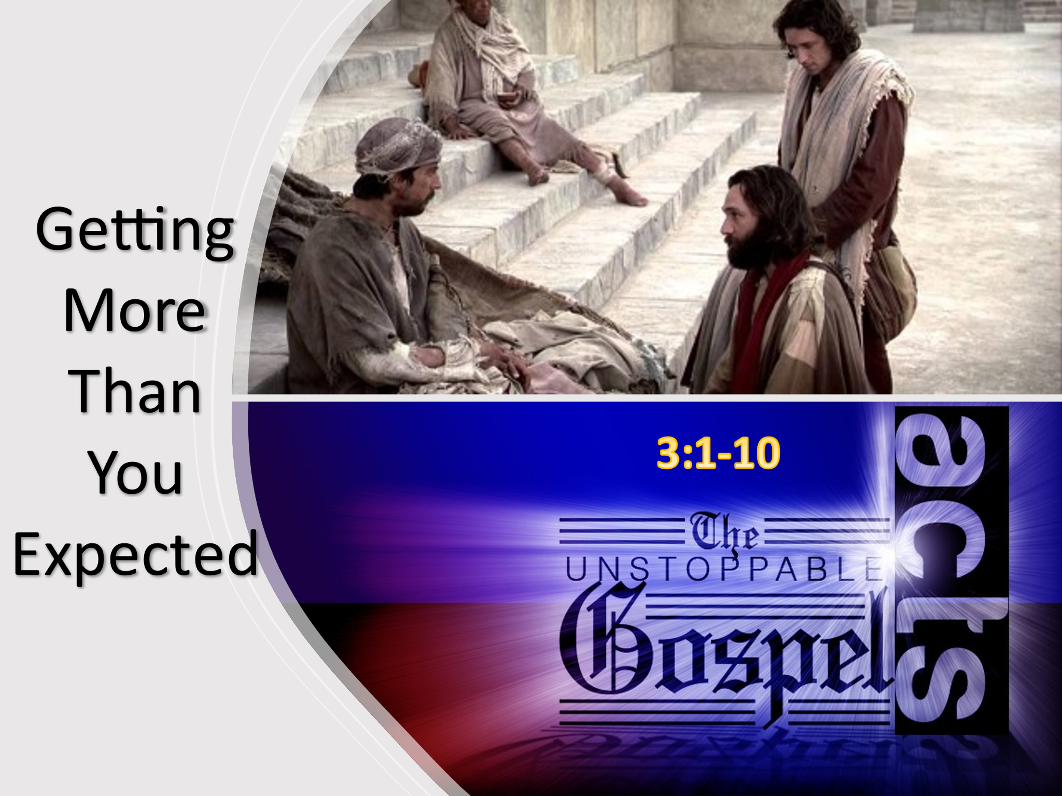
“Amazing grace how sweet the sound that saved a wretch like me, I was once lost but now I’m found, was blind but now I see!” Do you remember the unspeakable joy the day when you were not only cleansed but born again (John 3) and sealed by the very Spirit of God (Ephesians 1:13)? As the living waters flowed through your soul (John 4:1-26) no longer did the cross seem foolish to you (1 Corinthians 1:18) or the Bible mere words but the very breath of God that trained you in righteousness (2 Timothy 3:16-17). Having been blessed with every spiritual blessing in Christ Jesus (Ephesians 1:3) surely going from being a babe (1 Corinthians 3:1) to being a living sacrifice (Romans 12:1) who constantly prays (1 Thessalonians 5:16-18) and thirsts for the living God (Psalms 42:1-2) has already been realized in your life? And yet despite being Christ’s ambassadors (2 Corinthians 5:20) capable of planting and sowing seeds of righteousness (1 Corinthians 3:6-9), doing miracles in His name (Acts 3:6) and approaching His throne of grace (Hebrews 4:16) to draw nearer (James 4:8) and be ever more transformed into His likeness; many Christians are satisfied with an occasional glimpse of His glory! “Do you have the expectations of a beggar, or are you looking for God to do exceedingly, abundantly, above all that you can ask or think, according to the power, of the name that is at work in you?” The goal of this sermon is to spur you on and hopefully with the Spirit’s conviction have you be ignited with passion to not just exist in His kingdom but to be lifted up, dance, leap, and praise God with every fiber of your being with the assurance that whom God has enabled (Ephesians 2:10) truly can do unimaginable and glorious things that honors the Father in heaven (Matthew 5:15-16)!
Going to the Temple

To help ignite your passion to become more like Jesus I want to share the story of the lame beggar being healed in Acts 3:1-10. The story begins by stating that Peter and John went to the temple to pray. While there is “little recorded information concerning the forty days that Jesus spent with the disciples between the resurrection and His ascension,” Luke describes this time period as being one in which “everyone was filled with awe, and many wonders and miraculous signs were done by the apostles” (Acts 2:43). Not many days ago Peter and John stood at the empty tomb unsure of their future but now instead of arguing about who is the greatest they are seen here walking in unity through the gate called Beautiful and along the steps “leading from the outer court to the inner court” for a “service of prayer which accompanied the evening sacrifice.” Even though Pentecost had already come and the apostles themselves became the temple of the Spirit they chose not to “separate from the traditional practices of their religion” but to enter His gates with thanksgiving in their hearts (Psalms 100:4) and fulfill Christ’s command to bear witness first to the people of Jerusalem (Acts 1:8). As they repeated the prayers of the Shema (Deuteronomy 6:4-9), 18 Benedictions and the Ten Commandments, the apostles and the other Christians rejoiced amongst the Jewish crowd that the Lord was their “source of salvation and strength.”

Being Lame from Birth
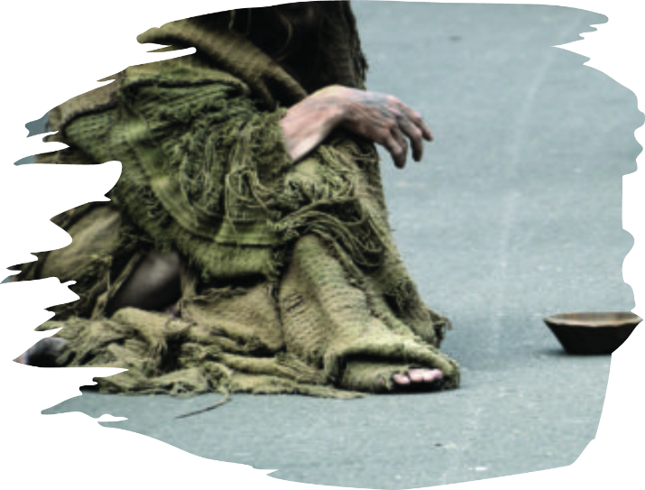
In verse two are told that there was “a man who was lame from birth was being carried into the temple gate called, Beautiful, where he was put every day to beg from those going into the temple courts.” Since there was no real social network in his day the only way this man could survive was by going to the entrance of the temple and hope that since “almsgiving which was classed in Judaism as a meritorious act” might lead to some not looking away but instead giving him a copper coin to buy some food. This was not a man merely having “just a bad day but this way his way of life.” He did not walk as a toddler, a preteen, teen or even at his current age of over 40! While we may not know what it is like to be physically unable to walk, we certainly can relate to this man for we were once spiritual cripples! “We were all born in sin, separated from God. Our sin was inherited, and we were born crippled by sin.” Once we were born again and had the Spirit of God living inside of us, we became capable of walking, running, and doing miracles in Jesus’ name! I am so glad that I had a mother and father who carried me into the house of God when I was a child and got to hear the words of the preacher who pointed me to Jesus! And yet despite being freed from the bondage of sin and capable of doing more than we could every ask or imagine, many believers come to church as if they are still lame, always needing others to carry them and never standing on their own! Do we have some spiritual cripples in the house of God today?

Expecting Too Little

In verses three and four we are told that when the lame beggar saw “Peter and John about to enter (the temple), he asked them for money. Peter looked straight at him, as did John. Then Peter said, look at us!” Since the beggar went to the temple not to meet God but to merely receive a handout, when the apostles noticed him and was relieved, they were about to give him some money! Having lived as a cripple for over 40 years he simply “resigned to his desperate condition and believing there was no hope of ever being freed from his crippled state” begging to exist was the best he felt he could ever attain. Even though a tiny coin clanging inside his tin cup would not cure him he was content with such an act of generosity for this meant he would exist for another day! Are we not like the beggar and often go to church with low the expectation of merely surviving the trials and tribulations of living in this world that is not our home (Hebrews 13:14)? As we admire those who get more than a glimpse of God’s glory, are we not somewhat saddened but at the same time relieved it is them and not us for do we truly want to be asked by the Master to commit our life to His path, rather than that of our own? After all, would this not require us to take every thought, word, and deep captive (2 Corinthians 10:5) for He who bought us at the price of His very life (1 Corinthians 6:19-20)? Being a living sacrifice (Romans 12:1-2) sounds nice but very expensive, so we chose to be complacent babes never really walking, running, or leaping for joy while serving our Master! Maybe we are more like the beggar than we would like to admit, ever searching and learning the truth about God but not really wanting to put His word into practice (James 1:22) so that we might reach the fullness of Christ in our lives (Ephesians 4:13)!

Looking for More

What would happen if we came to church looking to meet the eyes of Christ with an obedient heart so filled with overflowing joy that anything He asks of us we would say YES? Jeremiah 29:11 states, “For I know the plans I have for you, declares the Lord, plans to prosper you and not to harm you, plans to give you hope and a future.” It is not a lack of spiritual gifting that keeps us from living out the divine role God has assigned us but what keeps us from “attaining the whole measure of the fullness of Christ” (Ephesians 4:13) is the number one enemy of spiritual growth, complacency! We often don’t see that our real needs are not just for physical sustenance. Our real need is to have passion to be so discontent with being spiritually lame that we are willing to surrender the life we cannot keep to gain the honor of serving rightly in His kingdom that never ends! Instead of seeing oneself as the lame man in this story Luke is inviting us to see how easily we too live lame lives not because we must but merely because we don’t realize He who bound up the broken hearted and freed the captives from their sin (Isaiah 61:1) has enabled His own to do greater things than we could ever ask or imagine (Ephesians 3:20)! To ignite the passion, we simply must refuse to listen to the Devil who constantly tells us we cannot get close enough to Christ to experience His grace and power to do miracles in His name! To keep from being the lame man in the story we must go to church with the expectation of meeting God in our Bible reading, prayers, worshipping and listening to the sermon!

Evoking the Name of Jesus
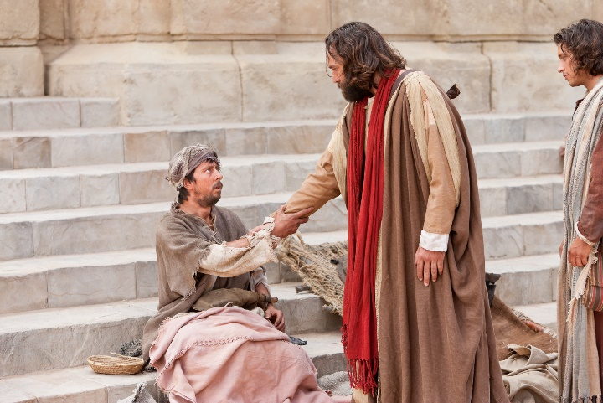
Going back to the story, in response to the lame man gazing into the eyes of Peter and John looking for some money Peter boldly states, “silver and gold I do not have but what I have I give you. In the name of Jesus Christ of Nazareth, walk.” Peter then took the man by the right hand, helped him to his feet and he began to walk (verses 6-7)! Though the lame man only expected to receive a few coins to survive, though the Spirit’s aid Peter peered into his heart and knew what he truly needed was the “truth of the Gospel that would set him free.” Later on in chapter Peter gave a sermon explaining to the crowd that this miracle was not done by “witchcraft, magic, sorcery, a mind-over-matter technique” or even a “right formula” of words but instead it was his faith in the name “Jesus by virtue of His resurrection, glorification” (Acts 2:36) and atonement by which this man was able to raise and walk! Many Christians are like the lame man for we come to the church expecting to receive mere glimpses of Jesus’ glory. If only we would have faith in His rule over all things seen and unseen (Colossians 1:16) then we could boldly approach the Father’s throne of grace and not just ask for things to keep us physically, mentally, and economically well but to have inexpressible and miraculous opportunities to bow our knee and do miracles for the glory of His name! To obtain such passion we simply must stop seeing ourselves and living as spiritual cripples but as those who have received a crumb from the Master’s table that is an invitation not just to be sealed by the Holy Spirit but to join the long list of “ordinary people” in the Bible that through His power closeness and the miraculous have become repetitive occurrences in our lives and the source of much rejoicing in our hearts!

Rejoicing in the Blessings
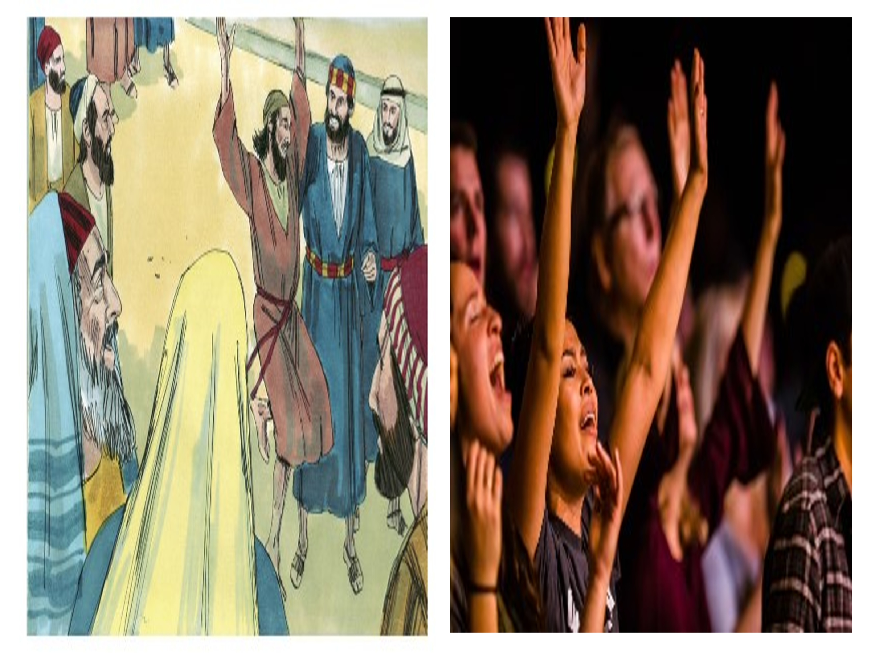
The story finishes with the man jumping to his feet, going into the temple courts, and praising God! When the people saw him, they recognized him as the lame man begging at the gate called Beautiful and they were filled with wonder and amazement! Instead of going home and telling his friends and family about this miraculous event, without caring what others might think, he immediately shared his testimony by walking, jumping, and praising the Lord! While some of the Jewish people would not have given God the glory many would have recalled Isaiah 35:6 that states the lame shall leap like a deer and would have seen this miracle as a “sign of the salvation of God’s people, in the context of a renewed creation.” Sadly, there are too many Christians that are lukewarm and need to be revitalized! Those who are content with being mere babes need a touch from the Lord to remind them to use their new hearts (Ezekiel 36:26) to rejoice and worship with vigor, passion and above all appreciation for being allowed to become a living sacrifice (Romans 12:1-2), holy and pleasing unto their Creator. Even though God does not need praise (Acts 17:25), He as our portion (Psalms 73:26) rightly deserves, to be praised! So, let us enter His gates with thanksgiving in our hearts (Palms 100:4), let us read the Bible, pray and worship expecting God to mold our complacent, often sinful, self-absorbed lives into bold and faithful servants who leap, dance, and joyfully yell from the mountains and valleys “He is Lord over everything and to Him alone I gladly bow my knee.” Praise be to God that we can receive more than we can ever ask or imagine!

Title taken from Tony Evans, “‘Getting More Than You Expected,’” in Tony Evans Sermon Archive (Tony Evans, 2015), Ac 3:1–10.
Words written by John Newton.
Tony Evans, “‘Getting More Than You Expected,’” in Tony Evans Sermon Archive (Tony Evans, 2015), Ac 3:1–10.
Tony Evans, “‘Getting More Than You Expected,’” in Tony Evans Sermon Archive (Tony Evans, 2015), Ac 3:1–10.
Chris Benfield, “There’s Just Something about That Name (Acts 3:1–8),” in Pulpit Pages: New Testament Sermons (Mount Airy, NC: Chris Benfield, 2015), 588.
James Montgomery Boice, Acts: An Expositional Commentary (Grand Rapids, MI: Baker Books, 1997), 64.
Chris Benfield, “There’s Just Something about That Name (Acts 3:1–8),” in Pulpit Pages: New Testament Sermons (Mount Airy, NC: Chris Benfield, 2015), 588.
Chris Benfield, “There’s Just Something about That Name (Acts 3:1–8),” in Pulpit Pages: New Testament Sermons (Mount Airy, NC: Chris Benfield, 2015), 589.
F. F. Bruce, The Book of the Acts, The New International Commentary on the New Testament (Grand Rapids, MI: Wm. B. Eerdmans Publishing Co., 1988), 77.
David G. Peterson, The Acts of the Apostles, The Pillar New Testament Commentary (Grand Rapids, MI; Nottingham, England: William B. Eerdmans Publishing Company, 2009), 167.
David G. Peterson, The Acts of the Apostles, The Pillar New Testament Commentary (Grand Rapids, MI; Nottingham, England: William B. Eerdmans Publishing Company, 2009), 167.
Lee Martin McDonald, “Acts,” in The Bible Knowledge Background Commentary: Acts–Philemon, ed. Craig A. Evans and Craig A. Bubeck, First Edition. (Colorado Springs, CO: David C Cook, 2004), 37.
David G. Peterson, The Acts of the Apostles, The Pillar New Testament Commentary (Grand Rapids, MI; Nottingham, England: William B. Eerdmans Publishing Company, 2009), 167.
Chris Benfield, “There’s Just Something about That Name (Acts 3:1–8),” in Pulpit Pages: New Testament Sermons (Mount Airy, NC: Chris Benfield, 2015), 589.
Richard N. Longenecker, “The Acts of the Apostles,” in The Expositor’s Bible Commentary: John and Acts, ed. Frank E. Gaebelein, vol. 9 (Grand Rapids, MI: Zondervan Publishing House, 1981), 293.
James Montgomery Boice, Acts: An Expositional Commentary (Grand Rapids, MI: Baker Books, 1997), 64.
Tony Evans, “‘Getting More Than You Expected,’” in Tony Evans Sermon Archive (Tony Evans, 2015), Ac 3:1–10.
Tony Evans, “‘Getting More Than You Expected,’” in Tony Evans Sermon Archive (Tony Evans, 2015), Ac 3:1–10.
David G. Peterson, The Acts of the Apostles, The Pillar New Testament Commentary (Grand Rapids, MI; Nottingham, England: William B. Eerdmans Publishing Company, 2009), 168.
Tony Evans, “‘Getting More Than You Expected,’” in Tony Evans Sermon Archive (Tony Evans, 2015), Ac 3:1–10.
Chris Benfield, “There’s Just Something about That Name (Acts 3:1–8),” in Pulpit Pages: New Testament Sermons (Mount Airy, NC: Chris Benfield, 2015), 589.
Chris Benfield, “There’s Just Something about That Name (Acts 3:1–8),” in Pulpit Pages: New Testament Sermons (Mount Airy, NC: Chris Benfield, 2015), 590.
Chris Benfield, “There’s Just Something about That Name (Acts 3:1–8),” in Pulpit Pages: New Testament Sermons (Mount Airy, NC: Chris Benfield, 2015), 592.
Tony Evans, “‘Getting More Than You Expected,’” in Tony Evans Sermon Archive (Tony Evans, 2015), Ac 3:1–10.
Chris Benfield, “There’s Just Something about That Name (Acts 3:1–8),” in Pulpit Pages: New Testament Sermons (Mount Airy, NC: Chris Benfield, 2015), 590.
Chris Benfield, “There’s Just Something about That Name (Acts 3:1–8),” in Pulpit Pages: New Testament Sermons (Mount Airy, NC: Chris Benfield, 2015), 590.
Tony Evans, “‘Getting More Than You Expected,’” in Tony Evans Sermon Archive (Tony Evans, 2015), Ac 3:1–10.
Tony Evans, “‘Getting More Than You Expected,’” in Tony Evans Sermon Archive (Tony Evans, 2015), Ac 3:1–10.
Tony Evans, “‘Getting More Than You Expected,’” in Tony Evans Sermon Archive (Tony Evans, 2015), Ac 3:1–10.
Taken from Richard Foster.
Chris Benfield, “There’s Just Something about That Name (Acts 3:1–8),” in Pulpit Pages: New Testament Sermons (Mount Airy, NC: Chris Benfield, 2015), 591.
Tony Evans, “‘Getting More Than You Expected,’” in Tony Evans Sermon Archive (Tony Evans, 2015), Ac 3:1–10.
Chris Benfield, “There’s Just Something about That Name (Acts 3:1–8),” in Pulpit Pages: New Testament Sermons (Mount Airy, NC: Chris Benfield, 2015), 591.
Tony Evans, “‘Getting More Than You Expected,’” in Tony Evans Sermon Archive (Tony Evans, 2015), Ac 3:1–10.
Chris Benfield, “There’s Just Something about That Name (Acts 3:1–8),” in Pulpit Pages: New Testament Sermons (Mount Airy, NC: Chris Benfield, 2015), 591.
John Piper, Sermons from John Piper (1990–1999) (Minneapolis, MN: Desiring God, 2007).
David G. Peterson, The Acts of the Apostles, The Pillar New Testament Commentary (Grand Rapids, MI; Nottingham, England: William B. Eerdmans Publishing Company, 2009), 169.
David G. Peterson, The Acts of the Apostles, The Pillar New Testament Commentary (Grand Rapids, MI; Nottingham, England: William B. Eerdmans Publishing Company, 2009), 169.
David G. Peterson, The Acts of the Apostles, The Pillar New Testament Commentary (Grand Rapids, MI; Nottingham, England: William B. Eerdmans Publishing Company, 2009), 170.
William J. Larkin Jr., Acts, vol. 5, The IVP New Testament Commentary Series (Westmont, IL: IVP Academic, 1995), Ac 3:4–7.
Tony Evans, “‘Getting More Than You Expected,’” in Tony Evans Sermon Archive (Tony Evans, 2015), Ac 3:1–10.
Tony Evans, “‘Getting More Than You Expected,’” in Tony Evans Sermon Archive (Tony Evans, 2015), Ac 3:1–10.
David G. Peterson, The Acts of the Apostles, The Pillar New Testament Commentary (Grand Rapids, MI; Nottingham, England: William B. Eerdmans Publishing Company, 2009), 170.
Chris Benfield, “There’s Just Something about That Name (Acts 3:1–8),” in Pulpit Pages: New Testament Sermons (Mount Airy, NC: Chris Benfield, 2015), 592.

