Imparting Wisdom
James 3:13-18
Online Sermon: http://www.mckeesfamily.com/?page_id=3567

Imagine what it must have been like to become the successor to the throne of King David! How could Solomon ever “fill the shoes” of one who subdued Israel’s enemies (1 Samuel 18:7) and was known as a “man after God’s own heart” (1 Samuel 13:14)? While making an alliance with Pharaoh king of Egypt by marrying his daughter, finishing his palace, the temple of the Lord and the wall around Jerusalem (1 Kings 3:1) seemed like a good start to his reign; Solomon was still concerned that being “but a little child” he was ill equipped to carry out his duties of ruling such a great nation (3:7-8)! One night at Gideon “the Lord appeared to Solomon in a dream and God said, ask for whatever you want from Me to give you” (3:5). If a sovereign God offered, you a “blank cheque” what kind of payment would you request? Solomon could have asked for physical strength like his father to sleigh the Goliaths threatening Israel or wealth beyond imagination to “purchase” what his eyes might see or heart desire but instead he humbly asked the Lord to give him “a discerning heart to govern Your people and to distinguish right from wrong” (3:9). Even at a tender age Solomon knew that to show his love for the Lord and walk according to the instructions given by his father David would mean not just knowing but living and making kingdom decisions based on God’s righteous decrees! For Solomon Godly wisdom was on infinite value to one who wanted to please the Lord and govern rightly!

Two Kinds of Wisdom
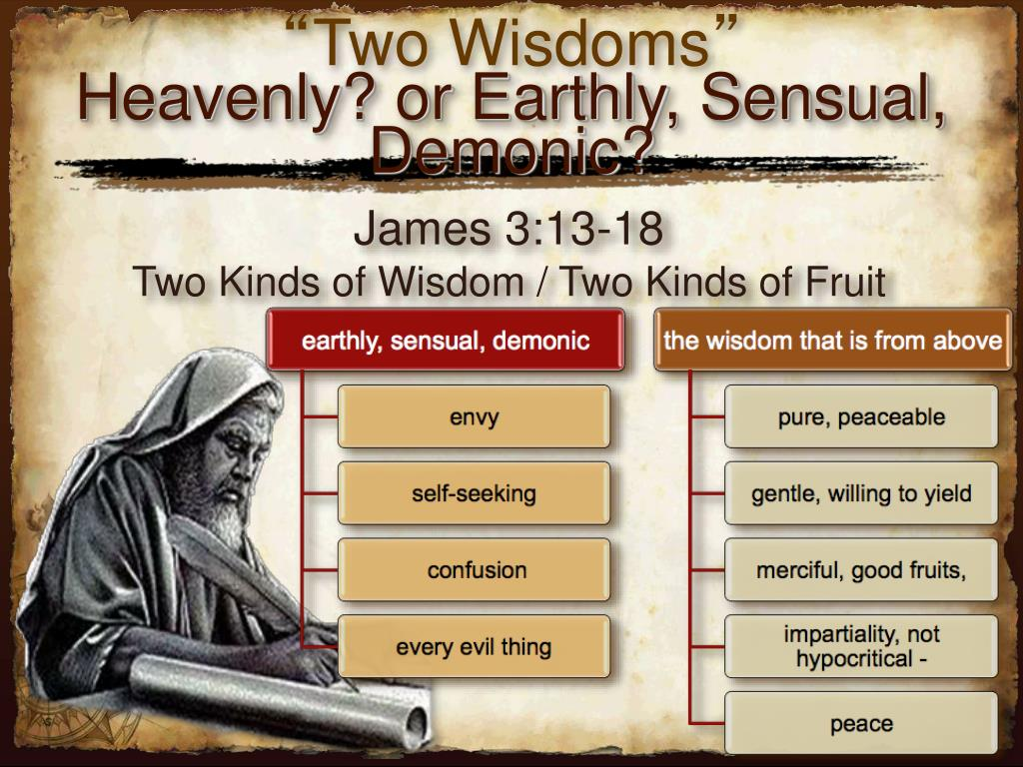
The following sermon is going to focus on two kinds of wisdom as found in James 3:13-18. Let’s take a quick review of the historical circumstances surrounding this passage. Like the church of Corinth, there were rival teachers in James’ church who believed their superior wisdom entitled them to have his leadership position! In response James stated they were false teachers for any wisdom marked by tongues like fire and a lifestyle of envy and selfish ambition is at “odds with the law of love and therefore is worldly in nature! While everyone ought to learn and put into practice the truth concerning God⁵ to do so with the attitude of showing off one’s supposed spiritual superiority through rivalry and political campaigning does not prove one is wise but merely that one is full of pride and breaking Christ’s command to not seek positions of power an authority. James reminded these false teachers that Godly wisdom comes from heaven, is “marked by humility, results in good deeds,” (3:13) and above all is “pure, peace-loving, considerate, submissive, full of mercy and good fruit, impartial and sincere” (3:17). While James is specifically speaking to the false teachers in his church his teaching on earthly and heavenly wisdom applies to all believers! What fuels a person to learn more about the truth concerning God and how one puts His righteous decrees into practice are the fruits by which one can discern what kind of wisdom one has obtained, earthly or heavenly!

Who is Wise?

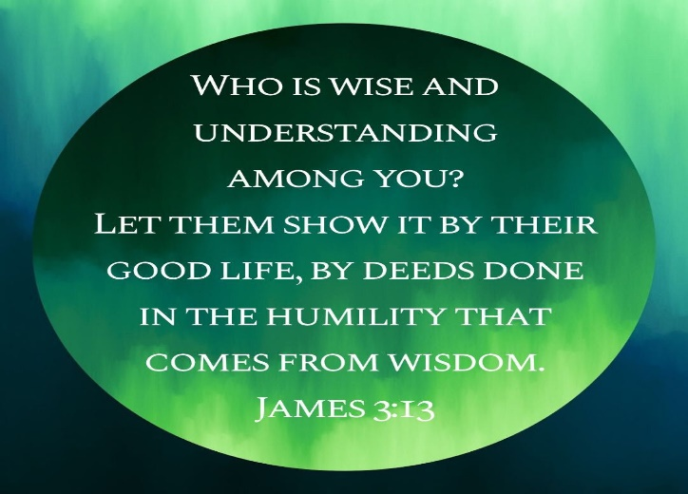
James begins by asking “who is wise and has understanding among you” (3:13)? To even attempt to answer such a provocative question one must first define what Godly wisdom truly is! If one were to picture oneself “as a car and one’s life as a road” then wisdom is knowing how to negotiate the twists and turns of life in a manner that “applies God’s word to the practical issues of life.” The Jews understood that wisdom was more than a philosophical esoteric word game” it comprised of three crucial levels to be from heaven and not earthly. First, since our ways and thoughts are not God’s ways and thoughts (Isaiah 55:8-9), the backbone of heavenly wisdom lies in knowing the absolute truth as contained in His holy word. Second, with the aid of the Spirit of Truth (John 16:13) Godly wisdom is acquiring understanding on how to negotiate the twists and turns of life in accordance with the commands one has read in His word. And lastly Godly wisdom takes knowledge and understanding of His word and puts it into practice! To accomplish these three levels, one must learn to fear the Lord (Proverbs 9:10) for until one completely puts God in charge of the “wheel” of one’s life the “old self” and all its evil desires will “win out” (Romans 7; James 1:14) and one’s presumed “wisdom” will only “seem right but in the end lead to destruction” (Proverbs 14:12). To obtain heavenly wisdom one cannot be motivated by self-proclaimed spiritual superiority but instead in seeing other Christians as better than oneself (Philippians 2:3) being teachable and seeking council from other believers (Proverbs 11:14). And the most important thing for wisdom to be Godly is through fasting, and prayer seeking the will of God the Father in heaven so that in all one does one’s footsteps are establish because His stamp of approval has already been obtained! It is no wonder that when asked by God what was the desire of his heart Solomon said wisdom for it truly is the “vehicle that will take you through and to the destination” called living a holy life!

Proof that one is Wise
To determine if one has obtained heavenly wisdom James states one merely needs to examine one’s life to see if there is evidence of good deeds done in humility. Wisdom is not based on knowing Greek and Hebrew and being able to parse complex verbs but on “living” out the truth consistently moment by moment in a manner that pleases the Lord! Reading God’s word is not to be done to amass knowledge but to “do what it says” (James 1:22)! We are to walk in the footsteps of Christ to not only please Him but also to witness to others (1 Peter 1:12) that it is possible to be holy as God is holy (1 Peter 1:16). Living a holy life also means not just doing the right things but having the right motivation, humility! To avoid the temptation of believing one’s newly acquired knowledge and living proves one is “more holy” than another, one must maintain an attitude of meekness that comes “from constantly understanding our position as sinful creatures in relation to the glory and majesty of our God.” This means our desire to learn more about God’s word is not to “lord our knowledge” over others but to allow His commands to not only plow furrows of righteousness in our hearts but in humility to witness to others what we have learned and are living. Heavenly wisdom is “not interested in defending” one’s position but remains teachable as but one person whom the Holy Spirit speaks the truth! This does not mean that to be humble one must accept every “wind of doctrine” one hears (2 Timothy 4:3-4) but merely that in love one fairly evaluates other member’s wisdom based on the evidence of holy fruits within their lives!

Proof that one is Unwise
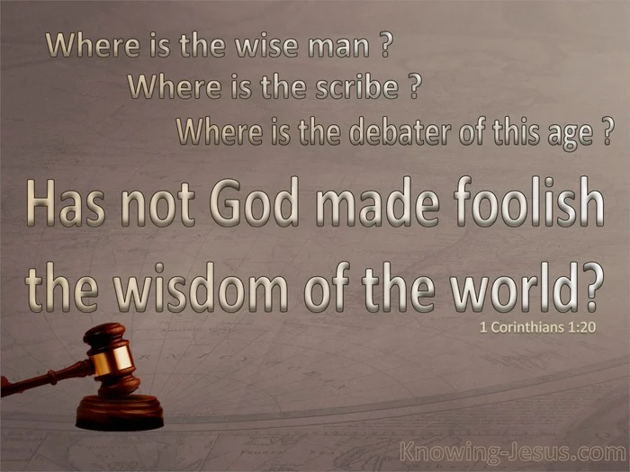
Whereas evidence of good deeds done in humility are signs one has Godly wisdom, “bitter envy and selfish ambition” (verse 14) are evidence one has worldly wisdom. James tells those who are motivated by “envy and the self-serving desire” to usurp his leadership position by claiming superior knowledge of God’s word they are inadvertently “allowing Satan to slip into the driver’s seat” of their lives! “Confusion, disorder and tumults will inevitably break out in the church were Christians, especially leaders, are more interested in pursuing their own ambitions or partisan causes than the edification of the body as a whole.” Not only is wisdom motivated by competition amongst various leaders worldly but so is promoting one’s own interpretations and reputations above that of others! Evidence of jealously, selfish ambition and creating dissension in the body of Christ for James are sufficient proof one’s wisdom does not come from God because His wisdom is always accompanied by good deeds and motivated by humility! This kind of wisdom does not come from above but is “earthbound, unspiritual and climatically demonic.” In allowing one’s own selfish ambitions to overrule God’s revelation it is sinful because it “begins and ends with this world instead of considering eternity!” In contrast Godly wisdom is sought after as a gift from God (Proverbs 2:6) not to be used in a spirit of “one-upmanship” but as the never-ending opportunity to invite God to take the wheel of one’s life and in complete surrender and though His Spirit’s power build up the body of Christ in love for Him and one another!

Characteristics of Wisdom
Not only is wisdom from above characterized by good deeds and done in humility but is also pure, peaceful, considerate, submissive, full of mercy and good fruit, impartial and sincere (3:17). Wisdom from God is “pure, unmixed with anything worldly or demonic” and as such is only attained by those who are “wholly and sincerely committed to following God’s moral directives” and will in their lives! While human wisdom says you must drive the “car of your life” your own way, Godly wisdom gladly and submissively says Lord take the while and drive me only to where you want me to go! By refusing to “lean unto one’s own understanding” (Proverbs 3:5-6), to “walk in the council of the ungodly” (Psalms 1) or seek the sinful desires of one’s soul (James 1:14), with the aid of the Holy Spirit Godly wisdom never stops striking a blow to double-mindedness with the singular belief that no one can drive the car of one’s life better than one’s own Kinsman Redeemer! A person with Godly wisdom is one that is kind and gentle in spirit, teachable and easily persuaded when hearing the truth, even when it contradicts one’s own long held positions on Scripture. This does not mean Godly wisdom is weak or gullible to every fanciful interpretation of God’s word but merely that it is less concerned with “intellectually” proving one is right in the eyes of another and only interested in forbearing and inviting both oneself and the other to fast and pray to discern God’s point of view! As such it is not combative, abrasive or hypocritically self-centered but stives in the fear of the Lord to be “stable, trustworthy, and transparent” in its desire to be morally righteous and blameless in the eyes of all, especially in the eyes of the Lord who purchased one at the price of His very life (1 Corinthians 6:20)!

The Fruit of Wisdom
The fruit of obtaining Godly wisdom is becoming a peacemaker who reaps a harvest of righteousness (3:18)! To be right by “living in accordance with the will of God” is not attainable by studying God’s word with bitter envy or selfish ambition to try to demonstrate one’s superior knowledge but can only be obtained in an atmosphere of peace! Conflict, combat and anger (James 1:2) does not produce holy living for in “striving for the truth” one must not forget Christ’s words in Matthew 5:9, “blessed are the peacemakers, for they will be called children of God.” Those who possess Godly wisdom will be not only at peace with God but also with their brothers and sisters in Christ! This does not mean that one is to accept sinful ways to maintain peace but even when fighting against sin, one is to hunger for peace, yearning to heal all divisions by one’s God-given wise counsel! To conclude let me answer the question which is hopefully by now on your mind: how do I get this kind of peace? In chapter one James states the following: “if any of you lack wisdom, you should ask of God, who gives generously to all without finding fault, and it will be given unto you” (1:5)! While wisdom is a gift from God that thankfully is offered to anyone who asks, to receive it one must have the kind of relationship with Christ that sees others better than oneself and wants to become more like Jesus … not one that wants to “show off” but to share the truth and build up one another in the faith! Let me finish with one final question to ponder: if God came and asked you what you wanted to live the best life you could, would you ask for money, power or riches or would you be like King Solomon and ask for the kind of Godly wisdom James has outlined in today’s passage?

Peter H. Davids, James, Understanding the Bible Commentary Series (Grand Rapids, MI: Baker Books, 2011), 87.
David P. Nystrom, James, The NIV Application Commentary (Grand Rapids, MI: Zondervan Publishing House, 1997), 205.
David P. Nystrom, James, The NIV Application Commentary (Grand Rapids, MI: Zondervan Publishing House, 1997), 203.
David P. Nystrom, James, The NIV Application Commentary (Grand Rapids, MI: Zondervan Publishing House, 1997), 204.
David P. Nystrom, James, The NIV Application Commentary (Grand Rapids, MI: Zondervan Publishing House, 1997), 206.
Craig L. Blomberg and Mariam J. Kamell, James, vol. 16, Zondervan Exegetical Commentary on the New Testament (Grand Rapids, MI: Zondervan, 2008), 171.
David P. Nystrom, James, The NIV Application Commentary (Grand Rapids, MI: Zondervan Publishing House, 1997), 205.
Douglas J. Moo, James: An Introduction and Commentary, vol. 16, Tyndale New Testament Commentaries (Downers Grove, IL: InterVarsity Press, 1985), 136.
Roger Ellsworth, Opening up James, Opening Up Commentary (Leominster: Day One Publications, 2009), 116.
Anthony T. Evans, “‘The Perspective of Wisdom,’” in Tony Evans Sermon Archive (Tony Evans, 1997), Jas 3:13–18.
Anthony T. Evans, “‘The Perspective of Wisdom,’” in Tony Evans Sermon Archive (Tony Evans, 1997), Jas 3:13–18.
Anthony T. Evans, “‘The Perspective of Wisdom,’” in Tony Evans Sermon Archive (Tony Evans, 1997), Jas 3:13–18.
Anthony T. Evans, “‘The Perspective of Wisdom,’” in Tony Evans Sermon Archive (Tony Evans, 1997), Jas 3:13–18.
Anthony T. Evans, “‘The Perspective of Wisdom,’” in Tony Evans Sermon Archive (Tony Evans, 1997), Jas 3:13–18.
Anthony T. Evans, “‘The Perspective of Wisdom,’” in Tony Evans Sermon Archive (Tony Evans, 1997), Jas 3:13–18.
Craig L. Blomberg and Mariam J. Kamell, James, vol. 16, Zondervan Exegetical Commentary on the New Testament (Grand Rapids, MI: Zondervan, 2008), 171.
Anthony T. Evans, “‘The Perspective of Wisdom,’” in Tony Evans Sermon Archive (Tony Evans, 1997), Jas 3:13–18.
Chris Benfield, “Godly Wisdom and Earthly Knowledge # 14 (James 3:13–18),” in Pulpit Pages: New Testament Sermons (Mount Airy, NC: Chris Benfield, 2015), 1471.
Anthony T. Evans, “‘The Perspective of Wisdom,’” in Tony Evans Sermon Archive (Tony Evans, 1997), Jas 3:13–18.
Anthony T. Evans, “‘The Perspective of Wisdom,’” in Tony Evans Sermon Archive (Tony Evans, 1997), Jas 3:13–18.
Douglas J. Moo, The Letter of James, The Pillar New Testament Commentary (Grand Rapids, MI; Leicester, England: Eerdmans; Apollos, 2000), 169.
Douglas J. Moo, The Letter of James, The Pillar New Testament Commentary (Grand Rapids, MI; Leicester, England: Eerdmans; Apollos, 2000), 170.
Douglas J. Moo, The Letter of James, The Pillar New Testament Commentary (Grand Rapids, MI; Leicester, England: Eerdmans; Apollos, 2000), 169.
Chris Benfield, “Godly Wisdom and Earthly Knowledge # 14 (James 3:13–18),” in Pulpit Pages: New Testament Sermons (Mount Airy, NC: Chris Benfield, 2015), 1472.
Douglas J. Moo, The Letter of James, The Pillar New Testament Commentary (Grand Rapids, MI; Leicester, England: Eerdmans; Apollos, 2000), 170.
Douglas J. Moo, The Letter of James, The Pillar New Testament Commentary (Grand Rapids, MI; Leicester, England: Eerdmans; Apollos, 2000), 170.
Peter H. Davids, James, Understanding the Bible Commentary Series (Grand Rapids, MI: Baker Books, 2011), 88.
Craig L. Blomberg and Mariam J. Kamell, James, vol. 16, Zondervan Exegetical Commentary on the New Testament (Grand Rapids, MI: Zondervan, 2008), 171.
Chris Benfield, “Godly Wisdom and Earthly Knowledge # 14 (James 3:13–18),” in Pulpit Pages: New Testament Sermons (Mount Airy, NC: Chris Benfield, 2015), 1472.
Douglas J. Moo, The Letter of James, The Pillar New Testament Commentary (Grand Rapids, MI; Leicester, England: Eerdmans; Apollos, 2000), 171.
Chris Benfield, “Godly Wisdom and Earthly Knowledge # 14 (James 3:13–18),” in Pulpit Pages: New Testament Sermons (Mount Airy, NC: Chris Benfield, 2015), 1473.
Roger Ellsworth, Opening up James, Opening Up Commentary (Leominster: Day One Publications, 2009), 118.
Douglas J. Moo, James: An Introduction and Commentary, vol. 16, Tyndale New Testament Commentaries (Downers Grove, IL: InterVarsity Press, 1985), 139.
Craig L. Blomberg and Mariam J. Kamell, James, vol. 16, Zondervan Exegetical Commentary on the New Testament (Grand Rapids, MI: Zondervan, 2008), 172.
Craig L. Blomberg and Mariam J. Kamell, James, vol. 16, Zondervan Exegetical Commentary on the New Testament (Grand Rapids, MI: Zondervan, 2008), 172.
Douglas J. Moo, The Letter of James, The Pillar New Testament Commentary (Grand Rapids, MI; Leicester, England: Eerdmans; Apollos, 2000), 174.
Douglas J. Moo, The Letter of James, The Pillar New Testament Commentary (Grand Rapids, MI; Leicester, England: Eerdmans; Apollos, 2000), 172.
Douglas J. Moo, The Letter of James, The Pillar New Testament Commentary (Grand Rapids, MI; Leicester, England: Eerdmans; Apollos, 2000), 173.
Anthony T. Evans, “‘The Perspective of Wisdom,’” in Tony Evans Sermon Archive (Tony Evans, 1997), Jas 3:13–18.
Roger Ellsworth, Opening up James, Opening Up Commentary (Leominster: Day One Publications, 2009), 118.
Douglas J. Moo, The Letter of James, The Pillar New Testament Commentary (Grand Rapids, MI; Leicester, England: Eerdmans; Apollos, 2000), 173.
Douglas J. Moo, The Letter of James, The Pillar New Testament Commentary (Grand Rapids, MI; Leicester, England: Eerdmans; Apollos, 2000), 174.
Craig L. Blomberg and Mariam J. Kamell, James, vol. 16, Zondervan Exegetical Commentary on the New Testament (Grand Rapids, MI: Zondervan, 2008), 175.
Peter H. Davids, James, Understanding the Bible Commentary Series (Grand Rapids, MI: Baker Books, 2011), 90.
Anthony T. Evans, “‘The Perspective of Wisdom,’” in Tony Evans Sermon Archive (Tony Evans, 1997), Jas 3:13–18.
David P. Nystrom, James, The NIV Application Commentary (Grand Rapids, MI: Zondervan Publishing House, 1997), 209.
Anthony T. Evans, “‘The Perspective of Wisdom,’” in Tony Evans Sermon Archive (Tony Evans, 1997), Jas 3:13–18.
David P. Nystrom, James, The NIV Application Commentary (Grand Rapids, MI: Zondervan Publishing House, 1997), 209.
Douglas J. Moo, The Letter of James, The Pillar New Testament Commentary (Grand Rapids, MI; Leicester, England: Eerdmans; Apollos, 2000), 176.
Peter H. Davids, James, Understanding the Bible Commentary Series (Grand Rapids, MI: Baker Books, 2011), 91.
Anthony T. Evans, “‘The Perspective of Wisdom,’” in Tony Evans Sermon Archive (Tony Evans, 1997), Jas 3:13–18.
Douglas J. Moo, The Letter of James, The Pillar New Testament Commentary (Grand Rapids, MI; Leicester, England: Eerdmans; Apollos, 2000), 177.
Douglas J. Moo, The Letter of James, The Pillar New Testament Commentary (Grand Rapids, MI; Leicester, England: Eerdmans; Apollos, 2000), 175.
Douglas J. Moo, James: An Introduction and Commentary, vol. 16, Tyndale New Testament Commentaries (Downers Grove, IL: InterVarsity Press, 1985), 141.
Roger Ellsworth, Opening up James, Opening Up Commentary (Leominster: Day One Publications, 2009), 120.
Douglas J. Moo, The Letter of James, The Pillar New Testament Commentary (Grand Rapids, MI; Leicester, England: Eerdmans; Apollos, 2000), 178.
Peter H. Davids, James, Understanding the Bible Commentary Series (Grand Rapids, MI: Baker Books, 2011), 91.
Peter H. Davids, James, Understanding the Bible Commentary Series (Grand Rapids, MI: Baker Books, 2011), 91.
Chris Benfield, “Godly Wisdom and Earthly Knowledge # 14 (James 3:13–18),” in Pulpit Pages: New Testament Sermons (Mount Airy, NC: Chris Benfield, 2015), 1475.
Craig L. Blomberg and Mariam J. Kamell, James, vol. 16, Zondervan Exegetical Commentary on the New Testament (Grand Rapids, MI: Zondervan, 2008), 177.
Anthony T. Evans, “‘The Perspective of Wisdom,’” in Tony Evans Sermon Archive (Tony Evans, 1997), Jas 3:13–18.
Chris Benfield, “Godly Wisdom and Earthly Knowledge # 14 (James 3:13–18),” in Pulpit Pages: New Testament Sermons (Mount Airy, NC: Chris Benfield, 2015), 1475.

