Roots of Faith

Luke 17 :5-10

Online Sermon: http://www.mckeesfamily.com/?page_id=3567

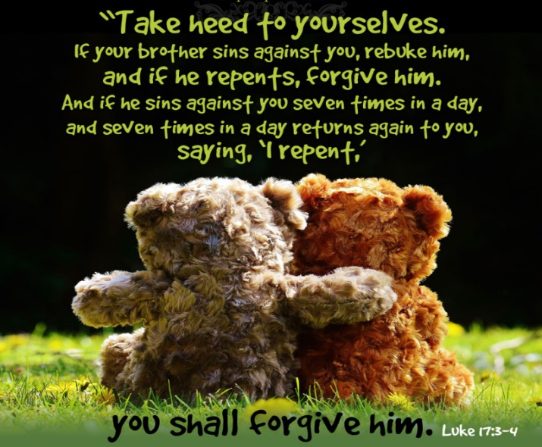
Since “religion is not a private pursuit, but is a shared family responsibility,” how difficult it is to rebuke and extend forgiveness to those who have “sinned against us” (17:1)! While we know that “unchecked sin is like yeast roaming through the community” that if left unchecked leads to indifference to God’s commands, is it not easier to “turn a blind eye to the sins of others” even if they are offensive or worse yet direct attacks against us? We say we are right to forebear one another but how is it right to silently bear a grudge and “demonize” those created in God’s very own image (Genesis 1:27)? If one does not rebuke another does not one risk becoming a stumbling block and oneself face God’s judgment (17:1-3) because silence often means tacit approval? On the other hand, if one rebukes another for the speaks in their eyes (Matthew 7:3-5) does not one risk losing the friendship or worst yet invite them to become one’s enemies? To offer unlimited forgiveness to those who repent but repeatedly offend is not something that us skeptical and lovers of “eye for an eye” people find overly attractive especially when the other “believer” responds by indulging a battery of swings in our general direction! Imagine how the shocked the disciples must have been when Jesus told them the condition of their forgiveness was mere repentance! To rebuke and forgive a repentant believer once is hard enough but to do it seven times in one day (17:4) … well that takes great faith not only that the rebuke will not offend, and one gains an enemy but also that each time the person repents they are being genuine! Not only did Jesus elsewhere ask the disciples to forgive “seventy-times-seventy” (Matthew 18:22) but also commanded them to not keep the offender pinned “down in the muck of their past failure” by keeping records of wrongs but instead to create an environment of unconditional love that sees the blood of Christ as sufficient to pay the price of their sin! While Jesus’ instruction to the disciples was clear, rebuking those who sin in the community and when they repent forgive them, well that is near impossible to put into practice!

Increase our Faith

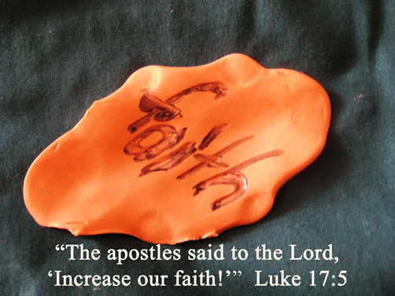
Since the disciples saw rebuking and then granting forgiveness to those who repented as demanding more faith than they had they asked Jesus to “increase their faith” (17:5). While it was by grace and faith in the atoning sacrifice of the Son (Ephesians 2:8-9) that we found the pearl in the field (Matthew 13:44) and were born again of the Spirit (John 1:13), the faith we had as mere spiritual infants (1 Corinthians 3:1-3) is expected to “grow” over time. The apostles asked for increased faith so it must be able to grow. While tens of thousands will enter heaven whose faith never reached beyond the simple reliance on Christ in which they were saved, others will enter rejoicing and standing firm on the Rock of their salvation in midst of turbulent tribulations and the fiercest of persecutions! And yet while we are consciously aware of our perseverance leading to greater faith over time (James 1:2-4), we must humbly admit that faith is also as gift from God that is given to us in degrees as we live in this world that is not our home (Hebrews 13:14). And yet even if faith is limited in a sphere of size ordained by God this in no way negates performing our duty with the power of the Holy Spirit to utilize more and more of whatever sphere we are given to do His “good, pleasing and perfect will (Romans 12:2)! When faced with challenges we are to rejoice for even in our weakness His strength is perfected for what He asks of us He enables! “It is not so much great faith that is required as faith in a great God!”

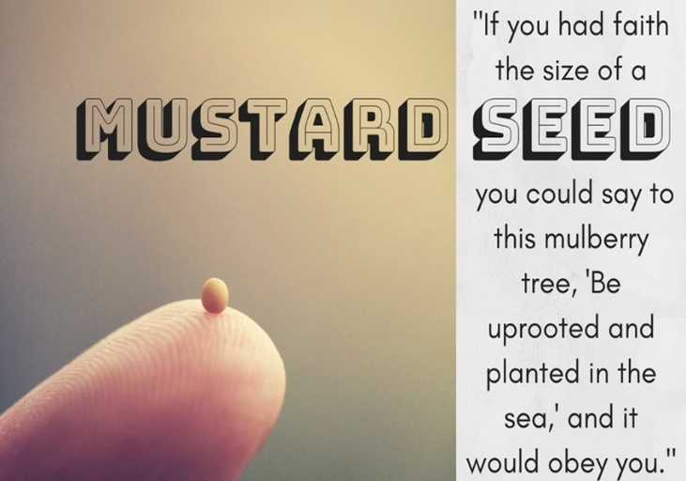
In response to the apostle’s request to have their faith increased so that they might be able to rebuke and forgive repentant sinners Jesus said that if they had faith as tiny as a mustard seed, they could command a mulberry tree to uproot and be replanted in the sea (17:6). “A mustard seed is so small that, held in the palm of one’s hand, it appears as a speck of dust, barely visible” and yet it “packs a lot of life” for it can grow a tree that is some thirty five feet high! It has a “vast and tenacious root system which intertwined with everything in its vicinity that is so strong that it can last up to 600 years! And yet despite the size and strength of this tree it could be uprooted by a single command given in faith! In using this metaphor Jesus is saying to do the seemingly impossible it is not more quantity of faith that one needs but the genuine desire to petition God with the faith one has already received! “Genuine faith can accomplish what experience, reason, and probability would deny, if it is exercised within God’s will.” If the apostles were to rebuke in love and forgive unconditionally, repentant sin all they needed was to ask Jesus to enable them to have the faith as tiny as a mustard seed to exercise the trust and spiritual strength needed to accomplish reconciliation in His name! “Faith is not so much a possession as it is a disposition!” So, we need not fear God’s wrath because we cannot accomplish what He asks but are to rejoice that He has already given us the faith needed to do good deeds that point to God the Father in heaven (Matthew 5:16)!

Roots in the World

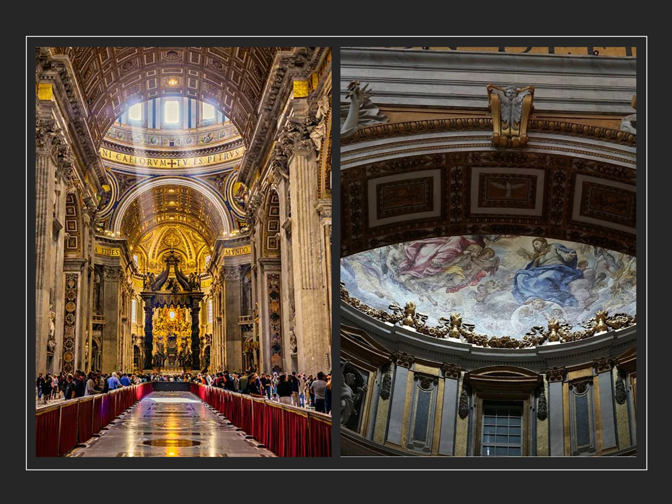
So why then are so many of God’s children like the apostles and feel that their faith must increase before they can do great things in His kingdom? The answer to this question can be found metaphorically in the roots of the mulberry tree. Our spiritual roots have been so tangled up by the “spiritual forces of evil” of this dark world (Ephesians 6:12) that we simply cannot untie them to grab ahold of and use the faith God has given us! One of the roots of evil that often strangles out our faith is the mistaken belief that only the “unapproachable heroes,” you know those saints who have been in the crucible of affliction and persecution so intense that the fiery smell of purification forever remains upon them, are the only ones capable of doing miraculous, kingdom work (John 14:12)! Seeing the masterpieces of Renaissance and Baroque of St Peter’s Basilica while reflecting on the time he walked on water (Matthew 14:22-33), resurrected Dorcas-Tabitha (Acts 9:36-41) and was called the rock of the church (Matthew 16:18-19); one can’t help but feel inferior and incapable of such greatness. To allow knowledge of great feats of the saints such as Noah, Moses, Elijah, Abraham, David, apostle Paul and so many other to instill doubts in our hearts of our ability to fulfill our calling is utter foolishness for were not all of them ordinary when called and dare I say weak so that through God’s power they might shame the strong (1 Corinthians 1:26-31)? Does not the same Spirit that kept them fervent and faithful live inside of us as well? Our lack of ability to do great things in God’s kingdom is not because our faith is less than the greats of the Bible but merely that our roots of unbelief in God’s ability to work in and through us are too deep within our soul to believe in our God-given, God-ordained abilities!

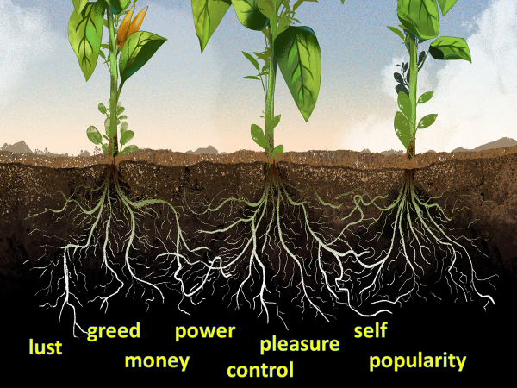
Another root of our “mulberry tree” of disbelief comes from loving and practicing the ways of this world. We are so tangled up in our personalities, our problems, our struggles, our relationships, our decisions, our finances that the “god” we focus most on is that of ourselves! Of what possible value would it be to pray for our faith to increase when what “little” faith we think we possess has been neglected to chase after the trinkets and toys of temporary pleasure of this world? While it is unavoidable to gratify the sinful desires of one’s heart from time to time (Romans 7:8-20; 1 John 1:10) this does not mean that we can “love the world or anything in the world” (1 John 2:15) and expect this to not affect our walk with God! While such roots are numerous and have a firm grip upon our lives this does not mean that we are “secure” for the moment tribulation comes our “faith” crumbles on the shifting sands of our culture in which it was built! Having little faith lurking behind unbelief is a root that leaves many Christians busy with a thousand cares of this world and so “deficient at the mercy-seat” that they cannot ask God to enable them to do great things but to merely practice a form of godliness (2 Timothy 3:5) that is void of power and barren of fruit! “It is by faith that sin is kept down” and unless we rigorously overcome our love of the broad path (Matthew 7:13-14) through the blood of the Lamb then what little faith we have will be choked out by the roots of love for another master other than the One who we have supposedly given our allegiance too (Matthew 6:24)!


The final root of our mulberry tree of disbelief comes from having an attitude of disrespect towards our Creator. Too many believers today lack faith due to being “spiritually out of order.” With a list of supposed “sacrificial” but often crumbs of occasional holy living and the promise “ask Me for anything in My name, and I will do it” (John 14:14) we boldly and dare I say sinfully try to lord our position of “blessing receiver” over our Creator by commanding Him to do our will! Christ told the apostles that accessing faith as tiny as a mustard seed was key to doing great things in His kingdom, but no amount of faith would challenge His sovereign right to rule over all things seen and unseen (Colossians 1:16)! To help them understand better this truth Jesus told them a parable about a servant and his master (17:7-10). Just like the servant who works hard all day for his master is not entitled to be rewarded with a meal or even a simple thank you from his master for doing his mere duties, Christ says, neither are His own children entitled to be rewarded/blessed for fulfilling their duties to their Creator! Reading the Bible, praying, singing worship songs, feeding the poor, taking care of the widows, or even being persecuted for righteousness’ sake can never be a down payment for receiving blessings because the atonement on the cross that we have received by faith and grace are of infinite value (Ephesians 2:8-9)! “Faith then is tied to being under spiritual authority.” Since the Lord will have mercy and compassion on whom He chooses (Exodus 33:19) the key to accessing the faith needed to do great things in His kingdom is to “be lowly in spirit, a profound sense of unprofitableness” in which our service, obedience and duty do not purchase blessings but are gladly received as an act of His grace so that we might in turn bring honor to Him.

Roots in Living Waters


Let us finish with one final point: faith is not something attainable only by climbing Jacob’s ladder and wrestling it from his mighty hands, as if his sainthood is any more precious than ours but is freely given to those who are firmly rooted in the living waters through which salvation and good works come! It is by the still waters that feed our souls (Psalms 23) that we feast at the Lord’s table on His holy word with an unquenchable desire to in faith live every precious word (James 1:22-25)! The key to obtaining faith that can move the mighty mulberry trees of our lives is not more faith but trust and complete surrender of our lives in such a manner that in trials and tribulations, suffering and pain, and even in the most intense of persecutions we have roots so strongly planted in the Rock of our salvation (Psalms 62) that nothing but rejoicing and praise for our Redeemer comes from our lips! It is by the still waters of His loving embrace (Psalms 91) that we never stop crying out Abba Father (Romans 8:14-125) help me with my unbelief (Mark 9:24) for I am a person of unclean lips (Isaiah 6:5)! It is here that we humbly say thank you Jesus for every spiritual blessing (Ephesians 1:3) you have given to someone so unworthy (Romans 3:10-18). It is in His presence that we get fed by the glorious bread of life to know His good and perfect will (Romans 12:1-2) so that we might humbly ask Him to speak the glorious word(s) of service and change in His kingdom. It is through these kinds of roots of faith that all creation gets to witness His sovereign power to do miracles in and through the weak (1 Corinthians 1:27) and yet masterpieces of His grace! May we never forget and always rejoice that while “insubordination to His legitimate spiritual authority over our lives cancels faith,” having the roots of total submission and thanksgiving for His undying love as our Lord, Savior and King leads to sacrificial living that brings honor and glory to His name! O to have the faith as tiny as a mustard seed!

Darrell L. Bock, Luke, The NIV Application Commentary (Grand Rapids, MI: Zondervan Publishing House, 1996), 439.
Darrell L. Bock, Luke, The NIV Application Commentary (Grand Rapids, MI: Zondervan Publishing House, 1996), 440.
Darrell L. Bock, Luke, The NIV Application Commentary (Grand Rapids, MI: Zondervan Publishing House, 1996), 441.
James R. Edwards, The Gospel according to Luke, ed. D. A. Carson, The Pillar New Testament Commentary (Grand Rapids, MI; Cambridge, U.K.; Nottingham, England: William B. Eerdmans Publishing Company; Apollos, 2015), 478.
Leon Morris, Luke: An Introduction and Commentary, vol. 3, Tyndale New Testament Commentaries (Downers Grove, IL: InterVarsity Press, 1988), 273.
Tony Evans, “‘The Keys to Increasing Your Faith,’” in Tony Evans Sermon Archive (Tony Evans, 2015), Lk 17:5–10.
D. A. Carson, “The Gospels and Acts,” in NIV Biblical Theology Study Bible, ed. D. A. Carson (Grand Rapids, MI: Zondervan, 2018), 1863.
Darrell L. Bock, Luke, The NIV Application Commentary (Grand Rapids, MI: Zondervan Publishing House, 1996), 442.
Darrell L. Bock, Luke, The NIV Application Commentary (Grand Rapids, MI: Zondervan Publishing House, 1996), 442.
Darrell L. Bock, Luke, The NIV Application Commentary (Grand Rapids, MI: Zondervan Publishing House, 1996), 442.
Walter L. Liefeld, “Luke,” in The Expositor’s Bible Commentary: Matthew, Mark, Luke, ed. Frank E. Gaebelein, vol. 8 (Grand Rapids, MI: Zondervan Publishing House, 1984), 994.
C. H. Spurgeon, “Growth in Faith,” in The Metropolitan Tabernacle Pulpit Sermons, vol. 59 (London: Passmore & Alabaster, 1913), 590.
C. H. Spurgeon, “Growth in Faith,” in The Metropolitan Tabernacle Pulpit Sermons, vol. 59 (London: Passmore & Alabaster, 1913), 592.
C. H. Spurgeon, “Growth in Faith,” in The Metropolitan Tabernacle Pulpit Sermons, vol. 59 (London: Passmore & Alabaster, 1913), 595.
C. H. Spurgeon, “Growth in Faith,” in The Metropolitan Tabernacle Pulpit Sermons, vol. 59 (London: Passmore & Alabaster, 1913), 590.
C. H. Spurgeon, “Growth in Faith,” in The Metropolitan Tabernacle Pulpit Sermons, vol. 59 (London: Passmore & Alabaster, 1913), 592–593.
C. H. Spurgeon, “Growth in Faith,” in The Metropolitan Tabernacle Pulpit Sermons, vol. 59 (London: Passmore & Alabaster, 1913), 591.
C. H. Spurgeon, “Growth in Faith,” in The Metropolitan Tabernacle Pulpit Sermons, vol. 59 (London: Passmore & Alabaster, 1913), 596.
Gavin Childress, Opening up Luke’s Gospel, Opening Up Commentary (Leominster: Day One Publications, 2006), 151.
Leon Morris, Luke: An Introduction and Commentary, vol. 3, Tyndale New Testament Commentaries (Downers Grove, IL: InterVarsity Press, 1988), 273.
James R. Edwards, The Gospel according to Luke, ed. D. A. Carson, The Pillar New Testament Commentary (Grand Rapids, MI; Cambridge, U.K.; Nottingham, England: William B. Eerdmans Publishing Company; Apollos, 2015), 479.
Tony Evans, “‘The Keys to Increasing Your Faith,’” in Tony Evans Sermon Archive (Tony Evans, 2015), Lk 17:5–10.
Walter L. Liefeld, “Luke,” in The Expositor’s Bible Commentary: Matthew, Mark, Luke, ed. Frank E. Gaebelein, vol. 8 (Grand Rapids, MI: Zondervan Publishing House, 1984), 994.
James R. Edwards, The Gospel according to Luke, ed. D. A. Carson, The Pillar New Testament Commentary (Grand Rapids, MI; Cambridge, U.K.; Nottingham, England: William B. Eerdmans Publishing Company; Apollos, 2015), 479.
Tony Evans, “‘The Keys to Increasing Your Faith,’” in Tony Evans Sermon Archive (Tony Evans, 2015), Lk 17:5–10.
Leon Morris, Luke: An Introduction and Commentary, vol. 3, Tyndale New Testament Commentaries (Downers Grove, IL: InterVarsity Press, 1988), 273.
Darrell L. Bock, Luke, The NIV Application Commentary (Grand Rapids, MI: Zondervan Publishing House, 1996), 439.
Walter L. Liefeld, “Luke,” in The Expositor’s Bible Commentary: Matthew, Mark, Luke, ed. Frank E. Gaebelein, vol. 8 (Grand Rapids, MI: Zondervan Publishing House, 1984), 994.
James R. Edwards, The Gospel according to Luke, ed. D. A. Carson, The Pillar New Testament Commentary (Grand Rapids, MI; Cambridge, U.K.; Nottingham, England: William B. Eerdmans Publishing Company; Apollos, 2015), 479.
Leon Morris, Luke: An Introduction and Commentary, vol. 3, Tyndale New Testament Commentaries (Downers Grove, IL: InterVarsity Press, 1988), 273.
Walter L. Liefeld, “Luke,” in The Expositor’s Bible Commentary: Matthew, Mark, Luke, ed. Frank E. Gaebelein, vol. 8 (Grand Rapids, MI: Zondervan Publishing House, 1984), 994.
Leon Morris, Luke: An Introduction and Commentary, vol. 3, Tyndale New Testament Commentaries (Downers Grove, IL: InterVarsity Press, 1988), 273–274.
Darrell L. Bock, Luke, The NIV Application Commentary (Grand Rapids, MI: Zondervan Publishing House, 1996), 440–441.
Joel B. Green, The Gospel of Luke, The New International Commentary on the New Testament (Grand Rapids, MI: Wm. B. Eerdmans Publishing Co., 1997), 613.
Tony Evans, “‘The Keys to Increasing Your Faith,’” in Tony Evans Sermon Archive (Tony Evans, 2015), Lk 17:5–10.
C. H. Spurgeon, “Growth in Faith,” in The Metropolitan Tabernacle Pulpit Sermons, vol. 59 (London: Passmore & Alabaster, 1913), 589.
C. H. Spurgeon, “Growth in Faith,” in The Metropolitan Tabernacle Pulpit Sermons, vol. 59 (London: Passmore & Alabaster, 1913), 598.
C. H. Spurgeon, “Growth in Faith,” in The Metropolitan Tabernacle Pulpit Sermons, vol. 59 (London: Passmore & Alabaster, 1913), 595.
C. H. Spurgeon, “Growth in Faith,” in The Metropolitan Tabernacle Pulpit Sermons, vol. 59 (London: Passmore & Alabaster, 1913), 595.
Tony Evans, “‘The Keys to Increasing Your Faith,’” in Tony Evans Sermon Archive (Tony Evans, 2015), Lk 17:5–10.
C. H. Spurgeon, “Growth in Faith,” in The Metropolitan Tabernacle Pulpit Sermons, vol. 59 (London: Passmore & Alabaster, 1913), 596–597.
C. H. Spurgeon, “Growth in Faith,” in The Metropolitan Tabernacle Pulpit Sermons, vol. 59 (London: Passmore & Alabaster, 1913), 594.
C. H. Spurgeon, “Growth in Faith,” in The Metropolitan Tabernacle Pulpit Sermons, vol. 59 (London: Passmore & Alabaster, 1913), 594.
Tony Evans, “‘The Keys to Increasing Your Faith,’” in Tony Evans Sermon Archive (Tony Evans, 2015), Lk 17:5–10.
Walter L. Liefeld, “Luke,” in The Expositor’s Bible Commentary: Matthew, Mark, Luke, ed. Frank E. Gaebelein, vol. 8 (Grand Rapids, MI: Zondervan Publishing House, 1984), 994.
Joel B. Green, The Gospel of Luke, The New International Commentary on the New Testament (Grand Rapids, MI: Wm. B. Eerdmans Publishing Co., 1997), 614.
Tony Evans, “‘The Keys to Increasing Your Faith,’” in Tony Evans Sermon Archive (Tony Evans, 2015), Lk 17:5–10.
Tony Evans, “‘The Keys to Increasing Your Faith,’” in Tony Evans Sermon Archive (Tony Evans, 2015), Lk 17:5–10.
James R. Edwards, The Gospel according to Luke, ed. D. A. Carson, The Pillar New Testament Commentary (Grand Rapids, MI; Cambridge, U.K.; Nottingham, England: William B. Eerdmans Publishing Company; Apollos, 2015), 481.
Darrell L. Bock, Luke, The NIV Application Commentary (Grand Rapids, MI: Zondervan Publishing House, 1996), 443.
Tony Evans, “‘The Keys to Increasing Your Faith,’” in Tony Evans Sermon Archive (Tony Evans, 2015), Lk 17:5–10.
Tony Evans, “‘The Keys to Increasing Your Faith,’” in Tony Evans Sermon Archive (Tony Evans, 2015), Lk 17:5–10.
Tony Evans, “‘The Keys to Increasing Your Faith,’” in Tony Evans Sermon Archive (Tony Evans, 2015), Lk 17:5–10.

