**Encouragement**[1]

Online Sermon: <http://www.mckeesfamily.com/?page_id=3567>

The Concise Oxford English Dictionary defines encouragement as “to give support, help or stimulate the development of confidence or hope in another person.”[2] Living in a fallen world where chance happens to everyone (Ecclesiastes 9:11), trials and tribulations are the norm (James 1:2-4), truth has become a figment of the world’s imagination that changes with the sifting sands of culture, famines, earthquakes, wars and rumors of wars ravage the land (Matthew 6:68) and belief in but one God invites harsh ridicule and persecution; we as the people of God need more than ever to encourage one another why we still have hope in the Lord, Jesus Christ (1 Peter 3:15)! When the world presents their gifts of the lust of the flesh, lust of the eyes, and the pride of life (1 John 2:15) to make self into the “god of choice” we as Christ’s ambassadors (2 Corinthians 5:20) are to let our light shine (Mathew 5:15-26) by choosing to cherish and obey His commands (Psalms 1:2) as those who truly believe He alone is our God and has the best plan for our lives (1 Corinthians 8:6)! To keep us on and rejoicing in being on God’s righteous path we as His children are called to humbly view others as better than ourselves (Philippians 2:3), to never stop encouraging them to love the Lord their God with all their heart, soul, and mind, and to love one another (Matthew 22:40) by building each other up in the faith (1 Thessalonians 5:11) and spurring one another onto doing good deeds (Hebrews 10:25)! The following sermon is going to begin by looking at how easy it is for believers to fall into the devil’s trap and encourage others to do evil instead of good. The remainder of the sermon is going to illustrate that while God is to be our best source of encouragement this does not absolve His children from the duty to encourage others by continually praying for them, supporting, and thanking them for the good work they are doing in God’s kingdom, building each other up in the faith, and by comforting them with the same comfort we have received from Christ!

**Do not Encourage Other Believer to do Evil but to do Good**

 While we are the temple of the Holy Spirit (1 Corinthians 6:19), we must confess that we are not always the best encouragers of God’s people! Has not some of the church become so drunk with the ways of this world that believes truth is situational dependent on the individual’s imagination and sinful desires that they have become at best lukewarm towards God’s righteous commands (Revelation 3:16) and worst yet utterly defiant? While few would openly and cunningly “hide snares” (Psalms 64:5) of deception to harm other church members (Jeremiah 29:8), are not gossiping and lies to tear down and snatch personal power just as deadly and sinful (James 4:1-11)? And does not silence when others are hurting and in need due to our perceived lack the time or desire to comfort them not breaking God’s second of greatest command to love one another (Matthew 22:38)? Is not a lack of rebuke (2 Timothy 4:2) either to retain friendship or out of indifference or participation in the other person’s sin one of the main reasons that many in the church continue to “hear what their itching ears want to hear” (2 Timothy 4:3-4) instead of embracing and living on the righteous path God has assigned them? So that none of us obtains a “sinful, unbelieving heart that turns away from the living God” the author of Hebrews states we are to “encourage one another daily” to walk in the faith (3:13)! Forbearance and “maintaining the bonds of peace” (Ephesians 4:2) does not mean indifference to sin but offering grace by giving one another time to pray and build each other up in the faith so that the planks in each others’ eyes (Matthew 7:3-5) might be clearly known, and Godly sorrow that leads to repentance (2 Chronicles 7:10-13) and the washing of one’s sins as white as snow might occur (1 John 1:9; Isaiah 1:18)! While those saved by grace through faith are not always the best at encouraging one another we can through the power of the Spirit be patient, provide careful instruction (2 Timothy 4:2) and help one another to be holy and righteous in God’s sight (1 Peter 1:16)!

**Encouragement from God**

If we are to keep the fiery darts of the devil (Ephesians 6:16) from piercing our hearts with an attitude of indifference or hostility towards fellow Christians, then we simply must take time in fasting and prayer to learn how to encourage others from the sovereign Creator who is pure love (1 John 4:7). Who better to teach us how to throw off “sin that so easily entangles us” than He who is “the pioneer and perfecter of faith” (Hebrews 12:1-2)? Who better to teach us how to not be indifferent or defiant towards others than He who was sent to “bind up the broken-hearted,” to “proclaim freedom for the captives” (Isaiah 61:1) by giving His very life to those who were still His enemies (Romans 5:10)? The Lord hears the desire of the afflicted and not only listens to their cries (Psalms 10:17) but when they stand firm upon the Rock of their salvation (18:2) they receive only good things from His hand (Romans 8:28)! The moment the fear of the Lord resides within our hearts of clay (Acts 9:31; 2 Corinthians 4:7-9) indifference towards Him and others gives way to an unquenchable desire to please He who enables us to do more than we can ask or imagine (Ephesians 3:20-21)! Even getting a glimpse of God’s glory compels us (2 Corinthians 5:14-15) to dethrone the “god of self” and see His commands not as a burden (1 John 5:1-3) but the road path to loving Him and one another. The more time we spend with He who “loves us with an everlasting love” (Jeremiah 31:3) the easier it becomes to do nothing out of “selfish ambition or conceit” (Philippians 2:3) but in love tenderly rebuke and build up in faith those Created in His image (Genesis 1:27; 1 John 4:20). What a joy it truly is to be and help others be one body and of one Spirit (John 17:20-25)! May we never stop believing and sharing with those we meet the reason we have hope is that our love and joy is not situationally dependent on what happens to us in this fallen world that is not our home (Hebrews 13:14) but purely on the promise that we who have received every spiritual blessing in Christ (Ephesians 1:3) will one day spend an eternity in paradise with Him (John 3:16)!

**Continually Thank God and Pray for one Another**

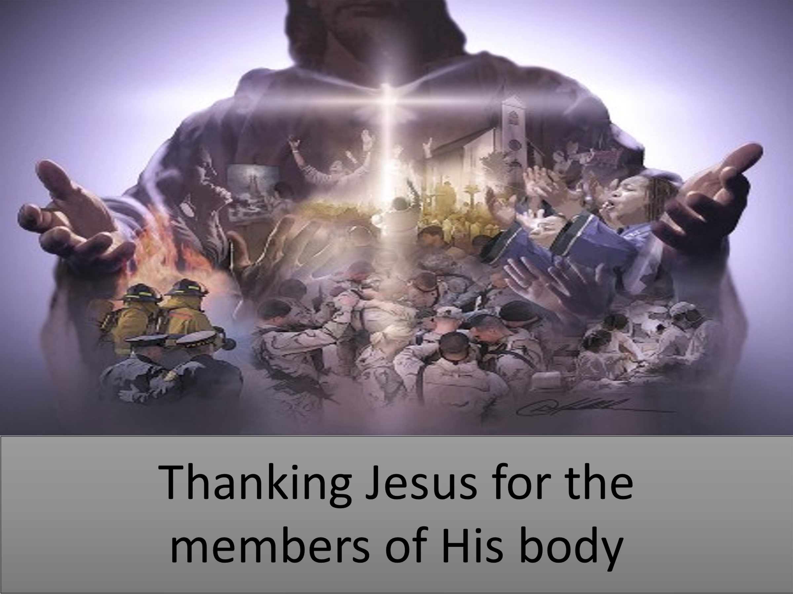 Through thankfulness and prayer, we can be a great source of encouragement unto one another. In his letter to the church of Rome Paul states that we are to rejoice for “in Christ though many, form one body, and each member belongs to all the others” (12:5). It is encouraging to hear that while the world glamours for power and popularity and loves only those who love them (Luke 6:32), one has brothers and sisters who unconditionally love and thank God for your presence in their lives! Another way to encourage one another is to share stories of victories over sin! Living in a fallen world of constant temptations it is very difficult to not give into the old self and live as the pagans of this world (Ephesians 4:22-24; 1 Peter 4:3). Even though we have 24/7 access to the full armour of God (Ephesians 6:10-18) and are divinely enabled to thwart the fiery darts of Satan we must admit that like Apostle Paul the evil we do not want to do we keep on doing (Romans 7:17-20). When shame ravages the soul how encouraging it is to hear that your temptation is “common to mankind” (1 Corinthians 10:13) for others have not only wrestled with the same sin that you are currently entangled in but have been granted victory over that sin in the name of Jesus! And how encouraging it is to hear that fellow believers are praying for us! To hear that one is making petitions to the God who created and is in control of all things seen and unseen (Colossians 1:16) gives us a great sense of encouragement that we need not worry about our financial, martial, health problems or persecutions because He who is our Rock and fortress will not leave nor forsake (Deuteronomy 31:6) but do good to those He loves (Romans 8:28)! While we should never tell someone we are praying for them to make ourselves appear holy (Matthew 6:5-7) neither should we neglect encouraging someone by telling them we love and are praying for them!

**Encourage the Workers of the Fields**

 Even though we know that it is an honor to serve the most-high God and that none of our work for the Lord is in vain (1 1Corinthians 15:58), a noticing and kind word of encouragement goes a long way towards rejoicing while serving in a kingdom that requires hard, selfless labour that often invites persecution! Just because atheists, agnostics, or “nothing in particular” are the fasting growing belief groups in North America,[3] this should not depress but challenge us for I believe that like in Jesus’ day the fields are truly ripe (Matthew 9:35-38)! We are “co-workers in God’s service” called to plant the seeds of righteousness amongst those God sends our way (1 Corinthians 3:1-9). While serving God can be exhilarating it can also be painful, frustrating and exhausting! For one thing often the repercussions of our service to the Lord is that of persecution by a world that “hates the light” (John 3:20) and ridicules those who it sees as foolish for having embraced what they see as the “yoke of God’s word” that snuffs out the unrestricted pleasures of life. Even more painful is the sting from fellow believers who in their desire to make themselves look powerful sometimes ridicule the hard labor of their brothers and sisters in Christ! And if persecution was not difficult enough to endure, it can be really frustrating planting and watering seeds (1 Corinthians 3:6-7) knowing full well that when the harvest comes in God’s time (Galatians 6:9) we might not get to see the fruits of our labour! Those who labor in the kingdom of God need to hear words of encouragement from members of the body of Christ not to puff up their egos but to reassure them that their living sacrifices of service are not only appreciated but also that many of their brothers and sisters are willing to help them stand firm and build up them up in the faith (1 Thessalonians 5:11)!

**Model to all the Believers**

 Another way to encourage fellow believers is by setting a “good example” by living in a manner that is holy and pleasing in God’s sight (Titus 2:6)! While hypocritically pointing out the specks in another’s eyes is not only condescending it is also demotivating for it does not instill hope in the other person that they can obey God’s commands (1 John 5:3) and be holy as God is holy (1 Peter 1:16)! How encouraging it is to see other believers model “genuine Christian behavior”[4] by doing good works that glories God the Father in heaven (Matthew 5:16)! Paul wrote to “his true son in their common faith” Titus (1:4) and said that to effectively teach and encourage other believers one must first “show integrity, seriousness and soundness of speech that cannot be condemned” (2:8). When one tries and yet fails to keep from sinning it often becomes a great source of shame that instead of becoming a light one has become a chameleon or imitator of the evil ways of this world. To combat the defeatist often associated with the entanglement of sin one needs to see hear testimonies of other believers who have struggled but also claimed victory over their sins through Christ Jesus (Hebrews 12:1-2)! Also what a great source of encouragement it is to hear stories of other believers who have faced trials of many kinds and yet persevered and as a result have grown in their faith (James 1:2-4)! So, let us never stop “encouraging one another as we see the Day approaching” (Hebrews 10:25) with words, thoughts, and deeds that come from imitating “Jesus who is the pioneer and perfecter of our faith” (Hebrews 12:2).

**Comfort one Another**

And lastly, “if you have any encouragement from being united with Christ, if any comfort from his love, if any common sharing in the Spirit, if any tenderness and compassion, then make my joy complete by being like-minded, having the same love, being one in spirit and of one mind” (Philippians 2:1-2). While we are to primarily go to Jesus when we are weary and burdened to find rest for our souls (Matthew 11:28-30) this does not absolve our responsibility as part of the body of Christ (1 Corinthians 12:12-14) to try to make one another’s load lighter by offering “cups of cold water” (Matthew 10:42) to fellow believers who are wrestling with the shame of sin or the pain of tribulations and persecutions. May our words and deeds not be condescending but comforting by living a life that through the power of the Holy Spirit that clearly shows holiness is attainable for those who stand on the Rock of their salvation! May we look out for and put the interests of others above ourselves (Philippians 2:3-4) by mourning with those who morn, rejoicing with those who rejoice (Romans 12:14-15), and by taking the time to lift one another up in prayer and share our love and time with the “neighbors” God has given to us (Matthew 22:37-39)! May our teers not be received by “salt less hearts” (Matthew 5:13) but instead be a rally cry for the living sacrifices to seek, love and embrace those God is far from finished molding their hearts (Isaiah 64:8) into His good and perfect will (Romans 12:1-2). By doing these things this is how we encourage one another!

1. Verse references found in D. A. Carson, ed., [*NIV Biblical Theology Study Bible*](https://ref.ly/logosres/nivzndrvnstbbl?ref=Page.p+2422&off=5725&ctx=ate+some+food%0a28%3a15+~Paul+thanked+God+and) (Grand Rapids, MI: Zondervan, 2018), 2422.
2. Catherine Soanes and Angus Stevenson, eds., [*Concise Oxford English Dictionary*](https://ref.ly/logosres/coed11?hw=Encourage&off=17&ctx=encourage%0a%E2%96%A0+verb+~give+support%2c+confidenc) (Oxford: Oxford University Press, 2004).
3. Taken from the following website [In U.S., Decline of Christianity Continues at Rapid Pace | Pew Research Center (pewforum.org)](https://www.pewforum.org/2019/10/17/in-u-s-decline-of-christianity-continues-at-rapid-pace/)
4. Gordon D. Fee, [*1 and 2 Timothy, Titus*](https://ref.ly/logosres/nibcnt75ti?ref=Bible.Tt2.7-8&off=148&ctx=+apostolic+role+of+%E2%80%9C~modeling%E2%80%9D+genuine+Ch), Understanding the Bible Commentary Series (Grand Rapids, MI: Baker Books, 2011), 188.