Blessings

Numbers 6:22-27, 2 Corinthians 13:14

Online Sermon: http://www.mckeesfamily.com/?page_id=3567


“In digging within the compound of the Scottish St. Andrew’s Church on the western slope of the Hinnom Valley in 1979, the expedition led by archaeologist G. Barkai unearthed a late seventh to sixth century b.c. burial complex. Among the remains recovered was a phylactery containing two silver scrolls the size of a small cigarette, upon which were written two versions of the priestly blessing.” The blessing on one of these scrolls is nearly identical to the Aaronic Benediction/blessing given in Numbers 6:22-27. While most Israelites were familiar with this blessing it was not repeated as a “thoughtless cliché” for the words of this blessing are exquisite, poetic and emotive, and had such a profound comfort to the Israelite people that this text has become known as the “Old Testament’s Lord’s Prayer!” Blessings were “spoken prayers” (2 Chronicles 30:27) given by the priests at the “close of the service in the temple and later in the synagogues” in which they asked Yahweh, the source of all blessings, to lift up and make His face shine upon His people with not only material wealth but spiritual closeness! Some scholars see a Trinitarian focus in this blessing and as such have connected it to the blessing Apostle Paul gave to the church of Corinth (2 Corinthians 13:14). The following sermon is going to review both of these blessings not so that they can become a “catchy, Christianese cliché” at the end of one of one’s prayer, but so that one might understand how important it is to ask and receive from God a blessing for His people!

The Lord Bless you and Keep You (Verse 24)!


The blessings and protection of our Creator are of infinite value and are beyond all measure! While the promises God gave Abraham and his descendants (Genesis 12:1-3), specifically those of the Pentateuch, were primarily focused on material blessings such as fruitful land, prosperity, good health, and long life; the most staggering of blessings God has given to His own relate to our spiritual well-being and standing before Him. What a blessing it is to be pardoned from sin, righteousness imputed by the atoning sacrifice of His Son, and to born and adopted into His very own family as heirs! Our enemies and even the fiery darts of the Devil who roars like a lion seeking to devour us are not to be feared for Christ promises to give us “bread to keep us alive and nourish our souls” and when we stand on the Rock of our salvation or hide beneath His wings not even a single hair on our heads will perish without His permission (Luke 21:18)! And even when God permits us to go through trials and tribulations we are still blessed for He promises to never leave no forsake us (Hebrews 13:5) but also through perseverance of turbulent waters and the furnaces of affliction to strengthen our faith and spiritual maturity (James 1:2-8), for His strength is made perfect in our weakness (2 Corinthians 12:8-10)! It is no small privilege that the Lord is our refuge for He has even sent angels to guard us in all our ways (Psalms 91:9-12)! It truly is a blessing when we fear temptation to pray “deliver us from evil” (Matthew 6:13) or have our physical lives threatened to pray “yea though I walk through the valley of the shadow of death, I will fear no evil, for Thou are with me; Thy rod and Thy staff, they comfort me” (Psalms 23). So, let us rejoice for God has truly blessed us beyond measure!

May the Lord make His Face Shine on you and be Gracious to You (verse 25)


The words “the Lord make His face shine on you” takes us back to Moses on Mount Sinai when after having spent forty days and nights with the Lord his face shone so brightly with God’s glory that the Israelites dared not approach him (Exodus 34)! The metaphor of God shining His light upon His people is a sign that out of His grace and mercy God does as He promised and bless His people beyond measure! This Light metaphor is widely attested in Scripture for we are told that when God hides His face or turns away from a person they experience despair, destruction and death (Deut. 31:17, 18; Job 13:24; Leviticus 17:10) but to those who God’s light shines on them they receive mercy, salvation and His special favor (Psalms 27:1, 44:3, 4:6, 31:16)! The reason why God, who is pure light and there be no darkness in Him, can shine upon those who have fallen short of His glory is because we have been washed by the blood of the Lamb. We have received the promised new heart mentioned by Ezekiel and as such eternally belong to His steadfast covenant of undying hesed. And even when one experiences times when God gets angry and disciplines (Hebrews 12:6) this does not mean His mercy and grace has ended but merely that He is gently coaxing you back onto the narrow path in which His blessings are fully seen and received! Praise be to God “the shining of His face upon His people, by which His good pleasure and good acts will be exerted on behalf of His precious possession, is enhanced by the invoking of His grace” which has no limit and cannot be measured!

May the Lord Turn His Face Toward You and Give You Peace (verse 26)


The fitting conclusion to the Aaronic blessing is the peace of God. This peace was not just an absence of war with one’s enemies but it is defined as “well-being” or “completeness, unity, prosperity, health, security and wholeness” of the child of God! While a connection can be made between the Aaronic and the great Abrahamic covenant blessing of Genesis 12:1-3, the peace described in the Numbers passage is more comprehensive. God’s peace is not like worldly peace that is temporary and leaves a person on the fringes of fear of the unknown but is rooted in a new heart and Spirit (Ezekiel 36:22-30), an eternal foundation of assurance of one’s good standing before He who is sovereign and in charge of all things seen and unseen (Colossians 1:16)! To be kept in the palm of His hand or under His wings truly is a peace that no human mind can understand (Philippians 4:7) but at best one can marvel that He would grant us sinners divine love and protection! The face of God shining is so bright that His peace, grace and glory even blind us to the attractions of the alluring, carnal pleasures of this world. While God’s grace and peace are often contingent on strict obedience to His commands, we must not forget that His love never ceases for even when we wander far from Him, through forgiveness and reconciliation, we can draw nearer and once again and have His light shine clear and brightly within our souls! “Like Jonah you might lose you gourd, but you cannot lose your God. You may see dark weather before you, but still you can go to Him who cannot fail you, and there shall your soul find repose!” There is no peace like that given by God for in Christ Jesus we find not condemnation but love, acceptance and assurance!

Blessing in the New Testament

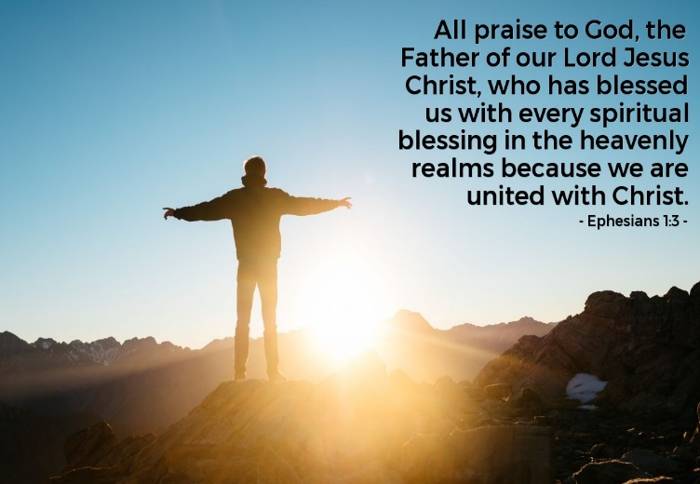
Lest we foolishly think that God’s blessings were only for the people of the Old Testament lets turn to 2 Corinthians 13:14. Like the Aaronic blessing this one has three sections as well, each pointing to a member of the Trinity. “The announcement of the host of angels at the birth of Christ brought a message of peace to those upon whom God’s favor rests” (Luke 2:14). When a sinner believes in the atoning sacrifice of Christ, he/she begins a relationship with Him that it meant to grow by being a “living sacrifice” (Romans 12:1). This person passes from death to life and finds unspeakable joy in the knowledge that they are no longer entangled in sin (Hebrews 12:1-3) and condemned to hell (Romans 8:1) but through His grace and mercy have received every spiritual blessing in Christ Jesus (Ephesians 1:3)! Even though God’s wrath and anger burns in discipline of those He loves (Hebrews 12:6) it is but for a moment for upon confession the sin is remembered no more. This does not mean we are to go on sinning so that His grace may abound for to obtain His blessings we must adhere to the truth in which the blessings reside by obeying His commands! Also, we do not need to fear that God would ever give a believer over to the fiery darts of the spiritual forces of evil of this world (Ephesians 6:12) because though we be unworthy (Ephesians 2:8-9) our position in God’s family forever remains justified by the blood of the Lamb who was slain from the foundation of this world (Revelation 13:8)! If we confess, He promises to cleanse our sins as white as snow and from the Prince of Peace (Isaiah 9:6), our Good Shepherd, Savior and King we can rejoice and feel unspeakable peace (John 14:27) knowing that our Portion (Psalms 16:5-11) is truly a Treasure and Pearl (Matthew 13:44-46) who will only do good to those who love Him (Romans 8:28)!

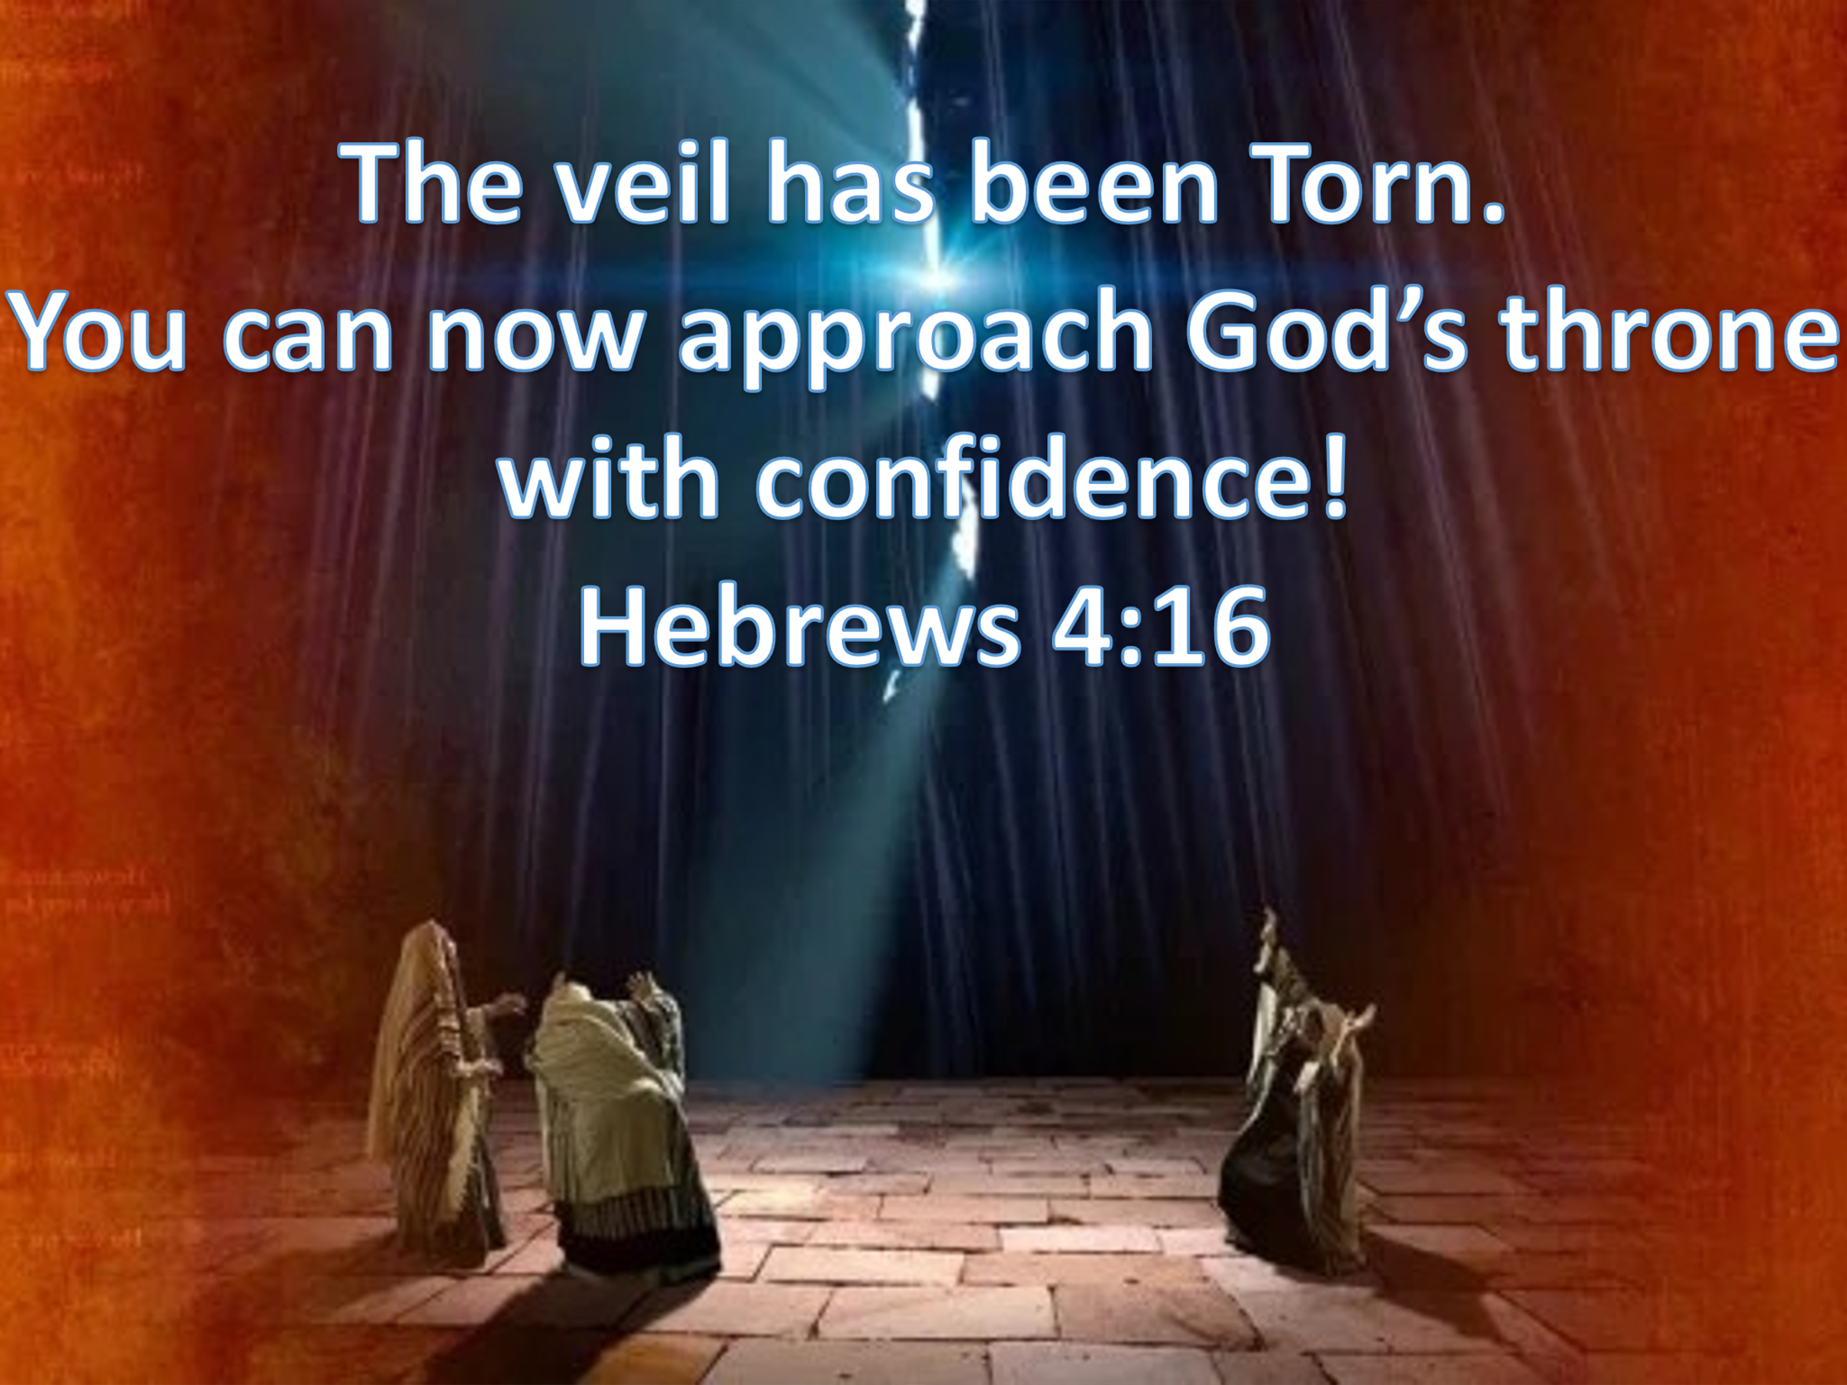
When the veil of the temple tore from top to bottom, Christ released so many blessings, the chief of which was access to God! No longer does God have an “earthly address in the sense that His visible Presence resides in an earthly meeting place.” Christ’s atonement has opened for us direct access to God’s throne of grace (Hebrews 14:6)! “God the Father has always loved His people, and Christ has removed the sin which restrained the shining of the most glorious manifestations of that love!” Don’t let this blessing escape your attention! Despite our filthy rags of righteousness (Isaiah 64:6) our Creator, who has no darkness in Him (1 John 1:5), grants us an audience with Him because Christ has freed us prisoners from the powers of darkness (Isaiah 61) by paying the sacrificial price needed (1 Corinthians 6:20) to clothe us with eternal life (John 3:16), an heir of the Father’s very own family (Galatians 4:7)! As a further consequence of God’s grace, in Christ’s name God sent an Advocate, the Holy Spirit who does not live in a temple built by hands but within our very own bodies (Acts 17)! What a divine blessing it truly is to have God’s Spirit to commune with our spirit and receive from Him a divine feast of truth, wisdom, and assurance that we are through the atoning sacrifice of His Son holy and pleasing in His sight! The Spirit also makes “intercessions for the saints according to the will of God, gives us peace and baptizes the church in fire!” While these unmerited blessings are beyond our imagination to understand, i.e. how deep and wide is the love of God (Ephesians 3:14-21), His own are still to rejoice for these blessings are offered by grace equally to all who believe in the Lord Jesus Christ!

Conclusion

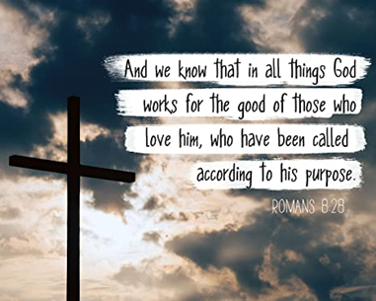
Both the Aaronic blessing and that of Apostle Paul are not just to be thoughtless clichés to be added to the end of a prayer but instead are the proclamation of grand assurances given to us by our Creator! God’s promises are real, beyond measure and a source of unspeakable joy for all those who believe in the atoning sacrifice of His Son Jesus. The blessings God has given us not only relate to our temporal existence such as prosperity, good health and long life but more importantly relate to our spiritual closeness to Him and our eternal destiny! We are to rejoice, for through grace and belief in Christ we not only have passed from death to life but have God’s very own Spirit living inside of us leading and guiding us to a divine feast of truth, wisdom, and assurance! To have the veil between us and God lifted so that we can have 24/7 access to He who sustains our very lives, our Lord, Savior and King; is truly an honor and blessing! No longer do we stand outside His holy sanctuary and dream of one day meeting Him but have the privilege of not only having His Spirit living inside us but also through prayer can at any time approach the Father’s throne of grace and talk to Him! Praise be to God! Is it not of infinite worth to have the Sustainer of all things seen and unseen, our Creator, to turn His face towards us and in doing so shine His light, glory, divine protection, and peace upon us? Yes, words cannot express the value of His blessings! So, let us pray for these blessings with the hope and assurance that what God promises will come to pass for He always does good to those who love Him!

R. Dennis Cole, Numbers, vol. 3B, The New American Commentary (Nashville: Broadman & Holman Publishers, 2000), 128.
R. Dennis Cole, Numbers, vol. 3B, The New American Commentary (Nashville: Broadman & Holman Publishers, 2000), 128.
Peter John Naylor, “Numbers,” in New Bible Commentary: 21st Century Edition, ed. D. A. Carson et al., 4th ed. (Leicester, England; Downers Grove, IL: Inter-Varsity Press, 1994), 176.
Ronald B. Allen, “Numbers,” in The Expositor’s Bible Commentary: Genesis, Exodus, Leviticus, Numbers, ed. Frank E. Gaebelein, vol. 2 (Grand Rapids, MI: Zondervan Publishing House, 1990), 754.
Roy Gane, Leviticus, Numbers, The NIV Application Commentary (Grand Rapids, MI: Zondervan, 2004), 540.
Roy Gane, Leviticus, Numbers, The NIV Application Commentary (Grand Rapids, MI: Zondervan, 2004), 541.
D. A. Carson, ed., NIV Biblical Theology Study Bible (Grand Rapids, MI: Zondervan, 2018), 235.
Gordon J. Wenham, Numbers: An Introduction and Commentary, vol. 4, Tyndale Old Testament Commentaries (Downers Grove, IL: InterVarsity Press, 1981), 101.
Roy Gane, Leviticus, Numbers, The NIV Application Commentary (Grand Rapids, MI: Zondervan, 2004), 539.
Peter John Naylor, “Numbers,” in New Bible Commentary: 21st Century Edition, ed. D. A. Carson et al., 4th ed. (Leicester, England; Downers Grove, IL: Inter-Varsity Press, 1994), 177.
C. H. Spurgeon, “Two Choice Benedictions,” in The Metropolitan Tabernacle Pulpit Sermons, vol. 59 (London: Passmore & Alabaster, 1913), 434.
C. H. Spurgeon, “Two Choice Benedictions,” in The Metropolitan Tabernacle Pulpit Sermons, vol. 59 (London: Passmore & Alabaster, 1913), 434.
R. Dennis Cole, Numbers, vol. 3B, The New American Commentary (Nashville: Broadman & Holman Publishers, 2000), 129.
Peter John Naylor, “Numbers,” in New Bible Commentary: 21st Century Edition, ed. D. A. Carson et al., 4th ed. (Leicester, England; Downers Grove, IL: Inter-Varsity Press, 1994), 176.
C. H. Spurgeon, “Two Choice Benedictions,” in The Metropolitan Tabernacle Pulpit Sermons, vol. 59 (London: Passmore & Alabaster, 1913), 434.
C. H. Spurgeon, “Two Choice Benedictions,” in The Metropolitan Tabernacle Pulpit Sermons, vol. 59 (London: Passmore & Alabaster, 1913), 434.
C. H. Spurgeon, “Two Choice Benedictions,” in The Metropolitan Tabernacle Pulpit Sermons, vol. 59 (London: Passmore & Alabaster, 1913), 434.
James Smith and Robert Lee, Handfuls on Purpose for Christian Workers and Bible Students, Series I–XIII, five-volume edition., vol. 3 (Grand Rapids, MI: William B. Eerdmans Publishing Company, 1971), 67.
C. H. Spurgeon, “Two Choice Benedictions,” in The Metropolitan Tabernacle Pulpit Sermons, vol. 59 (London: Passmore & Alabaster, 1913), 435.
C. H. Spurgeon, “Two Choice Benedictions,” in The Metropolitan Tabernacle Pulpit Sermons, vol. 59 (London: Passmore & Alabaster, 1913), 435.
C. H. Spurgeon, “Two Choice Benedictions,” in The Metropolitan Tabernacle Pulpit Sermons, vol. 59 (London: Passmore & Alabaster, 1913), 435.
C. H. Spurgeon, “Two Choice Benedictions,” in The Metropolitan Tabernacle Pulpit Sermons, vol. 59 (London: Passmore & Alabaster, 1913), 436.
C. H. Spurgeon, “Two Choice Benedictions,” in The Metropolitan Tabernacle Pulpit Sermons, vol. 59 (London: Passmore & Alabaster, 1913), 435–436.
C. H. Spurgeon, “Two Choice Benedictions,” in The Metropolitan Tabernacle Pulpit Sermons, vol. 59 (London: Passmore & Alabaster, 1913), 436.
C. H. Spurgeon, “Two Choice Benedictions,” in The Metropolitan Tabernacle Pulpit Sermons, vol. 59 (London: Passmore & Alabaster, 1913), 435.
Ronald B. Allen, “Numbers,” in The Expositor’s Bible Commentary: Genesis, Exodus, Leviticus, Numbers, ed. Frank E. Gaebelein, vol. 2 (Grand Rapids, MI: Zondervan Publishing House, 1990), 755.
Gordon J. Wenham, Numbers: An Introduction and Commentary, vol. 4, Tyndale Old Testament Commentaries (Downers Grove, IL: InterVarsity Press, 1981), 102.
R. Dennis Cole, Numbers, vol. 3B, The New American Commentary (Nashville: Broadman & Holman Publishers, 2000), 130.
Whitelaw Thomas, “Introductory Essay on the Authenticity and Authorship of the Book of Numbers,” in Numbers, ed. H. D. M. Spence, Exell Joseph S., The Pulpit Commentary (London; New York: Funk & Wagnalls Company, 1910), 52.
D. A. Carson, ed., NIV Biblical Theology Study Bible (Grand Rapids, MI: Zondervan, 2018), 235.
C. H. Spurgeon, “Two Choice Benedictions,” in The Metropolitan Tabernacle Pulpit Sermons, vol. 59 (London: Passmore & Alabaster, 1913), 437.
R. Dennis Cole, Numbers, vol. 3B, The New American Commentary (Nashville: Broadman & Holman Publishers, 2000), 130–131.
C. H. Spurgeon, “Two Choice Benedictions,” in The Metropolitan Tabernacle Pulpit Sermons, vol. 59 (London: Passmore & Alabaster, 1913), 437.
R. Dennis Cole, Numbers, vol. 3B, The New American Commentary (Nashville: Broadman & Holman Publishers, 2000), 130.
Whitelaw Thomas, “Introductory Essay on the Authenticity and Authorship of the Book of Numbers,” in Numbers, ed. H. D. M. Spence, Exell Joseph S., The Pulpit Commentary (London; New York: Funk & Wagnalls Company, 1910), 52.
Robert L. Hubbard Jr. and Robert K. Johnston, “Foreword,” in Leviticus, Numbers, ed. W. Ward Gasque, Robert L. Hubbard Jr., and Robert K. Johnston, Understanding the Bible Commentary Series (Grand Rapids, MI: Baker Books, 2012), 202.
Ronald B. Allen, “Numbers,” in The Expositor’s Bible Commentary: Genesis, Exodus, Leviticus, Numbers, ed. Frank E. Gaebelein, vol. 2 (Grand Rapids, MI: Zondervan Publishing House, 1990), 755.
R. Dennis Cole, Numbers, vol. 3B, The New American Commentary (Nashville: Broadman & Holman Publishers, 2000), 131.
R. Dennis Cole, Numbers, vol. 3B, The New American Commentary (Nashville: Broadman & Holman Publishers, 2000), 129.
R. Dennis Cole, Numbers, vol. 3B, The New American Commentary (Nashville: Broadman & Holman Publishers, 2000), 133.
C. H. Spurgeon, “Two Choice Benedictions,” in The Metropolitan Tabernacle Pulpit Sermons, vol. 59 (London: Passmore & Alabaster, 1913), 439–440.
James Smith and Robert Lee, Handfuls on Purpose for Christian Workers and Bible Students, Series I–XIII, five-volume edition., vol. 3 (Grand Rapids, MI: William B. Eerdmans Publishing Company, 1971), 67.
R. Dennis Cole, Numbers, vol. 3B, The New American Commentary (Nashville: Broadman & Holman Publishers, 2000), 132.
C. H. Spurgeon, “Two Choice Benedictions,” in The Metropolitan Tabernacle Pulpit Sermons, vol. 59 (London: Passmore & Alabaster, 1913), 438.
C. H. Spurgeon, “Two Choice Benedictions,” in The Metropolitan Tabernacle Pulpit Sermons, vol. 59 (London: Passmore & Alabaster, 1913), 439.
C. H. Spurgeon, “Two Choice Benedictions,” in The Metropolitan Tabernacle Pulpit Sermons, vol. 59 (London: Passmore & Alabaster, 1913), 439.
R. Dennis Cole, Numbers, vol. 3B, The New American Commentary (Nashville: Broadman & Holman Publishers, 2000), 131.
Roy Gane, Leviticus, Numbers, The NIV Application Commentary (Grand Rapids, MI: Zondervan, 2004), 543.
C. H. Spurgeon, “Two Choice Benedictions,” in The Metropolitan Tabernacle Pulpit Sermons, vol. 59 (London: Passmore & Alabaster, 1913), 439.
C. H. Spurgeon, “Two Choice Benedictions,” in The Metropolitan Tabernacle Pulpit Sermons, vol. 59 (London: Passmore & Alabaster, 1913), 440.
C. H. Spurgeon, “Two Choice Benedictions,” in The Metropolitan Tabernacle Pulpit Sermons, vol. 59 (London: Passmore & Alabaster, 1913), 439.
C. H. Spurgeon, “Two Choice Benedictions,” in The Metropolitan Tabernacle Pulpit Sermons, vol. 59 (London: Passmore & Alabaster, 1913), 439.
Peter John Naylor, “Numbers,” in New Bible Commentary: 21st Century Edition, ed. D. A. Carson et al., 4th ed. (Leicester, England; Downers Grove, IL: Inter-Varsity Press, 1994), 177.
R. Dennis Cole, Numbers, vol. 3B, The New American Commentary (Nashville: Broadman & Holman Publishers, 2000), 131.
Roy Gane, Leviticus, Numbers, The NIV Application Commentary (Grand Rapids, MI: Zondervan, 2004), 543.
C. H. Spurgeon, “Two Choice Benedictions,” in The Metropolitan Tabernacle Pulpit Sermons, vol. 59 (London: Passmore & Alabaster, 1913), 442.
C. H. Spurgeon, “Two Choice Benedictions,” in The Metropolitan Tabernacle Pulpit Sermons, vol. 59 (London: Passmore & Alabaster, 1913), 443.
C. H. Spurgeon, “Two Choice Benedictions,” in The Metropolitan Tabernacle Pulpit Sermons, vol. 59 (London: Passmore & Alabaster, 1913), 443.
C. H. Spurgeon, “Two Choice Benedictions,” in The Metropolitan Tabernacle Pulpit Sermons, vol. 59 (London: Passmore & Alabaster, 1913), 442.
C. H. Spurgeon, “Two Choice Benedictions,” in The Metropolitan Tabernacle Pulpit Sermons, vol. 59 (London: Passmore & Alabaster, 1913), 443.
James M. Scott, 2 Corinthians, Understanding the Bible Commentary Series (Grand Rapids, MI: Baker Books, 2011), 265.
Roy Gane, Leviticus, Numbers, The NIV Application Commentary (Grand Rapids, MI: Zondervan, 2004), 542.

