**A Mountaintop Experience**

**Matthew 17:1-13**

Online Sermon: <http://www.mckeesfamily.com/?page_id=3567>

**Introduction**

 Of all the experiences that a human being can have while on this earth is not a glimpse of our Savior the most treasured event one could ever receive? Living in this world that is not our home (Hebrews 13:14) we are constantly being bombarded by temptations to join the world on the broad path of pleasure (Matthew 7:13) and bow to the god of self. Even though we have the Spirit of truth living inside of us (John 16:13) there still wages a war between our old nature and our born-again self that like Apostle Paul we must admit we often lose by conforming to the sinful patterns of this world (Romans 7). If we as Christ’s ambassadors and royal priests are to offer our bodies as a living sacrifice that is holy and pleasing unto God (Romans 12:1-2), i.e. living our lives following in the footsteps of Jesus (1 Peter 2:21), then we simply must have our minds renewed by and in the presence of the Potter who molds the clay (Isaiah 64:8)! Is it not precisely in His presence that we become aware of and get the divine might to know and carry out His good, pleasing, and perfect will? Yes, but despite being told that in Scripture that we can boldly come before God’s throne of grace (Hebrews 4:16) for centuries most believers struggle and yes many fail to even get a glimpse of their Savior! The following sermon is going to review the glimpse of Christ’s glory that Peter, James, and John received in Matthew 17:1-13 and suggest that solitude, listening, reverence, acceptance, and desire to proclaim the truth concerning Christ is the key to seeing Christ!

**Being Alone with Jesus**

Verse one begins by stating that Jesus took Peter, James, and John up into the mountain by themselves. While tradition suggest it was Mount Taber,[1] due to it not being a high mountain (about 1900 feet), [2] not being located on the six-day journey Jesus and the apostles took from Caesarea Philippi to Capernaum[3] and being occupied by a Roman garrison which made it a poor place to be alone;[4] many scholars suggest that the mountain was either Mount Hermon or Mount Miron.[5] Many important encounters with God happened in the Bible both in solitude and upon a 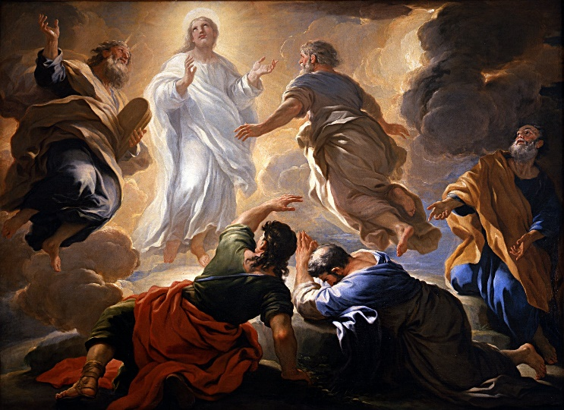mountain. For instance, Moses encountered God in the burning bush on Mount Sinai (Exodus 3:1-4:17) and later received the Law on this mountain (Exodus 19-24), God answered Elijah’s prayed on Mount Carmel by sending fire to consume his sacrifice (1 Kings 18:16-40) and would later be on a mountaintop when God whispered to him (1 Kings 19:11-12),[6] Jesus was taken to an extremely high mountain and tempted by Satan to bow to him (Matthew 4:1-11) and in this passage was transfigured before His inner three leaders.[7] It is not so much going to a mountain that ensures an encounter with God but “clearing our calendars” and finding a place where one can seclude from the world and all its distractions and temptations that is key to hearing from God. While we can hear from God anywhere and at anytime, inviting God to make us “lie down in the green pastures and by the still waters” (Psalms 23) increases our likelihood of drawing nearer to Him through meditation, prayer, and total submission to hear and obey His will!

**A Glimpse of His Glory**

Ever wonder what the first few moments in heaven will be like?[8] While Peter, James and John were not transported up into heaven they did receive a glimpse of Christ’s glory when while He was praying Jesus was “transfigured” before their very eyes. While we don’t fully know what happened from this obscure word “***metamorphoō***” that is used in this passage,[9] it seems that Christ was not “transformed” into another image[10] but lifted the corner of His veil[11] and gave the inner three disciples a glimpse of His “preincarnate glory (John 1:14, 17:5; Philippians 2:6-7) and His coming exaltation (2 Peter 1:16-18; A picture containing text
Revelation 1:16).[12] By showing them His face shining like the sun and His clothes becoming white as the light (verse 2) one day the apostles would look back at this glorious event and marvel at Christ’s “self-humiliation that brought Him to the cross and the height to which He had been raised by His vindicating resurrection and ascension.”[13] While the heights, depths, lengths, breath of Christ of His fullness is beyond our human capacity to comprehend,[14] in faith[15] the glimpse we can see of Christ is breathtaking, thought provoking and life changing! How sad it is that even though God’s very own Spirit seals every spiritual blessing imaginable in His own, very few saints[16] can genuinely say they have even seen a glimpse of He who bought them this privilege[17] with the cost of His very life! Even if one had to be persecuted for righteousness’ sake and walk-through great fires of tribulations (only a willingness to do so is often required to see the Lord) would not one gladly do so to please one’s Creator? So, to get on the mountaintop and see our Lord all we need is faith and a desire to deny ourselves, take up our cross and follow Jesus and the patience to wait upon the Lord to reveal us a mere glimpse!

**Listening to Jesus**

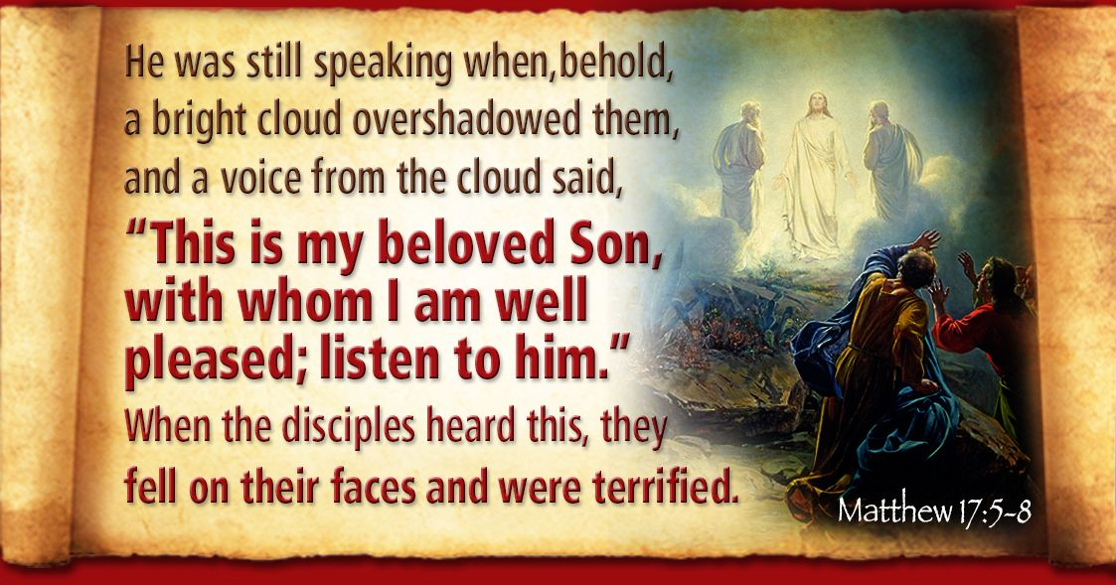 Upon Jesus’ transfiguration we are told that both Moses and Elijah appeared and began talking to Him (verse 3). While we are not told how the apostles recognized these great men of the Bible,[18] their presence was significant for “Moses the eschatological prophet (Deuteronomy 18:18) and Elijah the forerunner (Mal 4:5–6; Matt 3:1–3; 11:7–10; 17:9–13)”[19] signified that Christ was the culmination and the fulfillment of the entire Old Testament teachings![20] Possibly due to a desire to not be exposed to the consuming glory of the Son[21] but more likely out of fear[22] or impetuous speech,[23] Peter suggests three shelters should be built for Jesus, Moses and Elijah (verse 4). While Peter is still talking the “cloud of the Shekinah of the visible glory of God”[24] appears and the voice of the Father is heard saying that the apostles should listen to His Son in whom He is greatly pleased for He was willing to go down the mountain[25] and fulfill the prophecy that He indeed was the Suffering Servant (Psalms 2:7; Isaiah 42:1)[26] who would atone for the sins of all! If we want to have this kind of mountaintop experience in which we learn more about Jesus, then we must be willing to listen and obey our Master. I do not think drawing nearer to God can happen without first wanting to trade the burdens of our hopes, dreams, and self-preoccupation for His yoke that while easy and light (Matthew 11:29) still requires us to listen and obey the Shepherd’s voice when He calls upon our name. After all, why would the Son of God give a glimpse of His glory to those who think they have already found holy living and righteousness in the reflection of their own mirrors?

**Reverence for Christ**

When the disciples heard and felt the presence of God they fell facedown unto the ground and were apparently so terrified that they remained prostate until Christ invited them to get back up (verse 6)! For He “who commanded the light to shine out in the darkness”[27] to shine even a glimpse of His glory upon our hearts we must first allow the Spirit to cultivate furrows of righteousness into hearts so that our self glorification might be replaced with deep, humble, bow of reverence and awe before our Rock, fortress, Saviour and King! Think about it: we are not taking time to prepare to meet an important person but in solitude, meditation, and prayer to meet the Son of God who knit us in our mother’s womb, atoned for our sin, and gave us the Spirit of Truth to lead unto righteousness for His name’s sake! Merely finding the time and place to be alone with Jesus does not ensure even a momentary glimpse of Him for until the heart cries out “Abba Father help me with my unbelief for I truly am a person of unclean lips,” the pride of self attained worldly knowledge, which is foolishness in His sight, will continue to blind our sight and deafen our spiritual ears! We can only boldly enter the presence of God when the lens of our spiritual hearts is focused on confession and complete submission to whatever He asks while we are in His presence, after all are we not to be both hearers and doers of His word? And even the cost of receiving a mere glimpse of God was to physically die, thank goodness it is not, who, if possible, would not gladly die a thousand deaths but to see more of their Lord?

**Accepting the Truth and Living the Word**

It is at this point that the disciples reveled their confusion by asking Jesus, how could Elijah’s appearance during the Transfiguration be the fulfillment of the Messianic prophecy of Malachi 4:5-6 when 1) Christ appeared before and not after him and 2) the predicted restoration[28] of all things had not yet occurred?[29] Jesus stated the scribes were wrong, the predicted forerunner John the Baptist[30] had already come in the Spirit and power of Elijah (Luke 1:17)[31] and as to the restoration of all 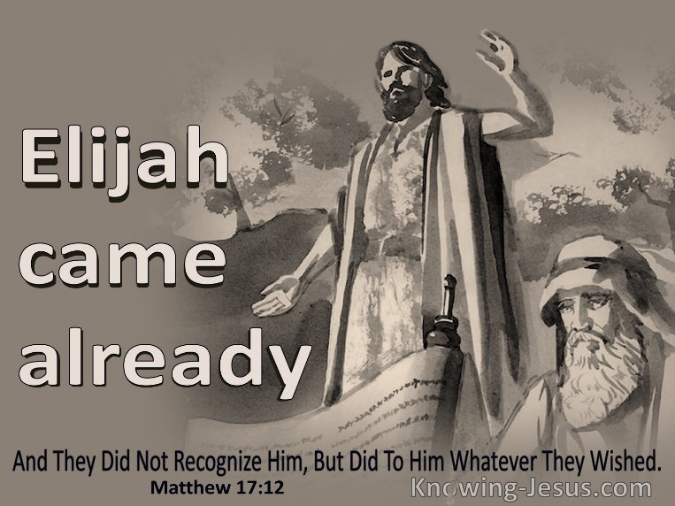things they should have read the end of the prophecy that said if the people did not repent after hearing the forerunner’s message then “God would return and strike their lands.”[32] The way that we listen to Jesus today is through meditating upon His holy word and through prayer.[33] Since we have a sinful nature and live in a fallen world that values experience above divine truth, if we want to see a glimpse of Christ then like the disciples we must also be willing to be corrected on what we think we know about God and His kingdom![34] We must be willing to “evaluate our experiences by the Bible’s teaching, rather than the other way around”[35] and we must be humble enough to admit that without the Spirit’s aid our interpretation of His word is seriously flawed because it is merely based on human wisdom and therefore foolishness in God’s sight (1 Corinthians 3:19)! We must also be ready to change for if we are granted even a glimpse of the divine results of His searching of our hearts much will be revealed that through the power of the Holy Spirit must be confessed and much more revealed that we are expected to embrace!

**Proclaiming the Word to Others**

 To avoid the “possibility of an uninformed Messianic upraising,”[36] on the way down the mountain Jesus told the disciples to remain silent about what they saw until after He was crucified and raised from the dead. Since the vindication and exultation of Christ has already occurred, we are now expected to always be ready (1 Peter 3:15) to let our light shine to the world (Matthew 5:14-16). Going up the mountain to get of glimpse of Christ is not just for the benefit for us but also that of the world. In ancient times they used mirrors to reflect the sunlight in mine shafts so that they could see natural light underground.[37] We often struggle to let God’s light within us shine to the people of this world on the dark path of destruction because our souls are so dirty.[38] We simply have not allowed His light to rightly influenced our words, thoughts, and deeds! Effective evangelism begins with getting glimpses of Christ so that our minds might be renewed daily (Romans 12:1-2) to learn and submit to His holy and pleasing will! Like the apostles, to receive a glimpse we too in solitude must listen, revere, and accept whatever the great Potter says needs to be changed in our lives. While we are unlikely to go upon a mountain and literally see Christ in His glory, through meditation, prayer, and an unwavering desire to serve and draw nearer to Him, we are often granted a gentle whisper of divine truth that will forever change our lives and those whom the light we have received falls upon!

1. James Montgomery Boice, [*The Gospel of Matthew*](https://ref.ly/logosres/boicecm61amt?ref=Bible.Mt17.1-13&off=3031&ctx=On+the+Mountain%0a~There+is+much+about+this) (Grand Rapids, MI: Baker Books, 2001), 320.
2. D. A. Carson, [“Matthew,”](https://ref.ly/logosres/ebc08?ref=Bible.Mt17.1&off=1414&ctx=e+be+read+together.%0a~Mount+Tabor%2c+the+tra) in *The Expositor’s Bible Commentary: Matthew, Mark, Luke*, ed. Frank E. Gaebelein, vol. 8 (Grand Rapids, MI: Zondervan Publishing House, 1984), 384.
3. D. A. Carson, [“Matthew,”](https://ref.ly/logosres/ebc08?ref=Bible.Mt17.1&off=1768&ctx=%3b+IV%2c+54%E2%80%9355+%5bi.8%5d).+~Mount+Hermon%2c+rising) in *The Expositor’s Bible Commentary: Matthew, Mark, Luke*, ed. Frank E. Gaebelein, vol. 8 (Grand Rapids, MI: Zondervan Publishing House, 1984), 384.
4. Michael J. Wilkins, [*Matthew*](https://ref.ly/logosres/nivac61mt?ref=Bible.Mt17.1&off=916&ctx=ow+know+that+it+was+~occupied+by+a+Roman+), The NIV Application Commentary (Grand Rapids, MI: Zondervan Publishing House, 2004), 590.
5. D. A. Carson, [“Matthew,”](https://ref.ly/logosres/ebc08?ref=Bible.Mt17.1&off=2208&ctx=+Gentile+territory.+~Liefeld+(p.+167%2c+n.+) in *The Expositor’s Bible Commentary: Matthew, Mark, Luke*, ed. Frank E. Gaebelein, vol. 8 (Grand Rapids, MI: Zondervan Publishing House, 1984), 384.
6. James Montgomery Boice, [*The Gospel of Matthew*](https://ref.ly/logosres/boicecm61amt?ref=Bible.Mt17.1-13&off=874&ctx=o+one+except+Jesus.%0a~Many+important+thing) (Grand Rapids, MI: Baker Books, 2001), 319–320.
7. Robert H. Mounce, [*Matthew*](https://ref.ly/logosres/nibcnt61mt?ref=Bible.Mt17.1-3&off=1657&ctx=o+pray+(Luke+9%3a28).+~Peter%2c+James+and+Joh), Understanding the Bible Commentary Series (Grand Rapids, MI: Baker Books, 2011), 167.
8. C. H. Spurgeon, [“Christ’s Transfigured Face,”](https://ref.ly/logosres/mtpserms47?ref=Page.p+261&off=652&ctx=ty%2c+or+persecution.+~I+have+often+tried+t) in *The Metropolitan Tabernacle Pulpit Sermons*, vol. 47 (London: Passmore & Alabaster, 1901), 261.
9. Leon Morris, [*The Gospel according to Matthew*](https://ref.ly/logosres/pntcmatt?ref=Bible.Mt17.2&off=177&ctx=+%E2%80%9Cwas+transformed.%E2%80%9D+~I+have+retained+the+), The Pillar New Testament Commentary (Grand Rapids, MI; Leicester, England: W.B. Eerdmans; Inter-Varsity Press, 1992), 438.
10. C. H. Spurgeon, [“Christ’s Transfigured Face,”](https://ref.ly/logosres/mtpserms47?ref=Page.p+257&off=1913&ctx=ine+as+the+sun.%E2%80%9D%0aI.+~First%2c+from+this+tru) in *The Metropolitan Tabernacle Pulpit Sermons*, vol. 47 (London: Passmore & Alabaster, 1901), 257.
11. C. H. Spurgeon, [“Christ’s Transfigured Face,”](https://ref.ly/logosres/mtpserms47?ref=Page.p+253&off=2071&ctx=ake+like+this+man.%E2%80%9D%0a~A+sort+of+radiance+w) in *The Metropolitan Tabernacle Pulpit Sermons*, vol. 47 (London: Passmore & Alabaster, 1901), 253–254.
12. D. A. Carson, [“Matthew,”](https://ref.ly/logosres/ebc08?ref=Bible.Mt17.2&off=530&ctx=+it+was+revelatory.+~As+they+would+come+t) in *The Expositor’s Bible Commentary: Matthew, Mark, Luke*, ed. Frank E. Gaebelein, vol. 8 (Grand Rapids, MI: Zondervan Publishing House, 1984), 385.
13. D. A. Carson, [“Matthew,”](https://ref.ly/logosres/ebc08?ref=Bible.Mt17.2&off=971&ctx=is+kingdom+(16%3a28).+~The+contrast+between) in *The Expositor’s Bible Commentary: Matthew, Mark, Luke*, ed. Frank E. Gaebelein, vol. 8 (Grand Rapids, MI: Zondervan Publishing House, 1984), 385.
14. C. H. Spurgeon, [“Christ’s Transfigured Face,”](https://ref.ly/logosres/mtpserms47?ref=Page.p+259&off=449&ctx=at+I+may+know+him%2c%E2%80%9D+~for+he+felt+that+he+) in *The Metropolitan Tabernacle Pulpit Sermons*, vol. 47 (London: Passmore & Alabaster, 1901), 259.
15. C. H. Spurgeon, [“Christ’s Transfigured Face,”](https://ref.ly/logosres/mtpserms47?ref=Page.p+261&off=2885&ctx=ld+to+look%3b+and+so%2c+~to+look+to+Jesus%2c+wh) in *The Metropolitan Tabernacle Pulpit Sermons*, vol. 47 (London: Passmore & Alabaster, 1901), 261–262.
16. C. H. Spurgeon, [“Christ’s Transfigured Face,”](https://ref.ly/logosres/mtpserms47?ref=Page.p+255&off=609&ctx=+three+of+them%3b+and+~I+venture+to+say+tha) in *The Metropolitan Tabernacle Pulpit Sermons*, vol. 47 (London: Passmore & Alabaster, 1901), 255.
17. C. H. Spurgeon, [“Christ’s Transfigured Face,”](https://ref.ly/logosres/mtpserms47?ref=Page.p+255&off=965&ctx=t%2c+even+amongst+us%2c+~there+are+some+who+h) in *The Metropolitan Tabernacle Pulpit Sermons*, vol. 47 (London: Passmore & Alabaster, 1901), 255.
18. Leon Morris, [*The Gospel according to Matthew*](https://ref.ly/logosres/pntcmatt?ref=Bible.Mt17.3&off=146&ctx=ses+and+Elijah.%EF%BB%BF12%EF%BB%BF+~Matthew+does+not+say), The Pillar New Testament Commentary (Grand Rapids, MI; Leicester, England: W.B. Eerdmans; Inter-Varsity Press, 1992), 439.
19. D. A. Carson, [“Matthew,”](https://ref.ly/logosres/ebc08?ref=Bible.Mt17.3&off=418&ctx=chatological+roles%3a+~Moses+was+the+model+) in *The Expositor’s Bible Commentary: Matthew, Mark, Luke*, ed. Frank E. Gaebelein, vol. 8 (Grand Rapids, MI: Zondervan Publishing House, 1984), 385.
20. Robert H. Mounce, [*Matthew*](https://ref.ly/logosres/nibcnt61mt?ref=Bible.Mt17.1-3&off=2874&ctx=ersuasive+(p.+343).+~Their+presence+on+th), Understanding the Bible Commentary Series (Grand Rapids, MI: Baker Books, 2011), 168.
21. Iain D. Campbell, [*Opening up Matthew*](https://ref.ly/logosres/openup61mt?ref=Bible.Mt17.3-4&off=4602&ctx=t+good+to+be+here%3f%E2%80%99+~For+Peter%2c+with+his+), Opening Up Commentary (Leominster: Day One Publications, 2008), 107–108.
22. Iain D. Campbell, [*Opening up Matthew*](https://ref.ly/logosres/openup61mt?ref=Bible.Mt17.3-4&off=4318&ctx=ar+on+the+mountain.+~It+is+difficult%2c+how), Opening Up Commentary (Leominster: Day One Publications, 2008), 107.
23. R. T. France, [*Matthew: An Introduction and Commentary*](https://ref.ly/logosres/tntc61mtus?ref=Bible.Mt17.4&off=3&ctx=mate+fulfilment.%0a4.+~Peter%E2%80%99s+proposal+to+), vol. 1, Tyndale New Testament Commentaries (Downers Grove, IL: InterVarsity Press, 1985), 267.
24. R. T. France, [*Matthew: An Introduction and Commentary*](https://ref.ly/logosres/tntc61mtus?ref=Bible.Mt17.5&off=3&ctx=g+that+festival.%0a5.+~A+cloud+is+often+in+), vol. 1, Tyndale New Testament Commentaries (Downers Grove, IL: InterVarsity Press, 1985), 267.
25. R. T. France, [*Matthew: An Introduction and Commentary*](https://ref.ly/logosres/tntc61mtus?ref=Bible.Mt17.4&off=300&ctx=+in+Exod.+33%3a7%E2%80%9311)%3b+~if+so+he+has+again+m), vol. 1, Tyndale New Testament Commentaries (Downers Grove, IL: InterVarsity Press, 1985), 267.
26. D. A. Carson, [“Matthew,”](https://ref.ly/logosres/ebc08?ref=Bible.Mt17.5&off=908&ctx=%E2%80%9D+(cf.+Exod+40%3a35).+~What+the+Voice+from+) in *The Expositor’s Bible Commentary: Matthew, Mark, Luke*, ed. Frank E. Gaebelein, vol. 8 (Grand Rapids, MI: Zondervan Publishing House, 1984), 386.
27. C. H. Spurgeon, [“Christ’s Transfigured Face,”](https://ref.ly/logosres/mtpserms47?ref=Page.p+260&off=233&ctx=ery+blessed+thing.+%E2%80%9C~For+God%2c+who+command) in *The Metropolitan Tabernacle Pulpit Sermons*, vol. 47 (London: Passmore & Alabaster, 1901), 260.
28. James Montgomery Boice, [*The Gospel of Matthew*](https://ref.ly/logosres/boicecm61amt?ref=Bible.Mt17.1-13&off=13116&ctx=erunner%E2%80%99s+ministry.+~Malachi+4%3a6+taught+t) (Grand Rapids, MI: Baker Books, 2001), 323.
29. D. A. Carson, [“Matthew,”](https://ref.ly/logosres/ebc08?ref=Bible.Mt17.10&off=1393&ctx=e+established.%0a2.+A+~few+scholars+have+su) in *The Expositor’s Bible Commentary: Matthew, Mark, Luke*, ed. Frank E. Gaebelein, vol. 8 (Grand Rapids, MI: Zondervan Publishing House, 1984), 388.
30. R. T. France, [*Matthew: An Introduction and Commentary*](https://ref.ly/logosres/tntc61mtus?ref=Bible.Mt17.11-13&off=506&ctx=+now+credited+with.+~Hence+the+failure+to), vol. 1, Tyndale New Testament Commentaries (Downers Grove, IL: InterVarsity Press, 1985), 268.
31. Michael J. Wilkins, [*Matthew*](https://ref.ly/logosres/nivac61mt?ref=Bible.Mt17.10-12&off=2227&ctx=tious+pagan+belief.%0a~The+correct+understa), The NIV Application Commentary (Grand Rapids, MI: Zondervan Publishing House, 2004), 594.
32. James Montgomery Boice, [*The Gospel of Matthew*](https://ref.ly/logosres/boicecm61amt?ref=Bible.Mt17.1-13&off=14101&ctx=hands%E2%80%9D+(vv.+11%E2%80%9312).%0a~This+means+that+the+) (Grand Rapids, MI: Baker Books, 2001), 324.
33. James Montgomery Boice, [*The Gospel of Matthew*](https://ref.ly/logosres/boicecm61amt?ref=Bible.Mt17.1-13&off=15983&ctx=or+them%2c+of+course.+~But+how+are+we+to+do) (Grand Rapids, MI: Baker Books, 2001), 324.
34. James Montgomery Boice, [*The Gospel of Matthew*](https://ref.ly/logosres/boicecm61amt?ref=Bible.Mt17.1-13&off=17881&ctx=rong+or+misleading.%0a~We+hear+people+justi) (Grand Rapids, MI: Baker Books, 2001), 325.
35. James Montgomery Boice, [*The Gospel of Matthew*](https://ref.ly/logosres/boicecm61amt?ref=Bible.Mt17.1-13&off=18440&ctx=ind+us+that+we+must+~evaluate+our+experie) (Grand Rapids, MI: Baker Books, 2001), 325.
36. Robert H. Mounce, [*Matthew*](https://ref.ly/logosres/nibcnt61mt?ref=Bible.Mt17.9-13&off=148&ctx=isen+from+the+dead.+~To+preclude+the+poss), Understanding the Bible Commentary Series (Grand Rapids, MI: Baker Books, 2011), 169.
37. C. H. Spurgeon, [“Christ’s Transfigured Face,”](https://ref.ly/logosres/mtpserms47?ref=Page.p+260&off=812&ctx=s+reflected+in+you.+~Some+Christians+are+) in *The Metropolitan Tabernacle Pulpit Sermons*, vol. 47 (London: Passmore & Alabaster, 1901), 260.
38. C. H. Spurgeon, [“Christ’s Transfigured Face,”](https://ref.ly/logosres/mtpserms47?ref=Page.p+260&off=1216&ctx=he+light+upon+them.+~Reflectors+are+not+o) in *The Metropolitan Tabernacle Pulpit Sermons*, vol. 47 (London: Passmore & Alabaster, 1901), 260.