Dangerous Prayers – Send Me O Lord!

Isaiah 6:8

Online Sermon: http://www.mckeesfamily.com/?page_id=3567


So far, we have explored two of Groeschel’s dangerous prayers. The first dangerous prayer was taken from Psalms 139 in which David threw off the bubble of spiritual safety and boldly approached God’s throne of grace to ask Him to search and reveal any anxious thoughts or offensive ways in his life so that he might confess them and forever be lead on the righteous path. The second dangerous prayer was taken from 1 Corinthians 11:24 in which Groeschel states like Christ whose body was broken and poured out for us, we too should live daily for Him, broken and poured out! Instead of praying for a comfortable spiritual bubble of self-preoccupation and gratification, quoting James 1:2-4 Groeschel states we are to not avoid hardship and struggles that might “break us” because in preserving such afflictions one’s maturity and faith increase. It often in our brokenness and utter weakness that God chooses to work in our lives, and we can do great things in His name and for the praise of His glory! In the following sermon we are going to look at the last of Groeschel’s dangerous prayers, “Search Me” that is based on Isaiah’s commission.

Isaiah’s Call


In the year that King Uzziah died, Isaiah went into the temple and saw a glorious vision of the Lord, high and exalted, seated on a throne with His train filling the temple. Above the Lord was seraphim, each with six wings, two covering their faces and two covering their feet. As the seraphim called out “holy, holy is the Lord almighty, the whole earth is full of His glory,” their voices shook the doorposts and thresholds of the temple as it became filled with smoke. In seeing the immense gap between his filthy rags and God’s holiness Isaiah thought that he would be put to death for who of such unclean lips could ever “see the King, the Lord Almighty” (verse 5). It was not until one of the seraphim touched his lips with a coal from the altar and said, “your guilt is taken away and your sin atoned for” (verse 6) that Isiah felt reassured that he might survive this glorious encounter with God. It is at this point that the Lord asked, “whom shall I send and who will go for us” (verse 8) to which Isaiah, boldly said “Here am I, send me.” Isaiah’s commission was to go to the people of Israel and tell them that they have reached a point that God’s judgment upon them was inevitable but in His mercy He will leave a stump or remnant that will one day become a great tree, a restored nation.

Get Rid of the Excuses


Notice how Isaiah did not flinch for even without knowing where he was to go or what was being asked of him, he told God YES, send me? If God were to ask you to surrender your comfortable spiritual bubble that you have been so earnestly praying for Him to maintain to go somewhere and to do something really BIG for Him, would you say YES? Truthfully most Christians when faced with a mission from God tend to be quick to recite Moses’ excuses such as “I am not adequate” (Exodus 3:11), “I don’t know what to say” (3:14), “what if the people don’t believe what I say” (4:1), “I am not good with words” (4:10) and the real truth of what is in their hearts “I simply am not willing, send someone else” (4:13). Our excuses of course have no validity for God usually calls the “imperfect, flawed, weak men and women” to do great things in His kingdom. After all was not Moses a murderer, David an adulterer, Gideon one who lacked faith, Jeremiah too young, Abraham too old, Elijah one who frequently battled depression and Paul a persecutor of Christians and yet they were called and did great things in God’s kingdom? If we want to grow spiritually and please God the Father in heaven then we simply must put aside our insecurities and life of comfort and be like Isaiah and pray his dangerous prayer, “here I am send me.”

Glory to God

Let us be truly honest, Groeschel states, to be like Isaiah and be willing to serve in any way or manner God requests can be quite frightening! To pray the dangerous prayer, “Send me,” requires a deep trust and reverence for God that Groeschel suggests is only attained through a genuine, deep, and ever-growing relationship with our Creator. While we are not likely to see a glorious vision of the Lord with fiery seraphim flying about, we certainly can draw nearer to God through prayer, meditation, and submission to His will so that He in turn will draw nearer to us (James 4:8)! Groeschel invites us to:

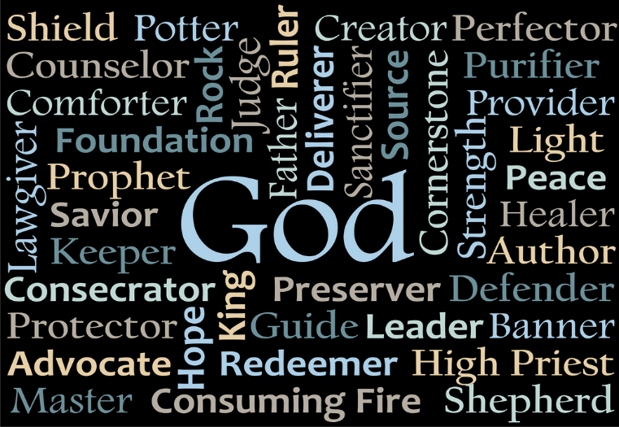
“consider that God is the Creator of heaven and earth (Genesis 14:19), the God of glory (Psalms 29:3), the great I am (Exodus 3:14), the righteous Father (John 17:25), our fortress and salvation (Psalms 28:8), eternal king (Jeremiah 10:10), the God of all comfort (2 Corinthians 1:3), the God of all grace (1 Peter 5:10), the God of peace (1 Thessalonians 5:23), the Almighty (Genesis 49:25), the God who is both compassionate, gracious (Exodus 34:6), and a consuming fire (Deuteronomy 4:24).”

So, surely when Someone who is your Rock (Psalms 42:9), Saviour (Psalms 18:46), stronghold (Psalms 144:2), Advocate (Job 16:19), your strength, helper when you are weak (2 Corinthians 12:10; Psalms 118:7), your hope (Psalms 25:5, 21), and strong deliverer (Psalms 140:7) asks you to serve in His kingdom, out of reverence and awe of His grace and goodness you will be willing to say “Yes Lord send me!”

Dealing with our Sin

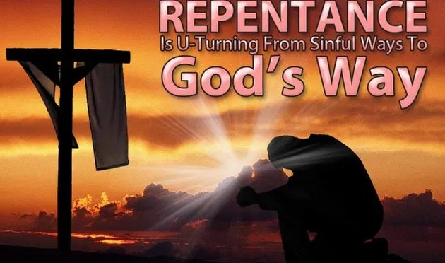
What often keeps Christians from developing a deep, trusting, and personal relationship needed to unconditionally serve God Groeschel suggests is our cherished, unconfessed sins. It is extremely difficult to live in a fallen world that is not our home and not ride upon the hills of the sifting sands of our culture that says all things are permissible and honorable if you are not infringing on the rights of another! This kind of thinking is contrary to Scripture that clearly says all human have inherited a sinful nature and a deceitful heart from Adam (Jeremiah 17:9; Romans 5:12). As we get closer to God the more His holiness reveals the sin in our lives. “Moses hid his face because he was afraid to look upon God (Exodus 3:6), Job abhorred himself when he saw the power of God (Job 42:6), Peter fell facedown at the Lord’s feet and told Jesus to depart from him because of his sinfulness,” and Isaiah said, “woe to me I am ruined for I am a man of unclean lips.” Until we see the depravity of our sin, we cannot see the unmerited, glorious grace of our Savior because for this to happen we need to stop comparing ourselves to others to justify our sin and become like David and invite God to search, reveal and empower us to confess our sins before Him. While the coal took away Isaiah’s guilt and sin, praise be that the blood of Christ takes away our confessed sin and allows us to draw nearer to His presence!

Your will be Done


Once search me and confession becomes a daily practice one must acquire the faith and desire to unconditionally do the will of God. Since it is impossible to please God without faith in Him (Hebrews 11:6), instead of passively looking for ways to maintain a spiritual bubble of comfort we are stand firm on the rock of our Salvation and aggressively look for and accept ways to serve God with the unwavering belief that all things are possible for those who God continually strengthens (Philippians 4:13). While at first a leap of faith might seem daunting or even overwhelming, pray that God might help you with your unbelief and in strict obedience do not be surprised Groeschel states when God “transforms you from someone with a self-centered faith to someone with a self-sacrificing, God-glorifying, other-centered faith! To this end Groeschel suggests praying that God would take every part of your body and in whatever way and in His time use you to accomplish His will in His kingdom! Never think that time spent in His kingdom is wasted and never forget that God alone is responsible for your ministry outcomes. Your role in God’s kingdom is to serve in faith with all your heart, mind, soul, and strength whatever divine task He asks you to do!

Asking the Question


To finish this sermon let me share with you a story. Each week after Sunday service Groeschel went to the exit of the church, shook hands and gave farewell greetings to each member as they left the church. One day a guy named Matt, whom Groeschel was just starting to get to know, upon shaking his hand said, “Pastor, I want you to know that my answer is YES. Now what is the question?” Not knowing if he heard the man correctly and not wanting to make things awkward Groeschel merely responded to the man “thank you, and God bless you.” The next week after church the man asked the same question and in a desire to keep the line moving Groeschel did not ask the man what he meant. The third week when the man asked the question Groeschel suggested that they meet during the week and have a longer conversation over the matter. They met for coffee and after some customary chit chat Groeschel asked the man to explain what he meant by the question that he had been asking for the last three Sundays in a row. With tears of regret and pain running down his face Matt explained how Christ had saved and forgiven him of his alcohol, porn, gambling addictions and all the bad decisions that often go with such sinful vices. Because he knew how much he had been forgiven Matt explained, he told His Savior that no matter what the question of service might be, no matter when or what the cost his answer to His Redeemer would always be YES. So, Matt looked square into Groeschel’ s eyes and once again asked, “Pastor, I want you to know that my answer is YES. Now what’s the question?” Are you ready and willing to yell from the mountain tops “here I am, send me,” what do you want me to do in Your kingdom God?

Conclusion

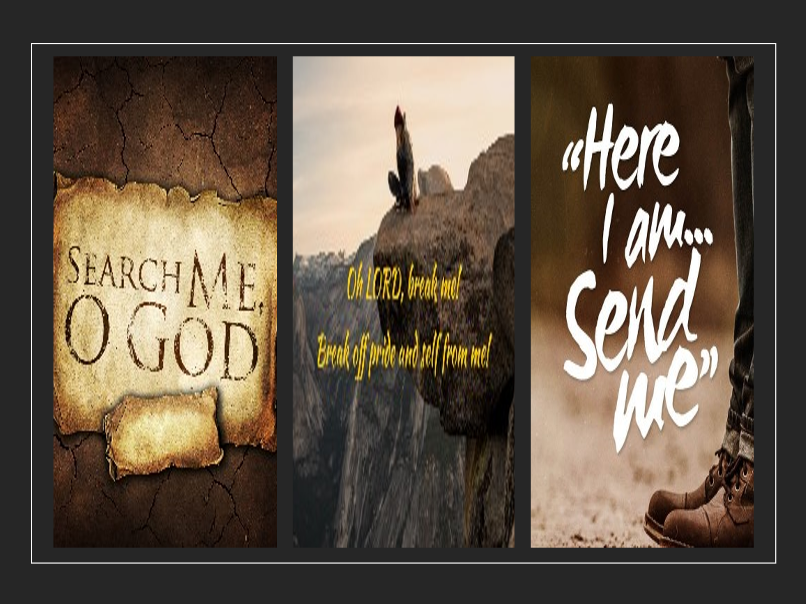
Are you ready to take your prayer life beyond merely asking God to maintain your bubble of spiritual security and in complete submission seek first the kingdom of God and His will in your life? Are you willing to be like King David and boldly approach God’s throne of grace knowing full well that He who knit you in your mother’s womb will expose every word, thought or deed that is unholy and expect you to repent? Are you willing to ask God to break you with hardships, trials, tribulations, and persecutions so that in your weakness you might experience His strength and in faith persevere and become more spiritually mature? Are you willing to be like Isaiah and even without knowing what or where God will send you cry out, “here I am send me!” While there is nothing wrong with asking God to protect and take care of our physical well-being or that of others, don’t you want to draw nearer to God so that His all-consuming fire might break and prepare you to do His will so that you will become more like Him?” Yes, Groeschel is right … to spiritually grow and become more like Jesus our prayers should include the words “Search me,” “Break me,” and “Send me” onto the righteous path of your will every day of my life and into eternity!

John Goldingay, Isaiah, ed. W. Ward Gasque, Robert L. Hubbard Jr., and Robert K. Johnston, Understanding the Bible Commentary Series (Grand Rapids, MI: Baker Books, 2012), 61.
John N. Oswalt, Isaiah, The NIV Application Commentary (Grand Rapids, MI: Zondervan Publishing House, 2003), 128.
Kindle Location 1034.
Kindle Location 1102.
Kindle Location 1135.
Kindle Location 1179.
Kindle Location 1195.
Kindle Location 1236.
Kindle Location 1356.
Kindle Location 1938.

