**Dangerous Prayers – Search me O Lord!**

**Psalms 139:23-24**

Online Sermon: <http://www.mckeesfamily.com/?page_id=3567>

Do you feel that your prayers to the Creator and sustainer of this Universe are a sweet aroma, holy and pleasing unto His ears? How often do we pray with the same requests, repeating long, loud, fancy words and even quoting Scripture but run the risk that such prayers will become flat, dull, predictable, stale, boring and Pharisaically vain? And how many times during such prayers does our minds “wander off” only to be found focussing on the things of this world rather than God? Even though the Holy Spirit intercedes for us in “wordless groans” (Romans 8:26) surely His ambassadors and royal priests (2 Corinthians 5:20; 1 Peter 2:9) are still expected to boldly approach God’s throne of grace not with mere platitudes of self-indulgence but with honesty, desperation, fierceness, unrelenting faith, and unbridled Spirit led power to humbly and yet boldly make their requests known to a loving and compassionate God? In Craig Groeschel’s book ***Dangerous Prayers*** he suggests that the prayers of many Christians are often to sustain a safer, stress-free lifestyle and as such they have become lukewarm and distant from their Creator. Groeschel also suggests it is not “a bubble of spiritual safety”[1] we should ask from our Creator but the opportunity to follow His Son and serve in His kingdom no matter what the costs might be! The following sermon series is going to look at three dangerous prayers, Search Me, Break Me, Send Me; that when daringly given from the heart will not only be God-honoring but life-changing and world transforming!

**PART 1: SEARCH ME**

 While there is certainly nothing wrong with praying a scripted prayer of another person or a fond passage of Scripture. Groeschel suggests that as our faith grows and our relationship deepens our prayers ought to go from scripted to those that “well up deep inside and come straight from the heart!”[2] For example, in the face of an enemy in Pslams 13 David cried out the following prayer:

“How long Lord? Will You forget me forever? How long will you hide Your face from me? How long must I wrestle with my thoughts and day after day have sorrow in my heart” (1-2)?

From inside of the belly of a large fish Jonah prayed to the Lord the following words

“In my distress I called to the Lord, and He answered me. From deep in the realm of the dead I called for help, and you listened to my cry. You hurled me into the depths, into the very heart of the seas, and the currently swirled around me; all you waves and breakers swept over me. I said, I have been banished from Your sight; yet I will look again toward Your holy temple” (2:2-4).

When Daniel got a vision from the Lord that the 70 years of exile was about to end he prayed the following words:

“Now, our God, hear the prayers and petitions of your servant. For your sake, Lord, look with favor on your desolate sanctuary. 18Give ear, our God, and hear; open your eyes and see the desolation of the city that bears your Name. We do not make requests of you because we are righteous, but because of your great mercy. 19Lord, listen! Lord, forgive! Lord, hear and act! For your sake, my God, do not delay, because your city and your people bear your Name” (9:17-19).

**Truth or Dare**

Groeschel defines prayer as “a sacred communication, the language of longing, a divine dialogue between you and your heavenly Father, your Abba, your Daddy.”[3] When I was growing up one of the games we used to play was called “truth or dare.” If you chose “truth” you had to answer an often very personal question truthfully or if you chose “dare” you had to do whatever was asked of you. In the book of Hebrews we are told that we are to come to the throne of grace with confidence, assurance and boldness to receive mercy and grace (4:16). While this sounds easy it is far from it for in doing so we must understand that He who is indivisbly present and knows every thought, word and deed (Pslams 139) is likely not only to reveal our sins to be repented of but also the glorious, Spirit led mission He indends us to accomplish! Do you dare to hear the truth about your sins and leave the safety or normalacy of your comfortable, daily routine to pray for a radical, faith driven life of passion that might “change eternity, shake hell, and scare demons”[4] but will most certainly invite trials, tribulations, suffering and termendous persecution (John 15:20, 16:33)?

**The State of Your Heart**

”Knowing that his motives weren’t always perfect, David surendered his heart before God and prayed one of the most vulnerable, transparent, and dangerous prayers you will ever hear.”[5]

“Search me, God, and know my heart; test me and know my anxious thoughts. See if there is any offensive way in me, and lead me in the way everlasting” (Psalms 139:23-24).

It would be one thing to invite a great detective like Sherlock Holmes to investigate your every word or deed but quite another to have “He who knit you in your mother’s womb” (verse 13) to examine and reveal the exact status of your spiritual life! The prophet Jeremiah portrayed the human heart as desperately wicked, gravely ill, [6] dangerously sick beyond repair and so filled with depravity “beyond human comprehension” [7] that only God can accurately measure it (Jeremiah 17:9)! [8] Since like Apostle Paul we simply cannot stop sinning (Romans 7) our only means of becoming right in God’s sight is to be like king David and plead for God to search and reveal our sin so that through the blood of Christ we might be forgiven and be continuously transformed into His image!

**Hard Choices**

Of course, the more earnestly we pray for God to search us the greater the probability that He will reveal to us our shortcomings, selfishness, lust, and critical spirits.[9] While God does not always speak to us audibly or give us a sign in the sky the parts of our lives that still need to conform to His image; a humble, seeking heart can not only sense God’s presence but hear the gentle whisper (1 Kings 19:12) of His voice! Lest we be accused of coming near to God and honor Him with our lips but not our deeds (Isaiah 29:13), the focus of our prayers must go from a 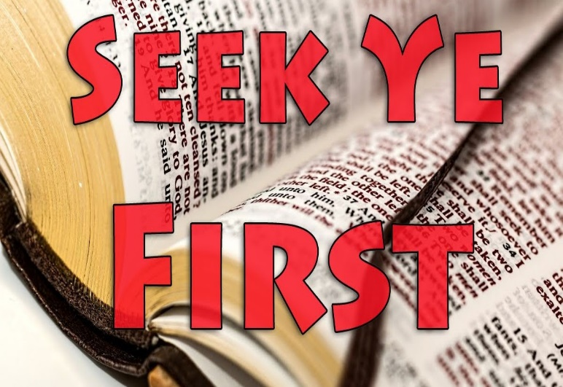“give me Lord” to a “search me O Lord” mentality with the expectation that God will give us the strength, courage, and power to change. For example, when Saul, who was “still breathing out murderous threats against the Lord’s disciples, encountered the risen Christ and was told that he would suffer greatly for Jesus’ name’s sake he did not give Jesus lip service but chose to repent and dedicate his life to serving his Lord for the remainder of his life! To repent of our self-indulgence and seek first the kingdom of God (Matthew 6:33) is far from easy but is the key to becoming a living sacrifice (Romans 12:1-2), holy and pleasing unto He who purchased at the price of His very life (1 Corinthians 6:20).

**Reveal my Fears**

What makes you anxious, nervous, unsettled, and afraid … you know those things that ricochet in your mind and rob you of your precious sleep?[10] David prayed that God would test him by whatever means necessary[11] and reveal to him anything evil that would lessen the “life-giving relationship” [12] he had with Him. While David’s biggest fear was that he had done similar offenses against God as that of his enemies,[13] Groeschel is right to point to “fear” itself as being a huge offense to God![14] Since born again believers are not given a Spirit of fear (2 Timothy 1:7) whatever “holds our minds hostage” offends God because it reveals where we are relying on ourselves the most and trusting God the least![15] What we fear the most in our lives reveals where we are spiritually the weakest and need God’s help to grow! Though we are incapable of achieving any sort of holiness on our own praise be that in our weakness God’s power is made perfect (2 Corinthians 12:9)! Since perfect love drives out fear (1 John 4:18) the key to having peace is found by constantly inviting God to build your faith through His power, Spirit, and holy word.

**Uncover my Sins**

King David was described as a “man after God’s own heart” (1 Samuel 13:14; Acts 13:22) and yet we find that he sinned gravely by committing adultery with Bathsheba and arranging the death of her husband Uriah (2 Samuel 11). It is one thing to ask God to search and reveal any offensive ways we might have but it is quite another to accept His findings! Are we not quick to rationalize and blame others for our sins? The Bible states humans tend to point out the specks in other people’s eyes while ignoring the logs in their own eyes (Matthew 7:1-5). To see more clearly into one’s own heart Groeschel suggests asking a trusted friend, family or a mentor who is born again if they would tell you the areas of your life, your habits, your relationships, your words or deeds that do not match up with holy living as described in the Bible and if two or more of them list the same problem, then this is an area you need to change.[16] Even though their candid suggestions might feel like harsh criticism and you will be tempted to “flatter yourself too much to detect or hate your own sin” (Psalms 36:2), remember Proverbs 12:15 states “the way of fools seems right to them, but the wise listen to advice.”

**Lead Me**

We do not just want God to search us, reveal anxious thoughts and our sins but also to lead us, to direct us, to guide us to become who He wants us to be! Groeschel states following Psalms 139:23-24 is not just “a game or a sterile little spiritual exercise to help you feel better about your day” but is to be a soul-cleansing, heart-mending, eternity altering prayer!”[17] Discovering our darkest of sins becomes a gift the moment we see it as an opportunity though A person holding a watch
the power of the Holy Spirit to change and become more like Jesus! Whenever you are weak, hurting, or tempted, God’s strength, comfort, and grace are available for the asking. Groeschel finishes part one by stating “if you are tired of boring, safe, sterile prayers, if you are stuck in a spiritual rut, if your faith fat, passion low and you are hungry for more” and ready to obey then pray “search me O Lord,” and when God reveals your sins then ask to be forgiven and enjoy His unfailing, unconditional, and unquenchable love!”[18]

1. Kindle location 121.
2. Kindle Location 178.
3. Kindle Location 190.
4. Kindle Location 217.
5. Kindle Location 236.
6. Charles L. Feinberg, [“Jeremiah,”](https://ref.ly/logosres/ebc06?ref=Page.p+487&off=347&ctx=to+be+weak%2c+sick%E2%80%9D).+~To+think+of+the+hear) in *The Expositor’s Bible Commentary: Isaiah, Jeremiah, Lamentations, Ezekiel*, ed. Frank E. Gaebelein, vol. 6 (Grand Rapids, MI: Zondervan Publishing House, 1986), 487.
7. Leslie C. Allen, [*Jeremiah: A Commentary*](https://ref.ly/logosres/otl24je?ref=Bible.Je17.9&off=4&ctx=%E2%80%9Cconsequence%E2%80%9D).%0a%5b9%5d+~The+radicality+of+hu), ed. William P. Brown, Carol A. Newsom, and David L. Petersen, First Edition., The Old Testament Library (Louisville, KY; London: Westminster John Knox Press, 2008), 200.
8. J. Andrew Dearman, [*Jeremiah and Lamentations*](https://ref.ly/logosres/nivac24je?ref=Bible.Je17.9-13&off=334&ctx=uman+deceitfulness.+~The+depths+of+its+po), The NIV Application Commentary (Grand Rapids, MI: Zondervan Publishing House, 2002), 176.
9. Kindle Location 306.
10. Kindle Location 324.
11. C. H. Spurgeon, [*The Treasury of David: Psalms 120-150*](https://ref.ly/logosres/treasdavd06?ref=Bible.Ps139.23&off=725&ctx=+and+undiscovered.+%E2%80%9C~Try+me%2c+and+know+my+), vol. 6 (London; Edinburgh; New York: Marshall Brothers, n.d.), 266.
12. W. Dennis Tucker Jr., [“Psalms 107–150,”](https://ref.ly/logosres/nivac19ps2?ref=Bible.Ps139.19-24&off=3116&ctx=nsive+way+in+me.%E2%80%9D27+~Because+the+psalmist) in *Psalms*, ed. Terry Muck, vol. 2, The NIV Application Commentary (Grand Rapids, MI: Zondervan, 2018), 925.
13. W. Dennis Tucker Jr., [“Psalms 107–150,”](https://ref.ly/logosres/nivac19ps2?ref=Bible.Ps139.19-24&off=2962&ctx=ed+in+verses+19%E2%80%9322.+~The+psalmist%E2%80%99s+only+) in *Psalms*, ed. Terry Muck, vol. 2, The NIV Application Commentary (Grand Rapids, MI: Zondervan, 2018), 925.
14. Kindle Location 324.
15. Kindle Location 336.
16. Kindle Location 402.
17. Kindle Location 512.
18. Kindle Location 552.